- With reference to the audit observation, output GST of ₹55,344 was inadvertently paid twice in the months of October and December 2024. The same has been rectified in the GSTR-3B for October 2025. A copy of the GSTR-3B for October 2025 is attached for your reference.

- With reference to the audit observation, ITC of ₹39,240 (CGST ₹19,620 and SGST ₹19,620), which was not claimed during Apr–Mar’25 though booked in the accounts, has been claimed in the GSTR-3B of August 2024.

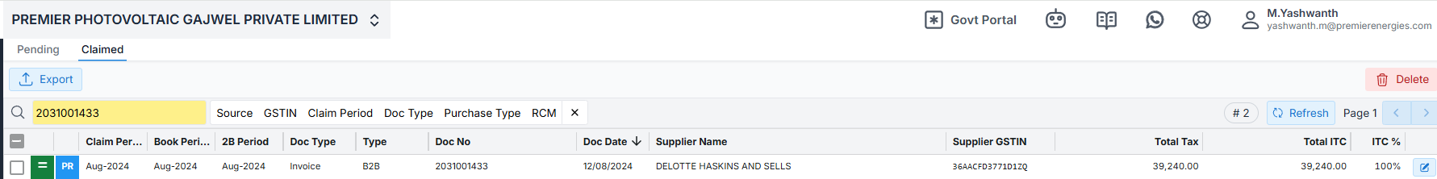

- With reference to the audit observation, it is clarified that the vendor reported the invoice under an incorrect GSTIN. As the time limit for invoice amendment has elapsed, the related input IGST is required to be reversed and the same will be treated as expenditure in the books of accounts.
