IT-204

Signals and Systems

Assignment-2

Kaggle notebook link: [notebook link](https://www.kaggle.com/code/pranavbhat1234/231it049-signalsandsystems-assignment2)

**Problem-set 1:**

Q1.

Output:

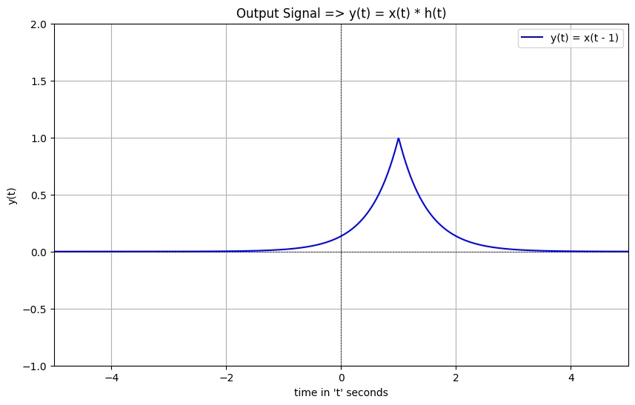

Q2.

Output:

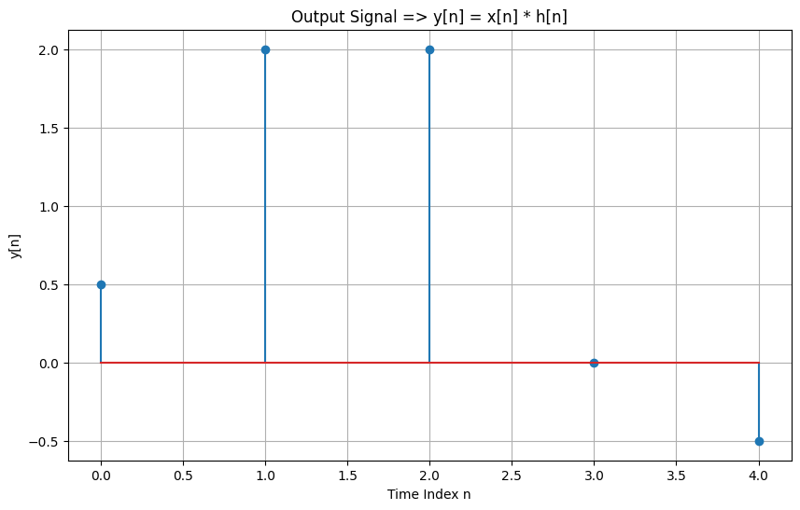

**Problem set - 2**

**Q3.**

Output:

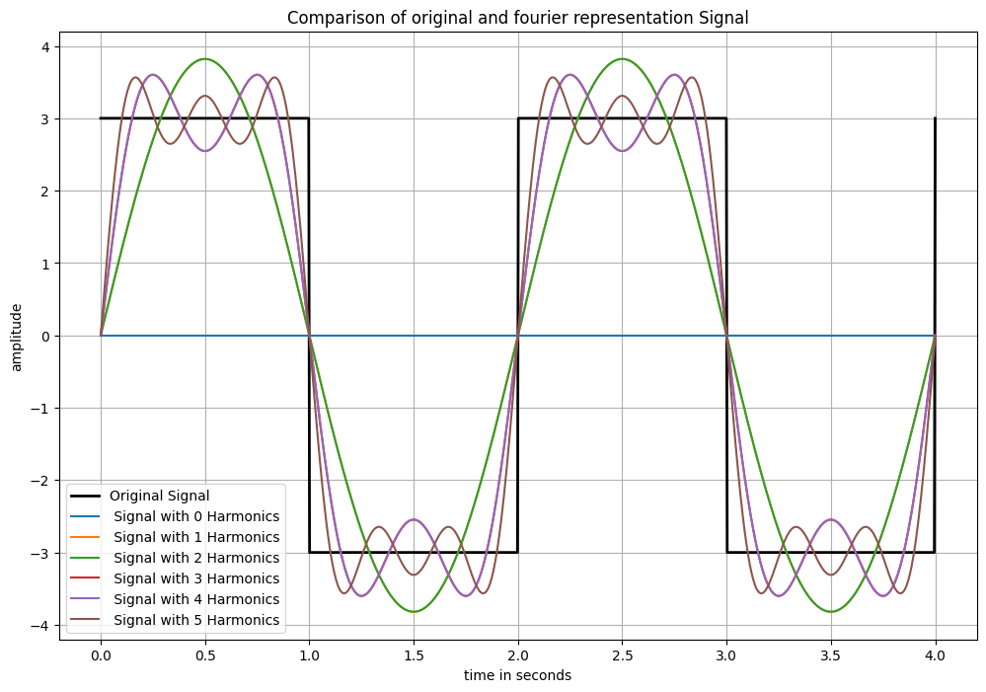

Observations:

While comparing the plots that we have here, we can compare the following:

**Original Square Wave**:

- The original square wave has a sharp rises and drops and represents a periodic signal.

**Representation using fourier series expansion**

- As more harmonics are added to the Fourier series representation, the reconstructed signal increasingly resembles the original square wave and the approximation gets better.

- The initial harmonics capture the general shape of the square wave but are having deviations from ther original shape of the square wave.

- Also as more and more harmonics are added there is a chance that there might be overshooting of values by the harmonic waves at points where there is jump discontinuity. This is called "Gibbs Phenomenon".

Q4.

Output:a)

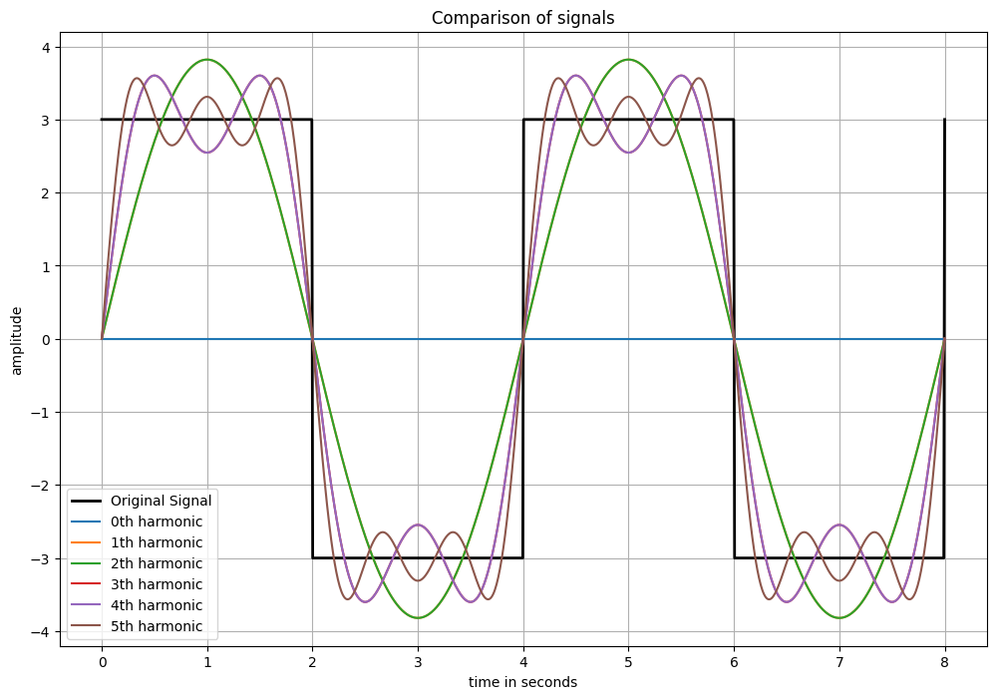

b): Fourier representation

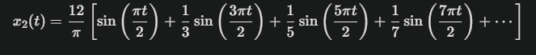

c) Observations:

- The only difference between the outputs of the waves in Q3 and Q4 is the difference in time period. Accordinly the output fourier curve is adjusted to match with the time period of the waves.

**Problem set-3**

**Q5.**

Output

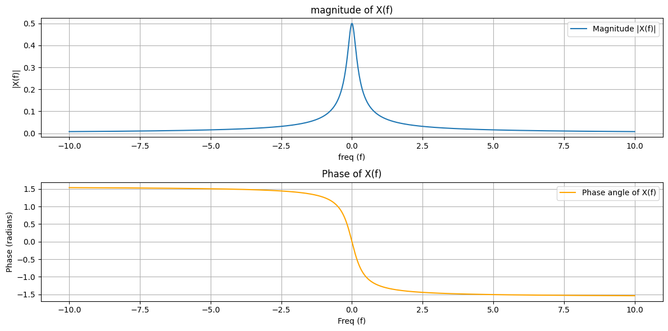

**Problem set-4**

**Q6.**

Output: NEXT PAGE

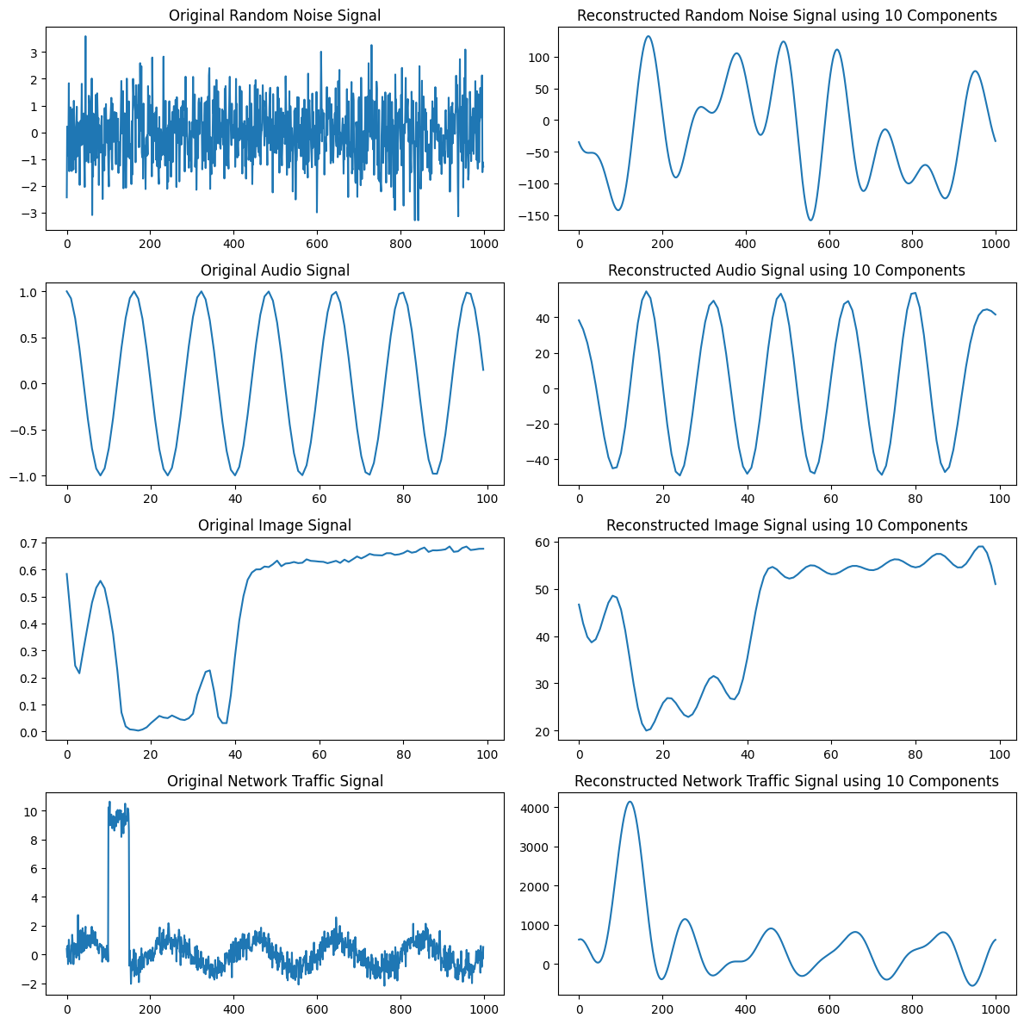

The image outputs are below

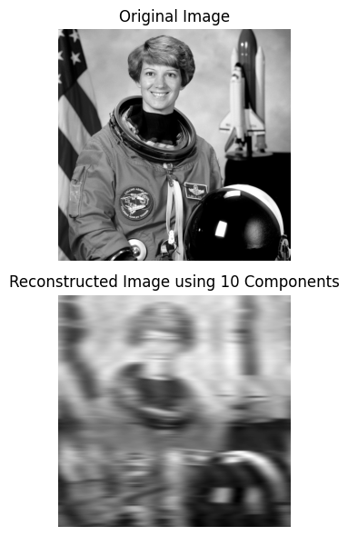

**Observations**:

1. Random noise: In the case of random noise, after performing the fourier analysis using the first 10 frequency component, we obtain a signal which represents the general shape of the random signal by breaking it down to 10 basic components.

2. Audio signal: In the audio signal we see that the wave is uniform. Hence, the fourier analysis using first 10 frequency components results in a wave form similar to that of the original signal due to the simplicity of the original audio signal.

3. Simple Images: In the example above, I have taken the gray-scale image from skimage library. The image is quite complex, and after breaking it down into 10 frequency components after fourier analysis, we see that the reconstructed image closely resembles the original, but is distorted due to loss of the image features after fourier analysis.

4. Signals it IT field: In the final observation using the fourier analysis, we see that the spike in the network traffic is effectively detected by the reconstruction of the signal using the 10 frequency components. This is a good example of real world application of fourier analysis.