TB-Xpredict Tutorial
Implementation of Gist and PHOG Features for Computer-Aided Diagnosis of
Tuberculosis without Segmentation



Department of Biotechnology and Bioinformatics
Jaypee University of Information Technology, Waknaghat
Himachal Pradesh-173234
INDIA
Contact: Dr. Chittaranjan Rout
E-mail: chittaranjan.rout @juit.ac.in
Tel: 91-11-239306
Fax: 91-11-245362

Summary:
This computer-aided diagnosis (CAD) software (MATLAB toolbox) has been developed for automated prediction of tuberculosis (TB) from chest X-ray (CXRs) of patients. This toolbox was developed by incorporating more diversified global features extraction methods such as Gist and PHOG. It is effective in discriminating between CXR(s) of non-TB and TB patients. It contains two modules: Training and Prediction Modules. The latter (Prediction Module) predicts input digital CXR(s) image as TB or non-TB so it will useful for general user. The former module (Training module) enables user to develop a model trained on his/her own TB and non-TB chest radiographs. The user developed automated model could be used for detection of TB from CXR(s). User has also option to choose between Gist and PHOG features to be used in both training and prediction module. This TB-Xpredict software is extremely efficient and having a maximum prediction accuracy of 94.2% with sensitivity of 0.961 for Gist features.
X-ray is widely used technique in developing countries as it is the least invasive primary diagnostic tool with better diagnostic accuracy. Further, the accuracy of smear microscopy test has been less than 50%. Therefore, diagnosis primarily relies primarily on interpretation of radiological patterns found in the CXR. Since poorer countries have limited resources and inadequate skilled radiologists, implementation of X-ray based CAD techniques is expected to improve TB diagnosis accuracy in a big way.

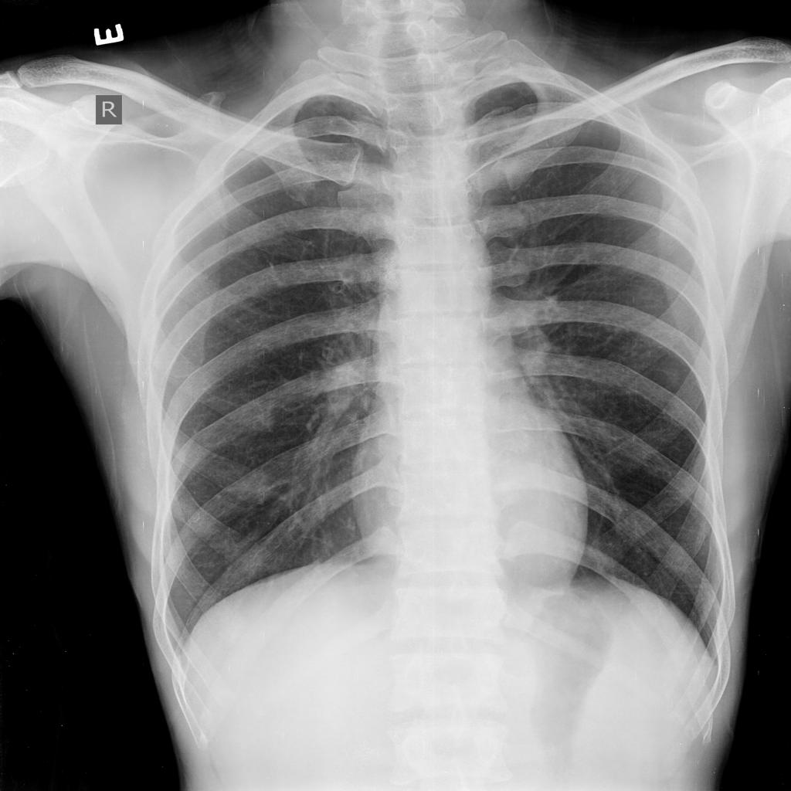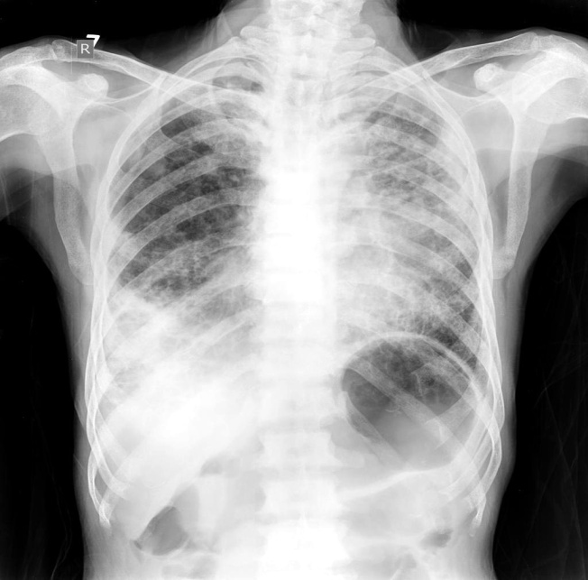

Fig. 1. X-ray images. Left: Normal person & Right: TB patient
Step by step guidance for installation and application of TB-Xpredict:
Prior to installation of TB-Xpredict, MATLAB should be installed. MATLAB may be downloaded from (http://www.mathworks.in/products/matlab/) this location. Installation procedure of this software (MATLAB) is also provided.
TB-Xpredict is freely available at http://www.bioinformatics.org/ftp/pub/bioinfojuit/

Installation of TB-Xpredict:
i. Download the TBXpredict.tar.gz or TBXpredict.zip from the http://www.bioinformatics.org/ftp/pub/bioinfojuit/
ii. Unzip the TBXpredict.tar.gz or TBXpredict.zip file to a folder
iii. Start MATLAB and change the working directory to “TBXpredict”. Working directory can be changed by clicking on the button just right side of “Current Folder”.
iv. Go to the file menu, and then click on "Set Path". In the "Set Path" click on "Add with Subfolders" and then browse to the "TBXpredict" folder. After clicking on the "TBXpredict" folder, click save.
v. Installation is now complete.

The software provides two modules which are given as follows:
I. Prediction Module: Prediction of TB or non-TB from chest X-ray image(s) (for general user)
II. Training Module: Training of the user’s own validated TB and non-TB X-ray images to develop model. The newly developed model can be used for classification of CXRs into suspected TB and normal.

I. Prediction Module
i. Start MATLAB. Set the working directory to the TBXpredict
ii. To predict your X-ray image(s), type "PREDICT" in the command window
iii. A GUI as shown below will appear:

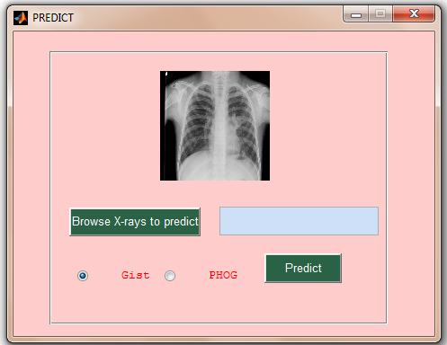
Fig. 2. Prediction Module GUI

iv. Browse the folder containing X-ray data to be predicted by clicking on button “Browse X-rays to predict". Check Gist or PHOG radiobutton to select feature extraction method. Gist is checked on by default. Then click "Predict" button to begin prediction of your CXR(s).
v. Once prediction is complete, a message box with message "Prediction complete" will appear. A GUI with scrollable image(s) containing image file name and its labelling as "suspected TB" or "Normal" will appear as shown below:

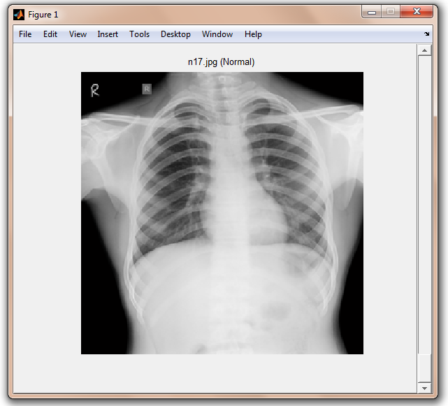

Fig. 3. Output of "Prediction Module"

vi. A log file will also appears in the "TBXpredict" folder which contains the full file name and its path along with its labelling as "Suspected TB" or "Normal".

II. Training Module:
i. Start MATLAB. Set the working directory to the TBXpredict.
ii. Put your TB positive X-ray images in one folder (i.e. named "positive") and normal X-ray images in other folder (i.e. named "negative"). For training your own data, type “TRAIN” in the command window of the MATLAB. A GUI as given below will appear.

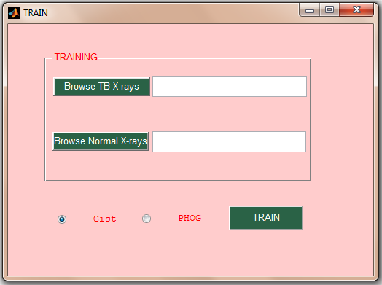

Fig. 4. GUI of Training Module

iii. Browse the folder containing TB positive data by clicking on button named "Browse TB X-rays" and similarly, browse the folder with normal X-rays by clicking button “Browse Normal X-rays”. Check Gist or PHOG radiobutton to select feature extraction method. Gist is checked on by default. Then click on "TRAIN" button to begin training with user own data.
iv. Once training is complete, to predict your X-ray images, repeat the procedure as mentioned in the "Prediction Module".
Note :

i. Always start with "TBXpredict" as working directory.
ii. Keep only .jpg or dicom format files in the positive, negative or test directories. Remove all other type of files.
iii. Training with your own data (subject to availability) is highly recommended.
Brief Methodology: (Flow diagram)

Fig. 5. Flow Diagram describing methodology used in the Software
As shown in Fig. 5, our toolbox uses above methodology for CXR classification: Preprocessing, feature extraction, feature selection and SVM classification. In contrast to earlier methods, no segmentation of CXR is required for Gist and PHOG feature extraction methods. Automatic segmentation of CXRs is often poor due to severe intensity distortions. Because of this segmentation failure, often CXRs are wrongly classified. These methods have outperformed the methods based on textural features which have earlier been used for CAD. Gist is a context-based scene recognition method and captures biologically plausible features in a signatory low-dimensional vector. The input for this MATLAB toolbox is an X-ray image in dicom or .jpg format. All processes including preprocessing, feature extraction, feature selection and classification are done automatically. With the increase in training data over time, the model becomes more accurate.

