


VISVESVARAYA TECHNOLOGICAL UNIVERSITY
“Jnana Sangama”,Belagavi-590 018

REPORT ON

“TECHNICAL WRITING USING LaTeX”
BCSL456D
Submitted in partial fulfilment of requirements for the degree of

BACHELOR OF ENGINEERING IN
COMPUTER SCIENCE AND ENGINEERING

Under the Guidance of
Shruthi G.K.,B.E.,M.Tech.
Assistant Professor
Department of Computer Science and Engineering Adichunchanagiri Institute of Technology

Submitted by

Mihir Misran (4AI24CS058)

Department of Computer Science and Engineering ADICHUNCHANAGIRI INSTITUTE OF TECHNOLOGY
Visvesvaraya Technological University, Belgavi.
JUNE 2025-26

ADICHUNCHANAGIRI INSTITUTE OF TECHNOLOGY
( Affiliated to Vishvesvaraya Technological University,Belagavi) Chikkamagaluru,Karnataka,India-577102
DEPARTMENT OF COMPUTER SCIENCE AND ENGINEERING

CERTIFICATE
This is to certify that the work entitled “Technical Writing Using LaTex” is a bonafide work carried out by SHANAWAZ (4AI24CS100) student of 4th semester B.E,in partial fulfillment for the award
of Degree of Bachelor of Engineering in Computer Science and Engineering of the
Visvesvaraya Technological University,Belagavi during the academic year 2025-2026.It is certified that all corrections and suggestions indicated for Internal Assesment have been incorporated in the report deposited in the department library.The LaTex report has been approved, as it satisfies the academic requirments in respect of LaTex work prescribed for the said Degree.

Submitted by

Mihir Misran (4AI24CS058)

Signature of Guide Shruthi G.K.,BE.,M.Tech, Assistant Professor & Guide, Department of CS&E,
AIT, Chikkamagaluru.
Signature of Principal
Dr. Goutham M A.,BE.,M.Tech,PhD
Principal
AIT, Chikkamagaluru.
Signature of HOD
Dr. Pushpa Ravikumar., BE.,M.Tech,PhD Professor & Head, Department of CS&E, AIT,Chikkamagaluru.



Examiner 1: Examiner 2:

ADICHUNCHANAGIRI INSTITUTE OF TECHNOLOGY
(Affiliated to Visvesvarya Technological University, Belagavi) CHIKKAMAGALURU, INDIA-577 102
DEPARTMENT OF COMPUTER SCIENCE AND ENGINEERING

APPROVAL
The work(BCSL456D) entitled “Technical Writing Using LATEX” is hereby approved as credible study of engineering subject carried out and presented in a satisfactory manner for acceptance as a pre-requisite to the degree of Bachelor of Engineering in Computer Science and Engineering during academic year 2025-26

Submitted by:

Mihir Misran (4AI24CS058)


Signature of Guide Shruthi G.K.,BE.,M.Tech, Assistant Professor & Guide,
Department of CS&E, AIT, Chikkamagaluru.
Signature of HOD
Dr. Pushpa Ravikumar, BE.,M.Tech,PhD Professor and Head, Departement of CS&E, AIT, Chikkamagaluru.

ACKNOWLEDGEMENT

I express our humble Pranamas to his holiness Parama Poojya Jagadguru Padmabushana Sri Sri Sri Dr. Balagangadharanatha Mahaswamiji and Parama Poojya Jagadguru Sri Sri Sri Dr. Nirmalanandanatha Mahaswamiji and also to Sri Sri Gunanatha Swamiji Sringeri Branch Chikkamagaluru who have showered their blessings on us for framing our career successfully.
I deeply indebted to my honourable Director Dr. C K Subbaraya for creating the right kind of care and ambience.
I am Thankful to our beloved Principal Dr. Goutham M A for inspiring us to achieve greater endeavours in all aspects of Learning.
I express my deepest gratitude to Dr. Pushpa Ravikumar, Professor and Head of the Department of Computer Science and Engineering for her valuable guidance, suggestions and constant encouragement without which success of our LATEX work would have been difficult.
I am Grateful to our guide and LATEX Coordinator Shruthi G.K., for her excellent guidance, constant encouragement, support and constructive suggestions. We are thankful to her inspiration and lively correspondence for carrying our work.
I would like to thank my beloved parents for their support, encouragement and blessings. And last but not least, I would be pleased to express our heartfelt thanks to all teaching and non-teaching staff of CSE Department and our friends who have rendered their help, motivation and support.

Mihir Misran (4AI24CS058)

Abstract
This report examines the impact of technical writing using LaTeX. The typesetting system commonly used for academic and technical documents. LaTeX uses markup language to define the structure and formatting of a document, making it popular for writing research papers, theses, and other complex documents. It’s known for producing high-quality documents with consistent formatting. Technical writing using LaTeX is quite popular among researchers, academics, and technical professionals because of its ability to produce professional-looking documents with complex structures and mathematical formulas.
LaTeX uses the TeX typesetting system to create professional-quality documents, particularly in the fields of mathematics, physics, engineering, and computer science. It’s a markup language that allows users to create documents with precise control over layout, formatting, and typography. LaTeX is widely used in academia and research for creating papers, theses, dissertations, and books. It’s also used in industry for creating technical documentation, reports, and presentations.
Technical writing using LaTeX offers a robust and versatile platform for creating high- quality documents with complex structures, mathematical equations, and precise formatting. LaTeX’s ability to handle various elements like sections, figures, tables, citations, and references makes it an ideal choice for researchers, academics, and technical professionals who need professional looking outputs. With its support for collaboration, templates, styles, and multiple output formats, LaTeX provides a comprehensive solution for producing well-organized and visually appealing technical documents.

Table of Contents

Prg NO. | PROG NAME | DATE | Marks
1 | SIMPLE DOCUMENT | 06-03-2026
2 | SAMPLE ABSTRACT | 06-03-2026
3 | FIRST PAGE | 13-03-2026
4 | CERTIFICATE | 13-03-2026
5 | TABLE OF STUDENT DETAILS | 27-03-2026
6 | SIDE-BY-SIDE GRAPHICS | 17-04-2026
7 | MATHEMATICAL EQUATION | 24-04-2026
8 | THEOREMS | 15-05-2026
9 | PARAGRAPHS WITH CITATIONS | 05-05-2026
10 | TREE DIAGRAM | 22-05-2026
11 | ALGORITHM | 22-05-2026
12 | IEEE TEMPLATE FORMAT | 22-05-2026

Total:

Lab Program 1

Develop a LaTeX script to create a simple document that consists of 2 sections [Section1, Section2], and a paragraph with dummy text in each section. And also include header [title of document] and footer [institute name, page number] in the document.

\documentclass{article}
\usepackage{authoraftertitle}
\usepackage{fancyhdr}
\fancyhead{}
\fancyhead[L]{left header}
\fancyhead[R]{right header \quad \thepage}
\fancyfoot{}
\fancypagestyle{plain}{
\fancyhead{}
\fancyhead[C]{Artificial Intelligence}
\fancyfoot{}
\fancyfoot[C]{AIT, Chikkamagaluru}
}
\pagestyle{fancy}
\title{Large language Models}
\begin{document}
\maketitle
\section{Introduction to LLMs}

Large language models (LLMs) are a category of foundation models trained on immense amounts of data making them capable of understanding and generating natural language and other types of content to perform a wide range of tasks.

\section{How large language models work}
LLMs operate by leveraging deep learning techniques and vast amounts of textual data. These models are typically based on a transformer architecture, like the generative pre-trained transformer, which excels at handling sequential data like text input. LLMs consist of multiple layers of neural networks, each with parameters that can be fine-tuned during training, which are enhanced further by a numerous layer known as the attention mechanism, which dials in on specific parts of data sets.

\end{document}

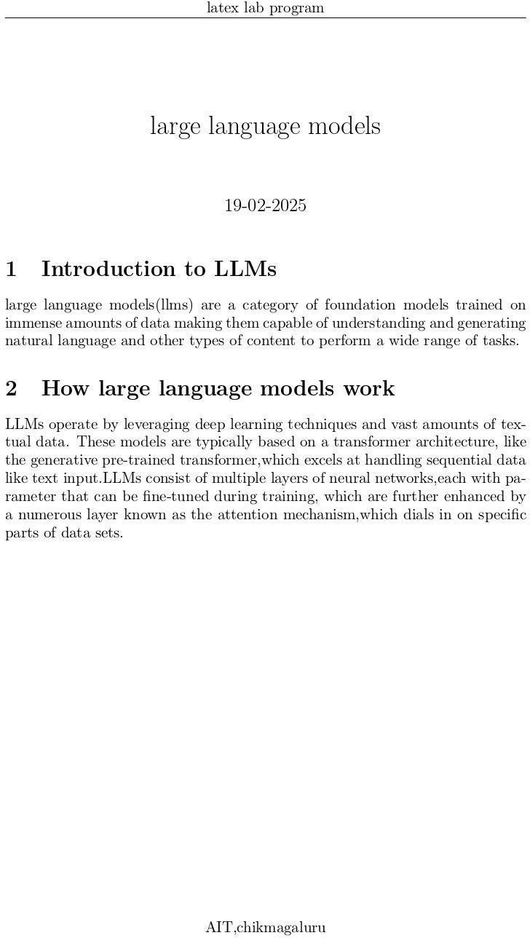
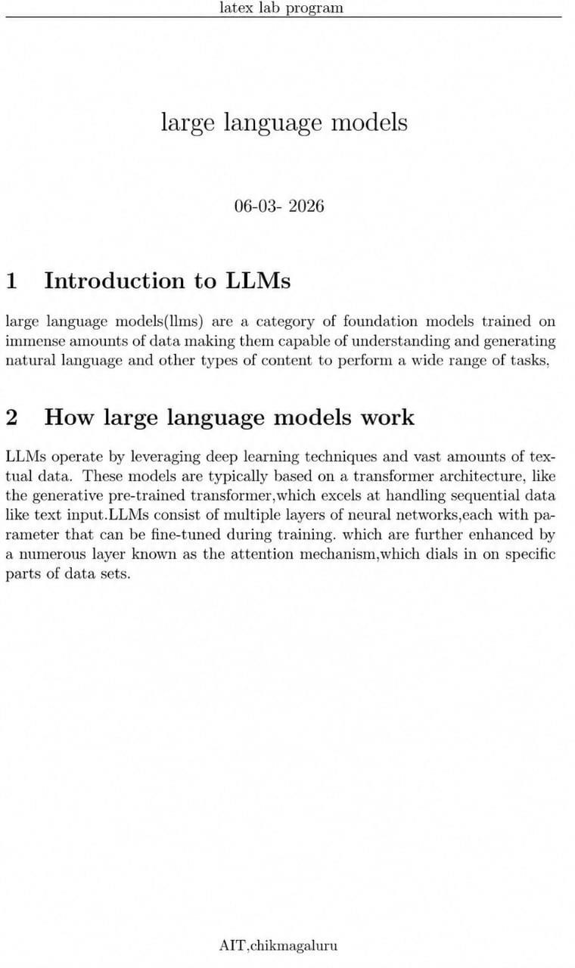
Output:

LaTeX Commands of Lab Program 1:

documentclass[a4 paper,12pt{article}: documentclass:
This is the command to specify the document class, which determines the layout and formatting of the document.

[a4paper,12pt]:
These are the options for the document class. a4paper specifies the paper size as A4, and 12pt sets the font size to 12 points.

{article}:
This is the document class itself, which in this case is the article class. This class is suitable for most articles, reports,and papers.

justify command:
This command helps to align more evenly.

begin{document}:
This command marks the beginning of the document’s content. It’s where you start adding your text, equations, figures, tables, and other elements that make up your document. Everything above this line is considered the preamble, where you set up the document’s layout, fonts, and other settings.

- end{document}:
This command marks the end of the document’s content. It’s the last line of your LaTeX document, and it signals the end of the document.
  - Text: paragraphs, headings, lists, etc.
  - Equations: mathematical expressions using LaTeX’s math mode.
  - Figures: images, diagrams, and other graphics.
  - Tables: tabular data, charts, and other tables.
  - References: citations, bibliographies, and other references.

thispagestyle command:
The thispagestyle command works in the same manner as the pagestyle command except that it changes the style for the current page only. It describes the header and footer style for current page.

fancypagestyle{}:
This command provided by the fancyhdr package, which allows you to customize the layout
and design of your document’s headers and footers.

  - fancypagestyle: This is the command to define a new page style.
  - fancyhead: defines the header
  - fancyfoot: defines the footer
  - lfoot, cfoot, rfoot: define the left, center, and right parts of the footer, respectively
  - lhead, chead, rhead: define the left, center, and right parts of the header, respectively
- title{}:
This command used to specify the title of a document. It is typically used in the preamble of a LaTeX document, before the begindocument line.

maketitle{}:
command used to generate a title page based on the information provided by the title, author, and date commands.

- section{} :
This command used to create a section heading in a document. It is a part of the document’s
structure and is used to organize the content into logical sections

Lab Program 2

Develop a LaTeX script to create a document that displays the sample Abstract / Summary
\documentclass{article}
\usepackage{ragged2e}
\usepackage{lipsum}
\usepackage{blindtext}
\title{\textbf{Abstarct}}
\vspace{-8ex}
\date{}

\begin{document}
\maketitle
\thispagestyle{empty}
\justify{\blindtext[1]}
\vspace{1mm}
\justify{\blindtext[1]}
\vspace{1mm}

\end{document}

Output:

Abstarct

Lorem ipsum dolor sit amet, consectetuer adipiscing elit. Etiam lobortis facilisis sem. Nullam nec mi et neque pharetra sollicitudin. Praesent imperdiet mi nec ante. Donec ullamcorper, felis non sodales commodo, lectus velit ultrices augue, a dignissim nibh lectus placerat pede. Vivamus nunc nunc, molestie ut, ultricies vel, semper in, velit. Ut porttitor. Praesent in sapien. Lorem ipsum dolor sit amet, consectetuer adipiscing elit. Duis fringilla tristique neque. Sed interdum libero ut metus. Pellentesque placerat. Nam rutrum augue a leo. Morbi sed elit sit amet ante lobortis sollicitudin. Praesent blandit blandit mauris. Praesent lectus tellus, aliquet aliquam, luctus a, egestas a, turpis. Mauris lacinia lorem sit amet ipsum. Nunc quis urna dictum turpis accumsan semper.
Lorem ipsum dolor sit amet, consectetuer adipiscing elit. Etiam lobortis facilisis sem. Nullam nec mi et neque pharetra sollicitudin. Praesent imperdiet mi nec ante. Donec ullamcorper, felis non sodales commodo, lectus velit ultrices augue, a dignissim nibh lectus placerat pede. Vivamus nunc nunc, molestie ut, ultricies vel, semper in, velit. Ut porttitor. Praesent in sapien. Lorem ipsum dolor sit amet, consectetuer adipiscing elit. Duis fringilla tristique neque. Sed interdum libero ut metus. Pellentesque placerat. Nam rutrum augue a leo. Morbi sed elit sit amet ante lobortis sollicitudin. Praesent blandit blandit mauris. Praesent lectus tellus, aliquet aliquam, luctus a, egestas a, turpis. Mauris lacinia lorem sit amet ipsum. Nunc quis urna dictum turpis accumsan semper.

LaTeX Commands of Lab Program 2:

ragged2e Package:
By default, LaTeX typesets text as fully-justified, but occasionally left-aligned or ”ragged right” text (for right-to-left languages) may be more appropriate—such as text within narrow columns. This article explains how to change text alignment for parts, or all, of your document using LaTeX’s built-in features and the package ragged2e.
There are 3 text alignment commands it provide:
1. ragged-right (\raggedright) 2.ragged- left (\raggedleft)
3. centred (\centering)

justify command:
It helps to align the text in order or it helps to align the text in more evenly than ragged format.
eg: \justify{ %dummy text }

blindtext command:
This command generates the dummy text.
eg: \usepackage{blindtext}
\blindtext[1]
As number varies number of dummy text varies too

Vspace command:
This command adds vertical space. The length of the space can be expressed in any terms that LaTeX understands, i.e., points, inches, cm, em, ex etc. You can add negative as well as positive space with an this command. LaTeX removes vertical space that comes at the end of a page.
eg: \Vspace{-8em}

thispagestyle command:
The thispagestyle command works in the same manner as the pagestyle command except that it changes the style for the current page only. It describes the header and footer style for current page.

eg: \thispagestyle{option}
option are:\\
  - empty: no header and footer.
  - plain: no header but footer with page number at center.
  - headings: no footer but has header.
  - myheadings: no footer but has header.

textbf command:
This command changes the font style to bold font.
eg: \textbf{Abstract}

date command:
This command gives a current date
eg: \date{May 2024}

Vspace* command
This command is useful when vspace command is not doing any changes in document. By using this command it provide required space as per length mentioned.
eg: \vspace*{length}
\vspace*{2pt}

Lab Program 3

Develop a LaTeX script to create a simple title page of the VTU project Report [Use suitable Logos and text formatting]

\documentclass[a4paper, 12pt]{report}
\usepackage{graphicx}
\usepackage{xcolor}
\begin{document}
\include{FrontPage-VTU}
\thispagestyle{empty}
\begin{center}
\textbf{\large Building Conversational AI Enabled Chatbots}
\end{center}
\vspace{18mm}
\begin{center}
\begin{small}

A Project Report\\ Submitted for the Award of the Degree\\ of\\ Bachelor of Engineering\\ in\\
Computer Science and Engineering\\ by\\
\vspace{.5cm} \textbf{Mihir Misran}\\ IV SEM\\ \
\vspace{.3cm}
Under the guidance of\\ \vspace{.5cm} \textbf{SHRUTHI G K}\\ Assistant Professor\\ Adichunchanagiri Institute of Technology\\ Visvesvaraya Technological University,
Belgavi.\\

\end{small}
\vspace{10mm}

\centerline{\includegraphics[scale=.6]{vtu_logo}}
\vspace{20mm}

Department of Computer Science and Engineering\\ ADICHUNCHANAGIRI INSTITUTE OF TECHNOLOGY\\
Visvesvaraya Technological University, Belgavi.\\ JUNE 2026\\

\end{center}
\end{document}


Output:

Building Conversational AI Enabled Chatbots

A Project Report Submitted for the Award of the Degree
of
Bachelor of Engineering in
Computer Science and Engineering
by
Mihir Misran IV SEM
Under the guidance of

Shruthi G.K.,
Assistant Professor Adichunchanagiri Institute of Technology
Visvesvaraya Technological University, Belgavi.

Department of Computer Science and Engineering ADICHUNCHANAGIRI INSTITUTE OF TECHNOLOGY
Visvesvaraya Technological University, Belgavi.
JUNE 2026

LaTeX Commands of Lab Program 3:

centerline:
Centerline is a simple and convenient way to center a single line of text, an image, or other material. It is often used in titles, headings, and captions, as well as in tables of contents, indexes, and other types of lists.

includegrahics{}:
In LaTeX,includegraphics is a command used to include an external graphics file, such as an image, into a document.
The graphicx package provides a range of options for customizing the inclusion of graphics files. Some common options include:
- width: specifies the width of the graphics file, e.g. 2.width=0.5.
- height: specifies the height of the graphics file, e.g. height=0.5.
- scale: scales the graphics file by a factor, e.g. scale=0.5.
- angle: rotates the graphics file by a specified angle, e.g. angle=45.
- origin: specifies the origin of the rotation, e.g. origin=c (center).

usepackagecolor{}:
In LaTeX, ’usepackagexcolor’ is a command used to load the xcolor package, which provides a range of features for working with colors in LaTeX documents.

The xcolor package is an extension of the standard LaTeX color package, and it provides a more powerful and flexible way to define and use colors in your document. With xcolor, you can:
- Define custom colors using various color models (e.g., RGB, CMYK, HSV).
- Use named colors (e.g., red, blue, green).
- Create color gradients and shades.
- Define colors with transparency (alpha channel).

Lab Program 4

Develop a LaTeX script to create the Certificate Page of the Report [Use suitable commands to leave the blank spaces for user entry]

\documentclass[a4paper]{article}
\usepackage{setspace}
\usepackage{tcolorbox}

\begin{document}
\begin{tcolorbox}[colframe=black, colback=white, boxrule=2pt, arc=0pt, outer arc=0pt]
\begin{center}
\vspace{1cm}
\textbf\Large{ADICHUNCHANAGIRI INSTITUTE OF TECHNOLOGY
\\[7pt]
JYOTHINAGARA, CHIKKAMAGALURU-577102 \\ [7pt] DEPARTMENT OF COMPUTER SCIENCE AND ENGINEERING\\
}
\vspace{1cm}
\includegraphics[width=0.3\textwidth]{vtu_logo.jpg}

\vspace{1cm}
\textbf{\underline{CERTIFICATE}}
\end{center}
\doublespacing
This is to certify that \textbf{\color{blue}Mihir Misran(4AI24CS058)} has submitted the Dissertation Phase 2 Report on textbf{\color{blue} "OntoCopy: Copyright Ontology on Indian Court Judgements for Case Summarisation"} for the fulfillment of \textbf{IV semester Computer Science and Engineering}, with a Master’s in Information Technology prescribed by the \textbf{ADICHUNCHANAGIRI INSTITUTE OF TECHNOLOGY} for the academic year 2025-2026. The Dissertation
report has been approved as it satisfies the academic requirements in respect of work guidelines prescribed for the said degree.
\doublespacing
\vspace{2cm}
\noindent
\begin{minipage}[t]{0.5\textwidth}
\begin{tabular}[t]{c}
\rule{10em}{0.4pt}\\
\textbf{Prof.Shruthi G K.,} \\ Assistant Professor \& Guide, \\ Department of CSE, \\
AIT, Chikkamagaluru.\\

\end{tabular}
\end{minipage}%
\begin{minipage}[t]{0.5\textwidth}
\begin{flushright}
\begin{tabular}[t]{c}
\rule{10em}{0.4pt}\\
\textbf{Dr. Goutham M A, } \\ Principal\\
AIT, Chikkamagaluru.\\
\end{tabular}
\end{flushright}
\end{minipage}
\vspace{1.5cm}
\noindent
\begin{minipage}[t]{0.5\textwidth}
\begin{tabular}[t]{@{}c}
\rule{10em}{0.4pt}\\
\textbf{Examiner 1} \\
\end{tabular}
\end{minipage}%
\begin{minipage}[t]{0.5\textwidth}
\begin{flushright}
\begin{tabular}[t]{@{}c}
\rule{10em}{0.4pt}\\
\textbf{Examiner 2} \\
\end{tabular}
\end{flushright}
\end{minipage}
\end{tcolorbox}

\end{document}

Output:

ADICHUNCHANAGIRI INSTITUTE OF TECHNOLOGY JYOTHINAGARA, CHIKKAMAGALURU-577102 DEPARTMENT OF COMPUTER SCIENCE AND ENGINEERING

CERTIFICATE

This is to certify that Mihir Misran (4AI24CS058) has submitted the Dissertation Phase 2 Report on ”OntoCopy: Copyright Ontology on Indian Court Judgements for Case Summarisation” for the fulfillment of IV semester Computer Science and Engineering, with a Master’s in Information Technology prescribed by the ADICHUNCHANAGIRI INSTITUTE OF TECHNOLOGY for the
academic
year 2023-2024. The Dissertation report has been approved as it satisfies the

academic requirements in respect of

Prof. Shruthi G.K., Assistant Professor & Guide, Department of CSE, AIT, Chikkamagaluru.
work guidelines prescribed for the said degree.

Dr. Goutham M A,
Principal
AIT, Chikkamagaluru.



Examiner 1 Examiner 2

LaTeX Commands of Lab Program 4:

usepackage{tcolorbox}:
The tcolorbox package in LaTeX is a versatile tool for creating colored boxes that can contain text, equations, images, or anything else. These boxes can be customized with various styles and colors, making them useful for highlighting important information, creating notes, or designing complex layouts.

usepackage[dvisgm][dvipsnames] color:
The color package in LaTeX is used to define and apply colors to text and other elements in your document. The options dvisgm and dvipsnames are specific to the driver being used and the set of named colors available.

begin{titlepage}:
In LaTeX, creating a title page can be easily done using the titlepage environment. This environment allows you to design a separate page for the title, authors, date, and any additional information you might want to include.

includegraphics:
Including graphics in your LaTeX document can be done using the graphicx package, which provides the ’includegraphics’ command. This command allows you to insert images into your document and customize their appearance.

doublespacing:
To double space a LaTeX document, you can use the setspace package, which provides commands to
change the spacing in your document.

noindent:
In LaTeX, is used to prevent the indentation of the paragraph that immediately follows it. By default, LaTeX indents the first line of each paragraph. Using removes this indentation for the specific paragraph.

begin{flushright}:
In LaTeX, the flushright environment is used to right-align text.

Lab Program 5

Develop a LaTeX script to create a document that contains the following table with proper labels.

\documentclass{article}
\begin{document}
\textbf{\huge Table of Students Details}

\begin{table}[h]
\centering
\begin{tabular}{|p|p|p|p|p|p|}
\hline

S.No&USN&StudentName& \multicolumn{3}{|c|}{Marks}\\ \cline{4-6} &&&Subject1&Subject2&Subject3 \\ \hline

1&4AI22CS095&Anu&90&87&78\\ \hline
2&4AI22CS096&Sana&90&95&82\\ \hline
3&4AI22CS097&Siri&91&88&77\\ \hline
\end{tabular}
\caption{Marks Details}
\label{tab:example}
\end{table}
\end{document}

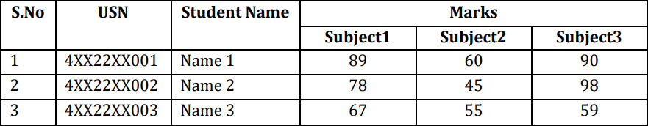
Output:

Table of Students Details

S.No | USN | Name | Marks
 |  |  | Subject1 | Subject2 | Subject3
1 | 4AI23CS095 | Aadhi | 90 | 87 | 78
2 | 4AI23CS096 | Sana | 90 | 95 | 82
3 | 4AI23CS097 | Siri | 91 | 88 | 77
Marks Details

LaTeX Commands of Lab Program 5:

usepackage (booktabs):
The booktabs package in LaTeX is used to create high-quality tables. It provides commands to create well-formatted tables with better spacing and layout compared to the default table formatting options.

usepackage (array):
The array package in LaTeX provides additional tools and enhancements for creating and customizing arrays and tabular environments. It extends the functionality of LaTeX’s default tabular environment, offering more control over column alignment, spacing, and formatting.

begin(table)[h!]:
The table environment in LaTeX is used to create floating tables, which means that LaTeX will decide the best placement for the table in your document. The [h!] option is a placement specifier that tells LaTeX to place the table ”here” (approximately where it appears in the source code), with an added ”!” to override internal parameters.

begin (tabular)(—c——c—):
The tabular environment in LaTeX is used to create tables. The syntax begintabular—c—— c— specifies the layout of the table.

The argument —c——c— defines the format for the columns:
— : A vertical line separatingcolumns. c: Centers the content in the column.
——: Double vertical lines, creating a thicker separation between the first two columns

hline:
The hline command in LaTeX is used within the tabular environment to create horizontal lines across the width of a table. It helps to separate rows visually, improving the table’s readability.

cline:
The cline command in LaTeX is used to create horizontal lines in a table that span specific columns.

caption:
The caption command in LaTeX is used to provide a caption for figures and tables. It typically describes the content or purpose of the floating object and is placed inside the figure or table environment.

label:
The label command in LaTeX is used to create a reference label for figures, tables, sections, equations, and other elements in your document. This allows you to refer to them elsewhere in the text using the ref or pageref commands.

Lab Program 6

Develop a LaTeX script to include the side-by-side graphics/pictures/figures in the document by using the subgraph concept
\documentclass{article}
\usepackage{graphicx} % Required for inserting images
\usepackage{subcaption}

\begin{document}
\textbf{\huge Side-By-Side Subgraph}
\begin{figure}[h]
\subfloat[First Dataset Accuracy]{
\begin{minipage}[c][\width]{0.3\textwidth}
\centering
\includegraphics[width=1\textwidth]{fig1.jpeg}
\end{minipage}
}
\hfill
\subfloat[Second Dataset Accuracy]{
\begin{minipage}[c][\width]{0.3\textwidth}
\centering
\includegraphics[width=1\textwidth]{fig2.jpeg}
\end{minipage}
}
\hfill
\subfloat[Third Dataset Accuracy]{
\begin{minipage}[c][\width]{0.3\textwidth}
\centering
\includegraphics[width=1\textwidth]{fig3.jpeg}
\end{minipage}
}

\caption{Performance Analysis}

\end{figure}

\end{document}

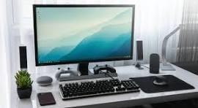
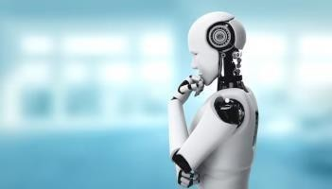


Output:

Side-By-Side Subgraph

(a) First Dataset Accuracy (b) Second Dataset Accuracy (c) Third Dataset Accuracy
Performance Analysis

LaTeX Commands of Lab Program 6:

ragged2e Package:
It’s important to clarify that ragged is a LaTeX command used for text alignment control, but it typically requires an argument specifying the alignment (right, left, or center).

usepackage (graphics)
The usepackagegraphics command is used in LaTeX documents to include the graphics package, which provides enhanced support for graphics inclusion and manipulation within your document.

hfill:
The command hfill in LaTeX is used to insert horizontal space that expands to fill the available horizontal space on the current line. It’s particularly useful for creating horizontal alignments or for spacing elements within a line.

subfloat[comparision]:
Subfloat is used to create subfigures labeled as (a) and (b). Each subfloat command takes two arguments: the content (here, includegraphics for including the image) and the caption inside [...]. The subcaption package provides support for subfigures and allows you to create subfloats within a figure environment.

begin(figure)[ht]:
The LaTeX command begin(figure)[ht] is used to begin a figure environment with optional placement specifiers [ht]. Here’s what each specifier means:
(h): Place the figure here, i.e., approximately at the same point it occurs in the text. (t): Place the figure at the top of a page.

begin(minipage):
The beginminipage command in LaTeX is used to create a minipage, which is a small boxed-in or side-by-side portion within a page. It’s particularly useful for placing content such as text, figures, or tables side by side or for controlling the layout of content that needs to be treated as a unit.

textwidth:
In LaTeX, textwidth is a length parameter that represents the width of the current text block. It’s a useful measure when you want to specify dimensions relative to the width of the text area, such as when setting the width of figures, tables, or minipages.

caption:
In LaTeX, the caption command is used to add captions to figures and tables.

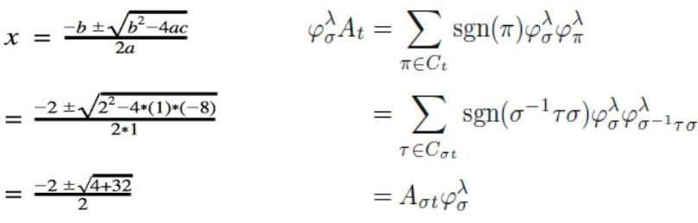
Lab Program 7

Develop a LaTeX script to create a document that consists of the following two mathematical equations

\documentclass{article}

\usepackage{amsmath}
\begin{document}
\title{Following Two Mathematical Equations}
\date{}
\maketitle
\begin{equation}
\begin{aligned}
\begin{split} y&=\frac{\frac{a}{b}}{c}\\
x&=\frac{-b\pm \sqrt{bˆ2-4ac}}{2ac} \\
&=\frac{-2\pm \sqrt{2ˆ2-4 \cdot 1 \cdot(-8)}}{2\cdot 1} \\ &=\frac{-2\pm \sqrt{4+32}}{2}
\end{split}
\quad
\quad &
\begin{split}
\sum_{i=0}ˆ{n} iˆ2& = 0+1+4+\ldot+iˆ2\\
\varphi_{\sigma}ˆ{\lambda} A_{t}
&= \sum_{\pi \in C_{t}}\operatorname{sgn} (\pi)
\varphi_{\sigma}ˆ{\lambda} \varphi_{\pi}ˆ{\lambda} \notag \\ &=
\sum_{\tau \in C_{\sigma t}} \operatorname{sgn}(\piˆ{-1}\tau
\sigma) \varphi_{\sigma}ˆ{\lambda} \varphi_{\piˆ{-1} \tau
\sigma}ˆ{\lambda} \notag \\
&= A_{\sigma t} \varphi_{\sigma}ˆ{\lambda}
\end{split}
\end{aligned}
\end{equation}
\end{document}

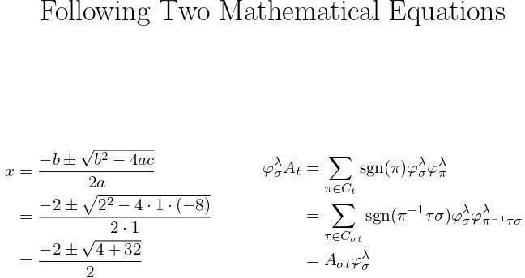
Output:

LaTeX Commands of Lab Program 7:

usepackage (amsmath):
The amsmath package is used in LaTeX to enhance the mathematical typesetting capabilities of the document. It provides a variety of features and improvements over the standard LaTeX math environment.

2.[ slash]:
In LaTeX, the [ slash] delimiters are used to create a display math environment, which centers the mathematical expression on a new line and separates it from the surrounding text. This environment is typically used for standalone equations that should be prominently displayed.

begin (aligned):
The aligned environment in LaTeX, provided by the amsmath package, is used to align multiple lines of equations. It is typically used within a math environment like equation or gather, or within display math delimiters [ slash]

begin (split):
The split environment in LaTeX, provided by the amsmath package, is used to split a long equation into multiple lines for better readability. This environment is typically used within an equation environment to ensure the equation is properly numbered. The split environment aligns the split parts at the and symbol.

varphi:
In LaTeX, varphi is used to produce the Greek letter(phi) in its variant form, which is commonly used in mathematics and science.

frac:
n LaTeX, the frac command is used to create fractions. The frac command takes two arguments: the numerator and the denominator.

usepackage (booktabs):
The quad, which is a LaTeX command used to insert horizontal space within a document. The command quad inserts a space equal to the width of the letter ’M’ in the current font.

cdot:
n LaTeX, cdot is used to produce a centered dot, which is commonly used to denote multiplication or the dot product in mathematical expressions

pm:
n LaTeX, the pm command is used to produce the plus-minus symbol (±), which is often used in mathematical
expressions to indicate a value that can be both positive and negative.

sum:
In LaTeX, the sum command is used to typeset a summation symbol. It is typically used within math environments to denote the sum of a series of numbers or terms.

tau:
In LaTeX, the tau command is used to typeset the lowercase Greek letter tau. Tau is the 19th letter of the Greek alphabet and is often used in various scientific and mathematical contexts.

sigma
In LaTeX, the sigma command is used to typeset the lowercase Greek letter sigma. Sigma is the 18th letter of the Greek alphabet and has various uses in mathematics, physics, statistics, and other scientific disciplines.

lambda:
In LaTeX, the lambda command is used to typeset the lowercase Greek letter lambda. Lambda is the 11th letter of the Greek alphabet and is commonly used in various scientific and mathematical contexts, including physics, mathematics, computer science, and engineering.

pi:
In LaTeX, the pi command is used to typeset the lowercase Greek letter pi. Pi is a fundamental mathematical constant representing the ratio of a circle’s circumference to its diameter, approximately equal to 3.14159.

Lab Program 8

Develop a LaTeX script to demonstrate the presentation of Numbered theorems,
definitions, corollaries, and lemmas in the document
\documentclass{article}
\usepackage{amsthm}
\newtheorem{theorem}{Theorem}
\newtheorem{definition}{Definition}
\newtheorem{corollary}{Corollary}
\newtheorem{lemma}{Lemma}
\begin{document}
\title{Numbered Theorems, Definitions, Corollaries, and Lemmas in the Document}
\date{}
\maketitle
\begin{theorem}
(Pythagorean Theorem) In a right-angled triangle, the square of the length of the hypotenuse is equal to the sum of the squares of the lengths of the other two sides.
\begin{equation}
aˆ2 + bˆ2 = cˆ2
\end{equation}
\end{theorem}

\begin{definition}
(Prime Number) A prime number is a natural number greater than

1 that is not divisible by any
\begin{itemize}
\item Example: 2, 3, 5, and
\end{itemize}
\end{definition}
number other than 1 and itself.

7 are prime numbers.

\begin{corollary}
(Euclid’s Corollary) There are
\begin{itemize}

infinitely many prime numbers.

\item Proof: Assume there are finitely many primes. Let them be
$p_1, p_2, \ldots, p_n$.Consider the number $N = p_1
\cdot p_2 \cdots p_n + 1$.This number is not divisible by any of the primes $p_1$ through $p_n$.Therefore, there must be a prime factor not in the list, contradicting the assumption that there are only finitely many primes.
\end{itemize}
\end{corollary}
\begin{lemma}
(Basic Arithmetic Identity) For any real numbers $a$ and b, we have:

\begin{equation}
(a + b)ˆ2 = aˆ2 + 2ab + bˆ2.
\end{equation}
\end{lemma}
\end{document}

Output:

Numbered Theorems, Definitions, Corollaries, and Lemmas in the Document
Theorem 1. (Pythagorean Theorem) In a right-angled triangle, the square of the length of the hypotenuse is equal to the sum of the squares of the lengths of the other two sides.
a² + b² = c² (1)
Definition 1. (Prime Number) A prime number is a natural number greater than 1 that is not divisible by any number other than 1 and itself.
- Example: 2, 3, 5, and 7 are prime numbers.
Corollary 1. (Euclid’s Corollary) There are infinitely many prime numbers.
- Proof: Assume there are finitely many primes. Let them be p1, p2, . . . , pn. Consider the number N =· p₁· ·p· 2 p_{n} + 1. This number is not divisible by any of the primes p₁ through p_{n}. Therefore, there must be a prime factor not in the list, contradicting the assumption that there are
only finitely many primes.
Lemma 1. (Basic Arithmetic Identity) For any real numbers a and b, we have:
(a + b)² = a² + 2ab + b². (2)

LaTeX Commands of Lab Program 8:

Usepackage amsthm:
The amsthm package enhances the capabilities of LaTeX for typesetting mathematical theorems, propositions, definitions, and similar structures. It provides commands to define theorem-like environments with automatic numbering, styling, and
cross-referencing features.

New Theorem(Theorem):

Defines a new theorem environment named theorem. [section] indicates that theorem numbers will be reset at the beginning of each new section. You can omit [section] if you want continuous numbering throughout the document.

Begin and End commands:
Begin and End commands are used to create environments. Environments are structural elements in LaTeX that affect the typesetting or formatting of content within them.

Title:
Sets the title of your document.

Begin and End Theorem:
These commands enclose the statement of the theorem.

Begin and End Equation:
These commands are used to start and end the equation environment.

Begin and End Definition:
These commands are used to start and end the definition environment.

Begin and End Corollary:
These commands are used to start and end the corollary environment.

Begin and End Lemma:
These commands are used to start and end the lemma environment.

Itemize:
Itemize is used to begin an unordered list environment, where each item is typically marked with a bullet (•).

item:
Each item command starts a new item in the list. By default, each item is marked with a bullet point (•).

Ldots:
Ldots is used to typeset an ellipsis, which is a series of three dots indicating an omission or continuation of text.

Cdots:
Cdots is used to typeset a centered ellipsis within mathematical expressions. This is particularly useful in contexts such as matrices, sequences, and series where the ellipsis is centered horizontally.

Lab Program 9

Develop a LaTeX script to create a document that consists of two paragraphs with
a minimum of 10 citations in it and display the reference in the section
\documentclass{article}
\usepackage[numbers]{natbib} % Use the ’natbib’ package for citation management
\begin{document}
\title{Document that Consists of Two Paragraphs with a minimum of 10 Citations in it and Displaying the References in the Section}
\date{}
\maketitle

% Write two paragraphs with at least 10 citations
\paragraph{Paragraph 1}
The theory of relativity has been explored extensively in various scientific papers \citep{author1,author2, author3}. Einstein’s contributions to physics are profound and have paved the way for manymodern discoveries \citep{author4, author5}. Researchers continue to investigate the complexities of spacetime and the universe
\citep{author6, author7}. These dvancements have led to new methods of measurement and analysis in cosmology \citep{author8}.

\paragraph{Paragraph 2}
Recent studies have focused on the impact of climate change on various ecosystems \citep{author9,author10}. Scientists are examining how rising temperatures and changing weather patterns affect biodiversity and human health \citep{author11, author12}. Furthermore, interdisciplinary research has brought about innovative solutions for sustainable development \citep{author13}. Collaboration among experts from different fields is essential to address the challenges of global warming \citep{author14}.

% Add a references section
\newpage % Optional: Start the references on a new page
\begin{thebibliography}{99}
\bibitem{author1} Author One. \textit{Title of Article One}. Journal Name, vol. 10, no. 1, pp. 1--10,2022.
\bibitem{author2} Author Two. \textit{Title of Book Two}. Publisher Name, 2021.
\bibitem{author3} Author Three. \textit{Title of Conference Paper Three}. In: Proceedings of Conference, pp. 100--110, 2020.
\bibitem{author4} Author Four. \textit{Title of Article Four}. Journal Name, vol. 9, no. 2, pp. 15--25,2019.

\bibitem{author5} Author Five. \textit{Title of Book Five}. Publisher Name, 2018.
\bibitem{author6} Author Six. \textit{Title of Conference Paper Six}. In: Proceedings of Conference, pp.200--210, 2017.
\bibitem{author7} Author Seven. \textit{Title of Article Seven}.
Journal Name, vol. 8, no. 3, pp. 30--40,2016.
\bibitem{author8} Author Eight. \textit{Title of Book Eight}. Publisher Name, 2015.
\bibitem{author9} Author Nine.\textit{Title of Conference Paper Nine}.
In: Proceedings of Conference,pp. 300--310, 2014.
\bibitem{author10} Author Ten. \textit{Title of Article Ten}. Journal Name, vol. 7, no. 4, pp. 50--60,2013.
\bibitem{author11} Author Eleven. \textit{Title of Article Eleven}. Journal Name, vol. 6, no. 5, pp. 70--80, 2012.
\bibitem{author12} Author Twelve. \textit{Title of Article Twelve}. Journal Name, vol. 5, no. 6, pp. 90--100, 2011.
\bibitem{author13} Author Thirteen. \textit{Title of Book Thirteen}. Publisher Name, 2010.
\bibitem{author14} Author Fourteen. \textit{Title of Conference Paper Fourteen}. In: Proceedings of Conference, pp. 400--410, 2009.
\end{thebibliography}
\end{document}

Output:

Document that Consists of Two Paragraphs with a minimum of 10 Citations in it and Displaying the References in the Section

Paragraph 1 The theory of relativity has been explored extensively in various scientific papers [1, 2, 3]. Einstein’s contributions to physics are profound and have paved the way for many modern discoveries [4, 5]. Researchers continue to investigate the complexities of spacetime and the universe [6, 7]. These advancements have led to new methods of measurement and analysis in cosmology [8].

Paragraph 2 Recent studies have focused on the impact of climate change on various ecosystems [9, 10]. Scientists are examining how rising temperatures and changing weather patterns affect biodiversity and human health [11, 12]. Furthermore, interdisciplinary research has brought about innovative solutions for sustainable development [13]. Collaboration among experts from different fields is essential to address the challenges of global warming [14].

Bibliography

- Author One. Title of Article One. Journal Name, vol. 10, no. 1, pp. 1–10, 2022.
- Author Two. Title of Book Two. Publisher Name, 2021.
- Author Three. Title of Conference Paper Three. In: Proceedings of Conference, pp. 100– 110, 2020.
- Author Four. Title of Article Four. Journal Name, vol. 9, no. 2, pp. 15–25, 2019.
- Author Five. Title of Book Five. Publisher Name, 2018.
- Author Six. Title of Conference Paper Six. In: Proceedings of Conference, pp. 200–210, 2017.
- Author Seven. Title of Article Seven. Journal Name, vol. 8, no. 3, pp. 30–40, 2016.
- Author Eight. Title of Book Eight. Publisher Name, 2015.
- Author Nine. Title of Conference Paper Nine. In: Proceedings of Conference, pp. 300– 310, 2014.
- Author Ten. Title of Article Ten. Journal Name, vol. 7, no. 4, pp. 50–60, 2013.
- Author Eleven. Title of Article Eleven. Journal Name, vol. 6, no. 5, pp. 70– 80, 2012.
- Author Twelve. Title of Article Twelve. Journal Name, vol. 5, no. 6, pp. 90– 100, 2011.
- Author Thirteen. Title of Book Thirteen. Publisher Name, 2010.
- Author Fourteen. Title of Conference Paper Fourteen. In: Proceedings of Conference, pp. 400–410, 2009.

LaTeX Commands of Lab Program 9:

Paragraph:
This used to create paragraph in your document.

Usepackage [numbers] ’natbib’:
The usepackage[numbers]’natbib’ command in LaTeX is used to include the natbib package with the numbers option.
The natbib package is widely used for handling bibliographic citations. By specifying the numbers option, you are instructing LaTeX to format the citations in the document using numeric style rather than author- year style.

Begin and End theBibliography:
The begin’thebibliography’ environment in LaTeX is used to create a bibliography or reference list in your document. It is one of the simplest ways to include a list of references without relying on external bibliography management tools like BibTeX or BibLaTeX.

theBibliography{99}:
The argument ’99’ specifies the widest label used for the bibliography items. Adjust this value to match the widest label you use, such as 9 for single digits, 99 for two digits, etc.

- Textit{}:
The Textit command in LaTeX is used to italicize text. It can be used in both text mode and math mode.

Bibitem [citation]:
The ’Bibitem’ command in LaTeX is used within the thebibliography environment to create individual bibliography entries. This method is a manual way of managing references and is suitable for shorter documents where using an external bibliography management tool like BibTeX is not necessary.
This method allows you to manually specify each reference and its label, which can then be cited in the text using the cite’citation’ command.

Lab Program 10

Develop a LaTex script to design a simple tree diagram or heirarchial structure in the document with appropriate labels using the Tikz library.
\documentclass{article}
\usepackage{tikz}
\usetikzlibrary{trees}
\begin {document}
\title{Simple Tree Diagram or Hierarchical Structure

in the Document with appropriate Labels using
\date{}
\maketitle
\begin{center}
\begin{tikzpicture}[
level 1/.style={sibling distance=7cm}, level 2/.style={sibling distance=3cm}, level distance=2cm,
every node/.style={font=\large}
]
\node {Root}
child { node {Child 1}
child { node {Grandchild 1.1}} child { node {Grandchild 1.2} }
}
child { node {Child 2}
child { node {Grandchild 2.1} } child { node {Grandchild 2.2} }
};
\end{tikzpicture}
\end{center}
\end{document}

Output:
the Tikz Library}

Simple Tree Diagram or Hierarchical Structure in the Document with appropriate Labels using the Tikz Library
Root

Child 1 Child 2

Grandchild 1.1Grandchild 1.2 Grandchild 2.1Grandchild 2.2

LaTeX Commands of Lab Program 10:

Usepackage Tikz:
Using the tikz package in LaTeX allows you to create high-quality graphics programmatically.

Usetikzlibary trees:
This command allows you to use additional Tikz functions related to tree structures.it is used to enable the tree library.

Node:
Nodes are fundamental elements for creating diagrams. Nodes can represent points, shapes, text, and more,
and they can be customized in various ways.

Child:
When using the TikZ package to create tree diagrams or hierarchical structures, the child command is used within the ’begin (tikzpicture)’ environment to specify parent-child relationships between nodes.

Root:
When creating hierarchical structures or tree diagrams using TikZ, the ’root’ concept refers to the starting node or the top-level node from which all other nodes originate.

Begin and End commands:
Begin and End commands are used to create environments. Environments are structural elements in LaTeX that affect the typesetting or formatting of content within them.

Title:
Sets the title of your document.

Maketitle:
The maketitle command in LaTeX is used to create a title for your document. It combines the title, author, and date information that you provide in the preamble.

Begin and End Center:
This environment is used to center content horizontally on the page.It is commonly used for centering text, images, tables, or other content.

Begin and End Tikzpicture:
The ’begin tikzpicture’ environment in LaTeX is used to create graphics using the TikZ package. TikZ is a powerful tool for creating vector graphics directly within LaTeX documents.

/.style:
The ’/.style’ directive in TikZ is used to define and apply custom styles to various elements in your graphics. This helps in creating reusable and consistent formatting across your TikZ pictures.

Level 1:
In LaTeX, particularly when working with TikZ and tree diagrams, the level 1 directive is used to specify the styling for nodes at a specific level of the tree. This allows for consistent and easily modifiable styling for each level of the tree.

Level 1/.style=sibling distance:
When working with TikZ trees in LaTeX, you can use the ’level 1/.style’ directive to customize the appearance and layout of nodes at the first level of the tree.
In the example you mentioned, ’level 1/.style’=’sibling distance=7cm’ sets the distance between sibling nodes at the first level to 7 cm.

Lab Program 11

Develop a LaTeX script to present an algorithm in the document using algorithm/ algorithmic/algorithm2e library

\documentclass{article}
\usepackage[ruled,linesnumbered]{algorithm2e}
\begin{document}
\begin{algorithm}[H]

\SetKwFunction{Dijkstra}{Dijkstra}
\SetKwProg{Fn}{Function}{:}{}
\Fn{\Dijkstra{$G, s$}}{

$d[s] \gets
\ForEach{$v
$d[v] \gets
\ 0$\;
\in V$}{
\infty$\;

$prev[v] \gets$ undefined\;
}
$Q \gets V$\;
\While{$Q$ is not empty}{
$u \gets$ vertex in $Q$ with minimum $d[u]$\; Remove $u$ from $Q$\;
\ForEach{$v \in$ neighbors of $u$}{
$alt \gets d[u] + \mathrm{weight}(u, v)$\;
\If{$alt < d[v]$}{
$d[v] \gets alt$\;
$prev[v] \gets u$\;
}
}
}
\KwRet{$d[], prev[]$}\;
}
\caption{Dijkstra’s Algorithm}
\label{algo:dijkstra}
\end{algorithm}
\end{document}

Output:
Algorithm 1: Dijkstra’s Algorithm
1 Function Dijkstra(G, s):
2  3  4  5  6  7  8  9  10  11  12  13  14  15  16  17  18  19 | d[s] ← 0;  foreach v ∈ V do  prev[v] ← undefined;  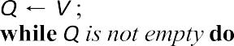  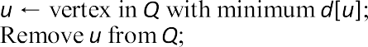  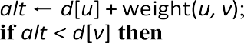  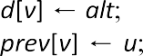  end  foreach v ∈ neighbors of u do  end  end  end  return d[], prev[];
LaTeX Commands of Lab Program 11:
- Documentclass article:
This command is used to specify the type of document your are creating such as a article,a book or a report.

- Begin and End commands:
Begin and End commands are used to create environments. Environments are structural elements in LaTeX that affect the typesetting or formatting of content within them.

- Usepackage[ruled,linesnumbered](algorithm2e):
The usepackage[ruled, linesnumbered]algorithm2e command in LaTeX is used to include the algorithm2e
package with specific options.

- Ruled:
This option (ruled) adds horizontal lines above and below the algorithm to visually separate it from the surrounding text. These lines provide a clear boundary for the algorithm, making it easier to distinguish.

Linesnumbered:
This option (linesnumbered) numbers each line of the algorithm sequentially. Line numbering helps in referencing specific steps or discussing parts of the algorithm in documentation or presentations. Each line of the algorithm is automatically assigned a number, typically placed on the left side of the algorithm block.

Begin and End algorithm:
These commands denote the beginning and end of the algorithm environment, where you write the actual algorithm.

Caption():
This command sets the caption for the algorithm. Replace Dijkstra’s algorithm with your own caption text.

SetalgoLined:
SetalgoLined is a command provided by the algorithm2e package. It is used to set whether or not the lines of an algorithm should be displayed with lines connecting the blocks.

SetkwFunction:
SetKwFunction is a command provided by the algorithm2e package to define a new function that can be used within algorithms typeset using algorithm2e.

SetkwProg:
SetKwProg is a command provided by the algorithm2e package that allows you to define new control structures for algorithms. It is particularly useful when you want to define custom control structures or procedures within your algorithm.

Fn:
Fn is a command provided by the algorithm2e package that is used to define functions or procedures within algorithms typeset using algorithm2e.

KwRet:
It is used to indicate the return statement in algorithms typeset using algorithm2e.

Lab Program 12
  - Develop a short technical report by using suitable commands and formats of user choice.

\documentclass[12pt]{article}
\usepackage[a4paper,margin=1in]{geometry}
\usepackage{graphicx}
\usepackage{amsmath}
\usepackage{hyperref}
\usepackage{fancyhdr}
\pagestyle{fancy}
\fancyhead[L]{Short Technical Report}
\fancyhead[R]{SHANAWAZ}
\title{A Technical Report on cellphone Technology}
\author{SHANAWAZ}
\date{\today}
\begin{document}
\maketitle
\begin{abstract}
This paper explores the implementation of cellphone technology, highlighting its evolution, underlying methodology, and impact. It examines how cellular networks operate and adapt to technological advancements. The study concludes that cellphone technology is vital for global communication and continues to evolve rapidly.
\end{abstract}
\section{Introduction}
Cellphone technology has revolutionized communication by enabling wireless voice and data transmission. Initially developed for military use, it rapidly evolved into a global consumer technology. The first generation (1G) allowed analog voice calls, while modern systems support high-speed internet and multimedia. This advancement has connected billions worldwide.
\section{Working Principle}
Cellphones operate by converting voice or data into radio signals, transmitting them to the nearest cell tower. These signals are then routed through a network of towers and switches to reach the recipient. The process is reversed at the receiver’s end. Modern systems use digital transmission for better clarity and speed.

\section{Conclusion}
The implementation of cellphone technology has transformed global connectivity and access to information. With ongoing advancements like 5G and beyond, the potential for smarter, faster communication grows. Challenges remain in coverage and cybersecurity. Nonetheless, it remains a cornerstone of modern digital life.
\end{document}

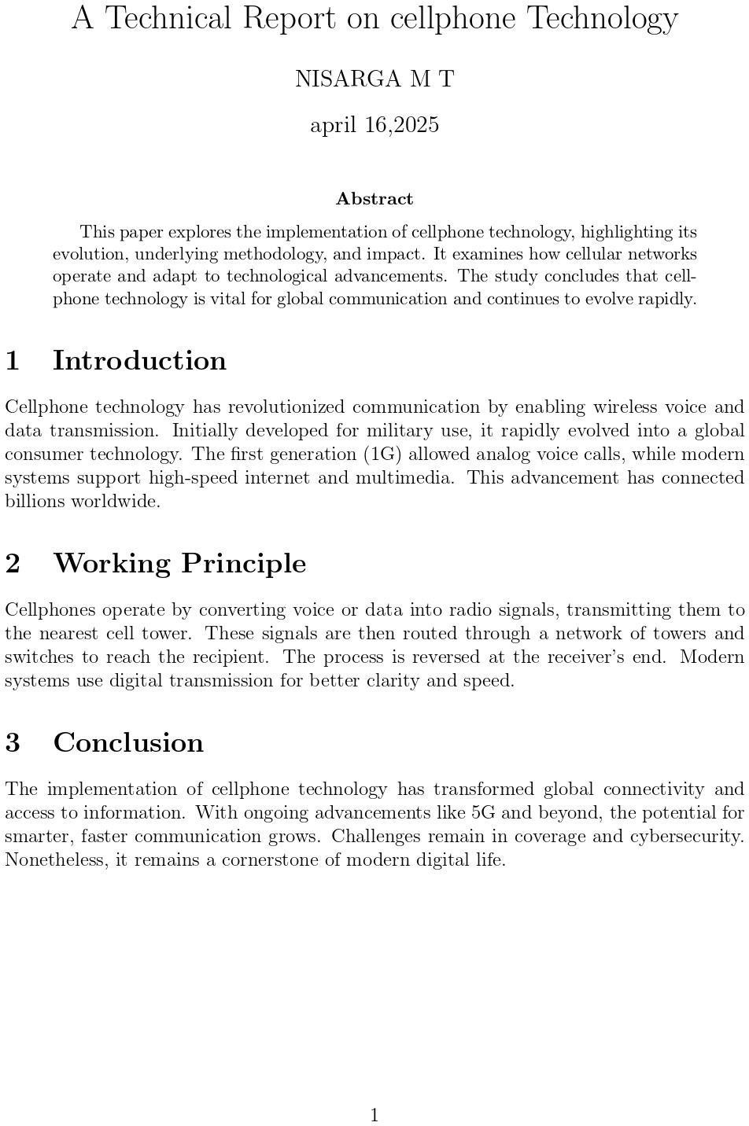
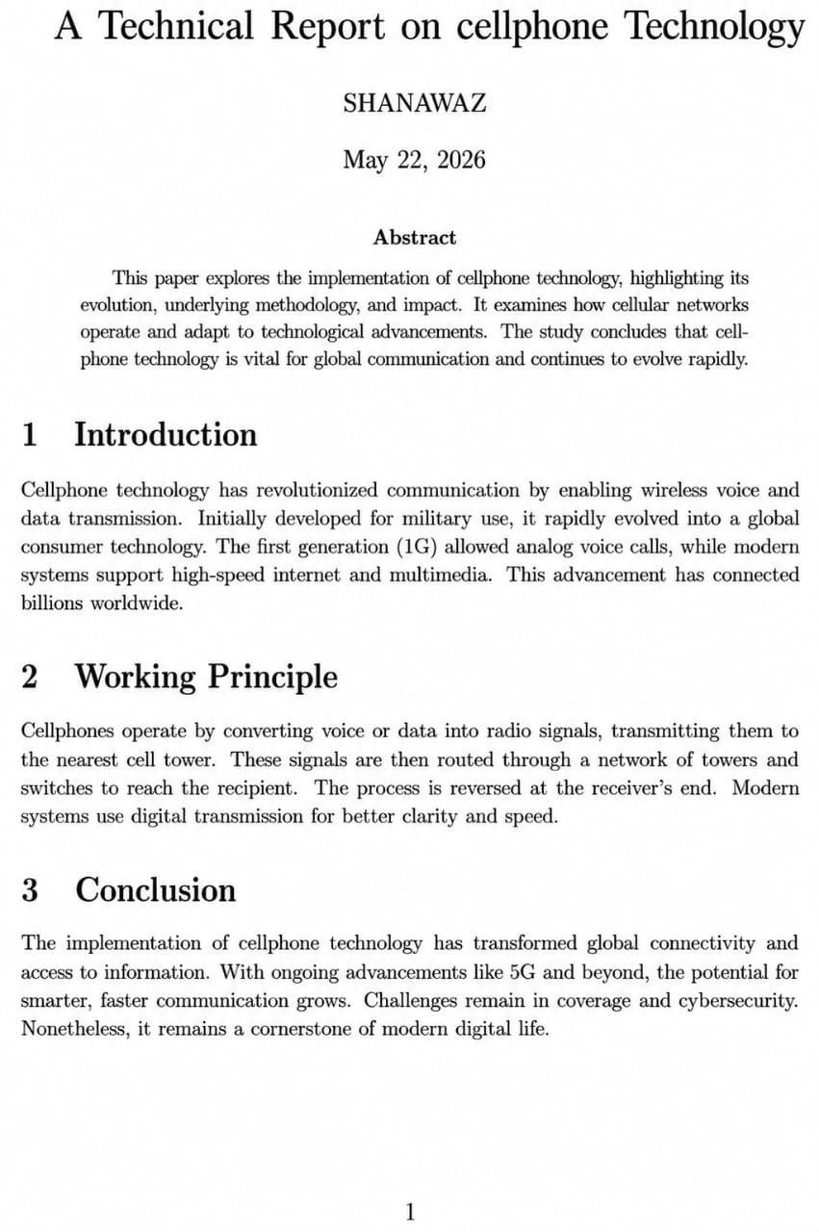
Output:

Develop an article as per standard format (like IEEE Template)
\documentclass[conference]{IEEEtran}
\usepackage{graphicx}
\usepackage{amsmath}
\usepackage{cite}
\usepackage{url}
\title{A Study on the Implementation of Cellphone Technology}
\author{\IEEEauthorblockN{SHANAWAZ }
\IEEEauthorblockA{Department of CSE\\ ADICHUNCHANAGIRI INSTITUTE OF TECHNOLOGY}}
\begin{document}
\maketitle
\begin{abstract}
This paper explores the implementation of cellphone technology, highlighting its evolution, underlying methodology, and impact. It examines how cellular networks operate and adapt to technological advancements. The study concludes that cellphone technology is vital for global communication and continues to evolve rapidly.
\end{abstract}
\section{Introduction}
Cellphone technology has revolutionized communication by enabling wireless voice and data transmission. Initially developed for military use, it rapidly evolved into a global consumer technology. The first generation (1G) allowed analog voice calls, while modern systems support high-speed internet and multimedia. This advancement has connected billions worldwide.
\section{Background and Literature Review}
This section delves into the historical development of cellphone technology, tracing its evolution from the first-generation (1G) analog systems to the current fifth-generation (5G) networks. It also reviews existing literature on the methodologies and frameworks employed in implementing cellular networks, highlighting key advancements and persistent challenges in the field.
\section{System Architecture}
Here, we detail the structural components of cellular networks, including the roles of base stations, mobile switching centers, and the core network. We discuss the architectural differences between various generations of mobile networks and how these architectures support scalability and efficiency.
\section{Communication Protocols and Standards}
This section covers the communication protocols that govern cellular networks, such as GSM, CDMA, LTE, and 5G NR. We explain how these protocols facilitate reliable and secure communication, and discuss the standardization efforts by organizations like 3GPP and IEEE.

\section{Methodology}
Cellphone networks are built on a hierarchy of cells, each served by a base station. Communication relies on radio waves, switching systems, and protocols like GSM, LTE, and 5G. Implementation involves infrastructure planning, frequency allocation, and software integration. Continuous upgrades ensure better speed, security, and coverage.
\section{Implementation Challenges}
We analyze the practical challenges encountered during the deployment of cellphone technology, including spectrum allocation, infrastructure costs, and regulatory hurdles. We discuss how these challenges vary across different geographical regions and what strategies are employed to overcome them.
\section{Security Considerations}
This section examines the security aspects related to cellphone technology, such as encryption methods, authentication protocols, and vulnerability to cyber threats. We discuss how security measures have evolved with each generation of mobile networks and the ongoing efforts to safeguard user data.
\section{Future Trends and Innovations}
We explore emerging trends in cellphone technology, including the integration of artificial intelligence, the Internet of Things (IoT), and the development of 6G networks. We discuss how these innovations are expected to shape the future landscape of mobile communication.
\section{Case Studies}
We present real-world examples of cellphone technology implementation in various contexts, such as urban vs. rural deployments, or in different countries. We analyze the outcomes, lessons learned, and best practices derived from these case studies.
\section{Conclusion}
The implementation of cellphone technology has transformed global connectivity and access to information. With ongoing advancements like 5G and beyond, the potential for smarter, faster communication grows. Challenges remain in coverage and cybersecurity. Nonetheless, it remains a cornerstone of modern digital life.

\bibliographystyle{IEEEtran}
\bibliography{references}
\end{document}

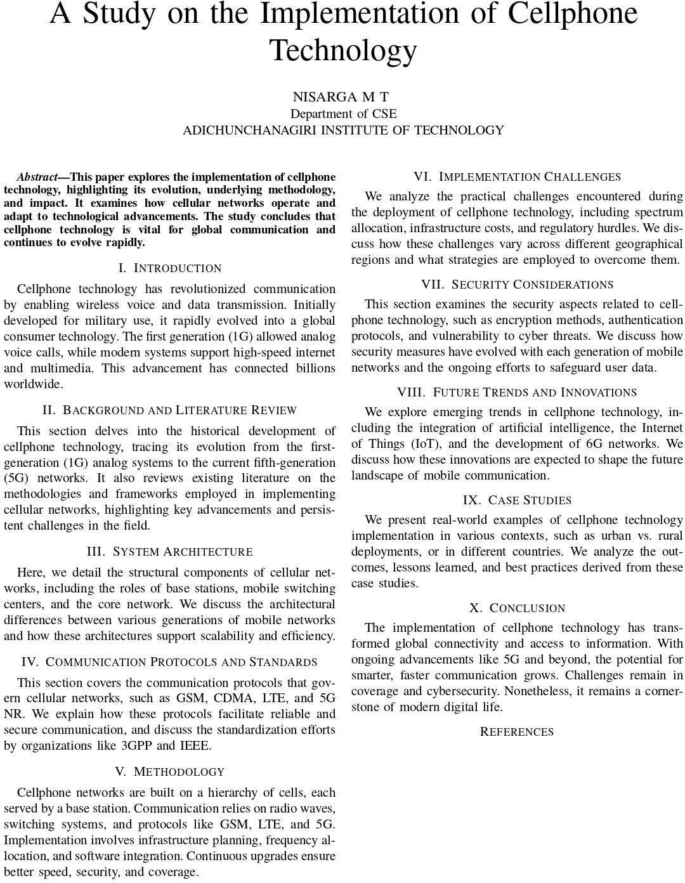
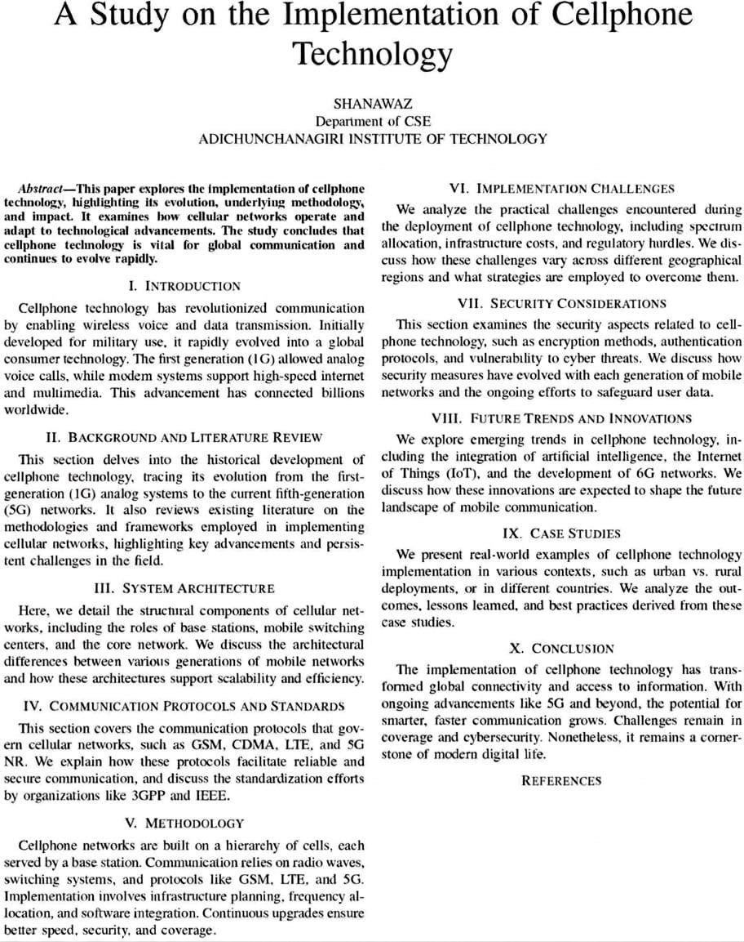
Output:

LaTeX Commands of Lab Program 12:

\documentclass{12pt}{article} :
Sets the document type to article with a 12-point font size.

\usepackage{graphicx} :
Enables inclusion of images using \includegraphics.

\usepackage{geometry} :
Allows custom page dimensions.

\geometry{a4paper, margin=1in} :
Sets the paper size to A4 and all margins to 1 inch.

\title{...} :
Sets the title of the document.

\author{...} :
Sets the author's name and affiliation.

\date{\today} :
Automatically inserts today’s date.

\maketitle :
Displays the title, author, and date at the top of the document.

\begin{abstract} ... \end{abstract} :
Creates a summary section of the document.

\section{...} :
Defines a new section (like Introduction, Components, etc.).

\begin{itemize} ... \end{itemize} :
Creates a bulleted list.

\item :
Adds an item to the bullet list

\documentclass[conference]{IEEEtran} :
Sets the document format to IEEE conference style.

\usepackage{graphicx} :
Enables inserting images using \includegraphics.

\usepackage{amsmath} :
Allows advanced mathematical symbols and formatting.

\title{Smart Irrigation System using IoT and Sensors} :
Sets the title of the paper.

\begin{document} :
Begins the document content.

\begin{abstract} ... \end{abstract} :
Creates the abstract section for summarizing the paper.

\begin{IEEEkeywords} ... \end{IEEEkeywords} :
Defines keywords for indexing/search purposes.

\section{Introduction} :
Starts a main section titled "Introduction".

\subsection{Hardware Components} :
Creates a subsection under the current section.

\begin{itemize} ... \item ... \end{itemize} :
Creates a bullet list.

\section{Conclusion} :
Starts a section for the final conclusion.

CONCLUSION

In conclusion, LaTeX commands form the backbone of document preparation in LaTeX, providing precise control over formatting, structure, and presentation. These commands are instrumental in crafting professional documents ranging from academic papers and reports to presentations and even books.
Through a LaTeX program, such as Overleaf, users can compile their LaTeX code into beautifully formatted documents. This process seamlessly translates commands into visually appealing outputs, incorporating text, equations, tables, figures, and more, all with exceptional typographical quality.
Ultimately, LaTeX commands empower users to create complex documents with ease, ensuring consistency and professionalism in the final output, making it a preferred choice for academia, publishing, and technical writing.

