CONNECTION

Initial Idea:

An interactive piece that describes the excitement of connecting with people

Using electromagnetic actuators to show popping points on the shirt that trigger when a distance sensor detects another person in the vicinity.

Showcase the exhilaration of how the connection makes people feel

A pressure sensor that acts as a switch to turn lights on the hands and the bodice of the wearable, so when two people shake hands the connection completes, and the pressure sensor values turn the lights on.

Physically showcasing the process of connecting with another person through a wearable shirt.

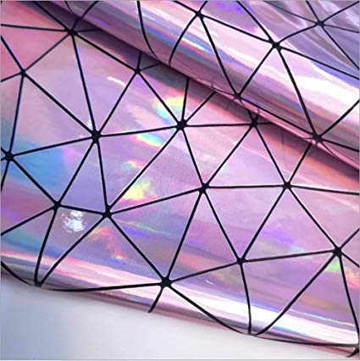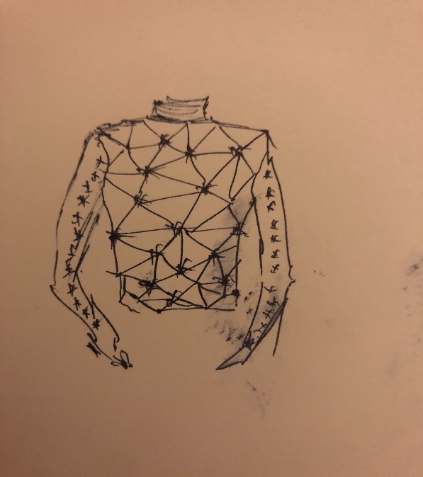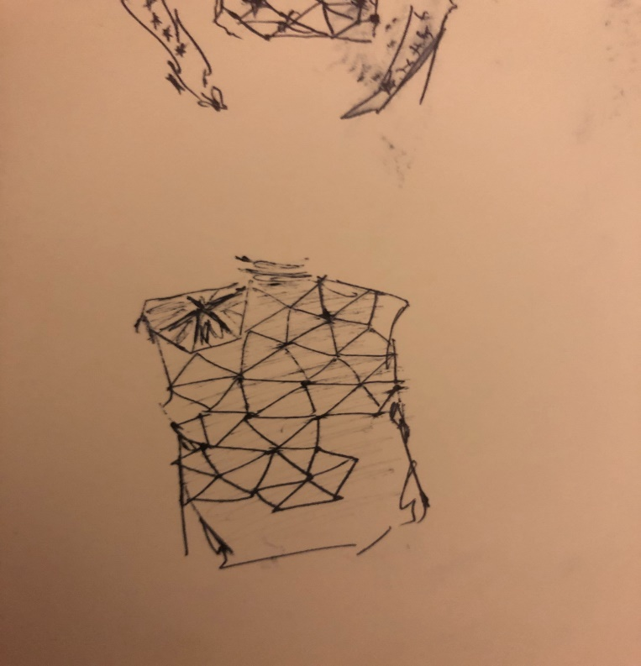

**Prototypes**:

For this project, I’ve used a mesh material bodysuit as a base for experimenting with silicone as a second skin material that shows a happy reaction to connecting with another person.

My initial prototypes included wearable capacitive sensors on the hands. However, capacitive sensors are very sensitive to movement and these did not produce stable enough readings to establishing an external connection. So instead of a capacitive sensor, I decided to use a pressure sensor that actives the LEDs on the bodice when a connection happens. The other element in this prototype was a distance sensor that activates an electromagnetic coil to jump based on proximity of a person. This prototype worked quite well, but was difficult to implement on the bodice in the period we had to work on it.

The final prototype of the wearable comprises a pressure sensor that activates both the LEDs and the electromagnet coil when a connection happened with another person.

**Materials**:

Since we wanted to experiment with show a more realistic facet of a connection, we wanted to work with a material that simulated skin. The lighting represents a glow and the electromagnet movement represents the excitement (heart racing, goosebumps etc.). With these two movements on a silicone bodice, I wanted to show the happiness and the excitement of meeting and connecting with another person, while Aashna wanted to showcase more of the anxiety of such interaction.

The materials we used for this were:

* A skin-toned mesh fabric bodysuit that we coated with silicone.
* Copper thread to create connections on the body. I initially tried to use copper wire but the wires are too unmanageable with body movements and kept breaking on the wearable.
* A Lilypad Arduino
* An enameled copper wire coil for the actuator with a neodymium magnet to trigger the movement.
* Resistors and a tip for the electromagnet circuit.
* Holographic vinyl to create texture and depth in the material, and add a holographic luminescent quality to the fabric.
* A pressure sensor made with copper thread, copper fabric, piezoelectric fabric, and neoprene for insulation.
* SMD LEDs, bright white, 20mA, 3.3V forward voltage.

**Process**:

The process of creating this bodice was long. We first unsewed the bodice and coated each surface with silicone. The silicone itself took 4 days to cure before we could start working on it.

We tested our circuits and schematics on a breadboard and added in the code.

Once the silicone was set, I had to design how the circuit would go onto the fabric. The copper wire circuit was really unstable and kept breaking off at the soldered points every time the fabric moved. This proved particularly unsatisfactory for a wearable. I then used the copper wire and used silicone’s insulation to thread it through the fabric so it did not come into contac with the skin. However, since the circuit was fairly complex on the bodice, a lot of places the thread was exposed, and I used the vinyl to insulate some parts of it.

I wanted the circuit to be seen outside, since this was more of a dissection of what it means to form a connection and it seemed fitting to have everything on the outside for people to see.

I soldered SMD LEDs onto copper fabric and sewed the fabric with resistors onto the arms. These were then connected to the circuit on the back of the bodice.

**Problems faced**:

The bodice was particularly complicated to sew back together with the silicone on. I had to use zippers on both arms and the sides to get it together, and be wearable. Even though the silicone stretches admirably, it is very difficult to slide on owing to its stickiness.

The connections with threads were sometimes weak in places where the thread started to fray due to wear and tear.

Since I was connecting the LEDs to the lilypad, the 3.7V LiPo battery really worked, but I had to use resistors so that the battery did not drain out. I used around 20LEDs on the bodice in total.

The electromagnet circuit needed a 9V battery but I could only use the 3.7V since the 9V was causing the tip circuit to heat up. However, silicone is EXCELLENT in insulating against heat as well and was very useful as a material to sew circuits on.

With some of the exposed conductive thread on the body, some of the LEDs did not function very well. Also, the pressure sensor did not do too well with the wearing since its connections were not too secure (this was more because of the time constraint than anything else.)

**Conclusions**:

While the bodice was not complete for the final course showcase, I got it done for the fashion show the next day. The reception to the body suit was amazing, and it really looked like second skin. Using a 9V battery would have really helped with making the movement of the coil more pronounced. However, the holographic vinyl added a very futuristic element to the whole wearable and added depth to the skin while being an excellent insulator for the circuit.

**References**

Koba Kant [Flapping Wing Swatch Example](https://www.kobakant.at/DIY/?p=5900)

Chun Shao *Silicone Love Finger* <https://www.chun-shao.com/>

Constanza [https://corazonderobota.wordpress.com/ (Links to an external site.)Links to an external site.](https://corazonderobota.wordpress.com/)

Ying Gao *Nowhere Nowhere* <http://yinggao.ca/interactifs/nowhere-nowhere/>

Melissa Coleman *The Holy Dress* http://melissacoleman.nl/holydress