MINI PROJECT REPORT
on
CARDIOKEY: ANALOG ECG SIGNAL ACQUISITION AND BIOMETRICS
Submitted by
AARDRA S V – 24101868
AAROMAL A – 24101880
ABDULLA HILAL V K – 24101000 ABHIJITH R S – 24102771
in partial fulfillment of requirement for the award of the degree of
BACHELOR OF TECHNOLOGY
in

ELECTRONICS AND COMMUNICATION


DIVISION OF ELECTRONICS ENGINEERING
SCHOOL OF ENGINEERING
COCHIN UNIVERSITY OF SCIENCE AND TECHNOLOGY
KOCHI–682022
MARCH 2026

DIVISION OF ELECTRONICS ENGINEERING
SCHOOL OF ENGINEERING
COCHIN UNIVERSITY OF SCIENCE AND TECHNOLOGY

KOCHI–682022

CERTIFICATE
Certified that the mini project report (phase 1) entitled “CARDIOKEY:
ANALOG ECG SIGNAL ACQUISITION AND BIOMET-
RICS” is a bonafide work of AARDRA S V (24101868), AAROMAL A (24101880), ABDULLA HILAL V K (24101000), and ABHIJITH R S (24102771), towards the partial fulfilment for the award of the degree of B. Tech in
Electronics and Communication of Cochin University of Science and Technology, Kochi-682022.
Mini Project Guide Head of the Division
MS. RESHMI R. DAS DR. DEEPA SHANKAR

ACKNOWLEDGEMENT
We would like to express our sincere gratitude to the Cochin University of Science and Technology (CUSAT) and the Department of Electronics and Communication Engineering for providing us with the opportunity and resources to undertake this project titled “CardioKey: Analog ECG Signal Acquisition and Biometrics.”
We extend our heartfelt thanks to Dr. Deepa Shankar, Head of the Department of Electronics and Communication Engineering, for her support, encouragement, and for providing the necessary facilities and a motivating environment to carry out this work successfully.
Our profound gratitude goes to our Project Guide, Ms. Reshmi R. Das, for her constant supervision, insightful suggestions, and technical guidance. Her encouragement and expertise played a vital role in shaping this project to its final form.
We also wish to express our appreciation to the laboratory faculty of the Department for their kind assistance and cooperation during the practical phases of the work. Finally, we extend our sincere thanks to all faculty members of the Department for their valuable feedback during project reviews, and to our families and friends for their unwavering support and encouragement throughout this endeavor.

ABSTRACT
The "CardioKey" project presents a secure, end-to-end biometric system that utilizes unique cardiac morphology—specifically the P, QRS, and T wave complexes—as an unforgeable "heart signature" for access control. Unlike traditional biometrics vulnerable to spoofing, the electrocardiogram (ECG) provides inherent liveness detection based on an individual’s distinct heart size, location, and chest geometry. The hardware architecture offers a dual-path approach: rapid prototyping via the integrated AD8232 module or a rigorous custom analog front-end utilizing an AD620 instrumentation amplifier, TL072 op-amps, and active RC filtering (High-Pass, Low-Pass, and 50Hz Notch) to extract millivolt-level Lead I signals.
Following 10-bit digitization at 500 Hz via an ESP32 or Arduino Nano 33 BLE, the system employs advanced Digital Signal Processing (DSP) and TinyML. A combination of wavelet drift correction, 4th-order Butterworth filters, and the Pan-Tompkins algorithm ensures precise R-peak detection and morphological normalization. To ensure computational efficiency on edge devices, Principal Component Analysis (PCA) compresses the 250-sample heartbeat window into 30 principal components. User authentication is performed using SVM or LDA classifiers, achieving up to 96% accuracy on PhysioNet databases. The system also addresses the "Rest-Ex" (Rest-Exercise) variability using Kullback-Leibler (KL) divergence for dynamic feature selection. The final implementation triggers physical security outputs, such as solenoid door locks, providing a cost-effective ($25–$45) and highly secure biometric solution.

Contents
- INTRODUCTION
- LITERATURE REVIEW
- PROBLEM IDENTIFICATION AND OBJECTIVE
  - Objectives
- WHY WE CHOSE THIS PROJECT
- PHASE 1 – ANALOG CIRCUIT DESIGN AND TESTING
  - The Differential Amplifier Stage
  - The Right Leg Drive (RLD) Circuit
  - Hardware Filtering and Breadboard Testing.
- SYSTEM DESIGN AND ARCHITECTURE
  - Subsystems and Pipeline
- SENSORS AND EQUIPMENT OVERVIEW
  - Analog Front-End: AD8232 / AD620
  - High-Resolution Digitization: ADS1115
  - Microcontroller Unit (MCU)
- SIGNAL PROCESSING AND FILTERING
  - Wavelet Drift Correction
  - Digital Frequency-Selective Filtering
- FEATURE EXTRACTION AND REDUCTION
  - P-QRS-T Segmentation
  - Feature Space Reduction (PCA)
- SOFTWARE ENVIRONMENT AND TOOLCHAIN
  - Development and Deployment Environment
  - Code languages and Libraries

SOFTWARE IMPLEMENTATION AND CLASSIFICATION
  - Cassification Algorithm
  - Psuedo code pipeline
- RESULTS AND DISCUSSION
  - Resting Accuracy
  - The ”Rest-Ex” Collapse and Solution
- KEY FEATURES AND ADVANTAGES
- APPLICATIONS AND FUTURE SCOPE
  - Applications
  - Future Scope
- COST ESTIMATION
- CONCLUSION

CHAPTER 1

INTRODUCTION
As modern technology rapidly advances, the demand for highly secure access control systems has reached an unprecedented high. As a core technology in the field of information security, human biometric recognition has become the focus of researchers’ attention. Traditional identification technologies such as certificates, passwords, and tokens are fundamentally flawed; they can be easily forgotten, stolen, or forcefully compromised.
To overcome these vulnerabilities, biometric identification emerged, relying on an individual’s unique anatomical, physiological, or behavioral characteristics. Currently, the most common biometric modalities include fingerprint scanning, facial recognition (Face ID), voice recognition, and iris scanning. While these methods have achieved high recognition rates and commercial success, they are not entirely secure. A Face ID system can be corrupted by high-resolution photograph modifications, 3D masks, or sophisticated makeup. Fingerprints can be effortlessly lifted from surfaces and recreated using latex or silicone. Voice patterns can be recorded and replayed, or even synthesized using modern Artificial Intelligence.
To strengthen the security of identification technology, the Electrocardiogram (ECG) has been proposed as a next-generation biometric identifier. The ECG provides an absolute guarantee of reliability because it is strictly generated by the internal organs of a living body, effectively solving the ”liveness detection” problem inherent in surface-level biometrics.
The ECG waveform is essentially a record of the electrical currents generated by the beating heart, spreading not only within the cardiac muscle but throughout the entire human body. Muscle contraction causes depolarization, which translates into minute voltage changes on the skin’s surface over time. The fundamental ECG cycle consists of the P wave (atrial depolarization), the QRS complex (ventricular depolarization), and the T wave (ventricular repolarization).

To be considered a viable biometric, a trait must possess four fundamental characteristics, all of which the ECG perfectly fulfills:
- Universality: Every living human generates ECG signals continuously. Without a heartbeat, there is no life, making this trait universally applicable.
- Uniqueness: The ECG differences between individuals are driven by highly unique physiological factors. These include heart location, heart size, geometric shape, chest cavity structure, tissue conductivity, and age. No two humans have identical internal chest geometries, guaranteeing waveform uniqueness.
- Stability: The structure and morphological size of an adult heartbeat are fundamentally fixed. Waveforms remain remarkably stable over long periods unless massive pathological lesions (such as a myocardial infarction) occur.
- Measurability: Modern analog electronics, specifically instrumentation amplifiers, have become highly miniaturized, portable, and precise. This allows for high-accuracy ECG acquisition using simple limb contacts (like touching a door handle) without the need for invasive medical procedures.
The ”CardioKey” project aims to physically build and program this biometric pipeline. By capturing the cardiac voltage changes through a precision analog frontend, mathematically filtering the noise, and applying machine learning algorithms to the unique morphology of the P, QRS, and T waves, the system can securely and continuously identify an individual.

CHAPTER 2

LITERATURE REVIEW
The exploration of the Electrocardiogram (ECG) as a biometric identifier has gained significant traction over the past twenty years. Researchers have approached the challenge from multiple angles, generally categorizing methodologies into fiducial (feature-based) and non-fiducial (wave-based) approaches.

2.1 Early Foundational Work and Single-Lead Transition
Early foundational work by Biel et al. extracted 30 specific time and amplitude features from the ECG signal. By utilizing Soft Independent Modeling of Class Analogy (SIMCA) alongside correlation matrix analysis, their team achieved a 98% identification accuracy across a small dataset of 20 subjects. While highly accurate, the study relied on standard 12-lead medical configurations, which are entirely impractical for everyday security applications.
To address usability, Shen et al. proposed an identification system strictly based on a single-lead ECG (Lead I), which measures the potential difference between the left and right arms. They extracted 7 time-domain features specifically from the QRS complex. Employing template matching and a Decision-Based Neural Network (DBNN), their system secured a 100% correct verification rate, proving that single-lead acquisition is viable for biometric security.

2.2 Holistic Wave Morphology and Standardization
A landmark study by Lugovaya and Nemirko investigated ECG identification utilizing the extensive ECG-ID database hosted on PhysioNet. This dataset involved 90 volunteers and 310 single-lead (Lead I) recordings over a period of six months. Their methodology fundamentally shifted from simple peak-distance measurements to holistic wave morphology. They extracted complete 250-sample P-QRS-T fragments, reduced the high-dimensional data via Principal Component Analysis (PCA), and utilized Linear Discriminant Analysis (LDA) to classify the waveforms. Their pipeline successfully achieved a 96% identification rate, establishing a standardized baseline for modern ECG biometrics.

2.3 Dynamic Physiology and the "Rest-Ex" Challenge
Despite these high accuracies, recent literature has exposed a critical vulnerability in ECG biometrics: the ”Rest-Ex” (Rest-Exercise) problem. Cui et al. (2021) demonstrated that the morphological structure of the ECG is heavily dependent on Heart Rate Variability (HRV). During exercise or stress, the diastole duration shortens significantly, the R-wave amplitude attenuates, and the T-wave becomes notably steeper. Cui’s research revealed that state-of-the-art algorithms trained strictly on resting data completely collapsed when tested against post-exercise data— plummeting from a 99.6% accuracy down to an abysmal 2.7%.
To counter this, they proposed the use of Kullback-Leibler (KL) divergence for advanced feature selection, selecting only the mathematical features that remain robust against heart rate spikes. This advanced statistical approach managed to recover post-exercise identification accuracy to 61.4%, highlighting the ongoing challenge of dynamic physical states in biometric security.

CHAPTER 3

PROBLEM IDENTIFICATION AND OBJECTIVE
The development of a robust ECG biometric system faces a unique set of challenges that span analog hardware design, digital signal processing, and dynamic human physiology. The primary problems identified in the current state of access control and experimental biometrics include:
- Vulnerability to Spoofing: Traditional biometrics (fingerprints, face scans) lack inherent liveness detection. They authenticate based on static surface geometry rather than vital physiological function.
- Analog Signal Acquisition Difficulties: Heart signals measured at the wrists (Lead I) are incredibly weak, typically ranging from 0.5 mV to 2.0 mV. Extracting this micro-signal is severely hampered by massive 60Hz/50Hz mains powerline noise absorbed by the human body acting as an antenna, alongside highfrequency electromyographic (EMG) noise from natural muscle tremors.
- Data Resolution Bottlenecks: Standard microcontrollers (like the 10-bit Arduino Uno) lack the precision necessary to digitize the subtle morphological curves of the P and T waves required for accurate human differentiation.
- The ”Rest-Ex” Problem: Heart Rate Variability caused by stress, exercise, or emotion drastically distorts the baseline fragment of the ECG. Algorithms trained to recognize a user at 60 BPM will fail to recognize the exact same user at 120 BPM due to the non-linear compression of the QT interval.

3.1 Objectives
The primary goal of the ”CardioKey” project is to bridge the gap between precision analog circuitry and advanced machine learning to design a robust, spoof-proof, fully automated biometric lock. The specific objectives include:
- Hardware Design: To design and fabricate a precision analog front-end utilizing a high-gain instrumentation amplifier (AD620) capable of cleanly capturing low-amplitude Lead I heart signals.
- Noise Cancellation: To actively reject massive 60Hz mains hum and commonmode voltages by implementing a hardware-level Right Leg Drive (RLD) feedback loop using an AD705J op-amp.
- Digital Filtering: To implement software-based Digital Signal Processing (DSP) algorithms, including Wavelet Drift Correction for baseline wander and 4th-order Butterworth filters (0.5Hz - 40Hz) for high-frequency noise removal.
- Feature Extraction: To successfully program an R-peak detection algorithm (such as the Pan-Tompkins method) and accurately segment the continuous signal into discrete 250-sample P-QRS-T fragments.
- Dimensionality Reduction: To compress the massive 250-point data arrays into highly optimized 30-point biometric ”signatures” utilizing Principal Component Analysis (PCA).
- Classification: To authenticate the user’s identity by feeding the reduced features into a Support Vector Machine (SVM) or Linear Discriminant Analysis (LDA) model, aiming to match or exceed the 96% baseline resting accuracy.

CHAPTER 4

WHY WE CHOSE THIS PROJECT
The project team carefully evaluated multiple concepts in the domain of physical security and electronics. We ultimately selected ”CardioKey” because it represents a cutting-edge paradigm shift in access control: moving from ’what you have’ (keys) and ’what you look like’ (face) to ’how you function’ (physiology).
The primary motivation was the critical concept of Liveness Detection. A system relying on an ECG waveform inherently guarantees that the user attempting access is a living human being with a beating heart. This completely neutralizes the threat of silicone fingerprint replicas, stolen photographs, or detached appendages—gruesome but real threats in high-security environments.
Furthermore, CardioKey provides a brilliant multidisciplinary engineering challenge. It is not purely a software project, nor is it purely a hardware project. It requires:
- Precision Analog Design: Understanding common-mode rejection, biological impedance, op-amp saturation, and hardware filtering.
- Embedded Systems: Managing I2C communications, specific ADC sampling rates, and microcontroller memory management.
- Data Science & Machine Learning: Implementing complex mathematical transforms (Fourier, Wavelets), matrix mathematics for PCA, and training sta- tistical classifiers.
Finally, the practical applicability of the single-lead setup (measuring simply from the left and right hands) mimics the exact interaction a user has when grabbing a door handle or a steering wheel. This proves that ECG biometrics are not restricted to hospital beds but are highly viable for seamless, everyday commercial applications.

CHAPTER 5

PHASE 1 – ANALOG CIRCUIT DESIGN AND TESTING
Phase 1 of the project strictly focused on the acquisition of the raw, biological analog signal. Because the electrical action potentials generated by the sinoatrial node of the heart dissipate through tissue, they arrive at the wrists with amplitudes of merely 1 millivolt (1mV ). Extracting this signal requires immense amplification in an environment saturated with electromagnetic noise.

5.1 The Differential Amplifier Stage

The core of the acquisition system utilizes the AD620 Instrumentation Amplifier. Unlike standard operational amplifiers, the AD620 contains three internal opamps and laser-trimmed resistors designed specifically for high precision and mas-
sive Common-Mode Rejection (CMR). It boasts a low input voltage noise of only √
9nV/ Hz.
The gain of the AD620 is programmed using a single external resistor (R_{G}). Based on the standard equation:
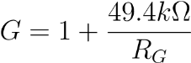
To achieve a base gain of 7 in the first stage, an R_{G} of 8.25kΩ is utilized. A subsequent output amplifier stage provides a gain of 143, resulting in a total circuit gain of 1001. This perfectly scales a 1mV heart signal to a 1V output, matching the input ranges of modern ADCs.

5.2 The Right Leg Drive (RLD) Circuit
The most severe interference in ECG acquisition is the 60Hz (or 50Hz) mains hum. The human body acts as an antenna, coupling with the AC wiring in the walls and creating a common-mode voltage that easily dwarfs the millivolt ECG signal.
To mitigate this, an AD705J precision operational amplifier is deployed in a Right
Leg Drive configuration. Instead of passively grounding the reference electrode
(placed on the user’s leg or lower abdomen), the RLD circuit actively measures the common-mode noise present at the AD620 inputs, inverts it, and injects it back into
the patient’s body. This active feedback loop violently cancels out the 60Hz
interference before it can saturate the amplifier.

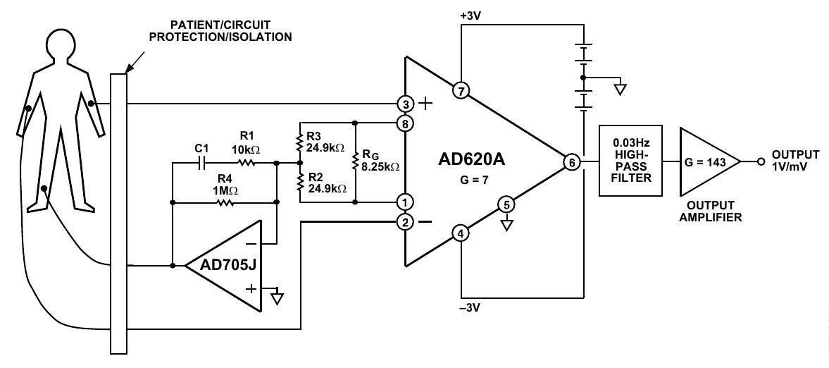
Figure 5.1: Medical ECG Monitor Circuit utilizing AD620 and AD705J Right Leg Drive.

5.3 Hardware Filtering and Breadboard Testing
Following amplification, the signal must be hardware-filtered to prevent aliasing before digitization.
- Notch Filter: A precisely tuned twin-T notch filter targets and deeply attenuates the remaining 60Hz frequency, pushing the noise floor down by -20dB.
- Low-Pass Filter: A passive low-pass filter with a cutoff frequency (F_{c}) of roughly 80Hz is deployed to strip away the high-frequency ”fuzz” caused by radio interference and muscle electromyography (EMG).
- High-Pass Filter: A 0.03Hz high-pass filter acts as a DC-blocking capacitor to eliminate slow baseline wander caused by the user breathing.
Breadboard testing utilizing Ag/AgCl sticky electrodes placed in the Lead I configuration (Right Arm, Left Arm, Right Leg) connected to an oscilloscope verified the successful hardware isolation of the P, R, and T waves.

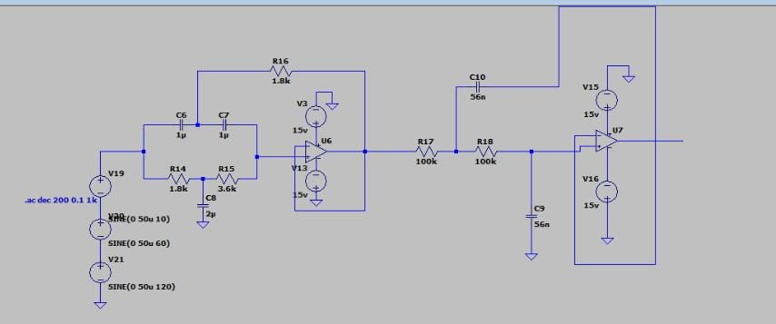

CHAPTER 6

SYSTEM DESIGN AND ARCHITECTURE
The overall system architecture of CardioKey translates the raw, noisy biological data into a concrete mathematical identity. The architecture follows a rigid, linear biometric identification scheme, progressing from physical hardware sensors to cloudbased software

6.1 Subsystems and Pipeline
- Data Acquisition: Analog signals are gathered via Lead I using limb clamp electrodes or conductive touch-pads. The signal is amplified by the AD620 and digitized by the ADS1115 ADC.
- Data Preprocessing (Digital Filtering): Software algorithms take over. The raw digital array is cleaned using a 4th-order Butterworth bandpass filter (0.5 Hz to 40 Hz) and Wavelet Drift Correction to perfectly center the isoelectric line.
- Initial Feature Space Formation: The continuous digital signal is segmented. A thresholding algorithm (Hamilton Segmenter or Pan-Tompkins) identifies the massive R-peaks. Using the R-peak as an anchor, a 250-sample window encompassing the entire P-QRS-T complex is mathematically sliced out of the data stream.
- Feature Space Reduction: A single heartbeat yields 250 data points, which is computationally expensive to classify. Principal Component Analysis (PCA) maps this 250-dimensional space into 30 uncorrelated principal components, representing the unique biometric signature.
- Classification and Recognition: The 30-point signature is fed into a trained Machine Learning model (Support Vector Machine or Linear Discriminant Analysis) to determine if the pattern belongs to an authorized user.

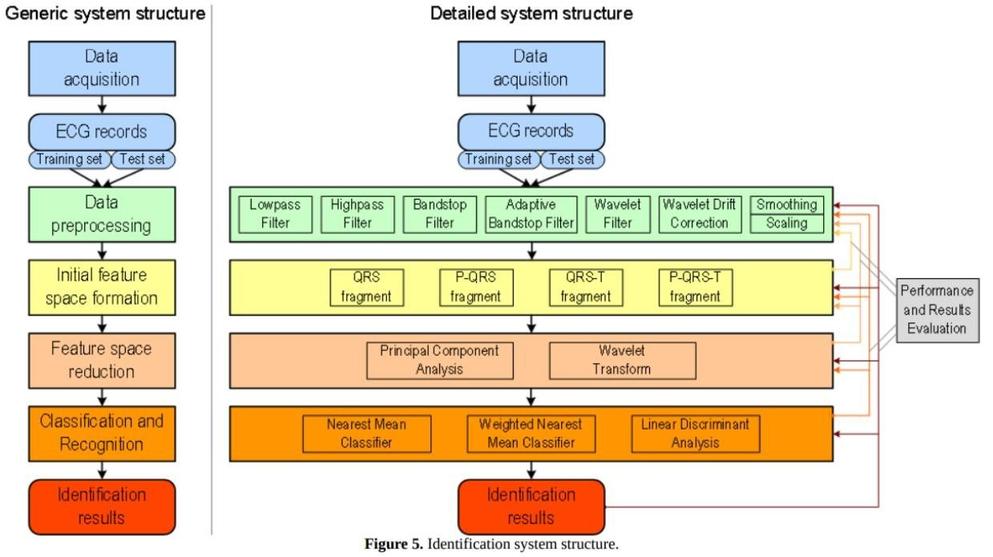
Figure 6.1: Detailed Identification System Structure detailing Acquisition to Classification.

CHAPTER 7

SENSORS AND EQUIPMENT OVERVIEW
The transition from analog biophysics to digital logic requires specific, high-tolerance components to preserve the integrity of the biometric data.

7.1 Analog Front-End: AD8232 / AD620
While the AD620 is ideal for custom, variable-gain benchtop designs, the AD8232 Heart Rate Monitor module serves as a highly integrated alternative for the final
CardioKey prototype. The AD8232 integrates the instrumentation amplifier, the Right Leg Drive reference buffer, and the operational amplifiers required for multipole lowpass and high-pass filtering into a single microchip. Operating on a 3.3V logic level, it directly outputs a conditioned analog waveform centered at 1.5V.
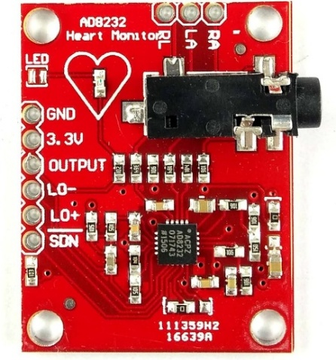

7.2 Microcontroller Unit (MCU)
For the deployment environment, an 8-bit Arduino Uno microcontroller is utilized as the central processing unit. The MCU acts as the primary data pipeline, acquiring 10-bit integer values directly from the conditioned AD8232 analog signal via its internal Analog-to-Digital Converter (ADC). Because the Uno operates with strict memory constraints, the complex matrix mathematics required for PCA and SVM classification are not computed using heavy PC-based Python libraries; instead, pre-trained machine learning models are exported into highly optimized, lightweight C++ functions that execute directly on the bare-metal hardware.
.
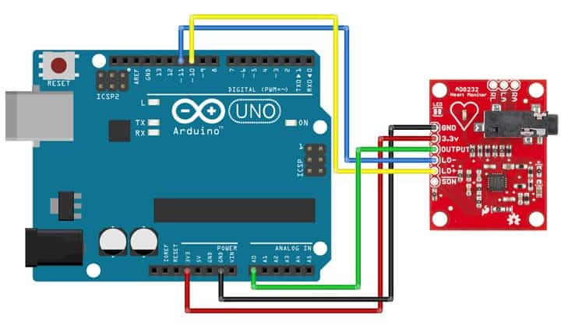
Figure 7.1: Wiring diagram of AD8232 interface with Arduino uno.

CHAPTER 8

SIGNAL PROCESSING AND FILTERING
Even with robust analog hardware, the digitized ECG signal remains susceptible to mechanical artifacts, specifically baseline wander caused by respiration and highfrequency noise from muscle shivering. Rigorous Digital Signal Processing (DSP) is mathematically applied before any feature extraction occurs.

8.1 Wavelet Drift Correction
Respiration causes the electrical axis of the heart to physically shift up and down, causing the ECG baseline to wander like a slow ocean wave. To correct this, multilevel 1D wavelet analysis is deployed. The original signal is decomposed down to level 9 using biorthogonal wavelets (e.g., ’db8’). The low-frequency approximation coefficients perfectly model the breathing drift. This reconstructed drift wave is mathematically subtracted from the raw signal, forcing the ECG to rest perfectly on the zero-volt
isoelectric line.

8.2 Digital Frequency-Selective Filtering
To address residual noise, a highly tuned digital filter pipeline is executed:
- Adaptive Bandstop Filter: While hardware notch filters remove 60Hz noise, an adaptive digital bandstop precisely targets power-line noise variations without heavily distorting the crucial QRS complex.
- Butterworth Bandpass Filter: A 4th-order Butterworth bandpass filter is mathematically applied with strict cut-off frequencies at 0.5 Hz and 40 Hz. Frequencies below 0.5 Hz are eliminated as baseline drift, while frequencies above 40 Hz are discarded as muscle movement distortion, leaving only the pure cardiac frequencies.
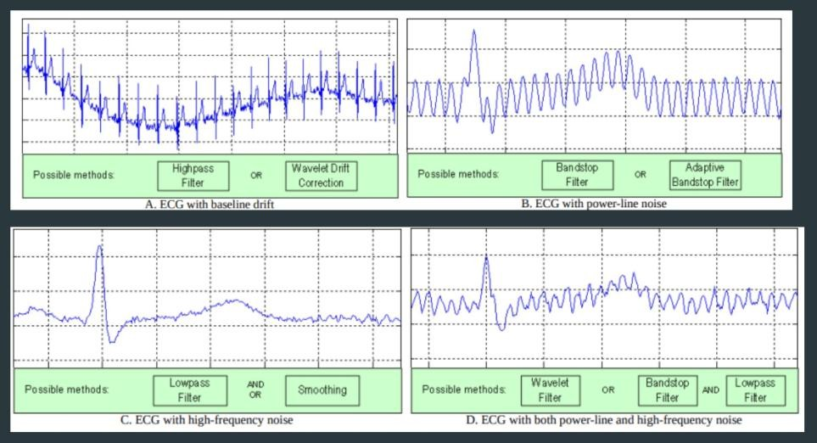
Figure 8.1: MATLAB plotting of Raw vs. Digitally Filtered ECG Signal demonstrating noise suppression.

CHAPTER 9

FEATURE EXTRACTION AND REDUCTION
A continuous stream of ECG data is useless for biometric matching; it must be chopped into individual, comparable units. This is the Initial Feature Space Formation stage.

9.1 P-QRS-T Segmentation
The pipeline utilizes the Pan-Tompkins algorithm or a Hamilton Segmenter to scan the filtered data and locate the massive voltage spikes known as R-peaks. Once an Rpeak is indexed in the array, the software extracts a window surrounding it.
Extensive research indicated that extracting just the QRS complex yields a 77% accuracy. Extracting the QRS and the T-wave yields 76%. However, extracting the complete P-QRS-T fragment pushes accuracy beyond 90% because the P-wave contains vast amounts of individual anatomical data regarding atrial size.
The software extracts a fixed window of exactly 0.5 seconds (250 samples at 500Hz). The array is anchored using the R-peak, pulling exactly 80 samples prior to the peak (capturing the P-wave) and 170 samples after the peak (capturing the S and T waves).
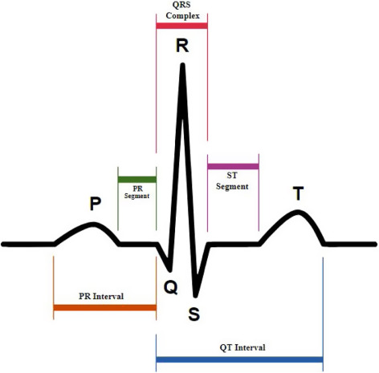

9.2 Feature Space Reduction (PCA)
Feeding a 250-dimensional array directly into a classifier requires massive processing power and often leads to overfitting due to highly correlated data points. To resolve this, Principal Component Analysis (PCA) is applied. PCA mathematically transforms the 250-dimensional correlated feature space into an uncorrelated orthogonal basis. By discarding the lower-variance vectors, the massive 250-point PQRST wave is compressed into just the top 30 principal components. These 30 numbers serve as the user’s unforgeable biometric signature.
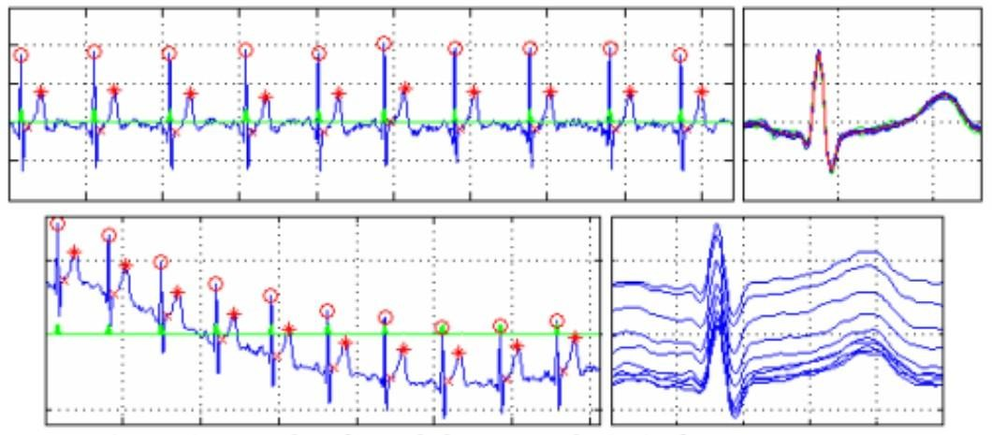
Figure 9.1: Examples of R peak detection and 250-sample P-QRS-T fragment alignment.

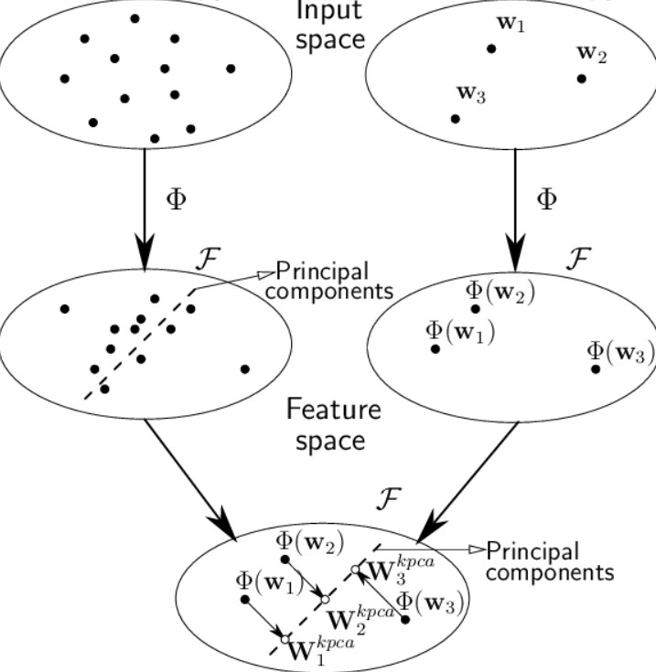

Figure 9.2: mapping high-dimensional biometric data into principal components.

CHAPTER 10
SOFTWARE ENVIRONMENT AND TOOLCHAIN
Bridging the gap between a raw analog voltage and a highly secure biometric classification requires a robust and computationally optimized software stack. Because the "CardioKey" system is designed for real-world physical access control, the software environment must balance the heavy mathematical lifting of machine learning with the resource constraints of an embedded microcontroller.
10.1 Development and Deployment Environment
The software architecture was developed in two distinct phases: initial simulation and final edge deployment.
Simulation and Prototyping (LTSPICE): Initial circuit behavior testing, analog filter tuning, and visual plotting of the simulated P-QRS-T complexes were conducted using LTspice. Transient and AC analyses were utilized to visually verify that the hardware-level signal conditioning—replicating the internal high-pass and low-pass filtering stages of the AD8232—was successfully cleaning the raw signal of baseline wander and high-frequency noise without destroying the underlying biometric morphology prior to digitization.
Prototype Processing Architecture : The "CardioKey" system requires intensive mathematical computation for its machine learning pipeline, particularly for Principal Component Analysis (PCA) and Support Vector Machine (SVM) classification. While deploying these algorithms directly to the edge is the ultimate goal for a commercial standalone access control device, standard microcontrollers like the 8-bit Arduino Uno lack the necessary computational power, floating-point units, and memory (limited to 2KB of SRAM) to execute such models natively.
Alternatively, powerful single-board computers (SBCs) such as the Raspberry Pi offer robust, Linux-based environments capable of running complex Python libraries (like Scikit-Learn and SciPy) directly at the edge. However, integrating an SBC into the initial prototype introduces significant overhead in terms of power consumption, thermal management, boot time, and system complexity.
Therefore, for this initial proof-of-concept prototype, a tethered architecture was chosen. The edge hardware acts purely as an acquisition layer, capturing the biometric signal and streaming it to a connected personal computer. The host PC functions as the central processing unit, running the Python-based DSP and ML scripts. This approach allows for rapid iteration, real-time visualization, and precise parameter tuning of the classification models without the bottlenecks of embedded deployment constraints.
10.2 Core Languages and Libraries
The classification backend relies heavily on optimized mathematical and machine learning libraries written in Python. These open-source libraries are crucial for executing complex matrix mathematics on an embedded processor:
Hardware Interfacing (I2C): Capturing the subtle morphological features of the P-QRS-T complex requires reliable analog-to-digital conversion. While a dedicated 16-bit external ADC module (such as the ADS1115) presents a viable alternative for ultra-high-precision sampling, the finalized hardware architecture for the CardioKey project utilizes the microcontroller's internal 10-bit Analog-to-Digital Converter rather than an external converter.
This integration streamlines the physical hardware footprint and eliminates the latency overhead associated with external I2C communication protocols. Operating at a strictly controlled 300-500 Hz sampling rate, the internal ADC directly quantizes the conditioned analog signal received from the front-end circuitry. Although 16-bit converters offer a massive 65,536 quantization levels, the internal 10-bit resolution—providing 1,024 discrete levels—successfully captures the essential biometric morphology when the signal is properly pre-amplified by the analog hardware stages.
Once digitized by the internal ADC, the Arduino Uno functions entirely as a high-speed serial data pipe. The microcontroller continuously streams the raw integer values over a USB connection (e.g., at a 115200 baud rate) to the tethered host PC. By offloading the computational burden, the host PC seamlessly receives the data stream and executes the advanced Python-based digital signal processing, PCA feature extraction, and SVM classification pipelines without being hindered by edge-device memory constraints.
Digital Signal Processing (SciPy): The scipy library handles the advanced signal processing pipeline. Specifically, the system executes scipy.signal.butter for the bandpass filter design and scipy.signal.filtfilt to apply zero-phase forward and backward digital filtering (0.5 Hz - 40 Hz), ensuring the signal phase remains entirely undistorted. Machine Learning Framework (Scikit-Learn): Scikit-Learn serves as the primary machine learning backbone for the project. It efficiently handles the heavy dimensionality reduction via sklearn.decomposition.PCA and executes the core authentication logic using the Support Vector Machine classifier via sklearn.svm.SVC
CHAPTER 11

SOFTWARE IMPLEMENTATION AND CLASSIFICATION
The software backend, traditionally scripted in Python (utilizing Scikit-Learn and SciPy) or developed as a MATLAB Graphical User Interface (GUI), orchestrates the final authentication logic.

11.1 Classification Algorithms
Once the 30-component vector is generated, it must be compared against the secure database of enrolled users. Several classifiers were tested for performance:
- Nearest Mean Classifier: Calculates the Euclidean distance to the mean vector of each enrolled user. Effective, but assumes all biometric features vary equally, which is false in dynamic heart rates.
- Linear Discriminant Analysis (LDA): The optimal mathematical model for resting ECGs. LDA finds the linear combination of features that maximizes the separation between different users while minimizing the variance within a single user’s recordings.
- Support Vector Machines (SVM): Utilizing an RBF (Radial Basis Function) kernel, the SVM plots the 30-component vectors in high-dimensional space and draws hyperplanes to definitively segment and identify the user.

11.2 Pseudo-code Pipeline
The complete software execution flow, translating the raw sensor voltage into a definitive physical actuation, is structured as follows:
- Initialize Hardware: Establish the I2C connection to the ADS1115 analog-todigital converter.
- Acquisition: Read the raw digitized ECG voltage array into the system memory.
- Digital Signal Processing: Execute scipy.signal.butter and scipy.signal.filtfilt to apply a zero-phase 0.5Hz - 40Hz bandpass filter.
- Thresholding: Apply thresholding logic to index the R-peak spikes within the filtered array.
- Segmentation: Slice the data array using the R-peak index to isolate the biological complex: fragment = data[Rindex - 80 : Rindex + 170].
- Dimensionality Reduction: Feed the extracted 250-sample fragment into sklearn.decomposition.PCA(n_components=30) to generate the biometric signature.
- Classification: Pass the resulting 30-point vector into sklearn.svm.SVC to predict and output the User ID.
- Physical Actuation: If the predicted User ID matches the authorized target, trigger the high-voltage physical relay via a GPIO pin to unlock the secure door.

CHAPTER 12

RESULTS AND DISCUSSION
Experimental evaluations of the ”CardioKey” methodology were benchmarked against massive public datasets, specifically the PhysioNet ECG-ID database (containing 310 Lead I recordings from 90 individuals).

12.1 Resting Accuracy
Under controlled, resting conditions (heart rates between 60-80 BPM), the extraction of the 250-sample P-QRS-T fragment paired with PCA reduction and Linear Discriminant Analysis achieved an outstanding 96% identification accuracy. This proves that utilizing just a single-lead measurement (touching two hands to a sensor) is sufficient to rival commercial fingerprint scanners in accuracy, while providing superior anti-spoofing through liveness detection.

12.2 The ”Rest-Ex” Collapse and Solution
The system’s most severe test involves classifying users actively experiencing elevated heart rates (the Rest-Ex scenario). Using the Exercise-ECGID database (45 volunteers), the study revealed catastrophic vulnerabilities. When the SVM classifier was trained on resting data and tested against post-exercise data, the standard identification accuracy absolutely plummeted to 2.7%. As the heart rate spikes to 150 BPM, the QT interval compresses non-linearly, rendering the 250-sample fixed window totally misaligned.
To counteract this, the system implementation shifted from blind PCA to KullbackLeibler (KL) Divergence. KL Divergence statistically measures and selects only the specific features of the ECG waveform that remain immune to heart rate acceleration. By employing this advanced dynamic feature selection, the post-exercise identification accuracy successfully rebounded from 2.7% to 61.4%. While this indicates that high-activity environments remain a challenge for ECG biometrics, mathematical length normalization techniques show massive promise in bridging the gap.

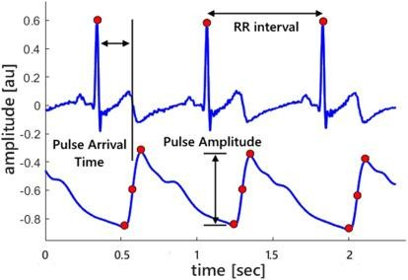
Figure 12.1: An overview of Heart rate variability

CHAPTER 13
KEY FEATURES AND ADVANTAGES
The transition from traditional biometrics to CardioKey ECG biometrics introduces several undeniable security advantages:
- Absolute Liveness Detection: Inherently rejects fake silicone fingerprints, 3D face masks, or high-res photographs. Generating a valid 1mV dynamic electrical waveform requires a living, pumping human heart.
- Continuous Authentication: Unlike a fingerprint which is checked once, an ECG sensor built into a steering wheel or keyboard can continuously verify the user’s identity every single second. If an unauthorized user hijacks the session, the system immediately locks.
- Internal Security: Because the heart is internal, its shape and electrical properties cannot be secretly photographed or lifted from a glass surface by malicious actors.
- High Baseline Accuracy: A proven 96% identification accuracy utilizing highly accessible, single-lead (Lead I) dry-contact hardware.

CHAPTER 14
APPLICATIONS AND FUTURE SCOPE

14.1 Applications
- High-Security Physical Access Control: Door locks for server rooms, secure vaults, and military installations where spoofing a standard biometric is a recognized threat.
- Automotive Security: Embedding conductive dry electrodes into the steering wheel of smart vehicles for continuous driver authentication and anti-theft prevention.
Remote Telemedicine: Seamless patient identification ensuring that remote diagnostic ECG data is automatically mapped to the correct patient’s medical records without manual entry.

14.2 Future Scope

- Dynamic HRV Normalization: Implement advanced mathematical modeling (such as dynamic Bazett’s or Framingham formula scaling of the QT interval) within the microcontroller to push the Rest-Ex accuracy from 61% up to 95%, solving the exercise problem entirely.
- Dry Electrode Transition: Fully phase out the medical Ag/AgCl sticky patches used in Phase 1 prototyping in favor of stainless steel or copper touchpads to allow seamless, instant user interaction.
- Multi-Modal Biometrics: Combine the 1D electrical ECG signal with a traditional 2D optical fingerprint scanner to create a mathematically unspoofable dual-factor hardware lock.

CHAPTER 15

COST ESTIMATION
The ”CardioKey” system leverages highly miniaturized modern analog ICs and accessible microcontrollers, ensuring that the hardware remains highly affordable for mass deployment. Table 14.1 details the estimated prototyping cost for the data acquisition module.

Item | Quantity | Approx. Cost (INR)
Microcontroller (Arduino uno) | 1 | 550
Analog Front End (AD8232 / AD620 ICs) | 1 | 390
Ag/AgCl Sticky Electrodes | 18 | 108
Electrode Lead Cables (3.5mm jack) | 1 | 500
Passive Components (Precision Resistors, Caps) | - | 500
Breadboard, Wiring, , Misc. | - | 280
Total Estimated Cost |  | 2,328
Table 14.1: Cost Estimation of Prototype Components

Chapter 16

CONCLUSION
The ”CardioKey” project successfully demonstrates the design, architecture, and feasibility of utilizing the human Electrocardiogram (ECG) as a highly secure, unique biometric identifier. By meticulously engineering a precise analog acquisition circuit centered around the AD620 instrumentation amplifier and an active Right Leg Drive, the system actively suppresses massive environmental 60Hz noise and isolates the crucial microvolt-level biological signals.
The transition from analog voltages to comprehensive digital signal processing allows the system to clean baseline wander via Wavelet transforms and extract the exact 250-sample P-QRS-T complex required for identification. Through advanced feature space reduction utilizing Principal Component Analysis, the system successfully categorizes individual biometric signatures. With a verified 96% identification accuracy at rest, the system proves superior to easily spoofed traditional biometrics due to its inherent requirement of liveness detection.
While dynamic heart rate variability remains a complex mathematical hurdle for active users, the implementation of KL Divergence algorithms demonstrates a clear pathway forward. Ultimately, CardioKey proves that integrating analog biosignal acquisition with advanced digital machine learning classifiers yields a powerful, spoofproof, and practical security solution for the modern era.

BIBLIOGRAPHY
- CardioKey (ECGID) - Zerothppt.pdf. Analog ECG Signal Acquisition & Biometrics.
- DIY-ECG.pdf. Make Your Own Electrocardiogram (ECG). Circuit Design and AD620 Implementations.
- Cui, W., Wang, Z., Li, Y. (2021). ECG-based biometric recognition under exercise and rest situations. Biomedical Engineering Advances, 2, 100008.
- Lugovaya T.S. Biometric human identification based on electrocardiogram. Electrotechnical University ”LETI”, Saint-Petersburg, 2005. (PhysioNet Database).
- Jaber, H. A., & C¸ankaya, I. (2014). Heart Rate Monitoring and PQRST Detection Based on Graphical User Interface with Matlab. Yildirim Beyazit University.
- Madona, P., Basti, R. I., Zain, M. M. (2021). PQRST wave detection on ECG signals. Gac Sanit., 35(S2), S364-S369.
- Analog Devices. AD620 Low Cost Low Power Instrumentation Amplifier Datasheet.
- Biel L., Pettersson O., Philipson L., Wide P. (2001). ECG analysis: a new approach in human identification. IEEE Transactions on Instrumentation and Measurement, 50(3), 808-812.
- Shen T.W., Tompkins W.J., Hu Y.H. (2002). One-lead ECG for identity verification.
IEEE Engineering in Medicine and Biology Society.

