ASSIGNMENT FINAL REPORT

Qualification | Pearson BTEC Level 5 Higher National Diploma in Computing
Unit number and title | Unit 20: Applied Programming and Design Principles
Submission date | 23/06/2026 | Date Received 1st Submission
Re-submission Date |  | Date Received 2nd Submission
Student Name | Le Huu Dan | Student ID | BD00889
Class | SE08101 | Assessor name | Vo Duc Hoang
Plagiarism
Plagiarism is a particular form of cheating. Plagiarism must be avoided at all costs and students who break the rules, however innocently, may be penalised. It is your responsibility to ensure that you understand correct referencing practices. As a university level student, you are expected to use appropriate references throughout and keep carefully detailed notes of all your sources of materials for material you have used in your work, including any material downloaded from the Internet. Please consult the relevant unit lecturer or your course tutor if you need any further advice.
Student Declaration
I certify that the assignment submission is entirely my own work and I fully understand the consequences of plagiarism. I declare that the work submitted for assessment has been carried out without assistance other than that which is acceptable according to the rules of the specification. I certify I have clearly referenced any sources and any artificial intelligence (AI) tools used in the work. I understand that making a false declaration is a form of malpractice.
 |  | Student’s signature | 
Grading grid
P1 | P2 | P3 | P4 | M1 | M2 | D1

ASSIGNMENT GROUP WORK
Qualification | Pearson BTEC Level 5 Higher National Diploma in Computing
Unit number and title | Unit 20: Applied Programming and Design Principles
Submission date |  | Date Received 1st submission
Re-submission Date |  | Date Received 2nd submission
Group number: | Student names & codes | Final scores | Signatures
 |  |  | 
Class | SE08101 | Assessor name
Plagiarism
Plagiarism is a particular form of cheating. Plagiarism must be avoided at all costs and students who break the rules, however innocently, may be penalised. It is your responsibility to ensure that you understand correct referencing practices. As a university level student, you are expected to use appropriate references throughout and keep carefully detailed notes of all your sources of materials for material you have used in your work, including any material downloaded from the Internet. Please consult the relevant unit lecturer or your course tutor if you need any further advice.
Student Declaration
I certify that the assignment submission is entirely my own work and I fully understand the consequences of plagiarism. I declare that the work submitted for assessment has been carried out without assistance other than that which is acceptable according to the rules of the specification. I certify I have clearly referenced any sources and any artificial intelligence (AI) tools used in the work. I understand that making a false declaration is a form of malpractice.
P5 | P6 | P7 | M3 | M4 | D2

OBSERVATION RECORD
 | Student
 | Description of activity undertaken
 | Assessment & grading criteria
 | How the activity meets the requirements of the criteria
 | Student signature: |  |  | Date:
 | Assessor signature: |  |  | Date:
 | Assessor name: | Vo Duc Hoang
r Summative Feedback: r Resubmission Feedback:

Grade: |  |  | Assessor Signature: |  |  | Date:
Internal Verifier’s Comments:
Signature & Date:

Table of Contents
Table of Contents I
Table of Figures II
Table of Tables III
Introduction 1
CHAPTER 1: Investigate the impact of SOLID development principles on the OOP paradigm (LO1) 2
I. Investigate the characteristics of the object- orientated paradigm, including class relationships and SOLID principles (P1) 2
1. Investigate object-oriented paradigm 2
2. Class diagram 7
3. SOLID principles 8
II. Explain how clean coding techniques can impact on the use of data structures and operations when writing algorithms (P2) 13
1. What Is Clean Code? 13
2. Principles of Clean Code 14
CHAPTER 2: Design a large dataset processing application using SOLID principles and clean coding techniques (LO2) 17
I. Design a large data set processing application, utilising SOLID principles, clean coding techniques and a design pattern (P3) 17
1. Use case diagram 17
2. Class diagram 18
3. Package diagram 20
II. Design a suitable testing regime for the application, including provision for automated testing (P4) 21
1. System testing strategy overview 21
2. Design test cases using the test pyramid 22
Conclusion 1
References 2

Table of Figures
Figure 1.1:OOPs concept of C# 2
Figure 1.2: Encapsulation illustration. 3
Figure 1.3: Inheritance illustration. 4
Figure 1.4: Polymorphism illustration. 5
Figure 1.5: Abstraction illustration. 6

Table of Tables
No table of figures entries found.

Introduction

Investigate the impact of SOLID development principles on the OOP paradigm (LO1)

Investigate the characteristics of the object- orientated paradigm, including class relationships and SOLID principles (P1)

Investigate object-oriented paradigm
As the name suggests, Object-Oriented Programming or OOPs refers to languages that use objects in programming. Object-oriented programming aims to implement real-world entities like inheritance, hiding, polymorphism, etc in programming. The main aim of OOP is to bind together the data and the functions that operate on them so that no other part of the code can access this data except that function (Thakur, 2023).
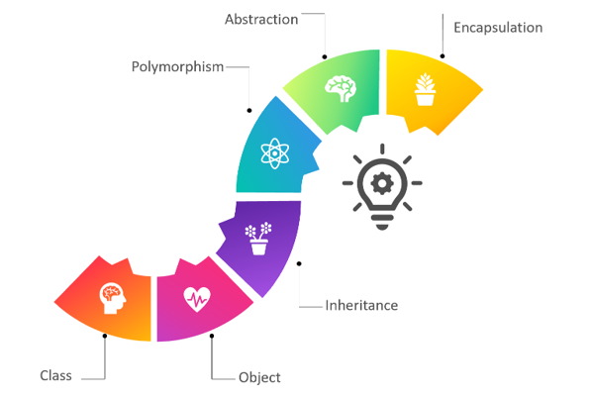
Figure 1.1: OOPs concept of C#
- OOP focuses on managing source code logic by breaking down the system into independent entities, enhancing software reusability, maintainability, and scalability.
- Class: A blueprint or template that defines common attributes and behaviors for all objects of the same type.
- Object: A specific instance created from a class, possessing its own memory areas to store actual state.
The object-oriented programming paradigm is built upon four foundational pillars that govern how data and behaviors are structured and managed within an application:
a) Encapsulation
Encapsulation is a technique for hiding the details and internal state of an object from the outside world, providing only public methods (Public APIs) to access or modify that state. To protect data from unauthorized and invalid modification, ensuring the integrity of the object. Use keywords to restrict access scope (such as private, protected) for variable fields, and expose them through properties with validation logic, or through methods.
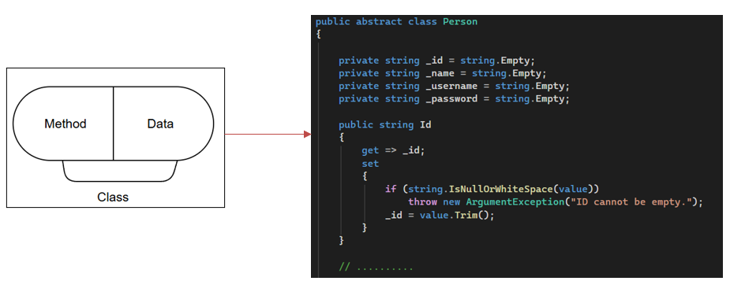
Figure 1.2: Encapsulation illustration.
In the class Student, the fields _className and _score are set to private to prevent direct external access. Interaction with these fields is routed through the public properties ClassName and Score. Inside the set block of ClassName, the condition if (string.IsNullOrWhiteSpace(value)) ensures the class name cannot be empty or contain only spaces, while trimming any leading or trailing whitespace. Similarly, the set block of Score validates that the input value must fall within the range from 0.0 to 100.0, throwing an exception if the data is invalid.
b) Inheritance
Inheritance is a mechanism that allows a new class (child class) to be built upon an existing class (parent class). The child class will inherit the attributes and methods of the parent class, and may also add its own characteristics or extend the functionality of the parent class. Using inheritance helps minimize code duplication, increase reusability, and support the construction of hierarchical systems.
This example demonstrates the core concept of inheritance in C#, showing how the Student derived class directly inherits fields and behaviors from the Person base class using the : operator to eliminate code duplication. The base class encapsulates shared identity attributes, while the derived class extends this state with specialized student properties.
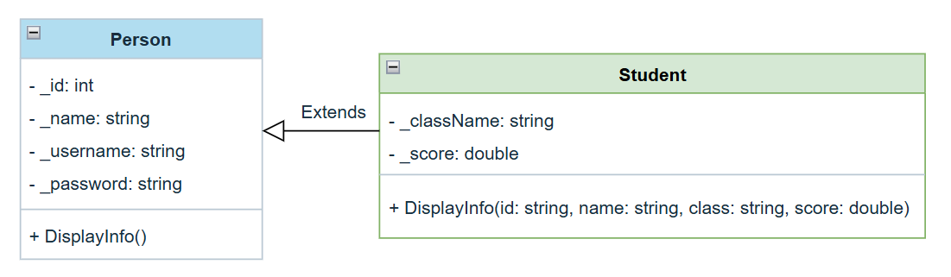

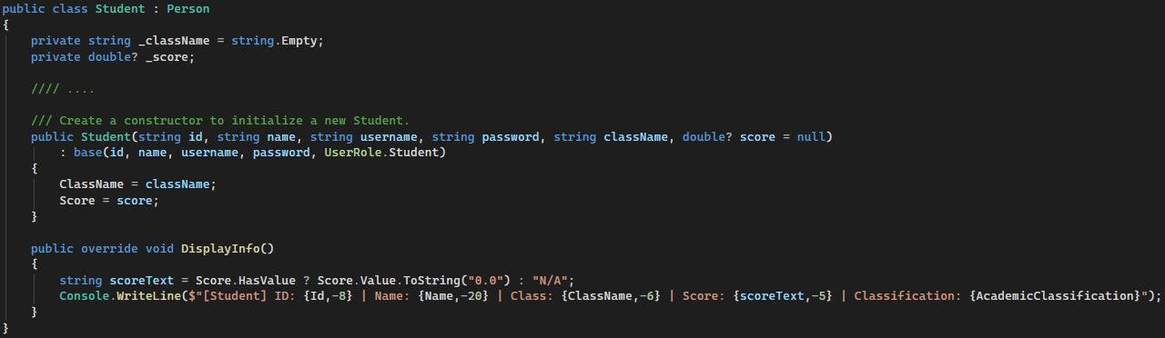
Figure 1.3: Inheritance illustration.
In the C# implementation, inheritance allows Student to reuse the initialization logic of Person by invoking its constructor via the base keyword. Furthermore, polymorphism is achieved through inheritance as the Student class uses the override keyword to redefine the inherited DisplayInfo method, providing specialized behavior while maintaining the structure defined by the parent class.
c) Polymorphism
Polymorphism is the ability to allow objects of different classes to be handled using the same common data type but still exhibit different behaviors. In C#, polymorphism is often implemented through method overrides combined with virtual or abstract methods.
Thanks to polymorphism, the program can work with an object through its parent class without needing to know which subclass the actual object belongs to. When a method is called, the system automatically executes the version appropriate to the actual object type at runtime.
Polymorphism is clearly demonstrated through the class structure diagram and the source code implementation below, where subclasses inherit from an abstract parent class and override methods to implement them according to their own specific characteristics.
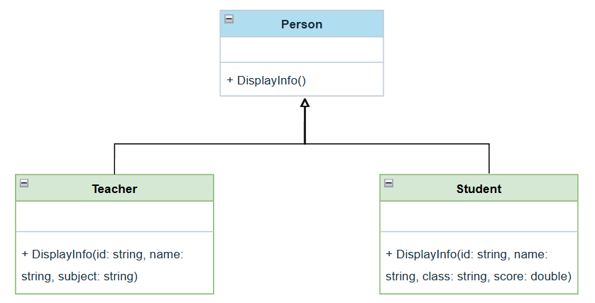

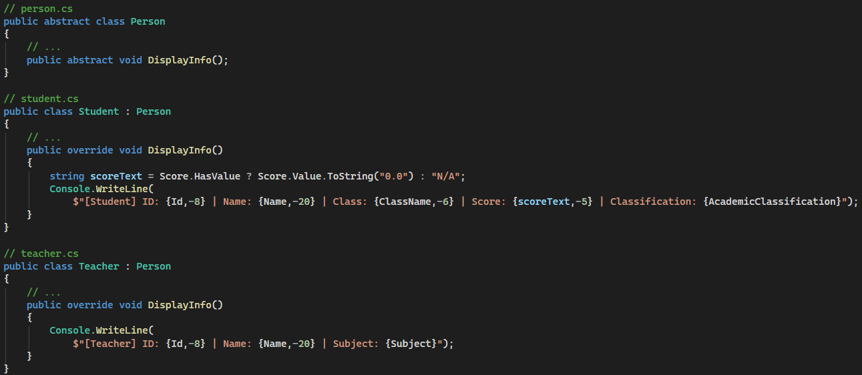
Figure 1.4: Polymorphism illustration.
The Person class acts as an abstract class that defines a common template. This class contains a DisplayInfo method to force all derived classes to implement it specifically.
The program is split into two separate entities: the student class and the teacher class. Each class receives the DisplayInfo method from the parent class but modifies the input parameters and internal data to suit its role. The teacher class manages subject information, while the student class manages class information and grades.
d) Abstraction
An abstract class is a class used as a general template for subclasses. An abstract class cannot be instantiated directly; it can only be inherited. Inside an abstract class, you can find both regular methods and abstract methods. Abstract methods only declare the name and return type, without containing any implementation. Subclasses that inherit are required to implement these methods. Using abstract classes helps define common characteristics of a group of objects, while ensuring that subclasses adhere to a certain structure and behavior.
To solve this problem without increasing the complexity of system expansion, abstraction is applied to generalize salary calculation behavior at the highest level. The example below describes how to build an abstract model for human objects in general and how to implement a specific salary calculation formula for a teacher object.
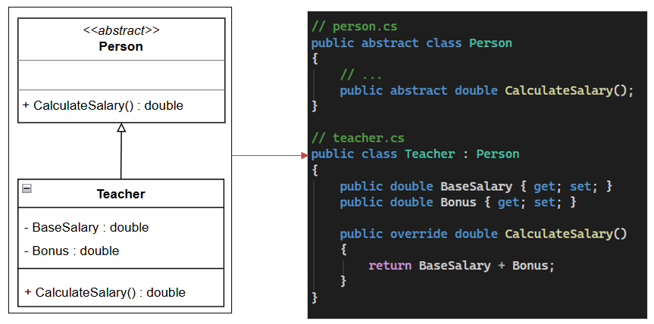
Figure 1.5: Abstraction illustration.
Parent class Person: An abstract class that defines the abstract method CalculateSalary, which returns a double floating-point number to create a common salary calculation template for the child classes.
Child class Teacher: Inherits from Person, adds two private attributes, BaseSalary and Bonus, of type double, and implements the CalculateSalary method concretely.
By using the keyword abstract in the Person class, the system focuses on what the object needs to do rather than how it does it. Other code components interacting with Person only need to call the CalculateSalary function without needing to worry about the detailed salary calculation formula. The override keyword in the Teacher class overrides the function and provides the actual processing algorithm. The calculation function will take the sum of the BaseSalary and Bonus attributes to return the final result.

Class diagram
a) Basic definitions and relationships in class diagrams
A UML class diagram shows the structure of a system by displaying its classes, their attributes, methods, and the relationships between them. It helps the team understand how the system is organized and how components interact. Represents classes, attributes, methods, and relationships within a system. Helps developers understand, communicate, and document the software structure more effectively (Rani, 2026).
- Access modifier in class diagrams
- Used to specify the access scope for attributes and operations of a class (granting permission for other classes to use this class's attributes and operations).
- 4 access scope options:
- Private (-): Only objects created from this class can use it.
- Public (+): All objects can use it.
- Protected (#): Only objects created from this class and classes inheriting from this class can use it.
- Package/Default: Objects created from classes within the same package can use it.
- Relationship trong class diagram
Used to represent the relationship between objects created from one class and objects created from other classes in a class diagram. Some types of relationships:
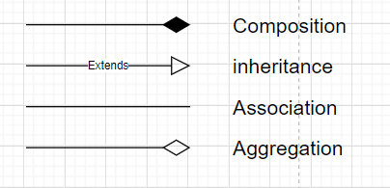
- Inheritance: One class inherits from another class.
- Association: Two classes are related, but the relationship is not explicitly stated.
- Composition: If an object created from class A is lost, the object created from class B will also be lost.
- Agreement: If an object created from class A is lost, the object created from class B will continue to exist independently.
b) Illustrative example
To operate a school management system, entities are closely linked through core relationships in the class diagram as follows:
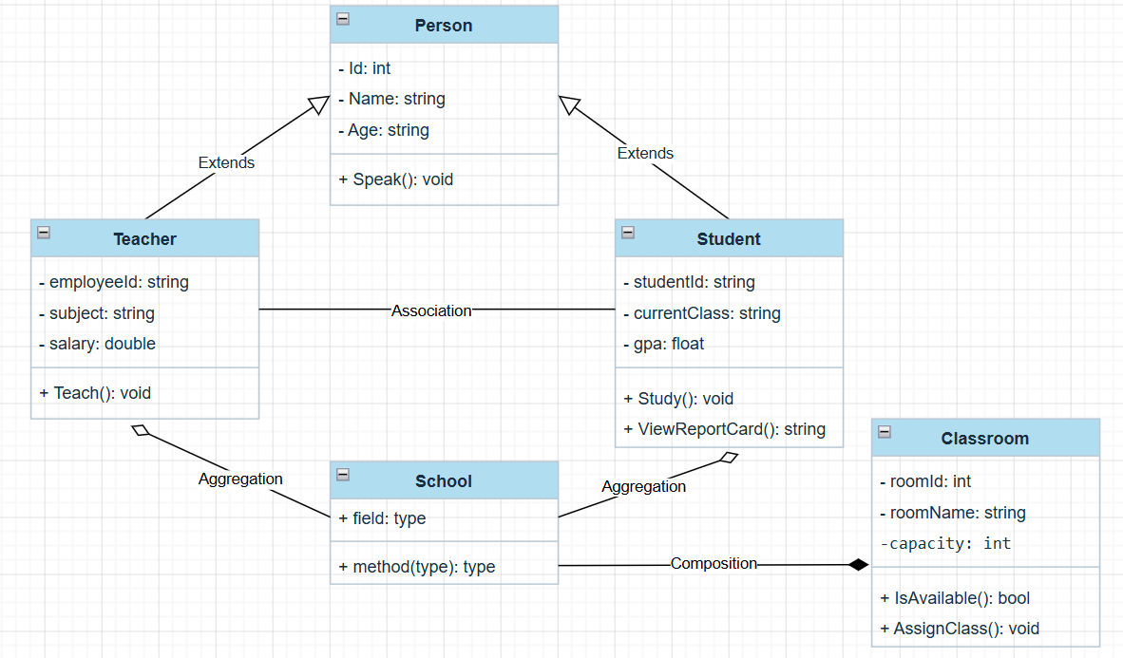
Inheritance: The Teacher and Student classes inherit from the parent class Person. These two child classes automatically inherit common attributes and methods from Person, while also extending their own characteristics.
Association: Represented by a horizontal line connecting Teacher and Student. This is an independent, two-way interaction within the educational environment, with no lifecycle dependency between the two entities.
Aggregation: Represented by an empty diamond from School to Teacher and Student. The school contains teachers and students, but this is a loose relationship; if the school is dissolved, these individuals still exist independently.
Composition: Represented by a solid diamond from School to Classroom. This is a relationship of full ownership and complete lifecycle dependency; If a school is demolished, the classrooms belonging to that school are also destroyed.

SOLID principles
The SOLID Principles were introduced by a software engineer named Robert C. Martin (also known as "Uncle Bob") in the early 2000s. Uncle Bob’s goal was to promote good software design practices, particularly in object-oriented programming (OOP), by addressing common problems developers face as software systems grow in size and complexity (Danny, 2024).
- Here are the five SOLID principles:
- S: Single Responsibility Principle (SRP)
- O: Open-closed Principle (OCP)
- L: Liskov Substitution Principle (LSP)
- I: Interface Segregation Principle (ISP)
- D: Dependency Inversion Principle (DIP)
a) Single responsibility principle (SRP)
The Single Responsibility Principle (SRP) states that a class should have only one responsibility and only one reason to change. This principle aims to make the source code more readable, understandable, and maintainable. When a class handles too many functions, it becomes complex, difficult to manage, and modifications can affect many other parts of the system.
Example: The Teacher class currently holds two responsibilities: one is to manipulate the database, and the other is to generate reports. The Teacher class should not be responsible for generating reports. If the system later requires exporting reports to Excel or any other format, this class would have to be modified accordingly.
public class Teacher
{
public int Teacher_Id { get; set; }
public string Teacher_Name { get; set; }
public bool InsertIntoTeacherTable(Teacher tc)
{
// Insert into teacher table.
return true;
}
public void GenerateReport(Teacher tc)
{
// Report generation with teacher data using crystal report.
}
}
Solution: Separate the report generation functionality into a separate class. Any changes to the report's formatting or logic will not affect the Teacher class.

public class ReportGeneration
{
public void GenerateReport(Teacher tc)
{
// Report generation with teacher data.
}
}
b) Open closed principle (OCP)
The Open-Closed Principle (OCP) states that software components such as classes, modules, or functions should be open for extension but closed for modification. The purpose of this principle is to make the system easily extensible, reduce the risk of errors when changing the source code, and increase the stability, maintainability, and future development of the software.
Example: The problem arises when the system wants to add more data output types such as XLS, WORD, and XLSX. At this point, you are forced to modify the existing ReportGeneration class and add more if statements inside the GenerateReport method. Directly modifying a stable, running class is not recommended.
public class ReportGeneration
{
public string ReportType { get; set; }
public void GenerateReport(Teacher tc)
{
if (ReportType == "CRS")
{
// Report generation with teacher data in Crystal Report.
}
if (ReportType == "PDF")
{
// Report generation with teacher data in PDF.
}
}
}
Solution: Use an interface to abstract the report creation functionality. When you need to add a new report type, you simply create a specific class that implements this interface without modifying existing classes.

public interface IReportGeneration
{
public void GenerateReport(Teacher tc);
}
public class CrystalReportGeneration : IReportGeneration
{
public void GenerateReport(Teacher tc)
{
// Generate crystal report.
}
}
public class PDFReportGeneration : IReportGeneration
{
public void GenerateReport(Teacher tc)
{
// Generate PDF report.
}
}
c) Liskov substitution principle (LSP)
The Liskov Substitution Principle (LSP) states that objects of a subclass must be interchangeable with objects of a parent class without altering the correctness of the program. In other words, the subclass must inherit and fully implement the behaviors defined by the parent class, without changing or breaking the system's expectations of the parent class.
Example: The AI_Teacher class represents an automated teaching AI system. It doesn't have a name structure like a human teacher, and throwing a NotImplementedException breaks the expected behavior of its parent class, Teacher.
public abstract class Teacher
{
public string TeacherCode { get; set; }
public string FirstName { get; set; }
public string LastName { get; set; }

public virtual string GetFullname()
{
return $"{FirstName} {LastName}";
}
}
public class Lecturer : Teacher
{
public override string GetFullname()
{
return $"Lecturer - {FirstName} {LastName}";
}
}
public class AI_Teacher : Teacher
{
public override string GetFullname()
{
throw new NotImplementedException();
}
}
Solution: AI_Teacher should not inherit from Teacher but should be separated into a distinct branch or independent class that suits its characteristics.
List<Teacher> teacherList = new List<Teacher>();
teacherList.Add(new Lecturer());
teacherList.Add(new AI_Teacher());
foreach (Teacher t in teacherList)
{
t.GetFullname();
}
d) Interface segregation principle (ISP)
The Interface Segregation Principle (ISP) states that a class should not be forced to implement methods it does not use. Instead of building one large interface containing many different functions, it should be broken down into smaller, specialized interfaces, each serving a specific purpose.
Example: Some instructors only need the Excel export function, while others need both. In this case, combining them would require reimplementing all the methods.
public interface IExportReport
{
void ExportExcelReport();
void ExportPdfReport();
}
Solution: Break down each type of export into smaller interfaces.
public interface IExportPdfFile
{
void ExportPdfReport();
}
public interface IExportExcelReport
{
void ExportExcelReport();
}
e) Dependency inversion principle (DIP)
This principle suggests that system components should communicate with each other through abstractions (such as interfaces or abstract classes) rather than directly relying on specific implementation classes.
This minimizes the impact on the rest of the system when a component needs to be changed or replaced. The goal of this principle is to reduce the tight binding between modules, making the code easier to maintain, extend, test, and reuse during software development.

Explain how clean coding techniques can impact on the use of data structures and operations when writing algorithms (P2)

What Is Clean Code?
Clean code is a term used to refer to code that is easy to read, understand, and maintain. It was made popular by Robert Cecil Martin, also known as Uncle Bob, who wrote "Clean Code: A Handbook of Agile Software Craftsmanship" in 2008. In this book, he presented a set of principles and best practices for writing clean code, such as using meaningful names, short functions, clear comments, and consistent formatting (Codacy, 2026).
Ultimately, the goal of clean code is to create software that is not only functional but also readable, maintainable, and efficient throughout its lifecycle.
By adhering to clean programming principles, the source code becomes easier to understand, maintain, and extend. This leads to a more stable and efficient system. Clean programming is essential for many reasons:
- Readability and maintainability: Clean code emphasizes clarity and simplicity, making it easier to read, understand, and modify. Well-structured code reduces the time needed to comprehend functionality, leading to more efficient development and maintenance.
- Enhanced team collaboration: Consistent coding standards and clear code organization improve communication among team members. Developers can easily understand each other's work, resulting in smoother collaboration and fewer misunderstandings.
- Simplified debugging and problem solving: Code that is organized, well-named, and modular allows developers to locate and fix issues more efficiently. Clear structure and meaningful identifiers make troubleshooting less time-consuming. Studies have also shown that AI-assisted development tools perform better when working with clean, well-structured code.
- Higher quality and reliability: By following established coding practices and maintaining a well-organized codebase, developers can reduce the likelihood of introducing defects. This leads to more stable, reliable, and higher-quality software over time.

Principles of Clean Code
Now that we understand why clean code is essential, let's delve into some best practices and principles to help you write clean code.
a) Meaningful naming
Meaningful naming is the most fundamental and crucial principle when writing clean code. Names of variables, functions, classes, or constants must clearly reflect their purpose and behavior rather than using generic characters or meaningless abbreviations. Good naming acts as a form of self-explanatory documentation, allowing other developers to understand the context instantly without wasting time guessing the underlying logic.
When calculating the number of elapsed days between two dates, using overly short or cryptic names makes it nearly impossible for anyone reviewing the code to immediately grasp the function's purpose.
Before: Using abbreviated and ambiguous variable names that fail to convey the true nature of the stored data.
public int GetD(DateTime s, DateTime e)
{
int d = (e - s).Days;
return d;
}
After: The function name and its parameters are replaced with clear, descriptive terms that explicitly state the calculation logic.
public int GetElapsedDays(DateTime startDate, DateTime endDate)
{
int elapsedDays = (endDate - startDate).Days;
return elapsedDays;
}
b) Modularity
Modularity requires source code to be divided into independent components, where each function or class should fulfill only one single and complete responsibility. An overly long function that crams multiple complex operations together is difficult to read, challenging to unit test, and highly prone to regression bugs when requirements change. By decoupling responsibilities, the codebase becomes more flexible, reusable, and maintainable.
A payroll processing function handles data validation, performs the mathematical calculation, and directly prints the result to the console window all at once. This coupling prevents the calculation logic from being reused elsewhere.
Before: A single function handles input validation, calculates the salary, and directly prints the output to the console.
public void ProcessSalary(double basicPay, int daysWorked)
{
if (basicPay > 0 && daysWorked > 0)
{
double totalSalary = basicPay * daysWorked;
Console.WriteLine("Total salary is: " + totalSalary);
}
}
After: The logic is modularized by separating the calculation and the display functionalities into two specialized methods, making the code cleaner and easier to manage.
public double CalculateTotalSalary(double basicPay, int daysWorked)
{
if (basicPay <= 0 || daysWorked <= 0) return 0;
return basicPay * daysWorked;
}

public void DisplaySalaryInfo(double totalSalary)
{
Console.WriteLine("Total salary is: " + totalSalary);
}
c) Comments

d) Consistency
Consistency is the core factor that maintains synchronization across an entire project, especially during team-based collaboration. Consistency manifests in the uniform application of naming conventions, indentation rules, directory structuring, and braces formatting. When a codebase strictly adheres to a shared standard, developers can seamlessly switch between different modules without facing style barriers.
Within the same source file, methods are written using conflicting coding styles—one method follows camelCase with an opening brace at the end of the line, while the next method follows PascalCase with an opening brace on a new line.
Before: Inconsistent programming styles across different methods, leading to a messy and unprofessional codebase layout.
public void saveUserData(string path) {
// Logic to save user data
}

public void DeleteFile(string path)
{
// Logic to delete a file
}
After: The entire code snippet is standardized using the PascalCase naming convention for methods and uniform Allman-style braces matching standard C# guidelines.
public void SaveUserData(string path)
{
// Logic to save user data
}
public void DeleteFile(string path)
{
// Logic to delete a file
}

Analyse, with examples, each of the creational, structural and behavioural design pattern types (M1)

Design patterns are comprehensive, optimized, and proven reusable solutions to common problems encountered in software design and development, especially in object-oriented programming (OOP). Design patterns are not complete designs ready for direct conversion, but rather frameworks or descriptions of how to solve problems that can be used in various situations.
During software development, programmers often encounter numerous problems in system design and implementation. To effectively solve these problems, design patterns are used as a set of design templates applicable across multiple programming languages. In object-oriented programming, design patterns help optimize program structure, increase reusability, and facilitate system maintenance and expansion.
- Why use design patterns?
In software development, the application of design patterns plays a crucial role in determining the quality and success of a project. Instead of independently searching for solutions to system architecture problems, using design patterns offers the following core benefits.
- Accelerating software development
Design patterns provide proven, comprehensive solutions to common and recurring problems. When faced with a complex system design problem, programmers don't have to spend a lot of time researching, testing, and fixing errors from scratch. Applying a standardized model immediately reduces design errors in the early stages, allowing the development team to quickly complete subsystems and bring the product into operation on schedule.
  - Supporting effective teamwork
Design patterns establish a common, standardized communication language for the entire engineering team. Using this standardized terminology makes discussing complex architectural solutions faster and clearer. Instead of spending time explaining the internal source code structure in detail, the team leader can simply name the design pattern so that programmers can immediately visualize the organizational structure and how the system operates. This completely eliminates information barriers, optimizes meeting time, and creates seamless collaboration when working together on a single source code platform.
  - Code reusability
One of the biggest goals of object-oriented design is code reusability. Design patterns help shape the source code structure by clearly separating the responsibilities of each data layer, creating loose links between components. Thanks to this independent and standardized structure, code snippets or functional modules can easily be transferred to other subsystems within the same system or used for entirely new projects without having to rewrite them from scratch or make too many modifications.
  - Maintainable and upgradeable code
Source code that adheres to design patterns is always highly encapsulated and has a clear structure, making it easier to read and understand. When system errors occur, programmers can quickly pinpoint and address the root cause of the problem without fear of causing cascading negative impacts on other code areas. Furthermore, when expansion or changes to business rules are required, the flexible structure of the design patterns allows for the smooth integration of new features, ensuring high scalability in the future.
Design patterns are divided into many different types, which include three main groups according to their purpose as follows:
a) Creational design patterns
This group focuses on creating objects in a flexible and controlled manner, masking complex initialization logic. Patterns within this group allow the system to become more independent of how objects are created, coupled, and represented. Typical examples include:
- Factory method: Provides a specialized interface for creating objects within a parent class but allows child classes to dynamically change the type of objects to be created.
- Abstract factory: Allows the creation of sets or families of related objects without having to specify their exact classes.
- Builder: Focuses on supporting the construction of complex objects in independent steps, completely separating the construction process from the object's representation.
- Prototype: Allows copying existing prototype objects to create similar new objects instead of having to repeat the resource-intensive initialization process from scratch.
In the SIMS system, processing a large dataset stored as a CSV file requires a robust concurrent access management mechanism to avoid conflicts or wasted system resources from continuously opening files. Therefore, the Singleton design pattern was chosen for the data management subsystem. This design pattern ensures that a class has only one instance throughout the application's operational lifecycle and provides a single global access point to that instance.
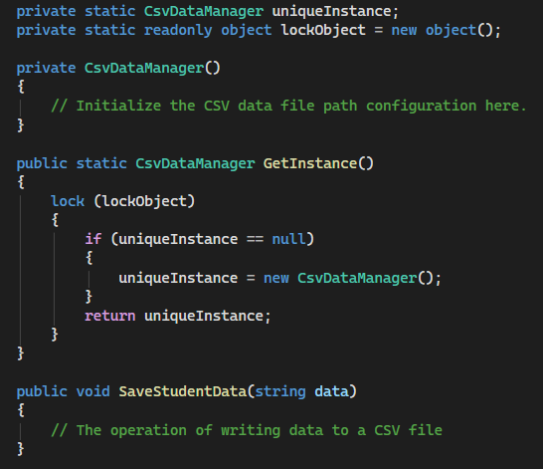
The CsvDataManager class possesses a constructor set to private, preventing other subsystems from freely initializing the object using the `new` keyword. The only access point is the static `GetInstance` function. Inside this function, a synchronous locking mechanism called `lock` is applied to ensure data flow security when the SIMS system receives multiple requests to write student information simultaneously. This solution completely eliminates the risk of process conflicts that could corrupt CSV files and saves memory resources for the server.
b) Structural design patterns
Structural groups address how to organize and combine objects and classes into larger structures while maintaining flexibility and efficiency. They focus on making objects and classes interoperable without increasing system complexity. Common patterns include:
- Adapter: Acts as an intermediary converter, allowing classes with incompatible interfaces to connect and work together seamlessly.
- Decorator: Allows dynamic addition of new responsibilities, features, or behaviors to a specific object without changing the original structure or source code of that class.
- Proxy: Provides a proxy object or an alternative office to control access, add security mechanisms, or delay the initialization of the underlying object.
- Composite: Supports arranging objects in a tree structure to represent hierarchical relationships, helping programmers interact with individual objects and groups of objects in a consistent manner.
The SIMS system, which handles student registration and course management, includes many complex internal processing steps such as account authentication, class attendance checks, and prerequisite course verification. The Facade design pattern is a suitable solution for organizing this structure, separating the business logic layer from the user interface layer. This design pattern provides a simplified interface for a complex underlying subsystem. The RegistrationFacade layer is created to act as the central point for receiving requests from the user interface and to self-coordinate component services.
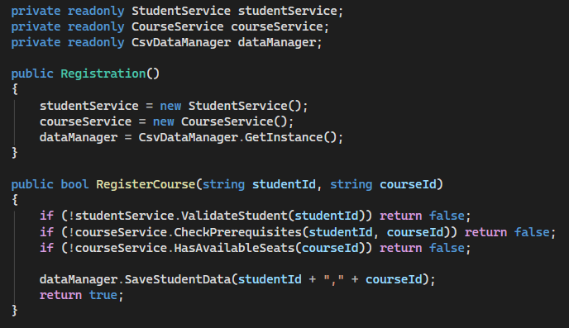
The Registration layer acts as a representative interface, hiding all the complex conditional validation logic, including student entity authentication, prerequisite course matching, and class availability checks. When the user interface layer needs to perform course registration functionality, it only needs to call a single RegisterCourse function with two input parameters instead of having to instantiate and interact with three different service layers.
c) Behavioral design patterns
Behavior patterns are concerned with algorithms and the division of responsibilities among objects. They describe how objects interact and communicate with each other to perform a specific task, improving the flexibility and scalability of the system. Examples of behavior patterns include:
- Strategy: Defines a set of independent algorithms, encapsulating each algorithm and allowing them to be interchangeable depending on the operating context.
- Command: Converts a request or task into an independent object containing all relevant information, supporting operation history storage or execution queuing.
- State: Allows an object to completely change its behavior when its internal state fluctuates.
- Template Method: Defines a fixed framework for an algorithm within the parent class but allows child classes to override or modify specific steps without breaking the overall structure.
For the SIMS system, when there is a change in the state of a course or teaching schedule, the system needs a mechanism to immediately notify the relevant students. The Observer design pattern is applied to solve this behavioral problem. This design pattern defines a one-to-many dependency relationship between objects, so that when a central object changes state, the objects subscribed to monitor it will automatically receive a notification of the behavioral update.
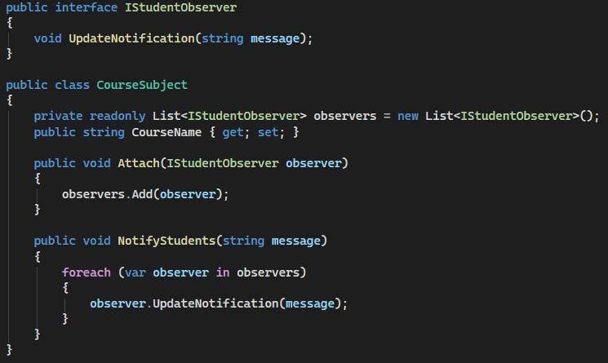
The IStudentObserver interface defines the behavior for receiving common messages for all student entities registered to monitor information. The CourseSubject class acts as the central entity being monitored, possessing a list of observer objects within the observers array variable. When the administrator changes course information, the NotifyStudents function is triggered to iterate through the entire list and automatically call the UpdateNotification function for each student.

Evaluate the impact of SOLID development principles on object- orientated application development (D1)

Design a large dataset processing application using SOLID principles and clean coding techniques (LO2)

Design a large data set processing application, utilising SOLID principles, clean coding techniques and a design pattern (P3)

Use case diagram
A Use Case Diagram is a behavioral UML diagram used to capture the functional requirements of a system. It provides a high-level visual representation of how different users, known as Actors, interact with the system's various features, known as Use Cases.
The use case diagram designed for SIMS, as shown in the image below, describes the core functionalities allocated to three main actors: Administrator, Teacher, and Student.
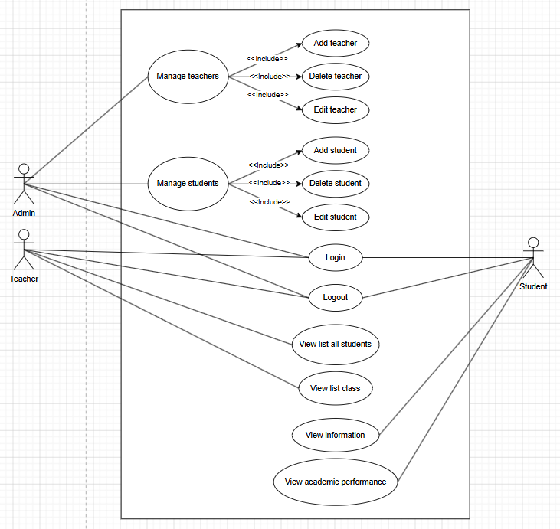

- All three actors interact with the core authentication boundaries:
- Login & Logout: The essential entry and exit points for any user session to ensure secure access control.
- The Admin possesses top-level management privileges over the system's data registry:
- Manage teachers: Broad capability to supervise the instructor directory, which strictly includes (<<include>>) three granular actions: Add teacher, Delete teacher, and Edit teacher.
- Manage students: Full authority to govern the student base, which strictly includes (<<include>>) the sub-actions: Add student, Delete student, and Edit student.
- The Teacher acts as an intermediary user focusing on data monitoring and basic analytics:
- View list all students: Allows teachers to look at the entire student registry.
- View list class: Enables instructors to filter and see rosters grouped by specific classrooms.
- The Student is a consumer-level user with strict read-only access to their personal metrics:
- View information: Gives access to individual profile data.
- View academic performance: Allows students to check their grades and academic report scores securely.

Class diagram
A class diagram is the most important structural diagram in the Unified Modeling Language (UML), providing a comprehensive view of the static architecture of a software system. By visually representing classes, attributes, methods, and how objects interact with each other, the class diagram serves as a blueprint for engineering design.
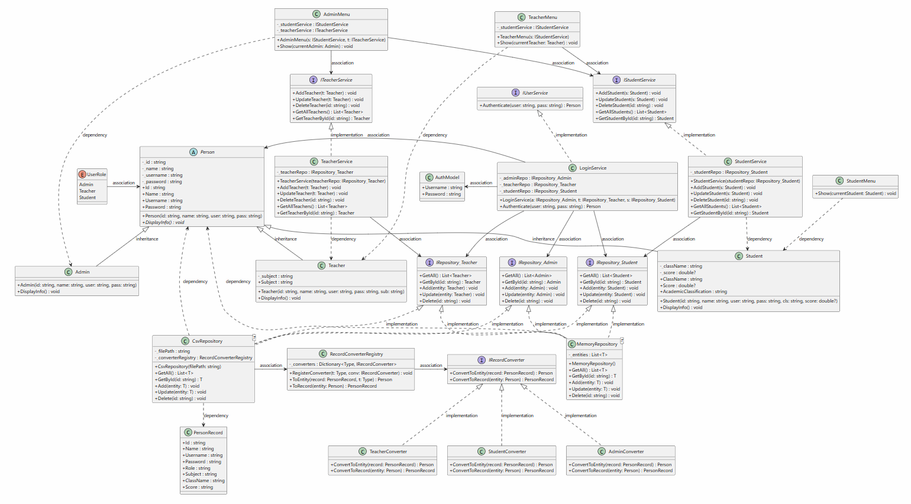
To understand the operation and organization of the SIMS system, the overall structure of the class diagram above will be analyzed in detail through the following three core aspects:
a) Main components of the class diagram
The system is organized according to a layered architecture with distinct tasks for each subsystem:
Presentation layer: Acts as the direct interface with users via the command line interface. Its main task is to receive input requests, control the flow of feature navigation, and display output results corresponding to the permissions of each account.
Business logic layer: The central control of all system operations. Its main task is to execute core logic rules such as access authentication, validating input data, processing score calculations, and making decisions on academic ranking.
Data access Layer: Responsible for data management, independent of the business layer. The primary task is to perform read/write operations to storage environments (physical files or cache), and to process the conversion of raw data structures into system entities.
Domain models (Entity Layer): The foundation that shapes the information structure of the entire system. Its main task is to encapsulate and organize data and establish inheritance relationships between objects (Administrators, Teachers, Students), serving as a synchronized database for the three upper architectural layers.
b) Relationships between classes
This diagram accurately applies the standard relationship types of the UML modeling language to demonstrate the close relationship between components:
Inheritance: Represented by a solid, hollow triangle arrow pointing from the child class to the parent class. The three specific entity classes admin, teacher, and student all inherit from the abstract parent class representing an individual, enabling code reuse and polymorphism through information display methods.
Implementation: Represented by a dashed, hollow triangle arrow. Service classes execute predefined contracts defined by their respective business interfaces. Simultaneously, data storage classes fully implement data management interfaces to ensure consistency.
Association: Represented by a solid arrow indicating long-term ownership. For example, menu classes own and maintain references to service interfaces through internal variables, or the login service class links to the authentication model to verify session information.
Dependency: Represented by a dashed arrow, this indicates a temporary usage relationship when one class receives an object of another class as a parameter in a method. Specifically, the student service class depends on the student entity to perform add or modify operations, while a flat file repository depends on the structure of the raw data record class.
c) Application of design patterns and clean code principles
System architecture in the class diagram demonstrates modern software design thinking through the application of design patterns and clean programming principles:
- Design patterns:
- Repository pattern: Completely separating storage interfaces from the service layer's processing logic isolates the data layer. This allows the system to easily switch storage environments (from physical flat text files to temporary caches) without affecting or modifying the source code at the business layer above.
- Registry pattern: The converter registry class acts as a centralized manager for data conversion interfaces. When the text file repository needs to process data, it simply calls this registry class to retrieve the correct specific converter for the admin, teacher, or student, deeply modularizing the data serialization process.
- Clean code & SOLID principles:
- Single responsibility principle: Each layer is responsible for only one single responsibility. Menu layers handle interface tasks, service layers handle business logic, storage layers are responsible for storage, and converters only perform data structure translation tasks.
- Open/Closed principle: The system is designed to be open for extension but closed for modification. When a new type of converter is needed, the programmer only needs to create a new class that inherits the converter interface and register it in the centralized management system without restructuring the existing source code.
- Dependency inversion principle: The menu layer does not directly communicate with the implementation layer of the service layer, and the service layer does not directly depend on specific storage layers. All relationships at higher architectural layers point to abstract interfaces. This minimizes dependencies, increases flexibility, and creates ideal conditions for deploying automated unit testing.

Package diagram
A package diagram is a structural diagram in the UML modeling language, used to group related source code elements together into independent subsystems. This diagram provides an overview of the system architecture at a macro level, helping programmers control encapsulation, organize namespaces, and manage dependency flows between modules in a project.
To understand how SIMS's source code directories are divided and organized, the overall structure of the package schema above will be analyzed in detail through the following aspects:
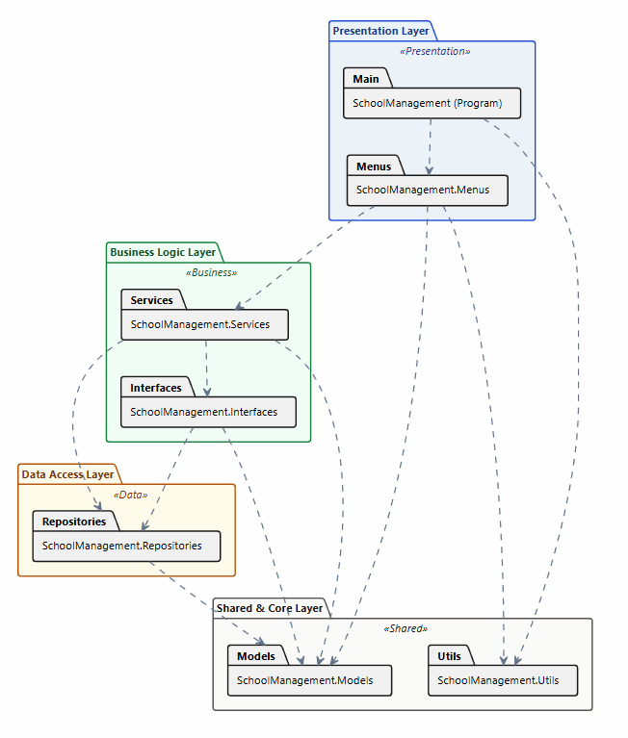
- The package diagram in this system is used for the following core purposes:
- Dividing the system into independent subsystems based on a hierarchical architecture, enabling scientific management of namespaces.
- Clearly illustrating the relationships and dependencies between architectural layers from top to bottom, ensuring that higher-level layers do not depend on lower-level layers.
- Giving programmers an overview of the boundaries between modules, making it easier to upgrade or replace a specific subsystem without affecting the entire system.

Design a suitable testing regime for the application, including provision for automated testing (P4)

System testing strategy overview
The testing strategy for the Student Information Management System (SIMS) focuses on automated testing solutions. The core objective is to ensure data integrity and optimize response times when the ASP.NET Core application performs I/O tasks on large datasets using flat CSV files. To achieve this, the testing process applies the Testing Pyramid model.
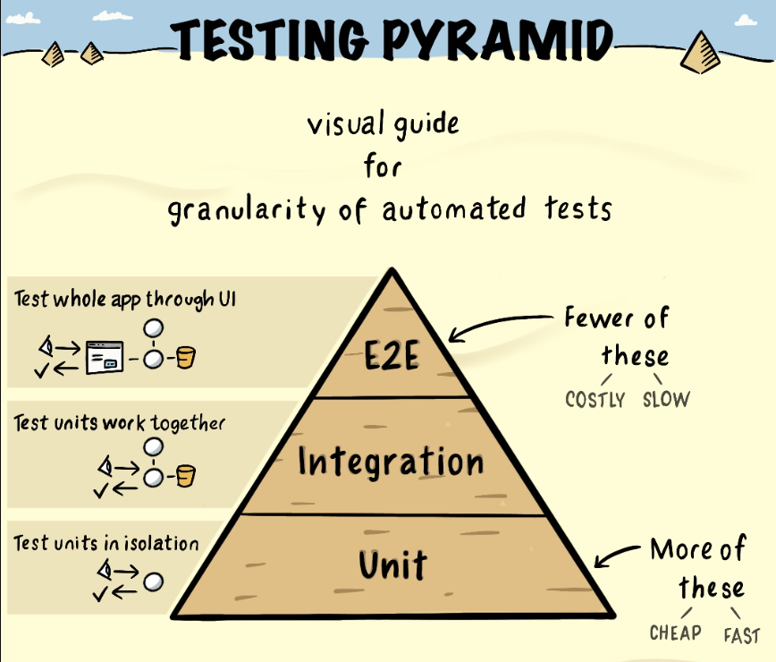
The testing structure is layered from bottom to top, ensuring independence but strong mutual support:
- Unit testing is the foundational layer, accounting for the largest proportion and having the fastest execution speed in the entire system. This method focuses at the source code level to isolate and validate the accuracy of each function, method, or processing class. For SIMS, this layer plays a crucial role in independently testing algorithms for reading, writing, and processing data from CSV files before moving on to higher layers.
- Integration testing is an intermediate layer focused on testing the interaction and operational coordination between different modules or architectural layers after connection. This layer ensures a smooth data flow between the business logic of the ASP.NET Core application and the physical CSV file system, preventing conflicts when processing large datasets.
- E2E testing is the top layer with the most streamlined scenarios due to higher operating costs and slower execution speeds. This layer focuses on the user interface and comprehensive end-to-end business flow testing. By using Selenium to simulate real-world user interaction behaviors on a web browser, the system is validated for accurate responsiveness and stable performance from the end-user's perspective.

Design test cases using the test pyramid
a) End to end test case
This method programmatically drives the browser to simulate real-world user workflows, validating the system from the front-end user interface down to the back-end core logic.
The primary purpose of implementing E2E test cases for this phase is to ensure the absolute stability of the user authentication lifecycle. By verifying that the system handles various routing, error rendering, and access control actions appropriately, we can guarantee a secure and seamless entry gate for SIMS.
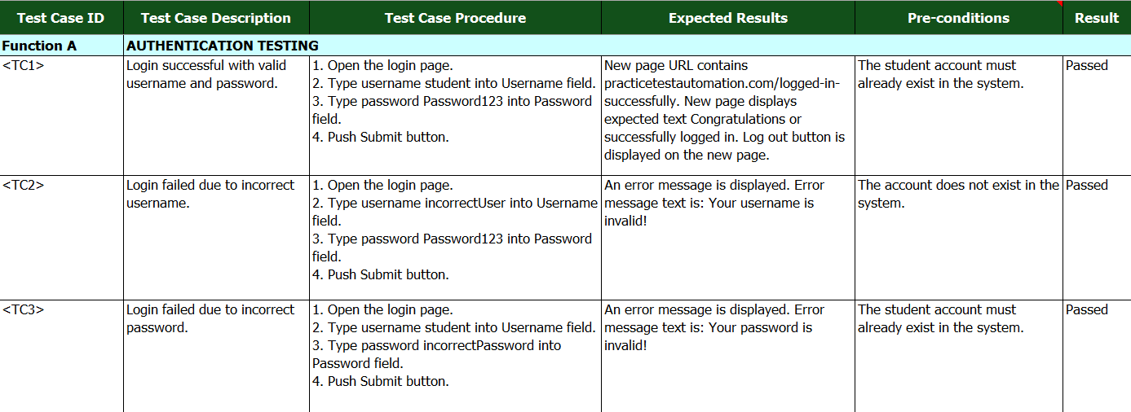
The E2E test suite for the login functionality evaluates system behavior through three distinct scenarios detailed in the specification table:
- TC1 - Positive Login Scenario: Validates the ideal system path when a user provides perfectly correct credentials. It checks the application's ability to handle successful state routing, verify the destination URL, and properly render session elements like the "Log out" button on the new page.
- TC2 - Negative Username Scenario: Evaluates system security boundaries when an unrecognized user attempts to gain access. It asserts that the application rejects the request immediately at the interface level and displays the exact feedback message indicating that the username is invalid.
- TC3 - Negative Password Scenario: Verifies the data-matching accuracy of the authentication layer. When a valid username is entered with an incorrect password, the system must recognize the credential mismatch, deny system entry, and return the specific invalid password alert to the user interface.
b) Unit testing
Unlike high-level testing methods, it focuses on isolating and verifying the correctness of individual functions, methods, or classes in a completely isolated environment, detached from external dependencies like databases or the file system.
The primary purpose of implementing unit test cases for the StudentService layer is to guarantee that the core student management logic such as record validation, data constraints, and exception handling executes flawlessly at the source-code level. This ensures regressions are caught immediately during development before the code integrates with higher layers.
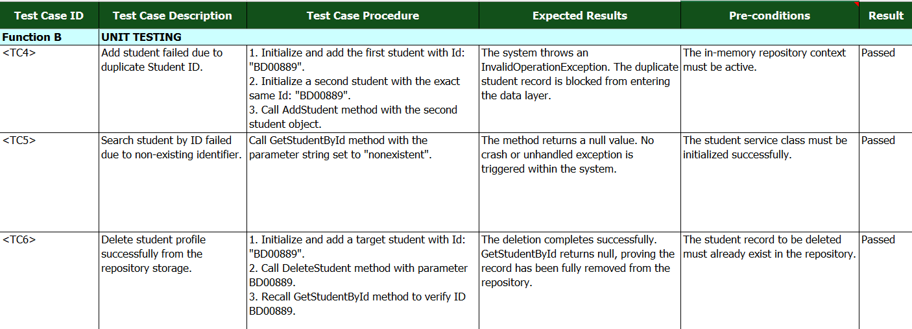
The unit test suite for student data management targets boundary constraints and operational logic through three specific test cases:
- TC4 - Duplicate Student ID Exception Scenario: Verifies the system's business rules regarding data uniqueness. When an operation attempts to register a student with an identity code (Id) that already exists in the system, the service must immediately intercept this violation and throw an InvalidOperationException to protect data integrity.
- TC5 - Non-existing Student Search Scenario: Validates the system's safety and resilience when querying missing records. If a user searches for an identifier string that does not exist ("nonexistent"), the method must gracefully handle the missing lookup and return a clear null value rather than causing an unhandled crash.
- TC6 - Successful Student Profile Deletion Scenario: Asserts the execution accuracy of modifying the application state. It ensures that calling the deletion method properly unlinks and drops the target record from the repository, meaning any subsequent fetch operations for that specific identifier will successfully return null.
c) Integration testing
This phase moves beyond isolated components to verify the interactions, data pipelines, and operational coordination between multiple integrated subsystems specifically combining the core business domain logic with external boundaries.
The primary purpose of implementing integration test cases in this project is to validate the actual data serialization lifecycle between StudentService and the physical file storage managed by CsvRepository. Since the system relies on flat CSV files instead of a standard SQL database server, integration tests are critical to ensure that I/O operations, text encoding, and file-writing streams execute correctly under real file-system conditions without data corruption or path failures.
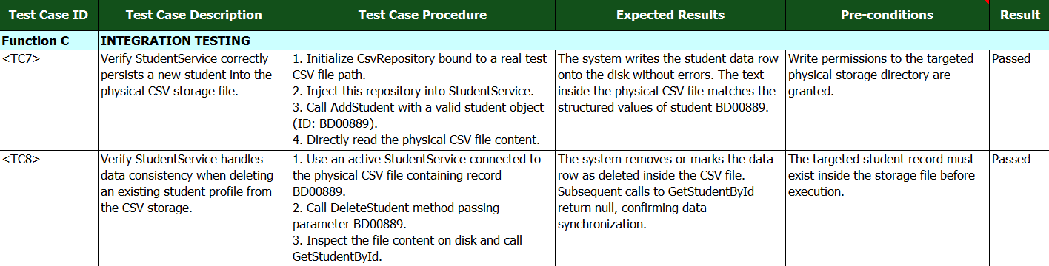
The integration test suite targets data persistence and stream synchronization through two core scenarios detailed in the specification table:
- TC7 - Physical CSV Data Persistence Scenario: Verifies the end-to-end write lifecycle from the business interface down to the disk storage. It ensures that when StudentService processes a new registration (ID: BD00889), the CsvRepository successfully opens an un-mocked file stream, maps the structured model properties into raw text columns, and accurately persists the record onto the physical hard drive without stream conflicts.
- TC8 - Storage Modification Data Consistency Scenario: Validates the absolute synchronization of application state across physical and logical boundaries. When a deletion command is triggered for a record (BD00889), this test ensures that the physical row is correctly modified or purged from the flat file, and that subsequent data-fetching calls correctly sync with the updated disk state to return a null value.

Refine the design to include multiple design patterns (M2)
The initial design in section P3 needs to be upgraded so that the SIMS system can efficiently handle large CSV datasets, is easy to maintain, and strictly adheres to SOLID principles. In practice, operating in an ASP.NET Core environment, the storage layer often faces significant pressure regarding memory release and thread synchronization when multiple accounts write data simultaneously. While the old design separated the basic layers, the conversion process was manual, creating rigid dependencies between components.
To enhance load capacity and flexibility, the system will combine the Registry pattern with the Singleton pattern and Factory Method pattern. This intersection comprehensively optimizes the initialization, management, and execution of raw data translation in a synchronized manner.
Show the integrated design patterns
Integration of multiple patterns

Build a data processing application based on a developed design (LO3)

Build a large dataset processing application based on the design produced (P5)

System architecture
The system was developed following the clean architecture pattern, which separates the application into multiple layers with distinct responsibilities. This architectural approach improves maintainability, scalability, and testability by minimizing dependencies between components. Each layer communicates with the others through interfaces and dependency injection, allowing implementation details to be modified without affecting the business logic.
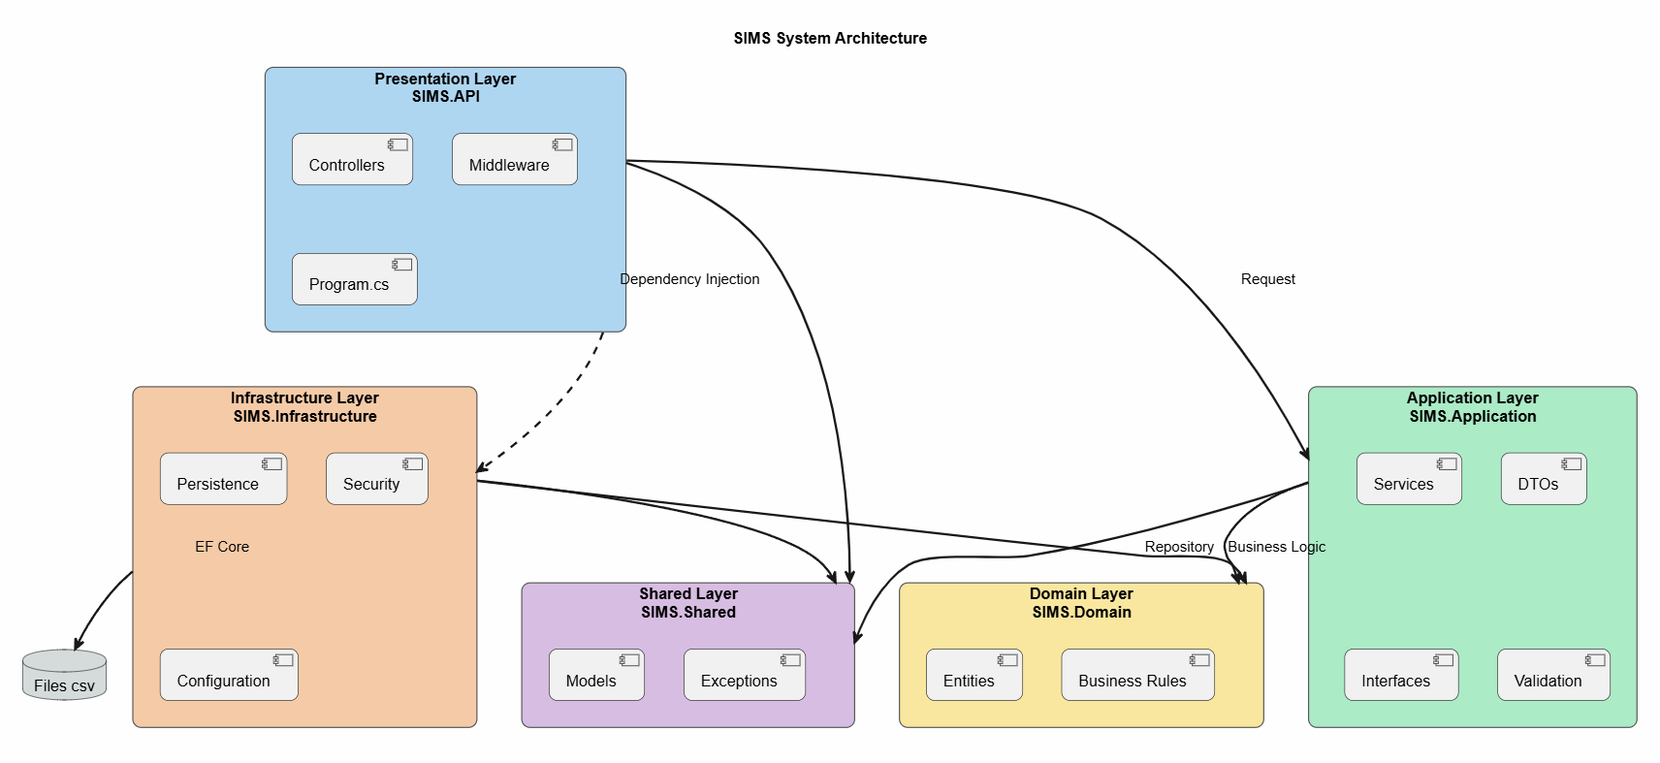
Figure 6: SIMS system architecture.
- The architecture consists of five main layers:
- Presentation layer (SIMS.API): Includes Controllers, Middleware, and Program.cs. This layer receives HTTP requests, performs authentication and authorization, and forwards requests to the Application Layer.
- Application layer (SIMS.Application): Includes Services, DTOs, Interfaces, and Validation. It contains the application logic, validates input data, coordinates business processes, and communicates with the Domain and Infrastructure layers.
- Domain layer (SIMS.Domain): Includes Entities and Business Rules. This is the core of the system, where the business model and domain logic are defined independently of any external framework or database.
- Infrastructure layer (SIMS.Infrastructure): Includes Persistence, Security, and Configuration. This layer implements data access using Entity Framework Core, manages authentication and authorization, and handles interactions with both the database and CSV files.
- Shared layer (SIMS.Shared): Includes Models and Exceptions that are shared across the solution to provide common data structures and error-handling mechanisms.
When a client sends a request, it is first received by the Presentation Layer, which authenticates the user and forwards the request to the appropriate application service. The Application Layer executes the required business logic by interacting with the Domain Layer and accessing data through repository implementations provided by the Infrastructure Layer. Finally, the processed result is returned to the client as a JSON response.

Main API endpoints
a) API endpoints overview
The system provides a collection of RESTful APIs that support authentication, user management, academic management, and large dataset processing. These APIs allow clients to perform CRUD operations on core entities while ensuring secure access through authentication and authorization mechanisms. In addition, the application includes endpoints for importing and processing large datasets from CSV files, enabling efficient handling of bulk student records.
The main API endpoints are grouped according to their functionalities as follows.
Method | Endpoints | Description
Authentication APIs
POST | /api/auth/login | Authenticate a user and generate an access token.
POST | /api/auth/refresh | Refresh an expired access token.
POST | /api/auth/logout | Invalidate the current authentication session.
POST | /api/auth/changepassword | Change the authenticated user's password.
User management APIs
GET | /api/users/me | Retrieve the profile of the currently authenticated user.
GET | /api/users | Retrieve all users.
POST | /api/users | Create a new user.
PUT | /api/users/me | Update the authenticated user's profile.
DELETE | /api/users/{id} | Delete a user by ID.
Student management APIs
GET | /api/students | Retrieve all students.
GET | /api/students/{id} | Retrieve a student by ID.
POST | /api/students | Create a new student.
PUT | /api/students/{id} | Update student information.
DELETE | /api/students/{id} | Delete a student.
Academic management APIs
GET | /api/instructors | Retrieve instructor information.
GET | /api/courses | Retrieve all courses.
POST | /api/courses | Create a new course.
GET | /api/subjects | Retrieve all subjects.
POST | /api/subjects | Create a new subject.
POST | /api/classes | Create a new class.
POST | /api/classes/{classId}/enrollments | Enroll a student in a class.
DELETE | /api/classes/{classId}/enrollments/{studentId} | Remove a student from a class.
POST | /api/grades | Create a grade record.
PUT | /api/grades/{id} | Update a student's grade.
GET | /api/grades/student/{userId} | Retrieve grades of a specific student.
Table 1: Main api endpoints.
b) API testing show case
To test the API endpoints, I used Postman to send HTTP requests and verify the responses returned by the API. The endpoints were tested in a local environment using the specified API Base URL. For protected endpoints, Bearer Token (JWT) authentication was used, and the API responses were returned in JSON format.
Item | Value
API Base URL | http://localhost:5198
Tool | Postman
Authentication | Bearer Token (JWT)
Response format | JSON
Table 2: Test environment.
To test the API system, an end-to-end test flow was designed to simulate a typical user workflow. This scenario verifies not only the functionality of individual APIs but also the correctness of data flow and the dependencies between APIs throughout the entire process.
- The test workflow consists of the following steps:
- Step 1: Authenticate the user by calling the Login API to obtain an access token.
- Step 2: Retrieve the authenticated user's profile using the access token.
- Step 3: Create a new student by submitting the student's information.
- Step 4: Enroll the student in a class using the created student record.
- Step 5: Retrieve the student's grades to verify that academic information can be accessed successfully.
Step 1: User authentication
The first step is to authenticate the user through the Login API. Valid login credentials are submitted to verify the authentication process and obtain an access token for subsequent protected API requests.
Endpoint: POST /api/auth/login
Expected result: The API should successfully authenticate the user and return an access token with an HTTP 200 OK status.
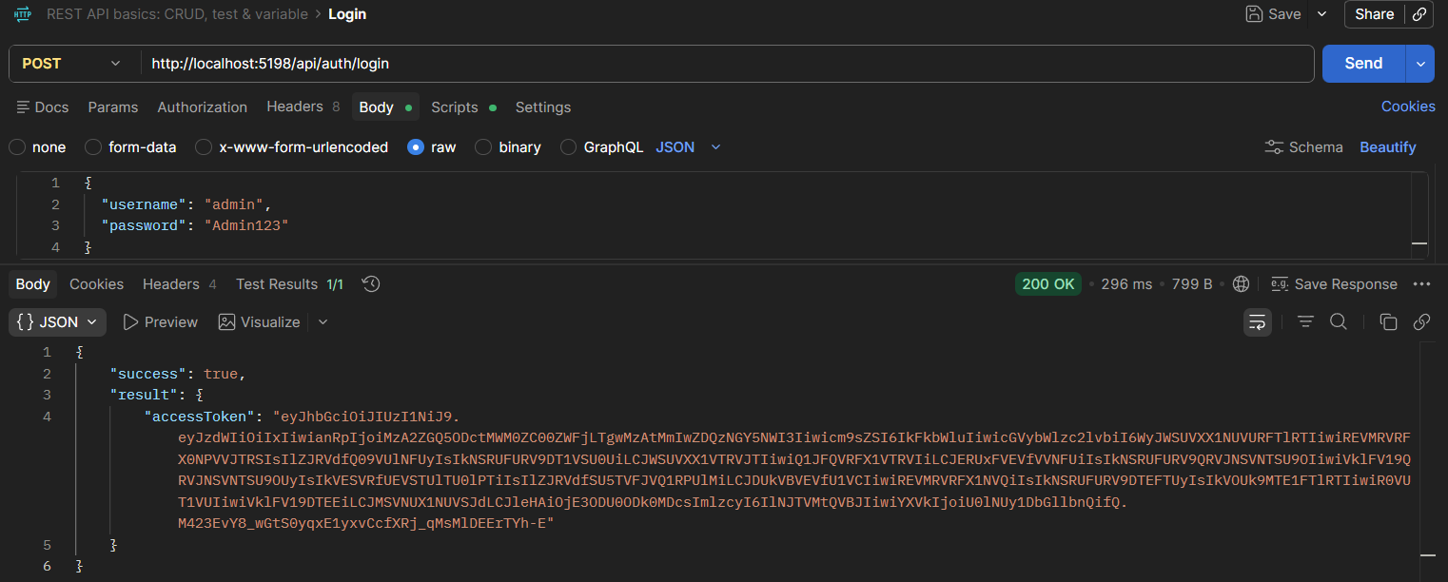
Figure 7: Login API – Successful authentication and access token generation.
Test evidence: The following Postman screenshot demonstrates the successful login request, including the request body, HTTP 200 OK response, and the returned access token.
Step 2: Retrieve authenticated user profile
After obtaining the access token, the token is used to access the authenticated user's profile. This step verifies that the authentication token is valid and that the system can correctly identify the current user.
Endpoint: GET /api/users/me
Authorization: Bearer <accessToken>
Expected result: The API should return the authenticated user's information with an HTTP 200 OK status. The returned data is also used to verify that the user identity from the authentication process is correctly maintained across subsequent API requests.
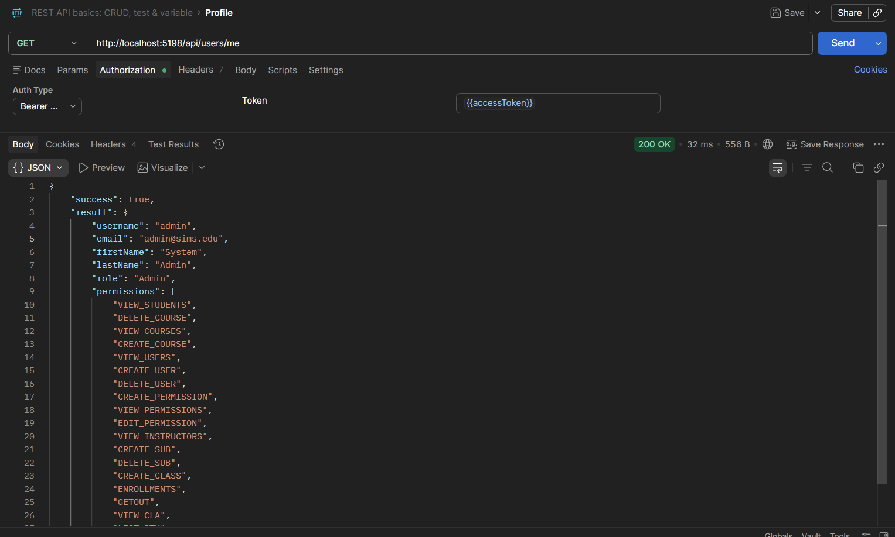
Figure 8: Get Current User API – Successfully retrieving authenticated user information.
Test evidence: The Postman screenshot demonstrates the authenticated request and the returned user profile data.
Step 3: Create a new student
After verifying the authenticated user, the next step is to create a student record. This step tests the student management functionality and verifies that the API can process and store the submitted student information successfully.
Endpoint: POST /api/students
Expected result: The API should successfully process the request and return the newly created student information with an HTTP 200 OK status. The created student's identifier is then used as input for the following enrollment process.
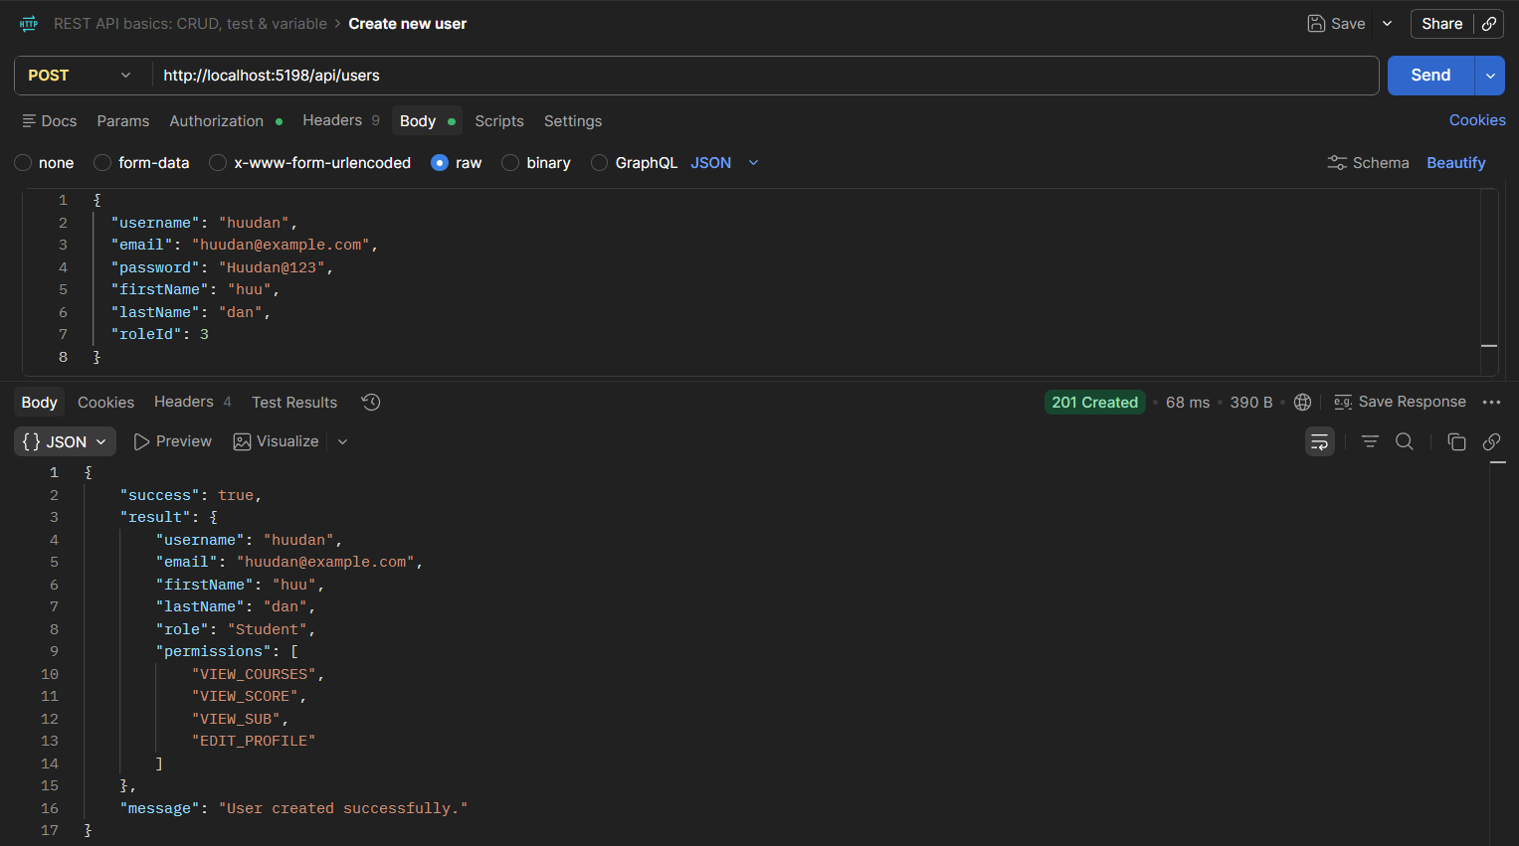
Figure 9: Create Student API – Successfully creating a new student.
Test evidence: The Postman screenshot shows the submitted student information, the successful HTTP response, and the returned student data.
Step 4: Enroll the student in a class
After creating the student record, the student is enrolled in a specific class. This step verifies the relationship between student and class data and demonstrates the interaction between different parts of the academic management system.
Endpoint: POST /api/classes/{classId}/enrollments
Expected Result: The API should successfully process the enrollment request and return an HTTP 200 OK status together with the enrollment result. The studentId used in this request is obtained from the student creation step, demonstrating the dependency and data flow between the APIs.
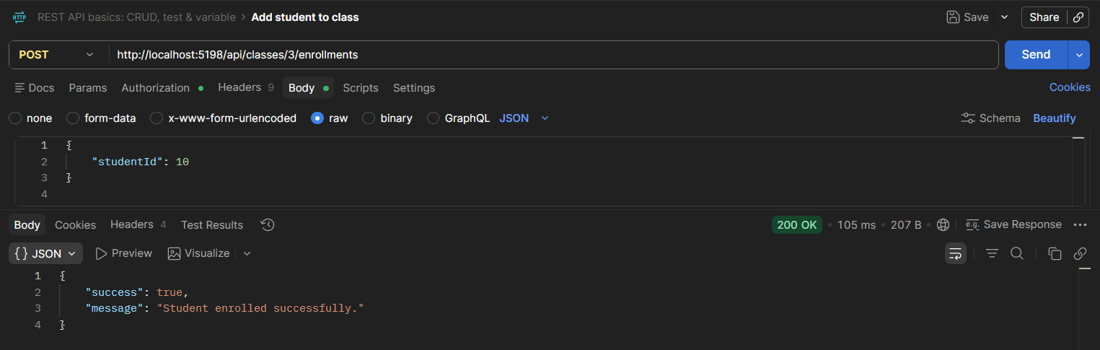
Figure 10: Student Enrollment API – Successfully enrolling a student into a class.
Test evidence: The Postman screenshot demonstrates the class enrollment request, the successful HTTP response, and the returned enrollment information.
Step 5: Retrieve student grades
The final step retrieves the academic results of the student. This step verifies that the student information created and processed in the previous steps can be used to access the corresponding academic data.
Endpoint: GET /api/grades/student/{studentCode}
Authorization: Bearer <access_token>
Expected result: The API should successfully retrieve the student's academic results and return an HTTP 200 OK status with the corresponding grade data.
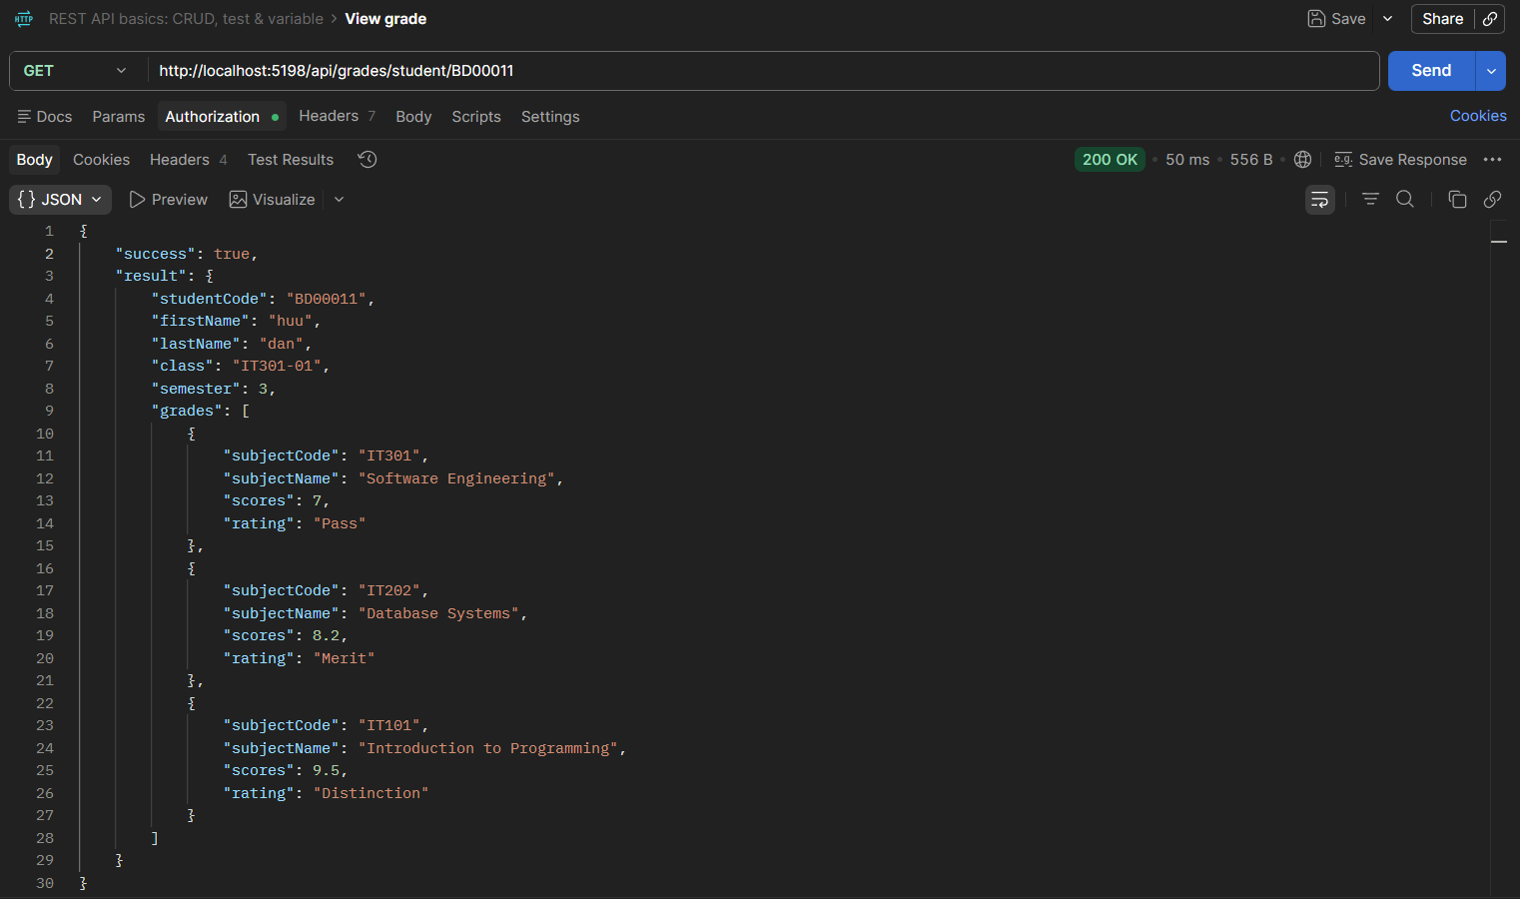
Figure 11: Get Student Grades API – Successfully retrieving academic results.
Test evidence: The Postman screenshot demonstrates the successful request and the returned academic information in JSON format.
After executing all five steps, the complete API workflow was successfully verified. Each API returned the expected response, and the data generated from one step was used as input for subsequent steps. This confirms not only the correctness of individual API endpoints but also the consistency of data flow and dependencies across the system.
Step | API | Expected result | Status
1 | POST /api/auth/login | Access token returned | ✅ 200 OK
2 | GET /api/users/me | User profile returned | ✅ 200 OK
3 | POST /api/users | Student created successfully | ✅ 200 OK
4 | POST /api/classes/{classId}/enrollments | Student enrolled successfully | ✅ 200 OK
5 | GET /api/grades/student/{studentCode} | Student grades returned | ✅ 200 OK
Table 3: Test result.

Assess the effectiveness of using SOLID principles, clean coding techniques and programming patterns on the application developed (M3)

Perform automatic testing on a data processing application (LO4)

Examine the different methods of implementing automatic testing as designed in the test plan (P6)

dá

Implement automatic testing of the developed application (P7)

Automated testing overview
To improve the reliability and maintainability of the SIMS, an automated testing project was implemented using xUnit together with the moq framework. The purpose of automated testing is to verify the correctness of key application functionalities and ensure that changes to the system do not introduce unexpected errors.
A separate test project named SIMS.Tests was created to contain the automated test cases. xUnit was used as the testing framework to define and execute unit tests, while moq was used to create mock objects for dependencies such as repositories and services. This approach enables isolated testing of business logic without requiring access to external resources such as databases.
The automated tests focus on important business functionalities, including user authentication, student validation, and academic score calculation. All test cases were executed using visual studio test explorer, and the final test results confirmed that every implemented test case passed successfully, demonstrating the correctness and stability of the tested components.

Automated test cases

- A total of 6 test cases were implemented:
- 3 test cases for user login.
- 2 test cases for student code validation.
- 1 test case for grade classification based on the predefined grading scale.
The tests were executed using visual studio test explorer, with all test cases expected to pass successfully. The following test cases were implemented:
Test ID | Description | Test scenario | Expected result
<TC_Login_01> | Verify successful login with valid username and passwordVerify successful login with valid username and password | Valid username and passwordValid username and password | Login succeeds
<TC_Login_02> | Verify login failure with correct username and incorrect password | Correct username, incorrect passwordCorrect username, incorrect password | Login fails
<TC_Login_03> | Verify login failure with incorrect username and correct password | Incorrect username, correct passwordIncorrect username, correct password | Login fails
<TC_StuCodeValid _04> | Verify student code validation succeeds with valid input | Valid student code | Validation succeeds
<TC_StuCodeValid _05> | Verify student code validation fails when code is null or empty | Student code is null or empty | Validation fails
<TC_GradeClassification_06> | Verify correct grade classification is returned for score within valid rangeVerify correct grade classification is returned for score within valid range | Score is within a predefined range | Correct grade classification is returned
Table 4: List of test cases.
The designed test cases were implemented using unit tests in visual studio. Each test case corresponds to a test method designed to verify the program's actual output against the expected output.
a) <TC_Login_01>
This test method verifies that the login process succeeds and returns a valid access token when valid credentials are provided. The logic follows the standard three-step Unit Test pattern.
In the Arrange step, the test initializes a mock user object with valid attributes such as ID, username, hashed password, and an active account status. It then configures the mock dependencies to simulate expected behaviors: the user repository returns the mock user, the password hasher confirms the password is correct, the role repository assigns the "Student" role, and the token service produces a result containing the access token "access-token-abc". Finally, the target service object is constructed with these setup mocks.
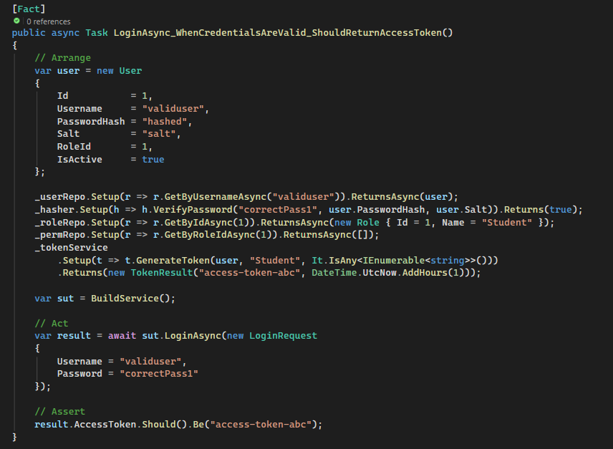
In the Act step, the code invokes the asynchronous login method using a request payload with the valid username "validuser" and password "correctPass1".
In the Assert step, the test validates the result of the login attempt. It asserts that the returned AccessToken matches the expected value "access-token-abc".

b) <TC_Login_02>
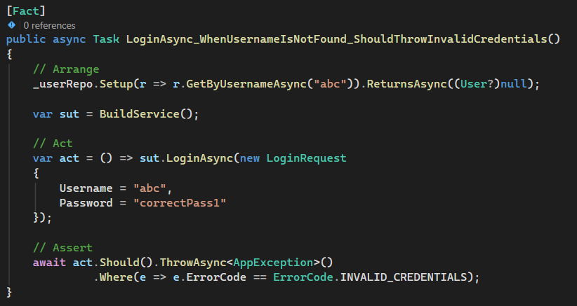
c) <TC_Login_03>
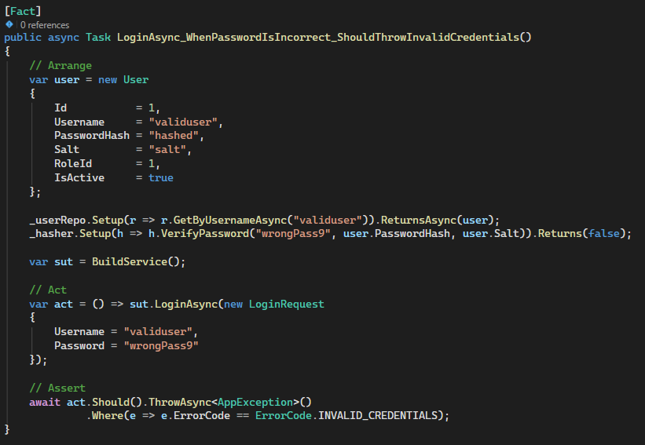
d) <TC_StuCodeValid _04>
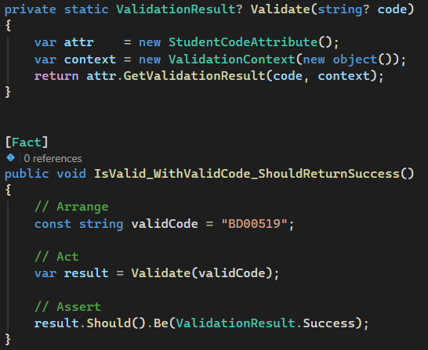
e) <TC_StuCodeValid _05>
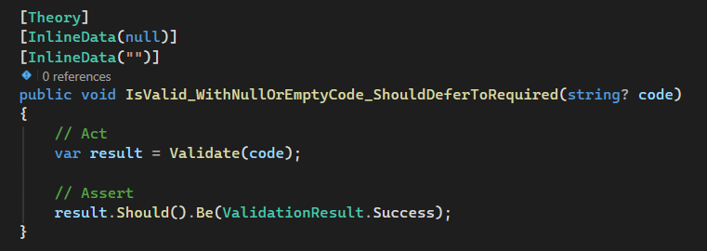
f) <TC_GradeClassification_06>
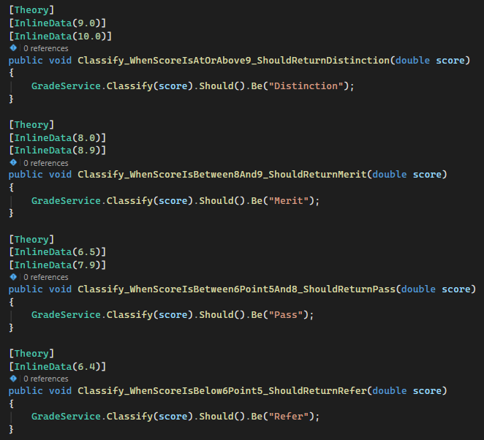

Conclusion

References

