Ballecer, Honorato Aaron R. Ballecer IV

BSIT221A

Documentation for Skill wallet

HANDMEN CUSTOMERS

This page displays the list of registered customers under the HandsMen system. It allows users to view, add, and manage customer records efficiently. The interface provides options such as creating new customers, importing customer data, changing record ownership, and assigning labels for organization.

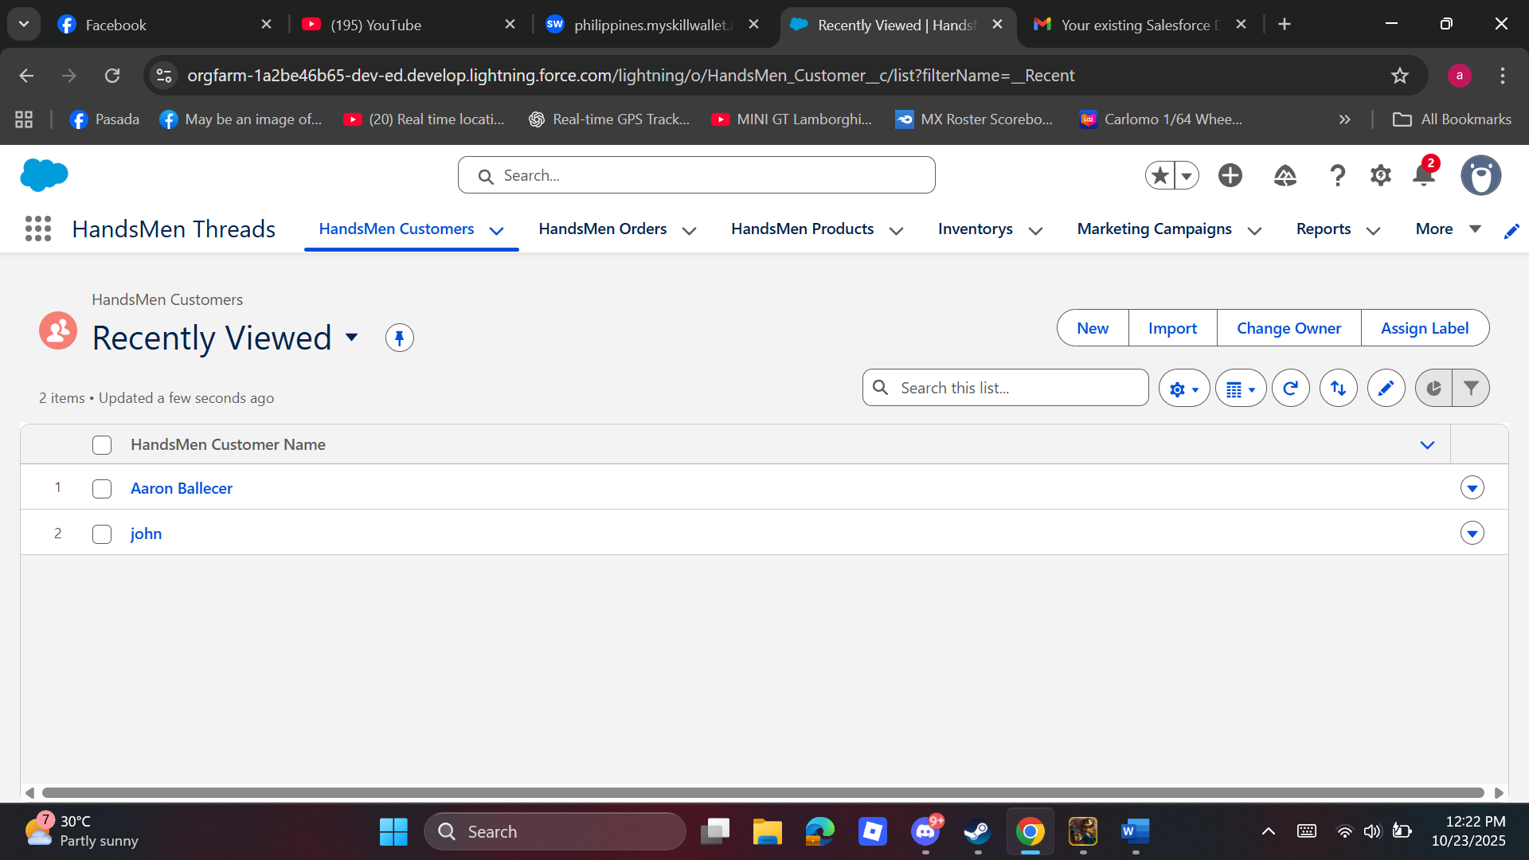

HANDSMEN ORDERS

This page presents all customer orders recorded within the HandsMen system. It allows users to view and manage orders through the order number listing. The page provides options to create new orders, import bulk data, change ownership, or assign labels for better organization.

HANDSMEN PRODUCTS

This page displays all products managed in the HandsMen system. Users can add, update, or import product details and quickly locate items using the search and filter options. It ensures organized tracking of available products.

HANDSMEN INVENTORYS

This page monitors product stocks within the HandsMen system. It allows users to view, update, and manage inventory levels, ensuring accurate tracking of product availability and preventing stock shortages.

MARKETING CAMPAIGNS

This page monitors product stocks within the HandsMen system. It allows users to view, update, and manage inventory levels, ensuring accurate tracking of product availability and preventing stock shortages.

REPORTS

This page provides a summary of system data and performance metrics. Users can generate, view, and analyze reports to track sales, inventory status, and overall business performance within the HandsMen system.

ORDER CONFIRMED EMAIL

This feature automatically sends a confirmation email to customers after placing an order. It ensures customers receive order details promptly, improving transparency and communication.

LOW STOCK ALERT EMAIL

This feature notifies administrators when product stock levels drop below the set threshold. It helps maintain sufficient inventory by prompting timely restocking actions.

