**PC Builds Online Research**

**Puget System(ww.pugetsystems.com)**

**Cons:**

* 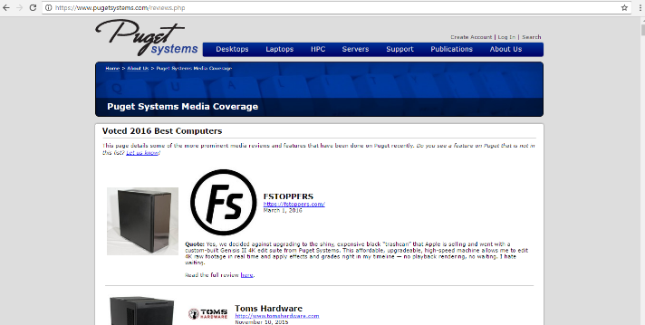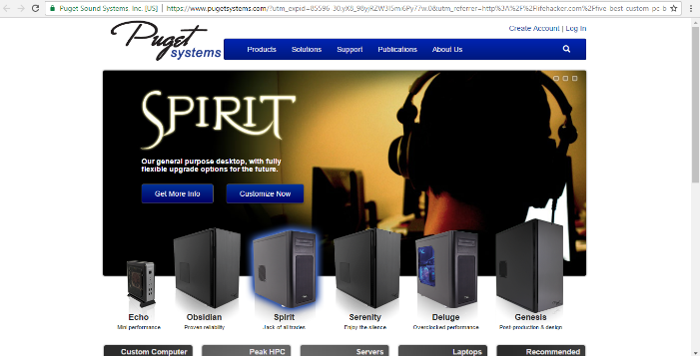Old design. Colour changes between switching pages.
* Poor review system.

**Pros:**

* Sells accessories i.e. monitors, keyboards etc.
* Wide range of custom pc i.e. build gaming pc, laptop, quiet pc, hpc workstation, video editing, liquid cooled.

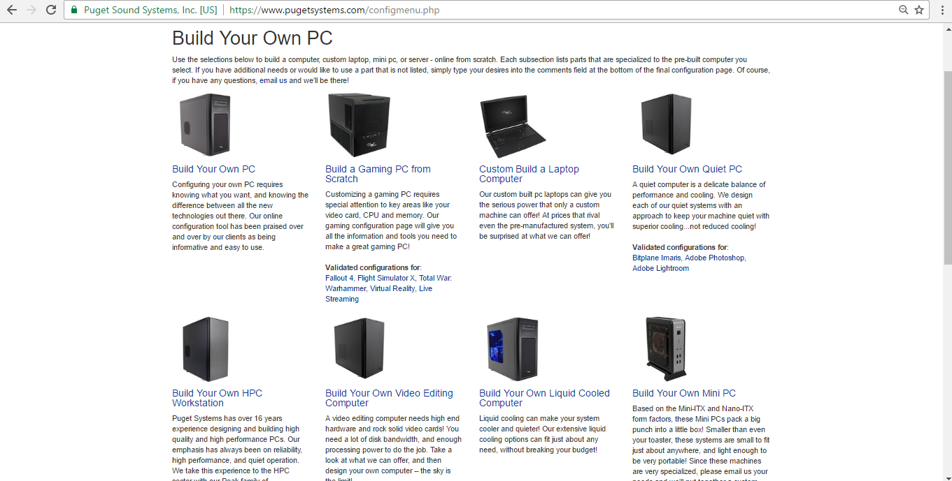

**Falcon(**[**www.falcon-nw.com**](http://www.falcon-nw.com)**)**

**Cons:**

* Navigation bar situated on the bottom of the page.
* Too much animation, looks futuristic and eye catching but can be confusing.
* Range of components is moderate.

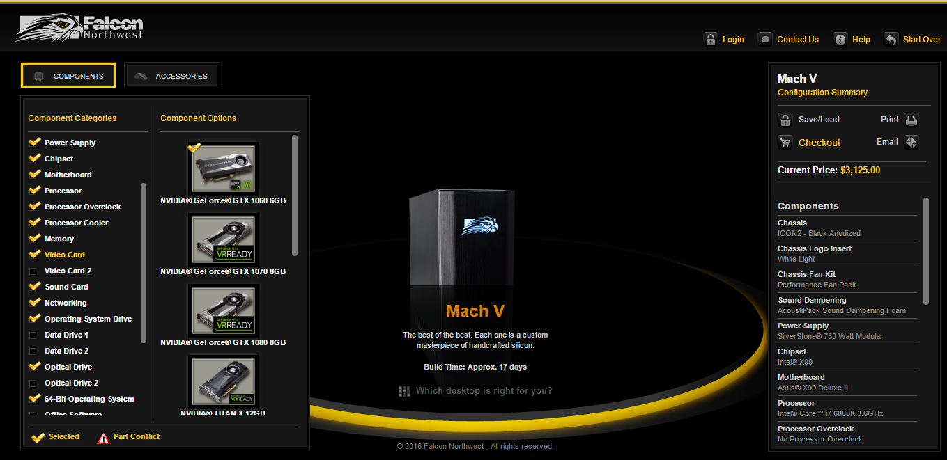

* Animations take long to load.
* Usually takes more than 3 clicks to get what user is looking for.

**Pros:**

* Building PC interface easy to use.
* Table of all main PC’s structured very well with a lot of detail

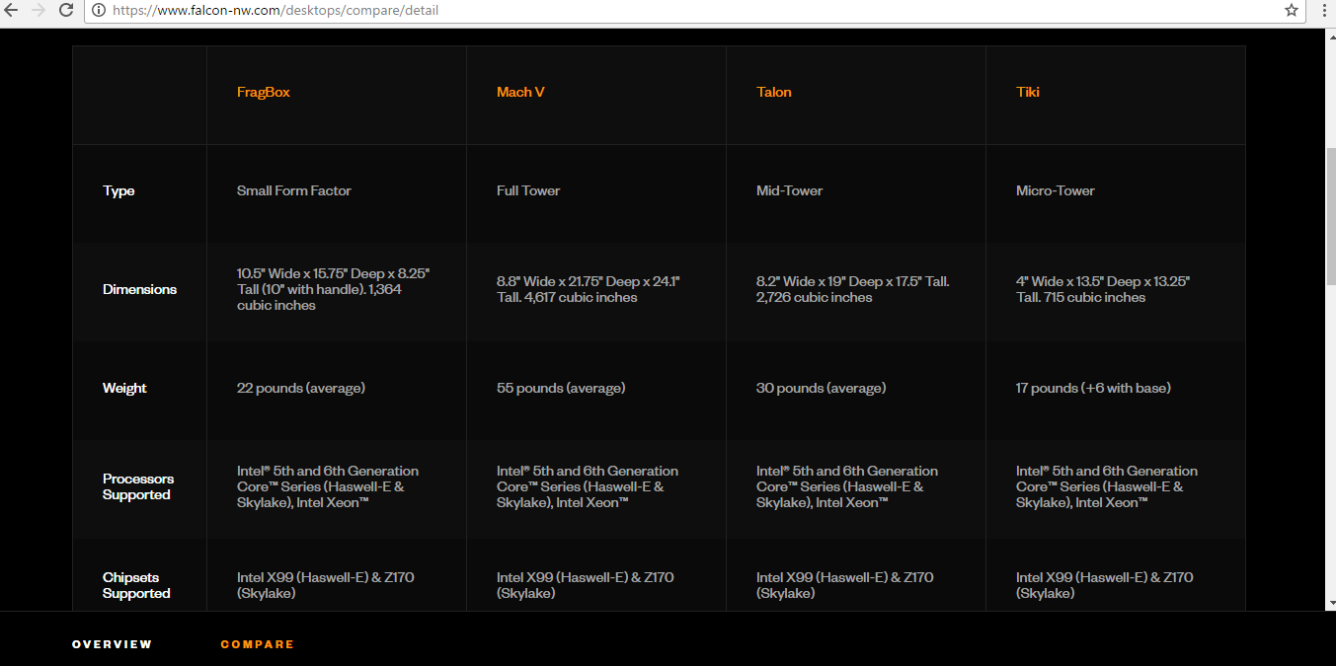

**Digital Strom(**[**www.digitalstorm.com**](http://www.digitalstorm.com)**)**

**Cons:**

* Range of PC’s and laptops is moderate.
* Topics on forum not sorted, mixed with customer reviews.

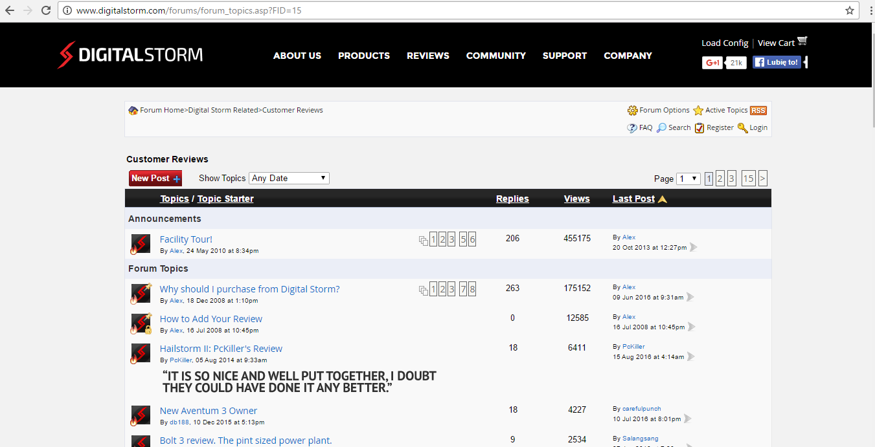

* Small range of hardware components.

**Pros:**

* Easy navigation.
* Content on pages is clear, easy to read and has all that user would expect.
* Customers review section displayed in neat way.

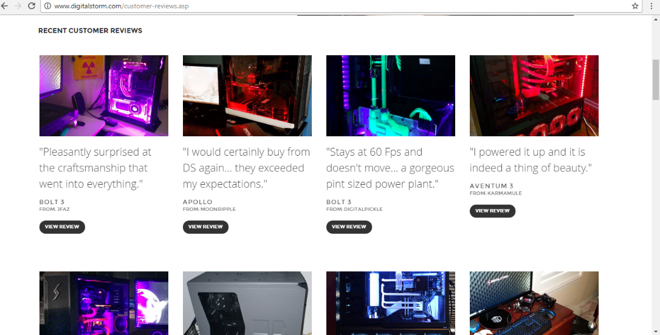

**Origin PC’s(**[**www.originpc.com**](http://www.originpc.com)**)**

**Cons:**

* Navigation bar drop down menu uses a lot of space plus area poorly filled with information.

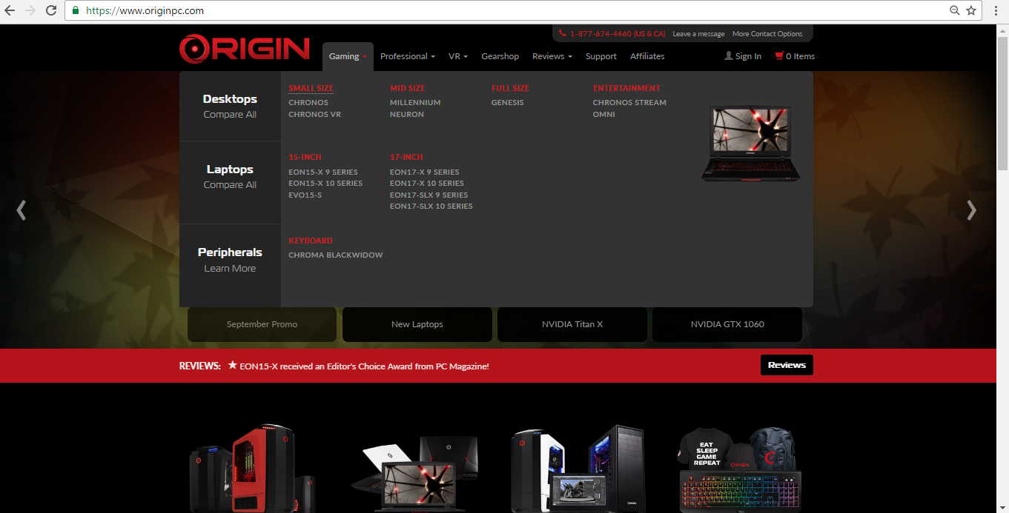

* Forum link is situated at the bottom of the page.

**Pros:**

* Interface for Computer’s Build very interactive.

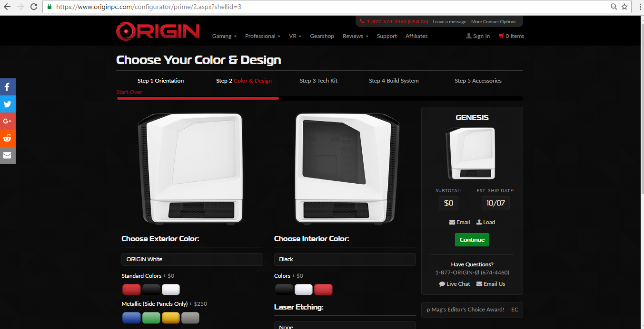

* Wide range of components.

**CollegePC(**[**www.ecollegepc.com**](http://www.ecollegepc.com)**)**

**Cons:**

* Page design is off-putting, very blocky.

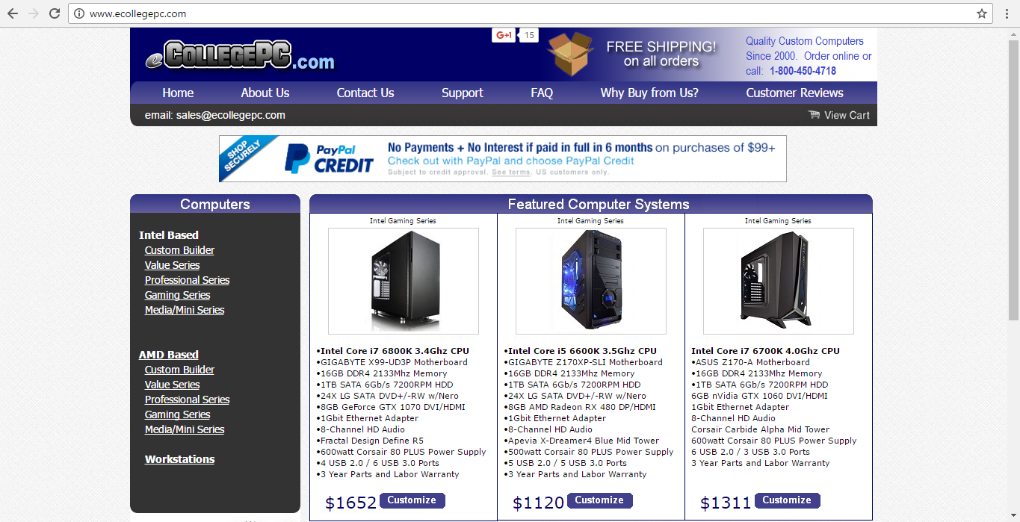

* No forum.
* Users cannot register.

**Cons:**

* Navigation of page is easy to follow.
* Wide range of hardware.