AeroForge — Final Report
Business Simulation Capstone — Marketplace® Conscious Capitalism (Bikes) · July 2026
Team: Aaron Rainier (President) · Luna Carballo (VP Marketing) · Justine Pellier (VP Analytics) · Patrick Yang (VP Finance) · Sarah Baraket (VP Sales) · Teysnim Abichou (VP HR)

1. Mission Statement and Vision
AeroForge exists to put elite carbon performance within everyone's reach. We forge custom-fitted, 3D-printed carbon fiber bikes that empower riders to conquer any trail and win any race — while creating value for our employees, our communities, and the planet we ride through.
Did the mission actually guide us? Partly at first, fully at the end. In quarters 1–2 it was a statement; from quarter 3 onward it became an operating rule with measurable consequences: we never entered a price war (premium positioning held even when we were last in market share); we kept investing in employees and the environment during loss-making quarters (clean-room air filtration, chemical containment, top-of-market compensation); and when the industry's safety crisis hit — standard carbon fiber frames injuring mountain riders — the mission made the decision for us: we invested $1.02M in enriched carbon fiber, the largest single bet of our game, to sell a bike that is actually safe to ride. By Q6, our entire range was built on it.

2. Business Strategy Summary
Target segments: Mountain (primary) and Speed (secondary), with an opportunistic Recreation extension (AeroForgeComfy) added by the team in Q4 at marginal cost. Positioning: premium, value-driven, conscious-capitalism — win on product quality and integrity, never on price. Distribution: New York City, then Amsterdam (opened Q4 — the game's largest market at 3,789 units/quarter when we committed), then Bangalore (opened Q5). Funding: $1.5M founding equity plus $1.0M team tranches, then a $2.5M venture round obtained on our business plan and deployed exactly as promised (R&D, production capacity, stores).
The strategy unfolded in five phases: (1) Q1–Q2 set-up and test market — where we failed, by designing on intuition; (2) Q3 repair — rebuilt the Bolt from the revealed data, #1 Speed product within one quarter; (3) Q4 investment — VC funds into R&D features, capacity ×1.5, Amsterdam, compensation catch-up; (4) Q5 expansion — 13→21 salespeople planned across three cities, proprietary tire features shipped, and the enriched-carbon bet placed; (5) Q6 harvest — the whole range relaunched on enriched carbon, first profitable quarter of the company's history (+$708k net income on $3.0M revenue).

3. Performance Review: Financial, Market, Operational, HR and CSR

3.1 Financial performance
Revenue grew ×13 from the test market to Q6 (226k → 373k → 740k → 1,440k → 3,018k). Net income traced the strategy: −257k, −151k, −106k (repair), −849k (Q4: planned VC deployment), −1,246k (Q5: enriched carbon R&D $1.08M plus $561k of system improvements), then +708k in Q6 — the first profitable quarter, at a 62.5% gross margin (up from 53% in Q2). We financed the entire game with equity: zero conventional loans, zero emergency loans, ending with $2.06M cash and a Financial Risk score of 1.000 — the class maximum, every single quarter. Why we still scored last on cumulative Financial Performance (14.4 vs class average 40.0): the index rewards accumulated profit, and our profits arrived one quarter before the game ended. Our Wealth score (0.620, class minimum) tells the same story — $2.6M of accumulated losses against $5.0M of paid-in equity. This was the accounting shadow of a deliberate long-term strategy plus one genuinely failed quarter.
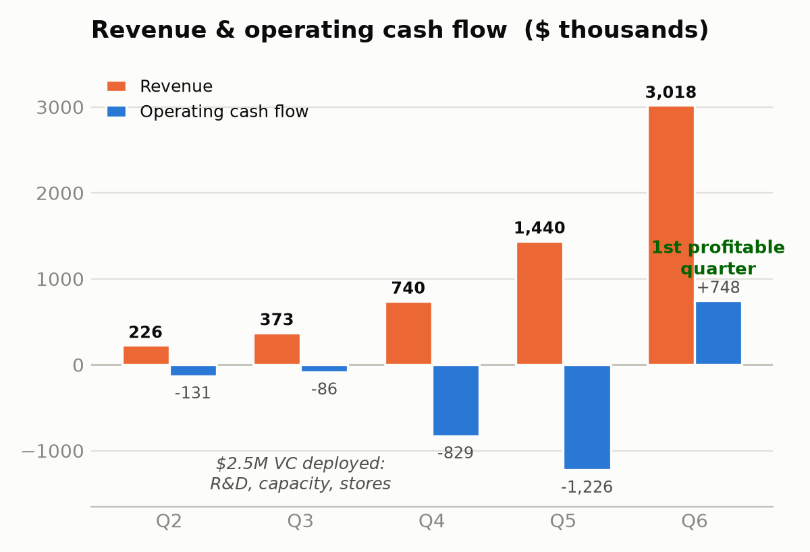
Figure 1 — Revenue and operating cash flow by quarter ($ thousands). The Q4–Q5 troughs are the planned deployment of the $2.5M venture round.

3.2 Market performance
Market share went 7.0% (Q3) → 7.1% (Q4) → 5.4% (Q5, as the whole market tripled) → 8.9% (Q6). Cumulative Market Performance finished last (0.071 vs average 0.159). The root causes are documented and split cleanly in two: first, two quarters of unrecommended product (our Mountain bike sat below the Customer Union's minimum rating until Q4, so the largest distribution channel of demand simply ignored us); second, chronic under-capacity — we lost sales to stock-outs in every single quarter (42, 88, 79, then 1,083 units in Q6). The product itself ended the game top-tier: brand judgments rose from 53/62/65 (Q2–Q3) to 87 Speed, 83 Mountain (top-2), 78 Recreation (top-2) in Q6; our ads scored 80–81 after the Q3 rebuild; price judgments were at or near 100 throughout. Q6 demand of 3,318 units — 84% above our own projection — proves the offer was right; we could manufacture only 2,235. We finished the game demand-rich and capacity-poor, the exact mirror of how we started.
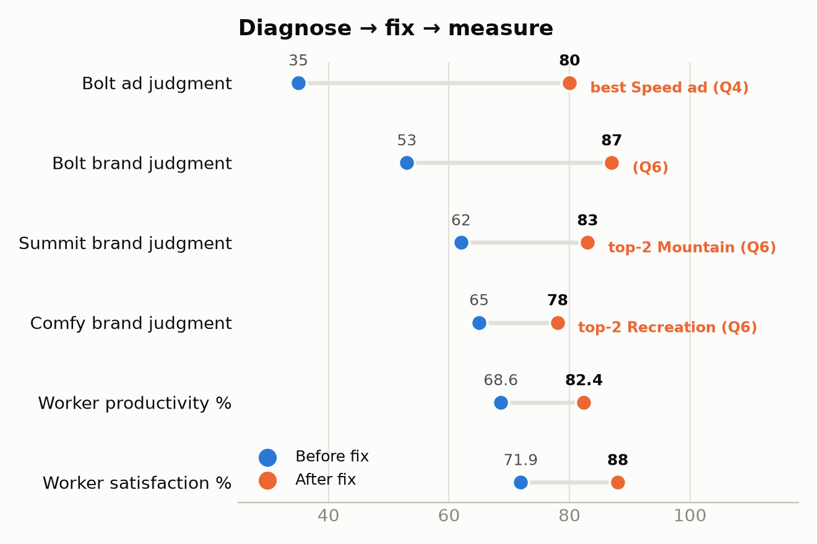
Figure 2 — Diagnose → fix → measure: every metric we corrected moved.

3.3 Operations
Production capacity scaled 6 → 11 → 16 → 32 units/day across Q3–Q6 (two 3D-printer purchases, $960k), with worker productivity up from 68.6% to 82.4% and unit labour cost down from $108 to $84. Quality investments (SPC, operator training, supplier programs) raised reliability steadily. Our recurring operational failure was demand planning: after every product fix, demand responded non-linearly and we projected linearly — four consecutive quarters of stock-outs, culminating in 1,083 lost sales in Q6 (≈$1.4M of revenue left on the table). We treated capacity as a cost to be minimised when it was in fact our binding constraint.

3.4 Human resources
In Q2–Q3 we paid below market (worker satisfaction 71.9%, turnover 32%/quarter, productivity falling) — a false economy that starved the factory. From Q4 we moved every package to the top of the market (workers $13.2k + expanded health + 3 weeks vacation + 5% pension; equivalent upgrades for supervisors and the sales force). Results: satisfaction 88%, turnover 11%, productivity +14 points, and the sales force among the best-compensated in the industry. Cumulative HR Management finished at 0.790 vs a 0.801 average — the two cheap early quarters cost us an above-average final score.

3.5 CSR / Conscious Capitalism
We ran sixteen system-improvement programs by Q6: chemical collection and containment, a clean-room reverse-flow air-filtration facility (a direct response to worker memos about carbon dust and epoxy vapour — our people told us before any metric did), protective equipment, air-filtering plants, a carbon-recycling consortium, cross-training, SPC, supplier quality programs, a fitness centre, daycare, school grants and community bike trails. AeroForge was the only firm in the industry never cited for toxic leaks — the newsletter repeatedly named four of our five competitors. Ethics showed up in small decisions too: we withdrew two advertising claims the moment the truth-in-advertising check flagged them, and we declined to buy a licence for technology we already owned rather than burn shareholder cash. Cumulative Reputation finished at 0.679 vs a 0.690 average — the cost of investing nothing in improvements before Q4.

4. Main Results vs. Other Teams
Final cumulative balanced scorecard (end of Q6), AeroForge vs class:
Cumulative metric | Class min | Class avg | Class max | AeroForge
Total Performance | 0.703 | 14.920 | 54.121 | 0.703 — last
Financial Performance | 14.380 | 39.963 | 74.217 | 14.380 — last
Market Performance | 0.071 | 0.159 | 0.271 | 0.071 — last
Marketing Effectiveness | 0.619 | 0.743 | 0.799 | 0.745 — above avg
Investment in Future | 4.228 | 5.223 | 7.874 | 7.874 — 1st in class
Wealth | 0.620 | 1.053 | 1.460 | 0.620 — last
HR Management | 0.766 | 0.801 | 0.854 | 0.790
Asset Management | 0.487 | 0.771 | 1.185 | 0.487 — last
Manufacturing Productivity | 0.636 | 0.701 | 0.738 | 0.720 — above avg
Financial Risk | 0.914 | 0.986 | 1.000 | 1.000 — 1st (tied)
Reputation | 0.635 | 0.690 | 0.752 | 0.679

Quarterly Total Performance — the trajectory behind the cumulative number:
 | Q2 | Q3 | Q4 | Q5 | Q6
AeroForge | 0.013 | 0.094 | 0.266 | 0.957 | 3.494
Class average | 0.229 | 0.943 | 4.190 | n/a | 83.7

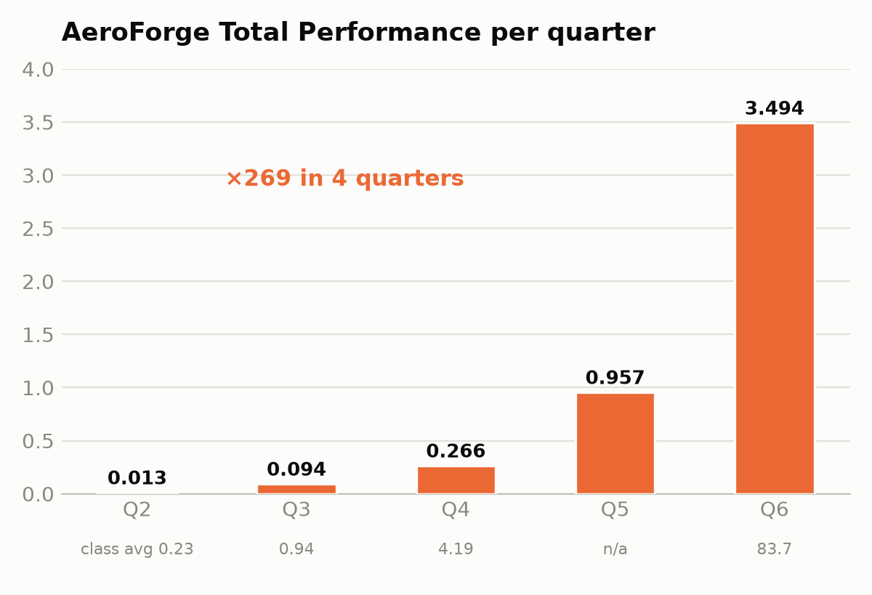
Figure 3 — AeroForge quarterly Total Performance: ×269 in four quarters, from 6% of the class average in Q2 to a level that would have been mid-pack two quarters earlier.
Q6 market share by company: WBB 36.0%, NatuRide 21.3%, Spe3d 17.0%, Carbon-Ride 9.8%, AeroForge 8.9%, The Bike Yard 7.0%. Reading the two tables together explains our final ranking honestly: the cumulative index is dominated by accumulated financial performance, and a 17× gap to the class average in Q2, compounded quarterly, is mathematically unrecoverable in four quarters — even while posting the steepest relative improvement in the class and finishing first on the two metrics that were winnable from any starting position: Investment in Future and Financial Risk.

5. Lessons Learnt
Lesson 1 — Under uncertainty, intuition is a hypothesis, not a decision. Our Q2 failure had three specific, avoidable causes: a Speed advertisement built on Mountain imagery and claims (scored 35/100 — it actually rated higher with Mountain customers than Speed customers); 'comfort' components on a mountain bike that felt logical and scored 62, below the Customer Union's recommendation threshold; and a brand architecture chosen before buying the market research that would have falsified all of it. The ~$45k of studies we skipped cost us two quarters of momentum and, through the cumulative scorecard, the game.
Lesson 2 — The business disciplines are one system. A 35-point ad starved the factory; below-market pay cut productivity, which capped output, which turned marketing wins into stock-outs. We never lost money 'in finance' — every financial loss originated upstream in a marketing or HR decision. The pro forma only reported it.
Lesson 3 — Learn how the scorecard computes before playing, not after. Metrics winnable from day one regardless of sales volume — Investment in Future, Financial Risk — we eventually won, but only started managing deliberately from Q4. The cumulative Total Performance metric punishes one bad quarter forever; protecting the floor matters more than raising the ceiling.
Lesson 4 — When product quality jumps, demand responds non-linearly. We under-projected demand in all four post-repair quarters (Q6: 3,318 actual vs 1,800 projected) because we extrapolated linearly from the previous quarter. Capacity should be built ahead of proven product quality, not behind realised sales.
Lesson 5 — People signal problems before metrics do. Worker memos about carbon dust preceded any measurable morale drop; acting on them (clean room, protective equipment) preceded the productivity and satisfaction gains. The in-basket was our cheapest and fastest market research.
How we changed our working methods mid-week: from Q3 every decision required a number from a purchased study or a revealed competitor matrix; every advertisement passed the truth-in-advertising check before submission; every quarter ended with the same discipline — Final Check, then the pro forma recomputed last; and each VP owned one function with the President arbitrating trade-offs. The rhythm turned a failing start-up into a machine that improved every metric it touched, every quarter, for four consecutive quarters.

6. Preparing the Firm to Compete in the Future
The game's own metric answers this: AeroForge finished first in class on cumulative Investment in Future. Concretely, a hypothetical Q7 would open with: (1) the industry's only fully enriched-carbon range, rated 87/83/78, one quarter after competitors began converting theirs; (2) proprietary R&D in the pipeline — hybrid comfort tires paid for and ready in Q7 for the Recreation line; (3) a modern factory at 32 units/day of fixed capacity with an 82% productive, 88%-satisfied, 11%-turnover workforce; (4) three stores covering the three largest markets with 21 trained sales and service people; (5) $2.06M of cash, a $200k certificate of deposit, zero debt and an intact borrowing capacity; and (6) sixteen running system improvements protecting quality, the environment and the community. Proven Q6 demand of 3,318 units against 2,235 produced means the first Q7 decision is already written: one more printer and a third production shift.

7. Top Recommendations If We Were to Start Over
1. Spend the first dollar on information. Buy every market study from the test market onward and design brands, ads and prices from the component matrices and revealed leader structures — never from instinct. One failed quarter costs fifty times the price of the studies.
2. Benchmark everything before shipping — an ad against the truth-check, a salary against the industry tables, a price against willingness-to-pay. The market has usually already published the right answer.
3. Build capacity ahead of product quality, not behind sales. Once judgments are top-tier, demand arrives non-linearly; four quarters of stock-outs converted our best marketing into our competitors' revenue.
4. Pay people at the top of the market from quarter one. The morale→productivity→output loop compounds slowly; started late, it cannot catch up.
5. Read the scorecard's formulas on day one and protect the cumulative floor: never let a single quarter crater, because the index never forgets.
6. Keep the financial discipline we kept: no emergency borrowing, investments financed by equity actually raised on a credible plan. Financial Risk was the one perfect score available to everyone; most teams dropped it.
We lost the race, and we know precisely why — which is the one outcome this simulation is designed to produce. Given a seventh quarter, the machine we built in the last four would have been the most dangerous company in the industry.

