**CHAPTER ONE**

**OVER VIEW**

1. **Introduction**

Microcontrollers are low-cost embedded systems that control and monitor consumer appliances, robots, machinery, etc. Microcontrollers are widely used in applications that necessitate computing power delivered within a small form factor, e.g., cellular phones, calculators, digital wristwatches, etc Because of space limitations, microcontrollers have limited connectivity options. For example, the type of connectivity provided for data communication to a personal computer (PC) user for data visualization and parameter adjustment “on-the-fly” is usually limited to a serial port interface. This interface is limited in that it allows only one user to control the microcontroller and restricts that user to be in close proximity of the microcontroller. Enabling a microcontroller to communicate to a ubiquitous data communication network, e.g., the Ethernet network, will allow developers and end-users to monitor and control microcontroller operated devices with greater flexibility.

In recent years, the Ethernet network protocol has been widely adopted as the choice method of data communication for personal computers and other digital devices. Its popularity is primarily due to the immense use of the Internet, an information exchange infrastructure that communicates data via the Ethernet network, by the general public. Furthermore, Ethernet communication is readily available on most of the currently deployed PCs. As a data communication protocol, the Ethernet is efficient. In all Ethernet networks, devices can easily communicate at speeds of about 10 megabits-per-second, with some of the most recent Ethernet networks communicating even at data speeds of 1 gigabit-per-second.

In our project we try to monitor and control three devices: i) Light system, ii) Surveillance Camera, and iii) DC motor. But the whole idea can be applied to many applications as factories ,home, companies and any place that need to be controlled but difficult to reach.

**Table of Contents**

**Chapter One: OVERVIEW**----------------------------------------- 1

1. INTRODUCTION ------------------------------------------------------- 2

**Chapter Two: PROJECT COMPONENT** --------------------------------3

2. 1 Hardware Environment----------------------------------------------------- 3

2.1.1 Microcontroller---------------------------------------------------------- 4

2.1.2 WIZ110SR ----------------------------------------------------------------- 5

2.2 Software Environment ------------------------------------------------------- 6

**Chapter Three: Procedure** ----------------------------------------------- **7**

3.1 Procedure ---------------------------------------------------------------------- 7

3.1.1 Server----------------------------------------------------------------------- 7

3.1.2 Ethernet connection ------------------------------------------------------ 7

3.1.3GUI-------------------------------------------------------------------------- 8

**Chapter Four: Problems and Results** ---------------------------- **7**

4.1 Problems---------------------------------------------------------------------- 7

3.1.1 USB cam------------------------------------------------------------------ 7

3.1.2 High voltage devices --------------------------------------------------- 7

3.1.3Feed back----------------------------------------------------------------- 8

**CHAPTER TWO**

**PROJECT COMPONENT**

1. **Hardware Environment**

In this project, a microcontroller interfaced with Wiznet is used to control 3 devices. The microcontroller interfaces with the decoders IC’s used to select device and choose the suitable command to be applied, Ethernet data communication between the microcontroller and a remote web-client is performed using the wiznet chip. Specifically, the wiznet receives reference commands from the remote web-client and communicates the same to the microcontroller. In addition, the wiznet receives feedback data from the microcontroller and communicates the same to the remote web-client. See Figure 1 for a schematic of the hardware environment.



**Figure1. Block Diagram**

* 1. **Microcontroller**

In this project, we focus on the 18f4620 microcontroller (figure.2) high because of computational performance at an economical price – with the addition of high endurance, Enhanced Flash program memory

This device is a logical choice for many high-performances, power sensitive applications. That makes it easy to interface with other devices, its IO ports (5 bidirectional ports on 40-pin devices) provides the ability to connect many devices that can be controlled

in different ways.

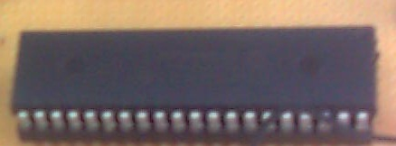



**Figure2. 18f4620 microcontroller**

**1.2 WIZ110SR**

WIZ110SR (figure.3) is a protocol converter that transmits the data sent by serial equipment as TCP/IP data type and converts back the TCP/IP data received through the network into serial data to transmit back to the equipment. When the data is received from serial port, it is sent to W5100 by MCU. If any data is transmitted from Ethernet, it is received in the internal buffer if W5100, and sent to the serial port by MCU. MCU in the module controls the data according to the configuration value that user defined (figure.4); we configure wiznet to take THCP IP and to work as client and server.



**Figure3. WIZ110SR**

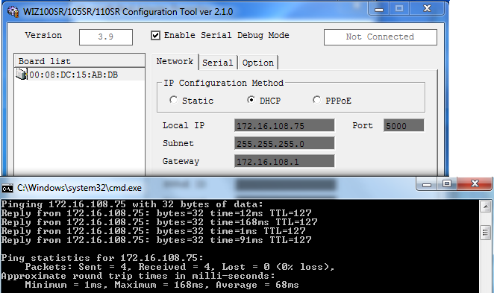

**Figure3. WIZ110SR configuration Tool**

1. **Software Environment**

The software environment of this paper consists of primarily PIC C and C#. Ethernet Communication between the wiznet and PC is accomplished by implementing a TCP protocol. The PIC C used to for microcontroller programming. the c# application connect to wiznet using TCP connection and send data from the graphical user interface , wiznet that connected serially to PIC send data that apply the command on device.(Figure.5)

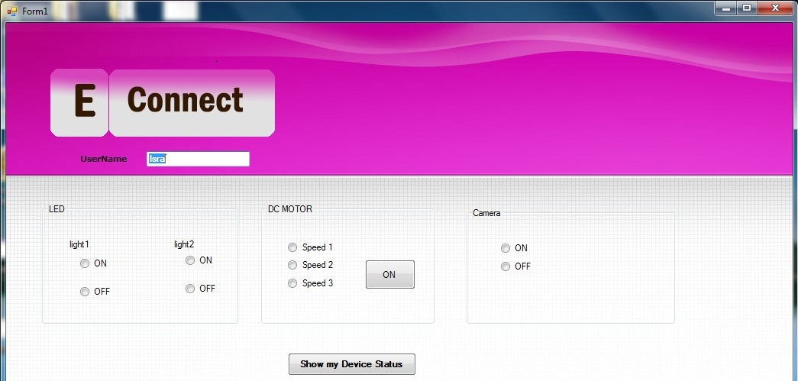

**Figure5. GUI**

\

**CHPTER THREE**

**PROCEDURE**

1. **Procedure**

Ethernet remote controller project consume us a 3 months working dividing in 3 steps:

* Server.
* Ethernet connection.
* GUI
  1. **Server**

Microcontroller used as a server that is connected serially with the Ethernet connector when it receive a command it directly take the received value which is a character from this value it take the first two bit for the decoder and the others bits to choose the control to be applied as an example :

Send Char ‘a’ // 97 decimal

Binary value received 0110001

01//enable Device1

0001 //apply ON command

* 1. **Ethernet connection:**

In this project we use WIZ110SR which is a gateway module that converts RS- 232protocol into TCP/IP protocol. It enables remote gauging, managing and control of a device through the network based on Ethernet and TCP/IP by connecting to the existing equipment with RS-232 serial interface WIZ110SR is a protocol converter that transmits the data sent by serial equipments TCP/IP data type and converts back the TCP/IP data received through the network into serial data to transmit back to the equipment. When the data is received from serial port, it is W5100 by MCU. If any data is transmitted from Ethernet, it is received in the internal buffer if W5100, and sent to the serial port by MCU. MCU in the module controls the data according To the configuration value that user defined.

* 1. **GUI**

A GUI, which runs on a remote client computer, has been created using the C# application, This GUI allows remote clients using any operating system to interact with our experiment test-bed. And it use the TCP/IP protocol to connect the server with a specific IP after connection it send the user name , after the name is verified the user can control any devices and send commands to turn devices On or OFF.

**CHAPTER FOUR**

**PROBLEMS AND SOLUTIONS**

**1. Problems:**

In this project we have 3 main problems

* USB CAM
* High voltage devices
* Feed Back problem
  1. **USB CAM:**

The idea of using a cam in our project was a challenge; we need to access a camera from via internet and control it by switch it on or off take a video, and record but we face a problem in video streaming and how to transmit data throw PIC to Ethernet and we could not find easy and efficient way so we replace our USB camera with Ethernet camera.

* 1. **High voltage devices.**

Connect devices that run in high voltage directly could damage the micro controller so we had to use a relay as a switch with a transistor as amplifier.

**1.3 Feed back problem.**

To send data from microcontroller to our client we need a web page this was a problem because we use desktop application so we had to build embedded PHP page in c# application that receive data send from microcontroller to the client.

**REFRENCES**

* Dr. ala’ eldeen al masri our teacher and supervisor.
* PIC 18F4620 Datasheet

<http://upcommons.upc.edu/pfc/bitstream/2099.1/9395/8/DS_Microcontrolador%20PIC%2018F4620.pdf>

* Wiznet product application web site

<http://www.wiznet.co.kr/Sub_Modules/en/library/Application.asp>

* PIC C program index.