Embedded systems Architecture (BACSE324)

Assessment 8: Hardware Interfacing With Arduino Uno
Lab Sl. No. | 8 | 
Lab Slot | L 45+ L46
Registration No. | 25BCE2640
Name: | AARON ROBERTSON
Mobile no.: | +91 9746244366
Title:: | Hardware Interfacing With Arduino Uno
TRA Name: | Mahesh Kumar | Assigned date of Task: Sept 15th , 2026
TRA Mobile number: | 7594975428 | Date of Completion: Oct 6th,2026
Faculty Name: | DEBASHISH DASH | Assessment no: 8
Email ID of student : aaron.robertson2025@vitstudent.ac.in
VTOP uploading Date and time: 25/10/2026 11:59 pm
Contents
Component | Page No. | Remarks
Program 1, 2, 3, 4 | 3, 6, 10, 14
AIM of Experiment | 3, 6, 10, 14
Tools Required | 3, 6, 10, 14
Basic Brief Theory | 3, 6, 10, 14
Circuit Connections | 4, 7, 11, 15
Arduino Code with Comments | 4, 7, 11, 15
Calculations | None
Procedure to perform the AIM | 4, 8, 12, 16
Output Snips with name | 5, 8, 13, 17
Results | 5, 9, 13, 17
Inference | 5, 9, 13, 17

Program 1
Design a hardware circuit using a physical Arduino board for blinking an LED.
Aim of the Experiment
To connect an external LED to an Arduino Uno and make it switch on and off repeatedly at one-second intervals.
Tools Required
Arduino Uno, USB cable, computer with Arduino IDE, breadboard, LED, 220 ohm resistor and jumper wires.
Brief Theory
Arduino Uno controls an LED through a digital output that switches between HIGH and LOW. When D13 is HIGH, current flows through the series resistor and forward-biased LED, producing light. When D13 is LOW, the LED turns off. Correct anode and cathode connections are necessary for normal operation.
The 220 ohm resistor limits current and protects the LED and output pin. Repeated one-second ON and one-second OFF intervals produce a two-second blinking cycle with a 50 percent duty cycle. This experiment demonstrates digital output control, component polarity and timing. Changing the intervals changes the blinking rate.
Circuit Connections
Component terminal | Connection
Arduino D13 | 220 ohm resistor, then LED anode (long lead)
LED cathode (short lead) | Arduino GND through the ground rail
Arduino USB port | Computer USB port
Arduino Code with comments
const int ledPin = 13; // External LED via 220 ohm resistor

void setup() {
pinMode(ledPin, OUTPUT); // Configure digital output
}

void loop() {
digitalWrite(ledPin, HIGH); // LED ON (first photo)
delay(1000); // Hold ON for one second
digitalWrite(ledPin, LOW); // LED OFF (second photo)
delay(1000); // Hold OFF for one second
}

Procedure
1. Disconnect power and place the LED on the breadboard.
2. Connect D13 through the 220 ohm resistor to the anode; connect the cathode to GND.
3. Connect the Uno by USB and select Arduino Uno and the correct port in Arduino IDE.
4. Prepare a sketch that sets D13 as an output and alternates HIGH and LOW, holding each state for one second.
5. Verify and upload the sketch. Observe at least five complete blinking cycles.
6. Record the on/off intervals and take a colour hardware photo with the GPS mark visible.
Output Snips
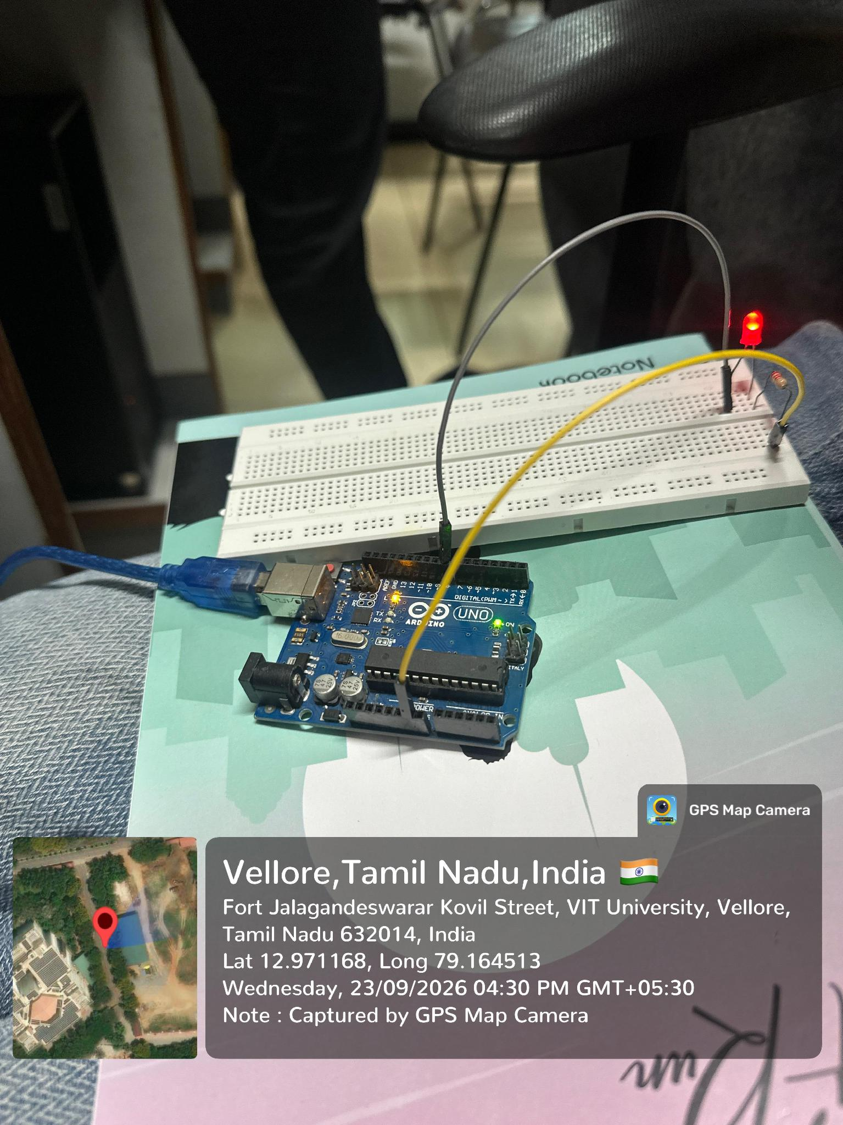 | 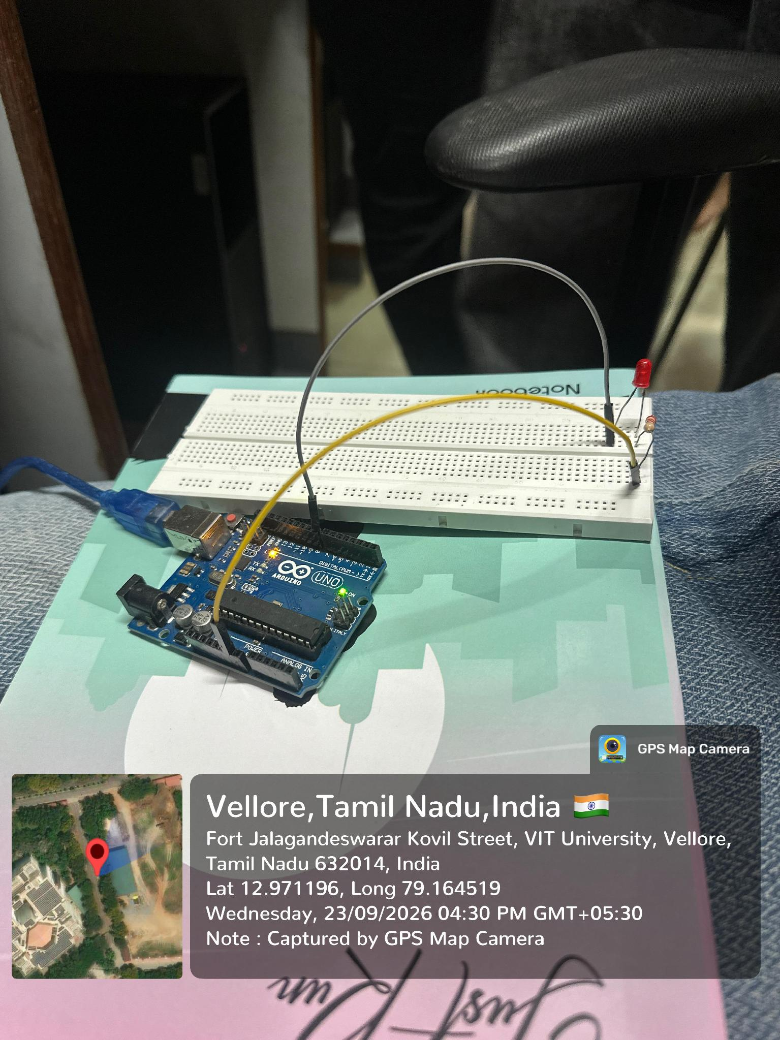
LED illuminated | LED unlit
Result
Expected result: The LED should blink repeatedly, staying ON for one second and OFF for one second. Verify a consistent pattern over several cycles. Check the LED polarity and series resistor, and record the observed ON and OFF states.
Inference
HIGH and LOW outputs switch the LED ON and OFF. Delays set the blinking interval, while a series resistor limits current. Correct polarity and grounding ensure reliable operation. This principle supports status indicators and signalling systems.
Program 2
Design a basic hardware circuit for a servo motor which will rotate from 0 to 180 degrees.
Aim of the Experiment
To interface a positional servo motor with Arduino Uno and command a repeated sweep from 0 to 180 degrees and back.
Tools Required
Arduino Uno, positional micro servo rated for the selected supply, regulated 5 V supply suitable for the servo current, USB cable, breadboard, jumper wires and computer with Arduino IDE.
Brief Theory
A positional servo contains a motor, reduction gears, a position sensor and a feedback controller. Timed pulses on its signal terminal specify the requested shaft position. Arduino uses the Servo library to generate these pulses. Gradually increasing and decreasing the commanded angle produces a sweep between the selected endpoints.
The proposed circuit uses D9 for the signal and a regulated supply suitable for the servo. Arduino and servo supply grounds must be joined. A positional servo is required because a continuous-rotation servo controls speed rather than angle. Physical travel depends on the model, so commands must not force the mechanism against its stops.
Circuit Connections
Component terminal | Connection
Servo signal (usually orange/yellow) | Arduino D9
Servo V+ (usually red) | Regulated 5 V servo supply positive
Servo GND (usually brown/black) | Servo supply negative and Arduino GND
Arduino USB port | Computer; powers the Arduino
Arduino Code with Comments
#include <Servo.h>

Servo motor;
const int servoPin = 9; // Signal lead; common GND

void setup() {
motor.attach(servoPin); // Enable servo control
}

void loop() {
// Sweep forward through the horn positions
for (int angle = 0; angle <= 180; angle++) {
motor.write(angle);
delay(15); // Allow time for movement
}
delay(500); // Pause at the endpoint
// Sweep back; do not force mechanical stops
for (int angle = 180; angle >= 0; angle--) {
motor.write(angle);
delay(15);
}
delay(500);
}

Procedure
1. Switch off power. Fit the servo horn securely and leave space for the sweep.
2. Connect the servo signal to D9 and power leads to the rated supply. Join the servo supply ground to Arduino GND.
3. Connect the Uno by USB and select the board and port in Arduino IDE.
4. Prepare a Servo-library sketch that commands 0 to 180 degrees, then 180 to 0 degrees in one-degree steps with a short delay between steps.
5. Verify and upload. Apply servo power and observe the sweep without forcing the shaft.
6. Check the 0, 90 and 180 degree commands against the horn positions. Adjust the usable range if the servo reaches a mechanical stop.
7. Capture GPS-marked colour photos of the setup and representative horn positions.
Output Snips
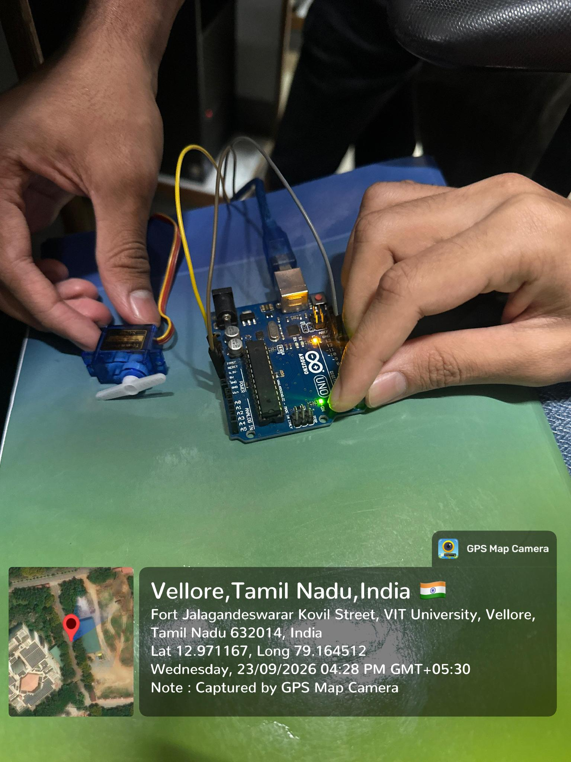 | 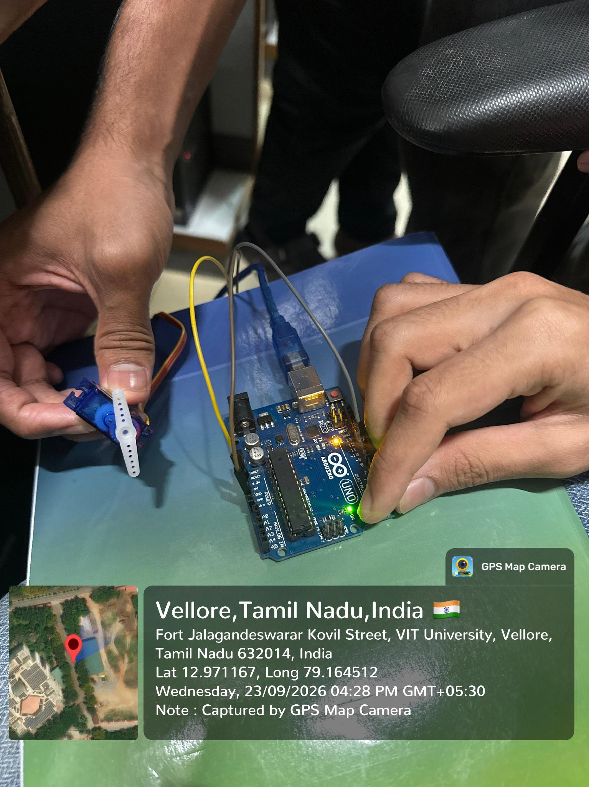
Servo horn horizontal | Servo horn vertical
Result
Expected result: The servo should sweep from the commanded 0° position towards 180° and return repeatedly. Check representative positions at 0°, 90° and 180° within its safe range. Observe smooth movement without strain or Arduino resets, and document the actual positions.
Inference
Timed signals control the servo position using internal feedback. Sequential angle commands produce a sweep, and step delays set its speed. Adequate power and a common ground improve stability. The safe movement range depends on the servo model.
Program 3
Design a basic hardware circuit for interfacing an ultrasonic sensor with Arduino Uno.
Aim of the Experiment
To interface an HC-SR04 ultrasonic sensor with Arduino Uno and display measured object distance in centimetres on the Serial Monitor.
Tools Required
Arduino Uno, HC-SR04 ultrasonic sensor, USB cable, breadboard, jumper wires, ruler or measuring tape, flat target and computer with Arduino IDE.
Brief Theory
The HC-SR04 measures distance by transmitting ultrasound and detecting its reflection from an object. A trigger pulse of at least 10 microseconds starts the measurement. Arduino times the ECHO pulse, which represents the sound travelling to the target and back. Dividing this time by approximately 58 gives distance in centimetres.
The nominal measuring range is 2 to 400 cm. A timeout identifies missing echoes instead of treating them as valid zero distances. Measurements should be spaced by at least 60 milliseconds. Target angle, surface and air temperature affect readings. Comparing repeated Serial Monitor values with ruler measurements checks consistency and measurement error.
Circuit Connections
Component terminal | Connection
HC-SR04 VCC | Arduino 5V
HC-SR04 GND | Arduino GND
HC-SR04 TRIG | Arduino D9
HC-SR04 ECHO | Arduino D10
Arduino USB port | Computer USB port
Arduino Code with Comments
const int trigPin = 9; // Trigger pin
const int echoPin = 10; // Echo pin

long duration; // Echo time
float distance; // Distance in cm

void setup() {
pinMode(trigPin, OUTPUT);
pinMode(echoPin, INPUT);
Serial.begin(9600); // Start serial output
}

void loop() {
digitalWrite(trigPin, LOW); // Clear trigger
delayMicroseconds(2);

// Send a 10 us pulse
digitalWrite(trigPin, HIGH);
delayMicroseconds(10);
digitalWrite(trigPin, LOW);

duration = pulseIn(echoPin, HIGH); // Read echo
distance = duration * 0.0343 / 2; // Calculate distance

// Display distance
Serial.print("Distance: ");
Serial.print(distance);
Serial.println(" cm");

delay(500); // Wait before next reading
}

Procedure to Perform the Aim
1. Disconnect power and wire VCC, GND, TRIG and ECHO as listed.
2. Connect the Uno by USB; select the board and port in Arduino IDE.
3. Prepare a sketch to trigger the sensor, time ECHO with a timeout, convert valid readings to centimetres and send them at 9600 baud.
4. Verify and upload, then open Serial Monitor at 9600 baud.
5. Place a flat target facing the sensor at ruler-measured distances such as 10, 20 and 30 cm.
6. Record several readings at each position and compare them with the ruler. Report missing echoes separately.
7. Take a GPS-marked colour hardware photo and capture the Serial Monitor readings with the target distances labelled.
Output Snips
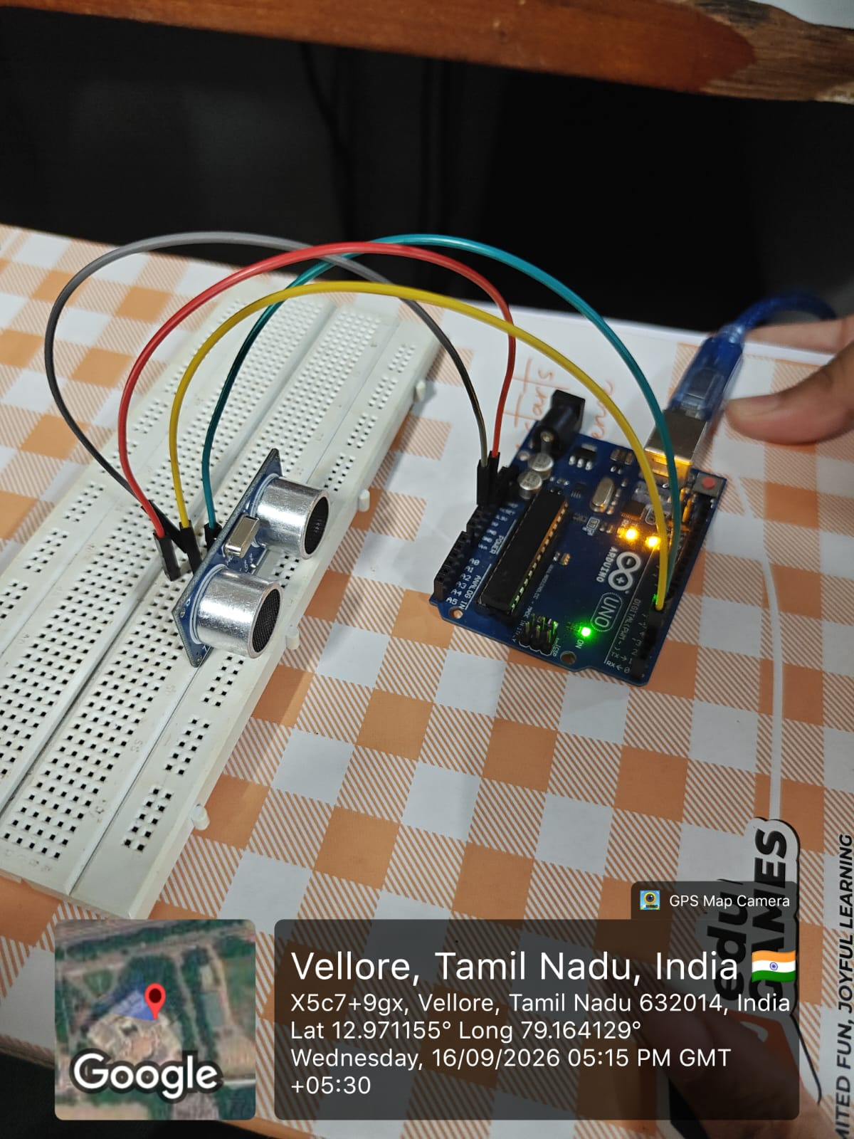 | 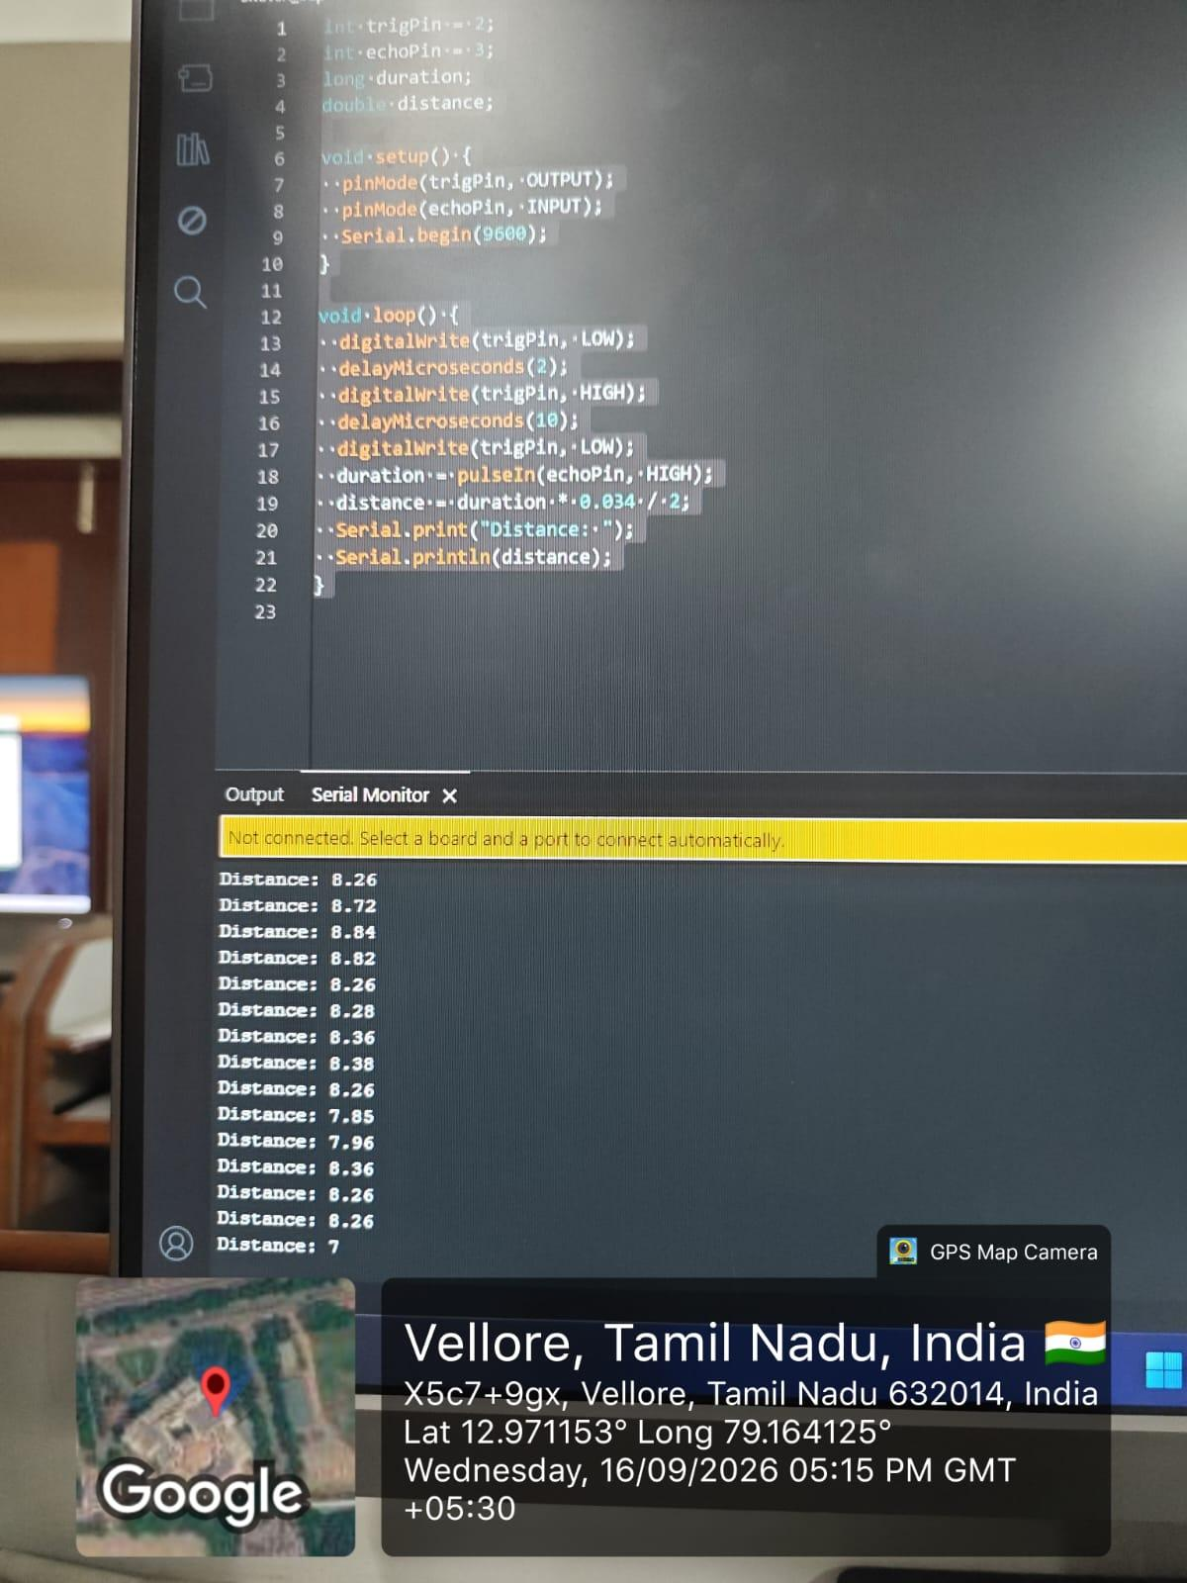
Picture 1 Ultrasonic sensor setup | Serial Monitor readings
Result
Expected result: The Serial Monitor should show changing distances as the target moves. Compare readings at 10, 20 and 30 cm with a ruler. Record actual measurements and report missing echoes separately. Capture the sensor arrangement and displayed readings for documentation.
Inference
Ultrasonic echo time determines the target distance shown on the Serial Monitor. Ruler comparisons help assess accuracy. Surface, orientation and environmental conditions affect readings. A timeout separates missing echoes from valid measurements for reliable obstacle detection.
Program 4
Design a hardware interfacing circuit using a normal 16 x 2 LCD and a potentiometer, and print your name and registration number.
Aim of the Experiment
To interface a parallel 16 x 2 LCD with Arduino Uno in four-bit mode, adjust its contrast with a potentiometer, and display AARON ROBERTSON and 25BCE2640.
Tools Required
Arduino Uno, HD44780-compatible parallel 16 x 2 LCD with 16 pins, 10 kilohm potentiometer, suitable LCD backlight series resistor if required by its module specification, breadboard, jumper wires, USB cable and computer with Arduino IDE.
Brief Theory
A 16 x 2 LCD displays two rows of sixteen characters. Four-bit operation uses data lines D4 to D7, together with RS and Enable, to transfer commands and text. Grounding R/W selects write operation. The LiquidCrystal library manages these transfers, and its configured pin order must match the physical circuit.
A 10 kilohm potentiometer controls contrast through the LCD VO terminal. Its outer terminals connect to 5 V and ground, while its centre terminal connects to VO. Initialising the display as sixteen columns and two rows allows AARON ROBERTSON and 25BCE2640 to appear on separate rows. Correct power and backlight current limiting support operation.

Circuit Connections
Component terminal | Connection
LCD 1 VSS; LCD 2 VDD | GND; Arduino 5V respectively
LCD 3 VO | Potentiometer centre terminal (wiper)
Potentiometer outer terminals | 5V and GND
LCD 4 RS; LCD 5 R/W; LCD 6 E | D12; GND; D11 respectively
LCD 11 D4; LCD 12 D5 | D5; D4 respectively
LCD 13 D6; LCD 14 D7 | D3; D2 respectively
LCD 7 to 10 (D0 to D3) | Leave unconnected in four-bit mode
LCD 15 A; LCD 16 K | 5V through required backlight resistor; GND
Arduino USB port | Computer USB port
Arduino Code with Comments
#include <LiquidCrystal.h>

// Pin order: RS, E, D4, D5, D6, D7
LiquidCrystal lcd(12, 11, 5, 4, 3, 2);

void setup() {
lcd.begin(16, 2); // Sixteen columns, two rows
lcd.clear();
lcd.setCursor(0, 0); // First row
lcd.print("AARON ROBERTSON");
lcd.setCursor(0, 1); // Second row
lcd.print("25BCE2640");
}

Procedure
1. Disconnect power and identify the LCD pins from its module labels or datasheet.
2. Wire the supply, control and data pins as listed; keep D0 to D3 unconnected.
3. Connect the potentiometer outer terminals to 5V and GND and the centre terminal to VO.
4. Connect the backlight using the module-specified current limiting. Connect the Uno by USB.
5. Prepare a LiquidCrystal sketch with pin order RS=12, E=11, D4=5, D5=4, D6=3 and D7=2; initialise 16 columns and two rows.
6. Set the cursor to the first row and display AARON ROBERTSON. Set the cursor to the second row and display 25BCE2640.
7. Verify and upload; adjust the potentiometer until the text is readable. Check spelling and registration number.
8. Take a GPS-marked colour photo showing the circuit and both displayed rows clearly.
Output Snips
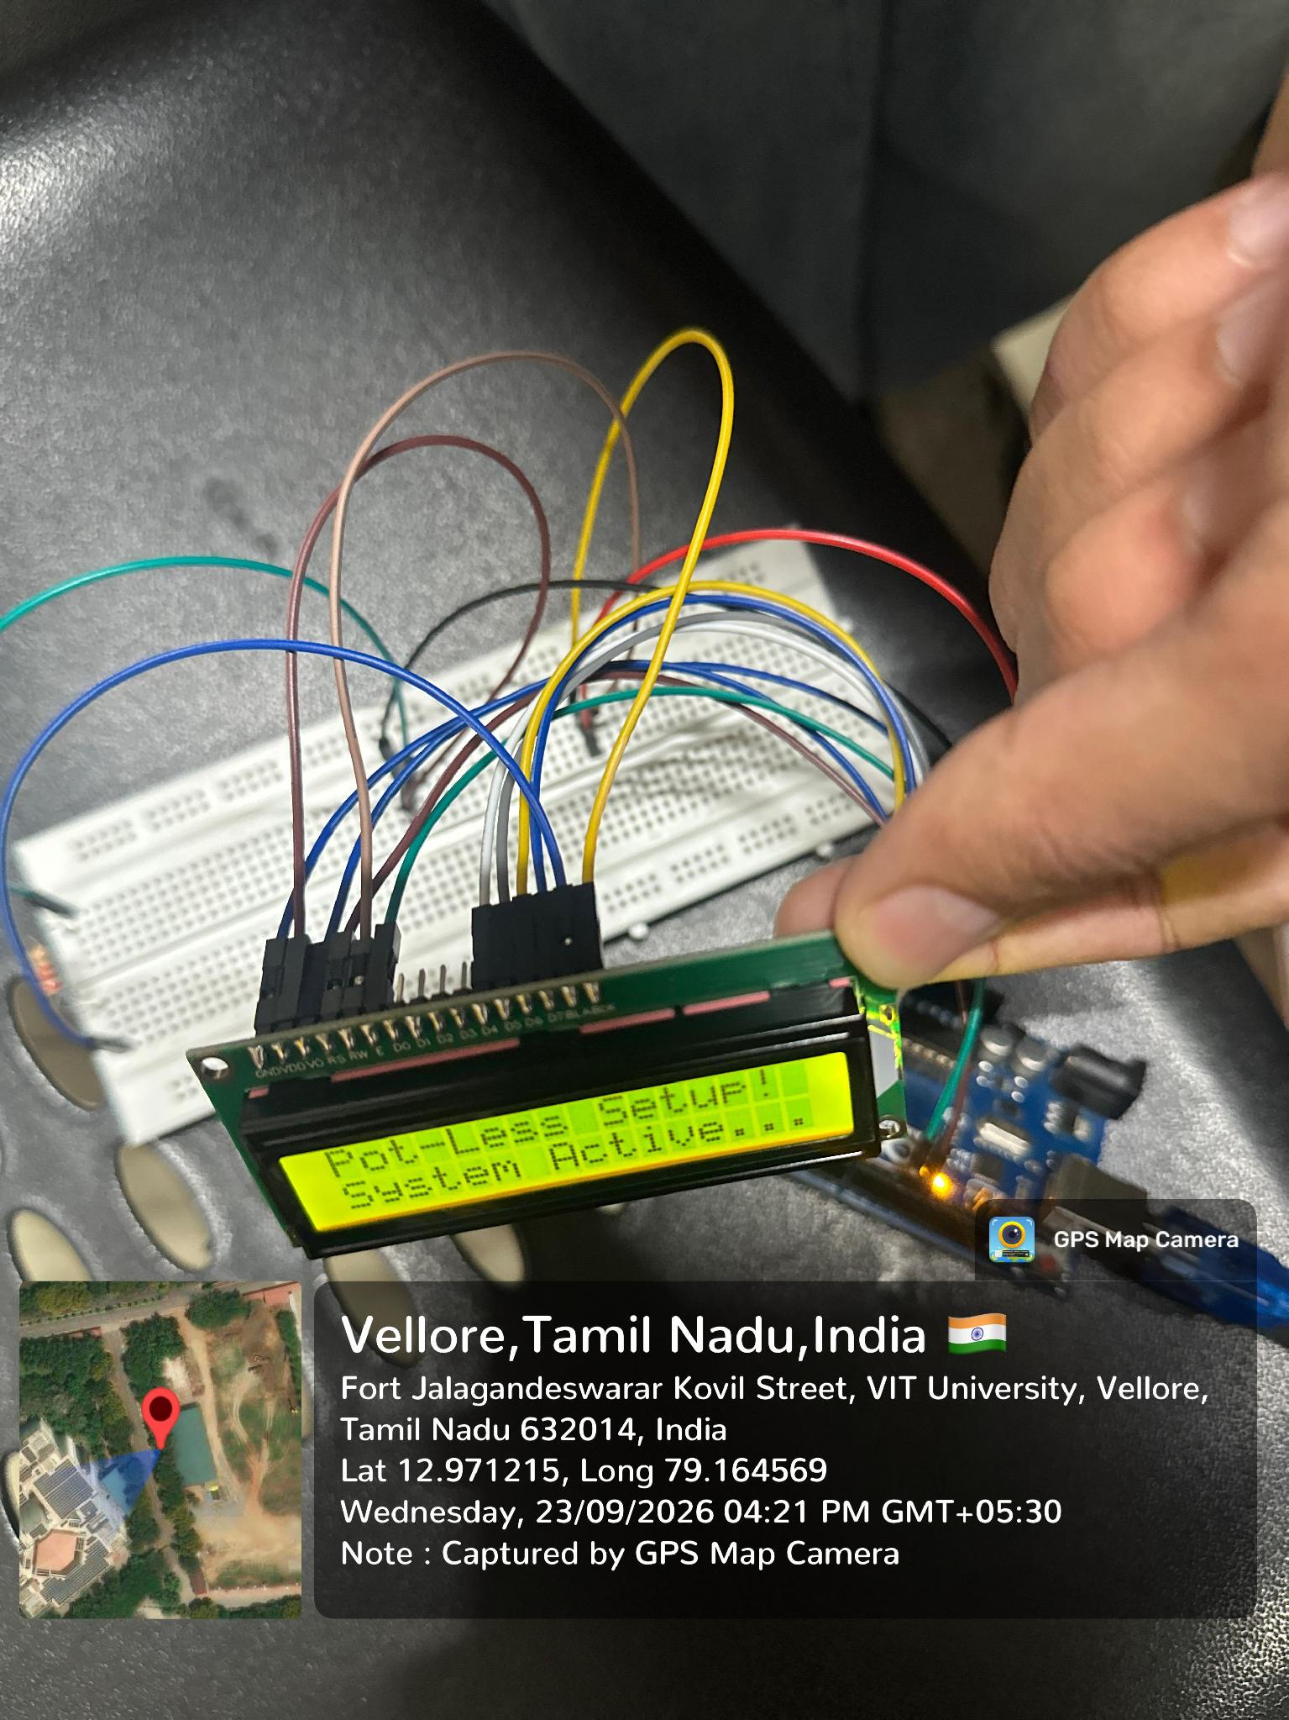 | 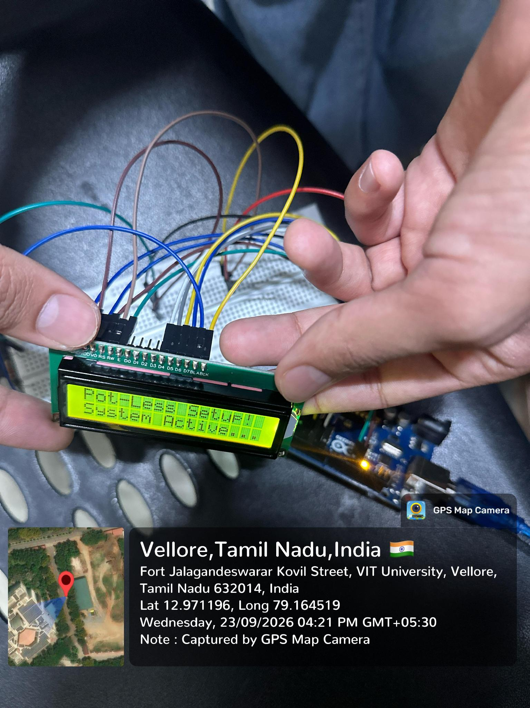
LCD test message and wiring | LCD display close-up
Result
Expected result: The LCD should display AARON ROBERTSON on the first row and 25BCE2640 on the second. The potentiometer should adjust character contrast. Verify correct text and stable display after upload and reset. Capture both rows clearly in the hardware photograph.
Inference
The LCD uses a four-bit parallel interface to display text. Correct wiring and cursor positioning place information on separate rows. The potentiometer adjusts contrast. This method supports identification details, sensor readings and short messages in embedded systems.

ESA Lab Assessment report
Sl.no. | Components |  | Marks Obtained
1 | Pre Lab Work (Flow chart and Algorithm) documentation (2)
2 | Hardware or software Implementation (2)
3 | Manual calculation , Output data table / graph verification (2)
4 | Result with Inference (2)
5 | Post Lab Work (C Code with comments) documentation (2)
 | Total (10)
1 | Name: Aaron Robertson
2 | Reg. No.: 25BCE2640
3 | Lab slot: L 45+ L46 | Lab. Slot Time: 3:50 PM – 5:30 PM
4 | Assessment no.:8
5 | Title of Assessment: HARDWARE INTERFACING WITH ARDUINO UNO
6 | Date of Assessment assigned | September 30th , 2026
7 | Completion date | October 21th , 2026
8 | VTOP Upload deadline | October 25th , 2026
9 | Mobile number: 91+ 9746244366
10 | Email id:aaron.robertson2025@vitstudent.ac.in
11 | TRA Signature with Date
12 | Faculty Signature with Date

