DeFi AMM Liquidity & Yield Farming Lab
Base Sepolia Testnet — Class AMM V2 & Class Farm
Student | Jiawei Shi
Date | October 5, 2026
Network | Base Sepolia Testnet
Topic | AMM, LP Tokens, Yield Farming, Harvesting, and Swap

1. Objective
The objective of this lab was to complete an end-to-end decentralized-finance workflow using the course AMM and farming applications: provide liquidity, receive LP tokens, stake LP tokens, earn and harvest FARM rewards, and swap FARM through the AMM.

2. Procedure and Results

Step 1 — Provide MAX/tUSDC Liquidity
I entered 0.04 MAX and 76.730289 tUSDC. The existing pool automatically matched the deposit to the current reserve ratio, and I approved MAX for use by the AMM.
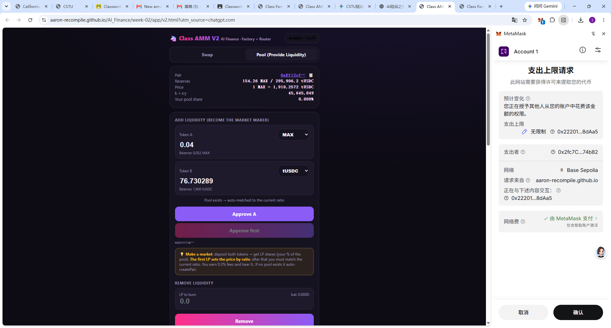
Figure 1. MAX and tUSDC amounts entered and token approval requested.

Step 2 — Confirm the Liquidity Transaction
After approval, I submitted the liquidity transaction in MetaMask. The transaction preview showed 0.04 MAX and about 76.73 tUSDC being supplied and about 1.721 LP tokens being received.
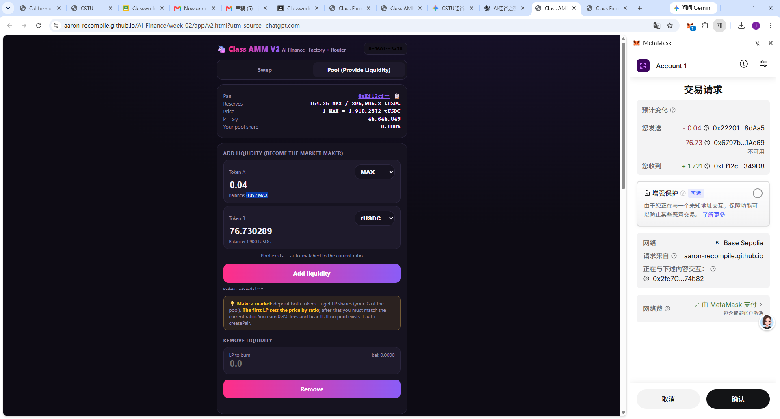
Figure 2. MetaMask confirmation for the Add Liquidity transaction.

Step 3 — Receive LP Tokens
The liquidity transaction succeeded. The interface showed an LP balance of about 1.7207, representing my share of the MAX/tUSDC pool.
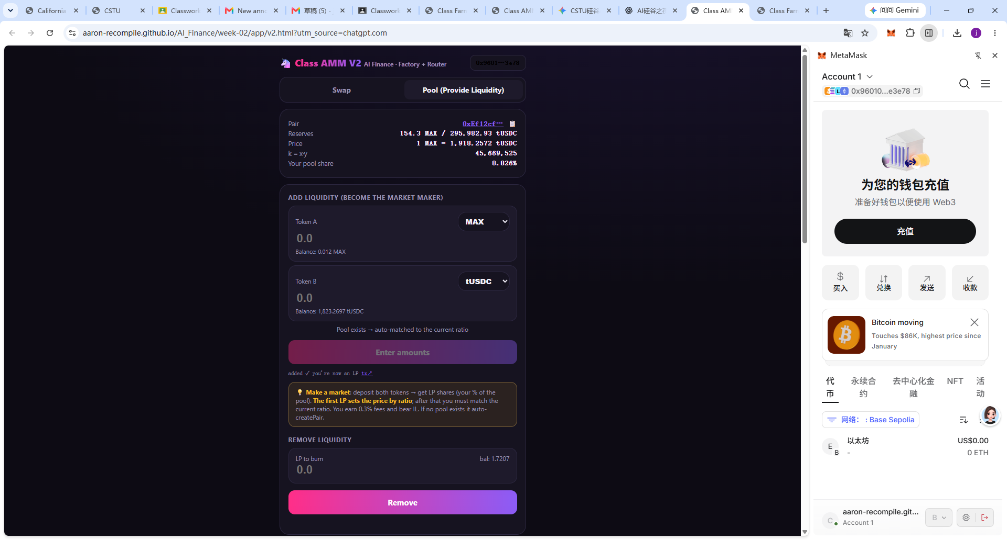
Figure 3. LP balance after liquidity was added.

Step 4 — Stake LP Tokens and Mine FARM
I approved the LP token and deposited approximately 1.7 LP tokens into the MasterChef farm. FARM rewards then accumulated as blocks were produced.
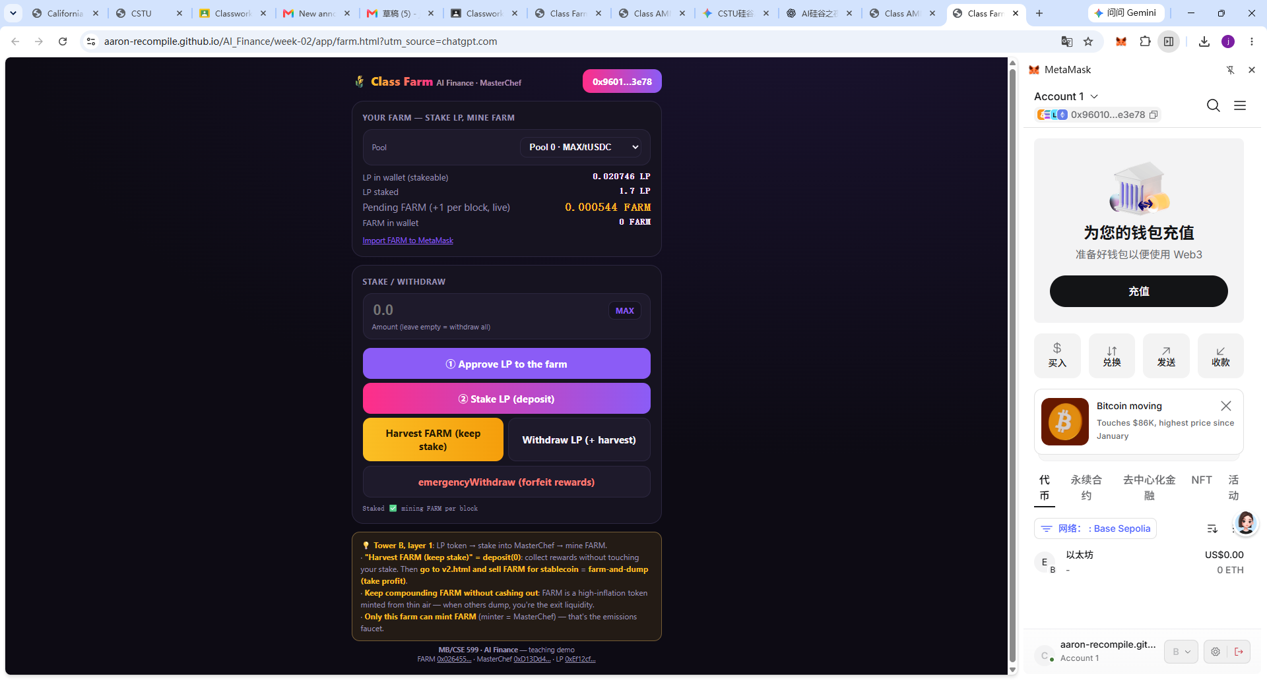
Figure 4. LP tokens staked in the Class Farm.

Step 5 — Harvest FARM Rewards
I used the Harvest FARM (keep stake) function. This collected FARM rewards without withdrawing the staked LP position.
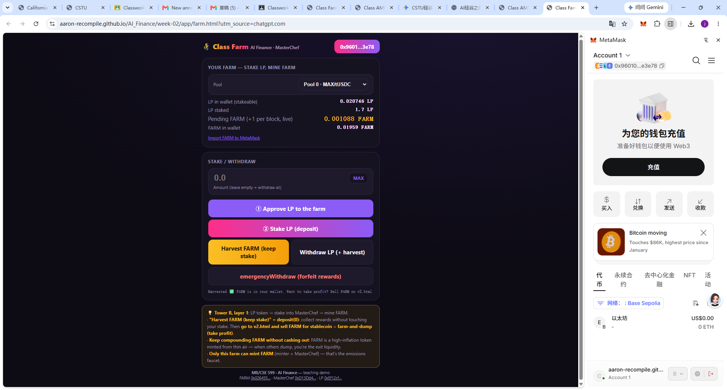
Figure 5. FARM reward harvested while the LP position remained staked.

Step 6 — Prepare FARM → tUSDC Swap
After harvesting, I selected FARM as the input token and tUSDC as the output token in the swap interface.
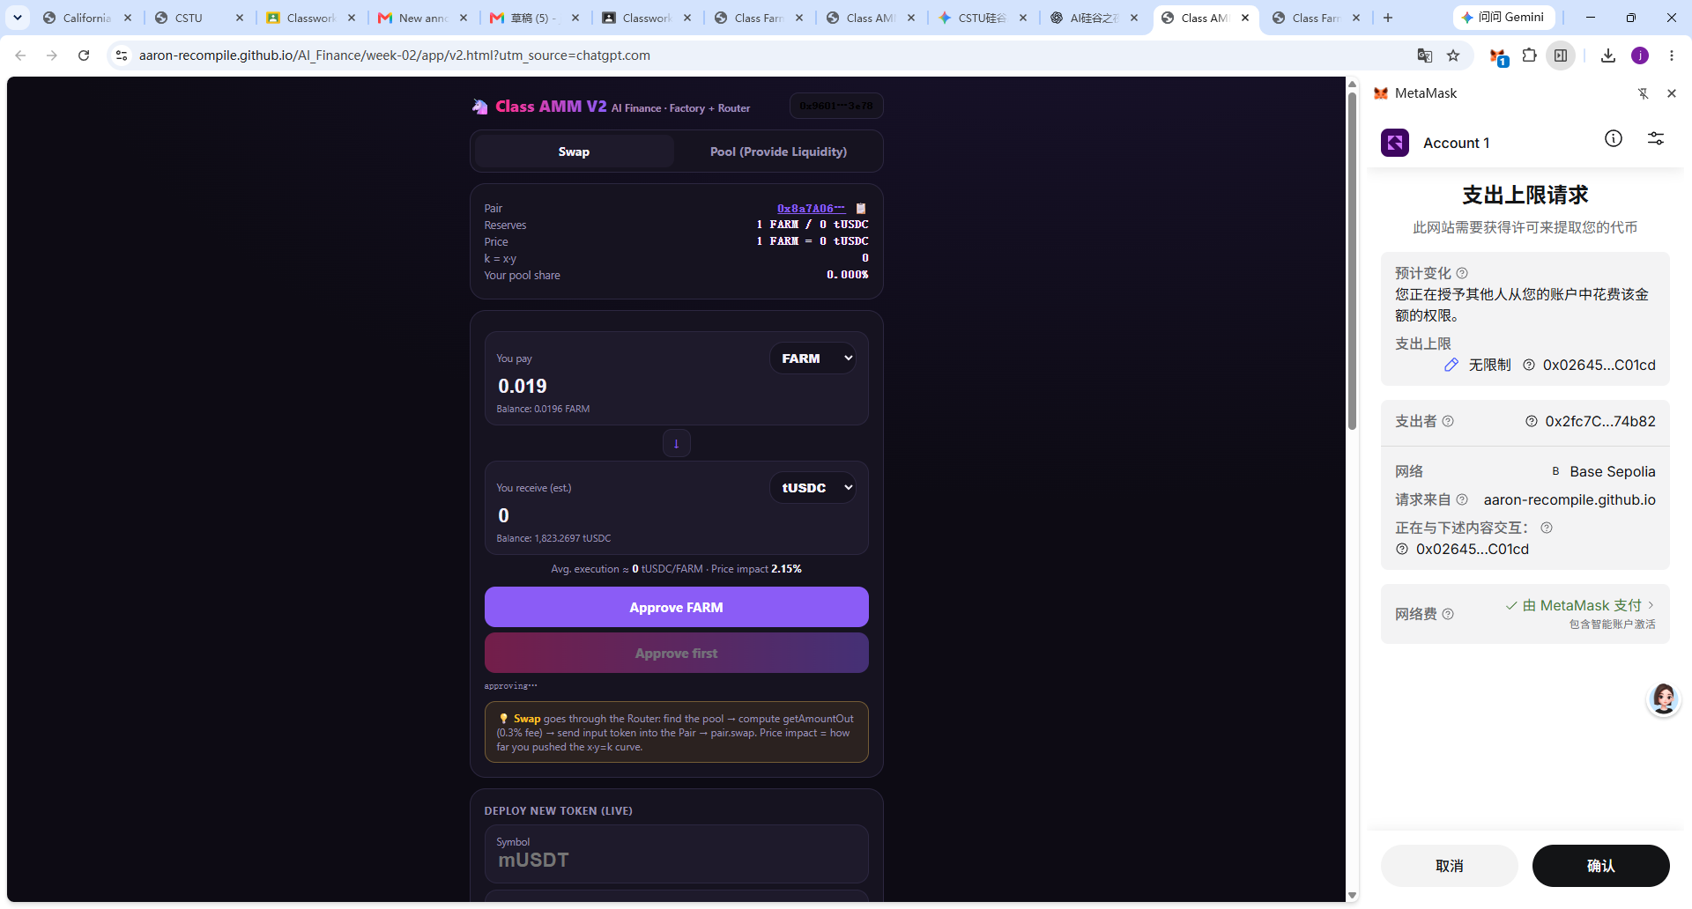
Figure 6. FARM selected for swapping through the AMM.

Step 7 — Complete the FARM Swap
The swap workflow completed successfully. The FARM balance was reduced to approximately 0.0006 FARM after selling most of the harvested FARM.
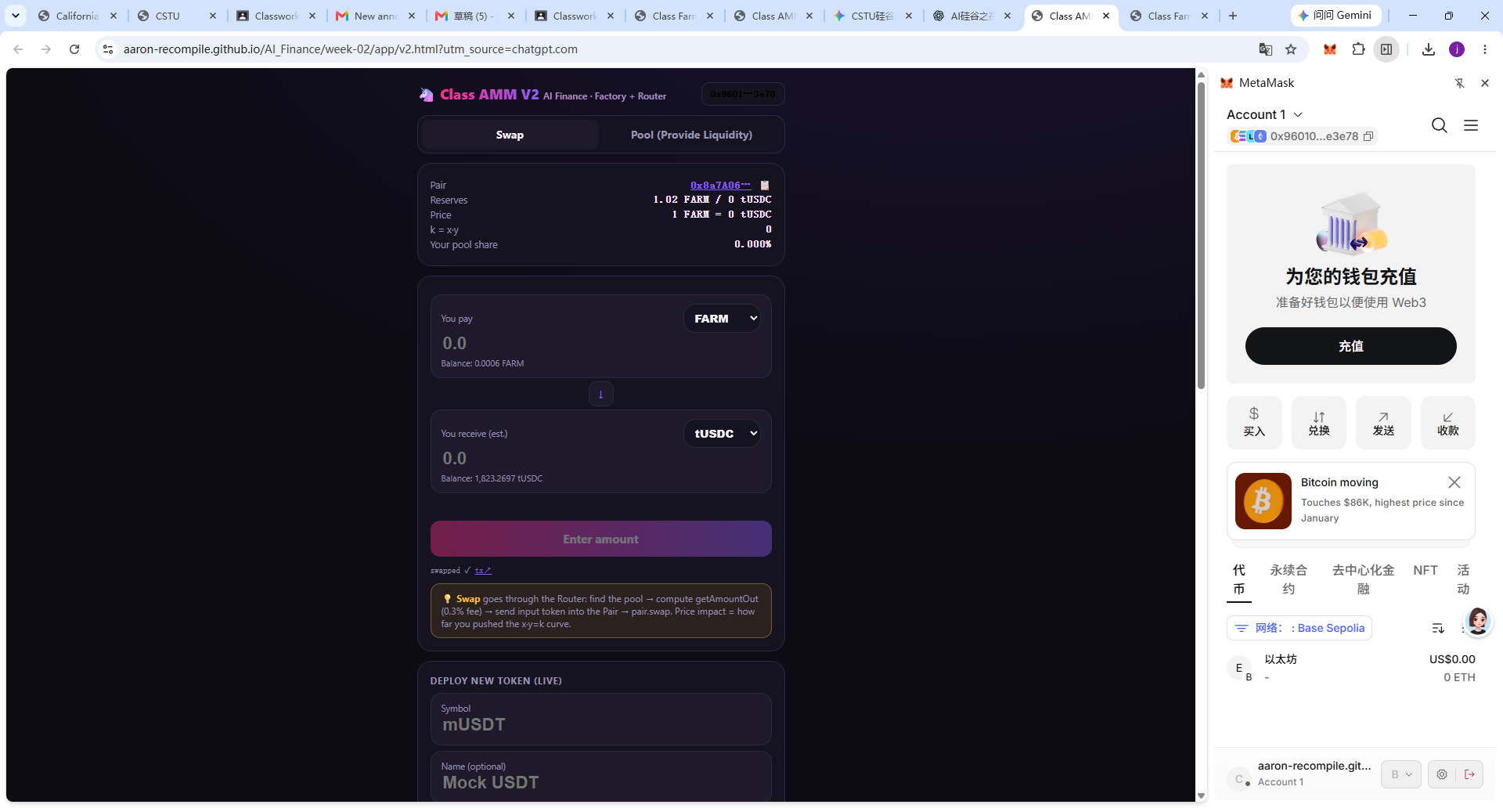
Figure 7. Final state after the FARM-to-tUSDC swap.

3. Key Concepts Demonstrated
- Automated Market Maker (AMM): The pool uses token reserves and the constant-product relationship x × y = k to determine trading behavior.
- LP Tokens: Supplying both assets generated LP tokens representing a proportional share of the pool.
- Yield Farming: The LP tokens were deposited in the MasterChef farm and FARM rewards accumulated over time.
- Harvesting: Rewards were collected while the LP stake remained deposited.
- Swap and Price Impact: The harvested FARM was routed through the AMM for a FARM-to-tUSDC swap. The exercise showed how thin liquidity can cause large price impact.

4. Observations
The MAX/tUSDC deposit used 0.04 MAX and 76.730289 tUSDC and produced approximately 1.7207 LP tokens. I then staked about 1.7 LP tokens and observed FARM rewards accumulating block by block. After harvesting, FARM was available for a swap. The FARM/tUSDC market had very limited liquidity, which demonstrated why reserve depth and price impact are important in AMM trading.

5. Conclusion
I successfully completed the DeFi workflow: provide liquidity → receive LP tokens → stake LP tokens → earn FARM → harvest FARM → swap FARM. The lab demonstrated how AMMs, liquidity-provider positions, farming incentives, ERC-20 approvals, and token swaps interact through smart contracts on a test network.
End of Report

