**Simple Calculator in Android**

**(Documentation)**

Submitted by:

Jason Mascariña

Submitted to:

Mr. Marc Anthony Reyman

Instructor

**Project Description:**

Made with practicality in mind, Daily Calculator is a simple and easy calculator app, ideal for your everyday use.

It is easy to use with large buttons, clean and stylish design, and provides the basic functionalities most people need for daily calculations.

For example, Daily Calculator is perfect in situations such as adding up receipts, calculating taxes or discounts when shopping, doing homework study for school, some calculation at your workplace, or even when you calculate a tip at restaurants.

*This is a free version of Daily Calculator, which displays ad at the bottom of the screen. Ad-free version is also available.

**Screenshots:**

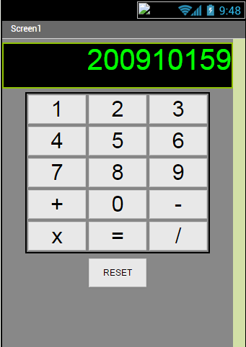

**Functions:**



To reset all function

Math operator such addition, subtraction, multiplication and division also the equal

Numeric number each button correspondent to a single number

**Mit App Inventor (Blocks)**

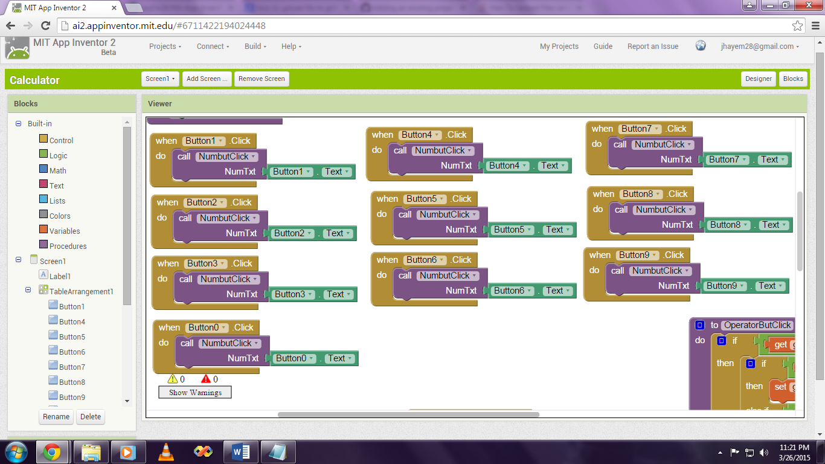

Here above you see block (codes) use for each number button.

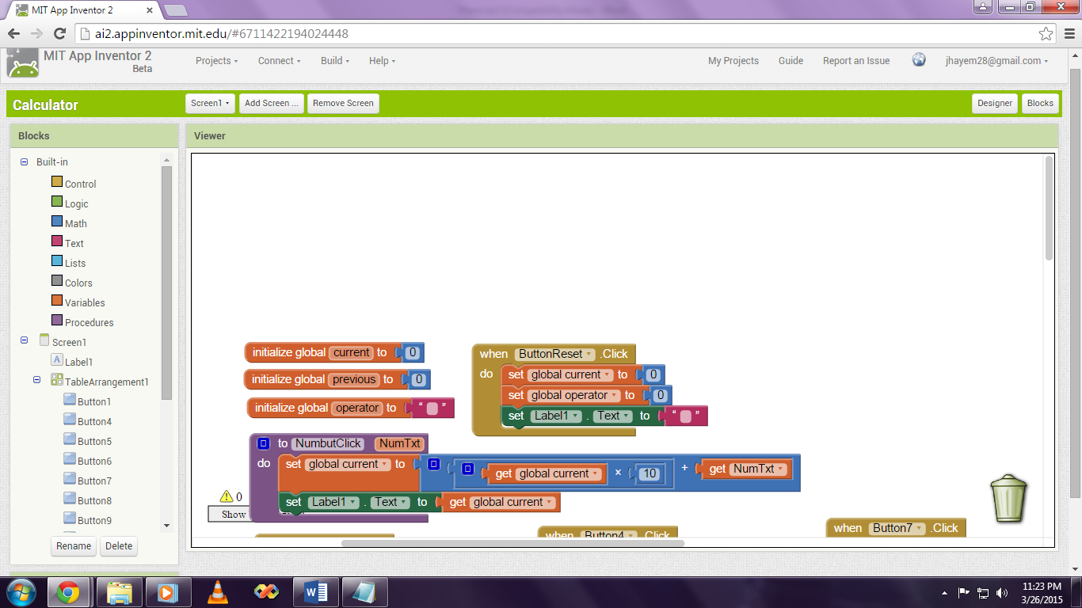

Next here you can see the function for the reset button and variables.

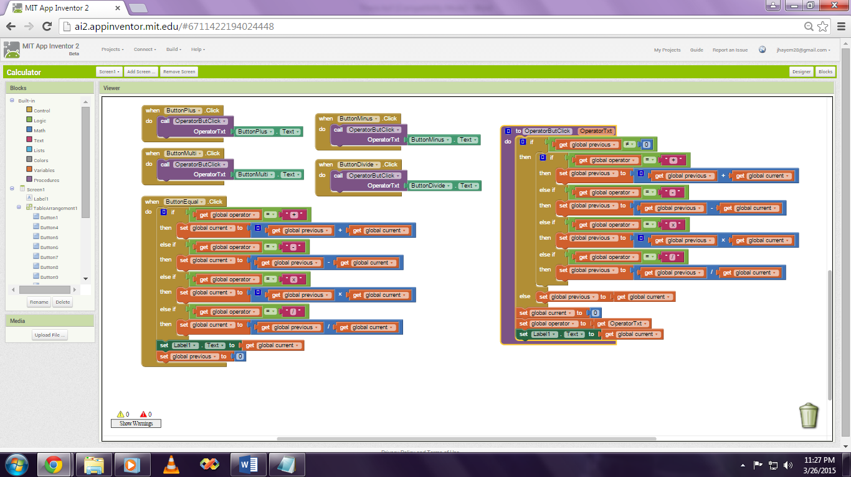

Last here you can see the blocks (codes) use for the four operator and equal function.