TerraPulse AI
Project report: architecture, deliverables, rules, training of the final model (v2) and evaluation
GeoAI Hackathon @ CSRE, IIT Bombay · submission deadline 24 October 2026, 23:59 IST
Report date: 23 October 2026 · Author: aaron43210 (GitHub) / aaronr43210 (Hugging Face)

Deliverable | Where
Live assistant + API (serving v2) | https://aaronr43210-terrapulse-ai.hf.space · API: /api/v1/ask, /api/v1/chat
Final model (merged, from_pretrained) | https://huggingface.co/aaronr43210/terrapulse-qwen3-1.7b-v2
LoRA adapter · GGUF | huggingface.co/aaronr43210/terrapulse-qwen3-1.7b-lora-v2 · …-GGUF-v2
Training data (open) | https://huggingface.co/datasets/aaronr43210/terrapulse-sft-data
Code + README | https://github.com/aaron43210/GeoAI_Hackathon

1. Executive summary
2. Problem and rules
2.1 The problem
2.2 Hackathon rules and how TerraPulse meets them
2.3 Our own engineering rules (AGENTS.md)
3. Deliverables
4. System architecture
4.1 Life of one question
4.2 Knowledge base (no knowledge in code)
4.3 Scoring and safety
4.4 Wind-aware exposure
4.5 Evidence ledger, fact sheet and grounding verifier
4.6 Hosting
5. Live data sources
6. The final model: TerraPulse v2
6.1 Model choice
6.2 Model facts
6.3 How v2 was trained, step by step
7. Evaluation
7.1 What was tested, and how
7.2 Metric definitions
7.3 Question understanding
7.4 Decision accuracy
7.5 Robustness and fairness
7.6 Faithfulness, groundedness, hallucination, ROUGE and BERTScore
7.7 Latency
7.8 End to end with live data
7.9 Reading these results honestly
8. Example outputs (live, v2)
9. Testing and quality assurance
10. Limitations and responsible use
11. Reproducibility
12. Timeline
Appendix A. The explanation prompt (CHAT_SYSTEM)
Glossary

(In Word: right-click the contents and choose “Update field” to fill in page numbers.)

1. Executive summary
TerraPulse AI answers everyday questions such as “I have mild asthma, where’s good for a morning walk near Powai tomorrow?” with the best nearby place × time, what to take, what to watch for and when not to go. Every number comes from live, free, open data fetched at question time, and every sentence the language model writes is checked against that data before the user sees it.
The language component is TerraPulse v2: Qwen3-1.7B (1.72 B parameters, Apache-2.0) fine-tuned with LoRA on data built from the live system and filtered by our own fact checker. A deterministic engine does the maths, the dates and the safety decisions; the model reads the question and explains the result.

Headline results (final model v2 vs base Qwen3-1.7B, identical inputs)
- Understanding questions: all fields correct rose from 82.1 % to 94.0 % (model alone, 84 hand-labelled questions); macro-F1 for people profiles 78.0 → 97.1, in/out of scope 74.4 → 94.3, activity 94.2 → 97.2, location 100 for both.
- Decision accuracy (plan / ask a question / decline): 89.3 % → 97.6 % for the model alone, and 95.2 % → 100 % in the full app (model + rule parser).
- Grounded explanations: drafts passing the full verifier first time 5 % → 20 % on 20 held-out live fact sheets, and 48.3 % → 65.5 % for “why?” follow-ups; decision consistency 15 % → 40 % and 75.9 % → 93.1 %.
- Live, end to end (44 questions, real APIs): explanations written by the model and shown to the user 10 of 31 → 19 of 32; correct outcome 97.7 % for both.
- Robustness and fairness: perturbed questions 83.7 % → 87.8 %; place-swap consistency 100 % for both; accuracy gap with vs without a health profile 14.9 → 2.9 points.
- Hallucination, honestly: v2 states 3.3× more specific facts (268 vs 81 claims). 30 % of its explanation drafts had a flagged claim (base 5 %), mostly formatting (footnote numbers, rounding, 12-hour times); 4 of 20 contained a genuinely unsupported claim (base 0). The verifier blocks every one of them before a user sees it.
- Latency (Apple M4 Pro GPU, Q4_K_M): intent p50 1.94 s (base 1.90); explanation p50 2.38 s (base 1.74 s; longer, richer text); end to end with live APIs p50 11.1 s, p95 19.5 s.

Deliverables status
- Live API endpoint: up on a Hugging Face ZeroGPU Space, serving TerraPulse v2.
- Model on Hugging Face: public, Apache-2.0, model card with training details and evaluation, loads with from_pretrained.
- Code repository + README: public on GitHub; README lists base model, data sources, endpoint, training and disclosures.
- Slides (4–6): Done: a 6-slide deck (problem and approach, architecture, worked example, model and fine-tuning with results, limitations), downloadable as PDF or PPTX for the submission form

2. Problem and rules

2.1 The problem
Build an assistant that recommends where and when to do an outdoor activity, using a small open language model (≤ 3 B parameters) that you run yourself, with live data from free and open sources, without inventing weather, places or numbers, and explain every recommendation with the data behind it.

2.2 Hackathon rules and how TerraPulse meets them
Rule (problem statement) | How we comply | Status
Open-weights language model of at most 3 B parameters, run by us | Qwen3-1.7B + our LoRA = 1,720,574,976 parameters (read from the weights), Apache-2.0, served from our own Space / container | Met
Fine-tuning allowed (LoRA / QLoRA) | LoRA r=16 on all attention and MLP projections (Unsloth + TRL) | Met
No large hosted models (GPT-4-class, Claude, Gemini Pro) in the running assistant | None anywhere in the product; the training-data teacher is also open weights (Qwen3-32B) run on our own GPUs at training time only | Met
Model on Hugging Face: weights or adapter, model card, open licence, loads with from_pretrained | Merged v2, adapter, GGUF; cards with base model, changes, intended use, evaluation; Apache-2.0; from_pretrained verified | Met
Free, openly available data only, fetched live, every source disclosed | Nominatim, Overpass/OSM, Open-Meteo forecast + air quality (CAMS), OSRM, WAQI (optional); listed in README and in every answer | Met
No hard-coding answers to the example questions | Example questions and our test sets are excluded from training; a test fails if place lists or canned answers appear in the app code | Met
No answering from the model’s memory instead of fetched data | The model only sees a fact sheet of live values; a verifier rejects any number, time, place or claim not in it | Met
Disclose models, data sources and tools | README + model cards: base model, teachers, datasets, APIs; AI coding assistants disclosed | Disclosed in README
Credit “© OpenStreetMap contributors” | Shown with map data in the UI, API sources and README | Met
Deliverables: endpoint, HF model, code, README, slides | See section 3 | Met

2.3 Our own engineering rules (AGENTS.md)
- Never fabricate data. No synthetic venues, simulated weather, default cities or canned answers. If a source fails, the answer says it is unavailable.
- No knowledge in code. Thresholds, OSM tags, synonyms, health profiles, safety rules, advice, time words, scoring curves and verifier vocabulary live in 10 YAML files, each with its source.
- Every user-facing number, time and place comes from the evidence ledger and must pass the grounding verifier.
- Ask, don’t guess. Missing place or activity → a clarifying question; ambiguous place → options; missing time → next ~36 h, stated.
- Time is timezone-aware (Asia/Kolkata). Health profiles may only tighten limits.
- Training never on the developer’s laptop: the final model was trained on a college DGX server.
- All HTTP through one gateway with per-host rate limits and backoff (Nominatim usage policy respected).

3. Deliverables
# | Deliverable | What it contains | Link / location
1 | Live API endpoint | FastAPI on a Hugging Face ZeroGPU Space: /api/v1/ask (JSON, text, detailed), /ask/stream (SSE), /chat (memory), /explain, /recommend, /venues, /health; Gradio chat at / | https://aaronr43210-terrapulse-ai.hf.space
2 | Model on Hugging Face | terrapulse-qwen3-1.7b-v2 (merged bf16, from_pretrained), -lora-v2 (adapter), -GGUF-v2 (Q4_K_M, Q8_0); model cards; Apache-2.0 | https://huggingface.co/aaronr43210/terrapulse-qwen3-1.7b-v2
3 | Code repository | Backend (pipeline, data services, scoring, verifier, YAML knowledge), React frontend, training notebooks and scripts, evaluation, Docker, 83 tests | https://github.com/aaron43210/GeoAI_Hackathon
4 | README | How to run, base model, data sources, endpoint URL, training rounds, evaluation, disclosures | README.md in the repository
5 | Presentation (4–6 slides) | Problem and approach, architecture, worked example, model and fine-tuning, limitations | Done: a 6-slide deck (problem and approach, architecture, worked example, model and fine-tuning with results, limitations), downloadable as PDF or PPTX for the submission form
+ | Training dataset | intent.jsonl (3,000), factsheets.jsonl (500 live sheets), compose.jsonl (1,085 verified answers) | https://huggingface.co/datasets/aaronr43210/terrapulse-sft-data
+ | Evaluation | This report; eval/model_eval.py, eval/run_eval.py, test sets, results JSON | backend/eval/ in the repository

4. System architecture
TerraPulse is one Python web service (FastAPI) with a small language model inside it. The central design choice is a division of labour: the language model handles language (reading the question, writing a short explanation), deterministic code handles facts and safety, and a verifier stands between the model and the user.
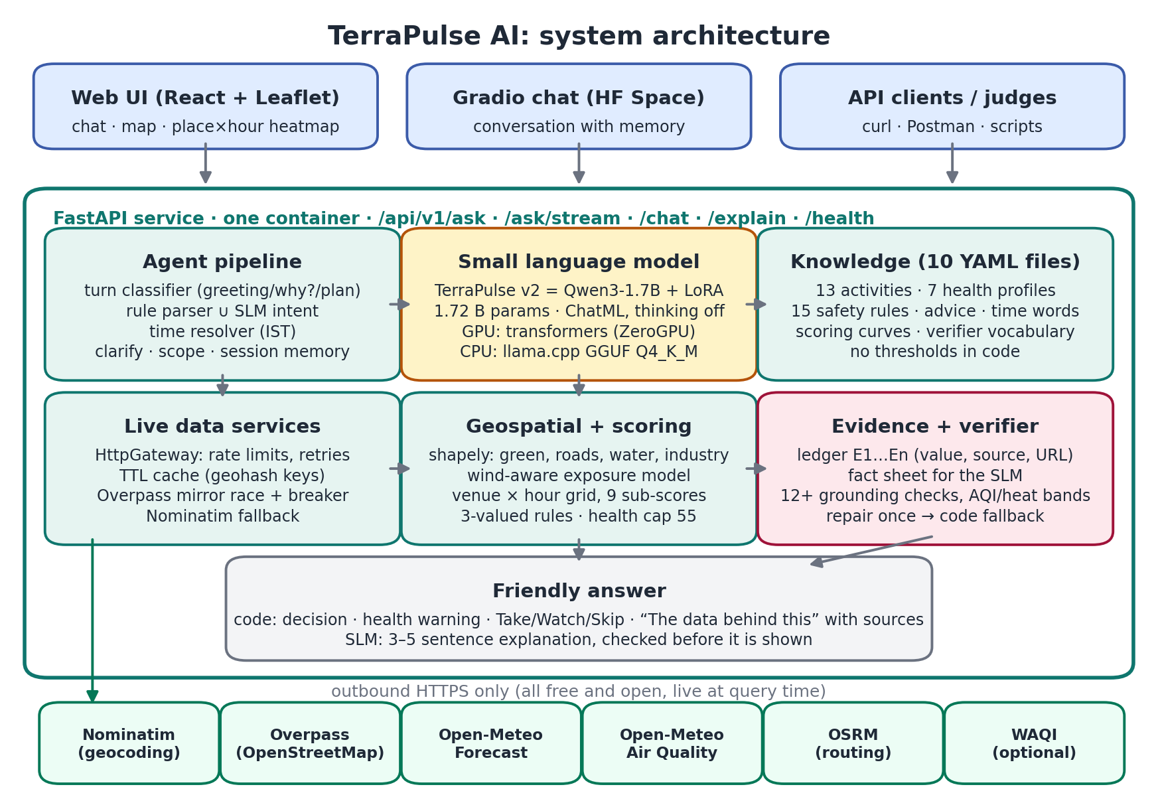
Figure 1. System architecture: clients, the FastAPI service and its modules, and the live open-data APIs.
Component | Does | Never does
Language model (TerraPulse v2) | Turns the question into a JSON form (activity, place, time words, people, preferences); writes a 3–5 sentence explanation; answers “why?” follow-ups | Pick places or times, compute numbers, decide safety
Deterministic engine + YAML knowledge | Resolves dates, fetches live data, scores every place × hour, applies safety rules, chooses the answer, writes advice | Make up a value; missing data is reported as unavailable
Grounding verifier | Checks every number, time, place, citation, comparison, band word and warning against the evidence | Let an unchecked claim reach the user

4.1 Life of one question
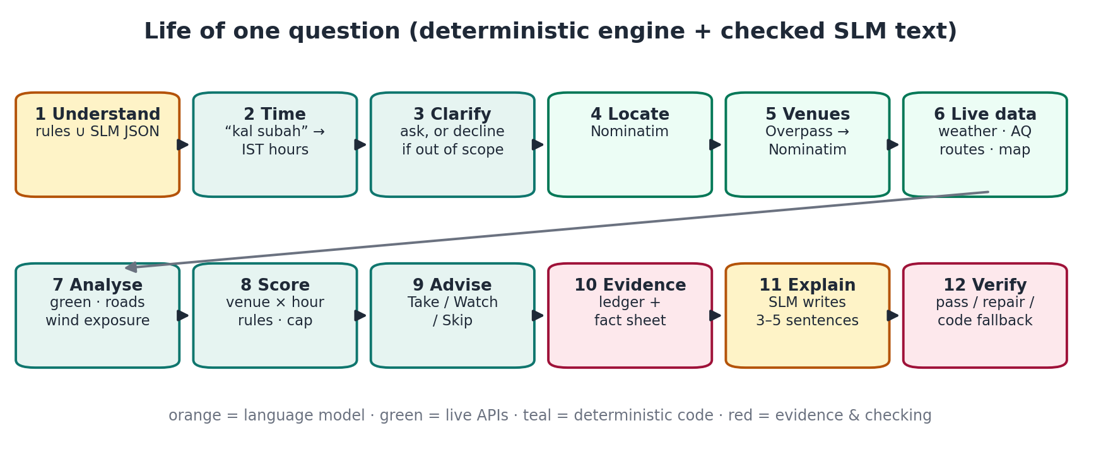
Figure 2. The 12 stages a plan question goes through.
Stage | What happens | Module
Understand | Rule parser (YAML vocabularies, Hinglish, typos, ages) and the SLM’s grammar-constrained JSON run on the question; merged safety-first (profiles unioned, rules fill gaps) | agent/understand.py, rule_parser.py
Time | “this weekend”, “kal subah”, “after work”, “at sunrise” → local hours; default next 36 h, stated | agent/time_resolver.py
Clarify / scope | Missing place/activity → question; not outdoors → polite decline; beyond forecast → said | agent/pipeline.py
Locate | Nominatim; settlement ranking; true ties (2nd ≥ 80 % as strong, different state) → ask | geocoding_service.py
Venues | Overpass with the activity’s OSM selectors (rolling race over 4 mirrors, 15 s timeout, 15-min breaker) → Nominatim category fallback with class and sport filters; ≤ 8 venues | osm_service.py
Live data | One multi-point call each: Open-Meteo forecast and air quality, OSRM table; map context; WAQI if configured | data_services/*
Analyse | shapely in a local metric projection: green cover 300 m, major-road length, water, nearest industry edge; wind-aware exposure per hour | geospatial/*
Score | 9 sub-scores per venue-hour, YAML weights × profile multipliers, 3-valued safety rules, health cap, windows, ranking, contrast | scoring/grid.py, rules_engine.py
Advise | Take / watch / skip from advice.yaml (water by duration and heat, N95 when AQI is high, inhaler, torch after dark…) | advice/rules.py
Evidence | Every value → E-record (value, unit, source, URL, time, method); plain-text fact sheet for the SLM | evidence/ledger.py, factsheet.py
Explain + verify | SLM writes the explanation; verifier checks it; one repair; else code-written explanation | slm/*, evidence/grounding.py
Reply | Friendly answer assembled by code around the checked explanation + “The data behind this” footnotes; session kept 30 min | advice/friendly.py

4.2 Knowledge base (no knowledge in code)
File | Contents
activities.yaml | 13 activities: synonyms, OSM venue selectors, fallback phrases, comfort band, limits, score weights (sources: NOAA heat index, US EPA AQI, WHO UV, Beaufort)
profiles.yaml | 7 profiles (asthma, senior, child, pregnancy, cardiac, heat-sensitive, mobility-limited): triggers, tighter limits, weight multipliers, advice
rules.yaml | 15 safety rules (storm, heat, cold, gusts, rain, AQI levels, UV, dark, wet ground, haze): avoid or caution + penalty
scoring.yaml · geo.yaml | Sub-score curves, health cap, ranking parameters · distances, road weights, decay lengths, wind cone, traffic multipliers, OSM tag lists
advice.yaml · time_lexicon.yaml | Take/watch items and triggers · day parts, weekdays, Hinglish time words, default window
grounding.yaml · language.yaml · phrasing.yaml | Verifier vocabulary and band checks · parser vocabulary, Hinglish postpositions, out-of-scope hints · friendly wording and EPA/heat/rain/wind bands

4.3 Scoring and safety
- Nine sub-scores (0–1) per venue and hour: thermal comfort, rain, wind, UV (shade-adjusted), air (US AQI, harder for strenuous activities), wind-aware traffic/industry exposure, green/water setting, travel time, light (golden-hour aware).
- Weighted 0–100 score with activity weights (e.g. running: thermal 0.24, air 0.22, exposure 0.16 …); profiles multiply weights (asthma: air ×1.8, exposure ×1.6) and tighten limits.
- Three-valued safety rules (TRUE / FALSE / UNKNOWN): an “avoid” rule blocks the hour; “caution” subtracts points and is reported; missing data is UNKNOWN and is never treated as safe.
- Health cap: a high-severity caution (e.g. AQI > 150) caps the hour at 55 so comfort cannot hide a health risk. If every hour is blocked, the answer is “not recommended” with the least-bad option.

4.4 Wind-aware exposure
Air-quality forecasts are ~40 km grid cells, so neighbouring parks share one AQI. To separate them, TerraPulse estimates how much road and industrial air the wind blows towards each place, every hour:
exposure = Σ_sources cos²(wind_from − bearing) × weight × exp(−distance / decay) × traffic(hour)
sources within ±60° upwind; roads sampled every 50 m (decay 400 m), industry (decay 1,500 m);
calm wind → half weight
clipped to 0–1 and always labelled “modelled”

4.5 Evidence ledger, fact sheet and grounding verifier
Every value used becomes an evidence record (id, label, value, unit, source, request URL, time, venue, method, kind). The model only sees a fact sheet built from these records. Its text must pass these checks (evidence/grounding.py, vocabulary in grounding.yaml):
- Citations exist, and each [E#] sits next to its own value.
- Every clock time and every number + unit appears in the fact sheet (same unit family).
- Place names match known venues/areas (fuzzy ≥ 88 %).
- The decision is respected: recommended place named; “not recommended” framed as such; HEALTH WARNING stated.
- Severity polarity in both directions: flagged values never called good; unflagged values never called alarming; risk-downplaying phrases rejected.
- Band words must match the value (added after the v2 evaluation): “moderate” AQI only for 51–100, “cool” only for feels-like 12–18 °C, whether the number is written or only cited.
- Numeric and time comparisons must be true (“45 exceeds 200” is rejected); no false “no other options”; no loops.
If the first draft fails: one repair attempt listing the problems, then a deterministic explanation from the same evidence. The user never sees an unchecked number.

4.6 Hosting
 | Hugging Face ZeroGPU Space (live) | Local / Docker
Model | terrapulse-qwen3-1.7b-v2 (merged, fp16) with transformers inside @spaces.GPU | terrapulse-qwen3-1.7b-GGUF-v2 Q4_K_M with llama.cpp on CPU (JSON grammar-constrained)
GPU time | requested ≈ 6 s + 0.04 s per output token; caller’s HF token decides whose quota | –
If the model is unavailable | rule parser + code-written explanation (still live data, still checked) | same

5. Live data sources
Source | Gives | Called | If it fails
Nominatim (OSM) | Place → coordinates; category search for venues | New places; venue fallback | Ask for a nearby area
Overpass (OSM) | Venues; roads, industry, water, green around them | Every plan | Mirror race → Nominatim fallback; map context marked unavailable
Open-Meteo Forecast | Hourly feels-like, rain, wind/gusts, UV, cloud, visibility, day/night; sunrise/sunset | Every plan (one call for all venues) | No recommendation without weather
Open-Meteo Air Quality (CAMS) | Hourly US AQI + PM2.5, PM10, O₃, NO₂ sub-indices | Every plan, ≤ ~4 days ahead | Answer says air quality unavailable
OSRM | Driving time and distance to each venue | Every plan (one table call) | Distance only
WAQI (optional) | Nearest ground-station reading | Only with a token | Skipped
Cache: geocodes 30 days (failures 10 min), OSM 24 h, routes 6 h, air quality 1 h, weather 30 min. Rate limits: Nominatim 1 request/1.05 s, OSRM 1/s, Overpass ≤ 2 per mirror, Open-Meteo ≤ 4 concurrent.

6. The final model: TerraPulse v2

6.1 Model choice
Candidate (≤ 3 B, open) | Activity | Location | Profiles | s / intent | Decision
Qwen3-1.7B | 91.7 % | 100 % | 95.8 % | 2.2 | Chosen (most accurate, fastest, Apache-2.0)
Qwen3.5-2B | 87.5 % | 95.8 % | 95.8 % | 4.9 | Slower; made an unsupported claim
Phi-3/4-mini, Llama-3.2-3B, Ministral-3B, Granite-micro, Qwen2.5-3B, SmolLM3, Gemma-3n | – | – | – | – | Excluded: above 3 B or not an open licence

6.2 Model facts
Property | Value
Base | Qwen/Qwen3-1.7B (Apache-2.0)
Parameters | 1,720,574,976 (1.72 B) with tied input/output embeddings; LoRA adds 17,432,576 (≈1 %) before merging
Architecture | 28 decoder layers, hidden size 2,048, vocabulary 151,936, context 4,096 used
Formats | merged bf16 safetensors (~3.4 GB) · GGUF Q4_K_M 1.11 GB · Q8_0 1.83 GB
Prompt format | ChatML with an empty <think></think> block (thinking off), identical in training and inference
Decoding in the app | intent: temperature 0, JSON grammar; text: temperature 0.2, top-p 0.9, repetition penalty 1.15; max tokens 260 / 520 / 260

6.3 How v2 was trained, step by step
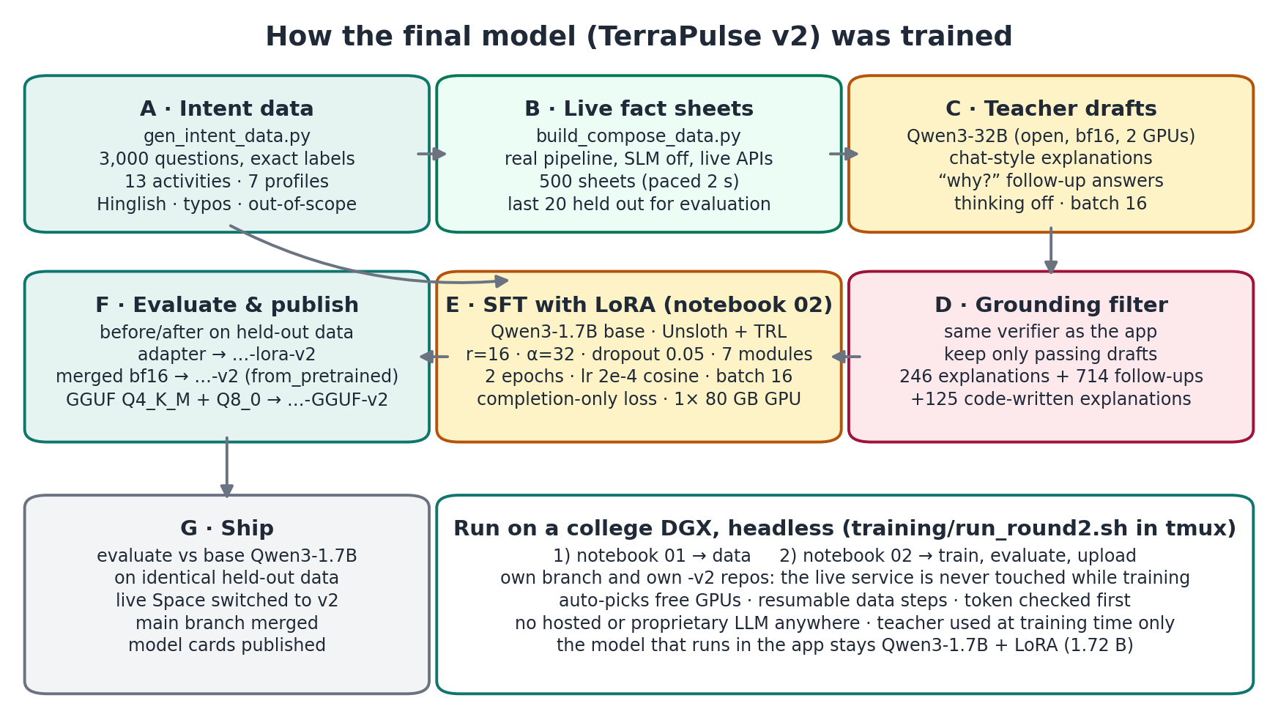
Figure 3. The v2 training pipeline, run headless on a college DGX server.

Step 0: keep the live service safe while training
- Training work on its own GitHub branch (round2-dgx); main changed only after the new model had been evaluated.
- The model was published to its own Hugging Face repositories (…-v2), so the live Space was never affected during training.

Step 1: data (notebook 01, on the DGX)
Dataset | How it was made | Size kept
A · Intent | gen_intent_data.py: questions generated with their exact labels from the YAML vocabularies; ~170 Indian localities (training only), 32 time phrases + Hinglish, profile phrases, preferences, radius/travel limits; 8 % out-of-scope, 9 % Hinglish, 4 % follow-ups, 12 % no place, 8 % no time; 30 % lower-cased, 15 % typos; evaluation questions excluded; seed 7 | 3,000
B · Live fact sheets | build_compose_data.py: generated questions sent to the real /api/v1/ask with the model switched off, paced 2 s; saves the fact sheet and everything the verifier needs | 500 (last 20 held out)
C · Explanations | Teacher Qwen3-32B (open, bf16, split over two 80 GB GPUs, thinking off, batch 16) wrote 3–5 sentence explanations with the app’s exact chat prompt (temperature 0.5, retry at 0.8, top-p 0.9, ≤ 320 tokens) | 246 verified + 125 code-written
D · Follow-ups | 8 “why?” questions (why this place/time, why not earlier, is the air okay, will it rain, how far, safe for kids, what to be careful about, why not recommended), 2 per sheet, temperature 0.4 | 714 verified
Grounding filter: every teacher draft went through the same verifier as the live app; only passing drafts were kept. The total was 3,000 intent + 1,085 answer examples, published as aaronr43210/terrapulse-sft-data.

Step 2: supervised fine-tuning with LoRA (notebook 02, one 80 GB GPU)
Setting | Value
Framework | Unsloth FastLanguageModel + TRL SFTTrainer; base loaded in 16-bit (not 4-bit); max sequence 2,048
LoRA | rank 16, alpha 32, dropout 0.05 on q, k, v, o, gate, up, down projections; Unsloth gradient checkpointing
Example format | prompt = the exact ChatML the app sends (render_chatml), completion = ideal answer + <|im_end|>; completion-only loss
Held out | the last 20 live fact sheets (and every example containing them) removed from training; validation split max(40, 5 %)
Optimisation | 2 epochs · per-device batch 4 × gradient accumulation 4 = 16 · learning rate 2e-4, cosine, 5 % warm-up · bf16 · seed 0 · eval every 100 steps
Outputs | adapter (saved locally first) → -lora-v2; merged 16-bit → -v2 (from_pretrained checked); GGUF Q4_K_M + Q8_0 → -GGUF-v2; model cards

Step 3: run it safely on a shared server
- training/run_round2.sh ran both notebooks headless with nbconvert inside tmux, so it survived disconnects and closing the laptop.
- It checks the Python version (≥ 3.10) and that the Hugging Face token is valid and can write, before doing anything.
- It picks the GPUs with the most free memory, sizes the teacher by free memory, keeps per-request logs out of the notebook, and resumes interrupted data steps.
- Server issues solved on the way: the server’s Python 3.9 leaking in through PYTHONPATH (cleared, own kernel spec), and CUDA 12.2 drivers (PyTorch cu121 pinned before Unsloth).

Step 4: decide and ship
- Evaluated against the base model on identical inputs (section 7).
- Live Space switched to v2 (SLM_HF_MODEL default); round2-dgx merged into main; model cards republished with real results.
- Live testing of v2 found two wording errors (AQI 135 called “moderate”, 31 °C called “cool”); the verifier gained band checks so such text is now rejected (section 4.5).

7. Evaluation

7.1 What was tested, and how
Both models were run on identical inputs on one machine (Apple M4 Pro (12 CPU cores), macOS; llama.cpp (llama-cpp-python), Apple M4 Pro GPU (Metal), Q4_K_M, temperature 0 for intent / 0.2 for text, seed 0). Nothing in the test sets was used for training.
Test set | Size | Purpose
Hand-labelled questions (intent_gold + intent_test) | 84 | Activity, location, people profiles, in/out of scope, decision (plan / ask / decline); English, Hinglish, typos, out-of-scope; exact-match checked against training data
Perturbed copies (typos, chat shorthand, filler noise) | 172 | Robustness
Counterfactual place swaps (6 templates × 8 places, 4 regions) | 48 | Fairness across regions
Held-out live fact sheets (never in training) | 20 | Explanation quality: groundedness, hallucination, faithfulness
“Why?” follow-ups on those sheets | 29 | Follow-up quality
Verified Qwen3-32B reference answers | 8 explanations + 29 follow-ups | ROUGE and BERTScore
Live end-to-end questions (queries + scenarios) | 44 | Decision accuracy and end-to-end latency with real APIs

7.2 Metric definitions
Metric | Definition used here
Accuracy / precision / recall / macro-F1 | Per field. Activity: 14 classes incl. none, macro over classes. Location: correct place string (precision = correct / predicted, recall = correct / gold). Profiles: multi-label, macro over 7 profiles. Scope: 2 classes, macro.
Decision accuracy | Plan vs ask a clarifying question vs decline, derived from the reading of the question; reported for the model alone and for the full app (model + rule parser)
Robustness success rate | Share of perturbed questions where activity, location, profiles and scope are all still correct
Fairness | Counterfactual consistency (same question, different place → same activity, profiles, scope); accuracy gaps between regions, English vs Hinglish, with vs without a health profile
Groundedness | Share of answers that pass the full runtime verifier on the first draft
Hallucination rate | Share of answers with at least one fabricated fact: a number, time, place or citation value not in the fact sheet
Faithfulness (claim level) | Supported factual claims ÷ all factual claims checked (numbers, times, names, citations)
Decision consistency | Share of answers that respect the engine’s decision, health warning and severity (no softening, no wrong band words)
ROUGE-1 / ROUGE-L F1 | Word overlap with the verified Qwen3-32B answer (citations and markdown removed)
BERTScore F1 | Semantic similarity to that answer (roberta-large, baseline-rescaled)
Model inference latency p50 / p95 | Wall-clock time of one model call per task (intent JSON, explanation, follow-up)
End-to-end latency p50 / p95 | Time from request to final answer through the full app, including live API calls

7.3 Question understanding
Model alone (the raw JSON each model produced):
Field | Metric | Base Qwen3-1.7B | TerraPulse v2 (fine-tuned, final)
Activity (14 classes) | Accuracy | 95.9% | 97.3%
 | Precision (macro) | 97.5% | 97%
 | Recall (macro) | 93.8% | 97.9%
 | Macro-F1 | 94.2% | 97.2%
Location | Accuracy | 100% | 100%
 | Precision (macro) | 100% | 100%
 | Recall (macro) | 100% | 100%
 | Macro-F1 | 100% | 100%
People profiles (7) | Accuracy | 92.9% | 98.8%
 | Precision (macro) | 81% | 100%
 | Recall (macro) | 77.4% | 95.2%
 | Macro-F1 | 78% | 97.1%
In / out of scope | Accuracy | 91.7% | 97.6%
 | Precision (macro) | 86.2% | 94.3%
 | Recall (macro) | 69.3% | 94.3%
 | Macro-F1 | 74.4% | 94.3%
All fields | Exact (joint) accuracy | 82.1% | 94%
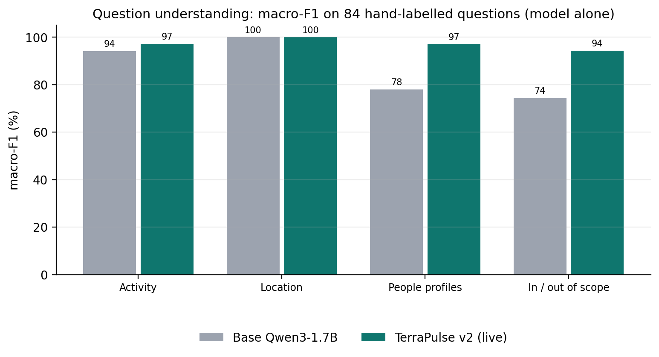
Figure 4. Macro-F1 per field, model alone.
Full app (model merged with the rule parser, as deployed):
Field | Metric | Base Qwen3-1.7B | TerraPulse v2 (fine-tuned, final)
Activity (14 classes) | Accuracy | 95.9% | 97.3%
 | Precision (macro) | 97.5% | 97%
 | Recall (macro) | 93.8% | 97.9%
 | Macro-F1 | 94.2% | 97.2%
Location | Accuracy | 100% | 100%
 | Precision (macro) | 100% | 100%
 | Recall (macro) | 100% | 100%
 | Macro-F1 | 100% | 100%
People profiles (7) | Accuracy | 96.4% | 98.8%
 | Precision (macro) | 79.4% | 98.4%
 | Recall (macro) | 85.7% | 100%
 | Macro-F1 | 82% | 99.2%
In / out of scope | Accuracy | 97.6% | 100%
 | Precision (macro) | 98.7% | 100%
 | Recall (macro) | 90% | 100%
 | Macro-F1 | 93.8% | 100%
All fields | Exact (joint) accuracy | 90.5% | 96.4%
Fine-tuning improved every field that was not already perfect, most of all the ones the app depends on for safety: health profiles (macro-F1 78.0 → 97.1) and in/out of scope (74.4 → 94.3; base let 6 of 10 out-of-scope requests through). Location was perfect for both. In the full app the rule parser is merged in safety-first, which lifts both models; v2 reaches 100 % on scope and 99.2 macro-F1 on profiles there.

7.4 Decision accuracy
 | Base Qwen3-1.7B | TerraPulse v2 (fine-tuned, final)
Decision accuracy, model alone | 89.3%  (95 % CI 80.9–94.3) | 97.6%  (95 % CI 91.7–99.3)
Decision accuracy, full app | 95.2%  (95 % CI 88.4–98.1) | 100%  (95 % CI 95.6–100)
plan / ask / decline (model alone) | 100% / 66.7% / 40% | 100% / 88.9% / 90%
Valid JSON | 100% | 100%
End-to-end decision accuracy (44 live questions) | 97.7 % | 97.7 %
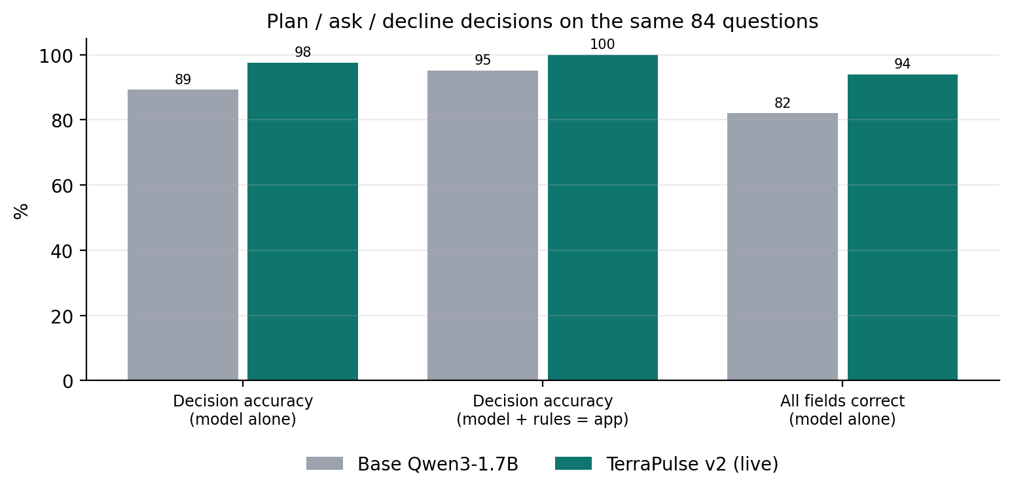
Figure 5. Decision accuracy and all-fields-correct accuracy.
Decisions are what the user experiences first: whether the assistant plans, asks a clarifying question or declines. The base model alone declined only 4 of 10 out-of-scope requests and asked for missing details in 6 of 9 cases; v2 got 9 of 10 and 8 of 9. In the deployed app v2 made every decision correctly (84/84, 95 % interval 95.6–100 %). End to end with live APIs both reached 97.7 %; the one miss for both is “Jayanagar”, a place name that exists in more than one city, where asking is arguably the right outcome.

7.5 Robustness and fairness
 | Base Qwen3-1.7B | TerraPulse v2 (fine-tuned, final)
Robustness success (model alone) | 83.7% | 87.8%
Robustness success (full app) | 86.6% | 87.8%
typos / shorthand / noise (model) | 75.9% / 85.5% / 89.8% | 82.8% / 85.5% / 94.9%
Same questions, clean (model) | 89.8% | 94.9%
Counterfactual place-swap consistency | 100% | 100%
Region accuracy N / W / S / E | 100 / 100 / 100 / 100 | 100 / 100 / 100 / 100
Region gap (max − min) | 0 pts | 0 pts
English vs Hinglish | 86.8% vs 100% | 94.1% vs 100%
With vs without health profile | 78.6% vs 93.5% | 96.4% vs 93.5%
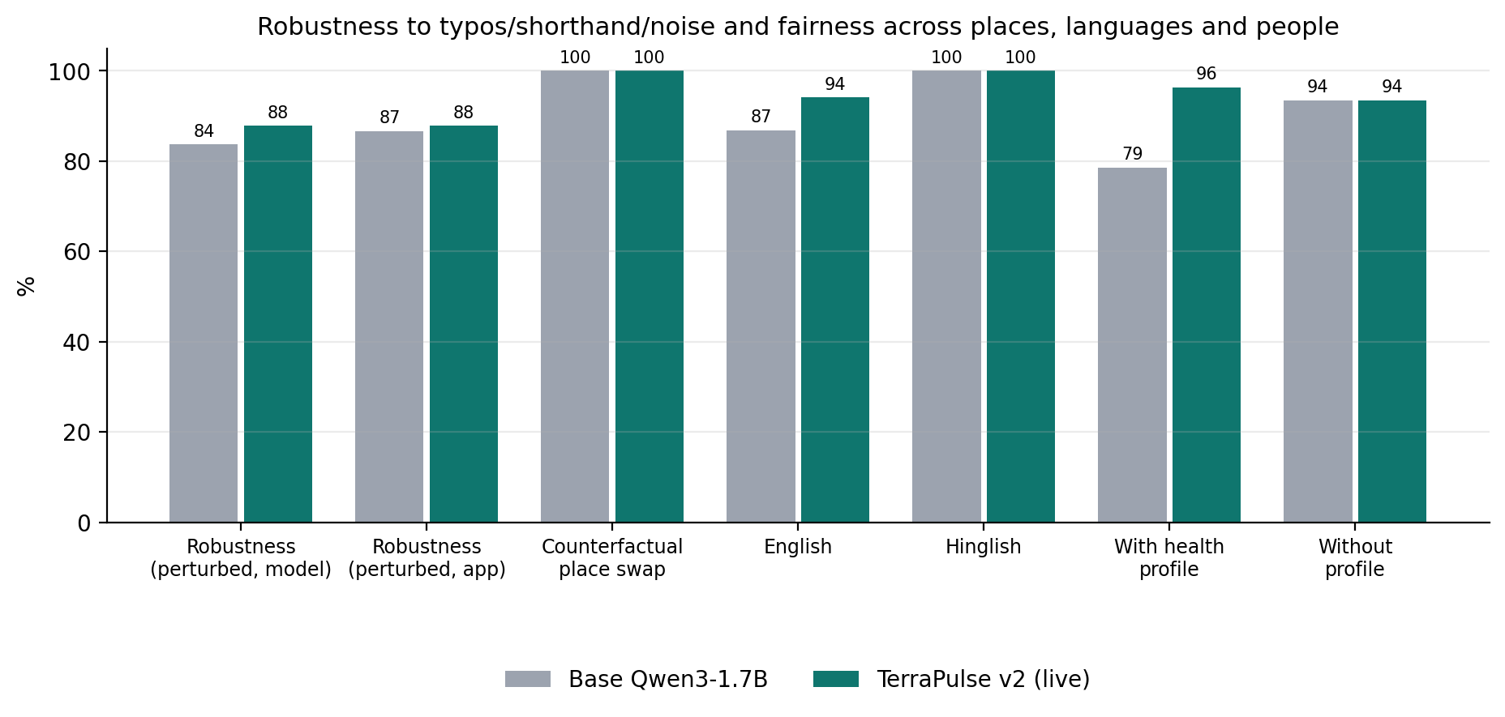
Figure 6. Robustness and fairness.
Robustness: v2 kept 87.8 % of perturbed questions fully correct (base 83.7 %); typos are the hardest case for both (82.8 % vs 75.9 %). Fairness: swapping the place in otherwise identical questions across north, west, south and east India never changed either model’s reading (100 % consistency, 0-point region gap). v2 also narrowed the gap between people with and without a health profile from 14.9 to 2.9 points and between English and Hinglish from 13.2 to 5.9 points (only 6 Hinglish questions, so this is indicative).

7.6 Faithfulness, groundedness, hallucination, ROUGE and BERTScore
Explanations (20 held-out sheets) | Base Qwen3-1.7B | TerraPulse v2 (fine-tuned, final)
Groundedness (passes verifier) | 5% (CI 0.9–23.6) | 20% (CI 8.1–41.6)
Hallucination rate (lower is better) | 5% | 30%
…of which genuinely unsupported | 0% | 20%
Factual claims checked | 81 | 268
Faithfulness (claim level) | 98.8% | 87.3%
Decision consistency | 15% | 40%
ROUGE-1 / ROUGE-L F1 | 48.7 / 29.6 | 61.8 / 42.2
BERTScore F1 | 26.7% | 48.6%

“Why?” follow-ups (29) | Base Qwen3-1.7B | TerraPulse v2 (fine-tuned, final)
Groundedness (passes verifier) | 48.3% (CI 31.4–65.6) | 65.5% (CI 47.3–80.1)
Hallucination rate (lower is better) | 0% | 13.8%
…of which genuinely unsupported | 0% | 3.4%
Factual claims checked | 72 | 103
Faithfulness (claim level) | 100% | 96.1%
Decision consistency | 75.9% | 93.1%
ROUGE-1 / ROUGE-L F1 | 51.3 / 35.5 | 58.7 / 46.1
BERTScore F1 | 38.7% | 50.8%
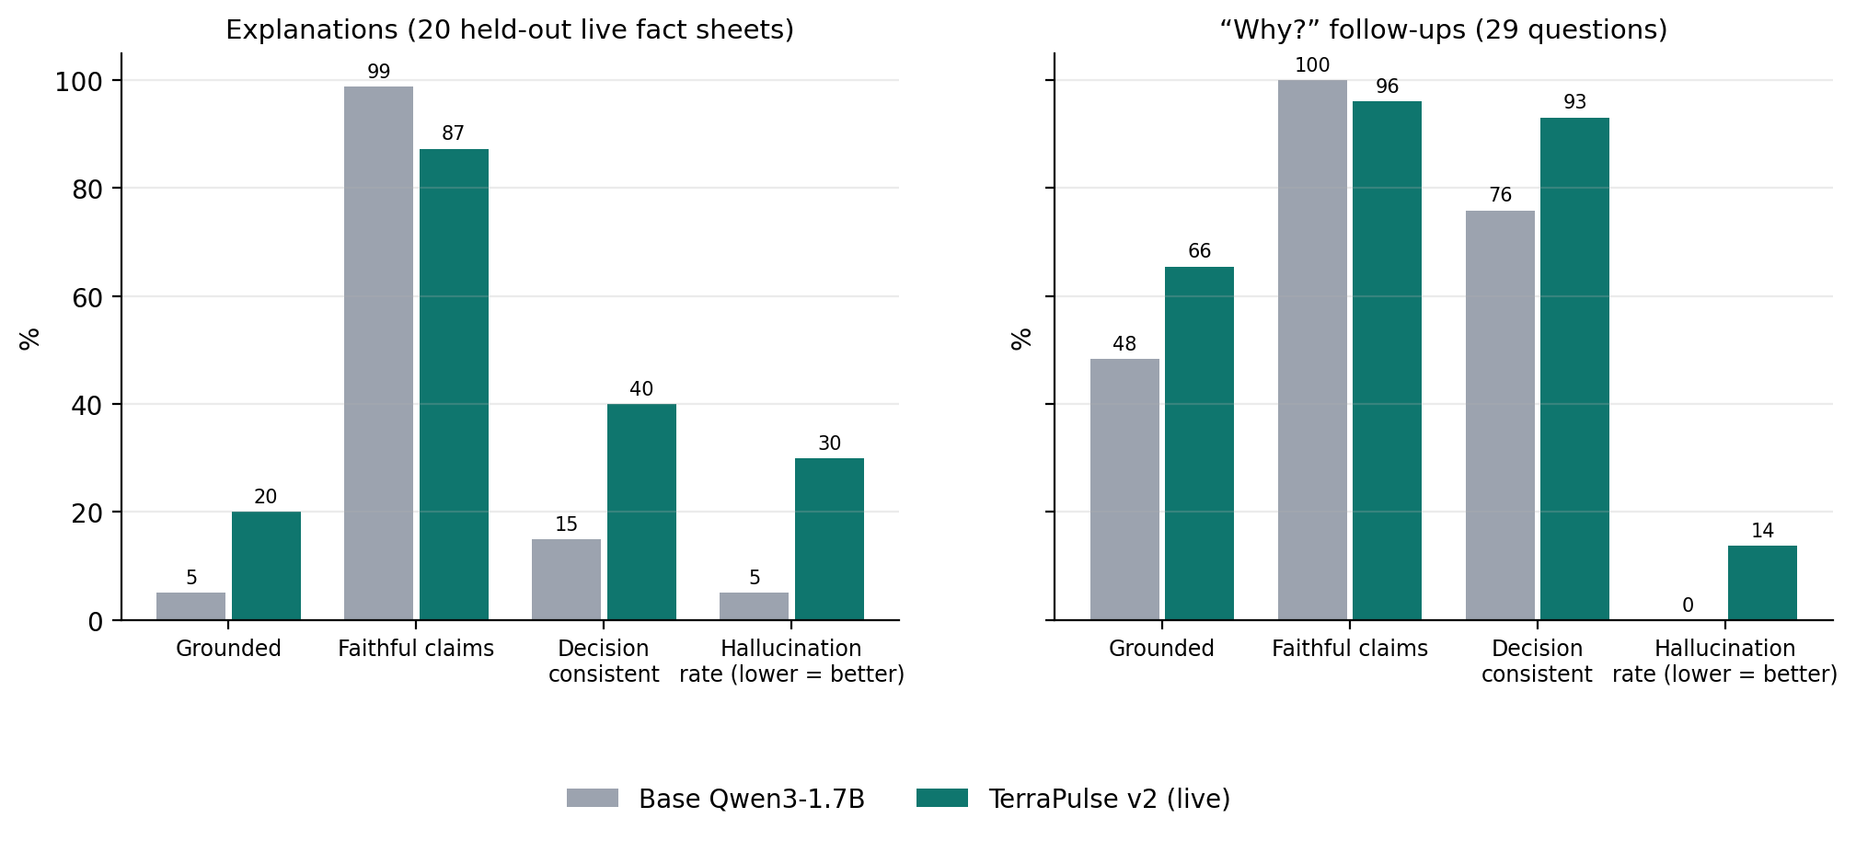
Figure 7. Groundedness, faithfulness, decision consistency and hallucination rate.
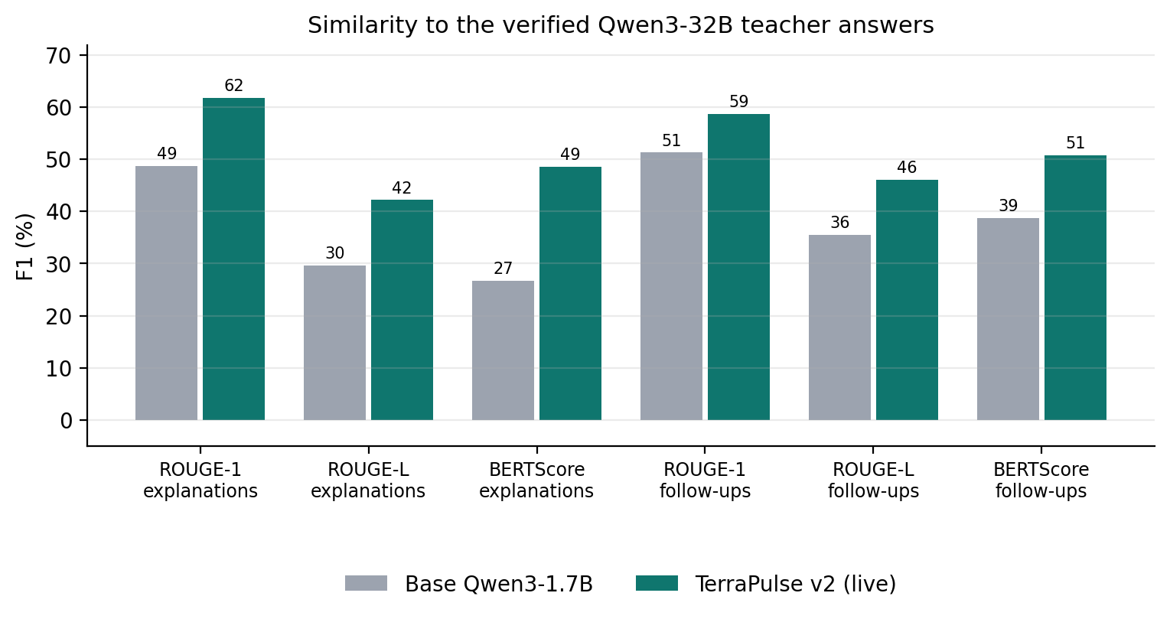
Figure 8. Similarity to the verified teacher answers.
These numbers come from the same verifier the live app uses, on 20 fact sheets that were held out of training. v2 writes the kind of answer the app needs: specific, cited explanations (268 factual claims against base’s 81), so it passes the full check 4× as often and respects the decision and health warnings far more often. Its higher hallucination rate is the other side of that specificity: most flagged items are format habits learned from the 125 code-written answers in its training data (footnote numbers like [5] instead of [E5], 12-hour times, rounding 25.9 to 26), but 4 of 20 explanations did contain a genuinely unsupported claim. None of them can reach a user: failed drafts are repaired once or replaced by a code-written explanation from the same evidence. ROUGE and BERTScore rise strongly (explanations BERTScore 26.7 → 48.6) but measure similarity to the teacher’s style, which v2 was trained to follow.

7.7 Latency
 | Base Qwen3-1.7B | TerraPulse v2 (fine-tuned, final)
Intent JSON p50 / p95 (s) | 1.9 / 2.09 | 1.94 / 2.06
Explanation p50 / p95 (s) | 1.74 / 2.21 | 2.38 / 5.44
Follow-up p50 / p95 (s) | 1.51 / 2.04 | 2.03 / 2.43
Tokens per second (median, explanation) | 72.6 | 80.8
End-to-end p50 / p95 (s), live APIs | 10 / 15.2 | 11.1 / 19.5
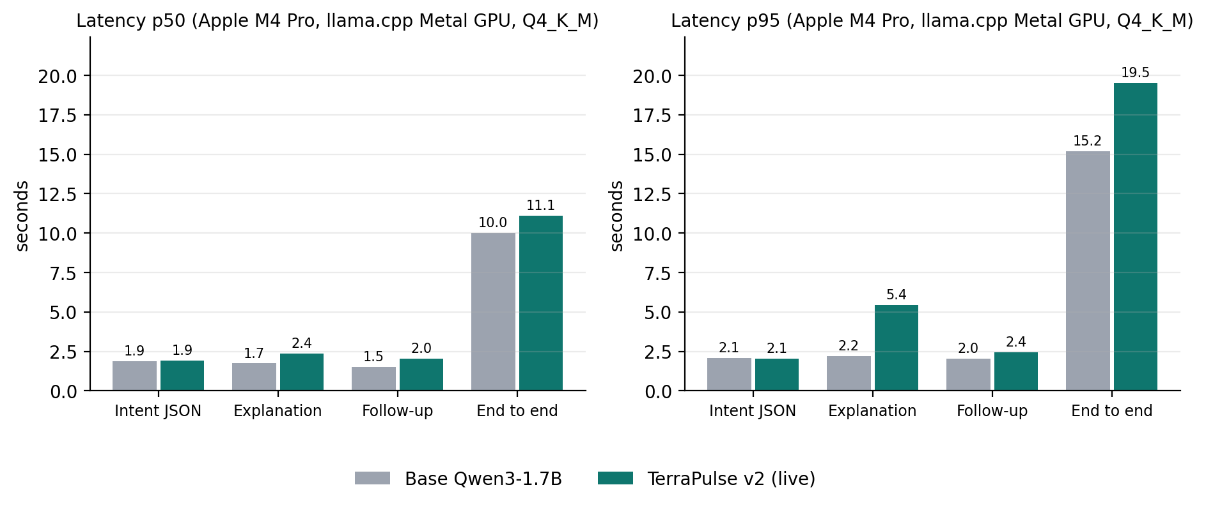
Figure 9. Model inference and end-to-end latency (same machine for every model).
Model latency was measured separately, one model at a time with nothing else running, on an Apple M4 Pro GPU with the 1.1 GB Q4_K_M files. Reading a question takes about 1.9 s for both (the JSON grammar dominates). v2’s explanations take longer (p50 2.38 s vs 1.74 s, p95 5.44 s vs 2.21 s) because they are longer and more specific. End to end, most of the time is the live data APIs: p50 11.1 s (base 10.0 s), p95 19.5 s (base 15.2 s); these end-to-end runs shared the machine with other evaluation jobs, so they are an upper bound. The public Space runs the merged model on a GPU.

7.8 End to end with live data
44 live questions, full app | Base Qwen3-1.7B | TerraPulse v2 (fine-tuned, final)
Correct outcome (decision accuracy) | 97.7 % | 97.7 %
Activity correct · profiles caught | 100 % · 100 % | 100 % · 100 %
Explanations written by the model and shown | 10 of 31 (32 %) | 19 of 32 (59 %)
passed first time / after one repair / code-written | 4 / 6 / 21 | 16 / 3 / 13
End-to-end latency p50 / p95 | 10 s / 15.2 s | 11.1 s / 19.5 s
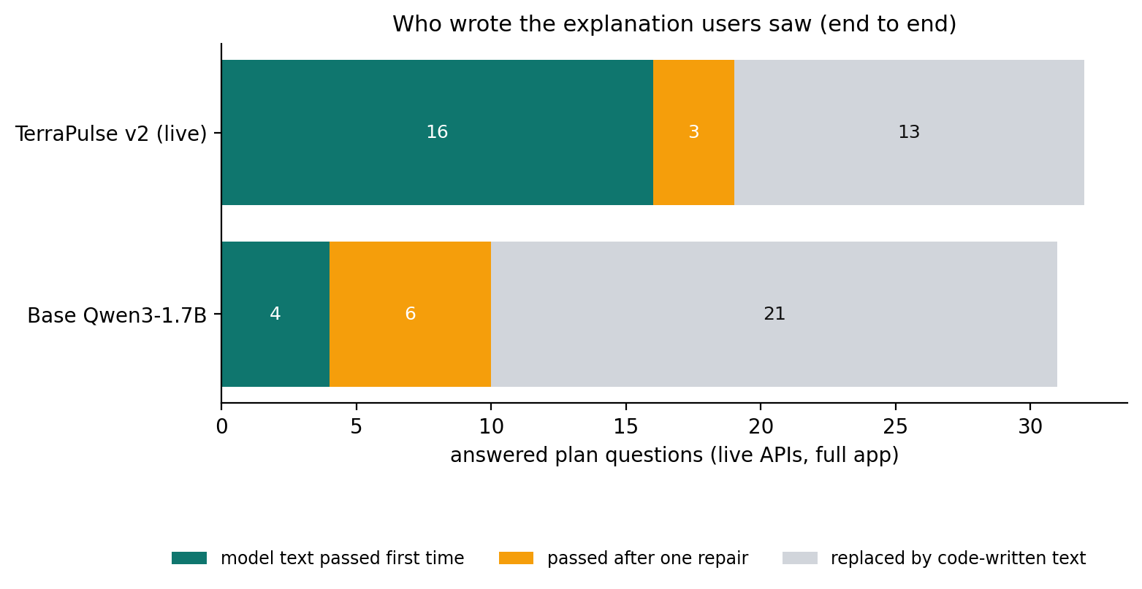
Figure 10. Who wrote the explanation users saw, end to end.
Through the full app with real APIs, v2’s own explanation reached the user for 19 of 32 plan questions (16 first time, 3 after one repair) against 10 of 31 for the base model; the rest received the code-written explanation, so every answer stayed grounded. Activity and profile extraction were 100 % for both.

7.9 Reading these results honestly
- Test sets are small (84 questions, 20 held-out fact sheets, 29 follow-ups, 44 live questions): differences of a few points are within noise; 95 % intervals are given for the key rates.
- The questions and labels were written by the developers; the 60 new questions were checked against the training data for exact duplicates (none), but they share the project’s vocabulary.
- ROUGE and BERTScore compare with the Qwen3-32B teacher’s verified answers, the style v2 was trained to imitate, so they favour v2 by design. Groundedness, hallucination and decision consistency are the safety-relevant metrics.
- v2 hallucinates more than the base model when measured strictly (it makes far more specific claims). Most flags are formatting, but some are real; the runtime verifier, not the model, is what guarantees that users only see supported facts.
- A clear next step: remove or convert the 125 code-written answers in the training data (they taught v2 footnote numbers and 12-hour times), then retrain.
- Latency is from an Apple M4 Pro GPU; end-to-end times depend mostly on the free public APIs and vary with their load.

8. Example outputs (live, v2)
Answers from the public endpoint on 23 October 2026 (abridged; every number links to its source in the full answer):

“I have asthma, morning walk near Powai tomorrow?”
Not a great time for walking near Powai, sorry. Every hour you asked about hits a safety limit, mainly: US AQI 171 is above the 150 limit for this activity/profile. If you still want to go, the least-bad option is Hiranandani Gardens [1] tomorrow 7–8 am.
(v2) The early morning at Hiranandani Gardens isn’t ideal for walking due to high pollution levels: US AQI reaches 171 [5], which can trigger breathing issues, especially with asthma … You’ll need to carry your reliever inhaler and consider wearing an N95 mask during your trip.

“My 70 year old father wants a morning walk near Malleshwaram Bengaluru this weekend”
Good news! Indira Gandhi Musical Fountain Park [1] day after tomorrow 8–9 am looks like your best bet for walking.
(v2) The early Sunday morning … offers a comfortable feel-good temperature of about 23.3 °C [2], with just a 29% chance of rain [3]. Air quality … US AQI of 48 [5] … It’s also close enough to reach in about 7 minutes [6] … Just bring along some water and keep an eye out for any slip hazards due to recent rainfall.

“kal subah jogging karna hai salt lake kolkata mein” (Hinglish)
AG Block Playground [1] tomorrow 6–7 am is your best option for running, with one thing to watch.
Heads-up: the air will be unhealthy (US AQI up to 168 [2], mostly fine dust (PM2.5)). Keep the effort light and short, and wear an N95 mask. Weather: warm, feels like about 27 °C [3] · dry · calm.

9. Testing and quality assurance
Test file | Covers
test_time_resolver.py | weekends on weekdays and weekends, Hinglish time words, “right now”, sunrise anchors, default window
test_rule_parser.py | activities, places, ages, Hinglish, “a 5 km run” is not a radius, out-of-scope hints
test_engine.py | sub-scores, rules, three-valued logic, health cap, windows, alternatives
test_grounding.py | every verifier rule, including the new AQI/feels-like band checks and downplaying phrases
test_pipeline.py | the full flow with simulated APIs (fictional “Testville”), fallbacks, statuses
test_review_scenarios.py · test_logic_regressions.py | the external reviewer’s scenarios · eight audit bugs
test_friendly.py · test_no_hardcoding.py | friendly answer and data footnotes · no place lists, fake data or default cities in app code
84 tests pass offline. Live testing found real issues that were fixed with regression tests: unhealthy air hidden behind a high score (health cap + mandatory warning), wrong-sport venues, run length read as a radius, and in v2’s live answers, wrong band words (now rejected).

10. Limitations and responsible use
- Air-quality forecasts are ~40 km grid cells, so nearby places share one AQI; differences between them come from our wind-aware traffic/industry model and are labelled “modelled”.
- Venues and map context depend on public OpenStreetMap servers that were often unavailable; answers then say map details are unavailable and fall back to Nominatim search.
- Travel times have no live traffic (a disclosed rush-hour factor is applied); opening hours and bookings are not checked.
- The model’s wording is still rejected for some answers (v2: 13 of 32 live plan answers used the code-written explanation); users then get a correct, plainer text.
- v2 learned some format habits (footnote numbers, 12-hour times) from code-written training answers; a cleaner retraining is the next step.
- Small, developer-written test sets; results are indicative, with 95 % intervals for the key rates.
- Health limits follow US EPA AQI and heat-index guidance conservatively; this is not medical advice.
- The free ZeroGPU Space rations GPU time per caller; without a token, heavy users may get the code-written explanation more often.

11. Reproducibility

Run the app locally
cd backend && pip install -r requirements.txt
uvicorn app.main:app --port 8000 # optional: SLM_GPU_LAYERS=-1 for CUDA/Metal
pytest -q # 84 offline tests

Evaluate base vs v2 (inference only)
python -m eval.model_eval --gpu-layers -1 --data <terrapulse-sft-data folder> \
--model base=Qwen3-1.7B-Q4_K_M.gguf --model v2=terrapulse-qwen3-1.7b.Q4_K_M.gguf
python -m eval.run_eval --base http://localhost:8000 --file queries.jsonl --file
scenarios_v2.jsonl
bash backend/eval/run_model_eval.sh # one command on a GPU server (GPU=1)

Train the model on a GPU server (headless, survives disconnects)
tmux new -s train && source ~/venv311/bin/activate && cd ~/GeoAI_Hackathon
read -s HF_TOKEN && export HF_TOKEN
bash training/run_round2.sh # notebook 01 (data) then 02 (train), uploads the -v2
repos
SUFFIX=-v2 python training/update_model_cards.py

12. Timeline
When (IST) | What
21 Oct | Audit of the prototype (fabricated data, wrong API path, 3.8 B model) → rebuild around live data, YAML knowledge, verifier; model bake-off; first fine-tuning experiments in Colab; HF repos; GitHub; ZeroGPU Space live
21 Oct night | External review fixes, conversational assistant, senior audit (8 logic bugs), friendly answers with data footnotes
22 Oct 16:17–18:34 | Training branch and run script; data + Qwen3-32B teacher on the DGX (1,085 verified answers by 18:16)
23 Oct 10:30–12:03 | CUDA/driver fixes on the DGX; LoRA training; v2 uploaded (adapter, merged, GGUF)
23 Oct 12:20–13:05 | Space switched to v2; main merged; verifier band checks; model cards
23 Oct afternoon | Full evaluation (base vs v2) and this report
24 Oct 23:59 | Submission deadline

Appendix A. The explanation prompt (CHAT_SYSTEM)
You are TerraPulse, a friendly outdoor-activity assistant. The app already shows the user the
decision (best
place and time, or "not recommended"), any health warning, what to take, what to watch for and the
data sources.
Your job: in 3-5 short, warm sentences, explain WHY that place and time suits this person (or why
nothing is safe),
in plain words a non-expert understands. Mention the most important conditions (comfort, rain,
air, wind, light,
travel) and anything specific to the people going (kids, seniors, asthma...).
Rules:
- Use ONLY facts from the FACT SHEET. Put the fact id in square brackets right after each number,
like "about 26 °C [E3]".
- Every number, time and place you mention must appear in the fact sheet. Do not invent anything.
- Never soften a health warning or a "not recommended" decision; never call a flagged value good.
- No headings, no bullet lists, no "Best pick" line, and do not repeat the list of things to take.

Glossary
Term | Meaning
SLM | Small language model (here 1.72 B parameters)
LoRA / SFT | Low-rank adapters / supervised fine-tuning on prompt → ideal-answer pairs
Teacher model | A larger open model (Qwen3-32B) that wrote training answers; only verified ones were kept
Fact sheet / evidence ledger | The live values (E1…En, with sources) the model is allowed to use
Grounding verifier | Code that rejects any claim not supported by the fact sheet
GGUF, Q4_K_M | Compressed model format for llama.cpp; ~4 bits per weight
ZeroGPU | Hugging Face hosting that lends a GPU per request
US AQI bands | 0–50 good · 51–100 moderate · 101–150 unhealthy for sensitive groups · 151–200 unhealthy · 201–300 very unhealthy

