Project documentation
HyperSpatial: A Local-First Parallel and Distributed Hyperspectral Analytics Suite for QGIS
EnMAP hyperspectral imagery processed by a C++ OpenMP/OpenCL engine and analysed with Apache Spark, Apache Sedona and Spark MLlib — all inside QGIS, on one's own computer
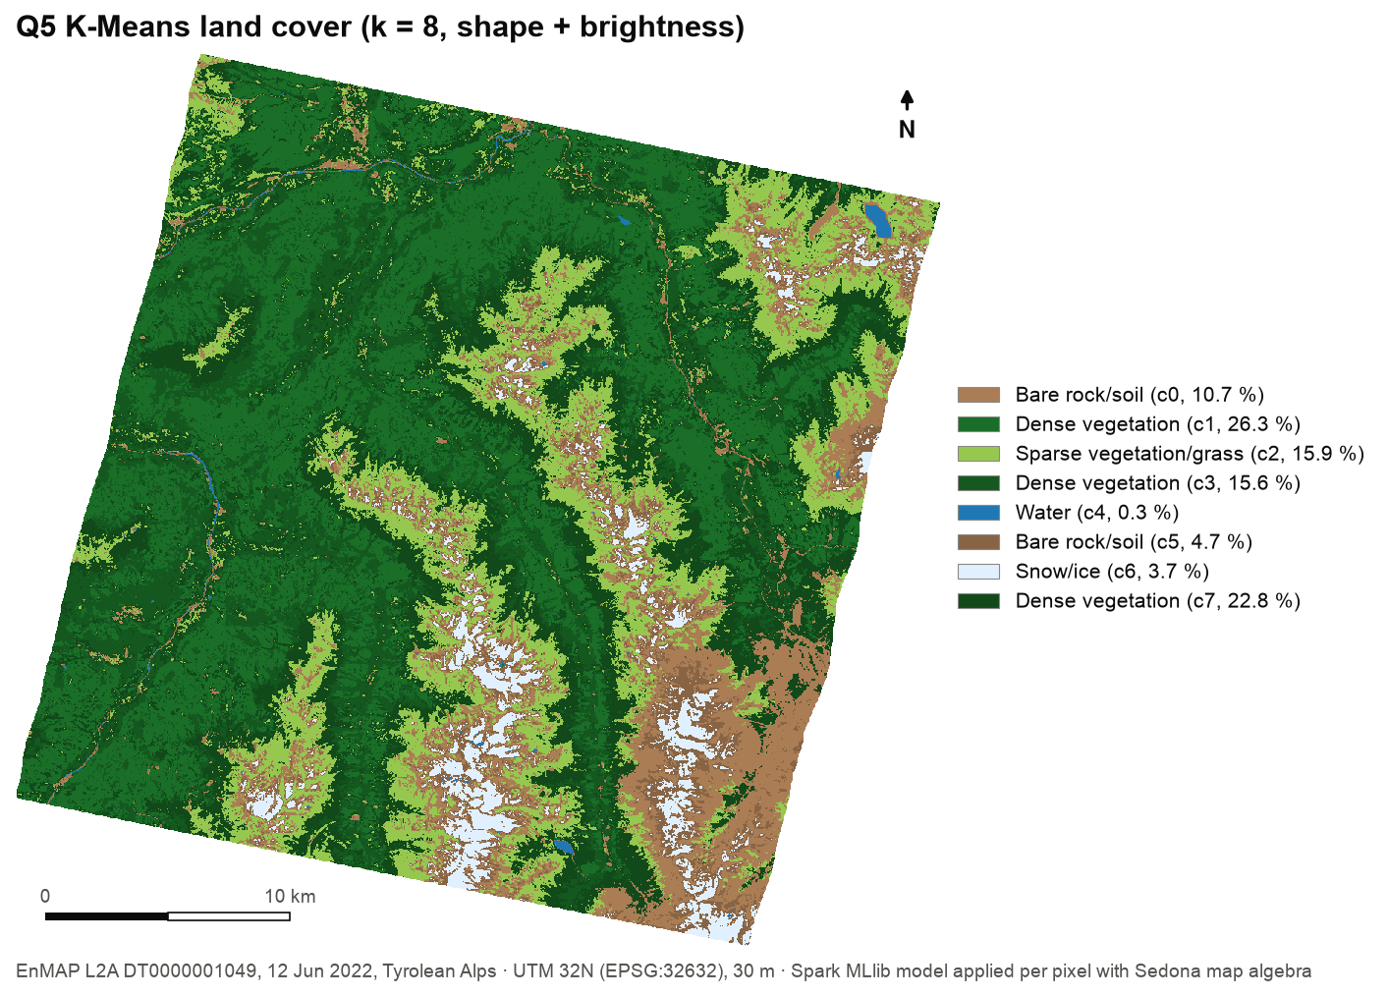
Document | Project documentation
Project | HyperSpatial — local-first hyperspectral analytics for QGIS
Author | Aaron R
Institution | Digital University Kerala
Version / date | 16 October 2026
Repository | github.com/aaron43210/HYPERSPECTRAL_DATA_DISTRIBUTED_SYSTEM

Contents
1. Project title
2. Problem statement and motivation
2.1 Problem statement
2.2 Motivation
2.3 Objectives
3. Data and geospatial layers
3.1 Primary dataset: an EnMAP L2A scene
3.2 Layers used and produced
3.3 Data preparation rules
4. Interactive and dynamic functionalities
4.1 Features
4.2 A typical session
5. Relevance, beneficiaries and expected outcome / impact
5.1 Practical significance
5.2 Potential users and beneficiaries
5.3 How the project addresses the problem
5.4 Expected outcome and impact
6. System architecture
7. Results summary
8. Limitations and future work
9. References

1. Project title
HyperSpatial: A Local-First Parallel and Distributed Hyperspectral Analytics Suite for QGIS
HyperSpatial lets a GIS user take a hyperspectral satellite scene — hundreds of spectral bands per pixel — and, from inside QGIS on an ordinary computer, compute vegetation, water and built-up indices, compress the spectrum with PCA, detect a target material by clicking a pixel, run distributed spatial SQL over the pixels, and produce a machine-learned land-cover map, all in seconds and without cloud services. It consists of two QGIS plugins and a native processing engine:
Table 1. Project components.
Component | What it does
HyperSpectral Processer (QGIS plugin 1) | Drives the C++17 engine: 7 spectral indices, PCA, Spectral Angle Mapper target detection. Parallel on CPU cores (OpenMP) and GPUs of any vendor (OpenCL).
HyperSpatial Sedona Analytics (QGIS plugin 2) | Runs Apache Spark + Apache Sedona jobs on the rasters: AOI statistics, per-field spatial joins, NDVI filtering, raw-cube NDVI, and unsupervised K-Means land-cover classification with Spark MLlib.
hyperspatial_cli (engine) | Out-of-core, tile-parallel processing of the full cube; writes GeoTIFF tiles that are also the input unit for Spark.

Table 2. Project summary.
Item | Detail
Author / institution | Aaron R · Digital University Kerala
Type | Open-source software project (two QGIS plugins + native engine), GPL-2.0
Study data | EnMAP L2A scene DT0000001049, Tyrolean Alps, 12 June 2022
Status | Working end-to-end and validated on the study scene (October 2026); processing plugin published on plugins.qgis.org (experimental)
Repository | github.com/aaron43210/HYPERSPECTRAL_DATA_DISTRIBUTED_SYSTEM

2. Problem statement and motivation

2.1 Problem statement
Imaging spectrometers in orbit — DLR's EnMAP, ASI's PRISMA, NASA's EMIT, ISRO's HySIS — measure each ground pixel in hundreds of narrow spectral bands. That spectral detail is what allows materials, plant condition, water quality, snow and minerals to be told apart, but it also makes the data heavy: a single EnMAP L2A scene used in this project is 686 MB, 1259 × 1216 pixels × 224 bands, about 240 million reflectance values for its 1.07 million valid pixels. Archives grow by many scenes per day.
The people who need these data most — agronomists, foresters, hydrologists, planners, students — mostly work in desktop GIS. Between them and the data stand four practical barriers:
Table 3. Barriers between GIS users and hyperspectral data.
Barrier | Consequence
Memory-bound desktop tools. Many open-source hyperspectral tools process scenes with in-memory Python/NumPy arrays. | Full scenes, or several scenes, exhaust the memory of ordinary laptops; users crop or subsample.
GPU acceleration tied to one vendor or licence. GPU-accelerated hyperspectral processing exists mainly in commercial software and NVIDIA/CUDA-only tools. | Apple-silicon, AMD and Intel machines — common in universities — get no GPU path at all.
Big-data analytics live outside GIS. Distributed engines such as Apache Spark require programming, clusters and data engineering. | Spatial SQL over pixels, joins with field boundaries and scalable statistics are out of reach from the GIS interface.
Machine learning needs labels and code. Supervised classifiers need training data and scripting. | Many users never get beyond single indices such as NDVI.

2.2 Motivation
- Local-first. Processing on the user's own machine avoids cloud costs, upload of large files and data-sovereignty questions, and works in teaching labs and in the field without connectivity.
- Use the hardware people already have. Modern laptops have 8–12 CPU cores and an integrated GPU; a tile-parallel engine can use all of them while keeping memory bounded.
- Bring distributed analytics and machine learning to the GIS user. Apache Sedona adds spatial SQL to Spark, and Spark MLlib adds scalable machine learning; wrapping them in QGIS dialogs removes the programming barrier.
- Trustworthy results. Every number should be checkable: the project validates its outputs against independent computations and against the quality masks DLR delivers with each scene.

2.3 Objectives
- Process a complete hyperspectral scene on a laptop in seconds, with memory that does not grow with scene size.
- Offer a GPU backend that runs on any vendor's GPU and gives the same results as the CPU.
- Bring distributed, per-pixel spatial analytics (Apache Sedona on Spark) into QGIS.
- Produce a land-cover map with machine learning, without requiring training labels.
- Keep QGIS fully responsive while any job runs.
- Validate every result against independent references.

3. Data and geospatial layers

3.1 Primary dataset: an EnMAP L2A scene
The study scene is an EnMAP Level-2A (atmospherically corrected surface reflectance) product over the Tyrolean Alps, Austria: valleys with forest and meadows, high mountains with glaciers and snow, and alpine lakes — a demanding mix of illumination, terrain shadow and surface types.
Table 4. The EnMAP study scene.
Property | Value
Product | EnMAP L2A, tile DT0000001049, processor version 01.05.06
Acquisition | 12 June 2022, 10:57 UTC
Location | Centre 47.09° N, 10.81° E (Tyrol, Austria)
Grid | 1259 × 1216 pixels at 30 m (≈ 37.8 × 36.5 km), UTM zone 32N (EPSG:32632)
Spectral bands | 224, from 418.2 nm to 2445.5 nm (VNIR + SWIR); no bands in the 1391–1461 nm and 1760–1940 nm water-vapour absorption gaps
Encoding | ENVI band-sequential (BSQ), Int16 reflectance × 10,000 (gain 0.0001), no-data −32768; 686 MB
Valid pixels | 1,069,499 (the remaining 461,445 are background outside the rotated footprint)
Source | DLR EnMAP data portal; use is subject to DLR's EnMAP data licence and acknowledgement requirements

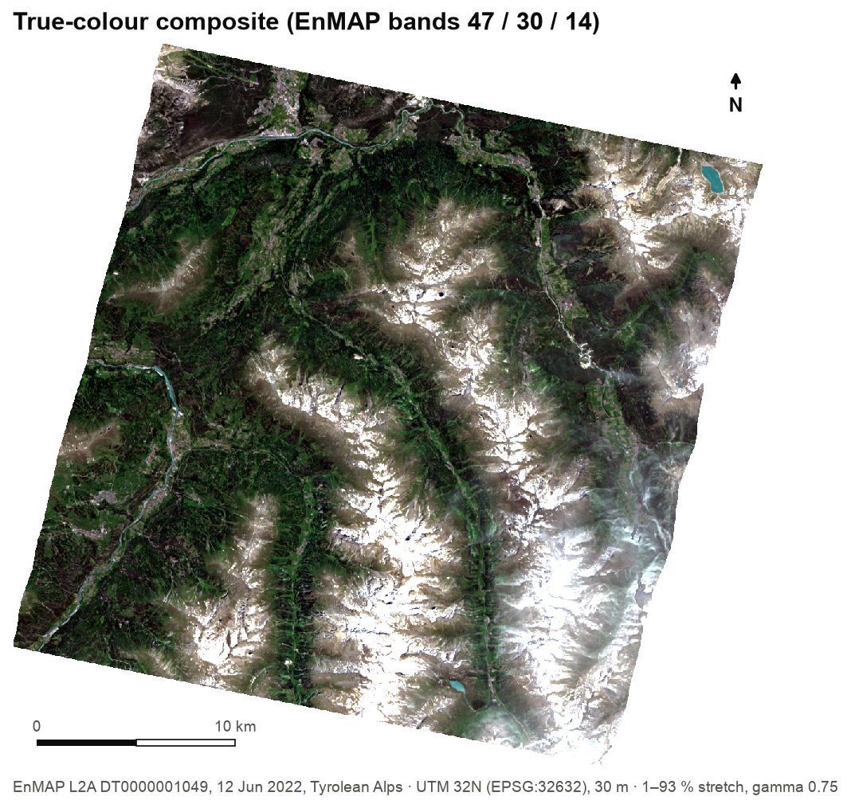
Figure 1. True-colour view of the study scene (EnMAP bands 47 / 30 / 14).

3.2 Layers used and produced
The project uses spatial layers (rasters and vectors) and non-spatial data (metadata and tables). Table 5 lists every layer, its source and how it is used.
Table 5. Spatial and non-spatial data used and produced by the project.
Layer | Type | Format | Source | Resolution / CRS | Intended use
Spectral image cube | Raster, spatial | ENVI BSQ + HDR, Int16 | DLR EnMAP L2A | 30 m, UTM 32N, 224 bands | Input to all processing and to Q4/Q5
Quality masks: land/water/background classes, cloud, cloud shadow, haze, cirrus, snow, test flags, pixel mask | Raster, spatial | GeoTIFF (byte) | DLR, delivered with the scene | Same grid as the cube | Reference data for validating SAM and K-Means; background detection
Quicklooks (VNIR, SWIR) | Raster, spatial | GeoTIFF RGB | DLR | Same grid | Visual inspection
AOI / field / zone boundaries | Vector polygons, spatial | GeoJSON, EPSG:4326 | Drawn in QGIS or from authority datasets (e.g. parcel registers); demonstration polygons supplied | — | Q1 AOI statistics, Q2 per-zone joins
Engine tiles | Raster, spatial (derived) | GeoTIFF, 224 + 7 bands | Processing engine | 30 m, 512-px tiles | Bridge to Spark/Sedona; source of index layers
Index layers (NDVI … MSAVI) | Raster (derived) | VRT or GeoTIFF | Processing engine | 30 m | Maps; Q1–Q3
PCA composite | Raster (derived) | GeoTIFF, 3 bands | Processing engine | 30 m | False-colour visualisation, dimensionality reduction
SAM angle, mask, similarity | Raster (derived) | GeoTIFF | Processing engine | 30 m | Target detection
Q3 vegetation masks, Q4 NDVI, Q5 class map | Raster (derived) | GeoTIFF / VRT | Analytics jobs | 30 m | Per-pixel analytics results; land cover
Scene metadata (METADATA.XML, HISTORY.XML, ENVI header) | Non-spatial | XML, text | DLR | — | Band wavelengths, gain/offset, map info, acquisition details
Reference spectrum | Non-spatial | 224 values | Clicked pixel on the map | — | SAM target definition
Result tables (zonal stats, clusters.csv, run_info.csv, pca_eigen.csv) | Non-spatial | CSV | Analytics jobs, engine | — | Statistics, legend labels, reporting
Benchmark and validation tables | Non-spatial | CSV | Project test scripts | — | Performance and accuracy evidence

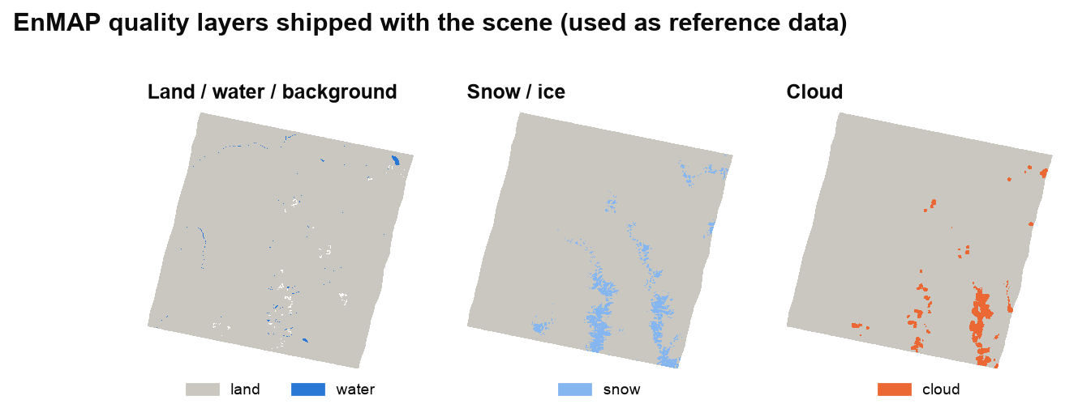
Figure 2. Three of the quality layers DLR delivers with the scene. They serve as independent reference data for validating the project's results.

3.3 Data preparation rules
- Bands by wavelength, not by number. The engine and the analytics plugin read every band's centre wavelength and pick the band nearest each target (e.g. NIR 860 nm → EnMAP band 75), so the same workflow works for other sensors.
- Reflectance scaling and no-data are handled explicitly. EnMAP stores reflectance × 10,000 with −32768 as no-data; the project keeps raw values, applies the 0.0001 factor where physical reflectance is needed, and passes the no-data value explicitly to every job (a silent scaling of the no-data value was found and fixed during validation).
- Vectors in EPSG:4326, rasters in their native CRS. Sedona reprojects zones into each raster's CRS on the fly; no manual reprojection is needed.
- Exchange formats. GeoTIFF for rasters, GeoJSON/WKT for geometries, CSV for tables — no proprietary or Arrow-based formats (which conflict with GDAL on macOS).

4. Interactive and dynamic functionalities
The project's dashboard is the QGIS window itself: the map canvas and layer panel display the results, and the two plugin dialogs act as control panels that launch processing and analytics and stream their progress live. Every result returns to the canvas as a styled, georeferenced layer that can be inspected, overlaid, queried and exported with standard QGIS tools.
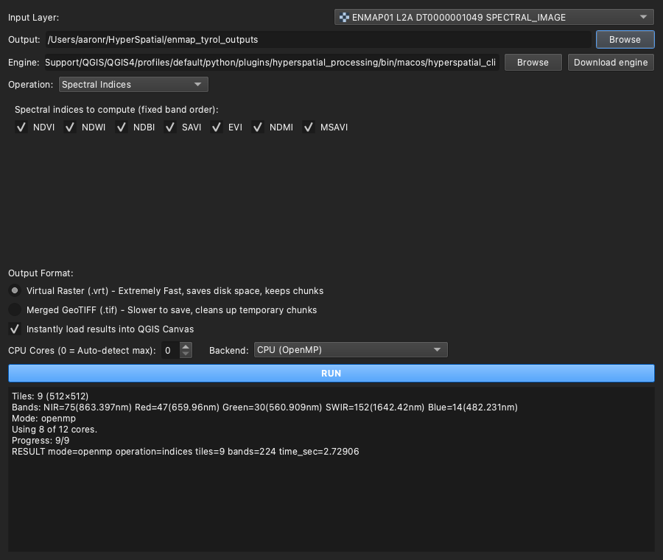
Figure 3. Control panel 1 — HyperSpectral Processer, with the engine's live output after a whole-scene run.
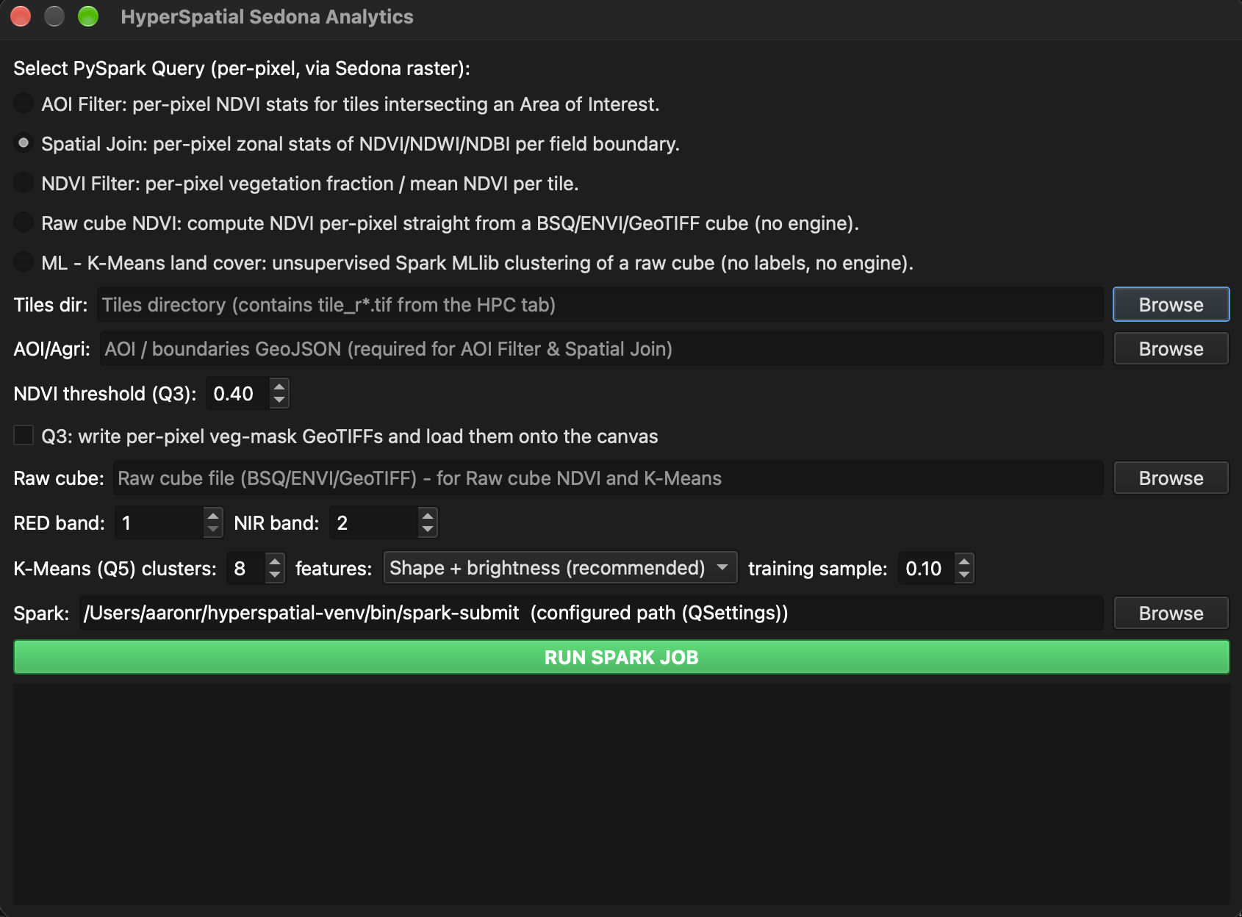
Figure 4. Control panel 2 — HyperSpatial Sedona Analytics.

4.1 Features
Table 6. Interactive and dynamic functionalities.
Feature | What the user does | What happens dynamically
Layer-based input | Picks any raster loaded in QGIS | The engine receives the file; bands are matched by wavelength automatically
Engine discovery and one-click download | Opens the dialog / clicks Download engine | The engine is found or downloaded for the user's OS in the background; status shown in colour
Operation switching | Chooses Indices, PCA or SAM | The panel changes to the options of that operation
Click-to-detect (SAM) | Clicks a pixel on the map | The pixel's full 224-band spectrum is captured; the angle threshold is shown in radians and degrees live
Backend and cores | Chooses CPU (OpenMP) or GPU (OpenCL) and the number of cores | Runs on the chosen hardware; falls back to the CPU automatically if the GPU is unavailable
Live progress | Clicks RUN | Engine and Spark output stream into the log; the interface stays fully responsive
Automatic, styled results | — | Index layers stretched −1…+1; PCA as RGB; SAM angle with an inverted colour ramp and red detection mask; Q5 class map with a labelled legend
Distributed queries | Chooses Q1–Q5, a tiles folder, an AOI/field file or a raw cube | Spark/Sedona jobs run in the background and return tables and maps
Automatic band detection | Selects a raw cube | RED/NIR (Q4) or six reflectance bands (Q5) are detected from wavelengths and filled in
Adjustable machine learning | Sets the number of clusters, feature mode and training fraction | A new land-cover model is trained and mapped in about 12 seconds; cluster labels are suggested automatically
Inspection and export | Uses QGIS's identify, layer styling, print layout and export tools | All outputs are standard GeoTIFF/VRT/CSV files

4.2 A typical session
- Load the EnMAP cube in QGIS and open HyperSpectral Processer; choose Spectral Indices and VRT output; click RUN — seven index layers appear in about 3 seconds.
- Switch to SAM, click a lake on the map, set the max angle, click RUN — the angle map and detection mask appear.
- Open HyperSpatial Sedona Analytics; choose the tiles folder and a field-boundary GeoJSON; run the spatial join — per-field NDVI, NDWI and NDBI appear as a table.
- Choose K-Means, select the raw cube, click RUN — a land-cover map with a legend appears about 12 seconds later (Figure 5).
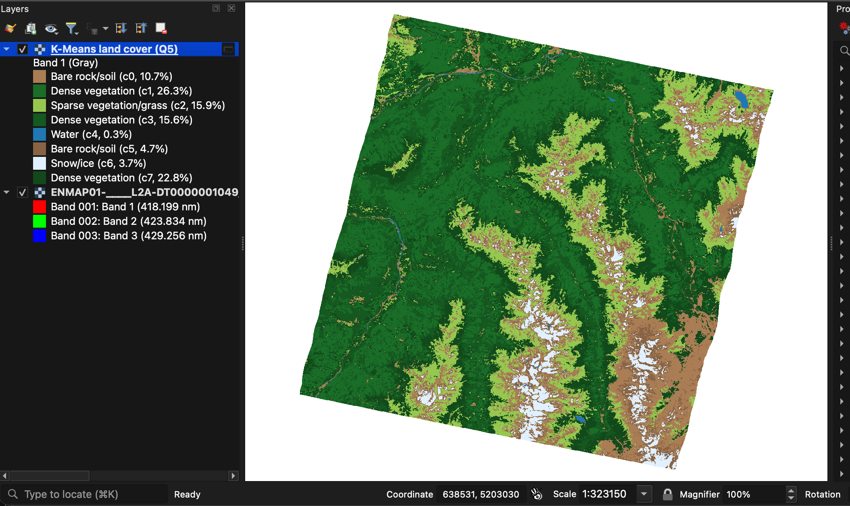
Figure 5. The QGIS dashboard after a K-Means run: the class map with its automatically labelled legend above the EnMAP scene.

5. Relevance, beneficiaries and expected outcome / impact

5.1 Practical significance
Hyperspectral archives are growing fast, and the applications that need them are everyday ones: crop condition and irrigation, forest health, inland and coastal water quality, snow and glacier monitoring, urban surfaces, and mineral mapping. The study scene illustrates several at once — alpine forest and meadows, glaciers and snowfields, and glacial lakes. HyperSpatial's significance is that it makes these analyses possible where the users already are (QGIS), on the hardware they already have, and without writing code, while remaining fast enough to explore interactively.

5.2 Potential users and beneficiaries
Table 7. Beneficiaries.
Beneficiary | How HyperSpatial helps
University researchers and students | Full-scene hyperspectral analysis on lab laptops and Macs, without a cluster, NVIDIA GPU or commercial licence; transparent, open methods for teaching.
Agriculture and forestry departments | Per-field index statistics (Q2) and vegetation masks (Q3) from field-boundary files; land-cover maps without training data.
Water-resource and disaster-management agencies | Water and snow/ice detection (NDWI, SAM, K-Means); rapid processing of new scenes.
Urban and regional planners | Built-up indices (NDBI) and land-cover classes for planning studies.
The QGIS and open-source community | Reusable plugins, a documented engine and a tested pattern for running Spark/Sedona and MLlib from QGIS.

5.3 How the project addresses the problem
Table 8. From problem to solution to evidence.
Barrier (§2.1) | HyperSpatial's answer | Evidence on the study scene
Memory-bound tools | Out-of-core tile engine; memory ≈ threads × 250 MB | Whole scene, all 7 indices in 2.5 s; peak 4.2 GB at 8 threads
Vendor-locked GPU | OpenCL 1.2 backend with CPU fallback | Runs on Apple-silicon GPU; CPU–GPU results identical except 1 pixel in 1.5 million
Big data outside GIS | Spark + Sedona jobs launched from a QGIS dialog | Per-zone joins in 8.4 s; per-pixel masks written in the JVM
ML needs labels and code | Unsupervised K-Means, compiled to per-pixel map algebra | Land-cover map in ~12 s; water IoU 0.58, snow precision 0.92 vs DLR masks

5.4 Expected outcome and impact
Table 9. Outcomes measured on the study scene (Apple M4 Pro laptop).
Outcome | Measured result
Speed | 7 indices for the whole scene in 2.52 s (3.4× faster than one core); SAM in 0.99 s; PCA in 5.96 s
Scalability of memory | Peak memory depends on threads (1.4 → 4.4 GB), not on scene size
Machine-learning land cover | 8-class map of 1,069,499 pixels in 12–14 s including Spark start-up
Correctness | Model-to-map agreement 100 %; raw-cube NDVI equal to an independent NumPy computation (0.5616)
Usability | QGIS never froze for more than 0.21 s during any job (automated test)
Reliability | 4 defects found and fixed by validating on real data; 7 unit tests, 7 end-to-end checks and 10 QGIS-level checks pass

The expected impact is a lower barrier to hyperspectral analysis for GIS users, faster turnaround from new scene to map, and reproducible, open methods that others can verify and extend.

6. System architecture
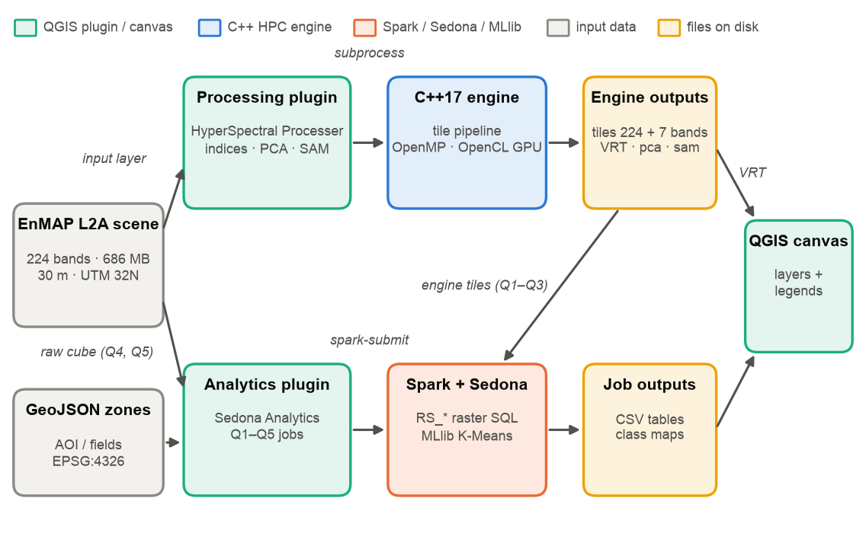
Figure 6. System architecture. Upper lane: processing plugin and C++ engine. Lower lane: analytics plugin and Spark/Sedona/MLlib. Both return layers to the QGIS canvas.
The two plugins communicate only through files: the engine's per-tile GeoTIFFs are both the source of the index layers and the input unit for Spark. The engine parallelises over tiles with OpenMP threads (each with its own GDAL handle) and can offload index, PCA and SAM kernels to an OpenCL GPU. The analytics plugin prepares inputs with GDAL on a worker thread, launches spark-submit, and Sedona evaluates per-pixel functions inside the JVM; for K-Means, the model trained by MLlib is compiled into a map-algebra script so that every pixel is classified without leaving the JVM. Detailed architecture is given in the two plugin documents.

7. Results summary
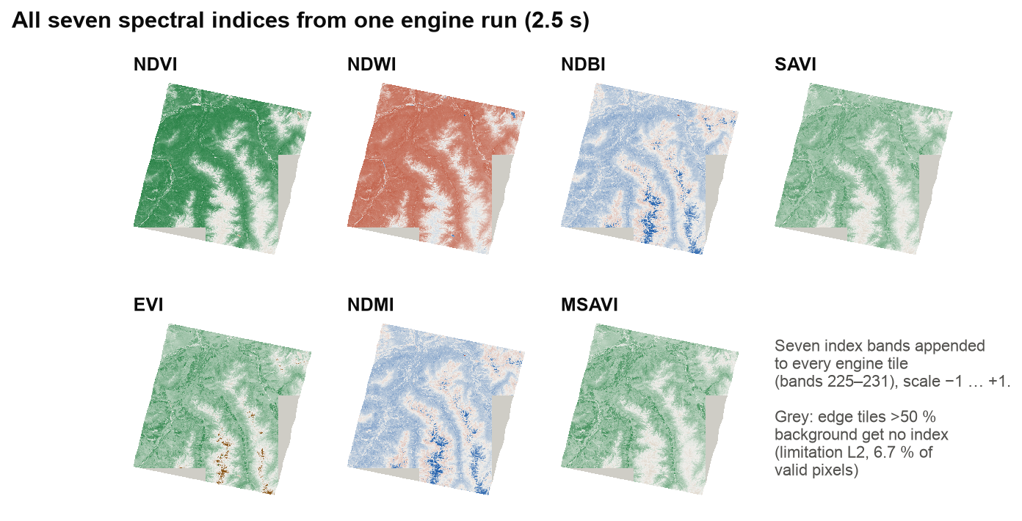
Figure 7. All seven spectral indices from one 2.5-second engine run.
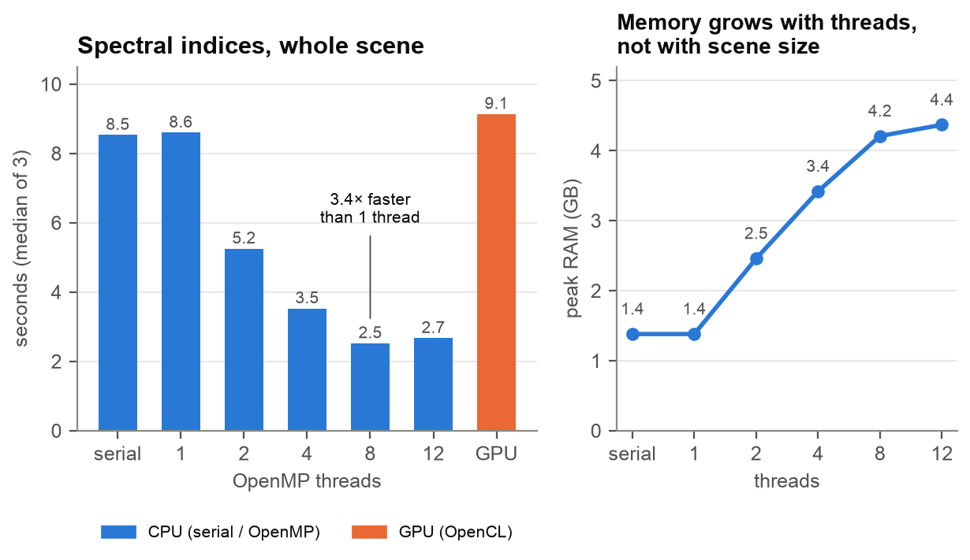
Figure 8. Engine scaling: runtime by thread count and backend, and peak memory.
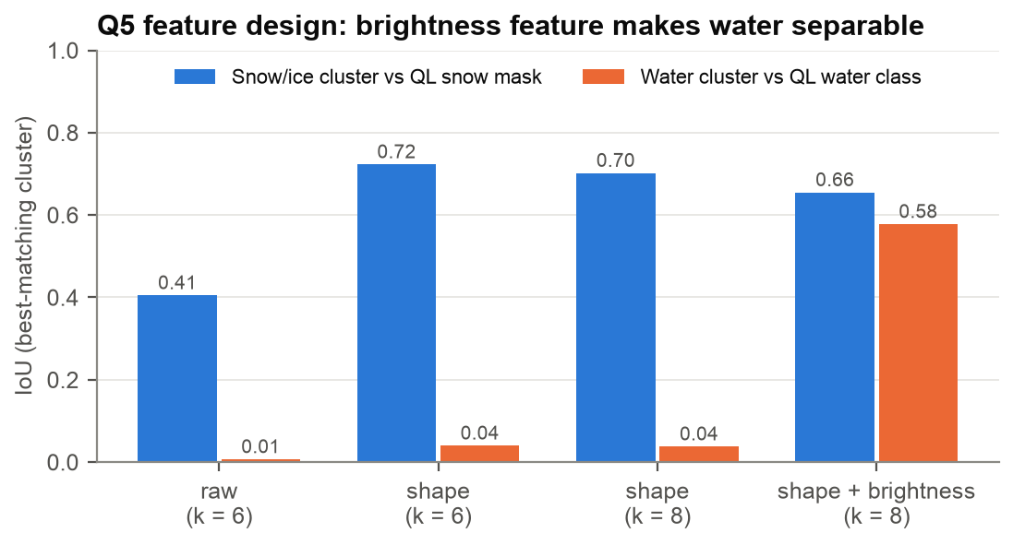
Figure 9. K-Means feature design validated against DLR's masks: adding a brightness feature to the spectral shape makes water separable.
Findings that matter for users: OpenMP scales well to 8 cores and memory stays bounded; on the Apple-silicon test machine the GPU backend is correct but not faster, because the index workload is dominated by file I/O; single-reference SAM is a precise target detector but not a general water mapper; and K-Means with shape-plus-brightness features separates water and snow reliably while clouds remain hard to distinguish from snow.

8. Limitations and future work
- Engine edge tiles (L2). Tiles that are more than 50 % background currently receive no indices (6.7 % of the study scene's valid pixels); the bad-band rule should consider only the valid footprint.
- GPU speed-up. No speed-up on Apple silicon for these I/O-bound operations; evaluate discrete GPUs and compute-heavier kernels; consider a Metal/Vulkan backend as Apple has deprecated OpenCL.
- Scale-out. All results are single-machine; the Spark jobs are cluster-ready but not yet benchmarked on a cluster.
- Machine learning. Add supervised classification (e.g. Random Forest in MLlib) when field labels exist; improve cloud/snow separation.
- Dashboard. A lightweight web dashboard for sharing results beyond QGIS is a possible extension.
- Time series. Multi-date analysis across several scenes.

9. References
- Guanter, L. et al. (2015). The EnMAP spaceborne imaging spectroscopy mission for Earth observation. Remote Sensing 7(7), 8830–8857.
- Jakimow, B. et al. (2023). EnMAP-Box: Imaging spectroscopy in QGIS. SoftwareX 23, 101507.
- Yu, J., Zhang, Z., Sarwat, M. (2019). Spatial data management in Apache Spark: the GeoSpark perspective and beyond. GeoInformatica 23, 37–78.
- Zaharia, M. et al. (2016). Apache Spark: a unified engine for big data processing. Communications of the ACM 59(11), 56–65.
- Meng, X. et al. (2016). MLlib: Machine Learning in Apache Spark. Journal of Machine Learning Research 17(34), 1–7.
- Kruse, F. A. et al. (1993). The spectral image processing system (SIPS). Remote Sensing of Environment 44, 145–163.
- Rouse, J. W. et al. (1974). Monitoring vegetation systems in the Great Plains with ERTS. NASA SP-351, 309–317.
- McFeeters, S. K. (1996). The use of the Normalized Difference Water Index (NDWI). International Journal of Remote Sensing 17(7), 1425–1432.
- Hall, D. K. et al. (2002). MODIS snow-cover products. Remote Sensing of Environment 83, 181–194.
- QGIS Development Team. QGIS Geographic Information System. Open Source Geospatial Foundation.

