Technical documentation · QGIS plugin 2 of 2
HyperSpatial Sedona Analytics
Per-pixel spatial SQL and machine learning over hyperspectral rasters with Apache Spark, Apache Sedona and Spark MLlib, inside QGIS
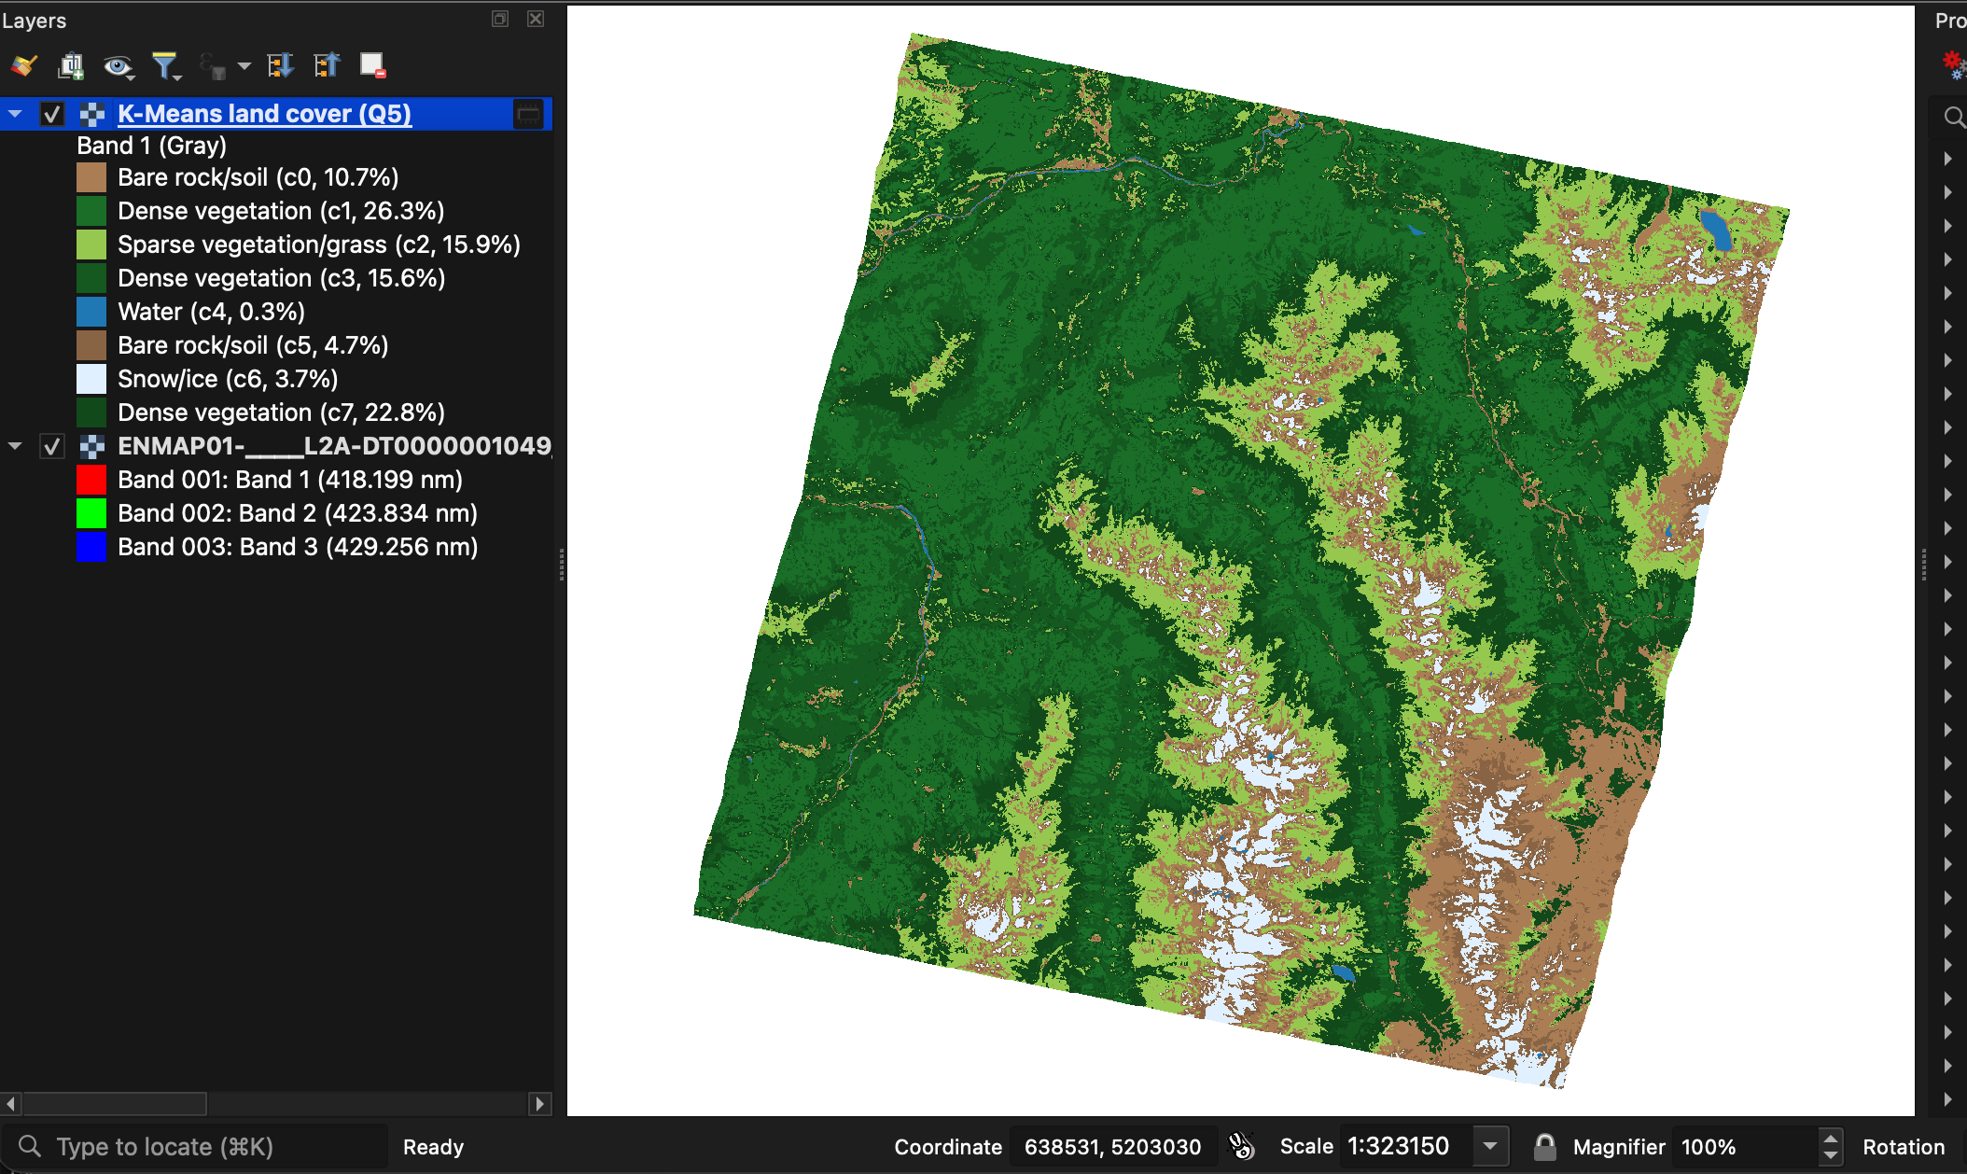
Document | Plugin documentation (architecture, usage, validation)
Project | HyperSpatial — local-first hyperspectral analytics for QGIS
Author | Aaron R
Institution | Digital University Kerala
Version / date | Plugin v0.2 · 16 October 2026
Repository | github.com/aaron43210/HYPERSPECTRAL_DATA_DISTRIBUTED_SYSTEM

Contents
1. Overview
2. Architecture
2.1 Components
2.2 Threads, processes and signals
2.3 Distributed execution model
2.4 Job interface contract
3. Installation and environment
3.1 Requirements
3.2 Installing the plugin
3.3 How the child environment is prepared
4. User interface
5. Index jobs Q1–Q4
5.1 Q1 — AOI filter
5.2 Q2 — Spatial join of zones and pixels
5.3 Q3 — NDVI filter with per-pixel masks
5.4 Q4 — NDVI straight from a raw cube
6. Q5 — Machine learning: K-Means land cover
6.1 Purpose
6.2 Pipeline
6.3 Feature design
6.4 Compiling the model to Jiffle
6.5 Cluster labelling
6.6 Outputs
6.7 Results on the test scene
7. Data contracts and the raw-cube tile rules
8. Validation and testing
8.1 Unit tests (no Spark, no QGIS)
8.2 End-to-end validation on a real scene
8.3 Headless QGIS smoke test
9. Performance
10. Defects fixed in version 0.2
11. Limitations and troubleshooting
11.1 Known limitations
11.2 Troubleshooting
Appendix A. Job command-line reference
Appendix B. References

1. Overview
HyperSpatial Sedona Analytics is the second of the two HyperSpatial QGIS plugins. The first plugin (HyperSpectral Processer) turns a hyperspectral scene into analysis-ready raster tiles with a native C++ engine; this plugin runs distributed, per-pixel analytics on rasters with Apache Spark and Apache Sedona, and adds an unsupervised machine-learning land-cover classifier built on Spark MLlib. Everything runs on the user's own machine: the plugin launches spark-submit as a background process, Sedona reads the GeoTIFFs directly, and the results come back to the QGIS canvas as styled layers.
The plugin answers five questions about a scene. Four work on spectral indices (NDVI and related ratios); the fifth learns land-cover classes from the reflectance spectra themselves without any training labels.
Table 1. The five analytics jobs.
Job | Question it answers | Input | Output
Q1 AOI filter | How green is the land inside my area of interest? | Engine tiles + AOI GeoJSON | Per-tile mean NDVI and pixel count inside the AOI (CSV)
Q2 Spatial join | What are the NDVI / NDWI / NDBI means of each field or zone? | Engine tiles + field GeoJSON | One row per field, pixel-weighted across tiles (CSV)
Q3 NDVI filter | Which tiles are vegetated, and where exactly? | Engine tiles + threshold | Tile list (CSV) + per-pixel vegetation masks (GeoTIFF)
Q4 Raw-cube NDVI | What is the NDVI of a raw cube without running the engine? | BSQ / ENVI / GeoTIFF cube | Mean NDVI (CSV) + NDVI raster
Q5 K-Means land cover | Which land-cover classes does the scene contain? | BSQ / ENVI / GeoTIFF cube | Class map with labelled legend + cluster table (CSV)

Table 2. Plugin facts.
Item | Value
QGIS plugin package | hyperspatial_analytics (display name: HyperSpatial Sedona Analytics), version 0.2, experimental
QGIS versions | 3.0 – 4.99 declared; tested on QGIS 4.2.3 (Qt 6.11, GDAL 3.13) on macOS (Apple M4 Pro)
Compute stack | Apache Spark / PySpark 3.4.2, Apache Sedona 1.5.1 (sedona-spark-shaded-3.4_2.12), geotools-wrapper 1.5.1-28.2 (provides the Jiffle map-algebra engine), Spark MLlib, Java 17
Python environment | A dedicated environment for Spark (tested: ~/hyperspatial-venv with Python 3.11, PySpark 3.4.2, Sedona 1.5.1, NumPy 1.26, Shapely 2). No pyarrow (see §3)
Data exchange | GeoTIFF rasters, GeoJSON / WKT geometries, CSV tables — no GeoParquet
Licence | GPL-2.0

What is new in version 0.2
- Q5 K-Means land cover — the machine-learning job (§6).
- Q4 NDVI bias fixed — EnMAP's no-data background was averaged in as NDVI 0 (mean 0.393 instead of 0.562).
- Q1–Q3 now run on full EnMAP engine output — they previously failed with OutOfMemoryError.
- Q3 no longer reports empty tiles as vegetated (Spark orders NaN above every number).
- Spark is protected from QGIS's own Python settings (PYTHONHOME / PYTHONPATH are removed from the child environment).

2. Architecture
The plugin is a thin user interface in front of a set of PySpark job scripts. It never computes on pixels in the QGIS process: QGIS's GDAL is used only to prepare GeoTIFF inputs and to mosaic results, and all per-pixel work happens in the Spark JVM through Sedona's raster functions. Figure 1 shows where the plugin sits in the complete HyperSpatial system, and Figure 2 shows the plugin's own data flow.
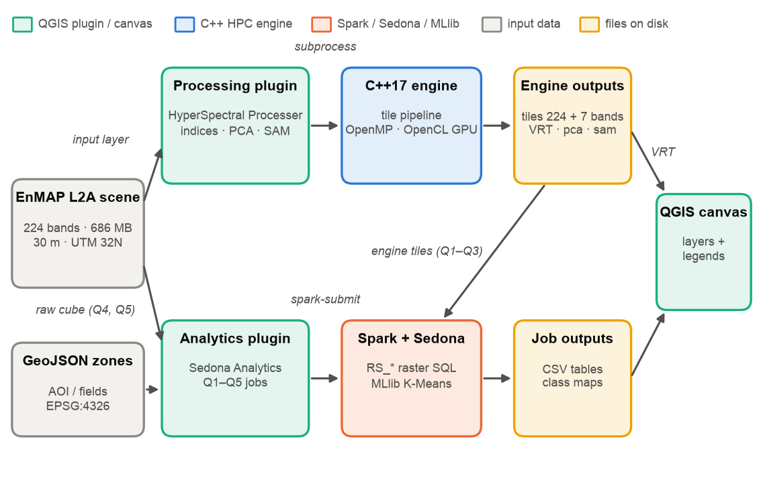
Figure 1. HyperSpatial system context. The analytics plugin (lower lane) consumes the engine's tiles for Q1–Q3 and the raw cube for Q4–Q5.
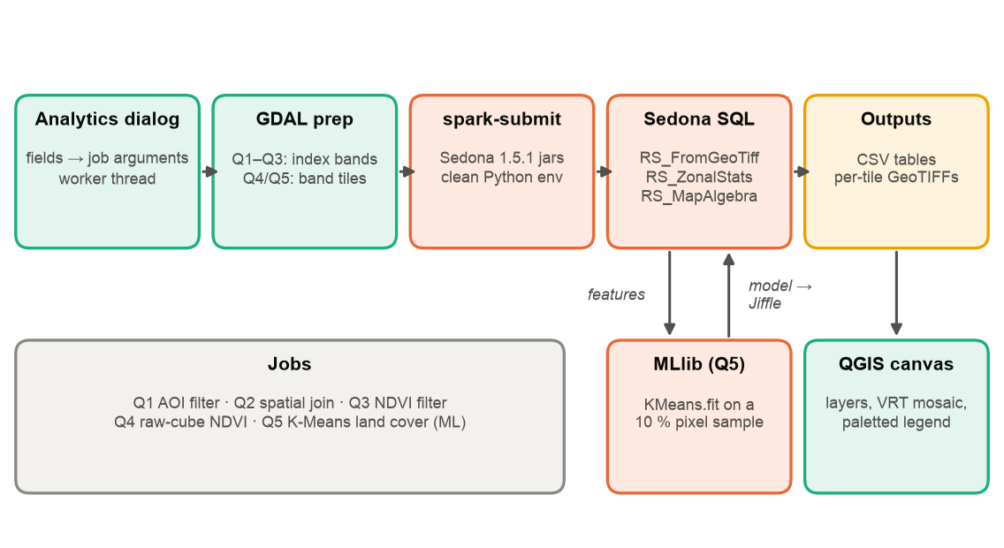
Figure 2. Analytics data flow: the dialog validates inputs, a worker thread prepares GeoTIFF inputs with GDAL, spark-submit runs a Sedona job in the JVM, and the results return to the canvas.

2.1 Components
Table 3. Plugin components.
File | Role
plugin.py | Registers the toolbar action and opens the dialog (modeless, so QGIS stays usable).
dialog.py | SedonaAnalyticsDialog: input widgets, job selection, worker threads, Qt signals, layer loading and styling.
spark_locator.py | Finds spark-submit (saved setting → SPARK_HOME → PATH → common install dirs → login shell) and builds a clean child environment (spark_env).
raster_prep.py | GDAL helpers run by the plugin: wavelength-based band detection, raw-cube tiling, 7-band index extraction from engine tiles.
spark-sedona/jobs/q1…q5 | The PySpark + Sedona job scripts (bundled copy of the repository's spark-sedona/).
spark-sedona/utils/sedona_session.py | Creates the SedonaContext (Kryo serializer, Sedona registrator).
spark-sedona/utils/raster_io.py | load_tiles: reads tile_r*.tif with binaryFile + RS_FromGeoTiff, derives index band numbers and tile footprints.
spark-sedona/utils/ml_jiffle.py | Q5: feature definitions (Spark and Jiffle from one source), model-to-Jiffle compiler, cluster labelling.
tests/ (not packaged) | Unit tests, end-to-end validation against a real EnMAP scene, headless QGIS dialog smoke test (§8).

2.2 Threads, processes and signals
QGIS must never freeze while Spark runs (a scene-level job takes 7–15 seconds, longer on bigger data). The plugin therefore uses three execution contexts and passes results between them only through Qt signals:
Table 4. Execution contexts.
Context | Runs | Never does
GUI thread | Widget handling, input validation, creating map layers and renderers (signal slots) | GDAL work on large files, waiting for Spark
Worker thread (threading.Thread) | GDAL preparation, launching spark-submit, streaming its log, building the VRT mosaic | Touching Qt widgets or QgsProject directly
spark-submit child process | Spark driver + executors (JVM) and the PySpark job script | Anything in the QGIS process

Table 5. Qt signals between the worker thread and the GUI.
Signal | Emitted by | Slot (GUI thread)
spark_log(str) | Worker, for every log line | Appends to the log panel
spark_finished() | Worker, always (in finally) | Re-enables the RUN button
rasters_ready(str) | Worker after a successful Q3 / Q4 run | Loads each result GeoTIFF as a layer
kmeans_ready(str, str) | Worker after a successful Q5 run | Adds the class-map VRT with a paletted legend built from clusters.csv

2.3 Distributed execution model
Each job is an ordinary Spark application. spark.read.format("binaryFile") turns every GeoTIFF into one row, so the tile is the unit of parallelism: Spark splits the files into partitions and runs one task per partition on each available core. Sedona's RS_* functions run inside those tasks, in the JVM, so raster data is never serialised into Python. Aggregations (for example Q2's per-field weighted means) are ordinary Spark SQL GROUP BYs, which Spark executes as a distributed shuffle.
The plugin starts Spark in local mode (local[*]: one JVM using every core), which is the right choice for a single workstation. Because the jobs are plain Spark, the same scripts run unchanged on a multi-machine cluster by pointing spark-submit at a cluster master and putting the tiles on shared storage; this is the scale-out path, but the results in this document were all measured on one machine.

2.4 Job interface contract
The plugin and the jobs communicate only through command-line arguments and files. A wrong argument name makes the job exit before Spark starts, so the contract is fixed (full reference in Appendix A):
spark-submit --packages org.apache.sedona:sedona-spark-shaded-3.4_2.12:1.5.1,\
org.datasyslab:geotools-wrapper:1.5.1-28.2 \
--repositories https://artifacts.unidata.ucar.edu/repository/unidata-all \
<job>.py --rasters <dir of tile_r*.tif> --output <dir> [job options]

The Sedona jars must be on the spark-submit command line (--packages): configuring them inside the job has no effect once the JVM is running, and the RS_* functions would be missing.

3. Installation and environment

3.1 Requirements
- QGIS 3.x or 4.x with its bundled GDAL (used only for preparing inputs and mosaics).
- Java 17 (Spark 3.4 also supports 8 and 11). On macOS: brew install openjdk@17.
- A separate Python 3.11 environment containing PySpark 3.4 and Apache Sedona 1.5.1, for example python3.11 -m venv ~/hyperspatial-venv then pip install "pyspark==3.4.*" "apache-sedona[spark]==1.5.1" shapely numpy, or the repository's environment.yml with conda.
- Internet access on the first run only: --packages downloads the Sedona jars into the Ivy cache (~/.ivy2); later runs use the cache.
Do not install pyarrow in the Spark environment
On macOS, pyarrow bundled into the Spark/Python process collides with the system GDAL libraries and crashes the process. The jobs therefore exchange tables only as CSV and geometries only as GeoJSON/WKT, and never use pandas_udf, mapInPandas or Arrow-backed toPandas(). (A second environment on the test machine, ~/py311, contains pyarrow and a broken NumPy 2 / Shapely combination and must not be selected.)

3.2 Installing the plugin
- Build the zip: bash qgis-plugin/hyperspatial_analytics/package_plugin.sh (produces hyperspatial_analytics.zip, 40 KB, with the jobs bundled and the tests excluded).
- In QGIS: Plugins → Manage and Install Plugins → Install from ZIP, choose the zip, install.
- Open the plugin from the toolbar. On the Spark row click Browse and select the environment's spark-submit (for example ~/hyperspatial-venv/bin/spark-submit). The path is remembered.

3.3 How the child environment is prepared
spark_locator.spark_env() builds the environment for the spark-submit process. Each item exists because its absence caused a real failure:
Table 6. Child-process environment.
Setting | Value | Why
HADOOP_CONF_DIR | empty | A populated value makes the JVM parse local Hadoop XML and crash on macOS.
PYTHONHOME, PYTHONPATH | removed | QGIS's embedded Python may export them; the Spark environment's interpreter (a different Python version) would then load QGIS's standard library and die before Spark starts (“SRE module mismatch”).
PYSPARK_PYTHON, PYSPARK_DRIVER_PYTHON | the Python next to spark-submit | Spark's Python must be the environment that contains PySpark and Sedona, not QGIS's Python.
JAVA_HOME, PATH | detected JDK; spark-submit and JDK bin dirs first | QGIS launched from Finder does not inherit the login shell's PATH.

4. User interface
Figure 3 shows the dialog. All fields are visible at all times; each job reads only the fields it needs (Table 8).
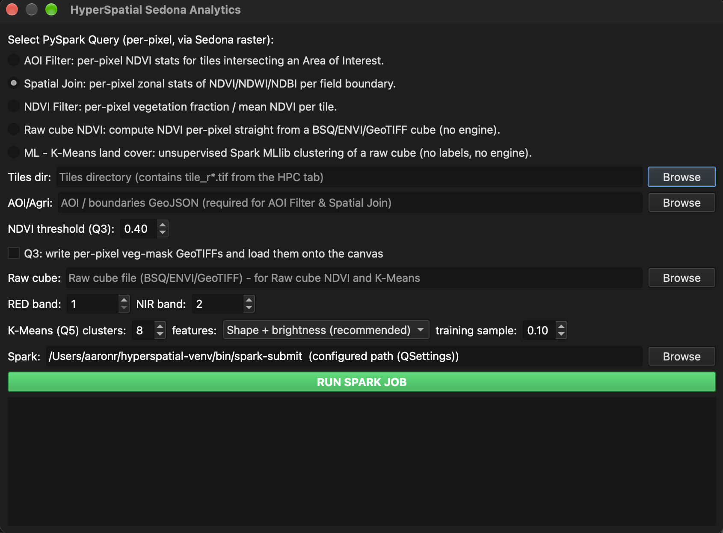
Figure 3. The HyperSpatial Sedona Analytics dialog in QGIS 4.2.3 (macOS, dark theme).
Table 7. Dialog controls.
Control | Used by | Meaning
Query radio buttons | all | Selects the job (Q1–Q5).
Tiles dir + Browse | Q1, Q2, Q3 | The processing plugin's output folder containing tile_r####_c####.tif (224 raw + 7 index bands). Use the processing plugin's VRT output mode so the tiles are kept.
AOI/Agri + Browse | Q1, Q2 | GeoJSON polygon(s) in EPSG:4326. Q2 reads the field_id and crop_type properties.
NDVI threshold | Q3 | Vegetation threshold (default 0.40).
Q3 veg-mask checkbox | Q3 | Also write a per-pixel vegetation mask per tile and load it onto the canvas.
Raw cube + Browse | Q4, Q5 | A BSQ / ENVI / GeoTIFF hyperspectral file (choosing the .hdr also works).
RED band / NIR band | Q4 | Filled automatically from the cube's wavelengths when the cube is chosen; editable.
K-Means clusters / features / training sample | Q5 | Number of clusters (2–12, default 8), feature mode (default shape + brightness) and training fraction (default 0.10).
Spark + Browse | all | The spark-submit executable (shown in red when not found).
RUN SPARK JOB | all | Starts the job; disabled until the job finishes.
Log panel | all | Live output of the preparation step and of Spark.

Table 8. What to fill in for each job.
Job | Fill in | Results go to
Q1 AOI filter | Tiles dir, AOI/Agri | <tiles dir>/sedona_results/q1_aoi_filter/ (CSV)
Q2 Spatial join | Tiles dir, AOI/Agri (with field_id, crop_type) | <tiles dir>/sedona_results/q2_spatial_join/ (CSV)
Q3 NDVI filter | Tiles dir; optionally threshold and the mask checkbox | <tiles dir>/sedona_results/q3_ndvi_filter/ (CSV) and …_rasters/ (masks, loaded on the canvas)
Q4 Raw-cube NDVI | Raw cube (RED/NIR auto-filled) | A temporary work folder printed in the log; NDVI raster loaded on the canvas
Q5 K-Means | Raw cube (K-Means row optional) | A temporary work folder printed in the log; class map with legend loaded on the canvas

5. Index jobs Q1–Q4
Q1–Q3 analyse the engine's spectral-index bands. Before Spark starts, the worker thread copies only the 7 trailing index bands of every engine tile into a temporary folder (raster_prep.extract_index_tiles, about 2 s and 32 MB for an EnMAP scene). The band order is unchanged, so the jobs still address NDVI as band RS_NumBands − 6, NDWI as − 5, and so on. Section 9 explains why this step is essential.
All results below were produced on the EnMAP L2A test scene (Tyrolean Alps, 12 June 2022; 1259 × 1216 pixels, 224 bands, 30 m) from the processing engine's 512-pixel tiles. Q1 and Q2 used demonstration polygons (Figure 4) included with the documentation in docs/deliverables/data/; they are illustrative zones, not surveyed field boundaries.
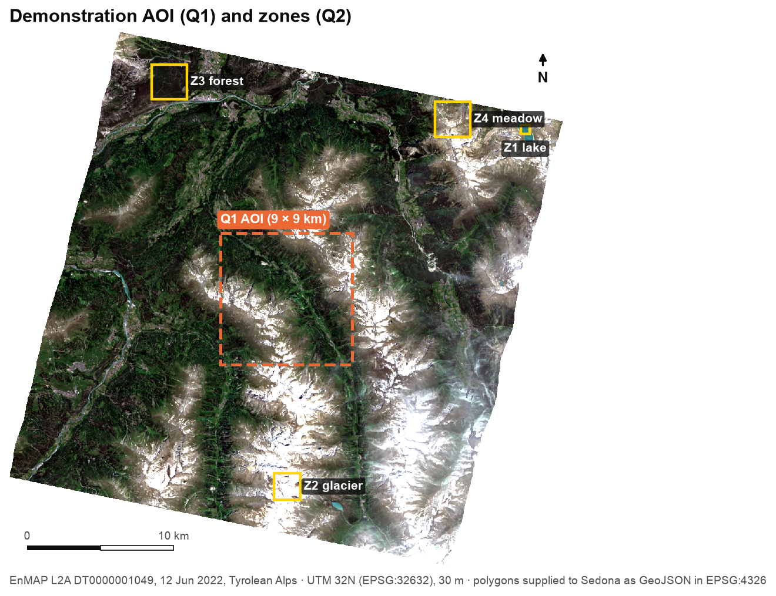
Figure 4. Demonstration inputs: a 9 × 9 km AOI for Q1 and four 0.6–2.4 km zones for Q2 (lake, glacier, forest, meadow), drawn on the true-colour composite.

5.1 Q1 — AOI filter
Method. The AOI (GeoJSON, one polygon or a dissolved collection) is loaded with Shapely and passed to Sedona as WKT in EPSG:4326. Tiles whose reprojected footprint intersects the AOI are selected with ST_Intersects; for each, RS_ZonalStats(rast, aoi, ndvi_band, 'mean' / 'count', true) computes the mean NDVI and pixel count of the pixels inside the AOI (Sedona reprojects the AOI into the raster's CRS internally).
Result (demo AOI). Four tiles contribute 89,991 pixels — the full 300 × 300-pixel AOI. Mean NDVI inside the AOI per tile: 0.585 (65,653 px), 0.613 (7,838 px), 0.561 (14,740 px) and 0.841 (1,760 px). Runtime: 6.6 s including Spark start-up.

5.2 Q2 — Spatial join of zones and pixels
Method. Every (zone, intersecting tile) pair produces a zonal mean and pixel count for NDVI, NDWI and NDBI. The per-zone result is the pixel-weighted mean across tiles — SUM(mean × px) / SUM(px) — so a zone that straddles tiles gets its true mean, not an average of per-tile averages.
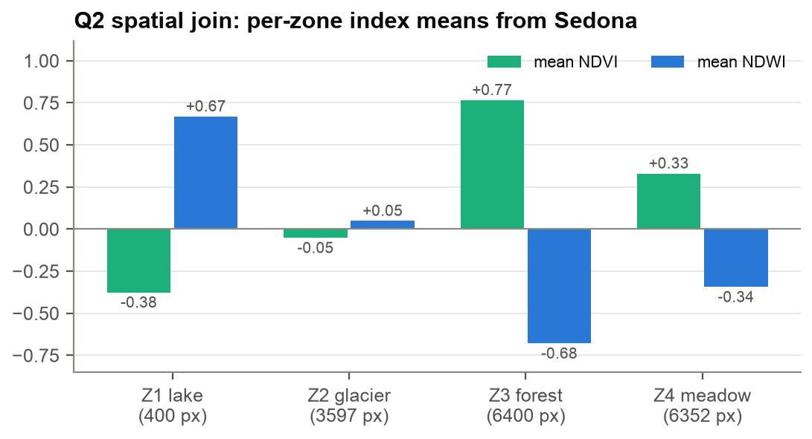
Figure 5. Q2 result for the demonstration zones. The lake has strongly positive NDWI, the forest high NDVI, the glacier values near zero.
The values behave as physics predicts — open water: NDVI −0.38, NDWI +0.67; forest: NDVI 0.77, NDWI −0.68; alpine meadow: NDVI 0.33; glacier: NDVI −0.05. Runtime: 8.4 s. This run also confirmed that Sedona's EPSG:4326 axis handling (a known risk on some GeoTools builds) works correctly with Sedona 1.5.1 on real UTM data.

5.3 Q3 — NDVI filter with per-pixel masks
Method. Per tile, RS_ZonalStats over the tile envelope gives the mean NDVI and valid-pixel count; tiles with mean ≥ threshold are reported. With the mask option, RS_MapAlgebra(rast, 'D', 'out = (rast[ndvi] >= t) ? 1 : 0;') produces a per-pixel vegetation mask that Sedona's native raster writer saves as one GeoTIFF per tile, entirely inside the JVM.
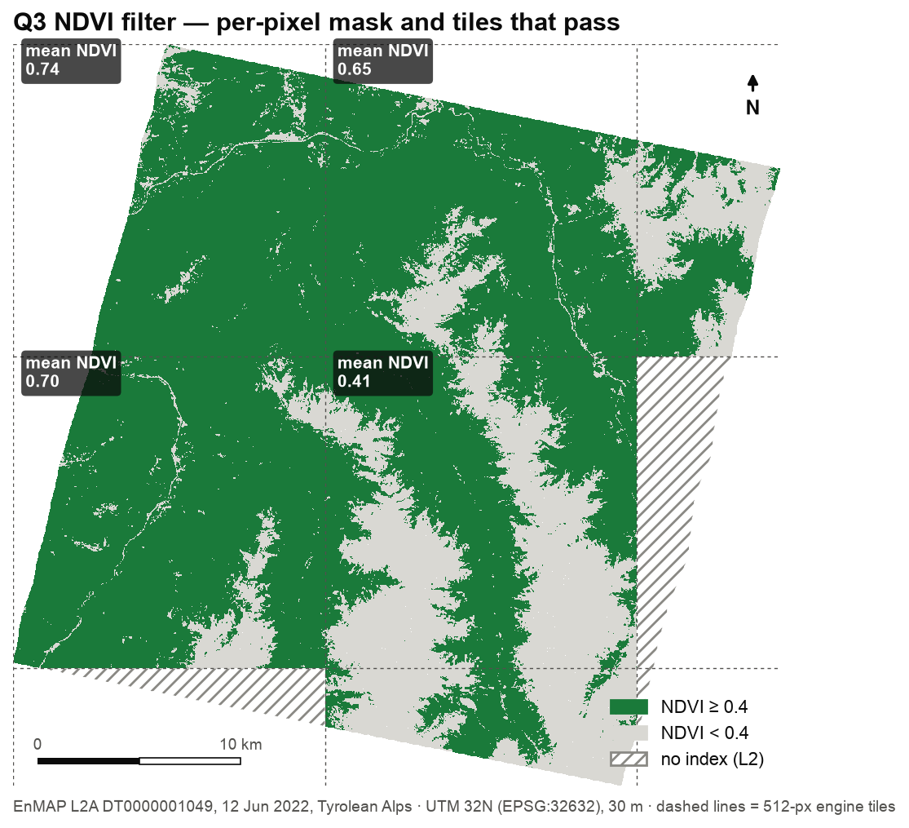
Figure 6. Q3 at threshold 0.4: per-pixel mask (green = NDVI ≥ 0.4) and the four tiles that pass, with their mean NDVI. Hatched areas are edge tiles for which the engine produced no indices (limitation L2, §11).
Result. Four of nine tiles pass (mean NDVI 0.74, 0.70, 0.65, 0.41). Runtime 6.3–9.0 s including the index extraction.

5.4 Q4 — NDVI straight from a raw cube
Method. The plugin detects the RED (~665 nm) and NIR (~842 nm) bands from the cube's wavelength metadata (EnMAP: bands 48 and 72), extracts them into a single GeoTIFF, and the job evaluates NDVI per pixel with RS_MapAlgebra. Pixels whose RED or NIR equals the cube's no-data value (--nodata, −32768 for EnMAP) or whose sum is zero become −9999, which RS_ZonalStats excludes.
Table 9. Q4 against an independent NumPy computation on the test scene.
Run | Mean NDVI | Valid pixels
NumPy reference (non-no-data pixels) | 0.5616 | 1,069,499
Q4 before v0.2 | 0.3929 (wrong) | 1,528,470 (includes background)
Q4 in v0.2 | 0.5616 | 1,069,486 (13 edge pixels skipped, see L4)

The pre-0.2 error came from metadata: gdal.Translate copied EnMAP's scale factor (0.0001) into the GeoTIFF, GeoTools applied it on reading, and the −32768 background reached Sedona as −3.2768 — no longer recognisable as no-data, so 30 % of the scene was averaged in as NDVI ≈ 0. Section 7 describes the fix.

6. Q5 — Machine learning: K-Means land cover

6.1 Purpose
Q5 produces a land-cover map of a hyperspectral scene without any training labels. K-Means clustering groups pixels with similar spectra; the plugin then names each cluster from its mean spectrum (snow/ice, water, dense vegetation, sparse vegetation/grass, bare rock/soil, shadow). Unsupervised clustering is the natural first machine-learning step for a new scene: no field data is needed, and the clusters show the spectral structure that any later supervised classifier would have to learn.

6.2 Pipeline
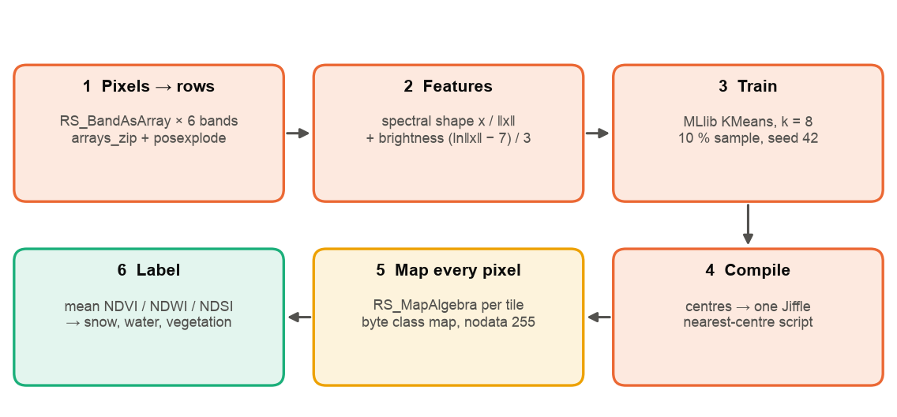
Figure 7. Q5 pipeline. Steps 1–5 run in Spark/Sedona; no raster ever crosses into Python.
- Prepare (worker thread, GDAL). Six bands are chosen by wavelength — blue 482, green 560, red 660, NIR 860, SWIR1 1650, SWIR2 2200 nm (EnMAP bands 14, 30, 47, 75, 153, 193) — and written as 256-pixel tiles (25 tiles for the test scene) with scale/offset and the no-data flag removed.
- Pixels → rows. RS_BandAsArray returns each band as a plain array<double>; arrays_zip + posexplode turn the arrays into one row per pixel; rows where any band equals the no-data value (or the vector is all zero) are dropped — 1,069,499 valid pixels.
- Features. ml_jiffle.add_spark_features builds the feature vector (§6.3).
- Train. pyspark.ml.clustering.KMeans (k-means‖ initialisation, maxIter 50, seed 42) is fitted on a 10 % random sample (≈107 000 pixels) — about 3–4 s.
- Compile and map. The k centres are compiled into one Jiffle script (§6.4) and applied to every pixel of every tile with RS_MapAlgebra(rast, 'B', script, 255), producing an unsigned-byte class map per tile; the native raster writer saves the tiles.
- Label and report. model.transform on all pixels gives each cluster's pixel count and mean reflectance, from which the label and the NDVI/NDWI/NDSI of the cluster are computed (§6.5). The plugin mosaics the class tiles into one VRT and loads it with a legend.

6.3 Feature design
Three feature modes are available. Let x be a pixel's six-band vector and ‖x‖ its Euclidean length.
Table 10. Q5 feature modes.
Mode | Feature vector | Effect
raw | x | Plain Euclidean K-Means on reflectance. Brightness dominates: the same material in sun and shade lands in different clusters.
shape | x / ‖x‖ | Spectral shape only — the idea behind the Spectral Angle Mapper. Insensitive to illumination, but dark water and bright snow have similar shapes.
shape_brightness (default) | [ x / ‖x‖ , (ln‖x‖ − 7) / 3 ] | Shape plus one log-brightness feature, scaled to roughly −0.3…1.0 — restores the brightness contrast needed to separate water from snow.

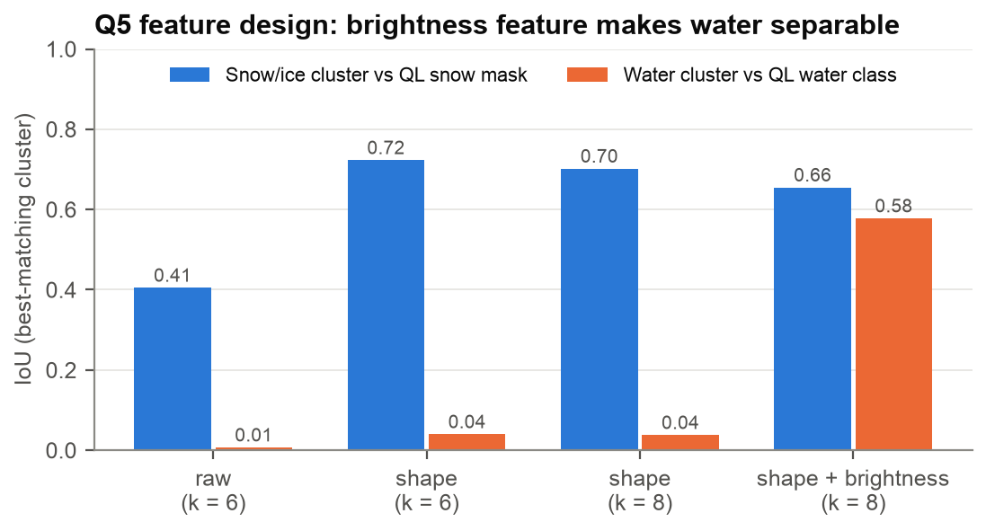
Figure 8. Effect of the feature design on the test scene, scored against EnMAP's own quality masks. Only shape + brightness isolates water (IoU 0.58).

6.4 Compiling the model to Jiffle
Sedona 1.5.1 cannot deserialise raster objects in Python, and a per-pixel Python UDF would be slow and would need pyarrow. Q5 therefore compiles the trained model: ml_jiffle.kmeans_to_jiffle writes the feature transform and the nearest-centre rule as a Jiffle script that RS_MapAlgebra evaluates per pixel in the JVM. The generated script for a two-band, two-cluster model (the real job uses six bands and eight clusters, ≈ 4,400 characters) is:
n = sqrt(rast[0]*rast[0] + rast[1]*rast[1]);
br = (log(n) - (7.000000000000)) / (3.000000000000);
d0 = ((rast[0]/n)-(0.310000000000))*(...) + ... + (br-(0.420000000000))*(...);
d1 = ((rast[0]/n)-(0.620000000000))*(...) + ... + (br-(1.360000000000))*(...);
best = 0;
bd = d0;
best = d1 < bd ? 1 : best;
bd = d1 < bd ? d1 : bd;
ok = n > 0 ? 1 : 0;
ok = rast[0] == (-32768.000000000000) ? 0 : ok;
ok = rast[1] == (-32768.000000000000) ? 0 : ok;
out = ok == 1 ? best : 255;

Three generator rules came from real failures: every constant is written in fixed-point and in parentheses (a negative centre otherwise produced x--3.2, which Jiffle rejects); ties go to the lowest cluster index, as in MLlib; and every ternary is single-level, which lets the unit tests execute the script in Python. The output nodata is 255, not −9999 — −9999 cannot be stored in an unsigned-byte band, yet Sedona accepts it silently.
Verified equivalence
With --verify, the job joins MLlib's own predictions with the Jiffle map pixel by pixel. On the test scene they agree on 100.000 % of the 1,069,499 valid pixels (k = 8; one run at k = 8 with shape-only features differed on a single pixel — a floating-point tie).

6.5 Cluster labelling
Each cluster's mean reflectance (stored values × the cube's scale factor) is converted to three normalised-difference indices and labelled by standard thresholds, checked in this order:
Table 11. Labelling rules (ml_jiffle.suggest_label). Labels are suggestions; the cluster table keeps the indices so a user can relabel.
Label | Rule | Basis
Snow/ice | NDSI > 0.4 and green reflectance ≥ 0.2 | MODIS snow rule (NDSI = (G − SWIR1)/(G + SWIR1)); brightness separates snow from water, which also has high NDSI
Water | NDWI > 0 and NIR < 0.15 | McFeeters NDWI = (G − NIR)/(G + NIR)
Dense vegetation | NDVI > 0.6 | NDVI = (NIR − R)/(NIR + R)
Sparse vegetation/grass | NDVI > 0.3
Shadow/dark surface | mean reflectance < 0.05
Bare rock/soil | otherwise

6.6 Outputs
Table 12. Q5 outputs (inside the work folder printed in the log).
File | Content
sedona_results/clusters.csv | cluster, suggested_label, pixels, pct, ndvi, ndwi, ndsi, refl_blue … refl_swir2 — one row per cluster
sedona_results/run_info.csv | k, features, sample, seed, bands, tiles, valid_pixels, fit_sec, wall_sec, jiffle_chars, agreement
class_tiles/…/tile_r####_c####_kmeans.tif | Unsigned-byte class map per tile (value = cluster id, no-data 255)
kmeans_classes.vrt | Mosaic of the class tiles, loaded on the canvas with a paletted renderer; repeated labels are shaded darker so they stay distinguishable

6.7 Results on the test scene
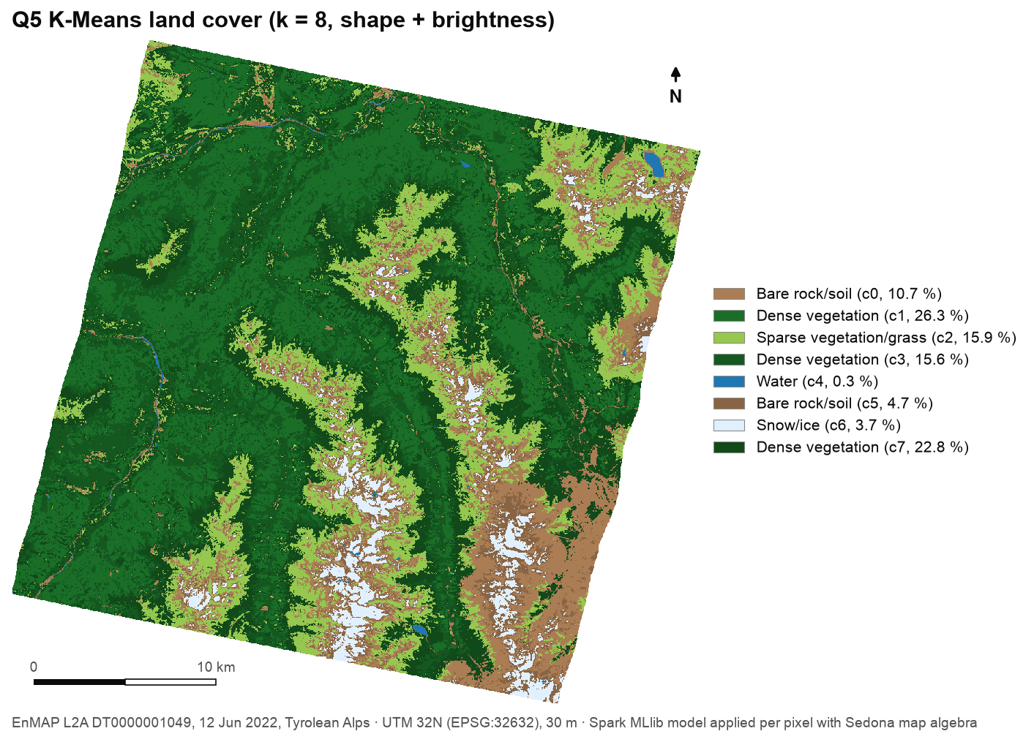
Figure 9. Q5 land-cover map, k = 8, shape + brightness features (the plugin's legend colours).
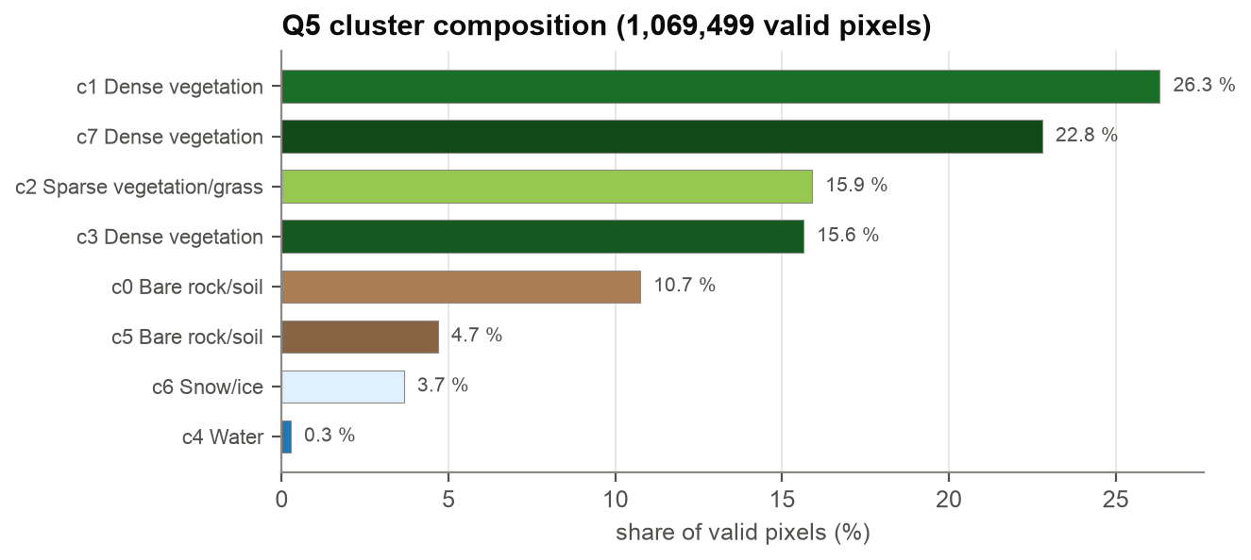
Figure 10. Cluster composition. Three forest clusters differ in NDVI and illumination; water is rare (0.27 %) but isolated.
Table 13. Q5 validation (k = 8, seed 42). EnMAP quality masks are outputs of DLR's processor — a reference, not field truth.
Check | Result
Background (no-data) pixels in the map vs EnMAP's QL background class | 461,445 = 461,445
Cluster labelled Water vs QL water class | IoU 0.578 · precision 0.820 · recall 0.662
Cluster labelled Snow/ice vs QL snow mask | IoU 0.655 · precision 0.922 · recall 0.693
MLlib predictions vs Jiffle map | 100.000 % agreement
Wall time (whole scene, including Spark start-up) | 12–14 s; training ≈ 3–4 s
Clouds | Not separable from bright snow with these features (IoU ≤ 0.28 vs the QL cloud mask)

Figure 11. The same result in QGIS 4.2.3: the class map loaded by the plugin with its labelled legend, above the raw EnMAP scene.

7. Data contracts and the raw-cube tile rules
The raster inputs prepared by the plugin follow rules that each prevent a silent error:
Table 14. Input rules enforced by raster_prep.
Rule | Applies to | Reason
Keep raw stored values; strip scale and offset | Q4, Q5 tiles | GeoTools applies a GeoTIFF's scale factor on reading; EnMAP's 0.0001 gain turned the −32768 background into −3.2768 and broke every no-data test. The scale is passed separately (--scale) for reporting.
Remove the no-data flag; pass --nodata | Q4, Q5 tiles | Jiffle sees declared no-data pixels as NaN; keeping the sentinel as a plain value and testing it explicitly is reliable.
256-pixel tiles for Q5 | Q5 | A whole EnMAP scene as one raster row exhausts the default 1 GB driver heap in RS_BandAsArray / posexplode; 256-pixel tiles keep each task small (OOM reproduced in testing).
Only the 7 index bands for Q1–Q3 | Q1–Q3 | RS_FromGeoTiff decodes a whole tile per row; the engine's 231-band tiles (~242 MB per 512-pixel tile) exhausted the heap even at 6 GB.
Temporary input folders | Q1–Q5 | Job outputs such as tile_r*_vegmask.tif live under the tiles folder and would otherwise be picked up by the recursive tile_r*.tif glob on the next run.
Coordinate system must survive | all | load_tiles drops rasters with no EPSG code (RS_SRID = 0). QGIS sets the PROJ database path; scripts run outside QGIS must set PROJ_DATA.

8. Validation and testing
Three test layers live in qgis-plugin/hyperspatial_analytics/tests/ (outside the packaged plugin).

8.1 Unit tests (no Spark, no QGIS)
test_ml_jiffle.py — 7 tests. The generated Jiffle script is executed by a small translator in Python and compared with an independent NumPy nearest-centre assignment for all three feature modes; further tests cover no-data and all-zero pixels, negative and tiny constants, invalid inputs, tie-breaking, and the labelling rules on typical spectra. All 7 pass.
~/hyperspatial-venv/bin/python -m unittest discover -s qgis-plugin/hyperspatial_analytics/tests

8.2 End-to-end validation on a real scene
validate_raw_cube_jobs.py runs Q4 and Q5 exactly as the plugin does (plugin preparation → bundled job → spark-submit) and checks the outputs against NumPy and the scene's quality masks. Results are saved to benchmarks/results/q5_kmeans_validation.csv.
Table 15. End-to-end validation.
Check | Result
Q4 mean NDVI = NumPy (± 0.001) | 0.5616 vs 0.5616 | PASS
Q4 valid pixels = NumPy minus outer-ring pixels | 1,069,486 vs 1,069,486 | PASS
Q5 MLlib vs Jiffle agreement ≥ 99.99 % | 100.000 % | PASS
Q5 job wall time < 30 s | 13.0 s | PASS
Q5 no-data pixels = QL background | 461,445 vs 461,445 | PASS
Q5 Water cluster IoU ≥ 0.5 | 0.578 | PASS
Q5 Snow/ice cluster precision ≥ 0.85 | 0.922 | PASS

8.3 Headless QGIS smoke test
qgis_dialog_smoke.py drives the real dialog inside QGIS 4.2.3's own Python (offscreen): it fills the widgets, clicks RUN for Q3 (on full engine tiles), Q4 and Q5, pumps the Qt event loop, and checks completion, the layers added and the longest stall of the GUI thread. All 10 checks pass; the GUI thread never stalled for more than 0.21 s.
A=/Applications/QGIS-final-4_2_3.app/Contents
PROJ_DATA=$A/Resources/qgis/proj QT_QPA_PLATFORM=offscreen \
PYTHONPATH=$A/Resources/python3.12:$A/Resources/python3.12/lib-dynload:$A/Resources/python3.12/site-packages \
QGIS_PREFIX_PATH=$A/MacOS PATH=~/hyperspatial-venv/bin:$PATH \
$A/MacOS/python3.12 qgis_dialog_smoke.py --cube <SPECTRAL_IMAGE.BSQ> --tiles <engine output dir>

9. Performance
Table 16. Job performance on an Apple M4 Pro (12 cores, 24 GB), Spark local mode. Times include Spark start-up (≈ 4–5 s).
Job (EnMAP test scene) | Spark input | Time | Notes
Q1 AOI filter | 9 index tiles, 32 MB | 6.6 s | default 1 GB driver heap
Q2 Spatial join (4 zones) | 9 index tiles | 8.4 s
Q3 NDVI filter + masks | 9 index tiles | 6.3–9.0 s | including ≈ 2 s index extraction
Q4 Raw-cube NDVI | 1 two-band tile | 6.7–7.5 s | including band extraction
Q5 K-Means (k = 8) | 25 six-band tiles (14 MB) | 10–14 s | training ≈ 3–4 s; peak memory ≈ 1.6 GB
Q1–Q3 on full engine tiles (before v0.2) | 9 × 231 bands, 1.0 GB | fails | OutOfMemoryError at 1 GB and at 6 GB

Most of each run is Spark's fixed start-up cost; the per-pixel work itself takes seconds. The decisive design choice is what each task has to decode: a 512-pixel tile with 231 float32 bands is ~242 MB in memory, and local Spark decodes one tile per core in parallel. Reducing the input to the bands a job actually needs turned a failing job into a 7-second one without any change to the job code.

10. Defects fixed in version 0.2
Table 17. Defects found while validating on a real EnMAP scene.
Symptom | Cause | Fix | Evidence
Q4 mean NDVI 0.393 on EnMAP (true 0.562) | Scale factor copied into the GeoTIFF and applied by GeoTools; background no longer matched | Strip scale/offset and no-data flag; pass --nodata | Validation: 0.5616 = NumPy
Q1–Q3 crash with OutOfMemoryError on real engine output | Whole 231-band tiles decoded per task | Extract the 7 index bands on the worker thread | Smoke test: Q3 passes in 6.3–9.0 s
Q3 reports empty tiles as vegetated | NaN >= threshold is true in Spark SQL | NOT isnan(mean_ndvi) filter | 7 reported → 4 real
Spark child can die before starting when launched from QGIS | Inherited PYTHONHOME / PYTHONPATH | Removed in spark_env() | Reproduced and fixed in the headless test

11. Limitations and troubleshooting

11.1 Known limitations
Table 18. Known limitations.
# | Limitation | Impact / mitigation
L2 | The processing engine assigns no indices to edge tiles that are more than 50 % background (its bad-band rule counts the background as no-data). | Upstream of this plugin: on the test scene 3 of 9 tiles (71,649 valid pixels, 6.7 %) have no indices, so Q1–Q3 see them as empty. Fix belongs in the engine.
L3 | EPSG:4326 axis order in ST_Transform on some GeoTools builds. | Verified correct with Sedona 1.5.1 + geotools-wrapper 1.5.1-28.2 on UTM 32N data; re-check after upgrades.
L4 | RS_ZonalStats over RS_Envelope(rast) skips the raster's outermost pixel ring. | 13 of 1,069,499 pixels on the test scene; means unaffected at 4 decimals.
L5 | K-Means clusters are not classes: rare classes need a suitable k and features; clouds and bright snow are not separated; cluster numbers depend on the seed. | Use the validated defaults (k = 8, shape + brightness, seed 42); treat labels as suggestions.
— | Local mode only was tested. | The jobs are plain Spark and can run on a cluster with shared storage; not yet measured.

11.2 Troubleshooting
Table 19. Troubleshooting.
Symptom | Likely cause | What to do
Spark row is red / “spark-submit not found” | QGIS launched from Finder has no shell PATH | Click Browse and select the environment's spark-submit.
JVM crash right after start on macOS | HADOOP_CONF_DIR set in the environment | The plugin clears it; for manual runs use HADOOP_CONF_DIR="".
“SRE module mismatch” or “No module named encodings” | QGIS's PYTHONHOME/PYTHONPATH leaked into Spark | Fixed in v0.2; for manual runs unset both variables.
OutOfMemoryError: Java heap space | Very large input rows | Use v0.2 (index extraction / tiling); for custom jobs reduce bands per row or add --driver-memory.
“no tiles found under --rasters” although files exist | GeoTIFFs without an EPSG code are dropped (RS_SRID = 0) | Make sure GDAL can find proj.db (PROJ_DATA) when preparing tiles.
JiffleException: extraneous input | A malformed map-algebra expression | Use the generated scripts; constants must be fixed-point and parenthesised.
Very long log | Spark prints thousands of INFO lines | The job summary lines start with Q1: … Q5:; results are always written to the folder printed at the end.

Appendix A. Job command-line reference
Table 20. Job arguments.
Job | Required arguments | Optional arguments
q1_aoi_filter.py | --rasters --output --aoi | —
q2_spatial_join.py | --rasters --agri --output | —
q3_ndvi_filter.py | --rasters --output | --threshold (0.4), --raster-out
q_raw_ndvi.py | --rasters --output --red-band --nir-band | --nodata, --threshold, --raster-out
q5_kmeans.py | --rasters --output | --raster-out, --k (8), --features (shape_brightness), --sample (0.1), --nodata, --scale (1.0), --roles, --seed (42), --max-iter (50), --verify

Appendix B. References
- Yu, J., Zhang, Z., Sarwat, M. (2019). Spatial data management in Apache Spark: the GeoSpark perspective and beyond. GeoInformatica 23, 37–78. (Origin of Apache Sedona.)
- Zaharia, M. et al. (2016). Apache Spark: a unified engine for big data processing. Communications of the ACM 59(11), 56–65.
- Meng, X. et al. (2016). MLlib: Machine Learning in Apache Spark. Journal of Machine Learning Research 17(34), 1–7.
- Guanter, L. et al. (2015). The EnMAP spaceborne imaging spectroscopy mission for Earth observation. Remote Sensing 7(7), 8830–8857.
- McFeeters, S. K. (1996). The use of the Normalized Difference Water Index (NDWI) in the delineation of open water features. International Journal of Remote Sensing 17(7), 1425–1432.
- Hall, D. K., Riggs, G. A., Salomonson, V. V., DiGirolamo, N. E., Bayr, K. J. (2002). MODIS snow-cover products. Remote Sensing of Environment 83, 181–194.
- Haut, J. M. et al. (2017). Cloud implementation of the K-means algorithm for hyperspectral image analysis. The Journal of Supercomputing 73, 514–529.
- Jakimow, B. et al. (2023). EnMAP-Box: Imaging spectroscopy in QGIS. SoftwareX 23, 101507.

