Technical documentation · QGIS plugin 1 of 2
HyperSpectral Processer
Parallel, GPU-capable hyperspectral processing in QGIS — spectral indices, PCA and Spectral Angle Mapper on a native C++17 / OpenMP / OpenCL engine
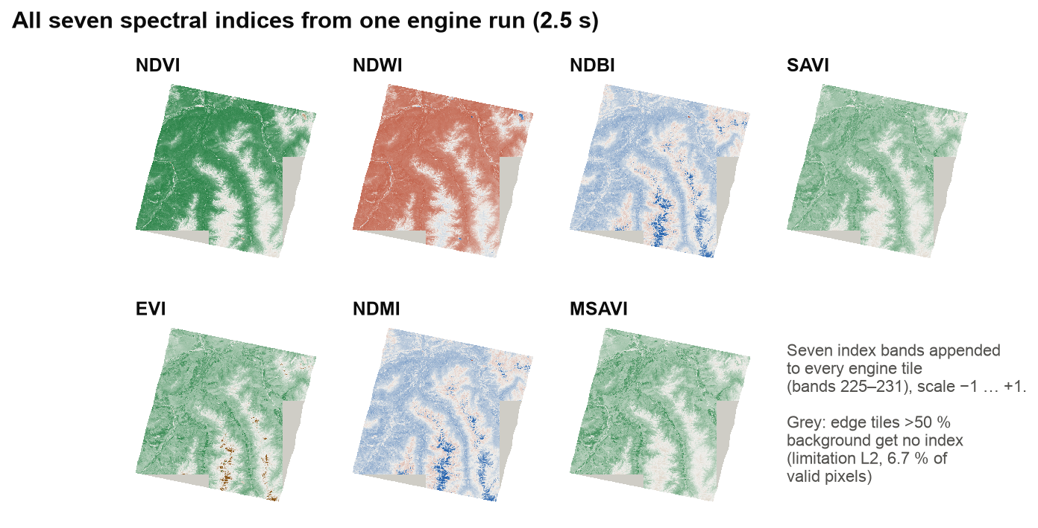
Document | Plugin and engine documentation (architecture, parallel computing, usage, validation)
Project | HyperSpatial — local-first hyperspectral analytics for QGIS
Author | Aaron R
Institution | Digital University Kerala
Version / date | Plugin v1.0.0 · engine hyperspatial_cli · 16 October 2026
Repository | github.com/aaron43210/HYPERSPECTRAL_DATA_DISTRIBUTED_SYSTEM

Contents
1. Overview
2. Architecture
2.1 Components
2.2 Process model
2.3 Engine interface contract
3. Installation
3.1 The plugin
3.2 The engine
3.3 Building the engine from source
4. User interface
4.1 How results are loaded
5. Parallel computing methods
5.1 Data decomposition: tiles
5.2 The per-tile pipeline
5.3 Shared-memory parallelism with OpenMP
5.4 Heterogeneous computing with OpenCL
5.5 Fault isolation and the error model
5.6 Memory model
5.7 From parallel to distributed
6. Algorithms
6.1 Wavelength-driven band selection
6.2 Spectral indices
6.3 Principal component analysis
6.4 Spectral Angle Mapper
7. Performance
8. Correctness: CPU versus GPU
9. Limitations
10. Troubleshooting
Appendix A. Command-line reference
Appendix B. Output band layout
Appendix C. References

1. Overview
HyperSpectral Processer is the first of the two HyperSpatial QGIS plugins. It turns a hyperspectral scene — for example an EnMAP L2A cube of 224 spectral bands — into map layers inside QGIS: seven spectral indices, a principal-component (PCA) composite, and Spectral Angle Mapper (SAM) target detection from a pixel picked on the map. The plugin itself is a light PyQt dialog; all per-pixel computation runs in an external native engine, hyperspatial_cli, written in C++17 on GDAL and parallelised with OpenMP on CPU cores and OpenCL on GPUs from any vendor.
The design goal is to process complete scenes on ordinary workstations and laptops: the engine never loads the whole cube into memory, it uses every core, and it keeps QGIS responsive while it runs. On the EnMAP test scene used throughout this document (686 MB, 1259 × 1216 pixels × 224 bands) all seven indices are computed in 2.5 seconds on a 12-core Apple M4 Pro.
Table 1. Plugin and engine facts.
Item | Value
Plugin | Display name HyperSpectral Processer; package hyperspatial_processing; version 1.0.0; experimental; published on plugins.qgis.org
QGIS versions | 3.0 – 4.99 declared; tested on QGIS 4.2.3 (Qt 6.11, GDAL 3.13)
Engine | hyperspatial_cli — C++17, GDAL, OpenMP, OpenCL 1.2; serial, OpenMP and GPU modes; single entry point src/main.cpp
Distribution | The plugin zip is binary-free (a plugins.qgis.org rule); the engine is found at run time or downloaded from the project's GitHub Releases
Operations | indices (NDVI, NDWI, NDBI, SAVI, EVI, NDMI, MSAVI) · pca · sam
Outputs | Per-tile GeoTIFFs (224 raw + 7 index bands), VRT or merged GeoTIFF index layers, pca.tif + pca_eigen.csv, sam_angle.tif (+ mask, similarity)
Licence | GPL-2.0

Parallel, GPU-capable — and how it connects to distributed computing
This plugin performs parallel computing on one machine: data parallelism over image tiles, shared-memory parallelism across CPU cores (OpenMP) and heterogeneous execution on a GPU (OpenCL). It does not distribute work across several machines.
Distribution is the job of the second plugin (HyperSpatial Sedona Analytics), which runs Apache Spark jobs over the engine's output. The engine's tiles are deliberately the unit of distribution: each tile is a self-contained, georeferenced GeoTIFF that Spark reads as one row (§5.7).

2. Architecture
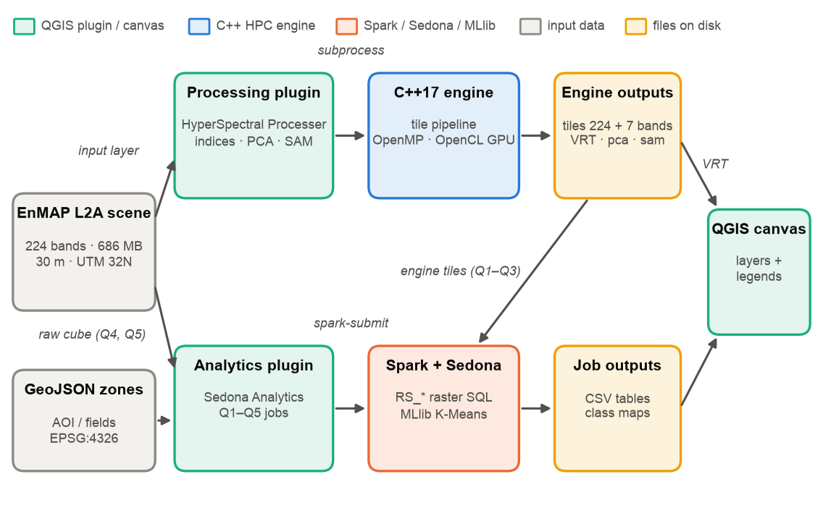
Figure 1. HyperSpatial system context. This plugin is the upper lane: the dialog drives the C++ engine through a subprocess, and the engine's files feed both the QGIS canvas and the analytics plugin.

2.1 Components
Table 2. Plugin and engine components.
Component | Role
plugin.py | Toolbar action; opens the dialog modelessly.
dialog.py | HyperspectralProcessingDialog: inputs, operation panels, SAM pixel picker, worker thread, post-processing (VRT/merge) and layer styling.
engine_locator.py | Finds the engine at run time and builds its environment (§3.2).
src/main.cpp | Engine entry point: argument parsing, scene metadata, band resolution, tile grid, operation dispatch, OpenMP loop, error model, RESULT line.
RasterReader / TileWriter | Thread-safe tile I/O: a fresh GDAL handle per read; one GeoTIFF per tile.
Tiler, NoDataHandler, BadBandRemover, SpectralFeatures, Normalizer | Header-only, independently testable pipeline stages (§5.2).
BandResolver | Chooses the NIR/Red/Green/SWIR/Blue bands by wavelength (§6.1).
PCA.hpp, SAM.hpp | Whole-scene PCA (two-pass covariance, Jacobi eigen-solver) and the Spectral Angle Mapper.
src/gpu/gpu_backend_opencl.cpp | OpenCL backend: index, SAM and PCA kernels with per-tile CPU fallback.

2.2 Process model
The dialog never runs the engine on the GUI thread. When the user clicks RUN, a threading.Thread launches hyperspatial_cli with subprocess.Popen, streams its standard output line by line into the log through the hpc_log signal, performs the GDAL post-processing (VRT building or merging) on the same worker thread, and finally emits hpc_finished; the slot on the GUI thread then adds and styles the layers. The engine-download button works the same way (engine_download_finished).

2.3 Engine interface contract
Table 3. How the plugin and the engine communicate.
Channel | Contract
Command line | hyperspatial_cli --input <file> --output <dir> --operation indices|pca|sam [options] (Appendix A).
Standard output | Scene, tile and band summary, then Progress: k/total, then one final line RESULT mode=<ran> operation=<op> tiles=<n> bands=<b> time_sec=<s> (kept stable for benchmark scripts). mode reports what actually ran — gpu only if the GPU initialised.
Exit code | 0 success; 2 if any tile failed (the run continues and the first error is printed); non-zero on invalid input.
Files | indices: tile_r####_c####.tif with 224 raw + 7 index bands; pca: pca.tif, pca_eigen.csv; sam: sam_angle.tif, optional sam_mask.tif, sam_similarity.tif. The engine clears its own earlier outputs at start.

3. Installation

3.1 The plugin
Install from plugins.qgis.org, or build the zip with bash qgis-plugin/hyperspatial_processing/package_plugin.sh and use Plugins → Manage and Install Plugins → Install from ZIP. The zip contains no compiled code, so it is the same on every operating system.

3.2 The engine
engine_locator.resolve_engine() looks for hyperspatial_cli in this order and shows the result (and its source) in the Engine row:
- A path saved with the Engine Browse button (stored in QGIS settings).
- hyperspatial_cli on the system PATH (for example after make install, conda or Homebrew).
- A copy under the plugin's bin/<platform>/ folder (development builds only; absent from the published zip).
Download engine fetches the prebuilt engine for the host from the project's GitHub Releases (engine-macos-arm64.zip, engine-windows-x64.zip or engine-linux-x64.zip, from …/releases/latest/download/), unpacks it into the plugin's bin/ folder on a worker thread, and refreshes the Engine row. engine_env() puts QGIS's own GDAL library folder first on the library path, so the engine links the same GDAL that QGIS uses.

3.3 Building the engine from source
# macOS: brew install gdal libomp cmake
cmake -S hpc-engine -B hpc-engine/build -DCMAKE_BUILD_TYPE=Release
cmake --build hpc-engine/build -j

- Requires GDAL; OpenMP is optional (auto-detected, Homebrew libomp on macOS); OpenCL is optional (-DUSE_OPENCL=ON by default; without an SDK, --mode gpu warns and runs on the CPU).
- The default build is portable (-O3 / /O2). -DNATIVE_ARCH=ON adds -march=native, which is faster but aborts on a different CPU — do not distribute such builds.
- The project's GitHub Actions workflow builds the engine and both plugin zips for Windows, Linux and macOS and attaches engine archives to tagged releases.

4. User interface
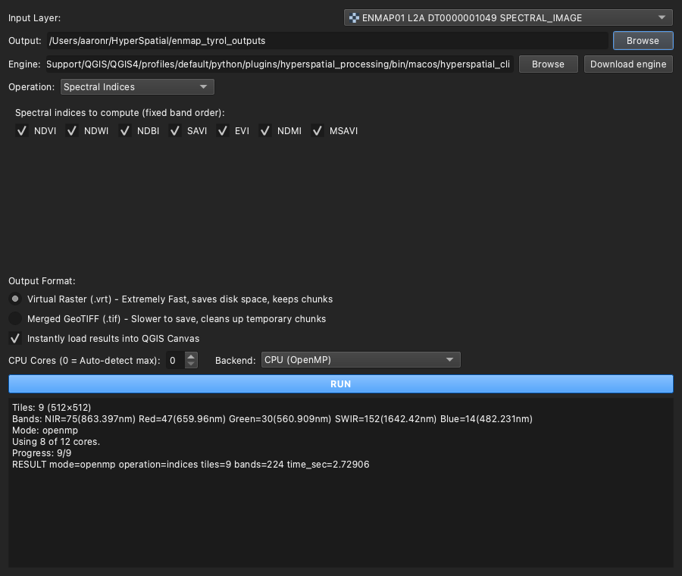
Figure 2. The dialog with the Spectral Indices operation and the engine's real output for the EnMAP test scene (rendered from the plugin running in QGIS 4.2.3).
Table 4. Dialog controls.
Control | Meaning
Input Layer | Any raster layer in the project (EnMAP .BSQ, ENVI, GeoTIFF …); its file is passed to the engine.
Output | Output folder; blank uses QGIS's temporary space.
Engine + Browse / Download engine | Shows the resolved engine and its source; red when missing (§3.2).
Operation | Spectral Indices · PCA (false-colour composite) · Target Detection (SAM). The panel below changes with the operation.
Index checkboxes | Which index layers to load. All seven are always computed and stored in the tiles; the band offsets are fixed, so unticking NDVI never shifts NDWI onto the wrong band.
PCA: Components; correlation matrix | Number of components written (default 3); correlation instead of covariance standardises each band first.
SAM: Pick reference pixel; Max angle; mask; similarity | Click a pixel on the map to capture its full spectrum; the max angle (radians, degrees shown) defines a detection; optional detection mask and similarity band.
Output Format | Virtual Raster (.vrt) keeps the per-tile GeoTIFFs (required for the analytics plugin); Merged GeoTIFF writes one file per index and deletes the tiles.
Instantly load results | Adds the results to the canvas with suitable styling.
CPU Cores | OpenMP threads (0 = all cores).
Backend | CPU (OpenMP) or GPU (OpenCL: Apple / NVIDIA / Intel / AMD); the GPU path falls back to the CPU automatically.

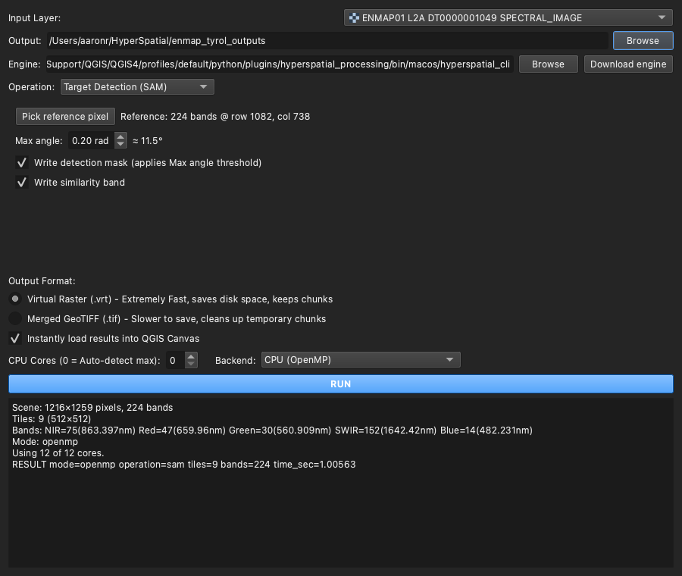
Figure 3. The SAM panel after a reference pixel has been picked on the canvas (224-band spectrum, row 1082, column 738), with the engine's output for this run.

4.1 How results are loaded
Table 5. Result loading.
Operation | Layers added | Styling
Indices | One layer per ticked index (ndvi_layer.vrt …), built with gdal.BuildVRT(bandList=[first_index_band + k]) over all tiles | Single-band, stretched −1 … +1
PCA | pca.tif as “PCA Composite” | RGB = PC1 / PC2 / PC3, each stretched to its min–max
SAM | sam_angle.tif, plus sam_mask.tif and sam_similarity.tif when requested | Angle: inverted red–yellow–blue ramp (small angle = strong match, capped at the max angle); mask: transparent / red

5. Parallel computing methods
This chapter describes how the engine turns one large scene into many small, independent pieces of work and executes them in parallel on CPU cores and GPUs, while keeping memory bounded and failures contained.

5.1 Data decomposition: tiles
Tiler cuts the scene into square tiles (default 512 × 512 pixels; --tile-size). The EnMAP test scene becomes 9 tiles. For the index pipeline every tile is processed independently — no tile needs data from another — so the problem is embarrassingly parallel: the tiles can be handed to any number of workers in any order. The same property makes the tile the natural unit of distribution for Spark (§5.7).
Tiling also makes the engine out-of-core: a worker reads one tile, processes it and writes it, so the scene is never held in memory as a whole. Peak memory therefore depends on the number of threads and the tile size, not on the size of the scene (§5.6).

5.2 The per-tile pipeline
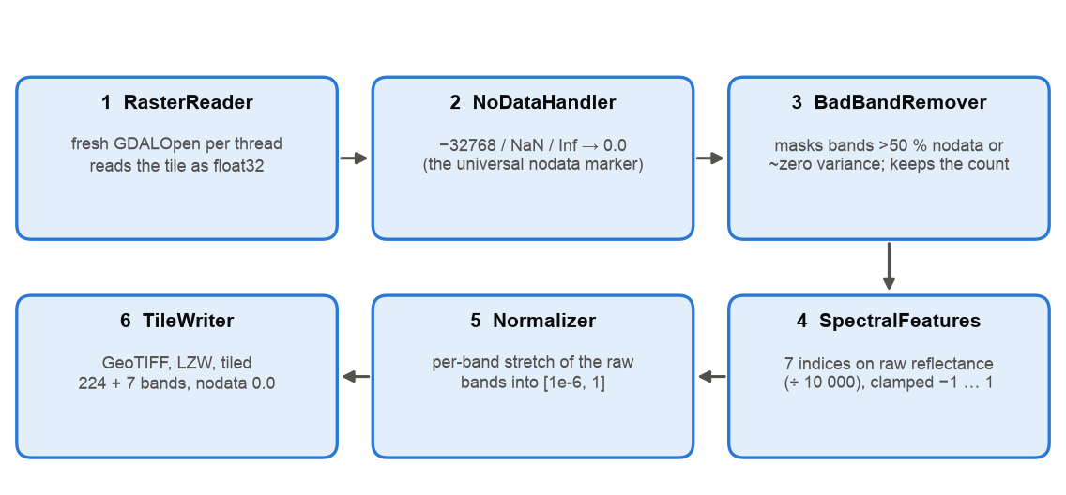
Figure 4. Per-tile pipeline of the indices operation. Each OpenMP iteration runs all six stages for one tile.
Table 6. Pipeline stages.
Stage | What it does | Why
1 RasterReader | Opens a new GDAL dataset and reads every band of the tile as float32; a failed read throws. | GDAL datasets are not thread-safe; a silent failure would produce a fake no-data tile.
2 NoDataHandler | Replaces the no-data value (with a 1e-3 tolerance), NaN and Inf by 0.0. | 0.0 becomes the single no-data marker for the rest of the pipeline.
3 BadBandRemover | Zero-fills bands that are > 50 % no-data or have near-zero variance (variance in double precision). | Masking instead of deleting keeps the band count identical in every tile, which the VRT mosaic and index offsets require.
4 SpectralFeatures | Computes the 7 indices on raw reflectance (de-scaled by 10,000), only where all operand bands are non-zero; clamps to −1 … 1. | Indices need physical reflectance, before any display stretch.
5 Normalizer | Stretches each raw band of the tile to [1e-6, 1]. | Display-friendly raw bands; 0 stays reserved for no-data.
6 TileWriter | Writes tile_r####_c####.tif (LZW, tiled, float32, no-data 0) with 224 + 7 bands. | One file per tile: writers never contend.

5.3 Shared-memory parallelism with OpenMP
The tile loop is a single #pragma omp parallel for schedule(dynamic). Each thread takes the next unprocessed tile when it finishes its current one. Dynamic scheduling matters because tiles carry unequal work: edge tiles of a rotated satellite footprint can be 60–97 % background, while interior tiles are full, so a static split would leave threads idle. The thread count (--threads, 0 = all) is clamped to the hardware concurrency.
Thread safety is achieved by not sharing anything mutable: every read opens its own GDALDataset (never a shared pointer), every write goes to a different file, and the only shared state — the first error — is guarded by an atomic flag and a mutex.

5.4 Heterogeneous computing with OpenCL
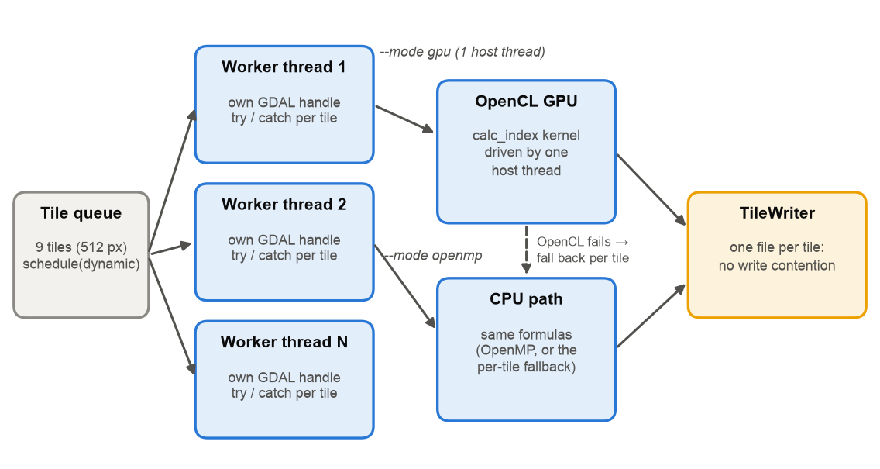
Figure 5. Concurrency and heterogeneous execution: in CPU mode, OpenMP workers with private GDAL handles; in GPU mode, a single host thread drives the OpenCL kernels with per-tile CPU fallback; one output file per tile.
- Portability. The backend targets OpenCL 1.2 (CL_TARGET_OPENCL_VERSION=120), the common denominator of Apple, NVIDIA, Intel and AMD drivers, and selects a CL_DEVICE_TYPE_GPU device. On macOS the OpenCL framework is built in; on Linux an ICD loader plus vendor runtime is needed; on Windows the GPU driver provides OpenCL.dll.
- Same results by construction. The calc_index kernel is a line-for-line port of SpectralFeatures: same formulas, same ÷10,000 de-scaling, same all-operands-non-zero rule, same clamp. SAM and PCA have their own kernels; the PCA covariance uses Kahan-compensated sums to limit float32 drift.
- One host thread in GPU mode. Apple's OpenCL queue was found to corrupt results when driven from several host threads, even behind the dispatch mutex, so in GPU mode the tile loop runs on a single host thread (the OpenMP pragma carries if(!use_gpu)). Tile reading and writing are therefore serial in GPU mode.
- Graceful fallback. If OpenCL cannot initialise, or a dispatch fails, that tile is computed on the CPU. A build without an OpenCL SDK runs --mode gpu on the CPU with a warning; the RESULT line always reports the mode that actually ran.

5.5 Fault isolation and the error model
An exception that escapes an OpenMP parallel region is undefined behaviour (in practice std::terminate). Every loop iteration therefore catches exceptions itself, records the first error, and lets the other tiles finish; the process then exits with code 2 and prints the error, so the plugin reports a failure instead of loading partial results as if they were complete. Numeric command-line options are parsed with guarded helpers, so a typo such as --tile-size foo falls back to the default rather than crashing.

5.6 Memory model
Each in-flight tile needs tile² × bands × 4 bytes — about 235 MB for 512² × 224 float32 bands — plus the 7 index arrays, so peak memory ≈ threads × ~250 MB, independent of scene size. Measured peak memory on the test scene confirms the model (Figure 11, right): 1.4 GB serial, 2.5 GB with 2 threads, 4.2 GB with 8 threads, 4.4 GB with 12 threads (the scene has only 9 tiles, so at most 9 are in flight). On memory-constrained machines, reduce --threads or --tile-size.

5.7 From parallel to distributed
The engine's output is designed for distributed processing. Every tile is a complete, georeferenced GeoTIFF with an identical band layout, so a cluster framework can treat tiles as independent records. The analytics plugin does exactly that: Spark's binaryFile reader makes one row per tile and Sedona processes the rows in parallel tasks, locally or across a cluster. The earlier MPI variant of the engine was removed in favour of this split: the C++ engine does the dense per-pixel arithmetic on one node, and Spark/Sedona handles distribution, spatial joins and machine learning.

6. Algorithms

6.1 Wavelength-driven band selection
Indices are only meaningful if NIR, Red, Green, SWIR and Blue are the right physical wavelengths, and band numbers differ between sensors and even processor versions. The engine reads each band's centre wavelength from the file (GDAL wavelength metadata or descriptions such as “Band 75 (863.40 nm)”, nm or µm) and BandResolver picks the band nearest each target: NIR 860, Red 660, Green 560, SWIR 1640 and Blue 480 nm. On the test scene this gives NIR = 75 (863.4 nm), Red = 47 (660.0 nm), Green = 30 (560.9 nm), SWIR = 152 (1642.4 nm), Blue = 14 (482.2 nm). --*-band flags override a role; without wavelength metadata the engine falls back to the standard EnMAP bands {75, 47, 30, 151, 14}. (An earlier hard-coded default pointed at 936 nm water-vapour absorption instead of NIR and biased every index; wavelength resolution removed that class of error.)

6.2 Spectral indices
Table 7. The seven indices, appended as bands 225–231 of every tile in this fixed order: NDVI, NDWI, NDBI, SAVI, EVI, NDMI, MSAVI.
Index | Formula (reflectance 0–1, L = 0.5) | Indicates
NDVI | (NIR − R) / (NIR + R) | Vegetation vigour
NDWI | (G − NIR) / (G + NIR) | Open water (McFeeters 1996)
NDBI | (SWIR − NIR) / (SWIR + NIR) | Built-up / bare surfaces
NDMI | (NIR − SWIR) / (NIR + SWIR) | Canopy moisture
SAVI | (NIR − R) / (NIR + R + L) · (1 + L) | Vegetation, soil-adjusted
EVI | 2.5 · (NIR − R) / (NIR + 6R − 7.5B + 1) | Vegetation, atmosphere/soil resistant
MSAVI | (2NIR + 1 − √((2NIR + 1)² − 8(NIR − R))) / 2 | Vegetation, iteration-free modified SAVI

Reflectance is de-scaled by 10,000 (EnMAP's integer scaling) so that the indices with additive constants (SAVI, EVI, MSAVI) are correct; for the pure ratios the scale cancels. A degenerate denominator or a negative square-root argument gives 0.0, never NaN or Inf.
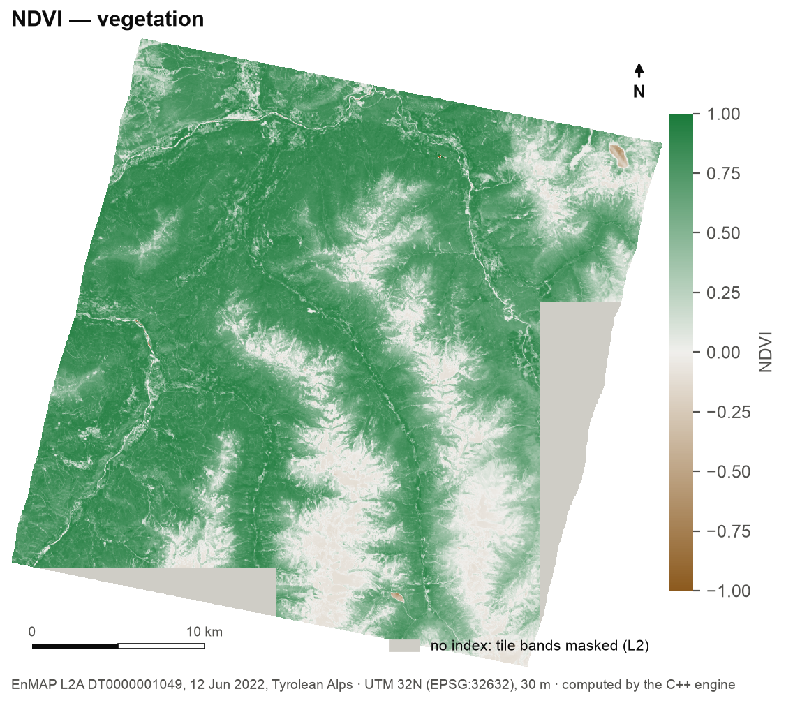
Figure 6. NDVI of the test scene from the engine. Grey: edge tiles without indices (limitation L2, §9).

6.3 Principal component analysis
PCA compresses the 224 correlated bands into a few uncorrelated components. The engine never holds the cube in memory: pass 1a accumulates per-band means over valid pixels in double precision; pass 1b accumulates the covariance Σ(x − μ)(x − μ)ᵀ using the exact means (avoiding the catastrophic cancellation of the E[xxᵀ] − μμᵀ shortcut on large reflectance values); a cyclic Jacobi eigen-solver returns eigenpairs in descending order with a deterministic sign convention (as in scikit-learn's svd_flip); pass 2 projects each pixel onto the first k eigenvectors. The correlation option standardises each band first; bands can be excluded (for example water-absorption regions).
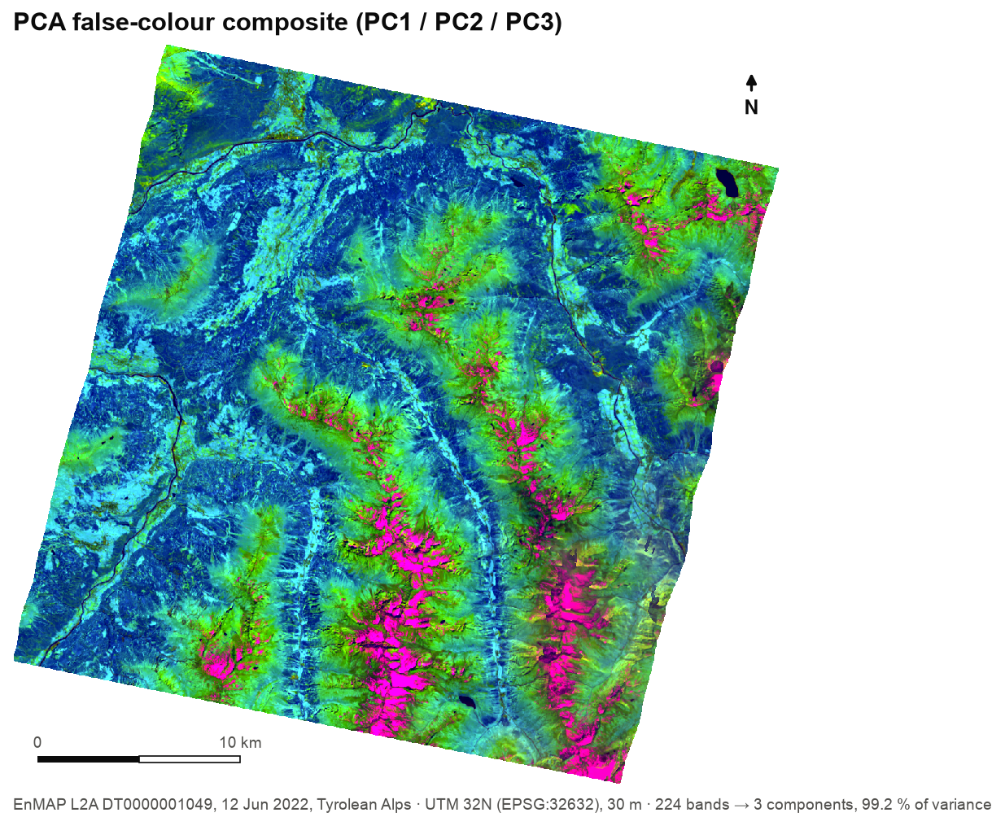
Figure 7. PCA false-colour composite (PC1/PC2/PC3) of the test scene.
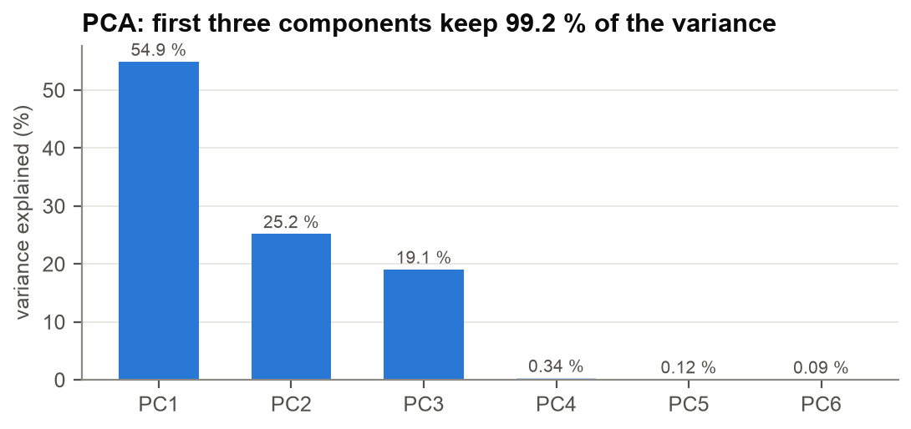
Figure 8. Variance explained: the first three components keep 99.2 % of the scene's variance.

6.4 Spectral Angle Mapper
SAM measures how similar each pixel's spectrum t is to a reference spectrum r as the angle between them in 224-dimensional space: θ = arccos( t·r / (‖t‖‖r‖) ). Because only the angle matters, SAM is insensitive to brightness (illumination, slope) and to the reflectance scale. The plugin captures r by a click on the map: it transforms the click into the layer's coordinate system, reads every band at that pixel, sends no-data bands as 0 (the engine's no-data marker), and rejects all-no-data border pixels. The engine writes sam_angle.tif (radians), optionally sam_mask.tif (angle ≤ max angle) and sam_similarity.tif (1 − θ/π).
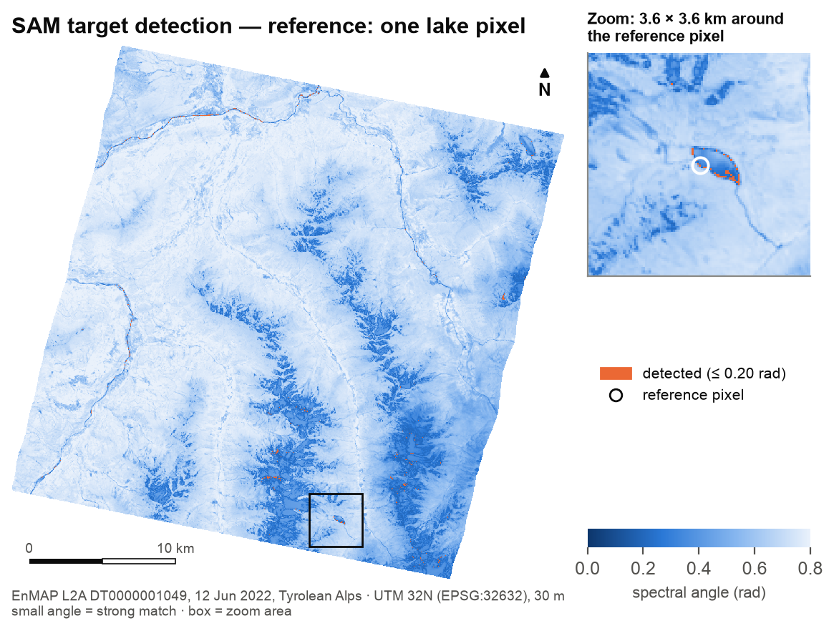
Figure 9. SAM with one lake pixel as reference. Orange: pixels within 0.20 rad; the zoom shows the detected shoreline around the reference.
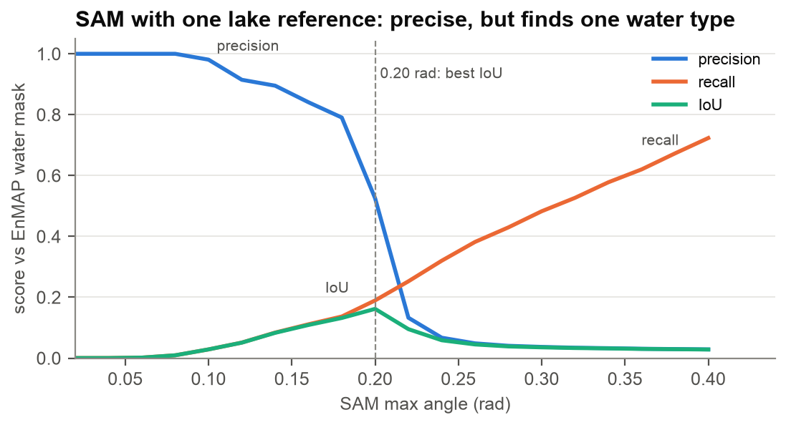
Figure 10. SAM scored against EnMAP's water mask for thresholds 0.02–0.40 rad.
Interpretation. SAM is a target detector: with one reference it finds material that looks like that reference. Precision is very high at tight thresholds (0.98 at 0.10 rad, 0.90 at 0.14 rad) but recall against all water stays low, because the scene's lakes and rivers differ spectrally (glacial turbidity, depth, shadow). For general water mapping, use NDWI or the analytics plugin's K-Means; for “find more of this material”, use SAM.

7. Performance
All measurements: EnMAP L2A test scene (686 MB, 1259 × 1216 × 224, 9 tiles of 512 px), Apple M4 Pro (12 cores: 8 performance + 4 efficiency, 24 GB), engine time from the RESULT line, median of 3 runs. Raw data: benchmarks/results/engine_benchmark.csv.
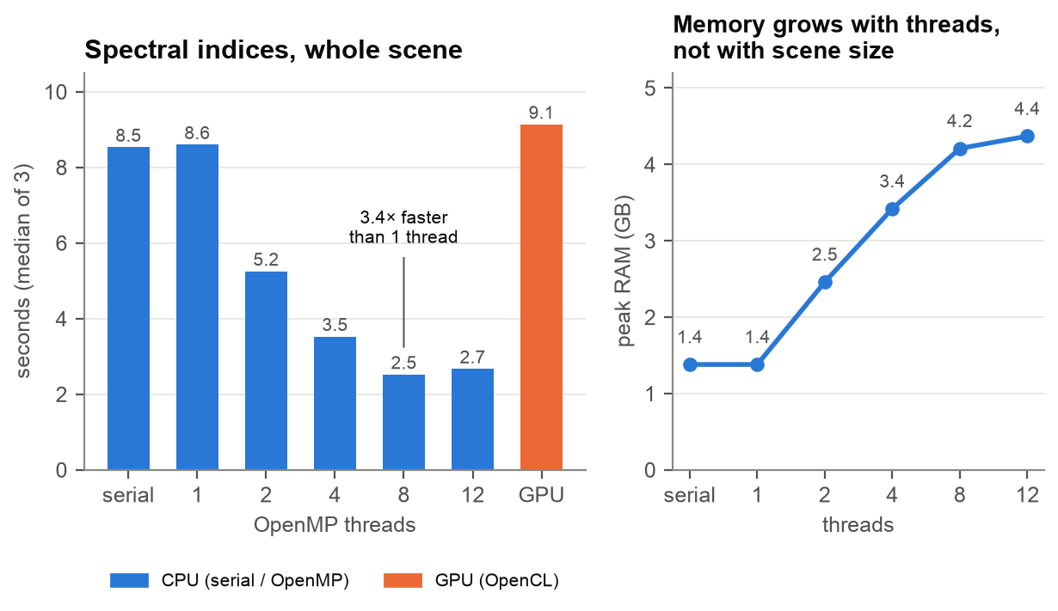
Figure 11. Indices on the whole scene: runtime by thread count and backend (left) and peak memory (right).
Table 8. Engine benchmark.
Configuration | Indices | PCA (3 PCs) | SAM | Peak memory (indices)
Serial | 8.53 s | — | — | 1.38 GB
OpenMP, 2 threads | 5.25 s | — | — | 2.46 GB
OpenMP, 4 threads | 3.52 s | — | — | 3.42 GB
OpenMP, 8 threads | 2.52 s | — | — | 4.21 GB
OpenMP, 12 threads | 2.67 s | 5.96 s | 0.99 s | 4.37 GB
GPU (OpenCL) | 9.13 s | 5.79 s | 1.15 s | 1.39 GB (SAM: 0.67 GB)

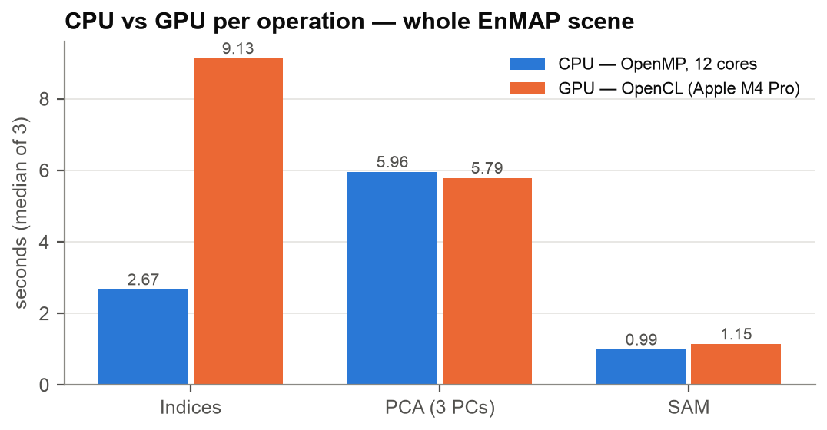
Figure 12. CPU (OpenMP, 12 cores) versus GPU per operation.
What the numbers mean. OpenMP gives a 3.4× speed-up from 1 to 8 threads; beyond 8 threads the run is limited by reading the 686 MB cube and compressing 1 GB of output, and by the efficiency cores. On this Apple-silicon machine the GPU backend is not faster: the index arithmetic is a few operations per value, so the time goes to file I/O and host–device transfer — and because GPU mode runs the tile loop on one host thread, that I/O is not parallelised, so the GPU indices run takes as long as the serial CPU run (9.1 s vs 8.5 s); for PCA and SAM it is on par with the CPU. The GPU backend's present value is portability and identical results, with a lower memory footprint for SAM; a discrete GPU or compute-heavier kernels would be needed to show a speed-up. These numbers are reported as measured.

8. Correctness: CPU versus GPU
The OpenMP and GPU paths were run on the same scene and their outputs compared pixel by pixel:
Table 9. CPU–GPU agreement on the test scene.
Output | Largest |CPU − GPU| | Pixels that differ
Raw bands 1–224 (in the tiles) | 0 | none
NDBI, SAVI, NDMI, MSAVI | ≤ 6 × 10⁻⁷ | float rounding only
EVI | 1.5 × 10⁻⁵ | float rounding only
NDVI, NDWI | 1.0 | 1 pixel each out of 1.53 million (CPU 0.0, GPU 1.0)
PCA components (pca.tif) | ≤ 1.6 × 10⁻⁵ of each component's range | correlation 1.000000
SAM angle / similarity | 1.1 × 10⁻⁶ rad / 1.2 × 10⁻⁷ | 2 / 0 pixels above 10⁻⁶
SAM detection mask | 0 | identical

The single differing NDVI pixel and NDWI pixel sit where one input band is at the tile's minimum (most likely exactly zero), an edge case of the zero-operand rule between the two paths; it is recorded as a known issue (§9).

9. Limitations
Table 10. Known limitations, with measured impact where available.
# | Limitation | Impact | Mitigation
L1 | Raw bands are stretched per tile (Normalizer). | The same reflectance can look different in neighbouring tiles; indices are unaffected (computed before the stretch). | Use indices or the source cube for science; add a global two-pass stretch.
L2 | BadBandRemover masks a band that is > 50 % no-data in the tile, and the scene's background counts as no-data. | Edge tiles that are mostly background lose every index: 3 of 9 tiles on the test scene (60 %, 77 %, 97 % background) → 71,649 valid pixels, 6.7 % of the scene. | Compute the no-data fraction over the tile's valid footprint, or run the indices before the bad-band step.
— | GPU backend shows no speed-up on Apple M4 Pro. | Indices are I/O-bound; GPU indices 9.1 s vs 2.5 s on CPU. | Use CPU (OpenMP) by default; evaluate on a discrete GPU.
— | CPU/GPU zero-operand edge case. | 1 pixel in 1.53 million for NDVI and NDWI. | Align the kernel's operand test with the CPU path.
— | Apple has deprecated OpenCL (macOS 10.14+). | Still works, but may disappear in a future macOS. | A Metal or Vulkan backend would be the long-term path.
— | Merged-GeoTIFF output deletes the tiles. | The analytics plugin then has nothing to read. | Choose VRT output when analytics will follow.

10. Troubleshooting
Table 11. Troubleshooting.
Symptom | Cause | What to do
Engine row red: “hyperspatial_cli not found” | No saved path, not on PATH, no bundled copy | Click Download engine, or Browse to a built engine.
Engine starts but cannot open the input | GDAL mismatch or unsupported format | Keep engine_env() (QGIS's GDAL first); check the file opens in QGIS.
RESULT mode=openmp although GPU was chosen | OpenCL not available or failed | Expected fallback; results are identical. Check GPU drivers / ICD loader on Linux.
Run reports exit code 2 | At least one tile failed | Read the first error in the log; other tiles were still written.
Machine runs out of memory | Too many tiles in flight | Lower CPU Cores or --tile-size.
Analytics plugin finds no tiles | Merged-GeoTIFF mode removed them | Re-run with Virtual Raster (.vrt) output.
SAM: “That pixel is all-nodata” | Click on the scene's black border | Click inside the image footprint.

Appendix A. Command-line reference
Table 12. Engine options.
Flag | Default | Meaning
--input | required | Any GDAL-readable raster (EnMAP ENVI .bsq/.hdr, GeoTIFF …)
--output | required | Output folder (created; earlier engine outputs removed)
--operation | indices | indices · pca · sam
--mode | openmp (if built with OpenMP) | serial · openmp · gpu
--tile-size | 512 | Square tile edge in pixels
--threads | 0 (all cores) | OpenMP threads, clamped to the hardware
--nodata-val | −9999 | Fallback no-data value when the file declares none
--nir-band --red-band --green-band --swir-band --blue-band | auto | 1-based band override for a role
--pca-components | 3 | Components written to pca.tif
--pca-matrix | covariance | covariance or correlation
--sam-spectrum | required for SAM | Comma-separated reference spectrum, one value per band
--sam-threshold | off | Max angle (radians); also writes sam_mask.tif
--sam-emit-similarity | off | Also writes sam_similarity.tif (1 − θ/π)

Appendix B. Output band layout
Table 13. Tile band layout. Readers locate the indices by offset from the band count, never by a hard-coded number.
Bands of every tile_r####_c####.tif | Content
1 … N (N = 224 for EnMAP) | Raw bands after no-data handling, bad-band masking and per-tile stretch
N + 1 … N + 7 | NDVI, NDWI, NDBI, SAVI, EVI, NDMI, MSAVI (fixed order, −1 … 1, no-data 0)

Appendix C. References
- Rouse, J. W. et al. (1974). Monitoring vegetation systems in the Great Plains with ERTS. NASA SP-351, 309–317. (NDVI)
- McFeeters, S. K. (1996). The use of the Normalized Difference Water Index (NDWI) in the delineation of open water features. International Journal of Remote Sensing 17(7), 1425–1432.
- Zha, Y., Gao, J., Ni, S. (2003). Use of normalized difference built-up index in automatically mapping urban areas from TM imagery. International Journal of Remote Sensing 24(3), 583–594.
- Huete, A. R. (1988). A soil-adjusted vegetation index (SAVI). Remote Sensing of Environment 25(3), 295–309.
- Huete, A. et al. (2002). Overview of the radiometric and biophysical performance of the MODIS vegetation indices. Remote Sensing of Environment 83, 195–213. (EVI)
- Qi, J. et al. (1994). A modified soil adjusted vegetation index. Remote Sensing of Environment 48(2), 119–126. (MSAVI)
- Kruse, F. A. et al. (1993). The spectral image processing system (SIPS) — interactive visualization and analysis of imaging spectrometer data. Remote Sensing of Environment 44, 145–163. (SAM)
- Guanter, L. et al. (2015). The EnMAP spaceborne imaging spectroscopy mission for Earth observation. Remote Sensing 7(7), 8830–8857.
- Qu, H., Zhang, J., Lin, Z., Chen, H. (2013). Parallel acceleration of SAM algorithm and performance analysis. IEEE JSTARS 6(3), 1172–1178.
- OpenMP Architecture Review Board. OpenMP Application Programming Interface. · Khronos Group. The OpenCL Specification, version 1.2. · GDAL/OGR contributors. GDAL Geospatial Data Abstraction Library, Open Source Geospatial Foundation.

