HydraNet Maps
End-to-end project document: hyperspectral and thermal mapping with one neural network
Agriculture, mineral and thermal maps from NASA EMIT and Landsat 8/9, produced by a single three-headed neural network (ONNX) that is trained and continuously verified to reproduce the classical remote-sensing methods, served by a production data platform (Kafka, Redis, PostgreSQL/PostGIS, MinIO / Amazon S3).

Item | Value
Repository | github.com/aaron43210/remote_sensing_pipeline
Branch documented | pre-production (folder pre_production/)
Model | HydraNet v1, MLP architecture, 469,390 parameters, ONNX opset 17, 1.93 MB
Feature spec hash | f15dd48ca7cd4dd6
Document date | 20 October 2026
Prepared by | Aaron R (platform, model, integration), with the preprocessing module by Ananthanarayanan B

Contents

(If the table of contents is empty, right-click it in Word and choose Update Field.)

1. Executive summary
A user draws a box on a map and receives three families of maps for it: agriculture (leaf chlorophyll Cab, carotenoids Car, water Cw, dry matter Cm, leaf area index LAI, leaf angle ALA, each with an uncertainty), minerals (the dominant of 12 USGS minerals or unknown, per-mineral abundance, fit quality) and thermal (cold/normal/hot classes, urban heat island zones, local anomalies, hotspots). Imagery comes from NASA EMIT (285-band imaging spectrometer, 60 m) and Landsat 8/9 (land surface temperature, 30 m).
Instead of running three separate classical algorithms per pixel, one neural network, HydraNet, produces all maps. It was trained with the classical methods as teachers (knowledge distillation), so it draws the same maps they draw, and every production job re-checks a sample of pixels against the classical method (shadow verification).
Table 1. Headline results
Result | Value | Notes
Mineral class agreement with SAM | 99.95 % (validation), 99.85 % (2,000 real EMIT pixels) | gate 98 % / 97 %
Mineral abundance vs SMA/FCLS (MAE) | 0.0041 (validation), 0.078 (real EMIT rows) | real-row gate 0.06 is NOT met (see section 12)
Agriculture vs PROSAIL LUT inversion | R² 0.969 (worst of Cab, Cw, LAI); nMAE Cab 1.6 %, Cw 1.4 %, LAI 3.4 % | gate R² ≥ 0.95, nMAE ≤ 5 %
Thermal vs ThermalAnomalyDetector | 99.84 % global, 99.94 % UHI, 99.96 % hotspots | ≥ 99.2 % on 6 real Landsat scenes
Real end-to-end job (EMIT + Landsat) | agriculture R² Cab 0.983, Cw 0.985, LAI 0.980; mineral class 99.75 %; thermal UHI 99.89 % | Fresno County, California; EMIT 22 Aug 2023, Landsat 9 29 Sep 2023
Speed (5 scenes, CPU) | minerals 11.5x faster, agriculture 6.9x faster; thermal 26x slower | thermal rules are already very cheap
Model size | 469,390 parameters, 1.93 MB | 61 % fewer than the earlier CNN (1.19 M)
Load test | 300 concurrent users, 0 failed of 55,225 requests, p95 < 10 ms | 3.8 jobs/s with 4 workers per stage
Security test suite | 63 attacks, all blocked | JWT forgery, brute force, IDOR, CSRF, XSS, header spoofing

2. Problem statement and objectives
Hyperspectral sensors such as EMIT record hundreds of narrow bands per pixel. The established ways of turning those spectra into maps are physically meaningful but slow and fragmented: spectral angle mapping (SAM) and spectral mixture analysis (SMA) for minerals, look-up-table (LUT) inversion of the PROSAIL radiative-transfer model for crop traits, and statistical rules for thermal anomalies. Each needs its own code, its own data and its own tuning, and per-pixel searches (SAM against a library, k-nearest neighbours in a 100,000-entry LUT, non-negative least squares) scale poorly to many users.

Objectives
- One neural network that predicts agriculture, mineral and thermal maps (three-in-one), trained on the project's Mineral, Agriculture and Thermal datasets.
- The network must produce the same maps as the classical methods: verified by gates before release and by shadow checks in production.
- A lightweight, CPU-only model (MLP, no CNN) exported to ONNX.
- A production platform that withstands many simultaneous users: queueing, retries, idempotency, caching, horizontal scaling.
- Storage on MinIO locally and on Amazon S3 (or any S3-compatible service) in deployment, with no code changes.
- A standard, secure web front end wired to the backend.

3. Repository and the pre-production branch
The repository is github.com/aaron43210/remote_sensing_pipeline. Team members worked on feature branches; the pre-production branch integrates the work into one runnable platform. The training datasets live beside it (Mineral/, Agriculture/, Thermal/) and are uploaded to object storage for CI.
Table 2. Branches
Branch | Purpose
base | default branch (the original multi-service skeleton)
pre-production | this document: the integrated platform, HydraNet, frontend, infrastructure
feature/preprocessing | Dask preprocessing module (Ananthanarayanan B), merged via PR #4
MINERAL_ANALYSIS | reference mineral analysis service (SAM, SMA, continuum removal): vendored as the parity reference
Priya_RTM_SERVICE | PROSAIL / RTM inversion approach used for the agriculture teacher
SPECTRAL_ANALYSIS_SERVICE, feature/thermal, development, aaron_dev | earlier service and experiment branches

Table 3. Recent history of pre-production
Commit | Author | Summary
4f7865f | Ananthanarayanan | preprocessing: Dask + Xarray streaming pipeline
3eadd4b / 5dd1e64 | Ananthanarayanan | self-contained Dask module, Landsat thermal; merged PR #4
4a8cdd9, 24cc04a | Ananthanarayanan | 16 measured bands for agriculture and minerals
dd125f3 | aaron43210 | complete production pipeline and UI (222 files)
2f179d4, 90a3e24, 3f91437 | aaron43210 | light mode only; real imagery only in the UI; sign-out-everywhere button removed
bfbe5c4 | aaron43210 | track the production hydra.onnx and verification artifacts

Table 4. Folder structure
Folder | Contents
api_gateway/, orchestrator/, pkg/ | Go control plane: REST API, auth, admission control, transactional outbox, job state machine, watchdog
ingestion/ | EMIT search (CMR), download (Earthdata), GLT orthorectification, cloud mask; Landsat STAC search and window reads
preprocessing/ | Dask spectral cleaning (EMIT) and Landsat thermal calibration, wired to Kafka
ml_inference/ | HydraNet serving (ONNX Runtime), map layers (COG + PNG), STAC items, shadow verification, model hot swap
libs/hydra/ | the feature specification, feature extraction, classical methods (teachers), runtime, maps; parity tests
libs/hs_common/ | storage (S3/MinIO), Kafka worker, message contracts, status, metrics, geo outputs, data sources
training/ | data generation, training, ONNX export, gates, map verification; artifacts/models/v1
frontend/ | React 19 + Vite + Leaflet single-page app
pipelines/ | Dagster batch assets (catalog, pre-staging, compaction, Gold tables, agreement report, backups)
infra/ | MinIO (built from source), Kafka topics, Postgres init, nginx, Prometheus, Grafana, Terraform (AWS)
contracts/ | JSON Schemas for every Kafka topic, generated from the pydantic models
tests/, scripts/, tools/ | end-to-end, browser, security and load tests; ops scripts; one-shot init container

A repository audit (20 October 2026) removed obsolete files (a stale hand-off note, a template icon sprite, an unused test library, unused storage helpers and dead UI code), fixed a fresh-clone failure (the LUT needed for shadow verification was not tracked), and restored the browser test after the UI became real-imagery-only.

4. System architecture
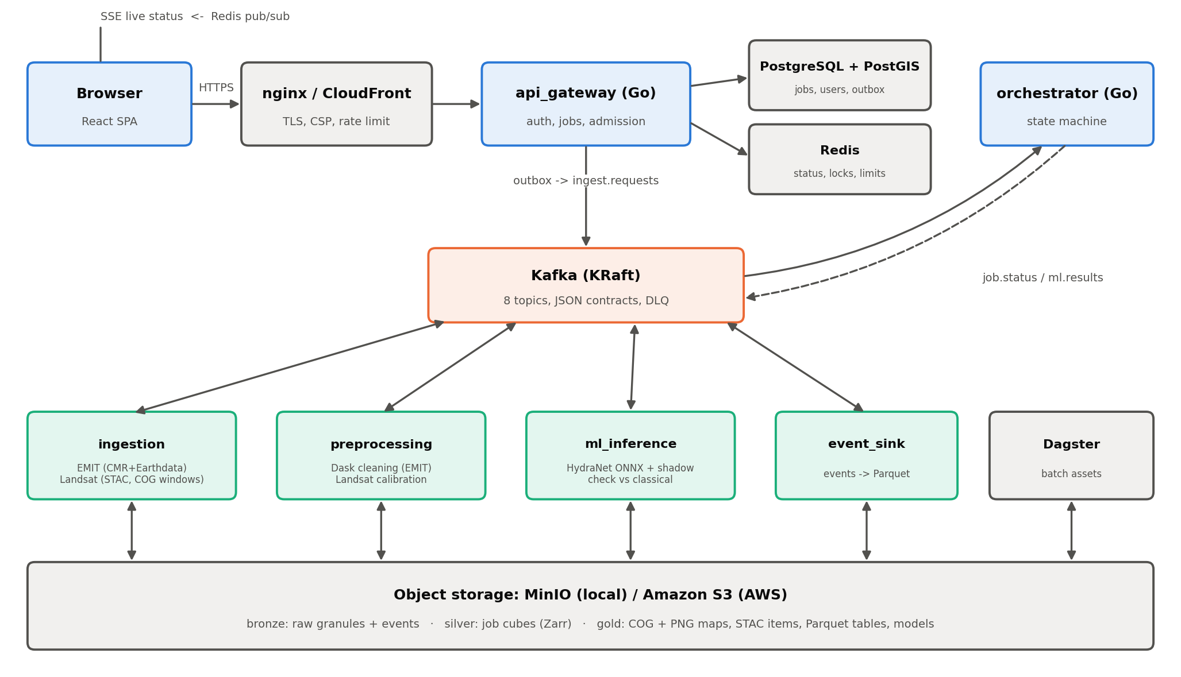
Figure 1. Platform architecture. Blue: Go services; green: Python workers; orange: Kafka; gray: state and storage.
Table 5. Components
Component | Technology | Role
Edge | nginx (local) / CloudFront (AWS) | TLS, static SPA, strict CSP and security headers, 30 req/s per-IP limit, overwrites the client-IP header
api_gateway | Go 1.26, gin | auth (JWT + refresh cookies), job submission, validation, admission control (3 active jobs/user, 500 global), result reuse, presigned map URLs, SSE
orchestrator | Go | consumes job.status and ml.results; per-task state machine; watchdog marks stages past their SLA as timed out; finishes coalesced follower jobs
ingestion | Python | EMIT and Landsat acquisition; stages each EMIT granule once platform-wide (Redis lock)
preprocessing | Python, Dask, Xarray | spectral cleaning of EMIT cubes; Landsat ST calibration and reprojection
ml_inference | Python, ONNX Runtime | HydraNet inference, map layers, STAC, shadow verification against the classical method
event_sink | Python | writes every Kafka event to the Bronze lake as Parquet
Kafka | Apache Kafka (KRaft) | 8 topics, at-least-once delivery, DLQ
Redis | Redis 7 | live status (pub/sub), idempotency keys, locks, rate limits, token denylist
PostgreSQL + PostGIS | Postgres 16 | system of record: users, jobs, tasks, layers, catalog, model registry, outbox, audit log
Object storage | MinIO / Amazon S3 | data lake (bronze/silver/gold), models, maps
Dagster | Python | batch pipelines
Prometheus + Grafana |  | metrics, alerts (DLQ, NN disagreement, backlog, gateway errors, outbox stuck)

4.1 Life of a job
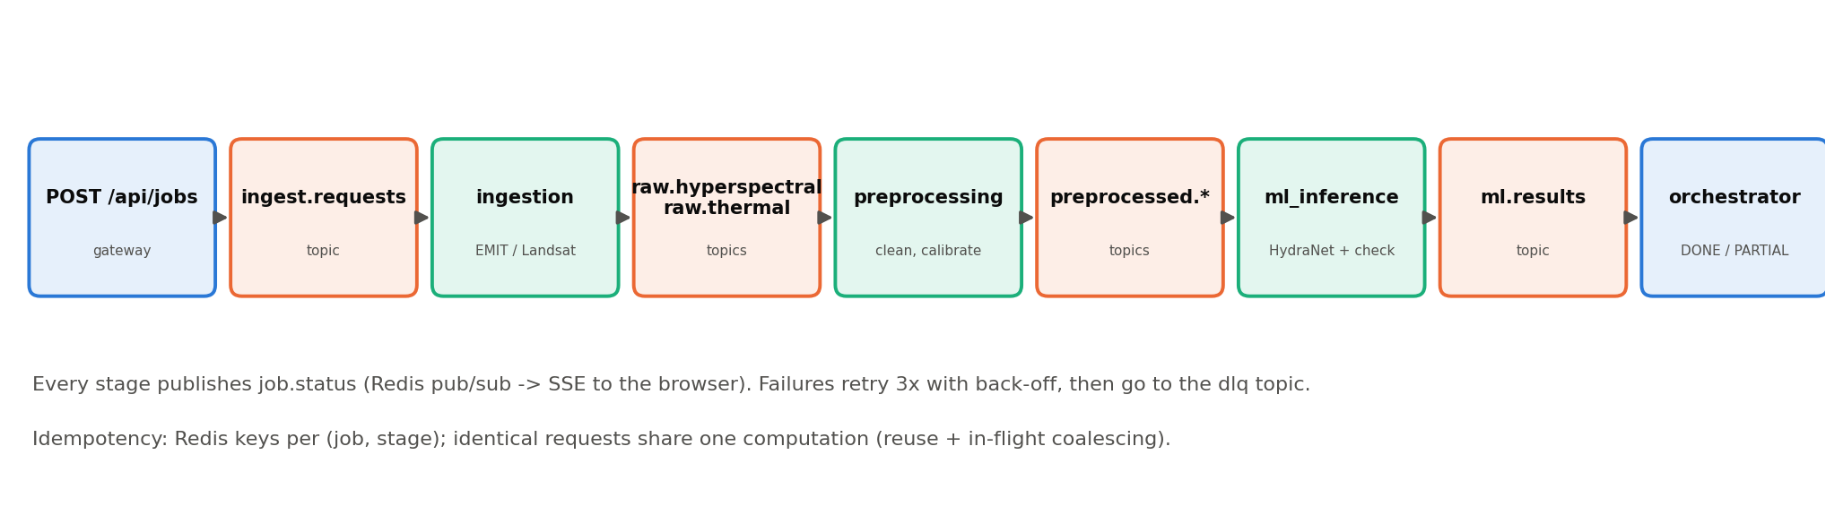
Figure 2. A job flows through Kafka topics; each stage reports progress on job.status.
- The browser POSTs the box, tasks and dates to /api/jobs with an Idempotency-Key. The gateway validates them, checks quotas, and looks for an identical finished job (same box, tasks, dates, source and model): if found, the maps are reused instantly; if an identical job is in flight, the new job follows it (coalescing).
- The job and an ingest.requests message are written in one database transaction (transactional outbox); a relay publishes the outbox to Kafka, so a crash can never lose or duplicate a job.
- Ingestion fetches imagery for each sensor and publishes raw.hyperspectral / raw.thermal; preprocessing cleans it and publishes preprocessed.*; ml_inference runs HydraNet, writes the layers and publishes ml.results.
- Each worker is idempotent (Redis key per job and stage), retries transient errors three times with back-off and sends permanent failures to the dlq topic. A task with no data (no clear acquisition) ends as NO_DATA without failing the others.
- The orchestrator updates the job (DONE, PARTIAL, FAILED, TIMED_OUT, CANCELLED); the browser follows live through Server-Sent Events backed by Redis pub/sub, with polling as a fallback.

5. Data sources and acquisition
Table 6. Data sources
Source | What | Access
NASA EMIT L2A RFL (EMITL2ARFL) | surface reflectance, 285 bands 381–2493 nm, 60 m, swath geometry with a geometry lookup table (GLT) | search: NASA CMR (public); download: Earthdata Login bearer token
NASA EMIT L2A MASK | cloud, cirrus, water, spacecraft and dilated-cloud flags | matched to the reflectance granule by acquisition time (±2 s)
Landsat 8/9 Collection 2 Level-2 | ST_B10 surface temperature, QA_PIXEL, MTL metadata, 30 m | Microsoft Planetary Computer STAC (free, anonymous); only the box window of the Cloud-Optimized GeoTIFF is read
USGS spectral library | 12 reference mineral spectra (alunite … quartz) | Mineral/*.csv, resampled to EMIT bands
RTM_NN_TRAINING_DATASET_WAVELENGTHS.csv | 10,000 PROSAIL spectra at 24 wavelengths with Cab, Car, Cw, Cm, LAI, ALA | Agriculture/
Mineral dataset_sample.csv / training_sample.csv | real EMIT pixel spectra with published teacher labels; owner's training set | Mineral/
HyperSpectral_Processer_macOS.csv | thermal processor output used to calibrate the thermal rules | Thermal/

5.1 API or download-and-stage?
EMIT files are 1.8–1.9 GB netCDF granules with no server-side subsetting, so the platform downloads each granule once, stages it in the Bronze lake, and crops every later job from the staged copy (a Redis lock makes concurrent jobs wait for one download instead of starting several). Landsat is served as Cloud-Optimized GeoTIFFs, so only the few hundred KB inside the box are read over HTTP range requests and no staging is needed. A Dagster asset can pre-stage the clearest recent EMIT granules for the service region, so users rarely wait for NASA.
Orthorectification: each EMIT file carries a GLT that maps every pixel of a north-up EPSG:4326 grid to a swath pixel. The ingestion crops that grid to the box and reads only the swath rows needed, which matches NASA's emit_tools output (unit-tested on a file with EMIT's exact layout and now exercised on a real granule, section 11.5).

6. Data engineering

6.1 Event streaming (Kafka)
Table 7. Kafka topics (partitions bound the maximum parallel workers per stage)
Topic | Partitions | Retention | Producer → consumer
ingest.requests | 12 | 7 days | gateway outbox → ingestion
raw.hyperspectral | 12 | 7 days | ingestion → preprocessing
raw.thermal | 6 | 7 days | ingestion → preprocessing-thermal
preprocessed.hyperspectral | 12 | 7 days | preprocessing → ml_inference
preprocessed.thermal | 6 | 7 days | preprocessing-thermal → ml_inference
ml.results | 6 | 7 days | ml_inference → orchestrator
job.status | 12 | 7 days | every stage → orchestrator, event_sink
dlq | 1 | 30 days | any worker (after 3 retries) → operators

Messages are JSON, defined once as pydantic models (libs/hs_common/messages.py). JSON Schemas are generated into contracts/ and a Go test checks the Go structs against them, so producers and consumers cannot drift. Delivery is at-least-once; consumers are idempotent. Large payloads (cubes, rasters) never travel through Kafka: messages carry object-storage keys.

6.2 Redis
- Live job status: workers publish, the gateway streams to browsers (SSE).
- Idempotency: done-keys per job and stage; reuse and in-flight keys for request coalescing.
- Distributed locks: one EMIT download per granule platform-wide.
- Rate limits (per IP, per user) and the access-token denylist / token versions.

6.3 PostgreSQL + PostGIS (system of record)
Table 8. Database tables
Table | Holds
users, refresh_tokens, audit_log | accounts, rotating refresh-token families, every authentication event
jobs, job_tasks, job_sources | requests (bbox as PostGIS geometry, GiST index), per-task state, which granule/scene was used
layers, job_results | every map layer (object key, stats, units, colormap) and per-task summaries and verification
catalog_granules | imagery catalog with footprints (GiST), filled by Dagster
model_versions | model registry: version, files, feature-spec hash, gates, which one is active
outbox, processed_events, dq_results | transactional outbox, consumer de-duplication, data-quality check results

6.4 Data lake (MinIO / S3)
Table 9. Lake layout
Layer | Key pattern | Contents
Bronze | bronze/emit/{granule}/…, bronze/events/topic=…/dt=…/ | raw EMIT granules exactly as downloaded; every Kafka event as Parquet (Hive partitions)
Silver | silver/{job}/raw.zarr, reflectance.zarr, multiband.zarr, cloud.npy, landsat/…, thermal/lst.tif | per-job working data: cropped cube, cleaned reflectance, LST in °C
Gold | gold/results/{job}/{task}/*.tif|png, manifest.json, stac_item.json; gold/tables/{name}/dt=…/ | map layers (Cloud-Optimized GeoTIFF + colour PNG), STAC metadata, analytics tables
Models | models/hydra/{version}/hydra.onnx, agri_lut.npz, model_card.json | the model registry's files

The same code talks to MinIO locally and to Amazon S3 in AWS: only S3_ENDPOINT_URL and the keys change (empty endpoint = AWS). Lifecycle rules expire Silver after 30 days and keep Gold for 180 days.

6.5 Batch pipelines (Dagster)
Table 10. Dagster assets
Asset | What it does
imagery_catalog | EMIT and Landsat acquisitions over the region, with footprints, into PostGIS
prestaged_granules | downloads the clearest recent EMIT granules into Bronze ahead of demand
events_compacted | merges event-sink micro-batches into one Parquet file per topic and day
gold_job_facts, gold_layer_stats | one row per job with time per stage; per-layer statistics (drift, usage)
model_agreement_report | HydraNet vs classical agreement over the last 24 h; fails below the floor
db_housekeeping, pg_backup | prunes idempotency/outbox rows; nightly Postgres backup to storage

In AWS, Glue and Athena expose the Gold Parquet tables to SQL without a running database.

7. Preprocessing
The hyperspectral preprocessing is the Dask module by Ananthanarayanan B. It works chunk by chunk, so memory stays bounded whatever the scene size; per-scene statistics are measured once to avoid seams between chunks.
Table 11. EMIT preprocessing steps
Step | Why
Quality gate on raw values | rejects scenes that are mostly no-data (> 50 %); partly cloudy scenes are kept
Fill (−9999), NaN, inf → 0; integer reflectance ÷ 10000 | auto-detected; EMIT L2A is already 0..1
Haze removal only for raw radiance | on EMIT L2A surface reflectance it destroys signal (NDVI +0.25 → −0.21 on a real crop), so it is skipped
Interpolate water-vapour (1340–1460, 1790–1960 nm) and low-SNR bands | never deleted, so band positions never shift
Savitzky-Golay smoothing (7, 2) | keeps the depth of the 2205 / 2350 nm absorption features
Clip to [0, 1] last | smoothing can ring below 0
Outputs | reflectance.zarr (all bands, HydraNet input) and multiband.zarr (16 measured target bands for quick looks)

Landsat: the ST_B10 digital numbers are converted to °C with the scene's own MTL calibration, clouds and shadows are removed with QA_PIXEL, and the raster is reprojected from its UTM zone to EPSG:4326 (nearest neighbour, so cloud edges are not smeared), so every layer of a job shares one grid.

8. The classical methods (teachers)
These are the "normal ways" of making each map. They are implemented in libs/hydra/classical and verified bit-for-bit against the owners' reference code (vendored in libs/hydra/tests/reference) by parity tests.

8.1 Minerals: SAM + SMA/FCLS
Table 12. Mineral teacher
Setting | Value
Library | 12 USGS minerals: alunite, calcite, chlorite, dolomite, goethite, gypsum, hematite, illite, kaolinite, montmorillonite, muscovite, quartz
Bands | 255 good EMIT bands (water-vapour bands excluded)
Continuum removal | upper convex hull (numba)
Class | Spectral Angle Mapper: smallest angle wins; best angle > 0.20 rad → unknown
Abundance | fully constrained least squares (non-negative, sum-to-one row weighted 1,000)
Quality | from the SMA fit residual (RMSE limit 0.10 reflectance)
Diagnostic depths | Al-OH 2100–2300, Fe-OH 2200–2330, Mg-OH 2250–2400, CO3 2300–2400, Fe3+ 750–1050, Fe2+ 900–1200, sulfate 1700–2300 nm

8.2 Agriculture: PROSAIL LUT inversion
Table 13. Agriculture teacher
Setting | Value
Forward model | PROSAIL (PROSPECT-5 + 4SAIL), SDR output
Fixed parameters | N = 1.5, Cbrown = 0, hotspot = 0.1, solar zenith 30°, view zenith 0°, relative azimuth 0°, psoil = 0.5, rsoil = 1.0, spherical LIDF (fitted to reproduce the CSV, RMSE 7×10⁻⁵)
Free parameters and ranges | Cab 0–110 µg/cm², Car 0–30 µg/cm², Cw 0–0.07 g/cm², Cm 0–0.05 g/cm², LAI 0–10 m²/m², ALA 0–90°
Bands | 22 of the CSV's 24 wavelengths (1357 and 1417 nm removed: water-vapour edges); interpolated from EMIT within 4 nm
LUT | 100,000 entries; inverse-distance mean of the k = 20 nearest spectra (k = 5 was unstable), spread = uncertainty
Mask | vegetated pixels only (NDVI ≥ 0.25)

8.3 Thermal: ThermalAnomalyDetector rules
Table 14. Thermal teacher
Map | Rule
Global class | z-score over the scene: < −2 cold, > +2 hot, otherwise normal
Local anomaly | z-score in an 11 × 11 window > 2
Urban heat island | above the 80th percentile = urban, below the 20th = rural; intensity = mean(urban) − mean(rural)
Hotspots | above the 95th percentile, connected regions of at least 10 pixels

9. HydraNet: the three-in-one neural network
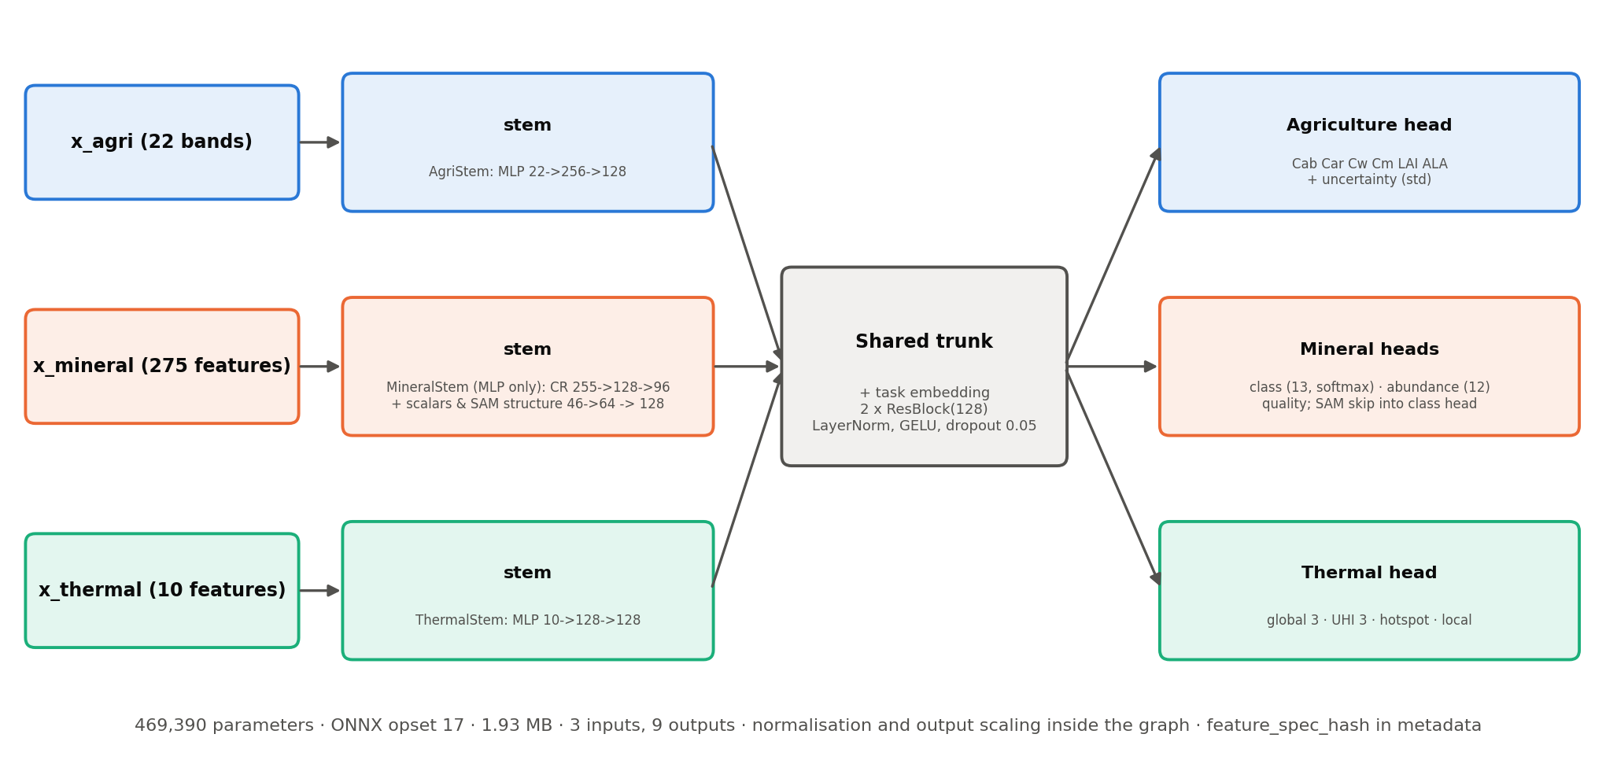
Figure 3. HydraNet: three input stems, a shared trunk with a task embedding, and task heads.
Each task has its own small input stem that maps its features to a common 128-wide representation. A learned task embedding is added and the result goes through a shared residual trunk (two pre-norm residual MLP blocks). Each head sees the trunk output concatenated with its stem output. The mineral class head also receives the SAM decision structure directly (a skip connection), which lets it resolve near-ties between similar minerals.
Table 15. Inputs (features are computed by libs/hydra/features, shared by training and serving)
Input | Size | Features
x_agri | 22 | reflectance at the 22 PROSAIL wavelengths
x_mineral | 275 | 255 continuum-removed reflectances + 7 diagnostic absorption depths + 12 SAM angles + brightness
x_thermal | 10 | global z, distance to p95/p80/p20, local 11×11 z, 3×3 mean difference, std and range, normalised LST, scene std

Table 16. Outputs (nine ONNX outputs)
Output | Shape | Meaning
agri_params, agri_std | 6, 6 | Cab, Car, Cw, Cm, LAI, ALA in physical units (sigmoid-scaled to their ranges) and their uncertainty
mineral_class_probs | 13 | softmax over 12 minerals + unknown
mineral_abundance, mineral_quality | 12, 1 | softmax abundances (sum to one) and fit quality
thermal_global_probs, thermal_uhi_probs | 3, 3 | cold/normal/hot and rural/neutral/urban
thermal_hot_prob, thermal_local_prob | 1, 1 | hotspot and local-anomaly probabilities

Table 17. Layers
Part | Layers
Agriculture stem | Standardize → Linear 22→256 → GELU → Linear 256→128 → GELU → Linear 128→128
Mineral stem (MLP) | Standardize; spectrum: Linear 255→128 → GELU → Linear 128→96 → GELU; scalars + SAM structure (46) → MLP 64; concat 160 → MLP → 128
Thermal stem | Standardize → MLP 10→128→128 → GELU → Linear 128→128
Shared trunk | + task embedding (3 × 128); 2 × ResBlock(LayerNorm, Linear 128→256, GELU, dropout 0.05, Linear 256→128); LayerNorm
Heads | two-layer MLPs on [trunk ‖ stem] (256 wide); mineral class head input 256 + 26 SAM-structure features
Loss weighting | learned task-uncertainty weights (Kendall et al., 2018), used in training only

Size: 469,390 parameters, 1.93 MB ONNX (opset 17). Normalisation, output scaling and softmaxes are inside the graph, so the file takes raw features and returns map-ready values. The ONNX outputs match PyTorch to within 9.5e-5 (agriculture), 1.2e-6 (minerals) and 1.2e-5 (thermal).
Safety lock: the feature specification (band lists, thresholds, library checksum, PROSAIL settings) is hashed (feature_spec_hash = f15dd48ca7cd4dd6) and the hash is written into the ONNX metadata. The runtime refuses to load a model whose hash differs from the code's, so a model can never run on features computed differently from those it was trained on.

9.1 Why an MLP instead of a CNN
The first version used a 1-D convolutional stem over the mineral spectrum (1.19 M parameters). Because SAM and SMA treat every pixel independently and the continuum-removed spectrum is a fixed 255-vector, a dense stem with the SAM structure as extra input learns the same decision with 61 % fewer parameters and is faster on CPU. The deployed v1 is the MLP.
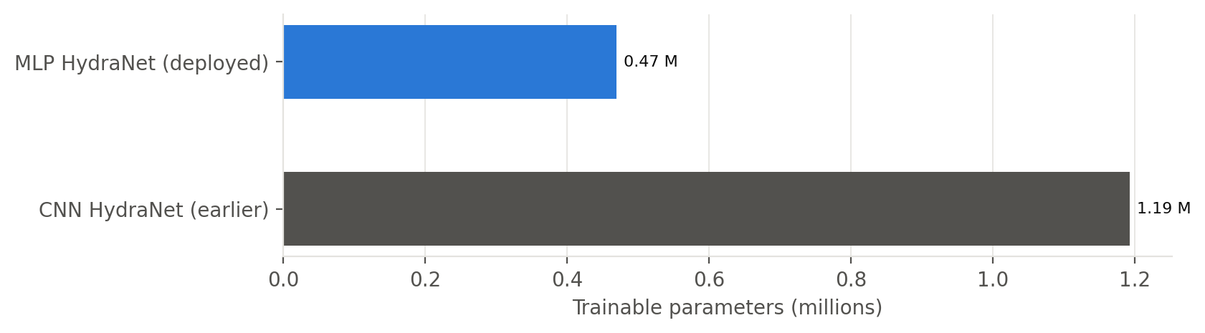
Figure 4. Trainable parameters of the two architectures.

10. Data generation and training
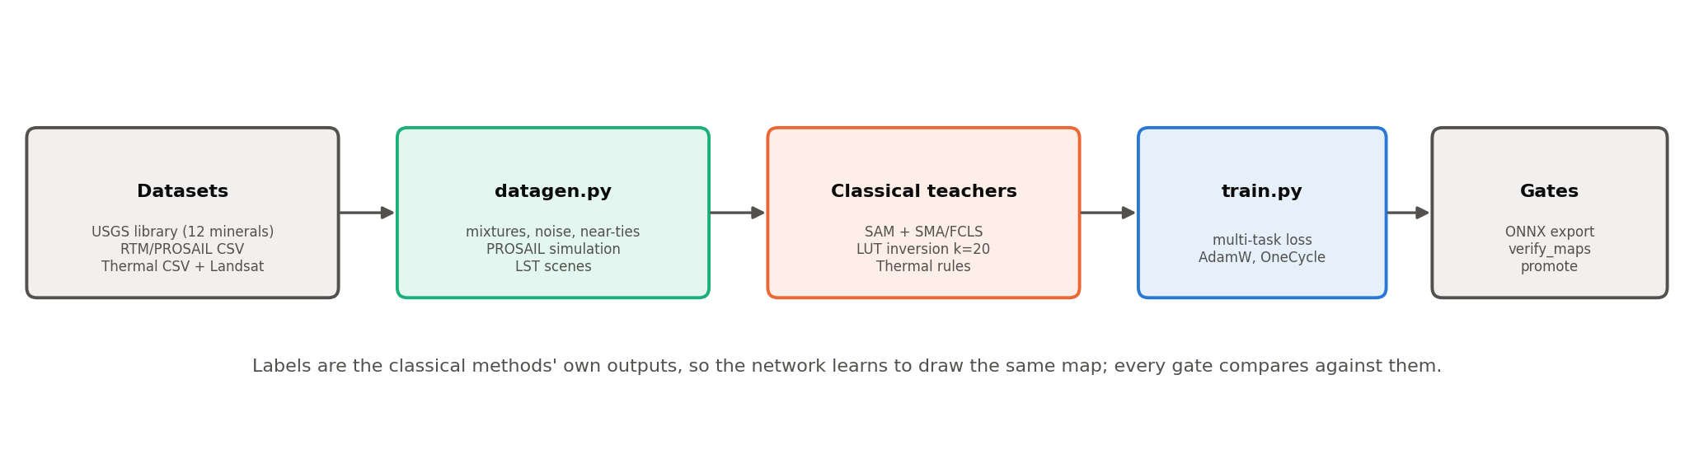
Figure 5. Teacher-student training: the classical methods label every training sample.
Table 18. Training data (every label comes from the classical teacher)
Set | Size | How it is made
mineral_train / val | 202,400 / 20,240 | the owner's 62,400-spectrum set (reproduced exactly, seed 0) + a coverage set of library mixtures with noise, brightness and continuum variation + 40,000 near-tie spectra (quartz/gypsum and other close pairs); labels from SAM + SMA
mineral_real | 2,000 | real EMIT pixels from dataset_sample.csv with the published teacher labels
agri_lut | 100,000 | PROSAIL spectra on random parameters: the classical method's LUT
agri_train / val | 200,000 | PROSAIL spectra with nuisance variation (soil, geometry, noise), labelled by LUT inversion
agri_csv | 10,000 | the CSV rows, labelled by LUT inversion (true parameters kept for reference)
thermal_train / val | 1,445,055 pixels (400 scenes) | synthetic land-surface-temperature scenes (urban cores, fields, water, fires), labelled by the detector rules

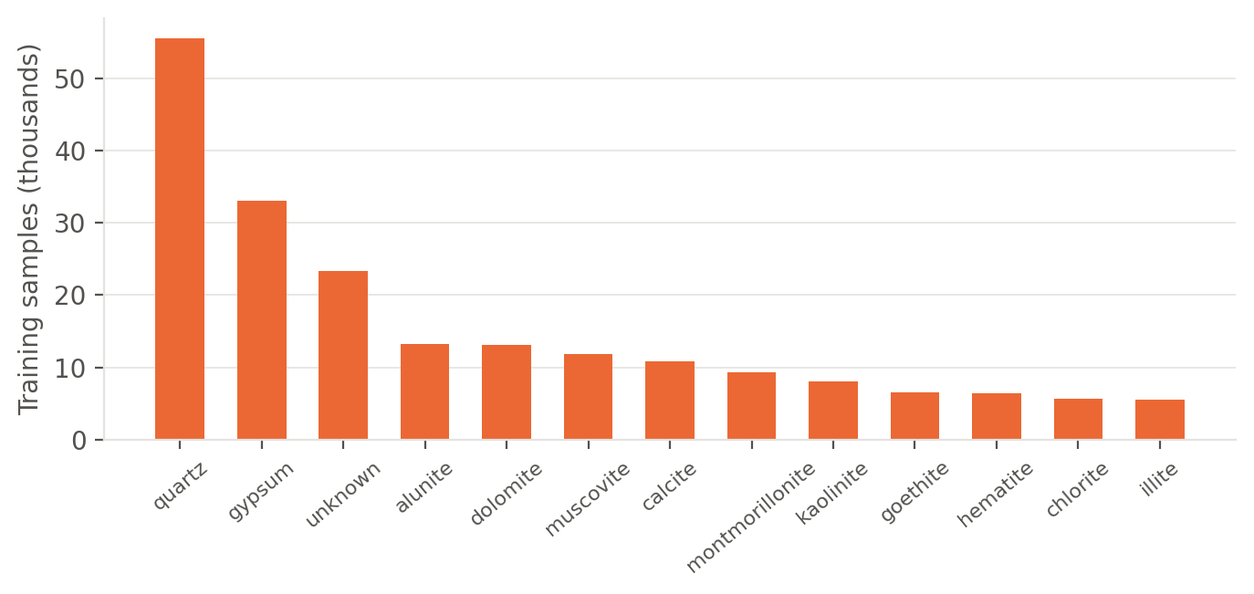
Figure 6. Mineral training samples per class.
Table 19. Training settings
Setting | Value
Optimiser | AdamW, weight decay 1e-4
Learning rate | 0.002, one-cycle schedule (5 % warm-up)
Steps / batch | 20,000 steps; batch 512 per task (thermal 1024)
Agriculture loss | MSE on range-scaled parameters + 0.25 × MSE on the uncertainty
Mineral loss | cross-entropy (class) + 20 × MSE (abundance) + 10 × MSE (quality)
Thermal loss | cross-entropy (global, UHI) + binary cross-entropy (hotspot, local)
Task balance | learned uncertainty weights; evaluation every 2,000 steps, best checkpoint kept
Hardware | CPU (10 threads)

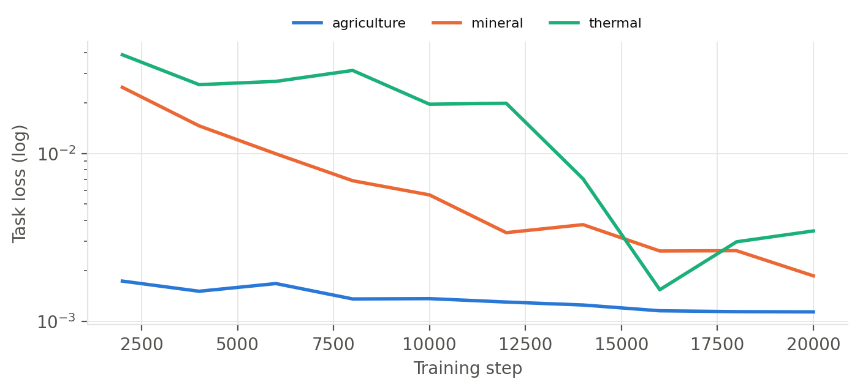
Figure 7. Validation loss per task during training.

11. Results

11.1 Release gates
Table 20. Gates checked by train.py before a model can be promoted
Gate | Value | Threshold | Result
mineral_val.class_agreement | 0.9995 | 0.98 | pass
mineral_val.abundance_mae | 0.0041 | 0.03 | pass
mineral_val.quality_mae | 0.0041 | 0.03 | pass
mineral_real.class_agreement | 0.9985 | 0.97 | pass
mineral_real.abundance_mae | 0.0782 | 0.06 | FAIL
agri_val.r2_min_core | 0.9689 | 0.95 | pass
agri_csv.r2_min_core | 0.9705 | 0.95 | pass
thermal_val.global_agreement | 0.9984 | 0.99 | pass
thermal_val.uhi_agreement | 0.9993 | 0.99 | pass
thermal_val.hot_agreement | 0.9996 | 0.99 | pass
thermal_val.local_agreement | 0.9998 | 0.99 | pass

All gates pass except the abundance error on the 2,000 real EMIT rows (0.078 vs 0.06). Version 1 was promoted with --force, which is recorded in the model registry and shown on the Platform page. Class maps on the same rows agree 99.85 %.

11.2 Map verification (whole scenes)
verify_maps.py runs both the classical method and HydraNet on complete scenes and compares the resulting maps pixel by pixel.
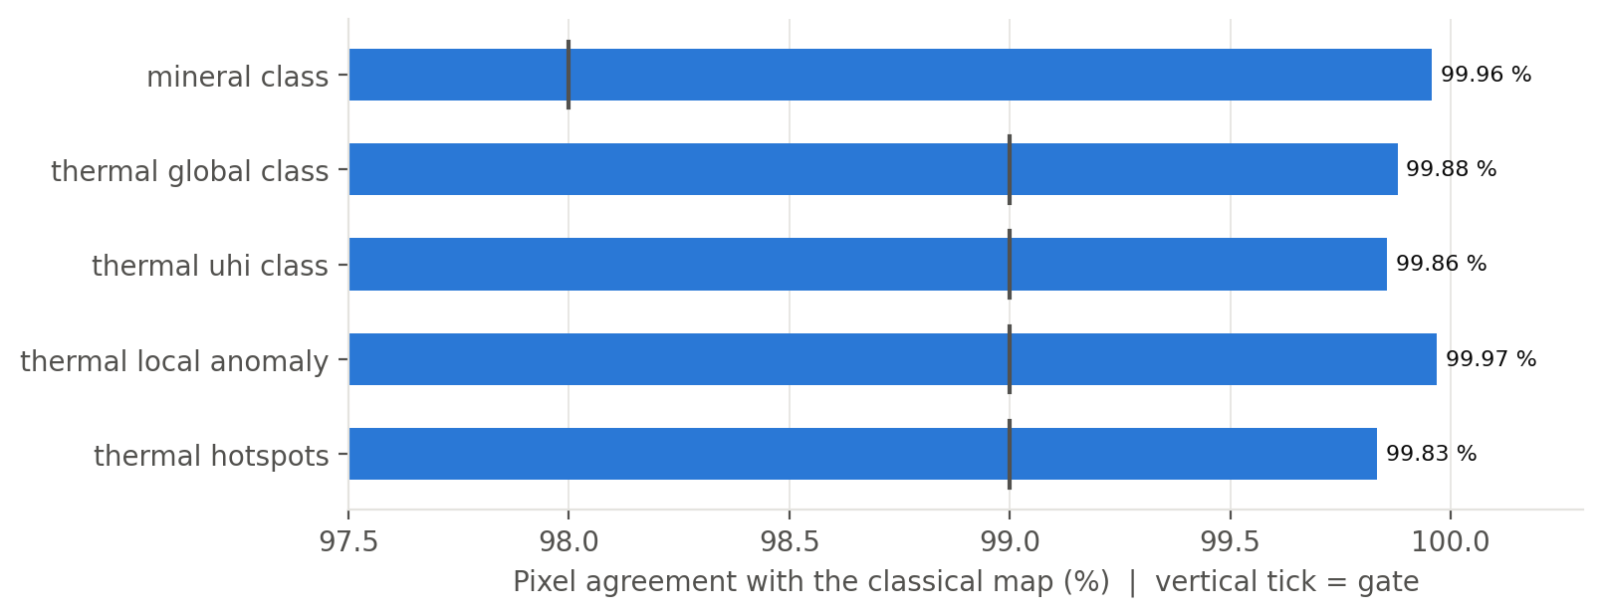
Figure 8. Class maps: pixel agreement with the classical method (vertical tick = gate).
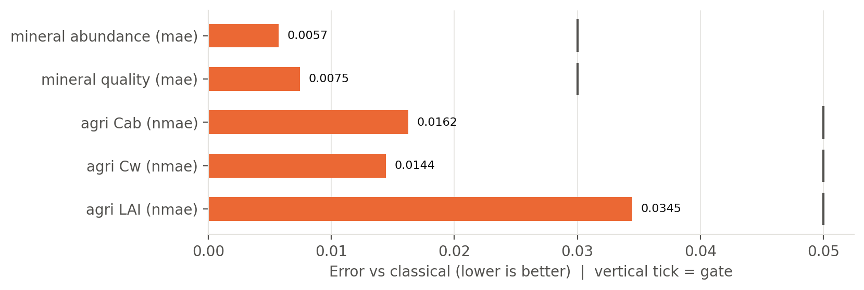
Figure 9. Continuous maps: error against the classical method (vertical tick = gate).
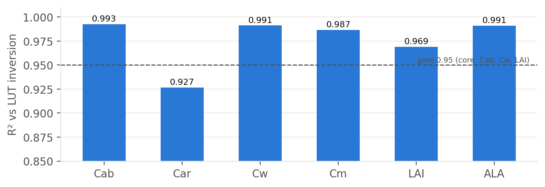
Figure 10. Agriculture: R² against the LUT inversion for each parameter (validation set).
Car (carotenoids) is the hardest trait for the LUT itself (weak, overlapping absorption), so it is reported but not gated; the core traits Cab, Cw and LAI are gated at R² ≥ 0.95.

11.3 Real Landsat scenes
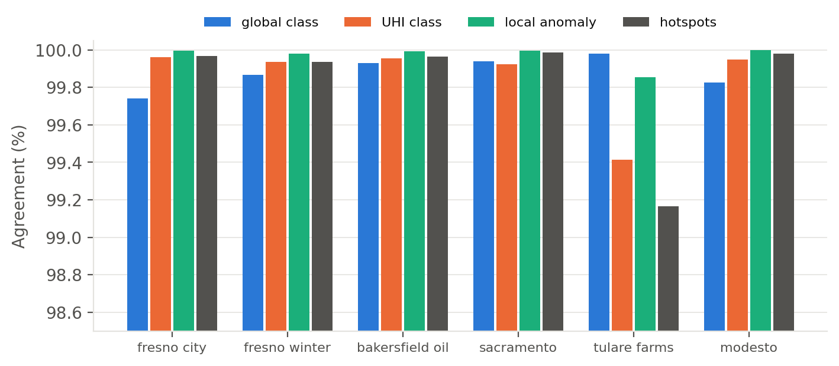
Figure 11. Agreement with the thermal rules on six real Landsat 8/9 scenes.
Table 21. Real Landsat scenes
Scene | Landsat ID | Date | UHI intensity (NN / rules)
fresno city | LC08_L2SP_043034_20240930_02_T1 | 2024-09-30 | 5.71 / 5.7 °C
fresno winter | LC08_L2SP_042035_20240228_02_T1 | 2024-02-28 | 4.17 / 4.17 °C
bakersfield oil | LC09_L2SP_042035_20240830_02_T1 | 2024-08-30 | 7.8 / 7.81 °C
sacramento | LC09_L2SP_044033_20240929_02_T1 | 2024-09-29 | 7.81 / 7.82 °C
tulare farms | LC09_L2SP_042035_20240729_02_T1 | 2024-07-29 | 17.01 / 17.06 °C
modesto | LC08_L2SP_043034_20240930_02_T1 | 2024-09-30 | 6.73 / 6.74 °C

11.4 Speed and size
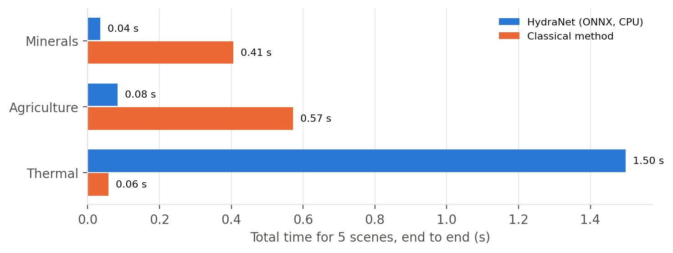
Figure 12. Time for five synthetic scenes on one CPU, end to end (features + model, or features + classical method).
For minerals and agriculture HydraNet replaces per-pixel searches (SAM against the library plus NNLS unmixing; nearest neighbours in a 100,000-entry LUT) with one batched matrix pass: 11.5× and 6.9× faster end to end, and 26× and 7.5× for the model step alone. For thermal the network is slower, because it needs the same scene statistics as the rules and the rules themselves are only a few array operations.

11.5 Real end-to-end job: EMIT + Landsat over Fresno County
A real job was run through the whole platform on 20 October 2026 with the project's NASA Earthdata account: box -120.10, 36.60, -120.05, 36.65 (farmland west of Fresno, California, about 25 km²), all three tasks. The platform selected EMIT granule EMIT_L2A_RFL_002_20230822T192555 (acquired 2023-08-22, 1 % cloud) and Landsat scene LC09_L2SP_042035_20230929_02_T1 (2023-09-29), downloaded and staged the 1.88 GB EMIT file (about 8.5 minutes at 2.8 MB/s; once per granule), orthorectified the box with the GLT, cleaned it, and ran HydraNet. Final status: COMPLETED; a repeat job over the same granule took 10 s.
Bug found by this test and fixed: the first real run finished DONE but with empty agriculture and mineral maps: every pixel was masked as cloud. EMIT's MASK product version 003 changed its band order (band 4 is now a continuous SpecTf cloud probability, above 0 everywhere), and the code selected flag bands by position. The fix selects the flag bands by the names stored in the file, works for both layouts, and a box that is more than 95 % cloud now ends as NO_DATA with a message instead of an empty DONE. Regression tests cover both mask layouts.
Table 22. Real job results (HydraNet vs the classical method on every pixel of the job)
Task | Status | Pixels mapped | Agreement with classical (all pixels)
Agriculture | DONE | 6,725 vegetated | Cab nMAE 1.9 %, r 0.992  Cw nMAE 2.5 %, r 0.995  LAI nMAE 1.5 %, r 0.990
Minerals | DONE | 2,016 bare | class 99.75 % (1930 quartz, 86 gypsum vs SAM 1935 / 81); abundance MAE 0.068; quality MAE 0.186
Thermal | DONE | 176×180 | global 99.98 %, UHI 99.89 %, local 99.98 %, hotspots 99.99 %; UHI intensity 12.75 vs 12.76 °C

Land cover of the box: no data / cloud 0.0 %, water 0.0 %, vegetation 76.9 %, bare soil / rock 23.1 %. Agriculture R² against the LUT on all 6,725 vegetated pixels: Cab 0.983, Cw 0.985, LAI 0.980 (ALA 0.917, Cm 0.801, Car 0.735). Steady-state time for the whole box (after warm-up): agriculture 0.007 s vs 0.142 s for the LUT inversion (20×), minerals 0.007 s vs 0.087 s for SAM + SMA (12×).
The production shadow check stored with the job (1,500 random pixels per task) agrees: Cab R² 0.983, Cw 0.985, LAI 0.981; mineral class 99.8 %; thermal 99.9–99.99 %. The LAI differences grow on the densest fields (LAI above 5), where the LUT inversion itself saturates. Mineral quality (the SMA fit-quality score) does not transfer to real EMIT: MAE 0.186 against 0.007 on synthetic scenes; the score is shown in the app but should not be relied on until the model is retrained with real-scene residuals.
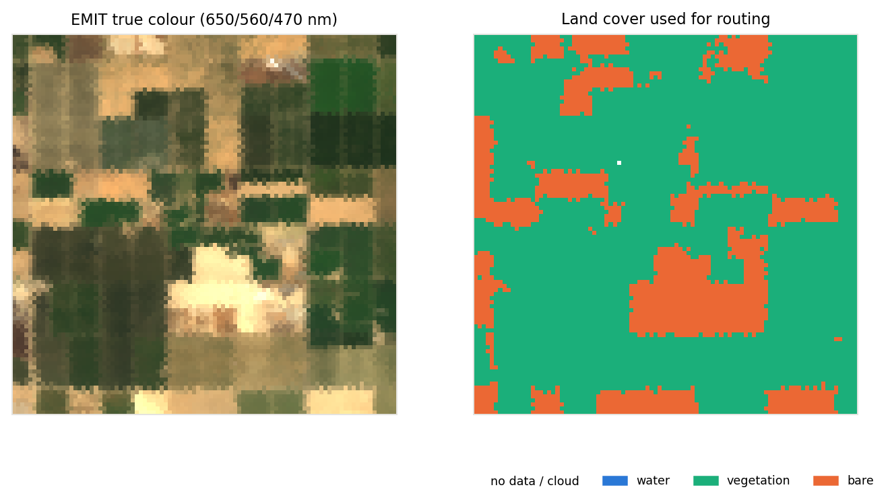
Figure 13. The EMIT box in true colour and the land-cover routing (vegetation → agriculture, bare → minerals).
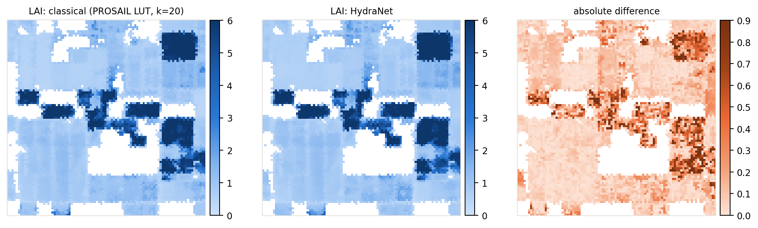
Figure 14. Leaf area index on real EMIT: classical LUT inversion, HydraNet and their difference.
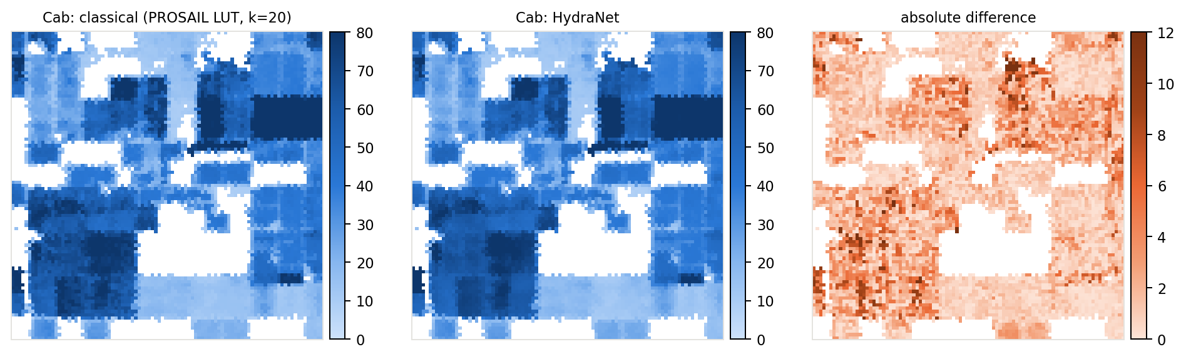
Figure 15. Leaf chlorophyll on real EMIT: classical, HydraNet, difference.
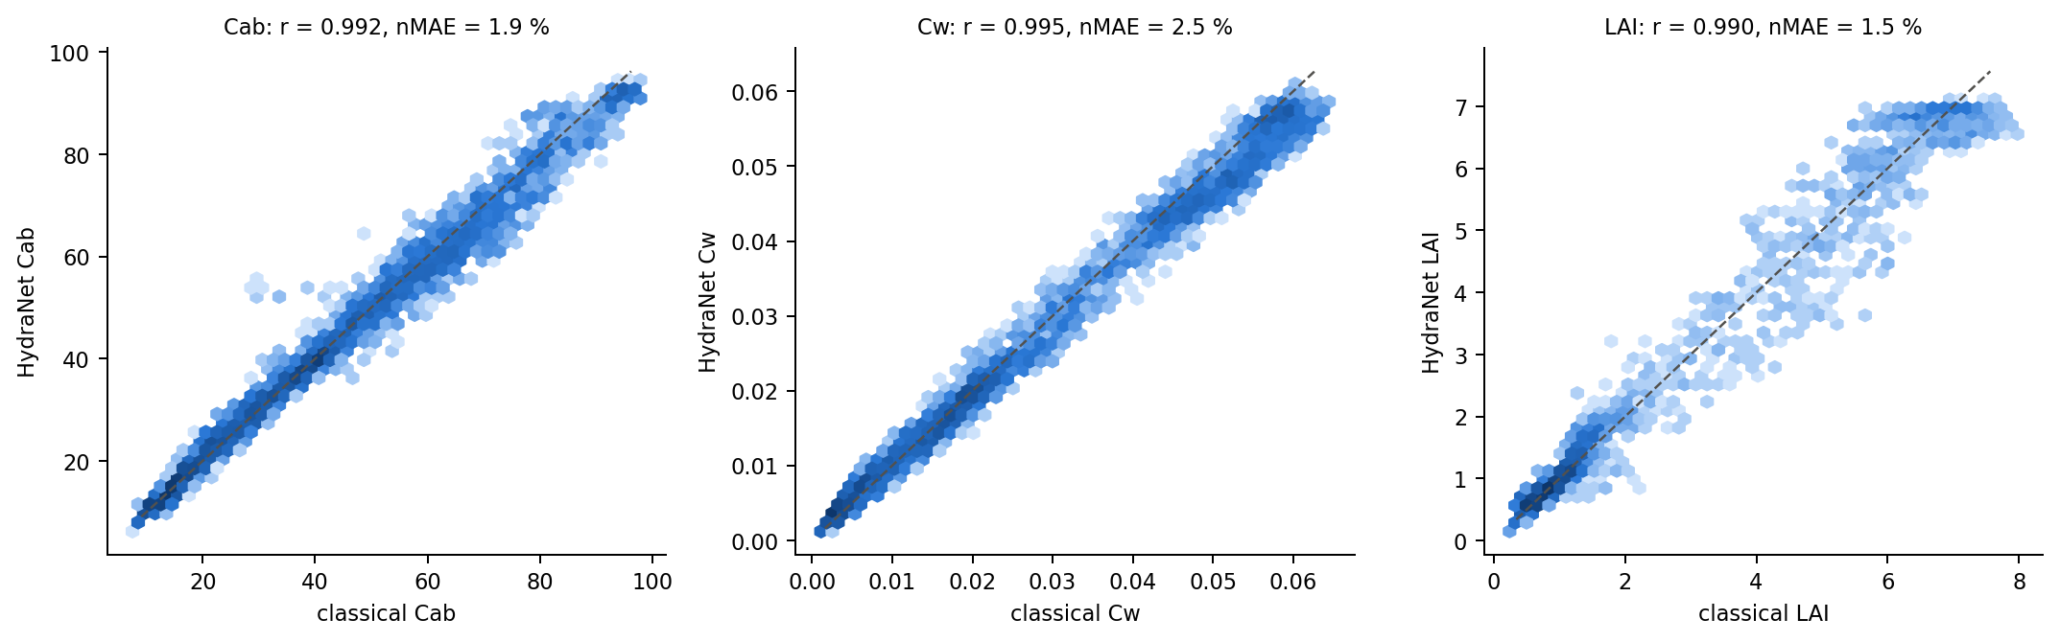
Figure 16. Every vegetated pixel: HydraNet against the classical inversion (dashed line = identical).
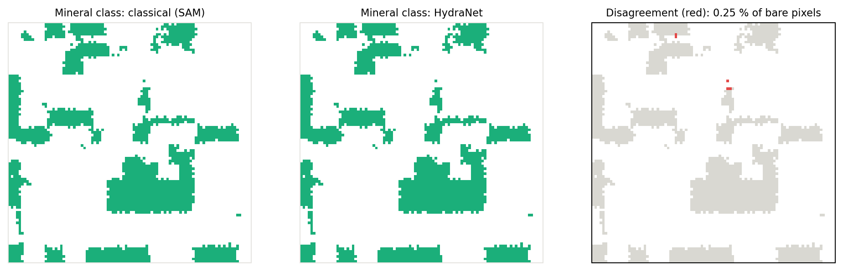
Figure 17. Mineral classes on the bare pixels: SAM, HydraNet and where they differ (quartz and gypsum share the colour of their group; red marks every pixel whose class differs).
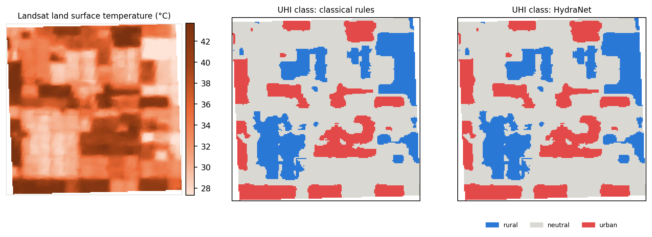
Figure 18. Landsat temperature and the urban-heat-island classes: rules vs HydraNet.
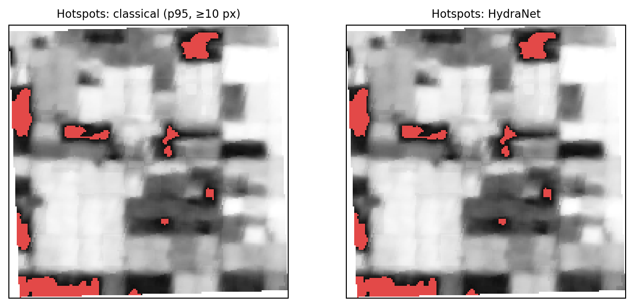
Figure 19. Hotspots: rules vs HydraNet.

12. Classical methods vs HydraNet
Table 23. Side-by-side
Aspect | Classical methods | HydraNet (ours)
What runs | three separate algorithms: SAM + NNLS unmixing, k-NN search in a 100,000-entry LUT, thermal rules | one ONNX file, three inputs, nine outputs
Accuracy | the reference (by definition) | reproduces it: 99.8–100 % class agreement, 1.4–3.4 % nMAE on crop traits; abundance on real EMIT still 0.078 MAE
Speed (CPU) | per-pixel search and optimisation | minerals 12×, agriculture 7× faster; thermal slower
Runtime files | library CSVs + 10 MB LUT + three code bases | 1.9 MB model + shared feature code
Scaling | cost grows with library and LUT size | fixed cost per pixel, batched; scales with workers
Uncertainty | LUT spread (agriculture only) | per-pixel confidence (minerals) and std (agriculture)
Deployment | Python/numba/scipy stacks | ONNX Runtime anywhere (CPU, GPU, browser, edge)
Can beat the teacher? | — | not as trained (it learns the teacher); fine-tuning on ground truth is the route (section 15)

Why HydraNet
- Speed where it matters: the expensive classical steps (library search, unmixing, LUT search) are replaced by a single matrix pass.
- One artifact: a 1.9 MB file is versioned, verified, hot-swapped and rolled back as a unit; the three classical code paths are kept only as the verifier.
- Verified, not trusted: gates before release, map verification on whole scenes, and shadow verification on every production job, with a Prometheus alert when agreement drops.
- Portable: ONNX Runtime runs the same file on a laptop, an ARM EC2 instance or a browser, with identical outputs.
- A base for improvement: unlike fixed rules, the network can later be fine-tuned on field measurements or fire records to exceed the teacher.
Honest limits: the network can only be as good as its teacher as trained; for thermal it is slower than the rules; on real EMIT the abundance error (0.078) is above its gate, because the network sees continuum-removed features while SMA sees raw reflectance.

13. Serving and inference
- The model store downloads the active model version (ONNX, LUT, model card) from the registry and hot-swaps it without restarting workers when a new version is promoted.
- ONNX Runtime runs in batches of 32,768 pixels; each worker is single-purpose and scaled by Kafka partitions.
- Each task writes its layers as Cloud-Optimized GeoTIFF (exact values, for analysis and the pixel inspector) and colour PNG (for the map), plus a STAC item and a manifest.
- Shadow verification: a random sample of each job's pixels is also run through the classical method; the agreement is stored with the result, shown in the UI, exported as a metric and alerted on.
- Maps reach the browser only through 15-minute presigned URLs; the bucket is private.

14. Web application
React 19 + Vite single-page app with Leaflet maps and geotiff.js. The user signs in, draws or types a box inside the service region, chooses tasks and dates and follows the job live. Results open in task tabs with legends, histograms, a mineral highlighter and a pixel inspector that reads exact values from the COGs. Colour palettes follow a validated, colour-blind-safe scheme (single-hue ramps for magnitude, blue–gray–red for polarity).
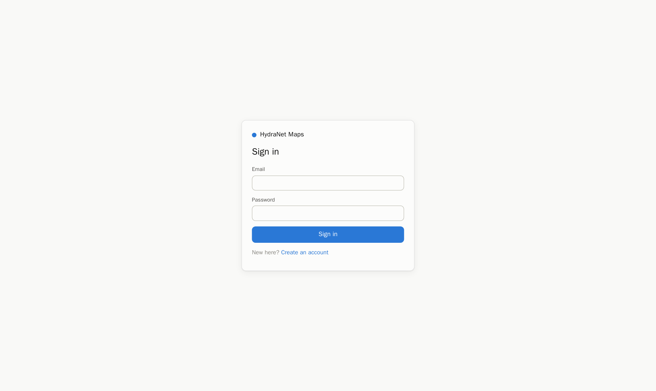
Figure 20. Sign-in page.
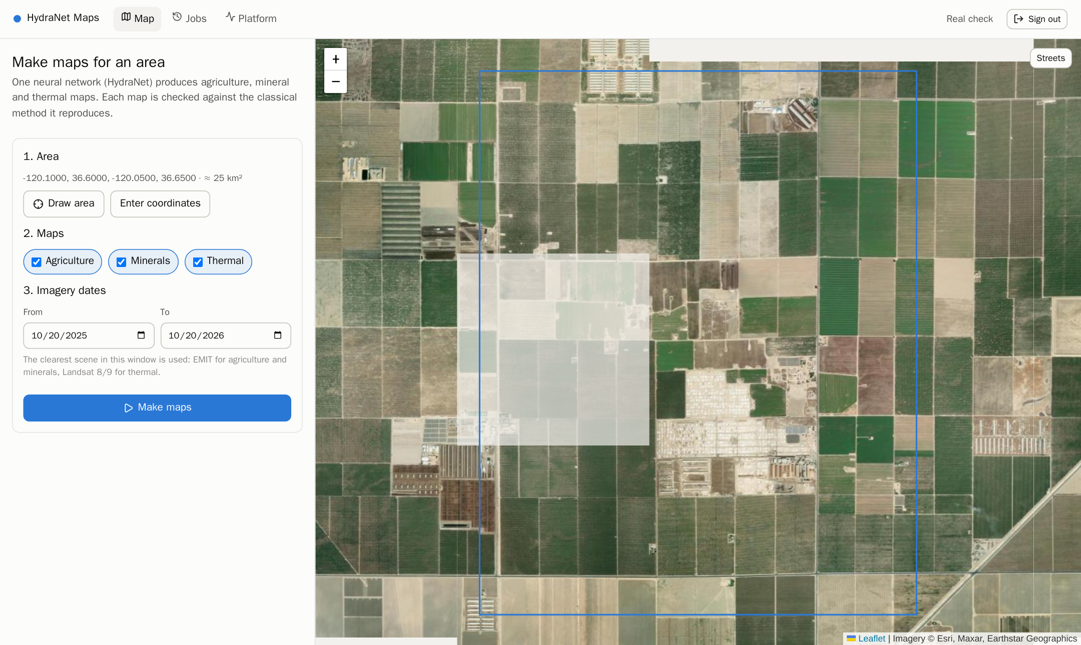
Figure 21. Workspace: choose an area, tasks and dates.
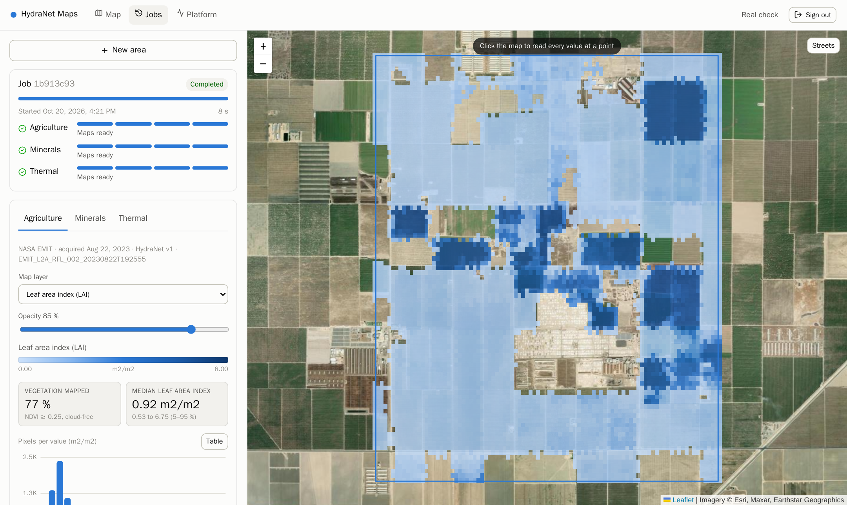
Figure 22. Real job: agriculture maps.
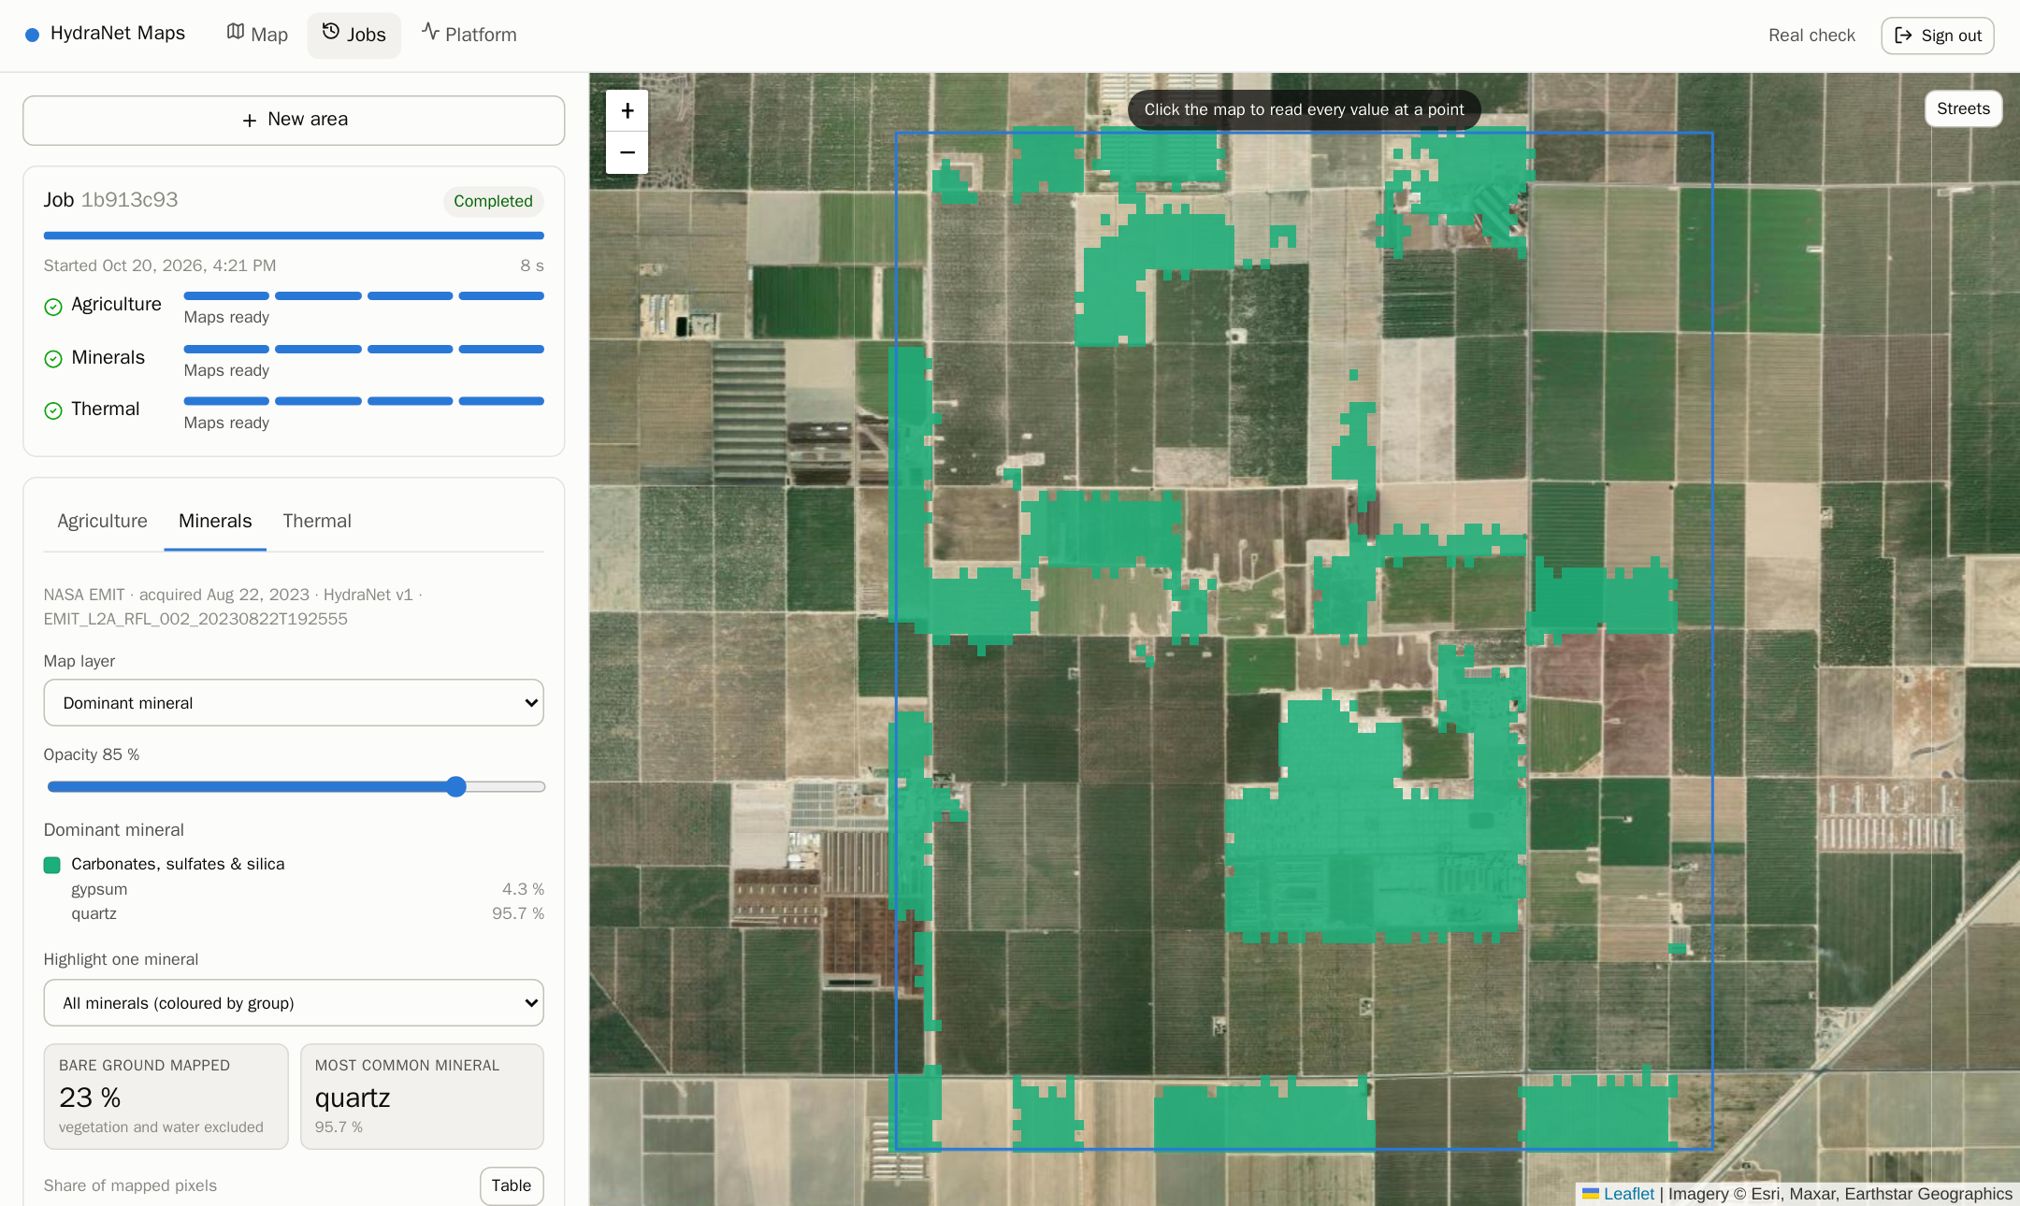
Figure 23. Real job: mineral maps.
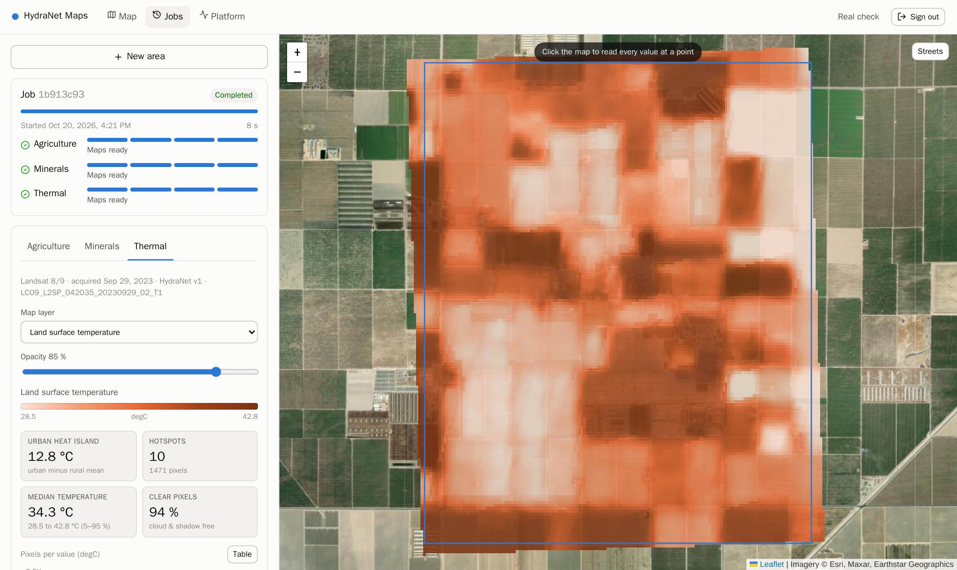
Figure 24. Real job: thermal maps.
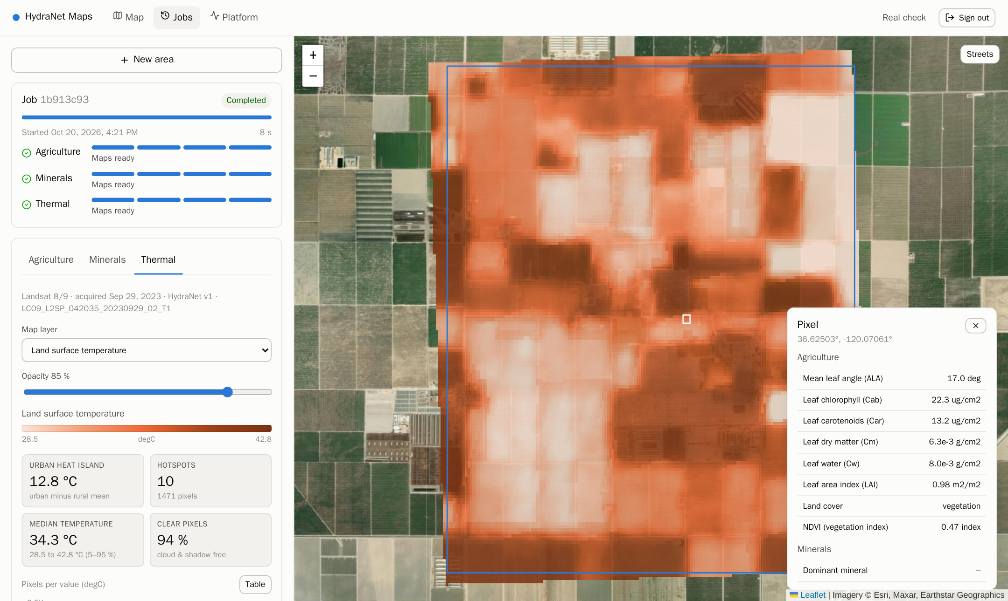
Figure 25. Pixel inspector: every value at a clicked point.
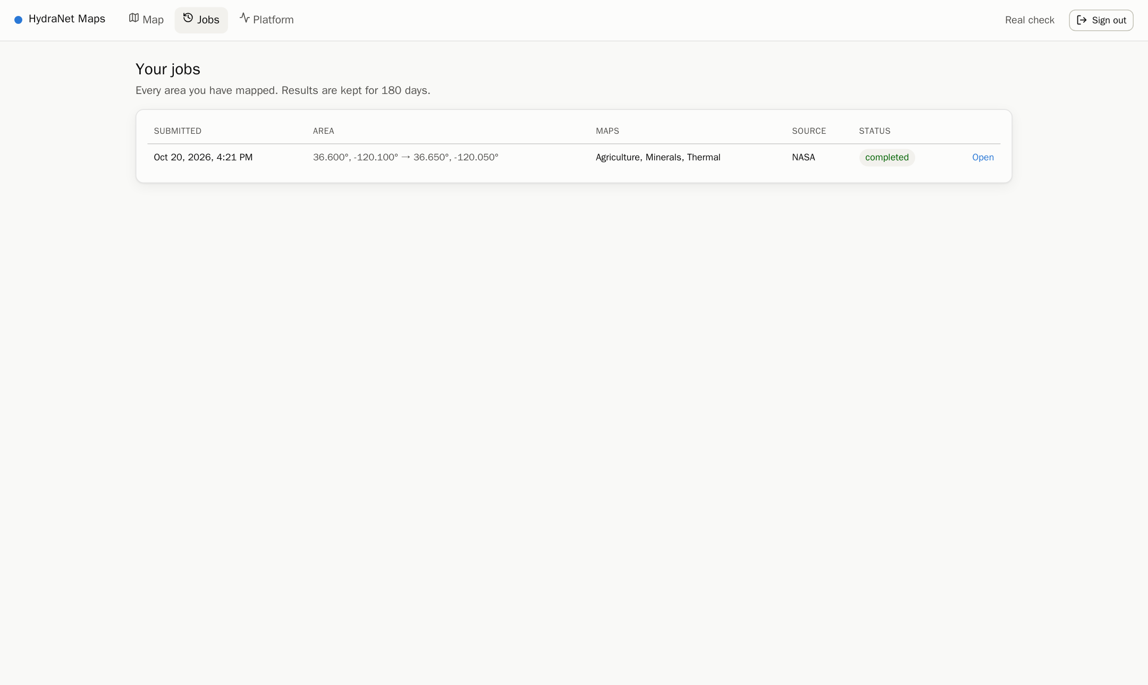
Figure 26. Job history.
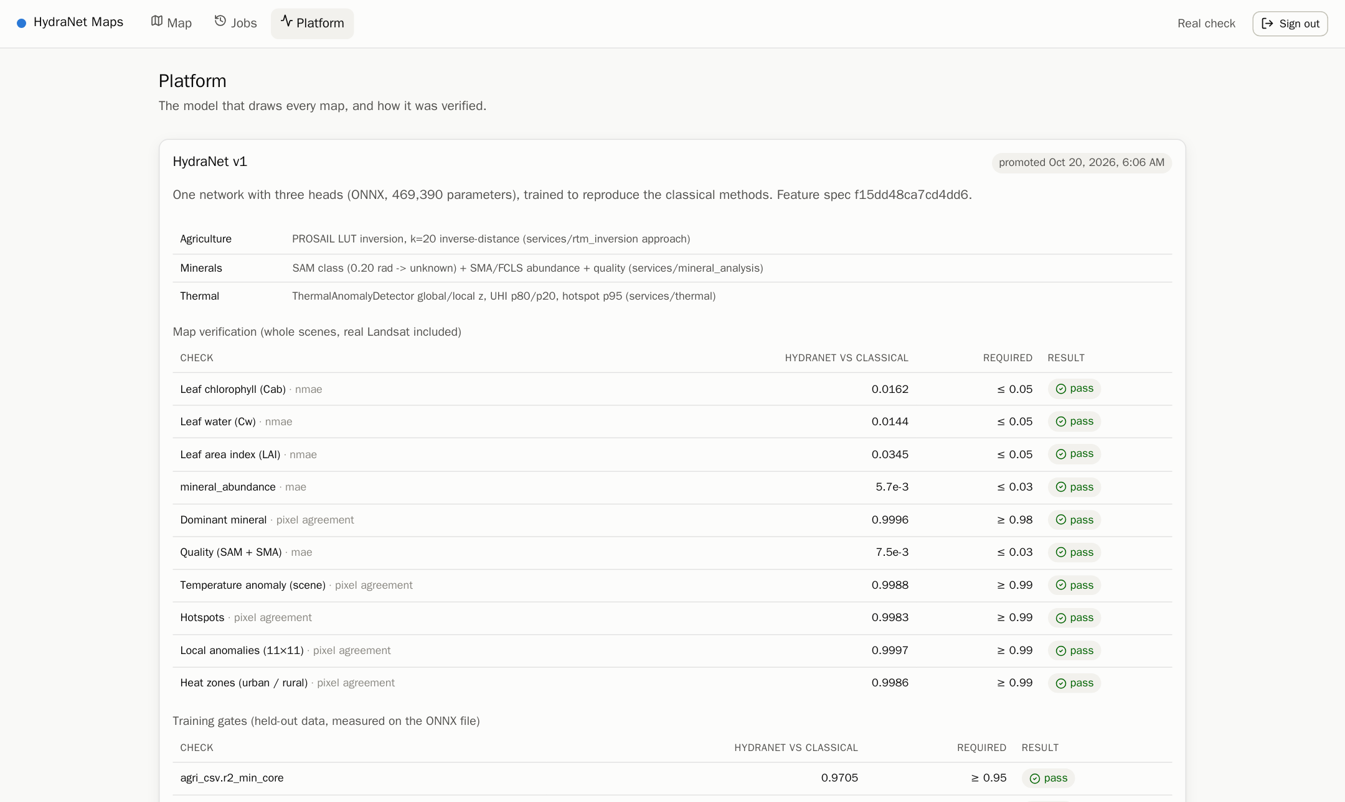
Figure 27. Platform page: the model, its gates and verification.

15. Security
Table 24. Threats and controls (all exercised by tests/security.py: 63 attacks, 0 succeed)
Threat | Control
Password guessing | per-IP limit (20/min) and per-account lockout (10 failures → 15 min); bcrypt cost 11; ≥ 10-character passwords, common-password list
Fake client IP to dodge limits | nginx overwrites X-Real-IP with the TCP peer (CloudFront-Viewer-Address behind CloudFront only); X-Forwarded-For never trusted
Forged / tampered JWTs | HS256 only; key ring with kid; issuer, audience, expiry checked; alg:none and algorithm confusion refused
Stolen access token | 15-minute lifetime, kept in memory only, revoked on logout (denylisted jti)
Stolen refresh token | opaque 256-bit, only its hash stored; HttpOnly, Secure, SameSite=Strict cookie; rotated on every use; reuse revokes the whole family
CSRF | SameSite=Strict + required X-Requested-With header + Origin allow-list
Tokens in URLs | never accepted; the live stream uses single-use 30-second tickets
Reading others' data | ownership check on every job route, 404 for others; admin-only statistics
Injection / XSS / clickjacking | parameterised SQL; strict validation; strict CSP, X-Frame-Options DENY, nosniff, HSTS
Abuse | 64 KB body cap, per-user API limit, admission control
Compromised container | non-root, no-new-privileges, all capabilities dropped, read-only root for Go services, internal services not published
Vulnerable dependencies, leaked secrets | CI: govulncheck, pip-audit, npm audit, Trivy, gitleaks; secrets in .env (local) and SSM (AWS)

16. Scalability and load tests
Table 25. Load tests (k6, one laptop, all services in Docker)
Test | Result
300 concurrent users (sign in, submit, poll, view maps) | 0 failed of 55,225 requests; p95 API 5.4 ms, submit 8.6 ms, status 2.3 ms, layers 7.6 ms
60 users, every job a new area, 2 workers per stage | 1.7 jobs/s, median 25 s
Same, 4 workers per stage | 3.8 jobs/s, median 3 s (horizontal scaling)

- Repeated areas are free: identical requests reuse finished maps or follow the in-flight job.
- Workers scale up to each topic's partition count; the gateway is stateless and scales behind nginx/CloudFront.
- EMIT granules are downloaded once and shared; Landsat reads only the box window.
- Admission control and rate limits protect the platform under overload instead of letting it degrade for everyone.

17. Deployment
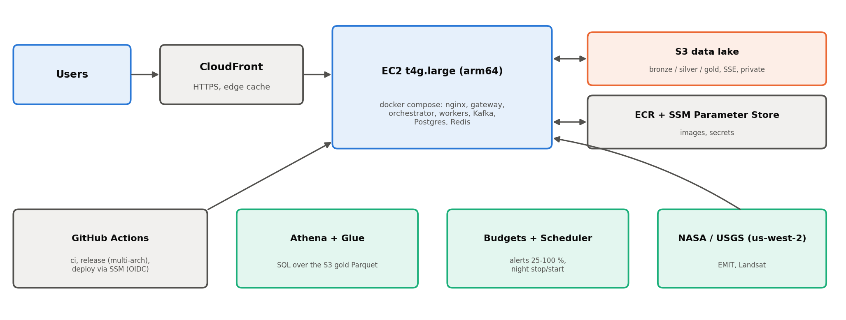
Figure 28. AWS deployment (Terraform, credits-friendly).
Table 26. AWS resources
Piece | Detail
Region | us-west-2 (Oregon): NASA Earthdata Cloud and the Landsat bucket are there, so downloads are fast and free of cross-region transfer
Compute | one EC2 t4g.large (2 vCPU, 8 GB, arm64) running the same compose stack; multi-arch images in ECR
Storage | S3 data lake, public access blocked, server-side encryption, lifecycle rules
Edge | CloudFront (HTTPS); the instance accepts traffic from CloudFront only
Secrets | SSM Parameter Store
Analytics | Glue catalog + Athena over Gold Parquet
Cost control | budget alerts at 25/50/80/100 %, scheduled night-time stop/start
CI/CD | GitHub Actions: ci (lint, tests, security scans, full-stack e2e), release (multi-arch images), deploy (via SSM with GitHub OIDC, no stored AWS keys), train
Moving off AWS | any S3-compatible store (MinIO, Cloudflare R2, Backblaze B2, Wasabi): change the endpoint and keys only

Latency estimate for users in India (not yet measured): page from the CloudFront edge 50–150 ms; API calls to Oregon 250–400 ms; a whole job 1–3 s for an area already mapped, 10–30 s for a new Landsat area and 1–3 minutes for a new EMIT area (mostly the download). A free Hugging Face Space can host a demo of the model but not the whole platform.

18. Testing and quality
Table 27. Test suites
Suite | What it proves | Result
libs/hydra, libs/hs_common (pytest) | classical methods identical to the owners' reference code; features; ONNX runtime; EMIT orthorectification; both EMIT MASK layouts | 17 passed
preprocessing/tests | the Dask pipeline, Landsat calibration, contracts | 57 passed
Go tests + go vet | Go structs match the message schemas | pass
frontend (vitest, oxlint) | formatting, layer helpers | 5 passed
training gates + verify_maps | the model reproduces the classical maps | 10/10 map checks; 10/11 gates
tests/e2e.py | full stack: auth, quotas, idempotency, reuse, IDOR, three maps per job, cancel | 0 failures
tests/ui_smoke.py (Playwright, CSP on) | the real UI: sign-up, job, live timeline, overlays, legends, charts, inspector, history, platform | 16/16, no console errors
tests/security.py | 63 attacks | 0 succeed
tests/load/k6.js | 300 concurrent users | 0 failures

19. Limitations, novelty and future work

19.1 Known limitations
- Mineral abundances on real EMIT differ from SMA by MAE 0.068–0.078 (gate 0.06): the network sees continuum-removed features, SMA sees raw reflectance. Class maps are unaffected (99.75–99.85 %).
- Mineral fit quality does not transfer to real EMIT (MAE 0.186 on the Fresno job); retrain with real-scene residuals before relying on it.
- Real-imagery validation so far: one real EMIT box (Fresno, 8,742 pixels), 2,000 real EMIT spectra and six real Landsat scenes; more regions and seasons are needed.
- The network reproduces its teachers; it does not measure anything the classical methods cannot.
- Thermal labels come from rules (the dataset has no labels).
- Synthetic test scenes are used for CI and load tests only; the UI uses real imagery only.

19.2 Novelty
Neural emulation of PROSAIL inversion is established (for example ESA SNAP's biophysical processor for Sentinel-2), and distillation is a standard technique. What this project contributes is the combination: one multi-task network covering minerals, crops and thermal across two sensors, a neural reproduction of SAM + SMA with explicit near-tie handling, and a production design where the classical methods remain as the continuous verifier (spec-hash lock, release gates, shadow checks).

19.3 Next steps
- Ablation: three separate small MLPs vs the shared network (accuracy, size, speed).
- Add reflectance-level inputs to close the real-EMIT abundance gap; validate on more real scenes.
- Fine-tune on ground truth (NASA FIRMS fire detections for thermal, field data for crops) to exceed the teacher.
- Calibrate the confidence outputs (reliability diagrams).
- Serve maps through CloudFront signed URLs for lower latency in India.
- Frontend redesign decisions pending (branding, public demo, MapLibre + TiTiler, SSO).

20. How to run
cd pre_production
cp .env.example .env # fill secrets (openssl rand -hex 32); EARTHDATA_TOKEN for real EMIT
docker compose --profile local up -d --build
open http://localhost:3000

# optional: --profile obs (Prometheus 127.0.0.1:9090, Grafana 127.0.0.1:3002), --profile batch (Dagster :3001)
docker compose --profile local up -d --scale ml_inference=4 --scale preprocessing=4 --scale ingestion=4

# train and verify the model (venv: source /Users/aaronr/py311/bin/activate)
cd training && python -m datagen --out artifacts/data && python -m train --arch mlp
python -m verify_maps --model artifacts/models/v1 --data artifacts/data

# tests
pytest libs/hydra/tests libs/hs_common/tests
python tests/e2e.py --base http://localhost:3000 --jobs 3 --real-thermal
python tests/security.py --base http://localhost:3000 --env .env

Appendix A. REST API
Table 28. Endpoints
Method and path | Purpose
POST /api/auth/register, /login | create account / sign in (access token + refresh cookie)
POST /api/auth/refresh, /logout, /logout-all | rotate session; sign out; end every session
GET /api/me, /api/config, /api/model | current user; UI limits; active model and its verification
POST /api/jobs; GET /api/jobs, /api/jobs/:id | submit (Idempotency-Key); list; status
DELETE /api/jobs/:id | cancel
GET /api/jobs/:id/layers | map layers with presigned URLs
POST /api/jobs/:id/stream-ticket; GET /api/jobs/:id/events | one-time ticket; live Server-Sent Events
GET /api/catalog; GET /api/stats (admin) | available imagery; platform statistics
GET /health, /ready, /metrics | probes and Prometheus metrics

