**Product Specifications**

Table of Contents:

Modification History 3

Major Milestones 4

Abstract 5

Document References 6

Glossary 7

Class Diagram 8

Use Case Sequence Diagram 9

Use case 1 9

General Description 9

Sequence Diagram 9

Use case 2 9

General Description 9

Sequence Diagram 9

User Interface 10

Others 11

# Modification History

9/16/2014: Initial draft.

9/22/2014: Added UI mockup

10/14/2014: Added UML Classes

11/2/2014: Added Use Case Sequence Diagrams

# Major Milestones

|  |  |
| --- | --- |
| **Date** | **Milestone** |
| 9/16/2014 | Complete preliminary specifications |
| 10/7/2014 | Refine specifications |
|  |  |
|  |  |
|  |  |
|  |  |
|  |  |
|  |  |

# Abstract

Design a multi-platform tic-tac-toe game played on a 5x5 grid that requires 4 stones in-a-row to win. Allow players to register or play as a guest. Keep track of registered player history (i.e.: wins vs losses). Game should allow player to select a difficulty when playing against the computer.

# Document References

|  |  |
| --- | --- |
| **Document** | **Location** |
| Requirements.doc | Google docs |
| SoftwareManagementPlan.doc | Google docs |
|  |  |
|  |  |
|  |  |
|  |  |
|  |  |
|  |  |

# Glossary

|  |  |  |  |
| --- | --- | --- | --- |
| **Term** | | **Definition** | |
| Blue | Player 1 |
| Red | Player 2 |
| Grid | The playing board |
| Stone | Player Piece |
| Guest | Unregistered Player |
| Player | Registered Player |
| Leaderboard | List of top N players |
|  | |  | |

|  |  |
| --- | --- |
| **Acronym** | **Meaning** |
| PVP | Player-vs-Player |
| AI | Artificial Intelligence (the computer) |
| TTT | Tic-Tac-Toe |
|  |  |
|  |  |
|  |  |
|  |  |
|  |  |

# Class Diagram

|  |
| --- |
| Player Class |
| - name : string  - wins : int  - losses : int  - draws : int |
| (getters and setters)  + makeMove(index : int) : void |

|  |
| --- |
| AI Class |
|  |
|  |

|  |
| --- |
| Grid Class |
| + _grid : QList< QList <int> >  - _lastMove : int  - _gridLength : int  - _countToWin : int |
| (getters and setters)  + placePiece(index : int, player : int) : void  + checkWin(index : int) : bool  + indexToRow(index : int) : int  + indexToColumn(index : int) : int  + coordinateToIndex(row : int, column : int) : int  + valueFromIndex(index : int) : int |

|  |
| --- |
| Registration Class |
|  |
|  |

|  |
| --- |
| Main Class |
| - turn : int  - blue : color  - red : color  - isVisible : bool  - board : grid  + players : QList < Player* > |
| + createOpponent(difficulty : int) : void  + lastMoveCheck() : void  + tileMouseArea.onClicked() : void  + tileMouseArea.onEntered() : void  + tileMouseArea.onExited() : void |

|  |
| --- |
| Login Class |
| + background : image |
|  |

|  |
| --- |
| Main Menu Class |
| + divisor : int |
|  |

|  |
| --- |
| Settings View Class |
|  |
|  |

|  |
| --- |
| Player Selection View |
|  |
| + register() : void  + login() : void |

# Use Case Sequence Diagram

## Use case 1 – Start new game

### General Description

When the user starts the application, the start page is displayed.

NOTE: The start page presents the user the option to login to play as an existing player, register to create a new player, or play as guest.

### Sequence Diagram



## Use case 2 – Pick difficulty

### General Description

After the user selects single-player mode, he is prompted to select the computer’s difficulty setting.

### Sequence Diagram



## Use case 3 – Login

### General Description

The user provides his username and clicks the “Login” button to play as a registered player.

### Sequence Diagram



## Use case 4 – Register

### General Description

The user provides his username and clicks the “Register” button. The application then validates the username, and if it is a valid username, it saves it to the database and automatically logs-in the user.

### Sequence Diagram



## Use case 5 – Play as guest

### General Description

The user clicks the “Play as Guest” button.

### Sequence Diagram



## Use case 6 – Complete game

### General Description

When the user makes a finishing move, the application updates his win/loss/draw record, clears the grid, and prompts for rematch/new-game.

### Sequence Diagram



## Use case 7 – Reset

### General Description

The user clicks the menu button (≡) then clicks “Reset.” The application then clears the grid and prompts the user “who is first to act?”

### Sequence Diagram



## Use case 8 – Who is first to act?

### General Description

When the user starts a new game, resets a current game, or chooses to rematch a completed game, he is prompted to select which player will be first to act. After making his selection, the grid will be displayed and the game will begin.

### Sequence Diagram



## Use case 9a – Place a stone (empty cell; no win)

### General Description

When the user clicks an empty cell on the grid, the application places a stone with the color that corresponds to the player whose turn it is. If this is not a winning-move, the application switches players, and waits for the next move.

### Sequence Diagram



## Use case 9b – Place a stone (empty cell; win)

### General Description

When the user clicks an empty cell on the grid, the application places a stone with the color that corresponds to the player whose turn it is. If this is a winning-move, the application ends the game.

### Sequence Diagram



## Use case 9c – Place a stone (occupied cell)

### General Description

When the user clicks an occupied cell on the grid, the application does nothing and waits for the next move.

### Sequence Diagram



## Use case 10 – Display user history

### General Description

The user clicks the menu button (≡) then clicks “History.” The application closes the menu and displays the Player History view.

### Sequence Diagram



## Use case 11 – Update player history

### General Description

When a round is over, the player’s win/loss/draw history is updated.

### Sequence Diagram



## Use case XXX

### General Description

### Sequence Diagram

# User Interface

Responsive 5x5 grid.

Stones are blue and grid.

Main Menu:

|  |  |  |  |  |
| --- | --- | --- | --- | --- |
| Tic-Tac-Toe | | | | |
|  |  |  |  |  |
|  | Play with: | | |  |
|  | A friend |  | The Computer |  |
|  |  |  |  |  |

Main Menu: Play the computer

|  |  |  |
| --- | --- | --- |
| Tic-Tac-Toe | | |
|  |  |  |
|  | Choose a difficulty. |  |
|  | Easy |  |
|  |  |  |
|  | Medium |  |
|  |  |  |
|  | Hard |  |
|  |  |  |

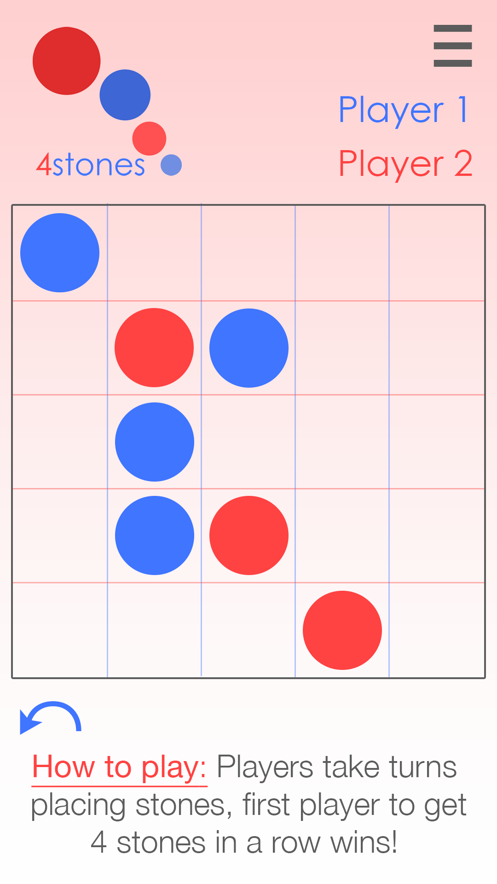

# Others

