Beliefs or Risk?
Does the Fed move long-term rates, or merely announce them?
Research design and preliminary results
Prepared 11 August 2026. All estimates in this document were run on the project archive in clean_reactionFunction/; code and data are in hillenbrand/. Nothing here is retyped from a write-up.
Summary
The secular decline in long-term interest rates accumulates almost entirely inside three-day windows around FOMC meetings (Hillenbrand 2025). Whether that decline is a revision of expected future short rates or a repricing of the term premium is contested: two circulating papers give opposite answers, and Hillenbrand himself sets the term premium aside on an argument he never tests.
This project asks the question with the Fed’s own published longer-run projection as the right-hand-side variable — no market-implied endpoint, no term-structure model on the regressor side. The preliminary answer is that the response is concentrated in the term premium, symmetrically in both directions, and that the expectations response does not replicate out of sample.
Why that matters is an accounting argument, not an empirical one. The long nominal yield is the expected average future short rate plus a term premium, and at long horizons the expected short rate is r* plus π*. The Fed fixes π* at 2% and has kept it credible; it does not control r*. So the only channel through which monetary policy can durably move the long nominal rate is the term premium. If the FOMC-window decline is expectations, the Fed is a forecaster revealing information about a fundamental it does not control. If it is the term premium, the Fed is an actor. The empirical question and the causal question are the same question.

Contents
1. The question
2. What is established
2.1 The Hillenbrand fact, replicated and extended
2.2 The component decomposition, and why it does not settle anything
3. Related literature
3.1 The secular decline and where it happens
3.2 Expectations versus term premium in policy transmission
3.3 Disagreement, beliefs and the term structure
4. The measurement problem, and why the design avoids it
5. The measurement of the Fed’s projection
6. The theory
7. Specification
8. Preliminary results
8.1 The baseline, and its instability
8.2 The asymmetry
9. Threats and what remains
9.1 Threats to identification
9.2 Next steps, in order
9.3 What is already secure

1. The question
When the Fed changes what it says about where interest rates end up, does the market change what it expects, or what it charges for the risk of being wrong?
Operationally:
Does a revision in the FOMC’s longer-run federal funds projection move the term premium component of long-term yields, over and above its effect on expected short rates?
The two answers are not variations on a theme, and the reason is developed in Section 6. Under the expectations reading the Fed is revealing information about r*, a fundamental it does not control — its influence is informational, and the secular decline would have occurred regardless of when the news arrived. Under the term-premium reading the Fed is changing the price of duration risk, which monetary policy genuinely does control. Only the second reading makes “the Fed and the secular decline in interest rates” a causal claim.
The question matters beyond this literature because the same ambiguity sits underneath every claim that central bank communication anchors long-term rates.

2. What is established

2.1 The Hillenbrand fact, replicated and extended
Using GSW zero-coupon yields and all 373 FOMC meetings from June 1989, the replication reproduces the published result closely: over June 1989 – June 2021 the 10-year yield fell 6.99 pp, of which 6.16 pp (88%) accumulated inside three-day announcement windows and 0.82 pp outside.
The result is best stated as an absence rather than a presence. The per-meeting effect is only about −2 bp. What is remarkable is that the other 90% of trading days have a drift of −0.012 bp/day (t = −0.18) across 7,036 days. Non-FOMC days contribute nothing on net over three decades.
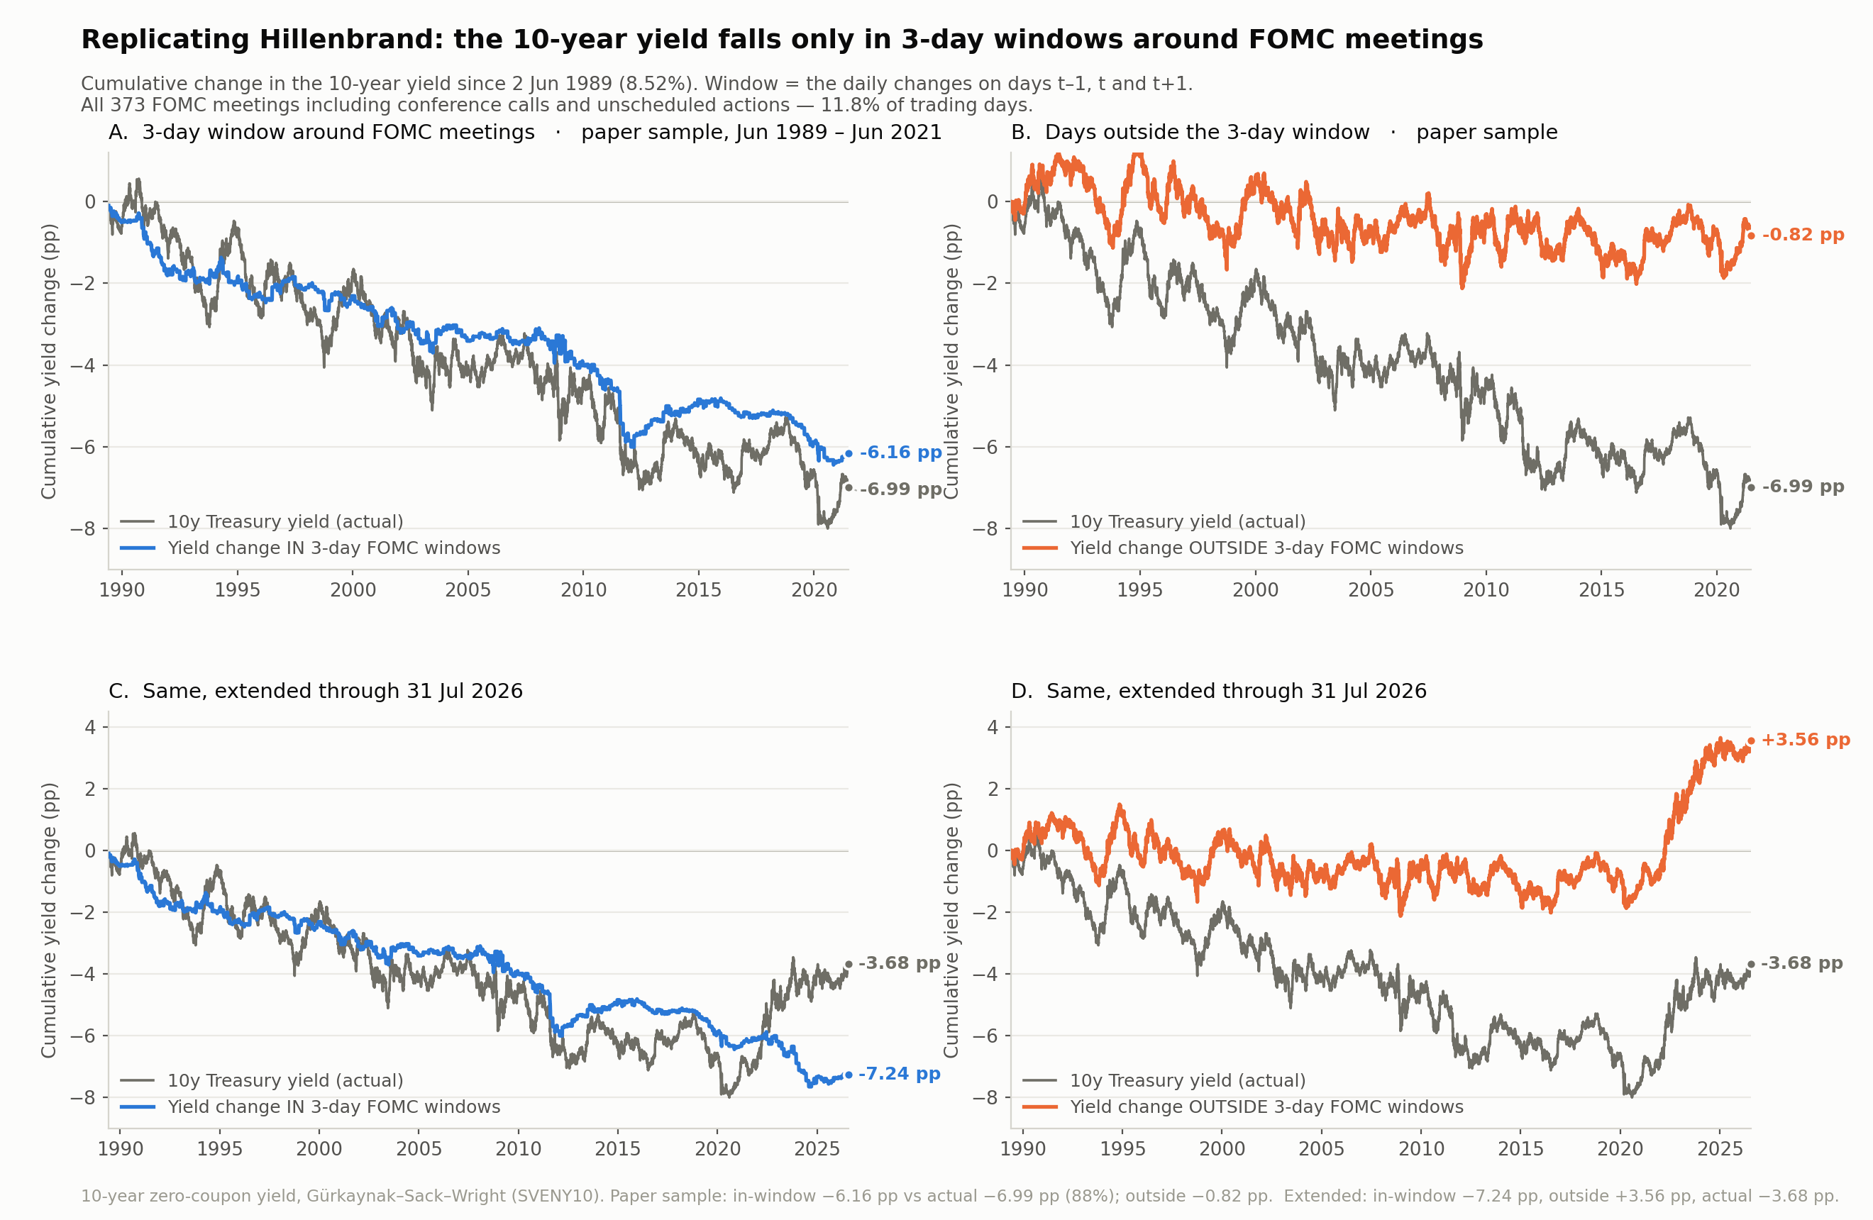
Figure 1. Cumulative change in the 10-year yield split by whether the day falls in a three-day FOMC window. Top row: the paper’s sample. Bottom row: extended to July 2026.
Extending past the paper’s endpoint, the in-window drift is statistically unchanged (−2.64 vs −2.08 bp per meeting, difference t = −0.26) while the outside drift turns positive. That outside move is a 1.9σ wander for a driftless random walk, so it is not evidence of a regime change, and it is not pursued here.

2.2 The component decomposition, and why it does not settle anything
Decomposing with Adrian–Crump–Moench over June 1989 – June 2021:
Component | Total decline | In-window | Outside | In-window share of own decline
10-year yield | −7.00 pp | −6.26 | −0.74 | 89%
Risk-neutral | −4.87 | −4.93 | +0.06 | 101%
Term premium | −2.13 | −1.33 | −0.80 | 63%
The sharp fact is the outside column. The “non-FOMC days do nothing” property holds exactly for expectations and only partially for the term premium. But the in-window share tilt (79% risk-neutral) is only modestly different from the unconditional split (70%), so it is close to a restatement of the unconditional decomposition and should not be reported as a finding on its own.
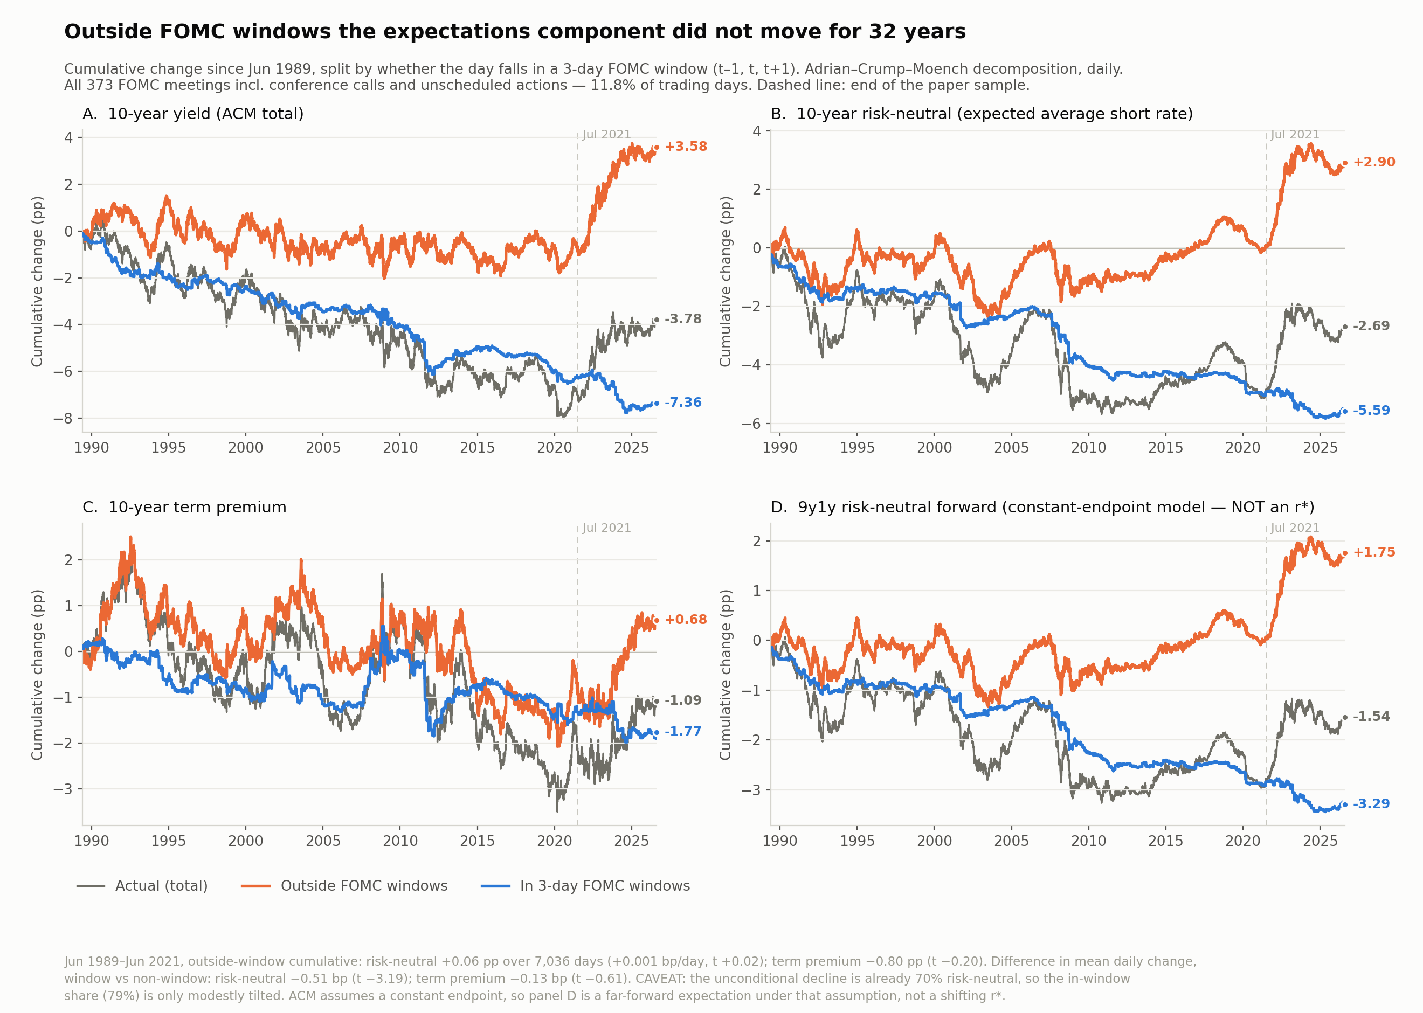
Figure 2. The same in/out split applied to the ACM components. Panel D is labelled to make clear it is not an r* estimate.

3. Related literature

3.1 The secular decline and where it happens
- Hillenbrand (2025), Review of Financial Studies 38(4), 981–1013. Establishes the three-day-window concentration. Decomposes nominal into real and breakeven — not into expectations and term premium. Reports in the Internet Appendix that ACM and Kim–Wright term premia fall 100–200 bp in windows, then sets this aside because the models “do not explicitly account for the secular decline.” That objection is correct as a statement about measurement, but it is never tested. It is the opening this project uses.
- Hofmann, Li & Wu (2025), BIS Working Paper 1252. Extends the fact to the G10 and decomposes with a Bauer–Rudebusch observed-shifting-endpoint model, concluding the window decline is risk-neutral (US pseudo-R² 96 vs 32). The endpoint proxy is defined as the first principal component of cumulative yield changes during FOMC windows — so the risk-neutral component inherits the series being explained, and the conclusion is close to definitional.
- Pan & Peng (2026), working paper. On day t−1 the 10-year falls 0.79 bp, of which 0.71 bp is term premium and 0.08 bp (insignificant) is expectations; cumulatively −3.09 pp of the −7.91 pp window decline. Uses ACM. Directly opposite to Hofmann–Li–Wu.
Reconciliation established here. On Pan & Peng’s sample definition — scheduled meetings only, September 1994 onward — our numbers reproduce theirs almost exactly (−0.80 bp per meeting against −0.79; term premium 91% against 90%). Adding conference calls, unscheduled actions and the pre-1994 period flips the t−1 attribution from 91% term premium to 61% expectations. The two papers are not testing the same object, and the disagreement is an event-list artifact neither of them flags.
t−1 day, cumulative | Yield | Risk-neutral | Term premium
Scheduled only, Sept 1994 → (their spec) | −2.03 pp | −0.19 | −1.85 (91%)
All meetings, June 1989 – June 2021 | −3.60 pp | −2.20 (61%) | −1.40

3.2 Expectations versus term premium in policy transmission
- Hanson & Stein (2015), JFE. A 100 bp FOMC-day move in the 2-year raises the 10-year real forward by 42 bp, and they attribute it to term premia. The canonical “it is the risk premium” answer — but about high-frequency responses to near-term policy surprises, not about the cumulative drift or about long-run projections.
- Nakamura & Steinsson (2018), QJE. Reaches the opposite conclusion using surveys and mean-reversion tests: risk premia do not play an important role. The tension with Hanson–Stein is long-standing and unresolved.
- Hanson, Lucca & Wright (2021), QJE. Announcement-window long-rate moves substantially reverse within 6–12 months, read as temporary term-premium effects. This is in direct tension with the Hillenbrand fact, which requires window moves not to reverse. Nobody has confronted the two. A test that discriminates without any decomposition: does the in-window term-premium component mean-revert while the risk-neutral component does not?
- Bauer & Swanson (2023), NBER Macroeconomics Annual. Announcement surprises are predictable from pre-meeting public information. The principal identification threat here, since a projection revision is partly forecastable.

3.3 Disagreement, beliefs and the term structure
- Cao, Crump, Eusepi & Moench, FRBNY Staff Report 934. Disagreement about future short rates comoves strongly with the term premium. Establishes the mechanism in the time series at monthly frequency.
- Bauer, Pflueger & Sunderam (2024), QJE. A pre-meeting subjective-belief variable — the perceived policy reaction-function slope — is related to term premia and to state-dependent announcement-window responses. The closest methodological template. Their state variable is a perceived slope; ours is a stated level.
- Ahonon & Roussellet (2026), FRBNY Staff Report 1187. Under Bayesian learning about unobserved trends, investor uncertainty about r* is roughly ±170 bp rather than ±55 bp under full information, and r* is the primary long-run driver of bond risk premia. This is the theoretical case for the risk channel: if investors genuinely do not know the destination, statements about the destination are risk-relevant, not merely informative.
- Couture (2021), Journal of Macroeconomics, and Engstrom (2026), FEDS 2026-026. The dot plot moves asset prices; SEP-minus-market discrepancies predict subsequent forecast errors. Both must be read in full before the introduction is written — they are the two places an overlapping specification could already exist.

4. The measurement problem, and why the design avoids it
The natural design is a wedge: the Fed’s longer-run projection minus a market-implied long-run endpoint, used to predict announcement-window responses. That design fails, and the reason is worth stating because it also disciplines what the paper can claim.
The market leg used in earlier work on this project is the ACM 9y1y risk-neutral forward minus 2.0. It is not an estimate of r*. Regressed on quarterly changes in the 1-year yield it has β = 0.287 (t = 10.83) with R² = 0.83; the level correlation with the 1-year yield is +0.984. For comparison, HLW r* has β = 0.057 and R² = 0.07 on the same regression.
The β is not a coincidence — it is the model’s own decay factor. Under a stationary VAR the h-step expectation is μ + Φʰ(Xₜ − μ), so the loading on today’s state at nine years is Φ¹⁰⁸ at monthly frequency. A dominant eigenvalue near 0.99 implies 0.99¹⁰⁸ = 0.34. The measurement matches the theory.
Lengthening the horizon does not help, and the reason is structural. As h → ∞ under a stationary VAR the risk-neutral forward converges to a constant. So the entire time-variation of an ACM forward at any horizon is Φʰ(Xₜ − μ) — pure current-state variation, scaled down. Short horizon: mostly cycle. Long horizon: converges to something that cannot move. There is no horizon at which it is mostly r*, because the model contains no r* to find. The horizon was never the problem; the model is.
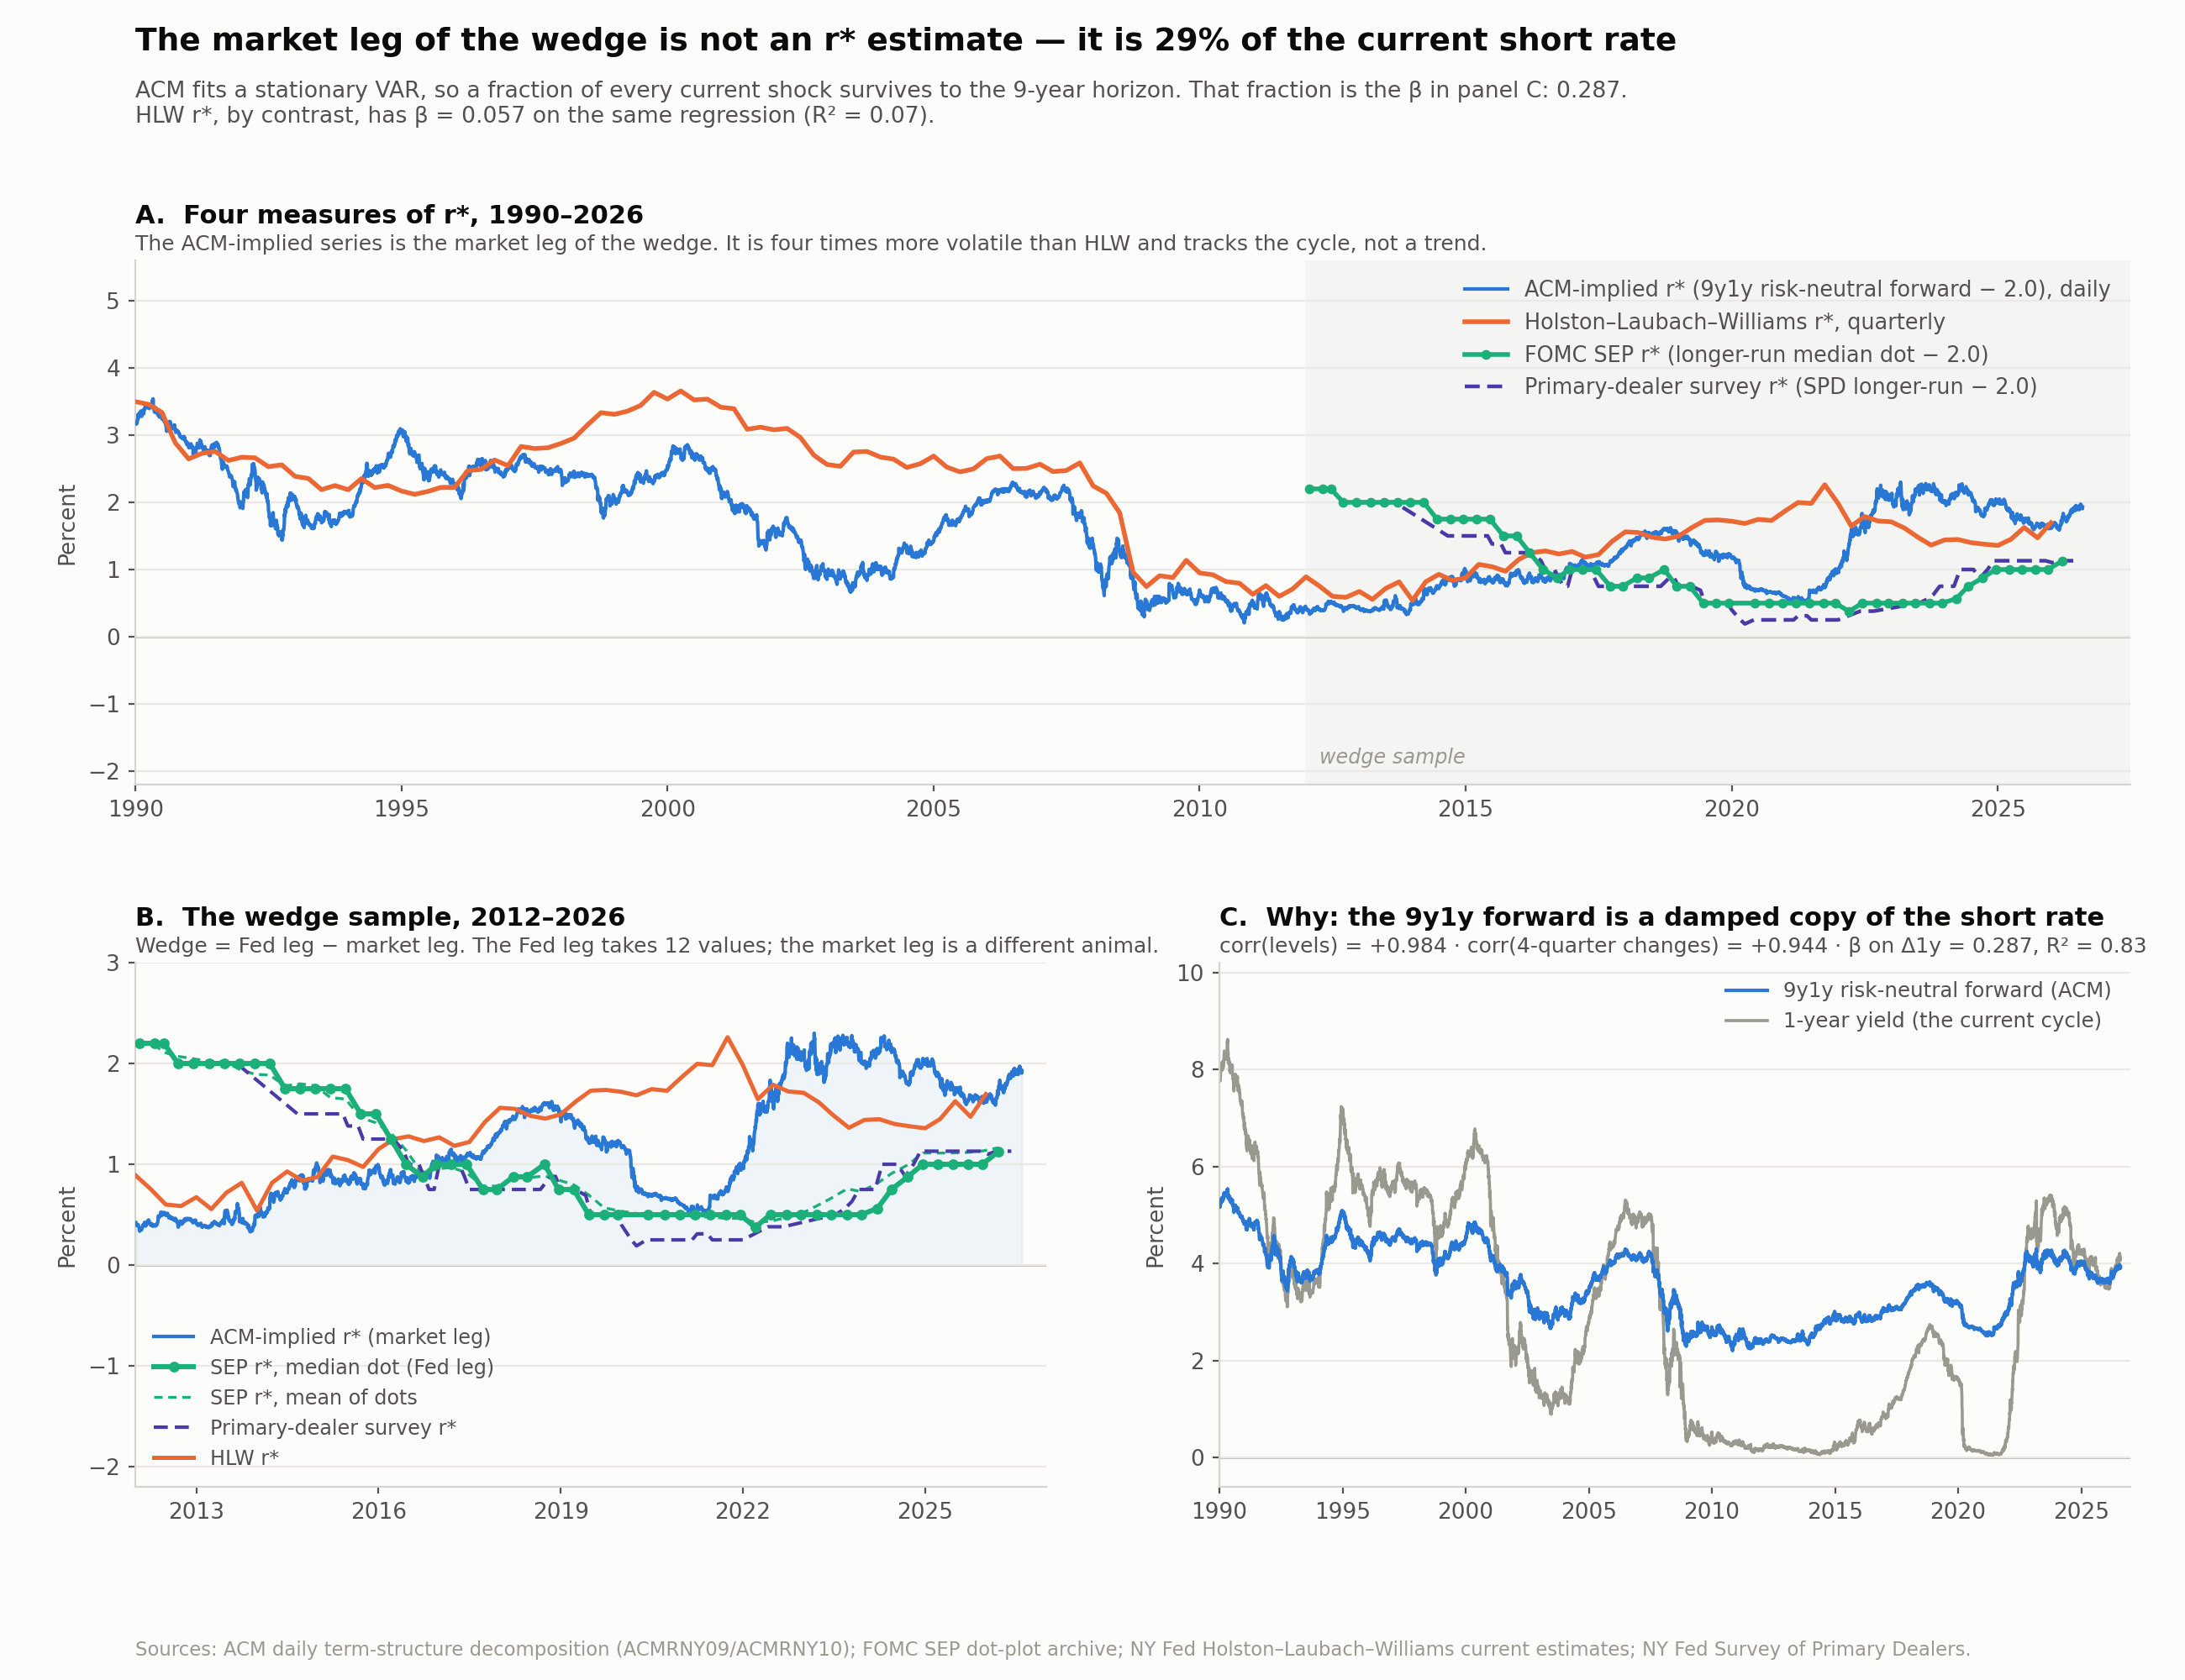
Figure 3. Four measures of r*. Panel C shows why the ACM-implied series is not one of them.
Two consequences. First, the two candidate market legs — ACM-implied and the primary-dealer survey — correlate −0.12 over the same meetings, because one is mostly cycle and the other is mostly trend; that was a category error, not a measurement puzzle. Second, the sign of any wedge built on the ACM leg is substantially a label for the phase of the policy cycle, which is why the Fed sits above the market in 100% of 2012–2015 meetings and 0% of 2020–2026 meetings. No asymmetry estimated on that split is identified.
The design adopted here therefore drops the market leg entirely. The question “does a revision to the Fed’s longer-run projection move the term premium or expectations?” does not require knowing what the market thinks. It requires only the Fed’s published number and a decomposition of the outcome.

5. The measurement of the Fed’s projection
The right-hand-side variable is the revision, since the previous SEP, in the cross-participant mean of the longer-run federal funds dot minus longer-run PCE. Because longer-run PCE is 2.0 in all 594 archived submissions, this is the longer-run dot minus a constant, and the paper should be written as being about the longer-run nominal policy rate rather than about the real natural rate.
The choice of mean over median is not cosmetic. It roughly triples the identifying variation at no cost, and it is what the published Figure 9 uses — a median of quarter-point dots would be visibly stepped, and it is not.
Fed leg | Distinct values | Meetings it moves | Longest flat run | Standard deviation
Median of dots | 12 | 19 / 56 | 9 meetings | 0.591
Mean of dots | 48 | 47 / 56 | 2 meetings | 0.563
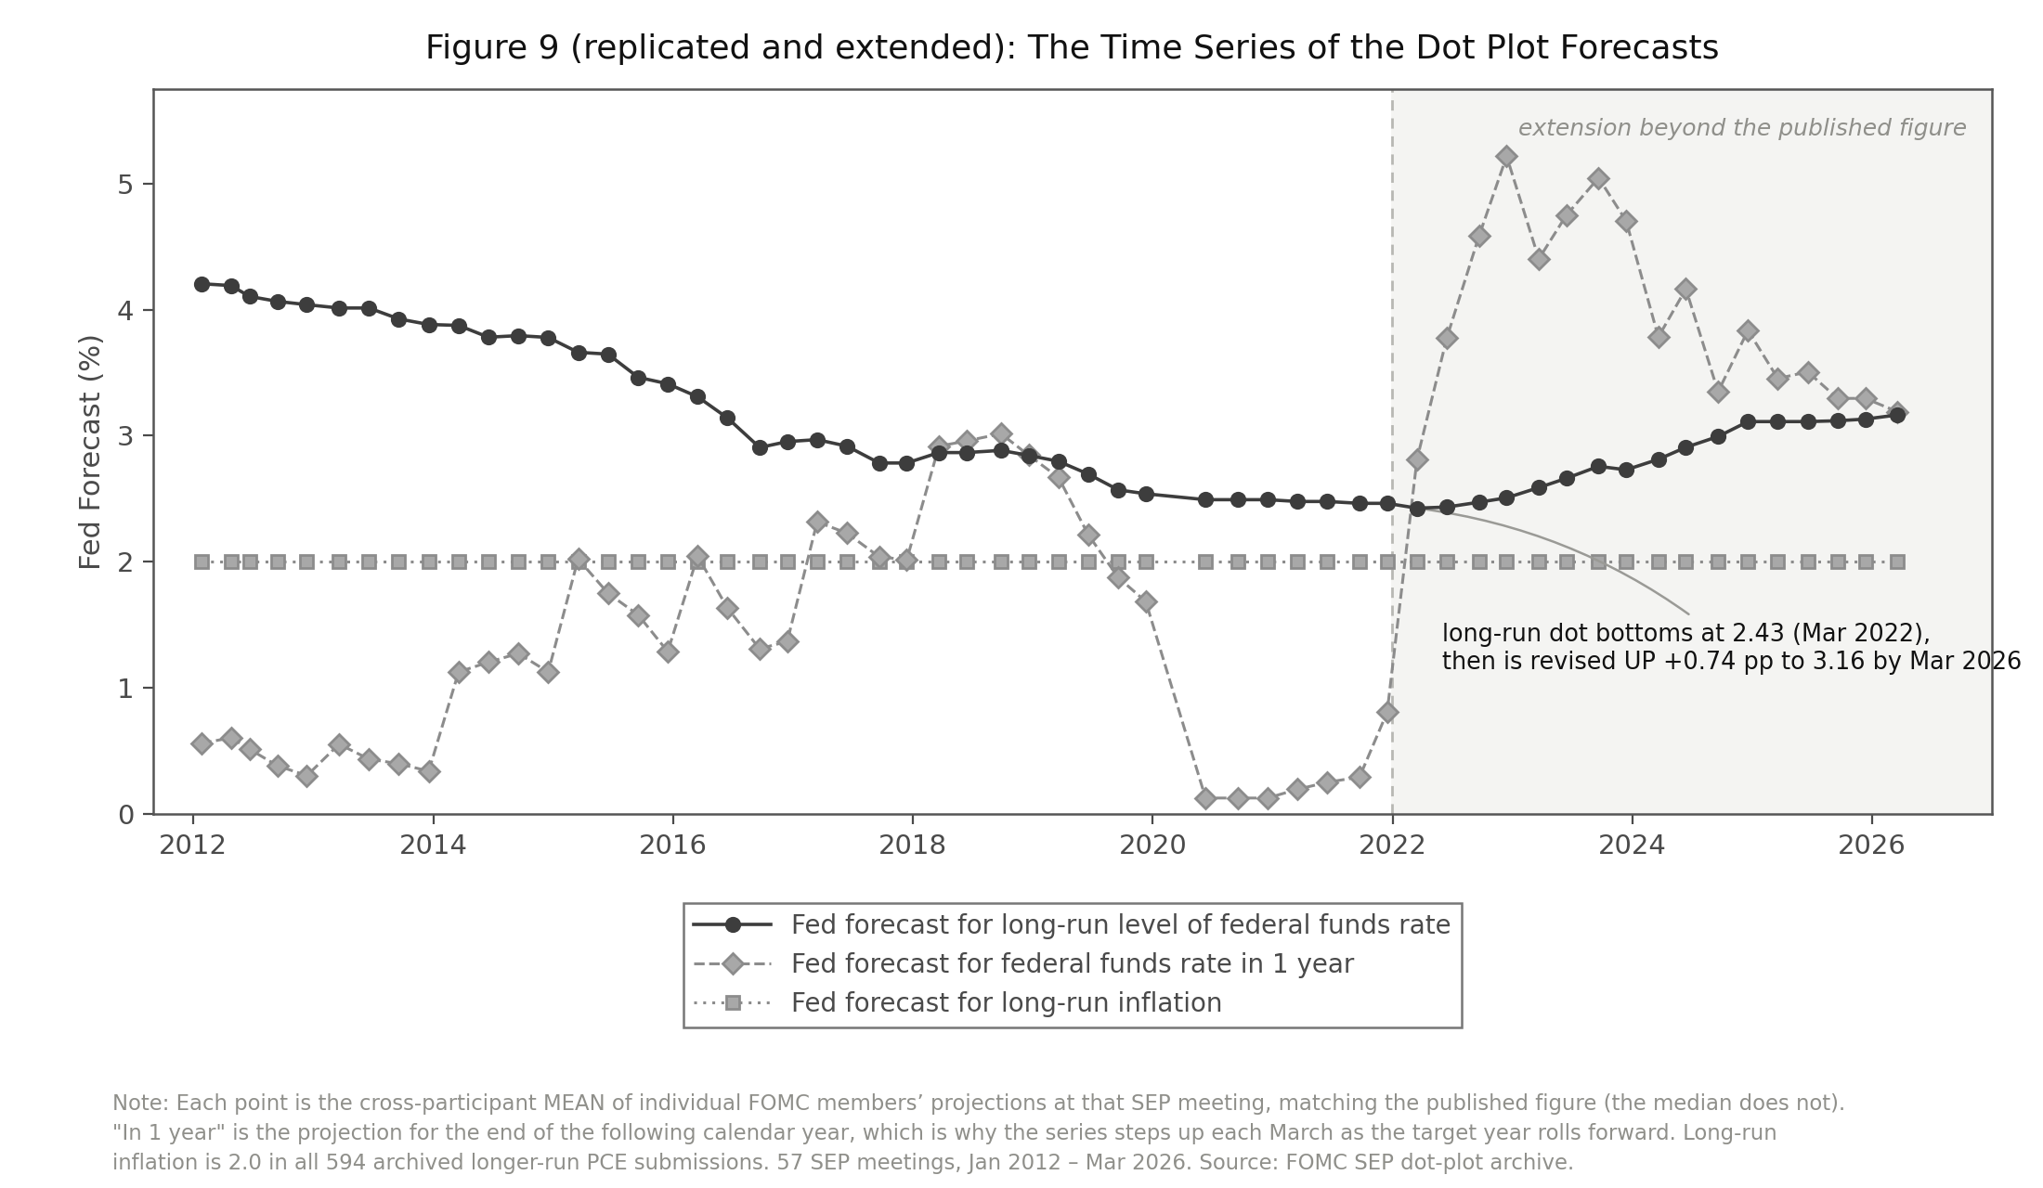
Figure 4. The published Figure 9, replicated and extended to the March 2026 SEP. The longer-run projection bottoms at 2.43% in March 2022 and is revised up 0.74 pp by March 2026.

6. The theory

6.1 An accounting constraint on what the Fed can do
Write the long nominal yield as the average expected future short rate over the life of the bond plus a term premium. At long horizons the expected short rate converges to the equilibrium nominal policy rate, which is r* + π*. So:
y⁽¹⁰⁾ ≈ r* + π* + term premium
The Fed sets π* by announcement and has held it at 2% with credibility — the archive is unambiguous on this, since all 594 longer-run PCE submissions across 36 de-anonymised SEP meetings are exactly 2.0, with zero within-meeting dispersion. It does not set r*, which is determined by savings and investment fundamentals: demographics, productivity growth, global demand for safe assets.
The implication is sharp. With π* fixed and credible and r* outside the Fed’s control, the only term in that identity monetary policy can durably move is the term premium.

6.2 What this does to the interpretation of the Hillenbrand fact
The FOMC-window concentration of the secular decline admits two readings, and the accounting constraint makes them very different claims.
If the window decline is expectations, the Fed is a forecaster. It is revealing information about r* — a fundamental it does not control — and the market is updating toward the truth. The decline would have happened regardless; the FOMC calendar is simply where the news was published. The Fed’s “influence” is informational, competed away by any other source of information about r*, and reversible if the Fed’s read turns out to be wrong. On this reading the paper’s title describes an information-timing result, not a monetary-policy result.
If the window decline is the term premium, the Fed is an actor. Policy uncertainty, the perceived reaction function, the credibility of the implicit floor under asset prices, and balance-sheet policy are all genuine levers over the price of duration risk. On this reading the Fed moved long rates, and the effect is not reducible to forecasting.
This inverts the usual framing. A term-premium finding is not a deflationary alternative to Hillenbrand’s mechanism. It is the only version of his claim under which the Fed is doing anything at all.

6.3 Why a projection revision should move the risk price
The mechanism does not need to be novel, and it is better that it is not. Bauer, Pflueger & Sunderam (2024) show that the market’s perceived slope of the policy reaction function is related to bond term premia and to state-dependent announcement-window responses. The longer-run dot is the perceived intercept of the same object — where the reaction function is centred.
Both slope and intercept govern the conditional distribution of future short rates, and therefore the risk borne by a holder of duration. A revision to the stated destination can widen or reshape that distribution without shifting its centre, which is precisely a term-premium event with no expectations counterpart. This positions the paper as an extension of an established result on perceived reaction functions rather than as a challenge to the interpretation of the secular decline.

6.4 Testable implications
- The term premium responds to revisions in the longer-run projection; the expectations component need not.
- The response is symmetric in the sign of the revision, since the mechanism is a change in the distribution rather than a directional belief update. This distinguishes it from a credibility story, which predicts asymmetry.
- Persistence discriminates the two channels. An expectations move is a forecast, so it should be corrected as data arrives. A term-premium move should persist for as long as the policy regime that generated it. This runs opposite to the standard reading of Hanson, Lucca & Wright (2021), who attribute the observed reversal of window moves to term premia.
- The response should be larger when policy uncertainty is high, and should scale with duration rather than loading flat across maturities.
- Central banks that publish rate paths — the Riksbank, Norges Bank, the RBNZ — provide independent tests, and their inflation targets are equally fixed, so the same accounting constraint applies.

7. Specification
Let Δr*ₜ be the revision in the FOMC longer-run projection at SEP meeting t relative to the previous SEP, in percentage points. Let Δyₜ⁽ⁿ⁾ be the change in the n-year yield from the close of t−1 to the close of t+1, in basis points, decomposed as Δyₜ = Δrnₜ + Δtpₜ using ACM. The baseline is:
Δyₜ⁽ⁿ⁾ = α + β · Δr*ₜ + εₜ
estimated separately with Δy, Δrn and Δtp on the left, with Newey–West standard errors at four lags, on 56 SEP revisions from January 2012 to March 2026. Because the components sum exactly, the two component coefficients sum to the total.
Four extensions:
- Near-term control. Add the two-year window change to absorb the near-term policy surprise, so that β identifies the effect of the destination rather than of the path.
- Persistence. Cumulate each component forward 1, 3, 6 and 12 months after the window and test for reversion. This is the central test of Section 6: it separates “the Fed announces” from “the Fed moves” without requiring any decomposition to be correctly labelled — only that the two components behave differently over time.
- Symmetry. Replace Δr* with its positive and negative parts, max(Δr*,0) and min(Δr*,0), and test equality of the two coefficients with a Wald test. Section 6 predicts symmetry; a credibility-based story predicts asymmetry.
- Maturity signature. Estimate at n = 1, 2, 3, 5, 7, 10. A permanent, believed endpoint shift loads roughly flat across maturities; compensation for duration risk rises with maturity.
- Orthogonalisation. Following Bauer & Swanson, partial the revision against pre-meeting public information before interpreting any coefficient as a response to news.

8. Preliminary results

8.1 The baseline, and its instability
Left-hand side (10-year) | 2012–2021 b | t | 2012–2026 b | t
Total yield | +54.29 | 2.22 | +31.81 | 1.96
Risk-neutral | +26.03 | 1.99 | +2.62 | 0.21
Term premium | +28.25 | 1.90 | +29.19 | 3.04
Basis points per percentage point of revision. On Hillenbrand’s own sample the response splits roughly evenly and the expectations channel is significant, so his interpretation is half-supported rather than refuted. Extended through 2026 the expectations response collapses to zero while the term-premium response is unchanged.
The headline finding is therefore about stability, not sign: the term-premium response replicates out of sample at ~28 bp per pp; the expectations response does not.
Controlling for the two-year window move, the term-premium coefficient is +28.43 (t = 3.12) and the risk-neutral coefficient is +1.00 (t = 0.20), so the result is not a by-product of the near-term policy surprise. Using the median instead of the mean, every coefficient is insignificant — the power problem was a measurement choice.
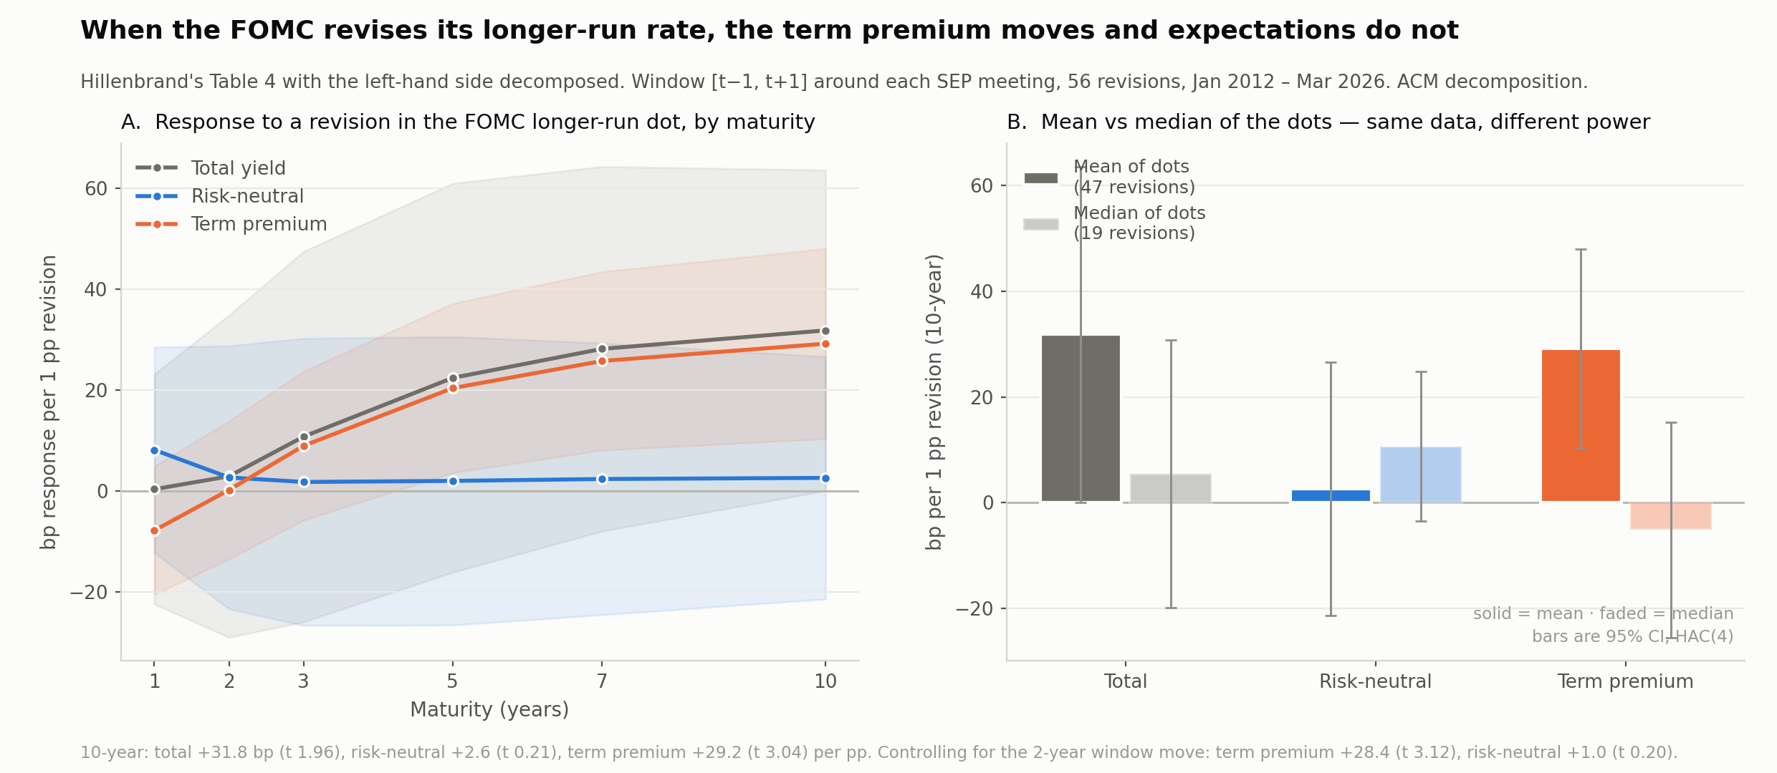
Figure 5. Left: response by maturity. The risk-neutral response is flat at zero; the term-premium response rises with duration. Right: the mean-versus-median comparison on the same 56 meetings.

8.2 Symmetry: a null, and a useful one
Splitting the revision into positive and negative parts and testing equality of the two coefficients:
Left-hand side (10-year) | b (up) | t | b (down) | t | H₀: b(up)=b(down)
Total yield | −8.79 | −0.19 | +50.75 | 2.28 | p = 0.334
Risk-neutral | −43.73 | −1.45 | +24.25 | 1.69 | p = 0.087
Term premium | +34.94 | 1.16 | +26.50 | 1.92 | p = 0.828
The term premium responds symmetrically. Symmetry cannot be rejected at any conventional level (p = 0.83), which is what Section 6.4 predicts: the mechanism is a change in the conditional distribution of future rates, not a directional belief update. A credibility-asymmetry story would have predicted the opposite and is not supported.
The expectations component does not behave like an expectations channel at all. Read as responses to a 1 pp move in each direction, the risk-neutral component falls 43.7 bp on an upward revision and falls 24.3 bp on a downward one — it falls either way. Its pooled coefficient of +2.62 is an average of two offsetting, individually insignificant estimates rather than evidence of a small effect. The marginal asymmetry (p = 0.087) should not be built on.
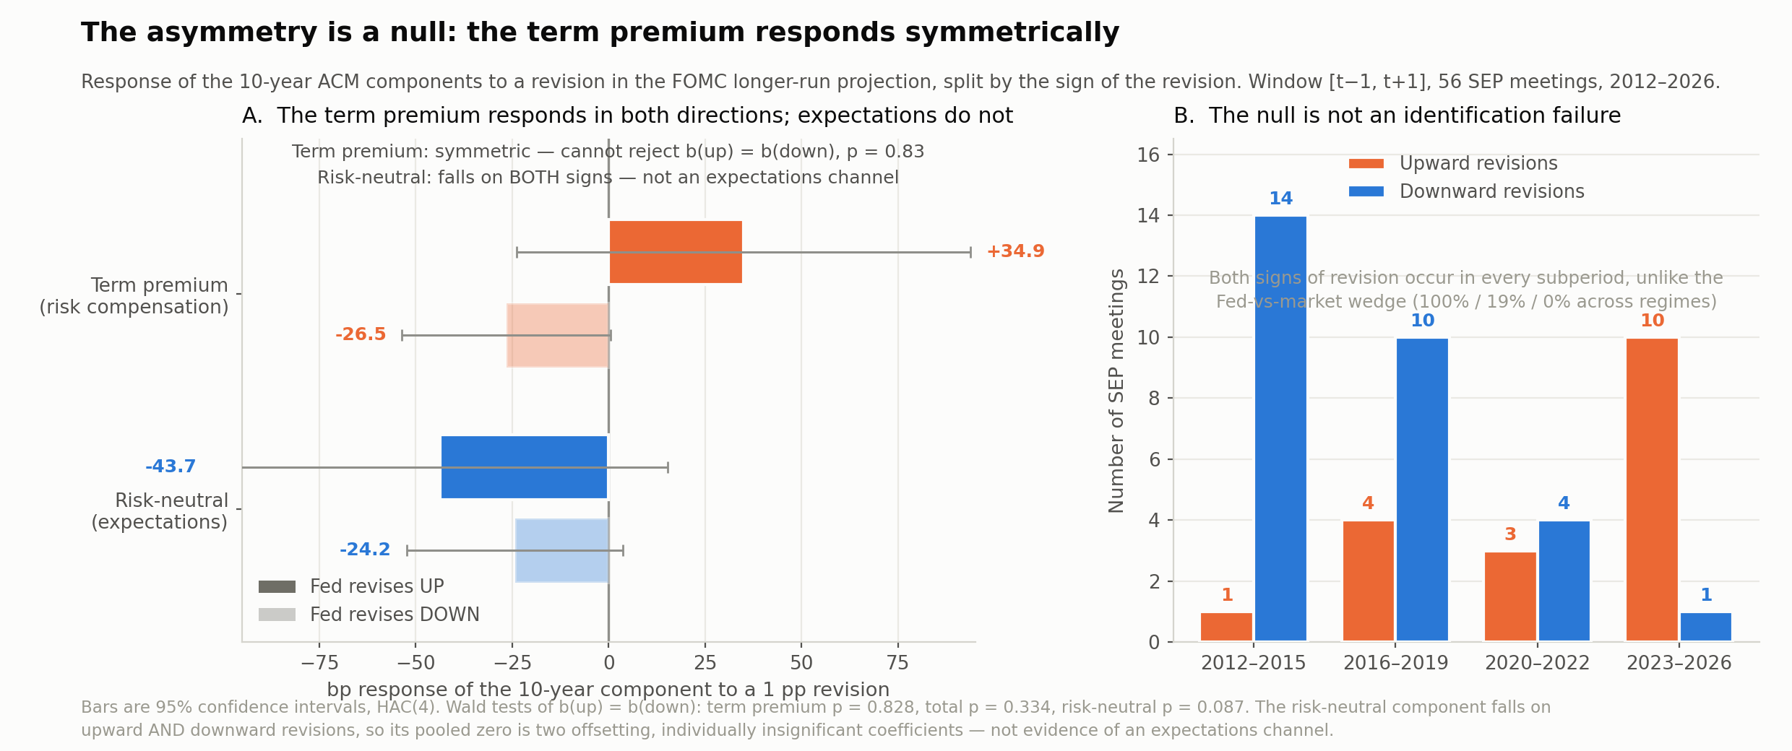
Figure 6. The symmetry test. Panel B documents that both signs of revision occur throughout the sample, so the null is not a confounding artifact — unlike the Fed-versus-market wedge, whose sign was 100% / 19% / 0% across regimes.
Two caveats. Eighteen upward revisions is thin, so the symmetry test has limited power against moderate asymmetries; and a failure to reject is not evidence of equality. The claim made here is only that the data give no support to a credibility-asymmetry mechanism, and that the symmetric term-premium response is the pattern that survives.

9. Threats and what remains

9.1 Threats to identification
- The decomposition is ACM’s. ACM’s risk-neutral component is a function of five yield principal components, so a curve move that does not resemble a standard factor move is booked as term premium by construction — and “the far end moves, the front end does not” is exactly such a move. The finding is consistent both with a genuine premium response and with an endpoint revision the model cannot represent. Partial defences: the two-year control, and the model-free total-yield maturity profile (+0.4 bp at one year against +31.8 bp at ten).
- Predictability of the revision. Bauer & Swanson show announcement surprises are forecastable from pre-meeting data. A projection revision is partly anticipated, which attenuates β and may relabel a Fed-response-to-news channel as a premium effect.
- Simultaneity within the window. The revision is released with the statement and the press conference. The two-year control absorbs the policy-path component but not everything.
- Overlap with the pre-FOMC drift. The window begins at t−1, which contains Pan & Peng’s term-premium drift. Report t and t+1 separately.
- Small effective sample. 56 revisions, 18 of them upward. R² around 5%; a one-standard-deviation revision (0.072 pp) moves the 10-year about 2.3 bp.

9.2 Next steps, in order
- Run the persistence test. Track each in-window component 1, 3, 6 and 12 months out. Section 6.4 predicts the expectations component reverts and the term-premium component persists — the opposite of the standard reading of Hanson–Lucca–Wright. This is the cheapest remaining test, it needs no new data, and it discriminates the two channels without requiring any decomposition to be correctly labelled.
- Pull Hillenbrand’s Table 4 and reconcile. The published coefficient (reported as 0.77 on TIPS yields) is not reproduced by either a levels regression (+0.34) or a window regression (+0.54) on our data. The specification may differ from what is assumed here, and the comparison is load-bearing.
- Extend the Fed leg backwards with Tealbook forecasts. 1981–2019, hand-collected, gives many more upward revisions and is the single change that would power the asymmetry test.
- Re-run on a shifting-endpoint decomposition. Kim–Wright is survey-anchored and daily; the Bauer–Rudebusch real-time series in the archive covers 1971–2018 and can be spliced to the dealer-survey longer-run rate thereafter. The point is not to trust one decomposition but to show the result is not an artifact of any.
- Cross-country. Central banks that publish rate projections — the Riksbank, Norges Bank, the RBNZ — provide an independent test of the credibility asymmetry with different institutional records of delivery.

9.3 What is already secure
Regardless of how the main specification resolves, five results are established and defensible: the accounting argument of Section 6, which constrains what any answer to this literature can mean; the replication and its extension to 2026; the diagnosis that the Pan & Peng and Hofmann–Li–Wu disagreement is an event-list artifact; the demonstration that a risk-neutral far forward from a constant-endpoint model is 83% current short rate and cannot serve as an endpoint measure; and the mean-versus-median measurement point, which materially changes the power of any regression using the dot plot.

