What Counts as an FOMC Announcement?
Reconciling two opposite answers on the pre-announcement drift in Treasury yields
Research note · 11 August 2026
Abstract
Two circulating papers decompose the FOMC-window decline in long-term Treasury yields and reach opposite conclusions. Hofmann, Li & Wu (2025) find the decline is almost entirely a revision of expected short rates. Pan & Peng (2026) find that the largest single day of the window is almost entirely term premium. This note reconciles them.
The disagreement has two sources, neither of which either paper discusses. First, they decompose different objects — a three-day window versus one day inside it — and the components differ by day, so both results can hold simultaneously. Second, and more consequentially, the day-level answer is not robust: it moves from 91% term premium to 39% term premium depending on whether unscheduled FOMC meetings are included and where the sample ends. We reproduce Pan & Peng’s coefficient to two decimals on their specification and show that adding the 68 conference calls and emergency meetings that a scheduled-only filter removes flips the attribution.
Neither answer is robust, for different reasons. The finding is not that one paper is wrong, but that the question as currently posed is under-determined by the data.

1. The question
Hillenbrand (2025) establishes that the secular decline in long-term US interest rates accumulates almost entirely inside three-day windows around FOMC announcements — days t−1, t and t+1. Over June 1989 to June 2021 the 10-year yield fell 6.99 percentage points, of which 6.16 pp accrued inside those windows and 0.82 pp outside.
The natural follow-up is which component of the yield moves. A long yield is the average expected future short rate plus a term premium, and the two carry very different implications. If the window decline is expectations, markets are revising their view of where policy settles, and the Fed is transmitting information about the equilibrium rate. If it is the term premium, the expected path is roughly unchanged and what moves is the compensation investors require for bearing duration risk.
Two papers have answered this question and they disagree.

2. The two claims

2.1 Hofmann, Li & Wu — expectations
BIS Working Paper 1252, March 2025. The paper extends Hillenbrand’s result to the G10 over 1989–2023 using the identical three-day window, and finds that roughly 70% of the secular decline in long rates across seven advanced economies occurs inside US FOMC windows, with other central banks’ windows contributing essentially nothing.
It decomposes using a Bauer–Rudebusch observed-shifting-endpoint model, and concludes the window decline is risk-neutral. For the United States the reported pseudo-R² is 96 for the expectations component against 32 for the term premium.
A caveat that bears on the interpretation. Their trend proxy is defined as "the first principal component of cumulative changes in the yield curve during FOMC windows." In a shifting-endpoint model the risk-neutral rate inherits the endpoint, so the risk-neutral component is constructed from the very series the paper sets out to explain. The conclusion is therefore close to definitional rather than an independent test.

2.2 Pan & Peng — term premium
SSRN 4764451, current draft June 2026. The paper studies the pre-announcement day in isolation, over September 1994 to December 2025, using the 250 scheduled FOMC announcements in that period — the Lucca–Moench sample convention. Decomposition is Adrian–Crump–Moench, with Kim–Wright as a robustness check.
On day t−1 the 10-year yield falls 0.79 bp (t = −2.39), of which the term premium accounts for 0.71 bp (t = −2.34) and the expected short rate 0.08 bp (t = −0.26, insignificant). Cumulatively they attribute 3.09 pp of Hillenbrand’s 7.91 pp window decline — roughly 40% — to that single day, and interpret it as compensation for bearing announcement uncertainty.

3. Data and method
- Yields and components. Adrian–Crump–Moench daily term-structure decomposition, ACMY10, ACMRNY10 and ACMTP10, June 1989 to August 2026. The components sum to the total by construction, so the two component contributions always add to the yield contribution.
- Event lists. The FOMC calendar was retrieved from the Federal Reserve’s historical meeting pages. Two lists are used: 297 regularly scheduled meetings, and those plus 68 conference calls and unscheduled or emergency meetings, for 365 events in total. The unscheduled set includes the intermeeting actions of October 1989, January and October 2008, and March 2020.
- Window. The daily change on day t−1 relative to t−2, isolating the pre-announcement day. Cumulative figures sum that daily change across all events in the stated sample.
- Specifications. Six cells: two event lists crossed with three sample ranges. The samples are chosen to span the two papers’ conventions — Pan & Peng’s September 1994 start and 2025 end, Hillenbrand’s June 1989 start and June 2021 end.

4. Resolution, part one: they decompose different objects
Hofmann, Li & Wu decompose all three days together. Pan & Peng decompose one of them. Because the components split differently across the days of the window, both can be right at once.
Day (all 365 events, Jun 1989 – Jun 2021) | Total | Risk-neutral | Term premium
t−1 | −1.10 | −0.68 (t −3.15) | −0.43 (t −1.30)
t | −0.78 | −0.83 (t −2.80) | +0.05 (t +0.22)
t+1 | −0.16 | +0.05 (t +0.16) | −0.21 (t −0.30)
Mean basis points per meeting. The pre-announcement day carries a term-premium component; the announcement day itself is expectations, with the term premium contributing nothing. Aggregate the three and the expectations component dominates — which is exactly the pattern that lets a whole-window study and a t−1 study reach opposite headlines without either being mistaken.
So the first thing to say is that the papers are not in direct contradiction. That alone, however, does not rescue either result.

5. Resolution, part two: the day-level answer is not robust
The substantive finding is that even holding the object fixed — day t−1 — the decomposition moves with two choices neither paper flags.
Event list | Sample | n | Yield | Risk-neutral | Term prem. | TP share
Scheduled only | Sep 1994 – Jun 2021 | 214 | −1.82 | −0.49 | −1.33 | 73%
Scheduled only | Jun 1989 – Jun 2021 | 256 | −2.06 | −0.43 | −1.63 | 79%
Scheduled only | Sep 1994 – Aug 2026 | 255 | −2.03 | −0.19 | −1.85 | 91%
All meetings | Sep 1994 – Jun 2021 | 246 | −2.83 | −1.49 | −1.34 | 47%
All meetings | Jun 1989 – Jun 2021 | 324 | −3.60 | −2.20 | −1.40 | 39%
All meetings | Sep 1994 – Aug 2026 | 287 | −3.05 | −1.19 | −1.86 | 61%
Cumulative percentage points on day t−1. The bottom-right of Pan & Peng’s specification — scheduled meetings only, September 1994 onward, extended through the current data — gives −0.80 bp per meeting with a 91% term-premium share, against their reported −0.79 bp and 90%. The replication is essentially exact.
Two choices drive the result. Holding the sample fixed, switching from scheduled-only to all meetings moves the term-premium share by 26 to 40 percentage points in every column. Holding the event list fixed, extending the end date from June 2021 to 2026 moves it by 14 to 18 points. Obtaining a 90% term-premium share requires both choices together.
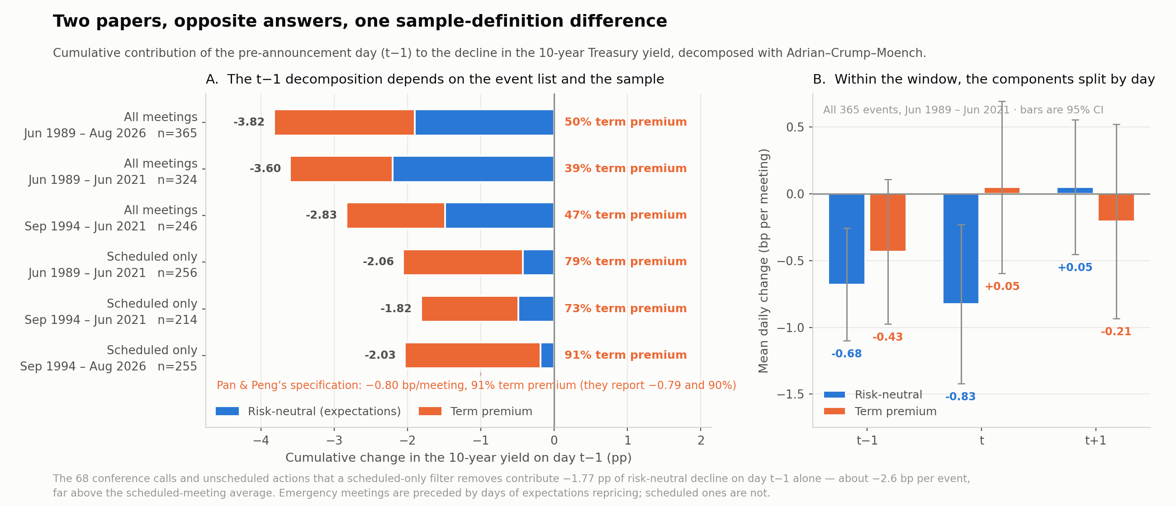
Figure 1. Panel A: the t−1 decomposition across six specifications. Panel B: the components by day within the window.

6. Why the event list matters
The mechanism is straightforward once stated. The 68 conference calls and unscheduled meetings that a scheduled-only filter removes contribute −1.77 pp of risk-neutral decline on day t−1 alone — about −2.6 bp per event, far above the scheduled-meeting average of roughly −0.2 bp.
That is what one would expect. Emergency intermeeting actions — the October 1989 cluster, January and October 2008, March 2020 — are preceded by days in which markets aggressively reprice the expected policy path in anticipation of a cut. Those days load on expectations, not on risk compensation, because the news is about where policy is going rather than about the resolution of scheduled-announcement uncertainty.
The pre-1994 period works the same way for a different reason: before February 1994 the FOMC did not announce its decisions, so there was no scheduled announcement for an uncertainty premium to resolve around, and the pre-meeting days again reflect expectations rather than premium.
Pan & Peng’s sample choice is defensible on its own terms — it follows Lucca–Moench, and studying an announcement-uncertainty premium sensibly restricts attention to scheduled announcements. But it is not neutral with respect to the question being answered. Restricting to scheduled meetings mechanically removes the episodes in which the pre-announcement day is an expectations event, which raises the term-premium share of what remains.

7. What this establishes, and what it does not

7.1 Established
- The two papers are not in direct contradiction — they decompose different objects, and the components differ by day within the window.
- Pan & Peng’s coefficient replicates exactly on their specification: −0.80 bp per meeting against their −0.79, with a 91% term-premium share against their 90%.
- The day-level attribution is not robust. Including unscheduled meetings moves the term-premium share from 91% to 61%; including them and using Hillenbrand’s end date moves it to 39%.
- The mechanism is identified: unscheduled meetings are preceded by expectations repricing worth roughly −2.6 bp per event on day t−1, more than ten times the scheduled-meeting average.

7.2 Not established
This note does not determine which decomposition is correct, and it cannot, because both are compromised in different ways.
- Hofmann, Li & Wu construct their shifting endpoint from cumulative FOMC-window yield changes, so their risk-neutral component inherits the series being explained. Their answer is close to definitional.
- Pan & Peng use an off-the-shelf ACM decomposition with no such circularity, but ACM assumes a constant endpoint — a stationary VAR with a fixed unconditional mean — so any genuine secular movement in the equilibrium rate is mechanically booked as term premium. The bias runs toward their conclusion.
Adjudicating would require a decomposition whose endpoint is allowed to move and is identified independently of the FOMC window — Kim–Wright, or a survey-anchored construction in the style of Crump, Eusepi & Moench. That is the obvious next step and is outside the scope of this note.

8. Implications
For the two papers. Both results should be stated conditionally. Pan & Peng’s finding is that among scheduled, post-1994 announcements the pre-announcement drift is risk compensation — a defensible and interesting claim, but not a general statement about FOMC windows. Hofmann, Li & Wu’s finding is that under an endpoint constructed from window data, window movements are risk-neutral — which requires an independent endpoint before it can be read as evidence.
For the literature. The event list is a free parameter in this literature and it is doing substantial work. Hillenbrand uses all meetings; Pan & Peng use scheduled only; Hofmann, Li & Wu follow Hillenbrand. Papers that compare results across these conventions are not comparing like with like, and the convention should be reported and varied as a matter of course.
For the underlying question. The expectations-versus-term-premium question is not settled and is not currently settleable with the standard tools. Every available decomposition requires an assumption about the equilibrium rate, which is the object under investigation. Progress requires either an endpoint measure identified outside the yield curve, or tests that do not rely on the decomposition at all — for instance, whether window moves in each component revert over subsequent months, which is a property of realised yields rather than of a model.

References
Adrian, T., R. Crump and E. Moench (2013). "Pricing the Term Structure with Linear Regressions." Journal of Financial Economics 110(1), 110–138.
Bauer, M. and G. Rudebusch (2020). "Interest Rates under Falling Stars." American Economic Review 110(5), 1316–1354.
Crump, R., S. Eusepi and E. Moench (2018). "The Term Structure of Expectations and Bond Yields." FRBNY Staff Report 775.
Hillenbrand, S. (2025). "The Fed and the Secular Decline in Interest Rates." Review of Financial Studies 38(4), 981–1013.
Hofmann, B., Z. Li and S. P. Y. Wu (2025). "Monetary Policy and the Secular Decline in Long-Term Interest Rates: A Global Perspective." BIS Working Paper 1252.
Kim, D. and J. Wright (2005). "An Arbitrage-Free Three-Factor Term Structure Model." FEDS Working Paper 2005-33.
Lucca, D. and E. Moench (2015). "The Pre-FOMC Announcement Drift." Journal of Finance 70(1), 329–371.
Pan, J. and Q. Peng (2026). "The Pre-FOMC Drift in Long-Term Treasury Bonds." Working paper, SSRN 4764451.

