Quotation 00036
Alajuela, Costa Rica
2026-08-28
Subject: Quotation - HOTWORK REPAIR
Dear Perez & Cía,
We are pleased to submit our quotation for the following services:
- HOTWORK REPAIR: $ 5,000.00 USD
Total amount: USD 5,000.00
This quotation is valid until Sep 12 2026.
Payment terms: 30 days from invoice date.
Sincerely,
Marine Surveyors & Logistics Group SRL

Sincerely,
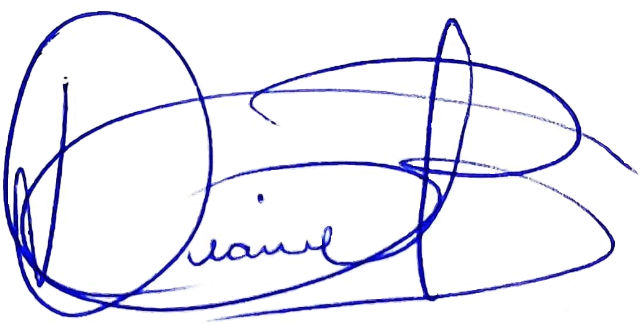
Diana Quiros Benambourg
Business Manager
Marine Surveyors & Logistics Group SRL

