CRANE INSPECTION REPORT

On February 23, 2026, we were appointed to carry out a crane inspection survey in MV ASL LUNA at Puerto Pisco, Peru.

CRANES GEAR SURVEY
- The cranes survey started on February 26, from 14:00 LT to February 27 at 18:00 LT.
- The cranes were inspected and found in apparent good condition with shortcomings.
- The hosting and luffing wires were visually inspected in four cranes; they were found in apparently good condition and greased.
- The hosting and luffing sheaves were visually inspected in four cranes, and were found with negative impressions.
- The operability inspection on the four cranes was carried out, and they were found in apparently good condition (Cargo Hook block upper and slack limits no working).

Crane Inspection
- -Crane Access (Clean and no obstacles).
- -Crane machinery space (Clean).
- -Crane operator cabin, were found apparently in good condition.
- -Crane jib head sheaves were found without negative impressions.
- Hoisting wire end pin / greased.
- -Luffing wire end pin / greased.
- -Crane wire rope visual inspection, were found in apparently good condition and greased.
- -Crane housing top sheaves were found with negative impressions.
- -Luffing center sheave visual inspection, it was found without negative impressions.
- -Cargo block sheave shaft. – were found in apparent good condition, free and greased, no Trunnion.
- -Slack hoisting wire limit – No Working.
- -Crane jib angle limits – Working.
- – Crane Jib Angle indicator – free to rotate / Unreadable Scale
- -Crane hoisting wire limits / upper limit from jib head to block top, and slack limit / No working.
- – Pedestal / Light project (Working)

REMARKS BY CRANE

CRANE #1:

- -Crane Jib Angle indicator – Unreadable Scale.
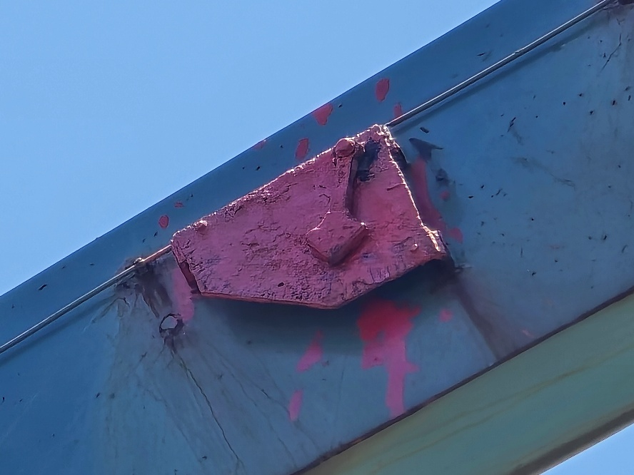

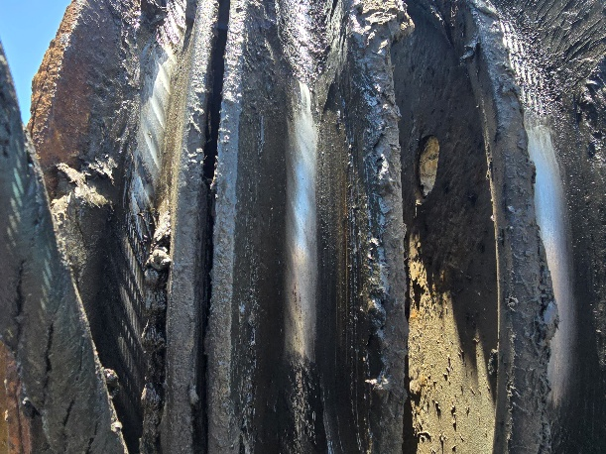
- -Crane Housing top Sheaves / L1 & L5 / Negative Imprint.

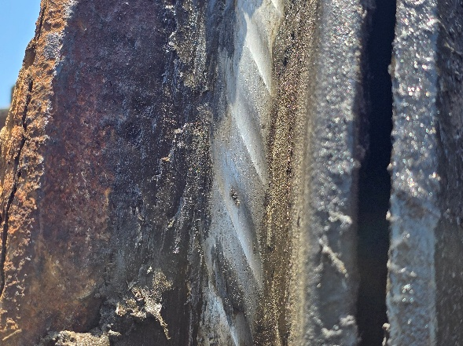
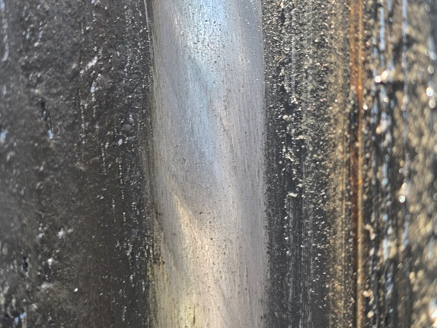

CRANE#2:
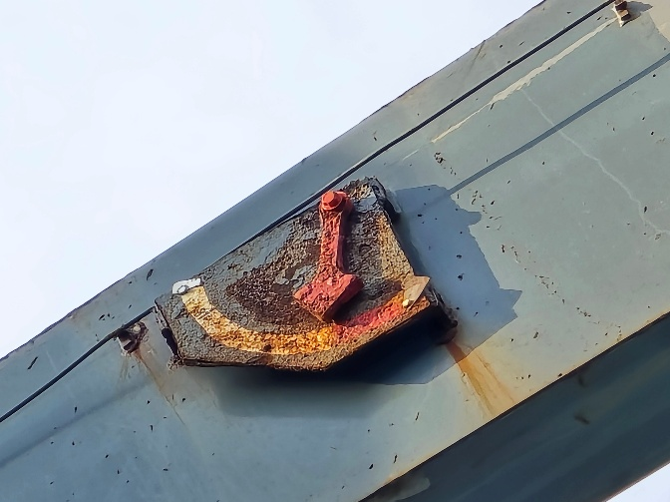
- -Crane Jib Angle indicator – Unreadable Scale.

- -Crane Housing top Sheaves / L1 & L5 / Negative Imprint.
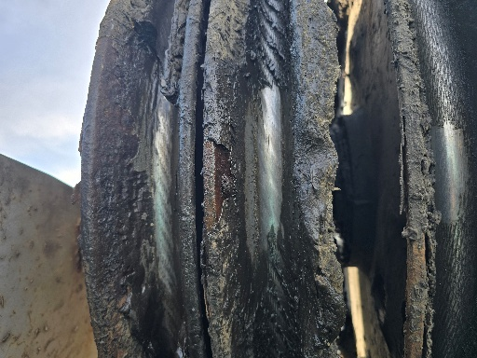

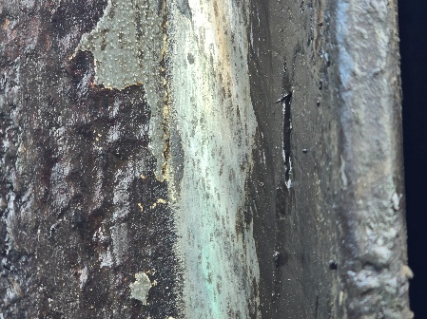
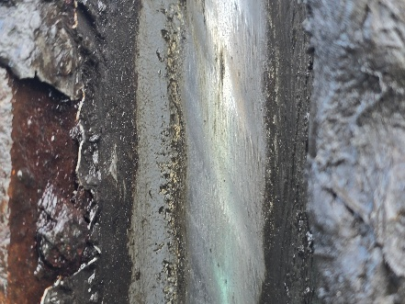

- -Crane hoisting wire limits and Cargo Hook block / Upper limit 3 mts / Working. Must be adjusted to 1.5Mts
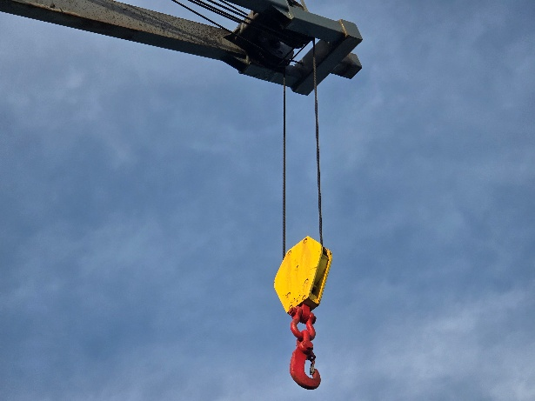
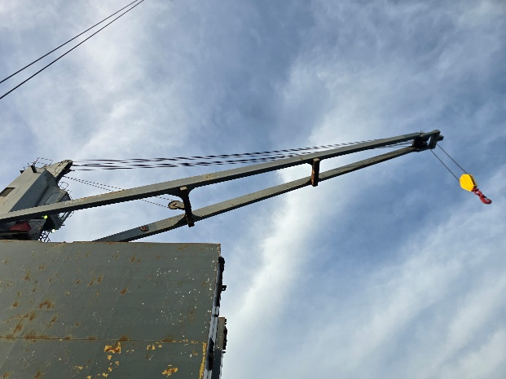

CRANE #3:
- -Crane Housing top Sheaves / L1 & L5 / Negative Imprint.

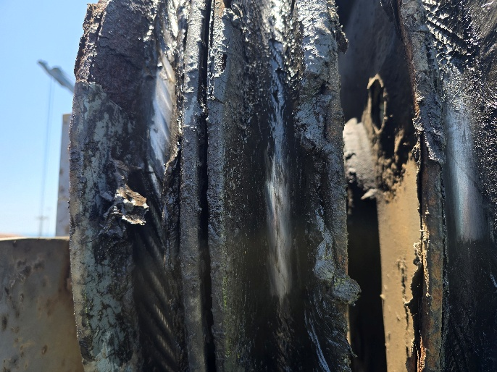

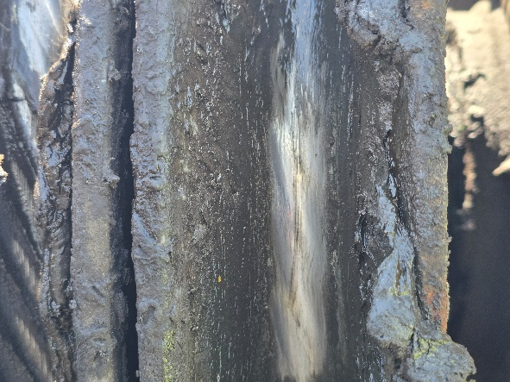
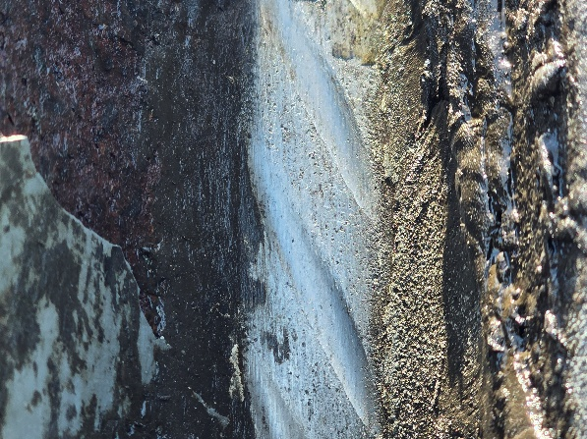

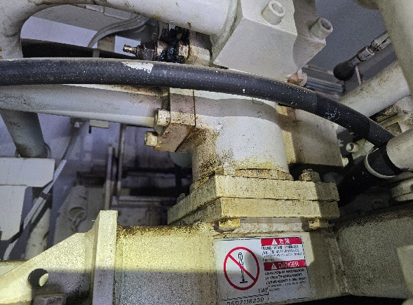
- -Machinery Space – Hoisting Control Motor / Active Leaking.

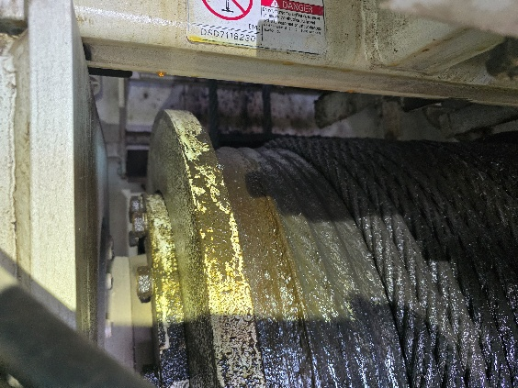
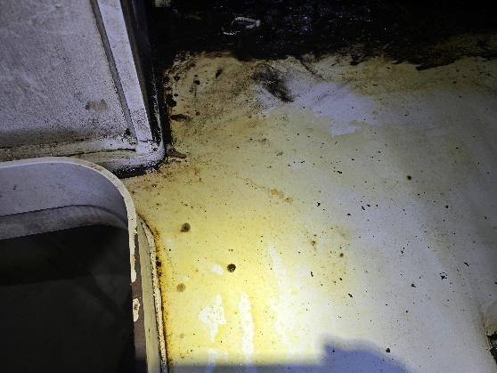

- -Crane hoisting wire limits and Cargo Hook block / Upper limit / No working.
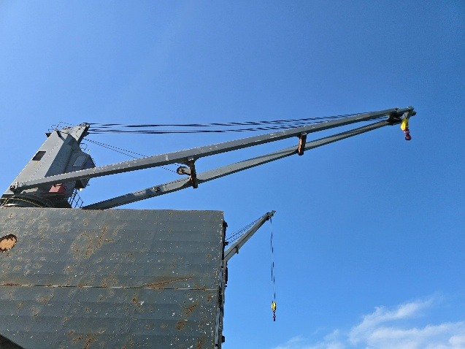
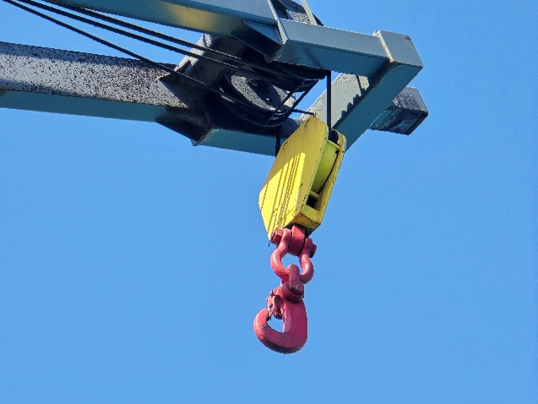

CRANE #4
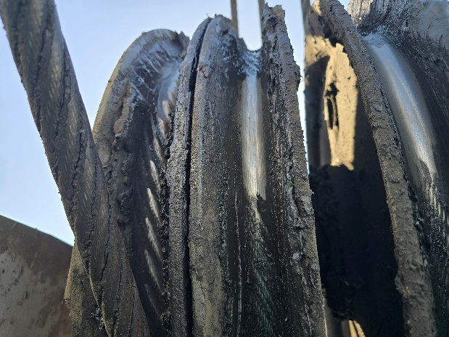
- - Crane Housing top Sheaves / L1 & L5 / Negative Imprint.

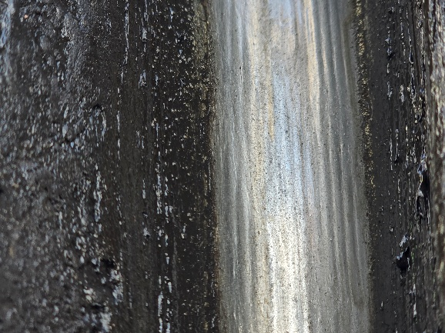
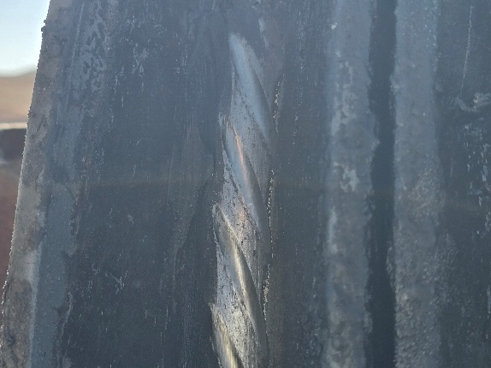

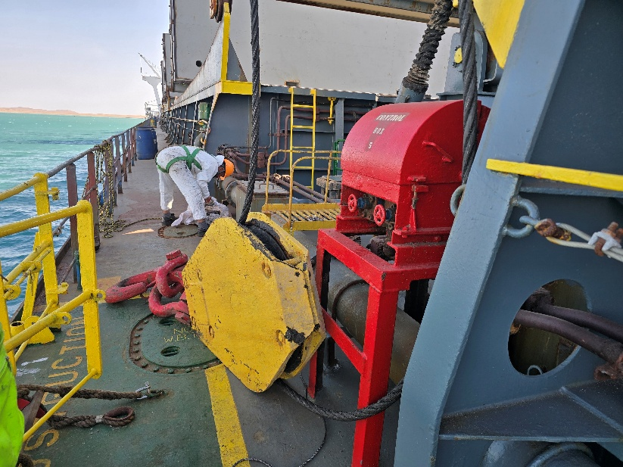
- -Crane hoisting wire limits and Cargo Hook block / Slack limit / No working.

RECOMENDATIONS
- Material abrasion on the sheave occurs as a consequence of the slightest relative motions between the wire rope and the sheave. The amount of abrasion can be reduced by using appropriate wire rope lubricants. Regular relubrication of steel wire ropes during service counteracts the formation of negative impressions.

GRABS CONDITION SURVEY
No Grabs onboard

CONCLUSION

The cranes were in apparently good condition for operation, nevertheless the relevant repairs and adjustments must be made according to the findings (See Remarks By Crane).
The Hoisting and Luffing wires lubricating condition was acceptable.
According to the Standard of Deck Crane Wire Rope Replacement, is required replace the hoisting wires due to operation time (Hook operation 700 – 900 hrs. / Grab operation 350 – 450 hrs) and luffing wire about (2 to 4 years).
Wire rope record of hoisting and Luffing.
The Hoisting wire records from September 09, 2015, until May 20, 2024.
The Luffing wire records from November 09, 2022, Replaced.
CRANE #1 – Luffing No Records / Hoisting 464 hrs, Date May 20, 2024
CRANE #2 – Luffing No Records / Hoisting 400 hrs, Date Dec 05, 2022
CRANE #3 - Luffing No Records / Hoisting 252 hrs, Date May 20, 2024
CRANE #4 – Luffing No Records / Hoisting 503 hrs, Date Sept 09, 2015

ENCLOSURE
Survey Link pictures and Videos of this report at: https://photos.app.goo.gl/85GVmmcQ9aniZnr46
Cargo Gear Certificates.
Hoisting and Luffing wires certificates.
Wires record.

THIS BONAFIDE REPORT IS ISSUED WITHOUT PREJUDICE AND IS FOR THE BENEFIT OF WHOM IT MAY CONCERN, AND WE RESERVE OUR RIGHT TO AMEND AND/OR EXTEND THIS REPORT SHOULD NEW INFORMATION COME TO OUR KNOWLEDGE


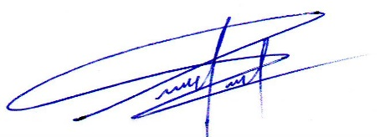

Surveyor. Pabel Peña
Marine Master Surveyor.
MSL Marine Surveyors and Logistics Group.

