Puerto Caldera - Costa Rica, January 14, 2026.

DRAFT SURVEY REPORT

- INTRODUCTION

  - Purpose
We MSL Marine Surveyors and Logistics, as independent supervision company, were appointed to carry out a Draft survey of {word_mt} mt of {word_product} aboard of M/V “{word_vessel}” at Puerto {word_port} – {word_country}.

  - Instructions
    - Survey requested by: {word_survey_requested_by}
    - On behalf of: {word_on_behalf_of}

  - Representatives
    - Master of the ship: {word_master}
    - Chief Officer: {word_chief_officer}

- VESSEL PARTICULARS
  - Name MV “{word_vessel}”
  - Port Of Registry / Flag {word_port_registry}.
  - GRT / NET {word_grt}/ {word_nrt}
  - Year Built {word_year}
  - IMO Number {word_imo}.

- EXTRACT TIME SHEET
  - Vessel Arrived at Sea buoy {word_arrived_buoy} LT.
  - N.O.R Tendered {word_nor_tendered} LT.
  - All Fast {word_all_fast} LT.
  - Initial Draft Survey {word_initial_draft} LT.
  - Commenced Discharge {word_commenced} LT.
  - Completed Discharge {word_completed} LT.
  - Final Draft Survey {word_final_draft} LT.

- THE GOODS
{word_metric_tons} metric tons of Grains in bulk ({word_goods_product}) Loaded in holds {word_holds}.

WEIGTH CONTROL
  - The weight was supervised by one method: By Draft Survey.

    - By Draft Survey, the weight was calculated by the MSL Surveyors, according to the International Draft Survey Procedures (See Amended Draft Survey Certificate).

  - The reliability of the method depend of the calibration degree in the vessel’s Hydrostatic / Ballast tables and Calibration.

- CARGO QUANTITY DISCHARGED BY DRAFT SURVEY
  - The Initial and Final Draft Survey were accomplished in joint with the Chief Officer. For the Draft Survey calculations were used the vessel’s Hydrostatic Tables.

Total Discharged By Draft Survey (By Msl Surveyor)

Draft Survey Figure {word_draft_figures} MT.
B/L Figures {word_bl_figures} MT.
Difference {word_difference} MT
Percentage {word_percentage} %

Total Discharged By Shore Scale as a Reference (By SPC Caldera)

Shore Scale Figures {word_shore_scale} MT.
B/L Figures {word_shore_bl} MT.
Difference {word_shore_difference} MT
Percentage {word_shore_percentage} %

THIS BONAFIDE REPORT IS ISSUED WITHOUT PREJUDICE AND IS FOR THE BENEFIT OF WHOM IT MAY CONCERN, AND WE RESERVE OUR RIGHT TO AMEND AND/OR EXTEND THIS REPORT SHOULD NEW INFORMATION COME TO OUR KNOWLEDGE

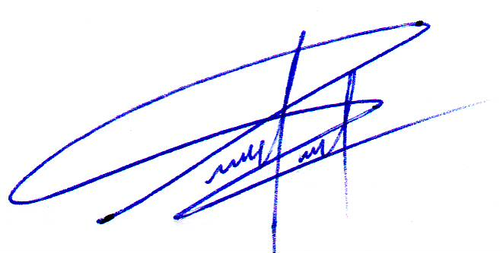

Surveyor. Pabel Peña
Marine Master Surveyor.
MSL Marine Surveyors and Logistics Group.
- ENCLOSURES
  - Draft Survey Certificate

