CERT Nº {report_number}

{vessel}
GRT: {grt}
NRT: {nrt}

TO: {requested_by}

PUERTO {port}, {country}, {service_start_date}

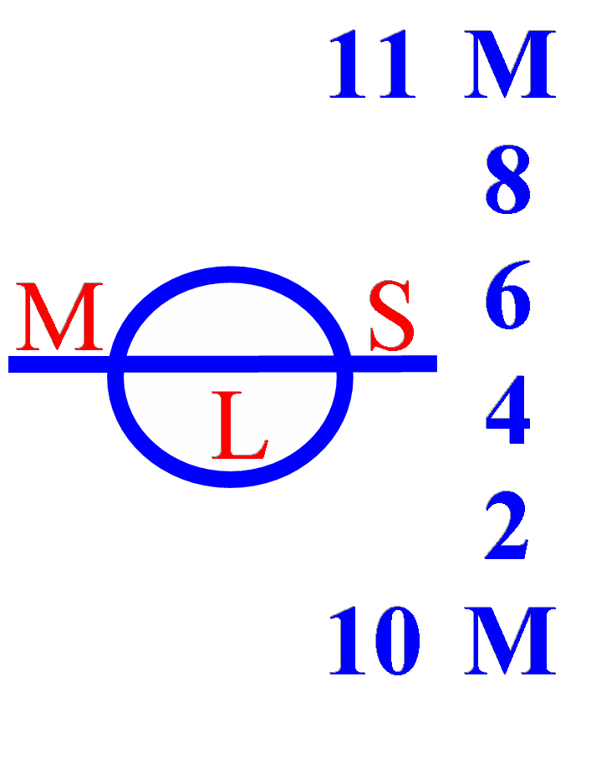
www.mslogisticsgroup.com

