CERT Nº {report_number}

WEIGHT CERTIFICATE

VESSEL: {vessel} VOYAGE Nº {voyage}

COMMODITY DESCRIBED AS: {commodity}
BILL OF LADING FIGURE: {bl_figure} METRIC TONS
VESSEL CARGO HOLD: {cargo_hold}
SHIPPER: {shipper}
CONSIGNEED: {consignee}
TERMINAL: {terminal}
LOADING PORT: {loading_port}
WEIGTH DETERMINATION: {weight_determination}
DATE: {date}

TO WHOM IT MAY CONCERN

This is to report that above mentioned vessel has loaded the following quantity:

{quantity} METRIC TONS

And the aforesaid quantity shall be considered the Official Bill of Lading Figure at the above Terminal.

REMARKS:

{remarks}


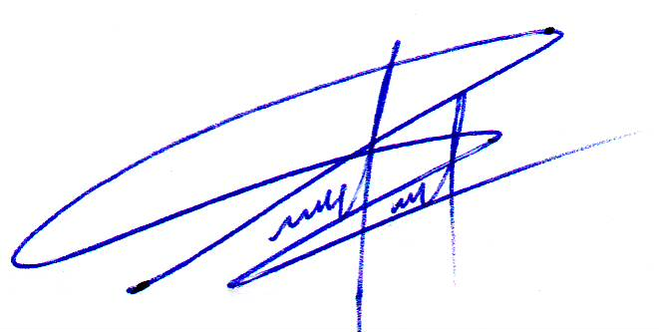

_____________________________
MSL S.R.L

This certificate is issued without prejudice, stating my findings only to the best of my knowledge
and ability but without any responsibility in our part; as does not relieves the parts of their contractual obligations

