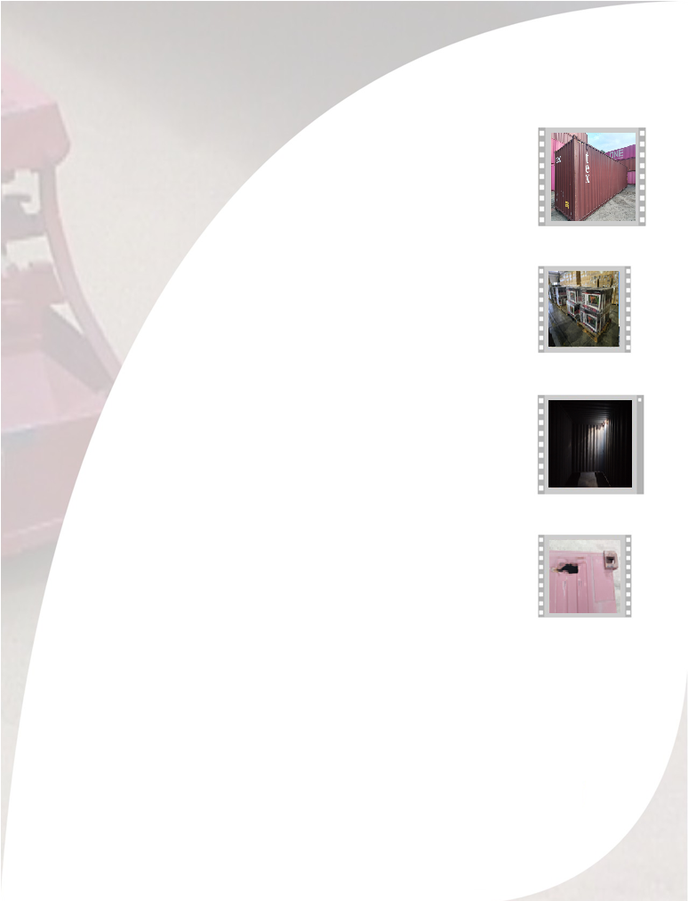
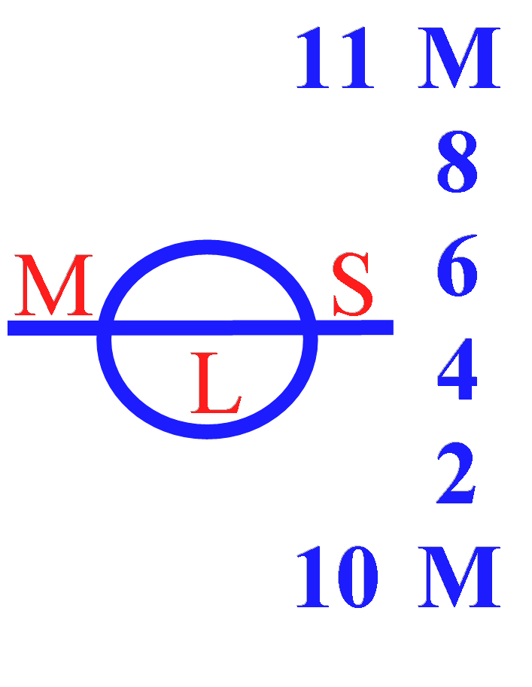
CONTAINER DAMAGE REPORT
CERT Nº 2066-0307-2025
TO: MAERSK.

CONTAINER
GCXU 253479-6
APM TERMINALS JULY 07, 2025

www.mslogisticsgroup.com

