SURVEY REPORT

CERT Nº {report_number}

{vessel},
GRT: {vessel_grt}
NRT: {vessel_nrt}

TO: {requested_by}.

Puerto {port}, {country}, {inspection_date}

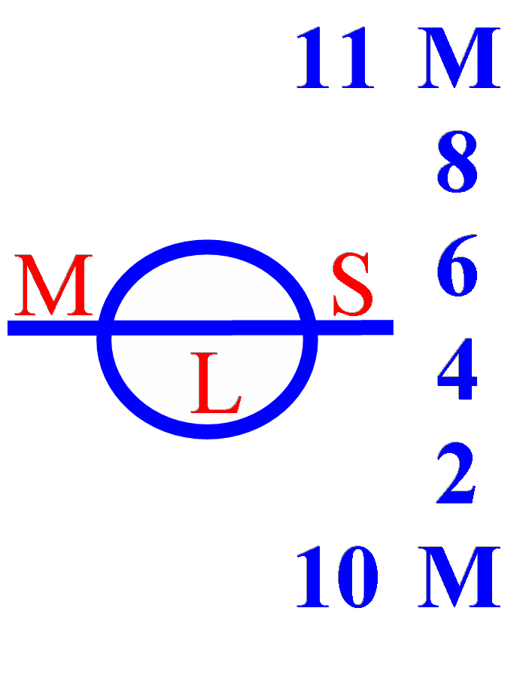

PUERTO MOIN - COSTA RICA, FEBRUARY 22, 2026

www.mslogisticsgroup.com

