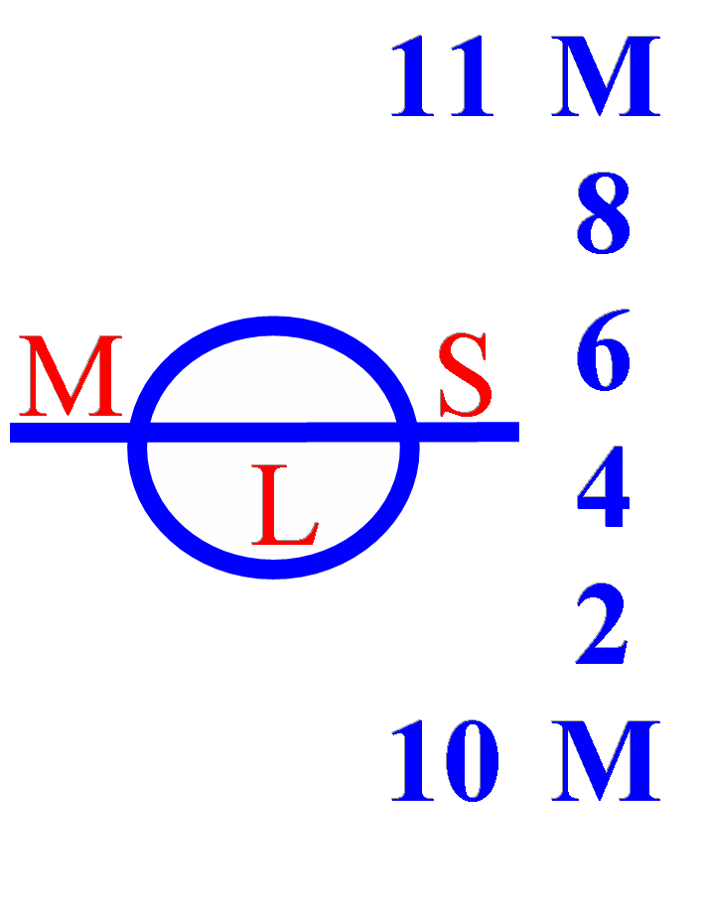
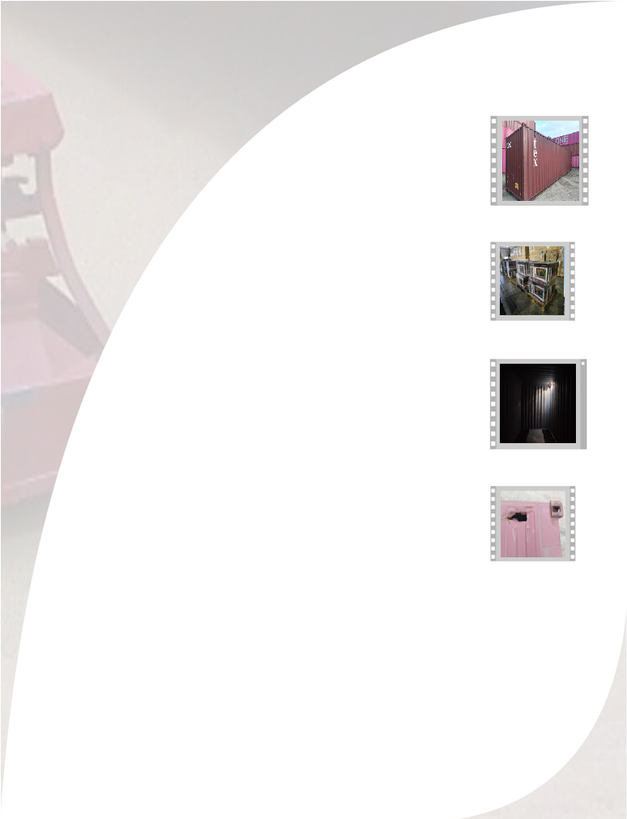
APM TERMINALS JULY 07, 2025

TO:

CONTAINER

CONTAINER DAMAGE REPORT
www.mslogisticsgroup.com

CERT Nº

