Quotation TEST-MCI
Alajuela, Costa Rica
2026-09-09
Subject: Quotation - Marine Claim Review
Dear client,
We are pleased to submit our quotation for services. This is a layout smoke test for MCI letterhead and watermark.
Best regards.

Sincerely,
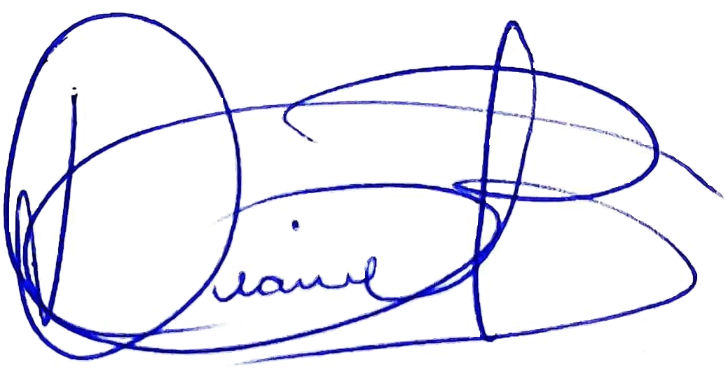
Msc. Diana Quiros Benambourg
Business Manager
MSL 2.0
MARINE CLAIMS & RISK INTELLIGENCE

