CARGO LASHING CERTIFICATE

FLAT RACK CONTAINER N° TTNU060858 1
TYPE OF CARGO: ANILLO DEL STATOR E44 COMPL / STATOR RING
LASHING MATERIAL: RATCHET LASHING
DATE & PLACE: DEC 15, 2017 / CONSORCIO AVENDAÑO SRL.

THIS IS TO CERTIFY THAT THE CARGO LASHING HAS BEEN INSPECTED AND WAS FOUND IN APPARENT GOOD ORDER CONDITIONS.

WHERE USED THIRTENN 13 RATCHET LASHINGS IN APPARENT GOOD CONDITION.

THE LASHING WAS CARRY OUT AT CONSORCIO AVENDAÑO SRL´S WAREHOUSE.

COMPLETION DATE OF THE SURVEY ON WHICH THIS CERTIFICATE BASED ON DECMBER 15, 2017.

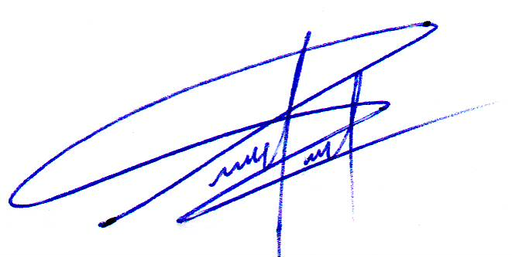

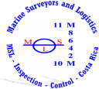
_______________________ Eng. Pabel Peña
MSL Surveyor

