Puerto Caldera - Costa Rica, January 14, 2026.

DRAFT SURVEY REPORT

- INTRODUCTION

  - Purpose
We MSL Marine Surveyors and Logistics, as independent supervision company, were appointed to carry out a Draft survey of 51,970.⁰¹ mt of Grains in bulk aboard of M/V “DSI PHOENIX” at Puerto Caldera – Costa Rica.

  - Instructions
    - Survey requested by: AGROPECUARIA EL SURCO S.A.
    - On behalf of: AGROPECUARIA EL SURCO S.A.

  - Representatives
    - Master of the ship: MUGAR RONNIE NACARIO.
    - Chief Officer: APDO NATHANIEL OLAZO.

- VESSEL PARTICULARS
  - Name MV “DSI PHOENIX”
  - Port Of Registry / Flag MAJURO / MARSHALL ISLANDS.
  - GRT / NET 34,551 / 19,663.
  - Year Built 2017.
  - IMO Number 9738337.

- EXTRACT TIME SHEET
  - Vessel Arrived at Sea buoy January 11, 2026 from 23:48 LT.
  - N.O.R Tendered January 11, 2026 from 23:48 LT.
  - All Fast January 14, 2026 from 14:30 LT.
  - Initial Draft Survey Janu 14, 2026 from 15:15 to 16:30 LT.
  - Commenced Discharge January 14, 2026 from 17:20 LT.
  - Completed Discharge January 18, 2026 from 00:05 LT.
  - Final Draft Survey Janu 18, 2026 from 00:05 to 00:45 LT.

- THE GOODS
51,970.⁰¹ metric tons of Grains in bulk (Soybean – Yellow Corn – DDGS) Loaded in holds 1-2-3-4-5.

WEIGTH CONTROL
  - The weight was supervised by one method: By Draft Survey.

    - By Draft Survey, the weight was calculated by the MSL Surveyors, according to the International Draft Survey Procedures (See Amended Draft Survey Certificate).

  - The reliability of the method depend of the calibration degree in the vessel’s Hydrostatic / Ballast tables and Calibration.

- CARGO QUANTITY DISCHARGED BY DRAFT SURVEY
  - The Initial and Final Draft Survey were accomplished in joint with the Chief Officer. For the Draft Survey calculations were used the vessel’s Hydrostatic Tables.

Total Discharged By Draft Survey (By Msl Surveyor)
Draft Survey Figures MT.
B/L Figures MT.
Difference MT
Percentage %

Total Discharged By Shore Scale as a Reference (By SPC Caldera)
Shore Scale Figures MT.
B/L Figures MT.
Difference MT
Percentage %

THIS BONAFIDE REPORT IS ISSUED WITHOUT PREJUDICE AND IS FOR THE BENEFIT OF WHOM IT MAY CONCERN, AND WE RESERVE OUR RIGHT TO AMEND AND/OR EXTEND THIS REPORT SHOULD NEW INFORMATION COME TO OUR KNOWLEDGE

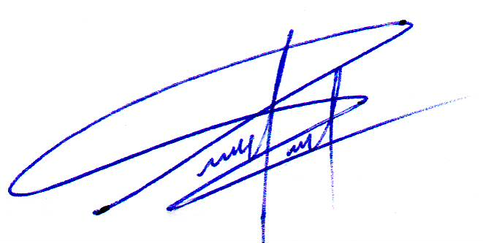

Surveyor. Pabel Peña
Marine Master Surveyor.
MSL Marine Surveyors and Logistics Group.
- ENCLOSURES
  - Draft Survey Certificate

