
DRAFT SURVEY REPORT
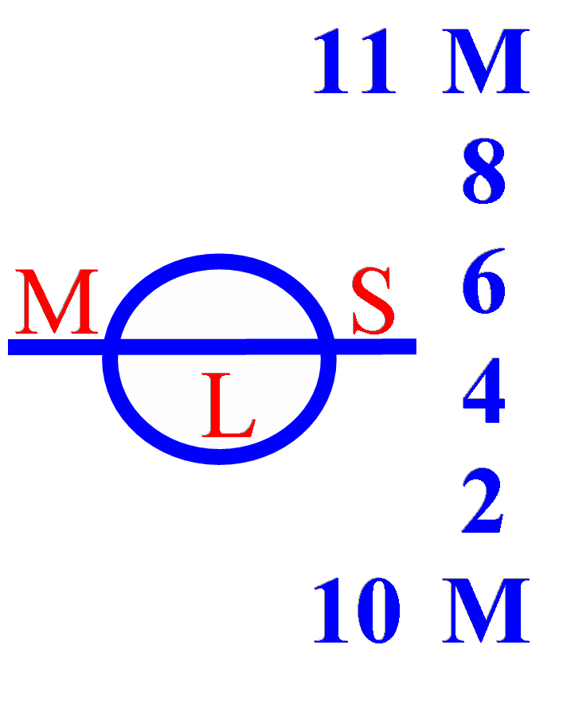
PUERTO CALDERA - COSTA RICA, JANUARY 14, 2026

MV DSI PHOENIX
GRT: 34,551.
NRT: 19,663.
TO: AGROPECUARIA EL SURCO S.A.

.

CERT Nº 2144-1401-2026
www.mslogisticsgroup.com

