2d Lt Aaron Bonner

Atmospheric Turbulence Simulation Module Writeup

## Prompt

Generate 100 phase screens and then create 100 optical transfer functions using the make_otf function.  Average the simulated OTFs and compare them to the averge otf generated by make_long_otf.  Use a seeing parameter of 1cm with an aperture diameter of 7cm to generate your phase screens and average otf.  In order to compare them, use Make_long_otf to generate long exposure OTF's with seeing parameters between 5 mm and 2 cm in increments of 1mm.  See which simulated long exposure OTF matches the otf created using the zernike method by computing the sum squared error between the simulated long exposure otf and the zernike OTF. Provide a plot of the sum squared error between the zernike created otf and the average otfs as a function of seeing.

## Data Generation

Data for this experiment was generated utilizing functions from the provided files for this module, $turbulance.py$, $make_otf2.py$, and $make_long_otf.py$. The functions used were not alternated in any way.

First, a set of phase screen were generated using the $generate_zrn_polys()$ and the $general_phase_screen()$ functions. The number of phase screen was set to 200 and the number of Zernike polynomials to 150.

Next, the variables pertaining to the OTF functions were used to make the pupil mask. The aperture was set to $7cm$ and a pupil was generated with a height and width of 300 pixels as seen in Figure 1.

Figure 1. The pupil mask used for the Zernike OTFs

Then, a complex pupil was created by multiplying the pupil mask with the phase screen. The Zernike OTF for that value was then calculated with the $make_otf()$ function using a seeing parameter of $1cm$. Once this process was complete for all phase screens generated, the array of OTFs was averaged and normalized. This concluded the creation of the Zernike OTFs.

Next, for the long OTF calculation, the range of seeing parameters was established as the set of numbers between $0.5cm$ to $2cm$ inclusively, with an interval of $0.1cm$. The long OTF was then calculated using all the values in the set of seeing parameters. During execution, the sum squared error between the average Zernike OTF and the current long OTF was calculated and stored in a separate array. Then, the plot of the sum squared error between the Zernike OTF and all of the long OTFs was plotted as seen in Figure 2. 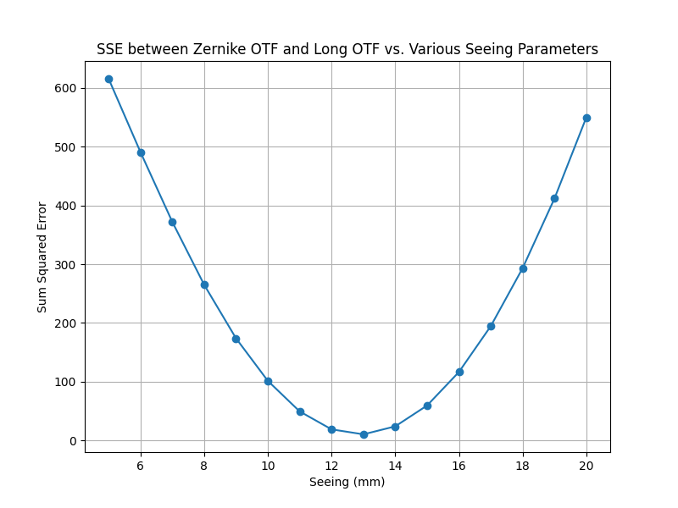

Figure 2. The SSE between the Zernike OTF at a 10mm seeing parameter and the Long OTF at a range of seeing parameters

## Graph Analysis

In the final graph generated, the lowest points were observed to be at the $1.3cm$ seeing parameter long OTF having the lowest sum squared error when compared to the Zernike OTF value that had a seeing parameter of $1cm$. Although the graph shows that the average Zernike OTF and long OTF models are exhibit approximately the same behavior, the Zernike still experiences some losses since there is a finite number of Zernike polynomials and phase screens used.