2d Lt Aaron Bonner

Polarization Module Writeup

## Prompt

Original - Create a columnated light beam by placing a lens one focal length in front of a light emitting diode. Measure the intensity of the light beam a distance z away from the lens. Next place a polarization analyzer in the path and measure the intensity of the light beam at different rotation angles of the polarizer (verify the original beam is unpolarized). Next place a second polarization analyzer in the path and measure the intensity of the beam at a angle difference of 0., 45 and 90 degrees between the polarization analyzers.

Modified – Measure the intensity of a laser light beam at various polarization angles to determine what the $0°$ polarization angle is for the beam. Measure this data as well as intensity data from a $45°$ polarization angle and a $90°$ polarization angle and analyze the results.

## Data Gathering

Data was collected for this experiment using a HeNe laser that produced a stable $632.8nm$ beam of coherent light. The laser propagated through an adjustable polarization screen before reaching the aperture of the detection system, where it additionally propagated through a random phase screen and onto a sensor to produce a laser speckle pattern.

The angle of the $90°$ offset was first determined, as it was found that at the correct value, the visible light passing through it was near zero. An attempt to start from $0°$ was abandoned as the ability to make visually observations between polarization degree shifts near the max power were difficult. The result in this testing yielded a $0°$ polarization angle of $72°$, a $45°$ polarization angle of $117°$, and $90°$ polarization angle of $162°$ polarization angle. The confidence level of the accuracy of these measurements is $±1°$. It is noted that these values are only valid if the HeNe laser remains rotation locked during all trials of the data collection phase.

Following the determination of the max power polarization angle, the next step was to determine an exposure time that maximizes the measured intensity without any saturation occurring. The values tested in milliseconds were 1, 2, 2.5, and 3. The exposure time of $2ms$ was chosen based on the criteria.

Next, five images of 2000x2000 pixels were captured at each of the three polarization angles that were previously determined. The images were converted from RBG to grayscale before saving. The first image in each set is seen in Figure 1, showing the difference in perceived intensity as the polarization angle changed. Since the images are not normalized and the raw intensity is shown, the grayscale is slightly different for each image. The max value for each image is displayed on top of the image to give a sense of scale.

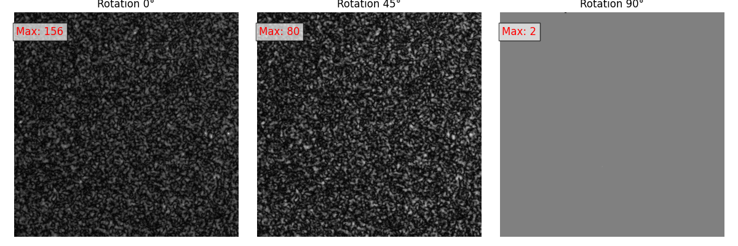

Figure 1. First image of each dataset plotted

## Data Analysis

To analyze the data, it was first converted from an image set to Python $numpy$ arrays. The values for each image in the set were then summed to provide a value for total intensity in digital counts. Those converted datasets were then plotted in a box and whisker plot shown in Figure 2.

Figure 2. Box and Whisker plot of image sets

As seen in Figure 2, there is clear linear behavior exhibited by the polarization filter. When the polarization filter is at $0°$ and has theoretically no effect on the power of the beam, the average intensity of the dataset it $9.30×{10}^{7}.$ Once rotated $45°$, the average intensity drops to $5.83×{10}^{7}.$ Lastly, when the polarized is rotated to $90°$ from the beam’s nature polarization angle, the average intensity is $3.99×{10}^{6}$.

From Malus’s Law, we know that when linearly polarized light with an intensity of $I_{0}$ passes through an ideal polarizer with offset angle $θ$ the output intesntiy, $I,$ is defined by Equation .



With this formula, when $θ$ is 0, $I={1*I}_{0}$. When $θ$ is 0, $I=\frac{1}{2}{*I}_{0}$. Lastly, when $θ$ is 90, $I={0*I}_{0}$. This trend is seen in Figure 2, and although the values show signs of background noise and other factors, the dominate incoming light passing through the polarization filter exhibits the expected behavior.