2d Lt Aaron Bonner

Temporal Coherence Module Writeup

## Prompt

Using a Michaelson Interferometer with a LED as the input signal, measure the power of a beam through one arm of the interferometer by blocking the reference arm.  Next block the first arm and measure the power coming from the reference leg.  Finally, unblock both arms and measure the combined power.  Attempt to adjust the propagation path in the main arm (first one) so that the combined power demonstrates an interference effect.

## Data Gathering

Data was taken in class and comprised of three major datasets, with each being at least 100 images in length. The first setup had the beams separate from each other and with an integration time of 0.5ms. The second setup did not move anything physically but increased the integration time to 1ms. The last setup moved the beam on top of each other to produce the desired integration effect. This setup also had an integration time of 1ms.

## Isolating Data Zones and Calibrating the Dectector

The datasets were first loaded into the program and converted from a $.tif$ file into $np.array$ for easier processing. Data zones were then determined to isolate the different parts of the separate beam datasets. The three zones chosen were named left, right, and background and represent the different components they encapsulated. The visual representation of these zones is seen in Figure 1.

Figure 1. A visual representation of the left, right, and background zones labeled with the colors red, blue, and green respectively.

Next, the SANUC algorithm was implemented using the two separate beams datasets. The data fed to the SANUC algorithm was restricted to only use the data found in the background zone, as using the whole image would add unwanted variance due to the subtle movements of the two beams because of physical setup used. The results of the SANUC algorithm calculated that the gain of the sensor was at 0.425 digital counts per photon and had a bias of 223.658 digital counts.

Similar to the separate beams dataset, the combined beams dataset active zone was isolated in pixel space, as visualized in Figure 2.

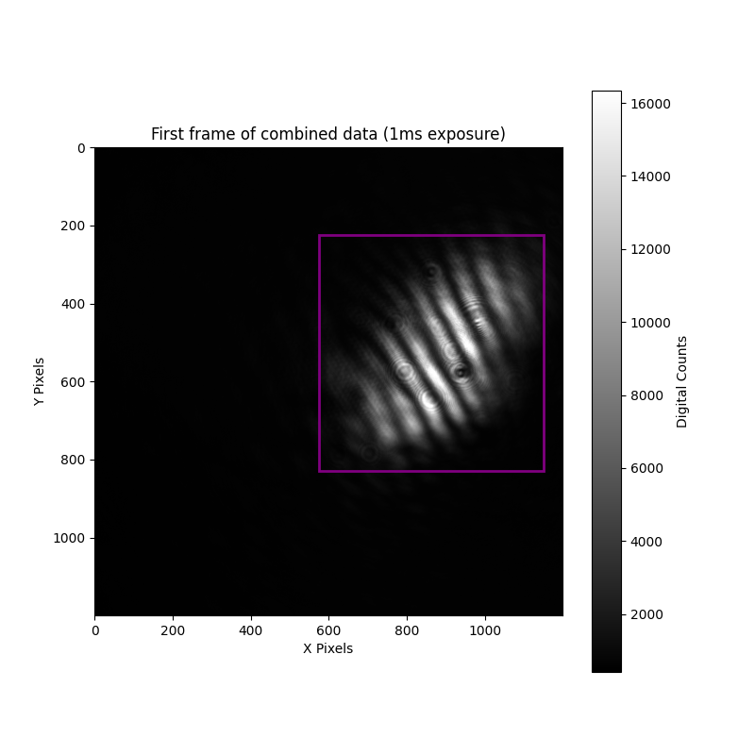

Figure 2. The combined beams dataset with the isolated zone highlighted in purple.

## Calculating Photons in each Dataset

With the sensor gain known, the power level in photons is now calculatable. The two datasets used to compare power levels were the separate beams 1ms integration time set and the combined beams 1ms integration time set. In order to calculate the total number of photons measured as a result of the beam and any interference, while compensating for the background and bias of the sensors the following steps were taken. First, the mean of the current zone was calculated, across all images and all pixels. Second, the mean of the background was subtracted from the mean of the current zone, thereby eliminating the additional digital counts from external noise as well as the bias, since the background zone saw the same sensor bias as the other zones. Third, the adjusted mean of the current zone was multiplied by the height and width values of itself, converting the adjusted mean to a total number of digital counts for that zone. Lastly, the total digital counts for the current zone were divided by the gain calculated earlier, since it relates digital counts to photons. The total number of photons for the left and the right beams were $1.96649*{10}^{9}$ and $1.9395*{10}^{9}$ respectively. The total number of photons found in the combined beams dataset was $1.8420*{10}^{9}$, which is lower than either of the left or right beams combined.

## Analysis

Although initially surprising that when both beams were on top of each other, the photon count was lower than either of the left or right beams, when considering the phase of the light and the constructive and destructive nature of light, this result is not unexpected. Looking at Figure 2, there are clearly interference fringes occurring. By comparing the scale of the right side of Figures 1 and 2, it is shown that when the beams were separate, white represented approximately 15,000 digital counts, whereas on the combined plot white represented over 16,000 digital counts. In a perfect system where the two beams had the exactly same phase, then the result would be completely additive. However, as the phase difference at each points approaches $π$, the two beams become increasingly destructive. In this system, it is evident that the phase difference between the two beams are more destructive in nature, as the photons measured reduced when they were combined.

## Code Output to Terminal

