DTSC670 Executive Summary

Aaron Binder April 17, 2026

Dataset  395 student records, 35 columns | Best near-term model  SVM with G1/G2 included | Best early-warning model  SVM without G1/G2

Project Summary & Problem Framing
This project evaluated whether student information from two Portuguese schools could be used to predict a student’s final math grade and help advisors identify students who may need additional support. Following the end-to-end project structure described in Hands-On Machine Learning, I built and compared models that used student background, school context, attendance history, and prior academic performance to estimate the final grade (Géron).
The overall pattern was clear. When first- and second-term grades were included, the model produced a much stronger forecast because those grades already capture how a student is performing during the year. When those two grades were removed, performance dropped, but the model still provided a useful early-warning signal. That difference matters for decision-making: one version is better for late-term accuracy, while the other is better for earlier intervention planning (Cortez and Silva).
My recommendation is to use the no-G1/G2 version as a screening tool, not as an automatic decision system. It can help flag students for counselor review, tutoring outreach, attendance monitoring, and family engagement. The version with G1/G2 should be treated as a later-cycle forecasting tool for confirming which students are most likely to struggle by the end of the course.

Data Overview
The dataset contained 395 student records and 35 columns. It combined demographic information, family and school context, behavioral indicators, attendance-related variables, and three grade measures. The target variable was G3, the final course grade. Most fields were complete, but four columns had missing values: age (12), absences_G1 (13), absences_G2 (9), and absences_G3 (14).
Those gaps were modest enough to address through imputation during preprocessing.
The strongest correlations with G3 were G2 and G1, which is expected because they are prior term grades from the same course. Outside of those grade variables, the most meaningful relationships were a negative association with past failures and smaller positive relationships with parent education and study time. In practical terms, students with more prior failures tended to finish with lower grades, while students with more study time or stronger educational support generally performed somewhat better.

I intentionally built one model with G1 and G2 and another without them because the school director may want help at different points in the academic year. Including G1 and G2 makes the model much more accurate, but it also means the model relies on information that is only available after the year is already underway. Excluding those columns creates a less accurate model, but one that is more useful for earlier outreach and intervention.

Analytical Insight
The first visual shows the distribution of final grades. Most students clustered in the middle of the grading scale rather than at the extreme high or low ends. That tells us the school system is dealing with many students who are not failing badly but may still benefit from support before small issues become larger ones.
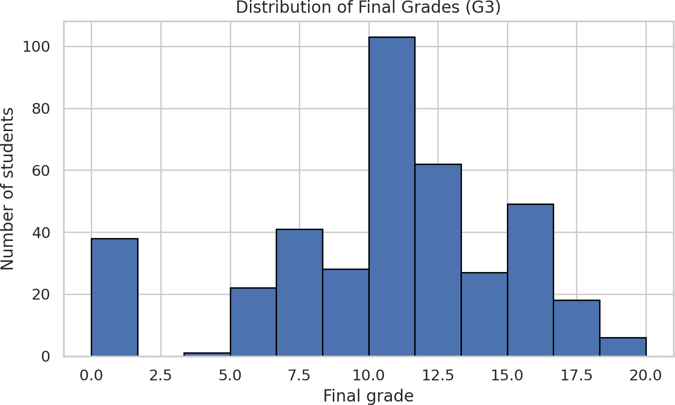

Figure 1. Distribution of final grades (G3).
The second visual shows average final grade by study-time category. Students in higher study-time groups generally earned better final grades, which supports the idea that time investment still matters even when it is not the single strongest predictor. This is important for intervention design because study behavior is a factor the school can try to influence through tutoring, coaching, and structured study plans.

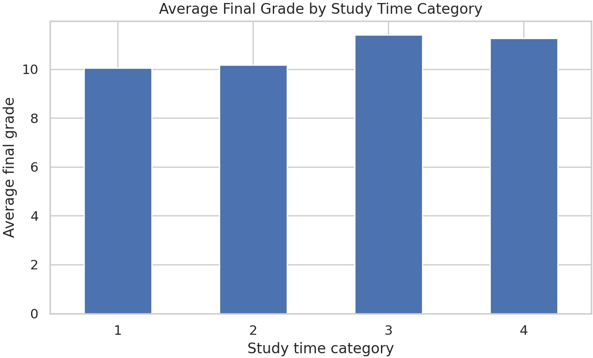

Figure 2. Average final grade by study-time category.
The third visual compares final grades across the number of past failures. This was one of the clearest non-grade patterns in the dataset. Students with more prior failures had visibly lower grade distributions, suggesting that repeated academic difficulty is a strong warning sign. For advisors, this means a student’s prior failure history should be treated as a major triage variable.
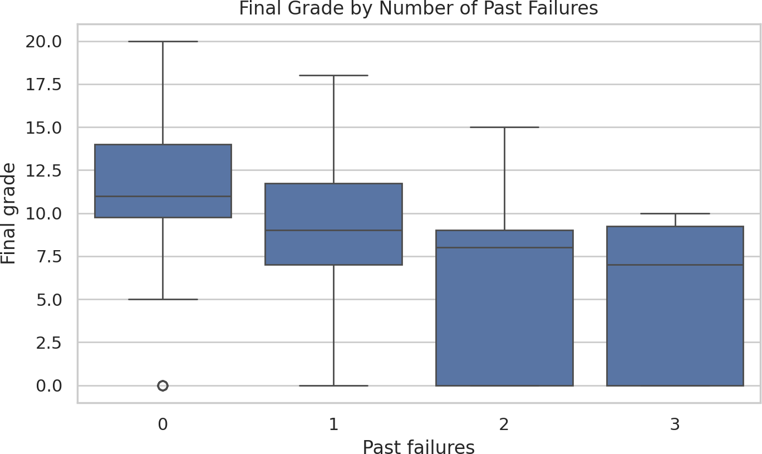

Figure 3. Final grade by number of past failures.
A fourth visual compares second-term grades with final grades. The relationship is very tight, which explains why the model with G1 and G2 performed much better. That insight also highlights an operational tradeoff: the most accurate model is not always the most actionable model. For early intervention, the school needs the model that works before those later grades are available.
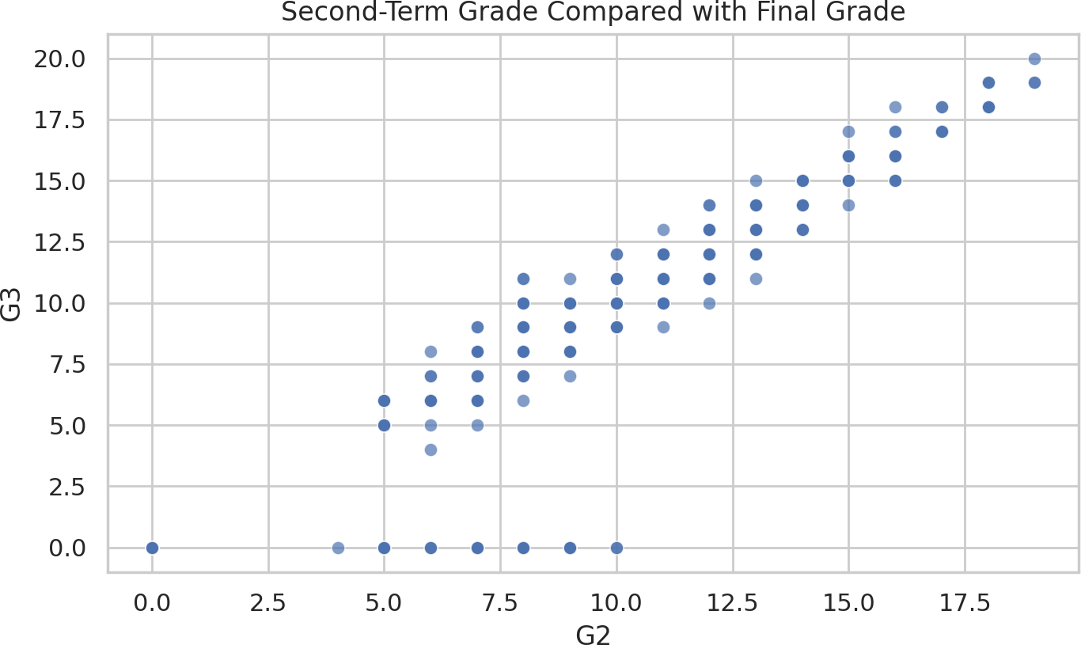

Figure 4. Second-term grade compared with final grade.
Beyond the visuals, several additional patterns influenced feature selection. Parent education showed a moderate positive relationship with final performance, suggesting that home academic environment may matter. Social activity, age, and travel time showed mild negative relationships, though not strong enough to drive decisions on their own. I selected features that balanced academic history, attendance, school context, and student background because together they provide a fuller picture of risk than any single variable alone.

Methodology
Three model families were tested: Linear Regression, Lasso Regression, and Support Vector Machine Regression. Linear Regression provides a straightforward baseline by estimating the overall direction and size of relationships. Lasso Regression is similar, but it also shrinks less useful inputs so the model does not rely too heavily on weak signals. Support Vector Machine Regression is more flexible and can capture patterns that are not perfectly linear, which made it a good candidate for a student-performance problem where many factors interact in uneven ways (Géron).

To judge performance, I used root mean squared error (RMSE) and R-squared. RMSE measures how far predictions are from the actual final grade, on average, in grade units, so lower values are better. R-squared shows how much of the variation in final grades the model can explain, so higher values are better. I also used cross-validation so results were not based on just one train-test split.

Key Results
Model scenario | Best model | Test RMSE | Test R²
With G1/G2 | SVM | 2.36 | 0.727
Without G1/G2 | SVM | 4.10 | 0.181

The strongest overall result came from the Support Vector Machine model that included G1 and G2. Its test RMSE was 2.36 and its R-squared was 0.727, meaning it explained a substantial share of the variation in final grades. The best early-warning version, which excluded G1 and G2, had a test RMSE of 4.10 and an R-squared of 0.181. That is a meaningful drop in accuracy, but it still provides a directional signal that can support human review.
I would not recommend deploying either model as a fully automated production decision system. I do recommend using the no-G1/G2 model in a limited advisory pilot because its purpose is screening, not final judgment. The school could use it to create a watch list for students who also show risk indicators such as prior failures, low study time, or attendance concerns. The with-G1/G2 model is suitable for later-term forecasting, resource planning, and evaluating which students may need the most intensive end-of-term support.
The most actionable business recommendations are to prioritize students with prior failures, strengthen attendance tracking, expand study-support resources, and combine model outputs with counselor judgment. The school should also collect more timely behavioral and academic progress measures if it wants a stronger early-year model in the future.

Conclusion
The most successful part of this project was the clear separation between an accuracy-focused model and an action-focused model. That distinction made the findings more useful to the school director because it matched the real timing of intervention decisions. The preprocessing pipeline also worked well because it handled missing values, mixed data types, and a custom absence feature in a consistent way.
What did not work as well was the attempt to predict final grades early in the year without using G1 and G2. The model remained usable, but its performance was much lower because the dataset did not include many strong early academic indicators beyond prior failures, study behavior, and background variables. In other words, the project showed both the promise and the limit of the available data.
The next steps would be to test the model on future cohorts, add richer early-term signals such as homework completion or formative assessment results, and monitor whether flagged students

actually benefit from interventions. Over time, that would allow the school system to move from simple risk detection toward a more complete student-support strategy.

Works Cited
Cortez, Paulo, and Alice Maria Gonçalves Silva. “Using Data Mining to Predict Secondary School Student Performance.” Proceedings of the 5th Annual Future Business Technology Conference, 2008.
Géron, Aurélien. Hands-On Machine Learning with Scikit-Learn, Keras, and TensorFlow. 3rd ed., O’Reilly Media, 2022.
“Student Performance.” UCI Machine Learning Repository, University of California, Irvine, 26 Nov. 2014.

