The Journals of Gerontology, Series B: Psychological Sciences and Social Sciences Supplementary Material: Noh, Cooper, Guo, Zhou, Stark, & Bornstein. Multi-step inference across the human lifespan can be improved with individualized memory interventions.

Online Data Collection
Participants were recruited on Amazon Mechanical Turk through the CloudResearch platform, allowing for stricter filtering criteria than baseline MTurk sampling. Participants logged in with their Amazon Worker ID, which was anonymized using a one-way hash before storage. Eligibility required a ≥90% approval rate across all prior HITs and a minimum of 100 completed HITs. Participants were also required to provide both their age and date of birth, which we cross-referenced for consistency with CloudResearch records. Upon consent, participants reviewed an online information sheet outlining procedures, rights, risks, and compensation. Several embedded quality controls were implemented to ensure participant engagement and data quality. Participants were required to keep the study window in full-screen mode. During the study phase, each trial included a rotation-detection cover task (press “u” for upright images, “r” for rotated). If participants missed or answered incorrectly for three consecutive trials, they received a warning; after five consecutive failures, they were removed from the study and compensated only for time spent.
Data were collected in two batches: an initial pilot sample (N = 82) collected in late 2020–early 2021 during COVID lockdowns, and a second batch collected in summer 2022 after funding was obtained. Participants in both batches were randomly assigned to the intermixed or blocked training sequence. We examined whether the time of data collection influenced the results by including a batch factor (Date_bin = early vs. late collection) in our primary analyses. Adding Date_bin as a predictor or moderator did not improve model fit (χ²(8) = 2.75, p = .949), and all Date_bin terms were non-significant (all ps > .30). Critically, the MST × DistDiff × Condition interaction was statistically indistinguishable across batches (p > .30), indicating that our findings were robust across the two collection periods. Thus, we report the results of both batches combined into one dataset.

RT-based Filters
Data were first combined across all conditions (age, training sequence). We excluded trials with RTs <400 ms, which were determined to be unrealistic (the lowest participant-level average RT was 463.2 ms), and >3000 ms, which may indicate connectivity issues, lag, or lapses in attention. This initial filter yielded a general acceptable range of [400, 3000 ms]. From this set, we further retained trials within twice the interquartile range ([Q3 – 1.5×IQR, Q1 + 1.5×IQR]) of the remaining data ([494, 2226 ms]). This range still encompassed the IQR of the original data (median = 1368 ms, IQR = [951, 2062]) and preserved sufficient variability to examine potential strategy differences, while excluding trials where participants were likely disengaged. These criteria align with prior approaches for filtering noise in online RT data (Ratcliff & Hendrickson, 2021).
In total, this resulted in 10,820 trials that were excluded (out of 44,689, roughly 25%) from analysis, which was roughly 31% of younger adult trials and 17% of older adult trials. This was anticipated and accounted for in our sample size determinations (which included a 25% buffer/increase in sample size to account for noisier online data) and is anecdotally consistent with the fact that older adults generally show better engagement with longer experiments conducted online (Ogletree & Katz, 2021; Turner et al., 2020). Most exclusions resulted from reaction times that were too long for the task (greater than 2226ms), which we interpret as failure to properly engage in our task rather than systematic differences related to age or LDI. Reaction times were not analyzed as an outcome measure in any reported analyses.

Experiment 1 Mediation Analysis
To test whether mnemonic discrimination ability (LDI) statistically mediated the relationship between age and judgment accuracy, a mediation analysis was conducted on participants’ mean accuracy for each difficulty bin (participant × difficulty). Age and LDI scores were standardized at the participant level, and trial difficulty was included as a covariate. The indirect effect of age on judgment accuracy through LDI was significant (ACME = −0.009, 95% CI [−0.019, 0.000], p = 0.035), whereas the direct effect of age controlling for LDI was reduced and only marginally significant (ADE = −0.022, 95% CI [−0.046, 0.000], p = 0.088). The total effect remained significant (B = −0.031, 95% CI [−0.054, −0.010], p = 0.009), with approximately 27% of the total effect mediated by LDI (proportion mediated = 0.27, 95% CI [0.01, 1.22], p = 0.044). These results indicate that individual differences in mnemonic discrimination ability account for a substantial portion of the age-related variance in judgment accuracy.

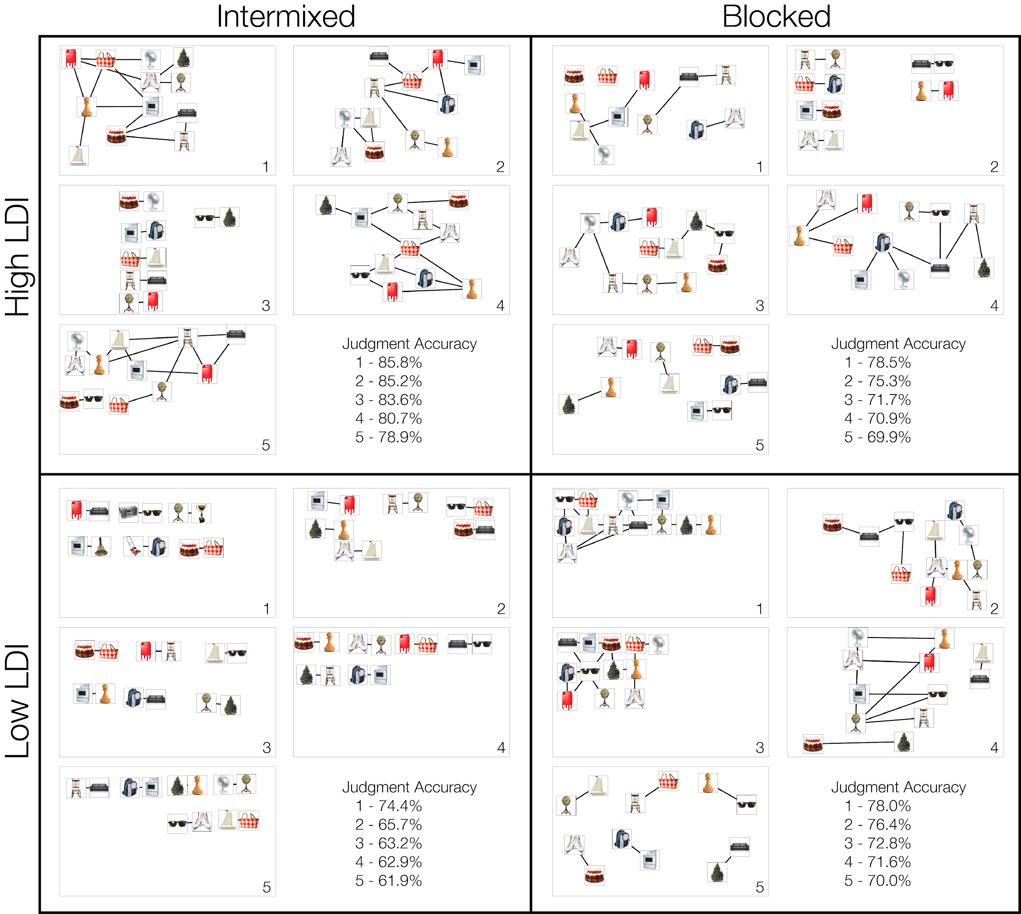
Supplementary Figure 1. Sample graph reconstructions from participants with the overall best judgment accuracy within each condition. LDI groups were created using a median split.

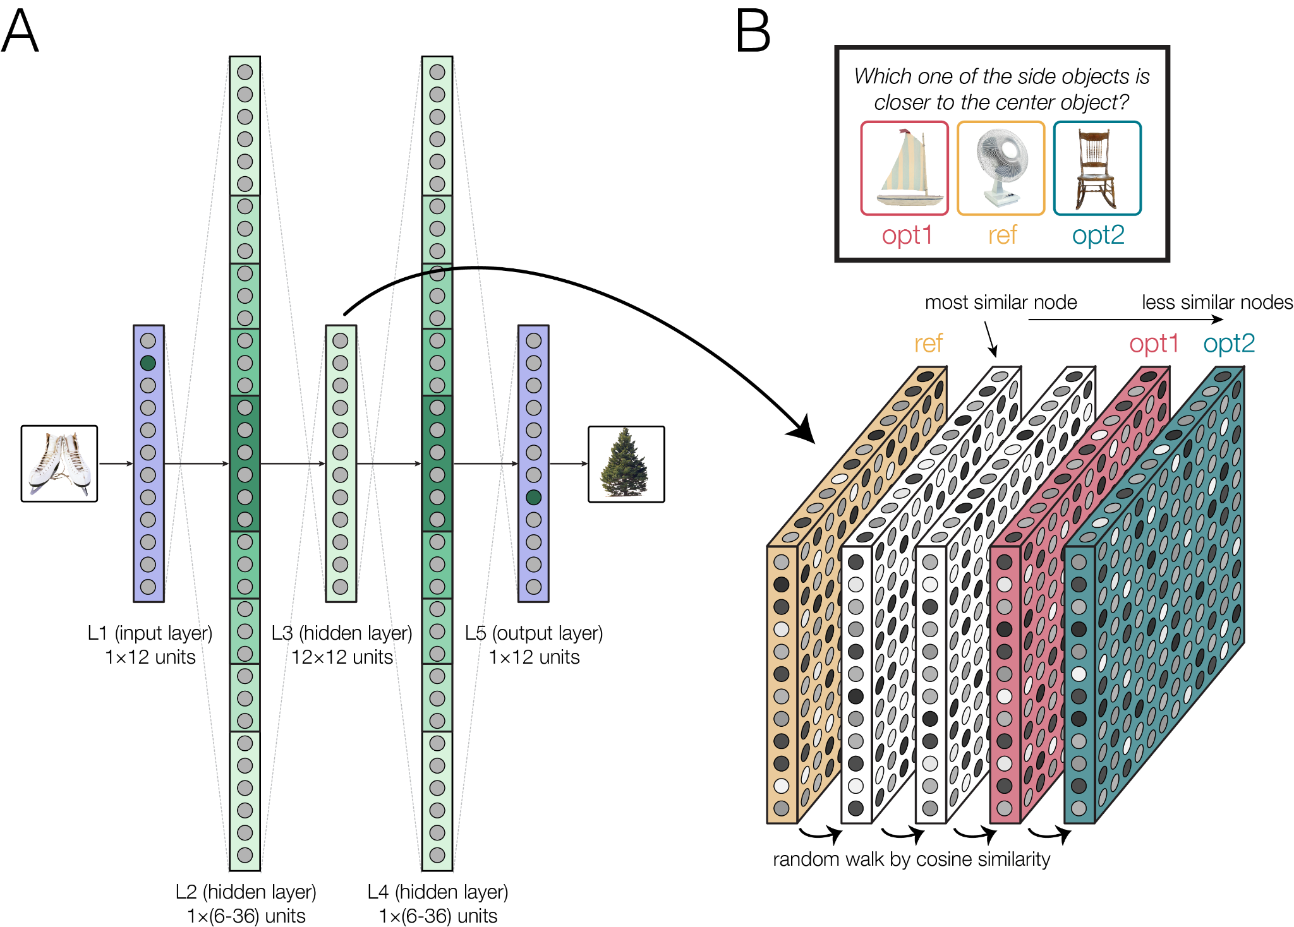
Supplementary Figure 2. Schematic of model design. A) A series of models were trained to learn the graph in a blocked or intermixed sequence. We varied the model’s “memory capacity” by manipulating the size of the hidden layers (specifically, L2 and L4). B) After training, the models performed the multi-step inference judgment task via a random walk based on cosine similarity between node representations obtained from the middle layer (L3). For each trial, the representation for the reference (center) node was used as the starting point, and the models performed a random walk until they reached one of the two left or right choice options (opt1 or opt2). The first option encountered was selected as the option that was “closer” to the reference node.

Artificial Neural Network Model (ANN)
To further examine the behavior of participants under different simulated conditions, we implemented a minimal-assumption feedforward network in PyTorch (Version 1.13.1, (Paszke et al., 2019)) under varying representational capacities (Supplementary Figure 2A). To avoid terminology confusion, node/edge refers to the graph task and unit/weight to the neural network. Given one node of a studied pair, the network learned to predict (pattern-complete) its complementary vertex. To simulate variance in memory encoding ability, the number of units in the 2nd and 4th layers of the network was varied. We used a fully connected five-layer network not including the 12-unit input and output layers (one per item) with a 12-unit by 12 dimension hidden layer. To model differences in “memory capacity,” the widths of the second and fourth layers were varied at increments of one-quarter the input size: 6, 12, 18, 24, 36 units. Smaller widths simulate low memory capacity by forcing many-to-one mappings (greater potential for interference). The model’s activation function at unit i of layer l was defined as:
$$h_{l}(i)=f({w^{T}}_{il}h_{l-1})$$
where f is a pointwise function, w_{il} is a vector of learnable parameters, h_{l−1} represents the output of the previous layer, and T is the matrix transposition operation. The input layer is referred to as h₀. For each condition (blocked vs. intermixed), the models were trained on the same 16 node pairs <x,y>. Each of the 12 images was one-hot encoded (the input unit for the presented node set to 1, others 0). The target was a one-hot vector for the paired node (1 for the complement; 0 otherwise). Training used both directions of each undirected pair with equalized exposures per direction. We estimated the parameters w_{il}, for all i and l, using stochastic gradient descent with the Adam optimizer (Kingma & Ba, 2014) to maximize the cosine similarity between the input and output. We used a rectified nonlinear unit for the pointwise function, f, for all layers except the output layer, where we used a sigmoid function. To account for variability due to stochastic weight initialization and to evaluate model generalizability, we trained 1000 models per condition (blocked and intermixed) across 5 different hidden layer widths (6, 12, 18, 24, 36). All models used He initialization, which samples weights from a uniform distribution scaled for ReLU activations to maintain stable gradients. We optimized cross-entropy over the 12-way next-item distribution using Adam without label smoothing, applying ReLU after the first two layers (L1 and L2), a linear bottleneck layer (L3), and symmetric decoding layers back to the output logits (L4 and L5). Learning rate and weight decay were set to 0.38 and 0.13, respectively, based on prior runs and sweep tests. Models were trained for 5 epochs, with each epoch containing 704 trials. In the blocked condition, node pairs were grouped into 4 mini-blocks, each with 4 unique, non-overlapping pairs (176 trials per mini-block); in the intermixed condition, all 704 trials were randomly shuffled.
To assess the ability of the model to infer the latently learned graph, we performed a relative distance judgment task (Supplementary Figure 2B). We evaluated all non-adjacent triples of nodes (reference, option 1, option 2) with a shortest-path length difference |d12−d13| of 1 to 3. For each trial, the model’s internal representation of the reference node was taken from the middle layer (L3) as a starting point. For each trial, we estimated the number of hops from the reference to each option using a beam search (keeping only the top-k candidates by similarity at each step), and selected the closer option via a softmax over the two estimated hop counts.
Loosely inspired by pattern separation in the dentate gyrus (Yassa & Stark, 2011), the larger hidden layers in our network model can accommodate more distinct representations of each node, while smaller hidden layers imply a greater chance of compressing or merging representations before the latent structure can be extracted by the middle layer. We conducted a linear mixed effects regression predicting accuracy on the judgment test as a function of difficulty (distDiff: 1/2/3; distDiff1=most difficult), training sequence (Sequence: blocked/intermixed), and layer width (Width: 6/12/18/24/36) of the model (Figure 6 Panel A). The full model was specified as: judgment accuracy ~ Width + distDiff + Sequence + Width*distDiff + Sequence*Width + Sequence*distDiff + Width*Sequence*distDiff, random = ~1|model_ID. This linear mixed-effects analysis specification is analogous to the one used to analyze participants’ behavior and is intended as a qualitative model-behavior comparison, focusing on whether the ANN exhibits the same interaction between training sequence and memory capacity as is observed in human participants. This analysis revealed a 3-way interaction between layer width, difficulty, and training sequence (β_{width*distDiff*sequence} = 0.0032, SE = 0.0006, t(23996) = 5.58, p < 0.001).

