Supercomputing for Big Data ET4310

Lab assignment 3

Submission deadline – November 11, 2015

Background
Fast progress in next generation sequencing of DNA has resulted in the availability of large DNA data sets ready for analysis. However, DNA analysis has become the bottleneck in using these data sets, as it requires powerful and scalable tools to perform the needed analysis. A typical analysis pipeline consists of a number of steps, not all of which can readily scale on a distributed computing infrastructure. In this assignment, you will create a framework that implements an in-memory distributed version of the GATK DNA analysis pipeline using Apache Spark.

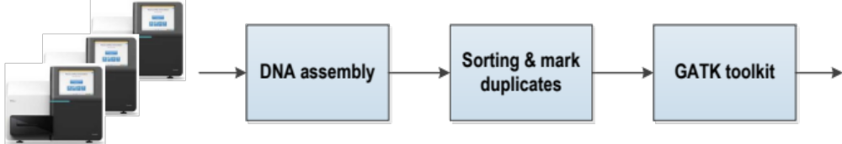

The figure above shows a typical DNA analysis and variant calling pipeline. The input data set to the pipeline is generated by sequencing a DNA sample in a sequencing machine and acquiring the DNA sequencing data. This is done in a massively parallel fashion with millions of short DNA pieces (called short reads) being sequenced at the same time. These reads are stored in large files of sizes in the range of hundreds of giga bytes. The DNA is usually over-sampled, resulting in generating multiple short reads for each segment of the DNA, typically with a coverage ranging from 30x to 80x, depending on the experiment. One standard file format used today to store these reads is called the FASTQ file format. Once the input data becomes available, the first step in the DNA analysis pipeline is to align the sequenced reads to a human reference genome and reconstruct the sequenced genome from the short read sequences, a process that is called DNA assembly. A well-known program used to perform this step is the Burrows Wheel Aligner, typically using the BWA-MEM algorithm. The results of this assembly step are stored in a file with the SAM file format.

After assembly, the short reads in the SAM file are sorted and duplicated reads are marked to avoid using them in downstream analysis. This reduces the bias effect resulting from the way the DNA sample is prepared and sequenced. A widely-used tool to perform this step is the Picard tool. The output of this tool is a compressed file format called BAM. Subsequently, a number of steps are performed to refine the read data and finally to identify the DNA mutations (or so-called variant calling). GATK toolkit is a commonly-used toolkit for this type of analysis that contains the following tools: Indel realignment, Base recalibration and the Haplotype caller. The output of this tool set is a VCF (variant call format) file with the variations in the sequenced DNA. These widely-used tools described here make part of the Broad best practices pipeline, widely used for variant calling both in research and in the clinic. You will use the GATK pipeline for demonstrating the distribution capabilities of Spark. If interested, you can find more info over GATK here https://www.broadinstitute.org/gatk/

The lab assignment
This lab assignment will replace the regular GATK pipeline with a distributed Spark version. It is based on a recently published Hadoop-based distributed pipeline using MapReduce as described in the paper “Halvade: scalable sequence analysis with MapReduce.”
http://www.ncbi.nlm.nih.gov/pubmed/25819078

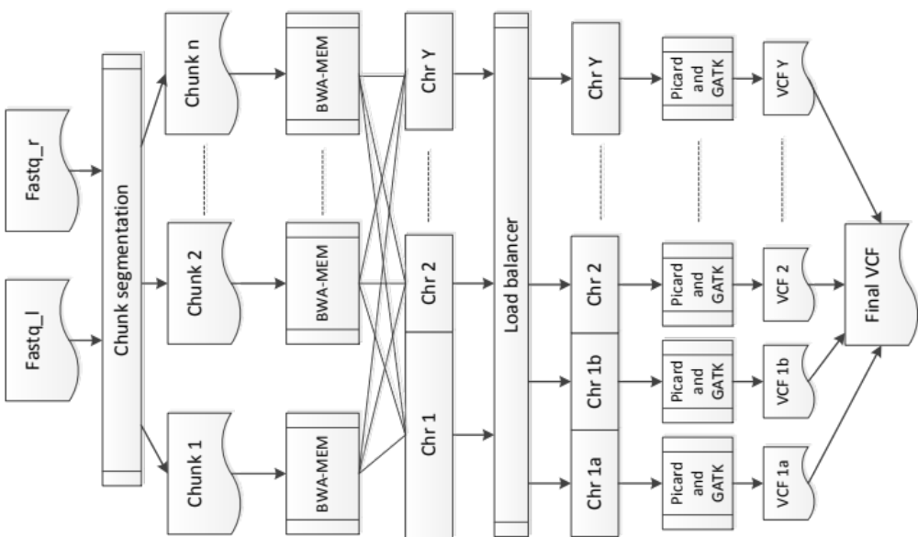
Time progression of the pipeline

The assignment tackles this challenge by using the Apache Spark big data infrastructure, as shown in the figure above. In a typical DNA sequencing experiment, two FASTQ files are generated, that represent the 2 ends of a pair of DNA sequences. These 2 input FASTQ files are divided and merged into interleaved chunks using the chunks segmentation tool, written in Scala and using Spark, that is also able to upload these files into HDFS, thereby making them accessible to all nodes in a distributed cluster. Each chunk is then processed by a separate BWA-MEM task that performs DNA alignment of the short reads against a reference genome. The output of this step represents a list of read alignments (so-called SAM records) that would normally be stored in the SAM file. These records are then read into <key, value> pairs in the memory and regrouped into sub-chromosomal regions by a load balancer according to the number of reads per chromosome. This ensures a better distribution of the subsequent tasks and a better utilization of the computational cluster.

Subsequently, these records are sorted using the position of the aligned reads on each chromosome region (which replaces the Picard sort step in the pipeline). Then the rest of the GATK tool set is performed in parallel by executing it on each chromosomal region separately, resulting in various VCF files. Finally, the content of those VCF files are merged into one with all variants identified in the analysis.

Parallelizing the GATK DNA analysis pipeline using Spark
The task of this assignment is to parallelize the GATK DNA analysis pipeline using Spark. You must use Spark version 1.4 or greater (Pre built for Hadoop 2.4 and later) for this assignment.

You can use an IBM Power7 machine to solve this assignment. Please login with your NetID to the Kova machine at
ssh NetID@kova-01.ewi.tudelft.nl

(Note: you can also solve the assignment on your own system as well, but you’ll have to setup and generate some of the reference files in the /data/spark/ref folder as well. Just copying the files to your own system will not work)

Use the template code given on blackboard for completing this assignment. You are allowed to modify the run script and code (but do not change the main class, project and file names in the template).

In the “template code” folder, there is a config.xml file where the configurations for the programs are set using tags. The details for each tag are given below.

- refFolder: The reference files used by the GATK pipeline. We have already put all the reference files in /data/spark/ref, so you don’t need to change that.
- toolsFolder: All the tools used by the GATK pipeline. We have already placed all the tools in /data/spark/tools, so you also don’t need to change that.
- tmpFolder: All the intermediate files produced by the program should be placed here. Your program must delete these files when no longer required.
- inputFolder: In case of local mode execution (Parts 1 and 2 of the assignment), this represents the local folder containing input chunk files used by the parallelized GATK pipeline. In case of cluster execution mode (Part 3 of the assignment), this folder would be located in HDFS. The programs in the GATK pipeline use this folder to store and read input chunk files.
- outpuFolder: Folder in which the final *.vcf file would be produced. In case of cluster mode, this folder would be located in HDFS. Please use the name output.vcf for this file.
- numInstances: Number of parallel tasks (where each task could be multithreaded) to execute. In cluster mode, this is equal to the number of executors (or containers), which are the different parallel processes that Spark executes.
- numThreads: Number of threads used by each task. In cluster mode, this is equal to the number of cores each executor is using.

When the provided template code is executed, this config.xml file is read at the beginning of the code using the initialize function of the Configuration class. You must use the functions provided by the Configuration class to get the tag values in the config.xml file.

The assignment consists of the following three parts.

- Create chunks of input files (20 points)
The first step is to divide the two provided FASTQ input files into many smaller chunks that are used as input to the parallelized GATK Spark pipeline. The two input files are placed at /data/spark/fastq on the Kova machine. You have to write a program in Scala using Spark, that creates interleaved chunks from data of these two files. Note that each DNA short read consists of 4 lines in the FASTQ files. You have to interleave such that the first read of fastq2.fq should come immediately after the first read of fastq1.fq, the second of fastq2.fq after the second of fastq1.fq and so on. Therefore, the interleaved content would look as follows.
Read1_of_fastq1.fq
Read1_of_fastq2.fq
Read2_of_fastq1.fq
Read2_of_fastq2.fq
…..

You have to create as many chunks as provided by the number numInstances in the config.xml file, and your program should write all these chunks in parallel. You must do the following steps to achieve that.

- Read fastq1’s data using the sc.textFile function
- Read fastq2’s data using the sc.textFile function
- Interleave the contents of the two files, such that in the resulting data, no read is cut in between. So just working on lines wouldn’t do, as each read consists of 4 lines, and neglecting this fact could result in broken reads. Moreover, you are also not allowed to modify the FASTQ files by inserting delimiters. You must be able to separate reads without using delimiters! Sequential processing is not allowed either.
- Write all chunks in parallel using mapPartitions (Sequential write not allowed!), with each partition writing a separate chunk. Therefore, the number of partitions should be equal to numInstances.

Submit the code and run script for this part separately. The run script must be written in python and named run.py. Just hard code the input FASTQ file names as /data/spark/fastq1.fq and /data/spark/fastq2.fq, and take the other values, such as numInstances from the config.xml file. So, no argument is required for either the run script or the Scala program. Moreover, use the same template code as given for Part 2 of the assignment (remove unnecessary parts from there), the output jar being dnaseqanalyzer_2.10-1.0.jar.

- Implement the program (30)
Implement the parallelized GATK pipeline from the template code. Note that the Memory string and reference file names are hard coded as constants at the top of the code. Write the program using the following steps.

- Create as many BWA tasks as the number of input chunks in the inputFolder, with each BWA task using threads equal to numThreads. The name of the input chunk files should be read from the inputFolder by having the program search for all the files in that folder. Note that you are not allowed to hard code the file names in the program.
- The BWA program would output data of the form <chromosome number, SAM record>. Since, there are 24 number of chromosomes in total, and you would be using maximum 8 tasks, you have to assign a particular region to each chromosome, such that you have in total as many chromosome regions as numInstances. Also, each chromosome region should have almost the same number of mapped reads (SAM records). This you would have to do by using load balancing. After load balancing, you must have key value pairs of the form <chromosome region, SAM record>.
- For each chromosome region, perform variant calling. First you would have to group the SAM records for each region. Inside the variant calling, you also have to sort the SAM records by position. Use this using the compare method of the SAMRecord class. The data returned by variant calling should be of the type <Integer, <Integer, String>>, where the key is the chromosome number, and the key of the value is the position of the read. The String here represents a line of the output *.vcf file.
- From the data returned by variant calling, a combined *.vcf file should be produced, such that the lines are sorted according to chromosome numbers, and for each chromosome, further sorted by position of the read.
- Check the accuracy and correctness of the output *.vcf file by using the comparison.py script. First argument should be ref.vcf while the second argument should be the *.vcf file produced by your program. The difference showed by comparison.py should be less than 35.
- Note that the config object should be broadcasted to all nodes using sc.broadcast.

- Port the solution to Hadoop Cluster (20)
In this part, you have to modify the program, so that it also runs with a Hadoop cluster (using the command-line flag “--master yarn-cluster”) and HDFS. For this, first of all, you should setup the Hadoop pseudo-distributed cluster, as described in the following document https://hadoop.apache.org/docs/r1.2.1/single_node_setup.html. You should not write two separate programs for this, but using a flag to instruct the program to run in either local or cluster mode. You must modify the run.py script such that it takes an argument, the value of which could be either “local” or “cluster” (If nothing is specified, make default “local”). The script would run the program accordingly. For cluster mode, assign both --driver-memory and --executor-memory a value of 14g. Likewise --num-executors should be equal to numIntances, while --executor-cores should be equal to numThreads. The “local” or “cluster” argument should also be passed to the Scala program, so that it can set the flag and execute the program accordingly. Also make necessary changes to spark-env.sh so that your program can run in cluster mode, and yarn-site.xml, so that you can run a maximum of 8 instances on the Kova machine. The total memory of Kova is 128 GB. Note that the input and output folders in this case should be in the HDFS. So, you must write code to read and write files to and from HDFS.

Further marks distribution
- Code (make code readable and modular): 10
- Performance and accuracy: 10
- Report: 10

You must submit the following along with your report.
- The code and run script for the first part in folder Part1. In the run script, always use $SPARK_HOME for specifying Spark’s installation path.
- The code and run script for the second and third parts in folder Part2. In that folder, also put spark-env.sh and yarn-site.xml for the third part.

