Documentation

## Meeting notes

**Meeting one**

* Assigned two members to be in charge of the front end code.
* Determined the front end would be done primarily in python.
* Prepared for next week's tutorial.
* Had completed menial coding at this point as it was the day after tutorial one.

**Meeting two**

* Meeting two was cancelled due to a heavy amount of scheduling errors.
* Completed other responsibilities instead.
* Completed a documentation of everything needed to be done.
* Finished up basic early code blocks (Classes, small functions)

**Meeting three**

* Started linking some smaller code together.
* Created flowcharts to easily document further work.
* Started work on larger aspects like database work.
* Re-assessed who would work on what due to a member leaving.

**Meeting four**

* Completed most bare bones functions.
* Finished up the basic GUI.
* Worked on quick bug testing for the rapid prototype.
* Agreed to work on polish at a later date.

**Meeting five**

* Assigned one group member to finishing functions that weren’t yet complete.
* Assigned two members to polishing the GUI.
* Assigned one member to preparing for the upcoming tutorial.
* Assigned one member to be on hand for help if needed in any aspect of the project.

**Completed functionalities**

* The GUI is functionally finished.
* The event creation is finished.
* The event update is finished.
* The event deletion is finished.
* Database access has been finished.

**Blocks**

* Polishing GUI requires further study into HTML.
* Some aspects of the code have only been menially tested.
* Login screen doesnt work.
* Login screen GUI doesn't not exist.

**Going forward**

* We have assigned two members to learn HTML, this will allow us to create a well organized login screen, as well as polishing the main GUI.
* The code is going to be tested extensively to assure there is no way of breaking anything.
* One member of the team is currently assigned to the backend. They should have time to work on the Login screen as most of our backend is functional.

## User Guide

After logging in to the calendar, you can add, view, and manage events. To sign up, click the “Sign Up” button and enter your information.

You can navigate the calendar and sort by day, month (default), week, and year.

**Creating a New Event**

1. **Find the “Add Event” Button:** Click the add event button in the bottom right corner.
2. **Enter Your Event Details:** You’ll need to fill in a few simple details:
   * **Title:** Give your event a name or heading.
   * **Date and Time:** Choose the date and time for when your event will take place.
   * **Description (optional):** Add a short description or purpose of your event
   * **Location (optional):** If your event is online, you can paste the link to your meeting here (like Zoom or Google Meet). For in-person events, enter the location address.
3. **Save Your Event:** Once everything looks good, click save. Your event will automatically appear on your calendar!

## 

## 

## 

## 

## 

## 

## Maintenance Plan

To maintain our application, we will use Github Issues to schedule and keep track of maintenance tasks, including:

* Maintaining clear documentation
* Performing code reviews
  + Performing updates on frameworks, APIs, and libraries used
  + Optimization and removing outdated dependencies
* Collecting and implementing user feedback on the application

Weekly team meetings will be held to delegate these issues. During these meetings, we will:

* Discuss new/existing issues and assign/update their urgency
* Delegate issues to team members with expected deadline

Outside of these meetings:

* Team members will communicate progress through Discord
* Critical issues that arise will be started with whoever is on hand and may require emergency meetings.

## Architecture Overview

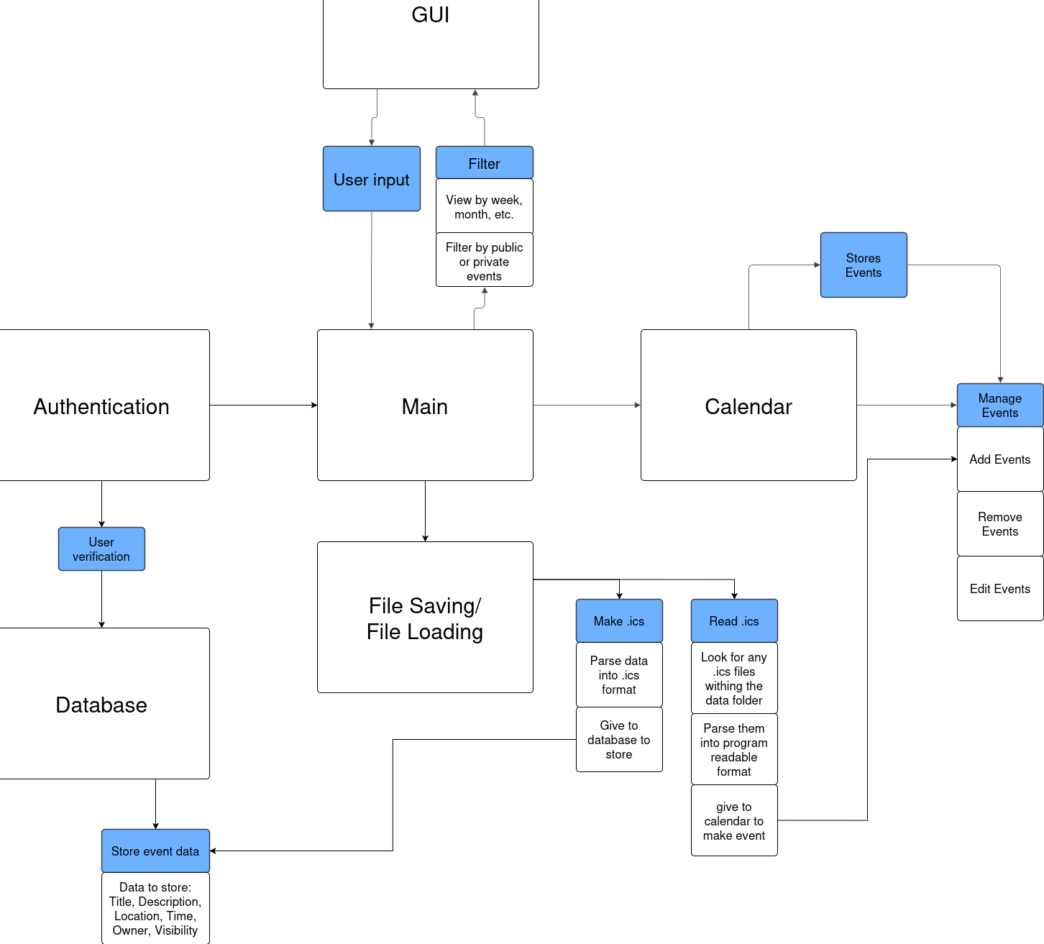

## Flow Chart

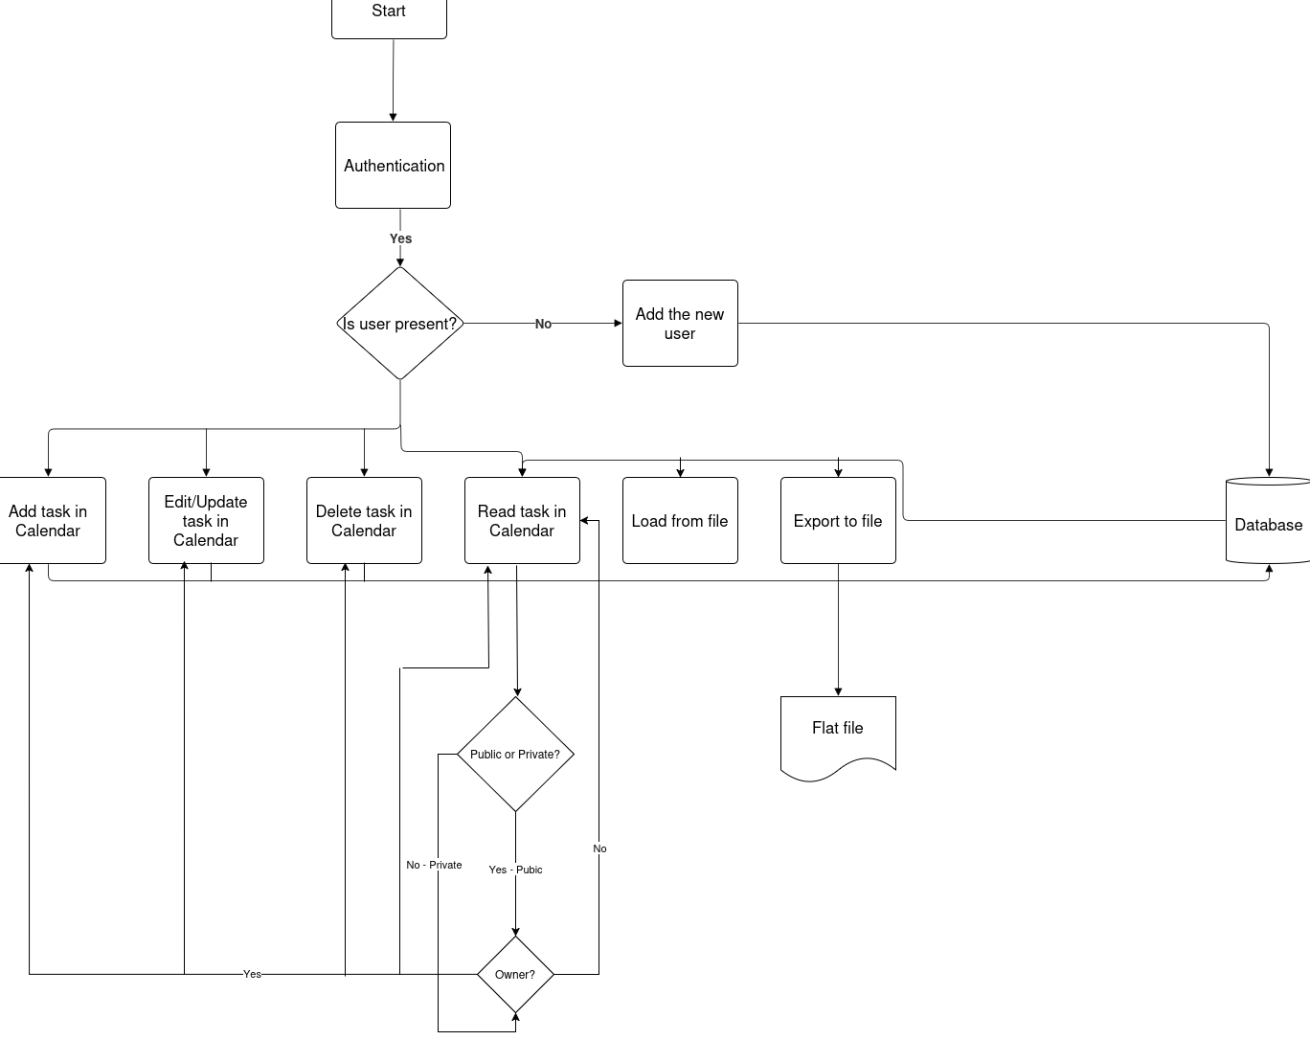

## Database

## 

## 

## 

## 

## 

## 

## FAQ

### How can I edit an event after I’ve created it?

To edit an event, just click on the event in your calendar. You’ll see an option to update or change the details. Once you're done, save your changes.

### How do I delete an event?

To delete an event, click on the event and look for the option to delete it. Confirm, and the event will be removed from your calendar.

### Can I add online meeting links for virtual events?

Yes, you can add a link for online meetings! Simply enter the link (like a Zoom or Google Meet URL) in the “Location” field when creating the event.

### Can I see past events?

Your past events are saved in your calendar. You can scroll back to view any event you've had before.

### How do I download the details of an event?

To download an event, click on the event and then select the "Download" option next to the "Add Event" button. This will let you save the event details for offline use.

### 