
X Squared Capital Management LPF
2026 Q1 Quarterly Newsletter | MANU
For Professional Investors only
All data as on 31 March 2026 unless stated otherwise

Investment Objective
A unique long-short trading strategy across various asset classes to achieve medium-term risk-adjusted returns.

Strategy Highlights and Characteristics
- Diversified portfolio taking both long and short positions including equities, fixed income, currencies, and commodities.
- Deploys an algorithmic-assisted approach that analyses data to identify trading opportunities and optimize the risk-reward ratio of each position.
- The algorithm considers historical price trends, market volatility and economic indicators to support trading decisions.

Fund Performance - Net Quarterly Returns
Year | Q1 | Q2 | Q3 | Q4 | YTD
2022 | — | — | -0.18% | -4.28% | -4.45%
2023 | -12.17% | -4.90% | -4.56% | 3.52% | -17.48%
2024 | -3.25% | -11.01% | -18.34% | 38.07% | -2.93%
2025 | -33.50% | 14.00% | 20.44% | 32.01% | 20.54%
2026 | -16.24% | — | — | — | -16.24%
Note: Please refer to the fund offering documents for a detailed fee structure.

NAV per Share
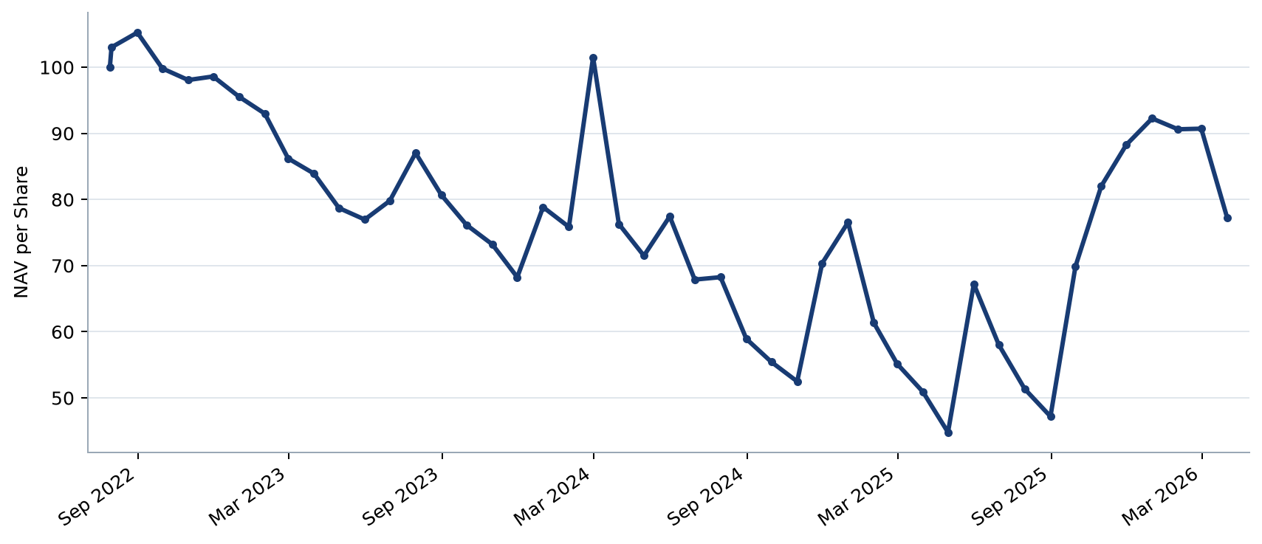

Fund Statistics
Statistic | Value
Inception Date | 2022-07-29
Return ITD | -22.72%
Return YTD | -16.24%
Annualized Return | -6.64%
Positive Months | 38%
Negative Months | 62%
Annualized Volatility | 53.92%
Maximum Drawdown | -57.44%
Sharpe Ratio | -0.201

Manager Commentary
2026 Q1 Portfolio Review
Quarterly review 1. During the quarter, portfolio positioning was actively adjusted as volatility moved across asset classes. Risk limits, liquidity, and concentration were reviewed continuously, while exposures were sized with regard to the strategy's medium-term objectives. The manager remains focused on disciplined implementation, drawdown control, and preserving flexibility as market conditions evolve.
Quarterly review 2. During the quarter, portfolio positioning was actively adjusted as volatility moved across asset classes. Risk limits, liquidity, and concentration were reviewed continuously, while exposures were sized with regard to the strategy's medium-term objectives. The manager remains focused on disciplined implementation, drawdown control, and preserving flexibility as market conditions evolve.
Quarterly review 3. During the quarter, portfolio positioning was actively adjusted as volatility moved across asset classes. Risk limits, liquidity, and concentration were reviewed continuously, while exposures were sized with regard to the strategy's medium-term objectives. The manager remains focused on disciplined implementation, drawdown control, and preserving flexibility as market conditions evolve.
Quarterly review 4. During the quarter, portfolio positioning was actively adjusted as volatility moved across asset classes. Risk limits, liquidity, and concentration were reviewed continuously, while exposures were sized with regard to the strategy's medium-term objectives. The manager remains focused on disciplined implementation, drawdown control, and preserving flexibility as market conditions evolve.
Quarterly review 5. During the quarter, portfolio positioning was actively adjusted as volatility moved across asset classes. Risk limits, liquidity, and concentration were reviewed continuously, while exposures were sized with regard to the strategy's medium-term objectives. The manager remains focused on disciplined implementation, drawdown control, and preserving flexibility as market conditions evolve.
Quarterly review 6. During the quarter, portfolio positioning was actively adjusted as volatility moved across asset classes. Risk limits, liquidity, and concentration were reviewed continuously, while exposures were sized with regard to the strategy's medium-term objectives. The manager remains focused on disciplined implementation, drawdown control, and preserving flexibility as market conditions evolve.
Quarterly review 7. During the quarter, portfolio positioning was actively adjusted as volatility moved across asset classes. Risk limits, liquidity, and concentration were reviewed continuously, while exposures were sized with regard to the strategy's medium-term objectives. The manager remains focused on disciplined implementation, drawdown control, and preserving flexibility as market conditions evolve.
Quarterly review 8. During the quarter, portfolio positioning was actively adjusted as volatility moved across asset classes. Risk limits, liquidity, and concentration were reviewed continuously, while exposures were sized with regard to the strategy's medium-term objectives. The manager remains focused on disciplined implementation, drawdown control, and preserving flexibility as market conditions evolve.
Quarterly review 9. During the quarter, portfolio positioning was actively adjusted as volatility moved across asset classes. Risk limits, liquidity, and concentration were reviewed continuously, while exposures were sized with regard to the strategy's medium-term objectives. The manager remains focused on disciplined implementation, drawdown control, and preserving flexibility as market conditions evolve.
Quarterly review 10. During the quarter, portfolio positioning was actively adjusted as volatility moved across asset classes. Risk limits, liquidity, and concentration were reviewed continuously, while exposures were sized with regard to the strategy's medium-term objectives. The manager remains focused on disciplined implementation, drawdown control, and preserving flexibility as market conditions evolve.
Quarterly review 11. During the quarter, portfolio positioning was actively adjusted as volatility moved across asset classes. Risk limits, liquidity, and concentration were reviewed continuously, while exposures were sized with regard to the strategy's medium-term objectives. The manager remains focused on disciplined implementation, drawdown control, and preserving flexibility as market conditions evolve.
Quarterly review 12. During the quarter, portfolio positioning was actively adjusted as volatility moved across asset classes. Risk limits, liquidity, and concentration were reviewed continuously, while exposures were sized with regard to the strategy's medium-term objectives. The manager remains focused on disciplined implementation, drawdown control, and preserving flexibility as market conditions evolve.
Quarterly review 13. During the quarter, portfolio positioning was actively adjusted as volatility moved across asset classes. Risk limits, liquidity, and concentration were reviewed continuously, while exposures were sized with regard to the strategy's medium-term objectives. The manager remains focused on disciplined implementation, drawdown control, and preserving flexibility as market conditions evolve.
Quarterly review 14. During the quarter, portfolio positioning was actively adjusted as volatility moved across asset classes. Risk limits, liquidity, and concentration were reviewed continuously, while exposures were sized with regard to the strategy's medium-term objectives. The manager remains focused on disciplined implementation, drawdown control, and preserving flexibility as market conditions evolve.
Quarterly review 15. During the quarter, portfolio positioning was actively adjusted as volatility moved across asset classes. Risk limits, liquidity, and concentration were reviewed continuously, while exposures were sized with regard to the strategy's medium-term objectives. The manager remains focused on disciplined implementation, drawdown control, and preserving flexibility as market conditions evolve.
Quarterly review 16. During the quarter, portfolio positioning was actively adjusted as volatility moved across asset classes. Risk limits, liquidity, and concentration were reviewed continuously, while exposures were sized with regard to the strategy's medium-term objectives. The manager remains focused on disciplined implementation, drawdown control, and preserving flexibility as market conditions evolve.
Quarterly review 17. During the quarter, portfolio positioning was actively adjusted as volatility moved across asset classes. Risk limits, liquidity, and concentration were reviewed continuously, while exposures were sized with regard to the strategy's medium-term objectives. The manager remains focused on disciplined implementation, drawdown control, and preserving flexibility as market conditions evolve.
Quarterly review 18. During the quarter, portfolio positioning was actively adjusted as volatility moved across asset classes. Risk limits, liquidity, and concentration were reviewed continuously, while exposures were sized with regard to the strategy's medium-term objectives. The manager remains focused on disciplined implementation, drawdown control, and preserving flexibility as market conditions evolve.
— Archie Ma, Portfolio Manager

General Information
Item | Details
Structure | Hong Kong Limited Partnership Fund
Domicile | Hong Kong
Currency | USD
Return Basis | Net
Portfolio Manager | Archie Ma
General Partner | ARC Partners Limited
Investment Manager | Solomon Capital Management Limited
Fund Administrator | HKB Fund Services (Hong Kong) Limited
Minimum Contribution | USD100,000
Valuation Frequency | Monthly
Base Currency | USD
Bloomberg Code | XSQMANU HK Equity
Year End Date | December 31st
Management Fee | 2% per annum
Lock-up Period | 36 months
Carried Interest | 20%

Contacts
Contact | Details
Portfolio Manager | Archie Ma  archie.ma@xsquaredcapital.com

Disclaimer
This document is prepared for general communication for informational purposes only.
X Squared Capital Management LPF (the “Fund”) is a limited partnership fund registered under the laws of Hong Kong.
This document has not been reviewed by any Hong Kong authority or the Securities and Futures Commission of Hong Kong (“HKSFC”). ARC Partners Limited is the General Partner of the Fund. Solomon Capital Management Limited (“Solomon”), the Investment Manager of the Fund, is regulated by the HKSFC to conduct Type 1, Type 4 and Type 9 regulated activities. The Type 9 regulated activity is subject to the condition that Solomon shall only provide services to professional investors.
Different fee structures and terms are applicable subject to the respective series of interests. Potential investors should read the offering documents carefully before deciding whether to invest.
While reasonable care has been exercised in preparing this document, Solomon does not warrant its completeness or accuracy and is not responsible for damages arising from reliance upon this information.
This document is for information only and is not an offer, solicitation or recommendation. Past performance and forecasts are not necessarily indicative of future performance.
Investing in equities, fixed income, commodities, FX and derivatives involves a high degree of risk. Investors should consider their circumstances and seek professional advice.
All opinions, projections and estimates are as of the publication date and may change without notice. Forward-looking statements involve risks and uncertainties. This information is confidential and intended only for the recipient.
Calculation and provenance: legacy_excel_v1 | Report ID 1 | Version 1 | Snapshot 2026-07-18T02:52:18.470747+00:00 | RFR MANUAL / MANUAL

