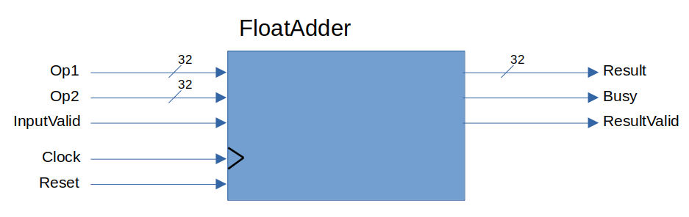

Inputs:
- Op1
  - Type: IEEE Single-Precision Floating Point
  - Description: First input operand
- Op2
  - Type: IEEE Single-Precision Floating Point
  - Description: Second input operand
- InputValid
  - Type: Active-high synchronous control signal
  - Description: Control signal to the floating point adder to signify that the inputs contain valid data. Once InputValid is asserted, the adder de-asserts ResultValid and begins a computation with the provided input operands.

Outputs:
- Result
  - Type: IEEE Single-Precision Floating Point
  - Description: Addition result
- Busy
  - Active-high status signal
  - Description: Status signal which indicates that the floating point adder is currently computing an addition result. Once computation is finished, Busy is de-asserted. While Busy is asserted, the inputs Op1, Op2, and InputValid are ignored.
- ResultValid
  - Active-high status signal
  - Description: Status signal which indicates that the value currently on the Result output contains the valid result of the previous addition which was performed.

