
| Customer Service Documentation

The New CMS

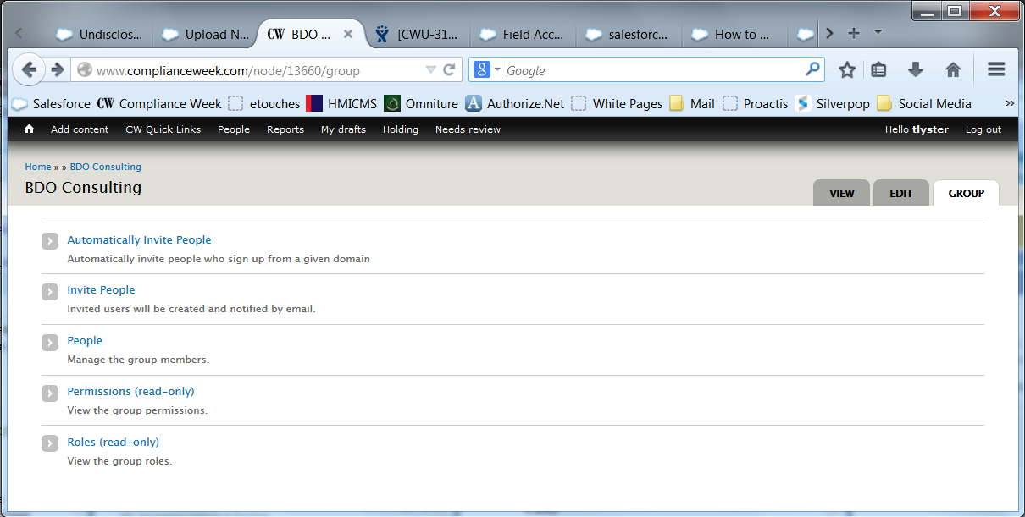

- Opening a case
- User cannot log on
- Password problems
- Multi cannot see where to manage account
- Missing members of multi
- Adding a new multi-user account

User reports a problem with the new website – either with their access or managing their group subscription. Follow steps methodically, and save related emails to the contact record.

- Open a Case: Create a new case from the contact record page in Salesforce.
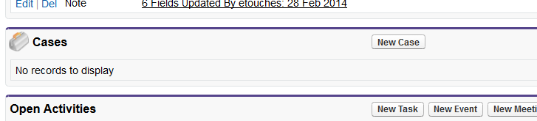
Click New Case, select Case Origin, enter “Website Access” or “Multi Admin Problem” in the Subject field, and a brief summary of the problem in the Description field. Status refers to the next step:
Pending | CS working on the problem internally
Pending | IT awaiting a fix from an outside source (e.g. Deeson)
Pending | Subscriber awaiting feedback from the user
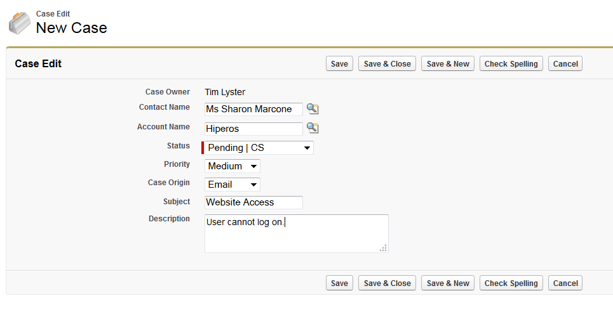
- Check Contact Status in Salesforce: Before jumping into the CMS, ensure that the subscriber is active (i.e. their expiration date is in the future) and that, in the case of a multi-user subscription, that their MoMs are active.

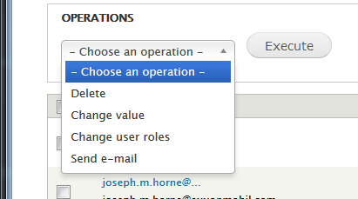
- Issue | The user cannot log on: User reports that their email is not recognized or they are unable to access their account. Search for their email address under People in the CMS. Confirm that they are using the correct email address.
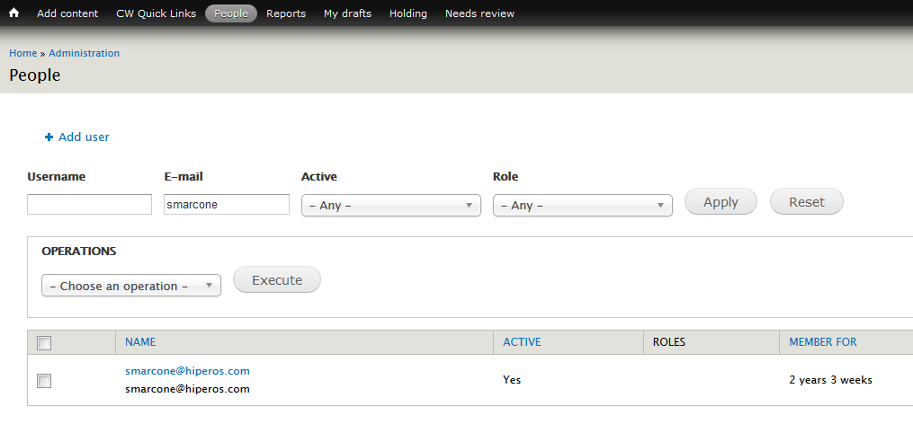Check the user role—it can be “Registrant,” “Trialist” or “Subscriber” (other roles exist for internal use). Both Trialist and Subscriber allow the user to access behind-the-paywall content.
Note, user accounts may have more than one role. You can add or remove roles by checking the box next to the Name and selecting “Change user roles.”

- If the user is not in the CMS, open a new browser (say Internet Explorer if you are already in Firefox), go to www.complianceweek.com, and register them. Enter their email address and job title.
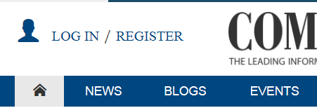 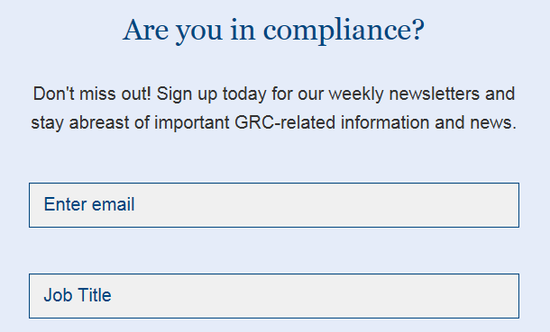
- Rerun the search in the CMS. The user account should now appear. Assuming it’s there, a welcome email will have been sent to the user with a link allowing them to set their password.
- Issue | Password Problems: As administrators, we can reset a user’s password at any time. Simply search for their email address under People, click edit, and then enter a temporary password (I normally set it to “password”).
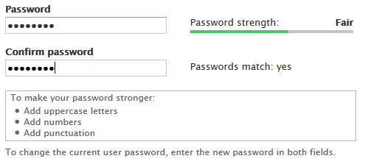
Before contacting the user, log on as them (i.e. log off, and then log on using their email address and the password “password”).
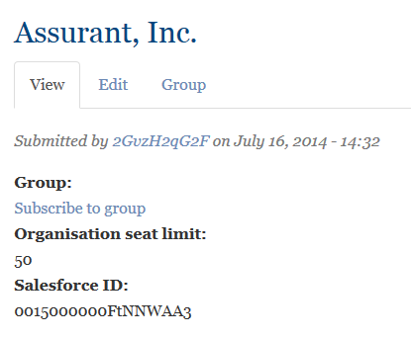
- Issue | Multi cannot see where to manage account: First, ensure the Multi is able to access their account. In the CMS, navigate to Content under the CW Quick Links menu.
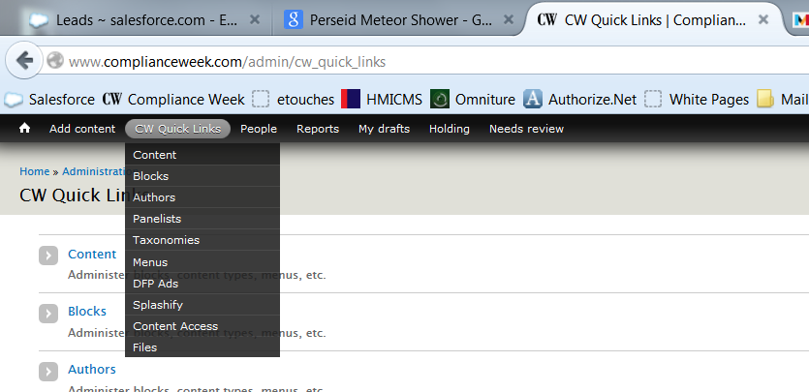
Type the multi’s account name into the “Title” search box. You may filter results to accounts by selecting “Organisations” in the drop-down menu. Otherwise, you’ll see the organization plus any articles with that account name in the title.
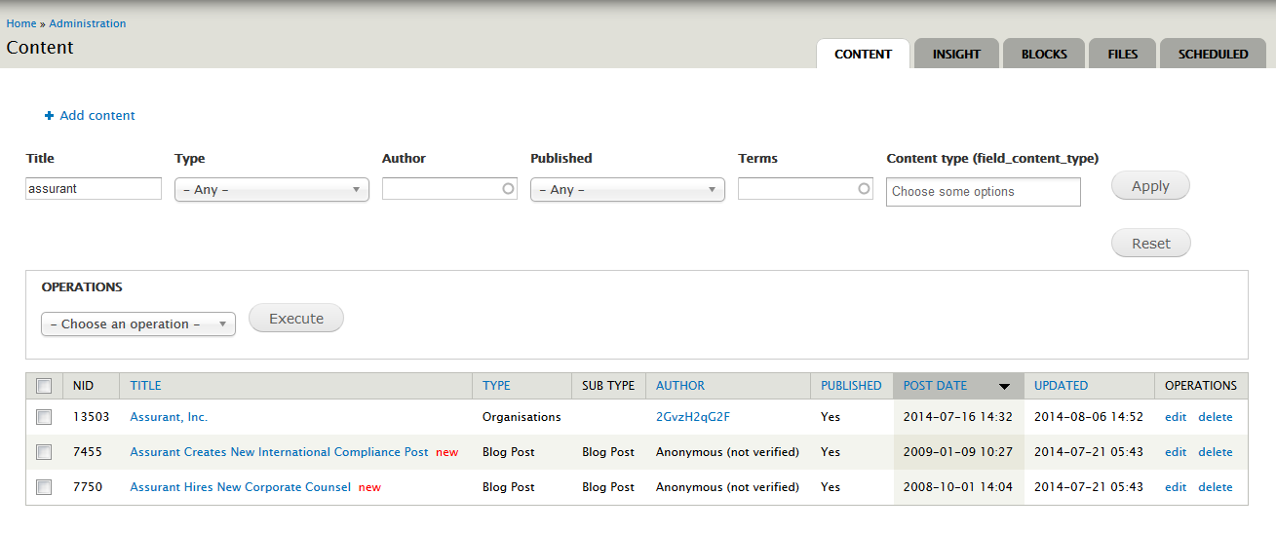
Click on the account name.
You can change the seat limit by clicking Edit and entering a new number in the box marked “Organisational seat limit.”
To view a list of members of multi, click on “Group” then “People.”
Look for the multi user’s email address in the list. If it is not there, click on the Invite People tab and paste in their email address. Leave “Active” selected under Membership state. Return to the People screen.
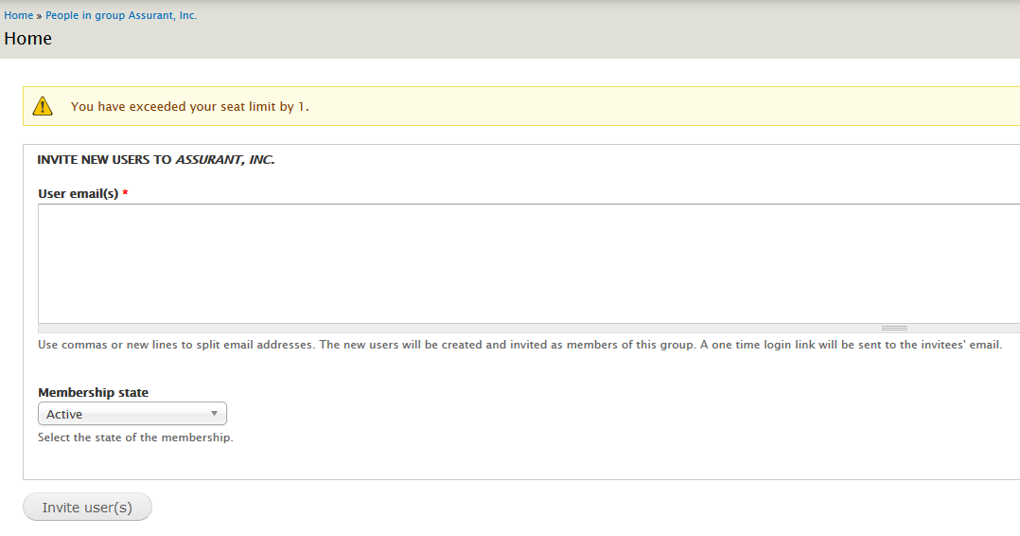
Click grant group admin next to the multi’s email address. They’ve now become the subscription administrator, and will be able to add and remove users. Next time the multi logs in they’ll see the Manage staff access tab after clicking My CW.
- Issue | Multi cannot see Members of Multi: Simply enter the MoM’s email addresses under the Invite People tab. The CMS can be a bit sensitive, so only add 3-4 email addresses at a time. If an error dialog message is displayed, navigate back to the member list (CW Quick Links Content) and follow the steps in 7. Each subscriber should receive a welcome email with a link. Existing users will be added to the group; new email addresses will create a new user account.
- Issue | Sales Closes a New Multi Account: After updating Salesforce with the sale, search for the Account Name as described in Step 7. If it’s not in the CMS, you’ll need to add it.
Navigate to Add content Organisations. Copy and paste the Account Name into the “Title” box, then transfer the seat limit and Salesforce ID into the appropriate boxes. Click Save. Add the Multi and members of multi as described above.

