How to get data from IPE site:

1. Open site, and developer tools: 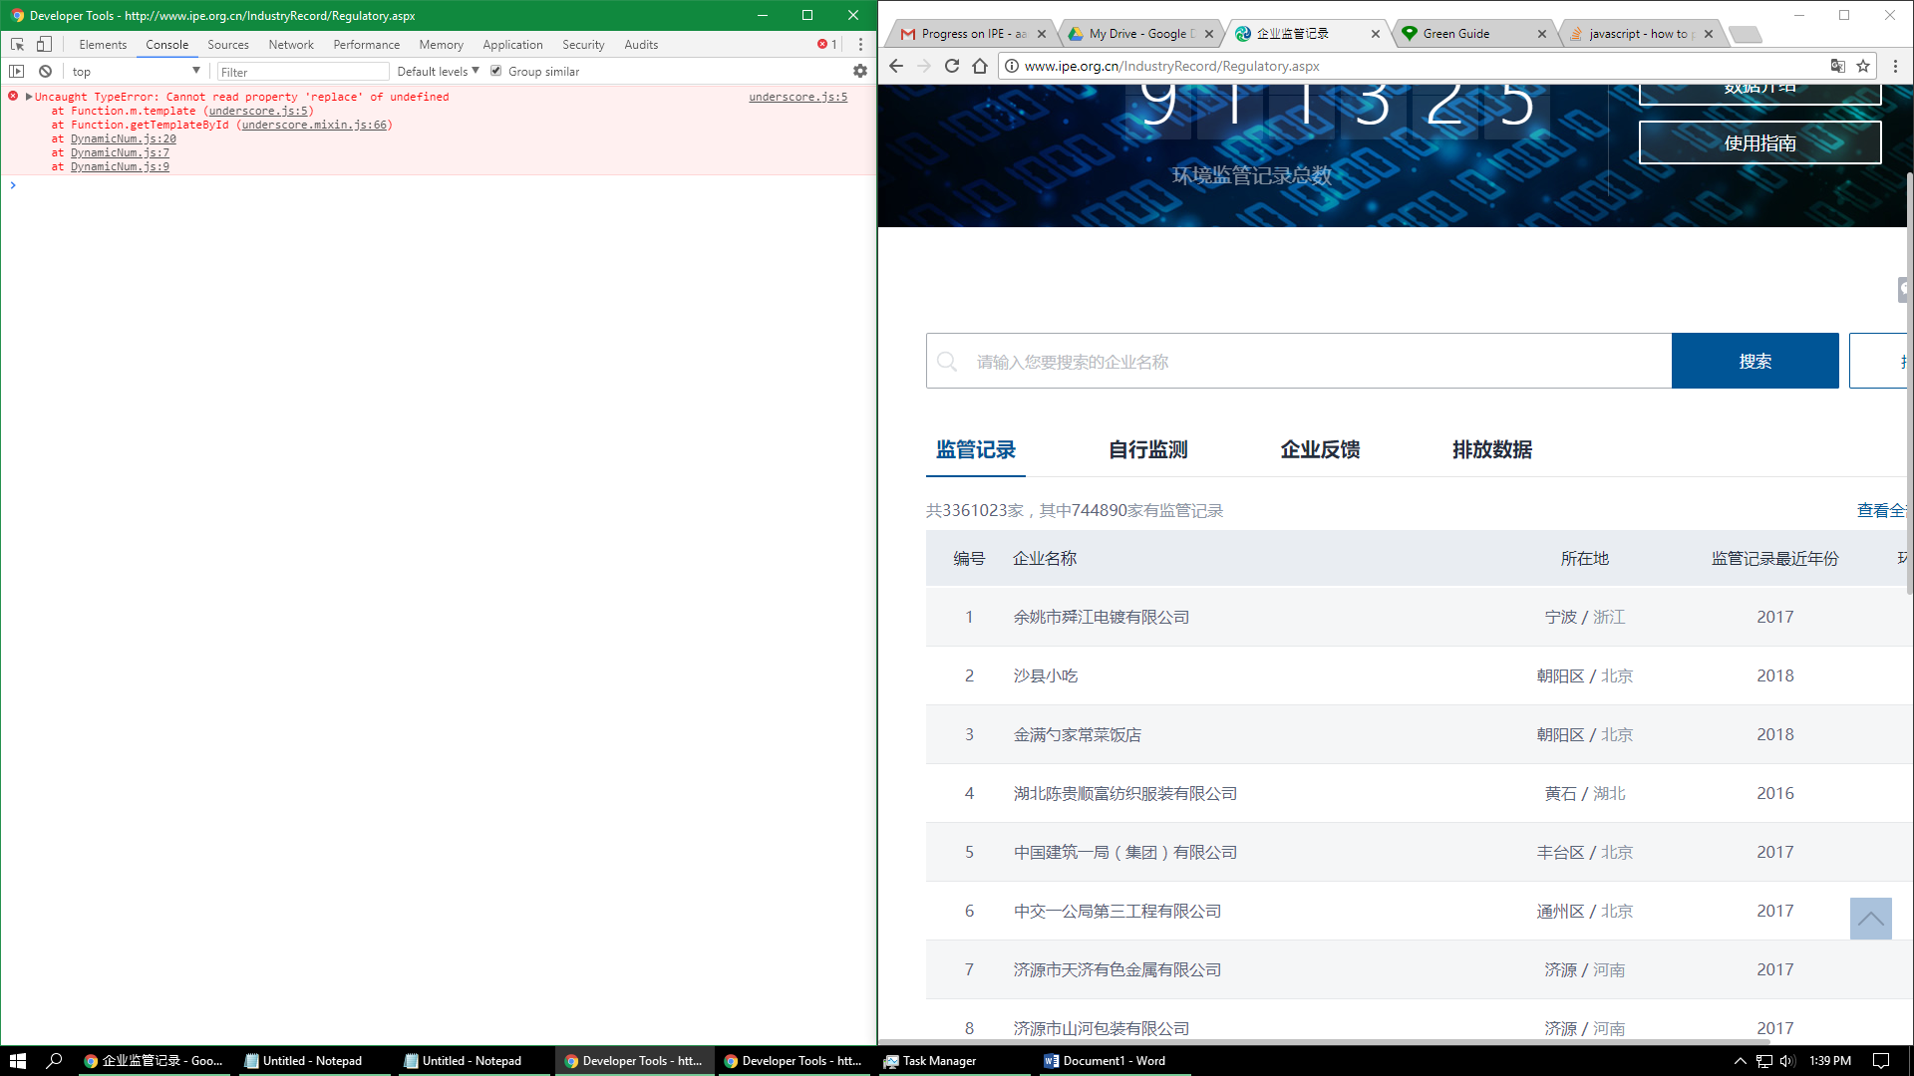
2. Use code from first part of IPE_SubmitCheckCode (use all the code except for items under “//code for getting data”): 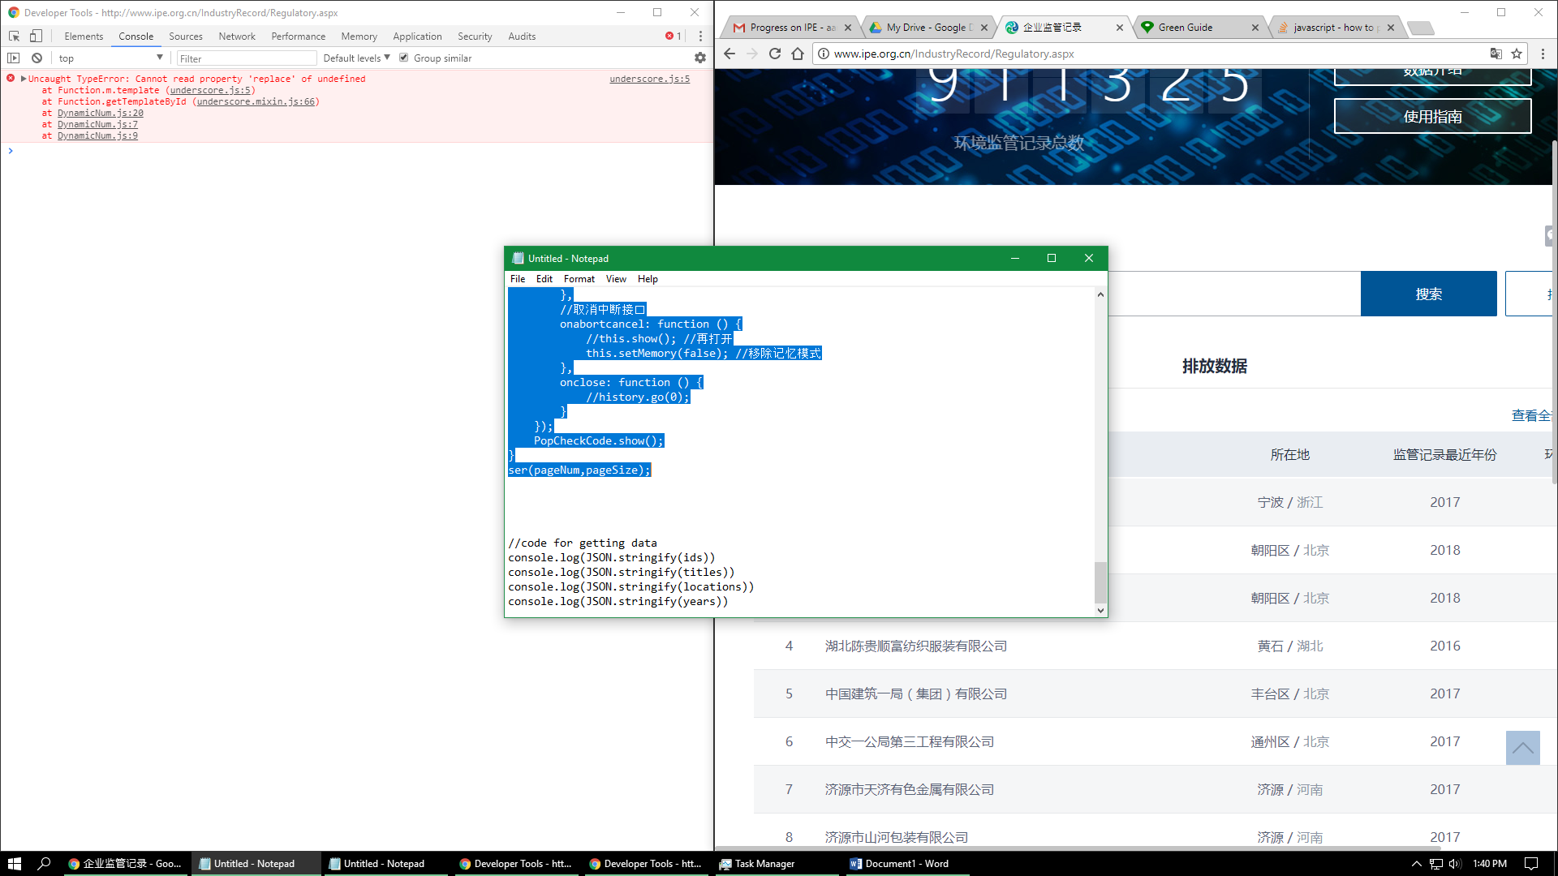
3. Copy and paste code into the console and run. For my example, pageSize is 50,000, so that the IPE server doesn’t crash. It worked with 100,000, but maybe it depends on the time of day: 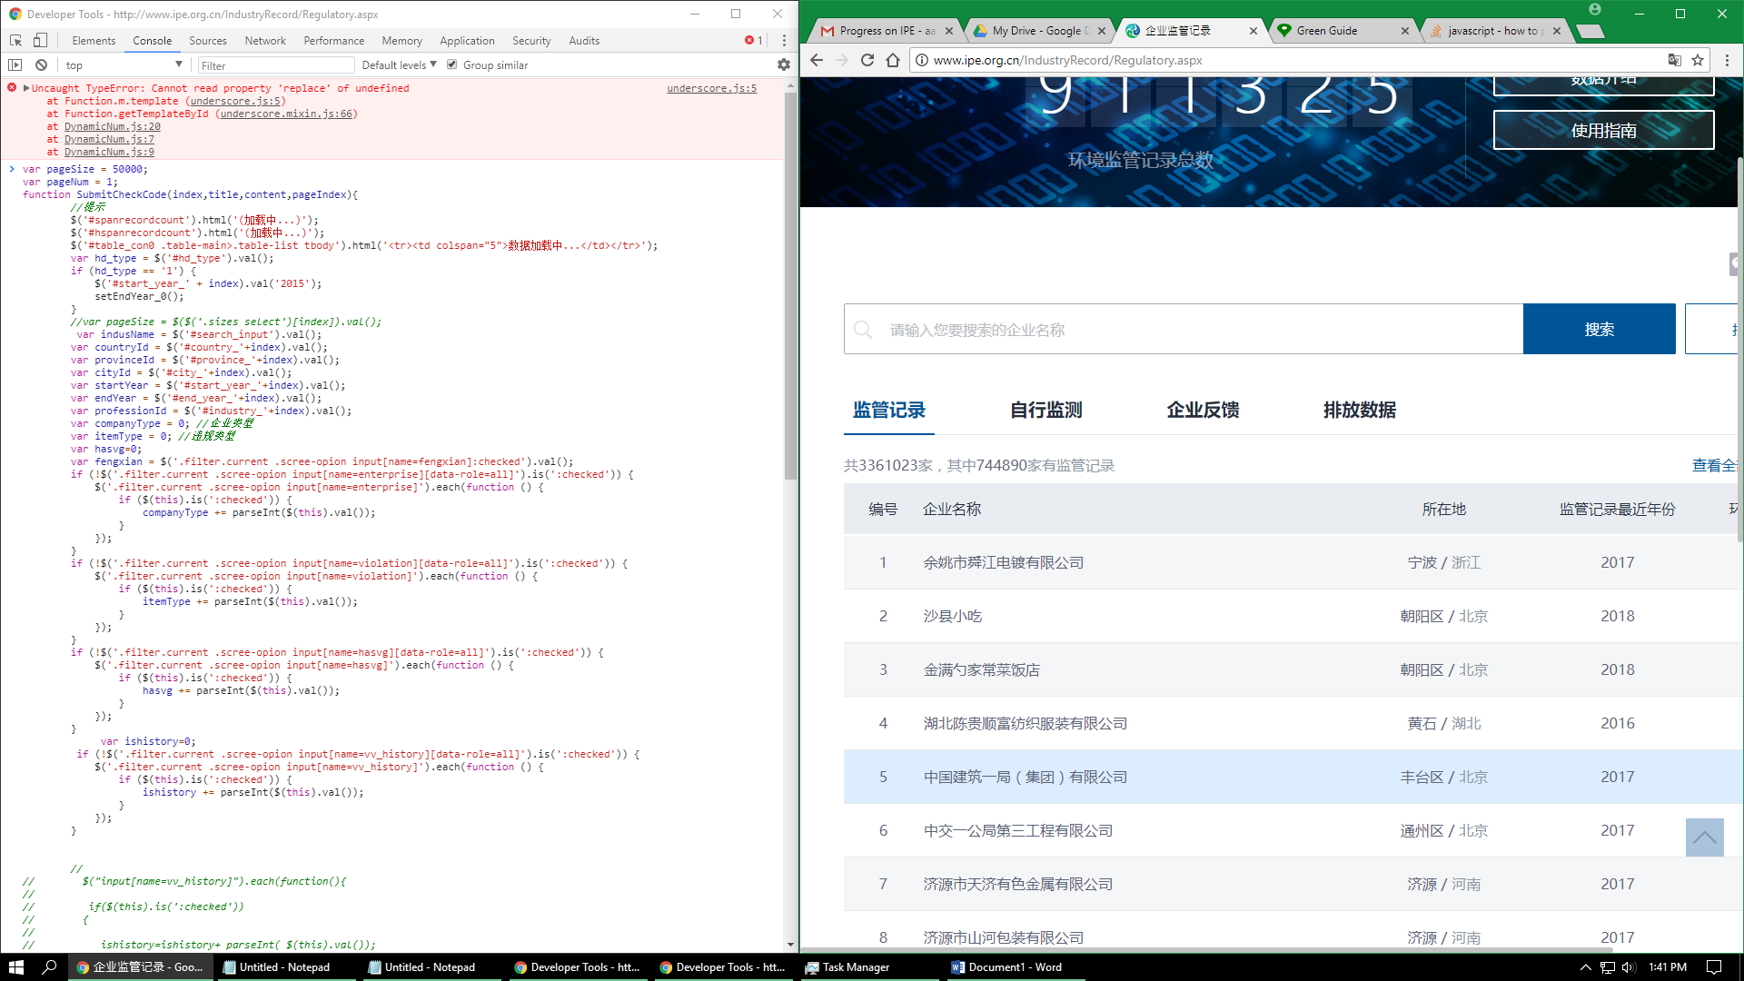
4. Enter captcha: 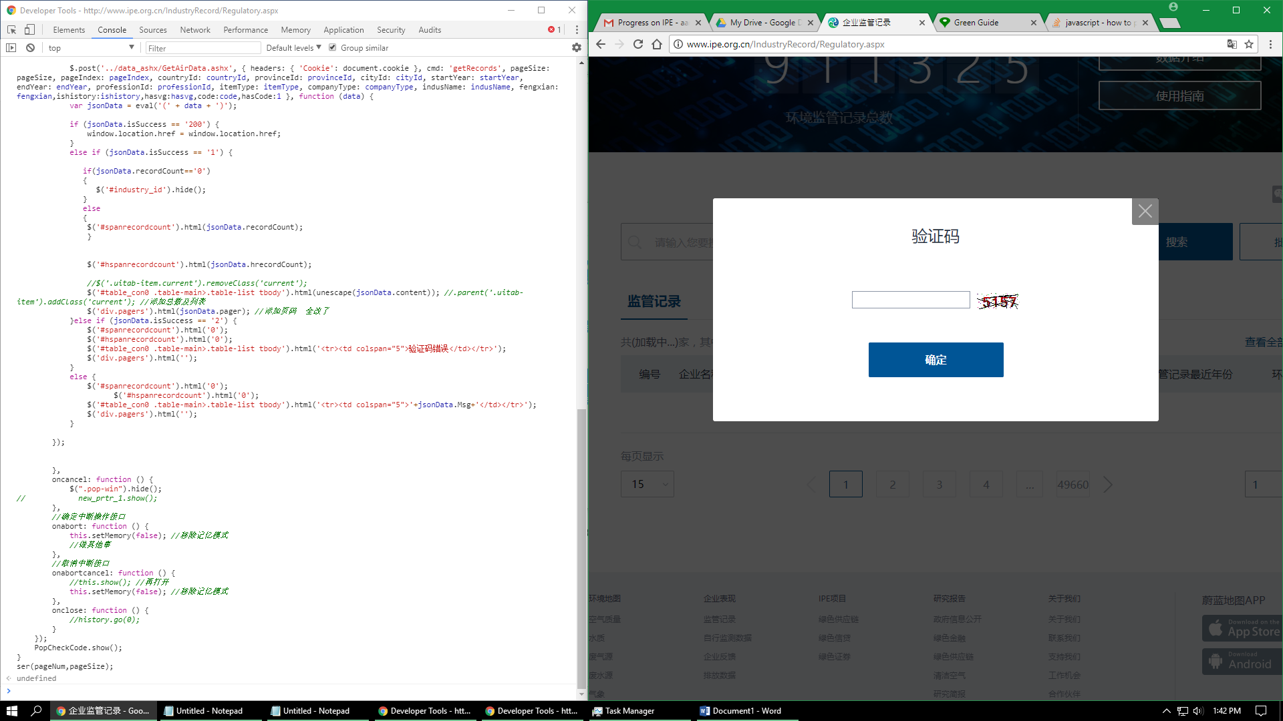
5. 50,000 lines of data will now appear. The items may take some time to load depending on how much RAM and/or CPU you have: 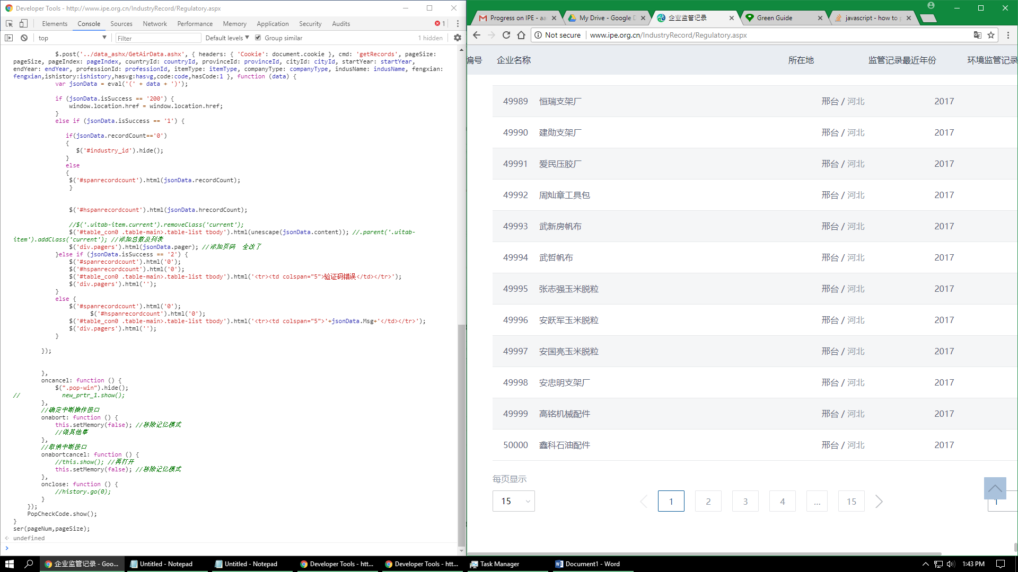
6. Run your code to collect the data: 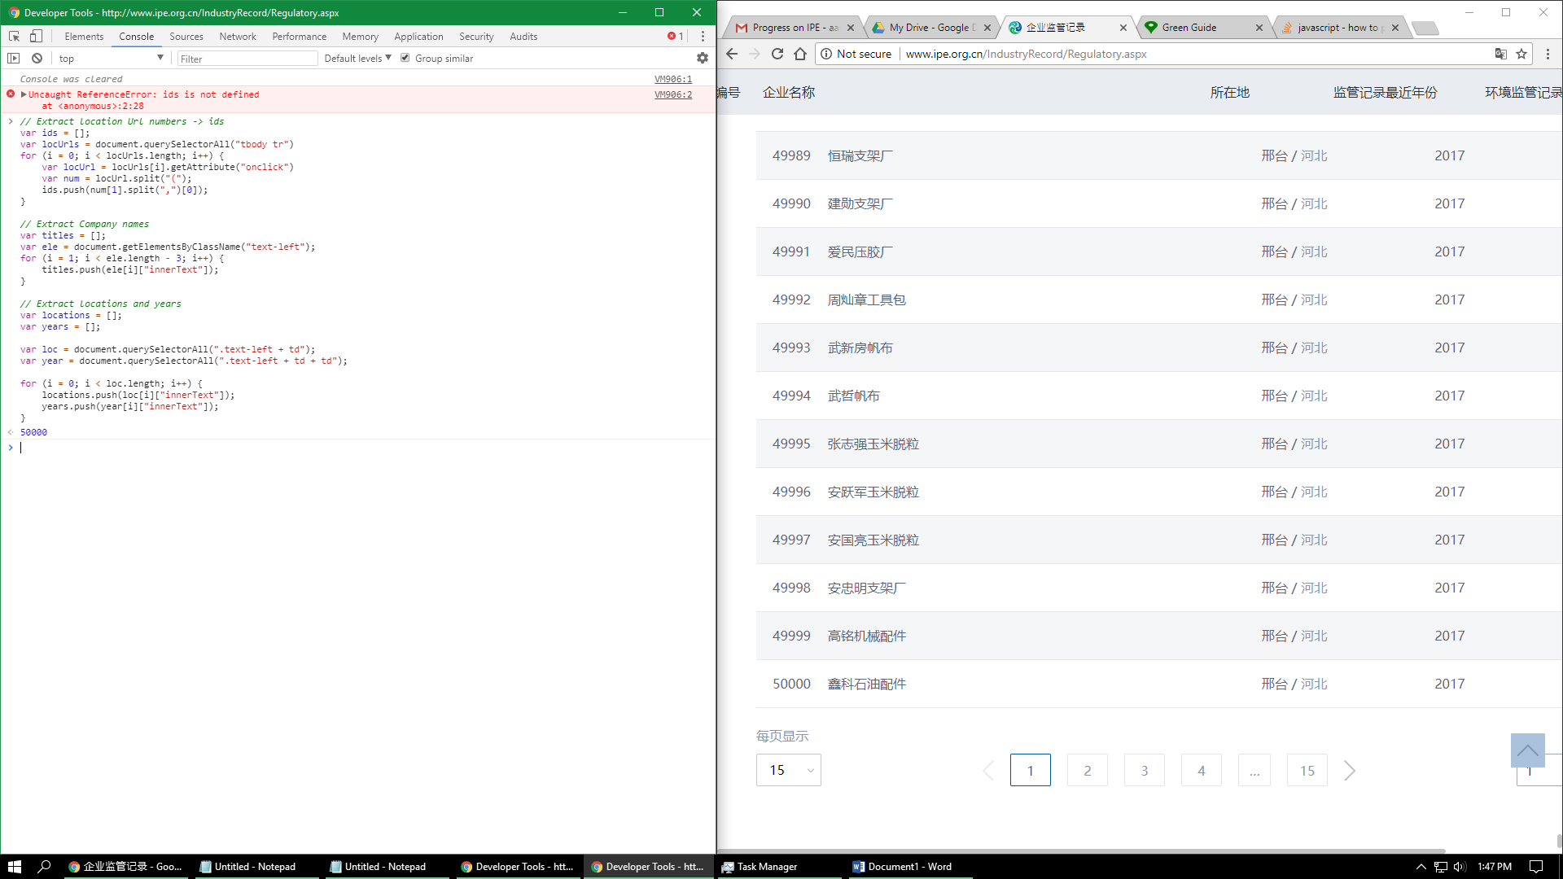
7. Run code from the bottom of IPE_SubmitCheckCode: 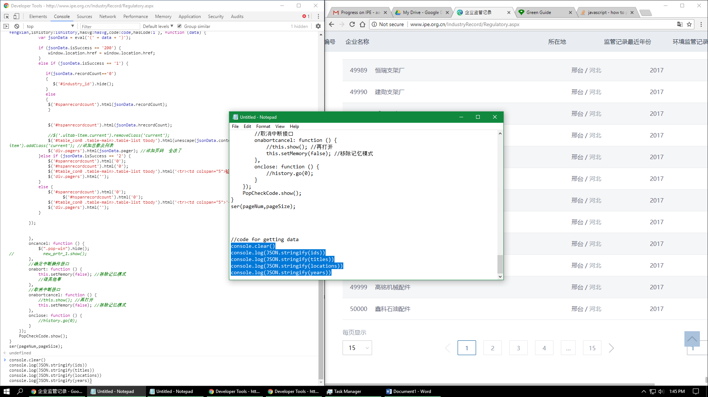
8. Data will be printed to the console. At the end of each array is a “copy” button. 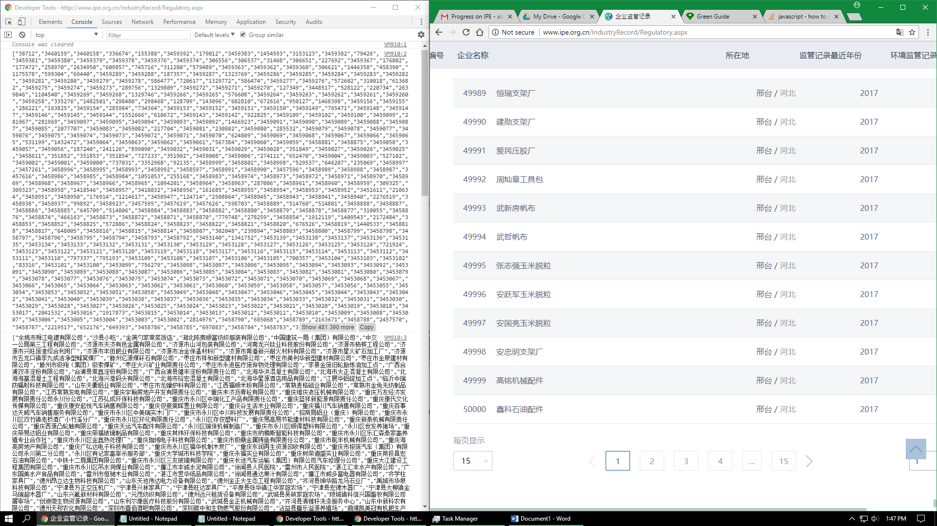
9. Copy over to lovegreenguide’s index.php. You can now run the rest of your code.