Aaron Daniels

CIS593

Lab 3

2430989

I first wrote a script to return my Mongo DB connection. This returns the client to the mongo db. Its named getdb.py

Next, I setup the twitter stream. My code is in twitterStream.py. I extended the tweepy StreamingClient with my class, IDPrinter. I rewrote the on_data method that is called each time data is received from the twitter stream. At the end it calls the original super().on_data method

def on_data(self, raw_data):

data = json.loads(raw_data)

collection_name.insert_one(data)

return super().on_data(raw_data)

It adds a step to insert the json into my Mongo db. I added my twitter rule to filter for Covid. Then, I ran my script to start retrieving tweet data.

I wasn’t able to get any geo data for 3.4. I literally requested every piece of data that I could, and geo data just isn’t showing up. I did some google searches and eventually gave up. I think I needed to use twitter api v1.1 or not use tweepy.

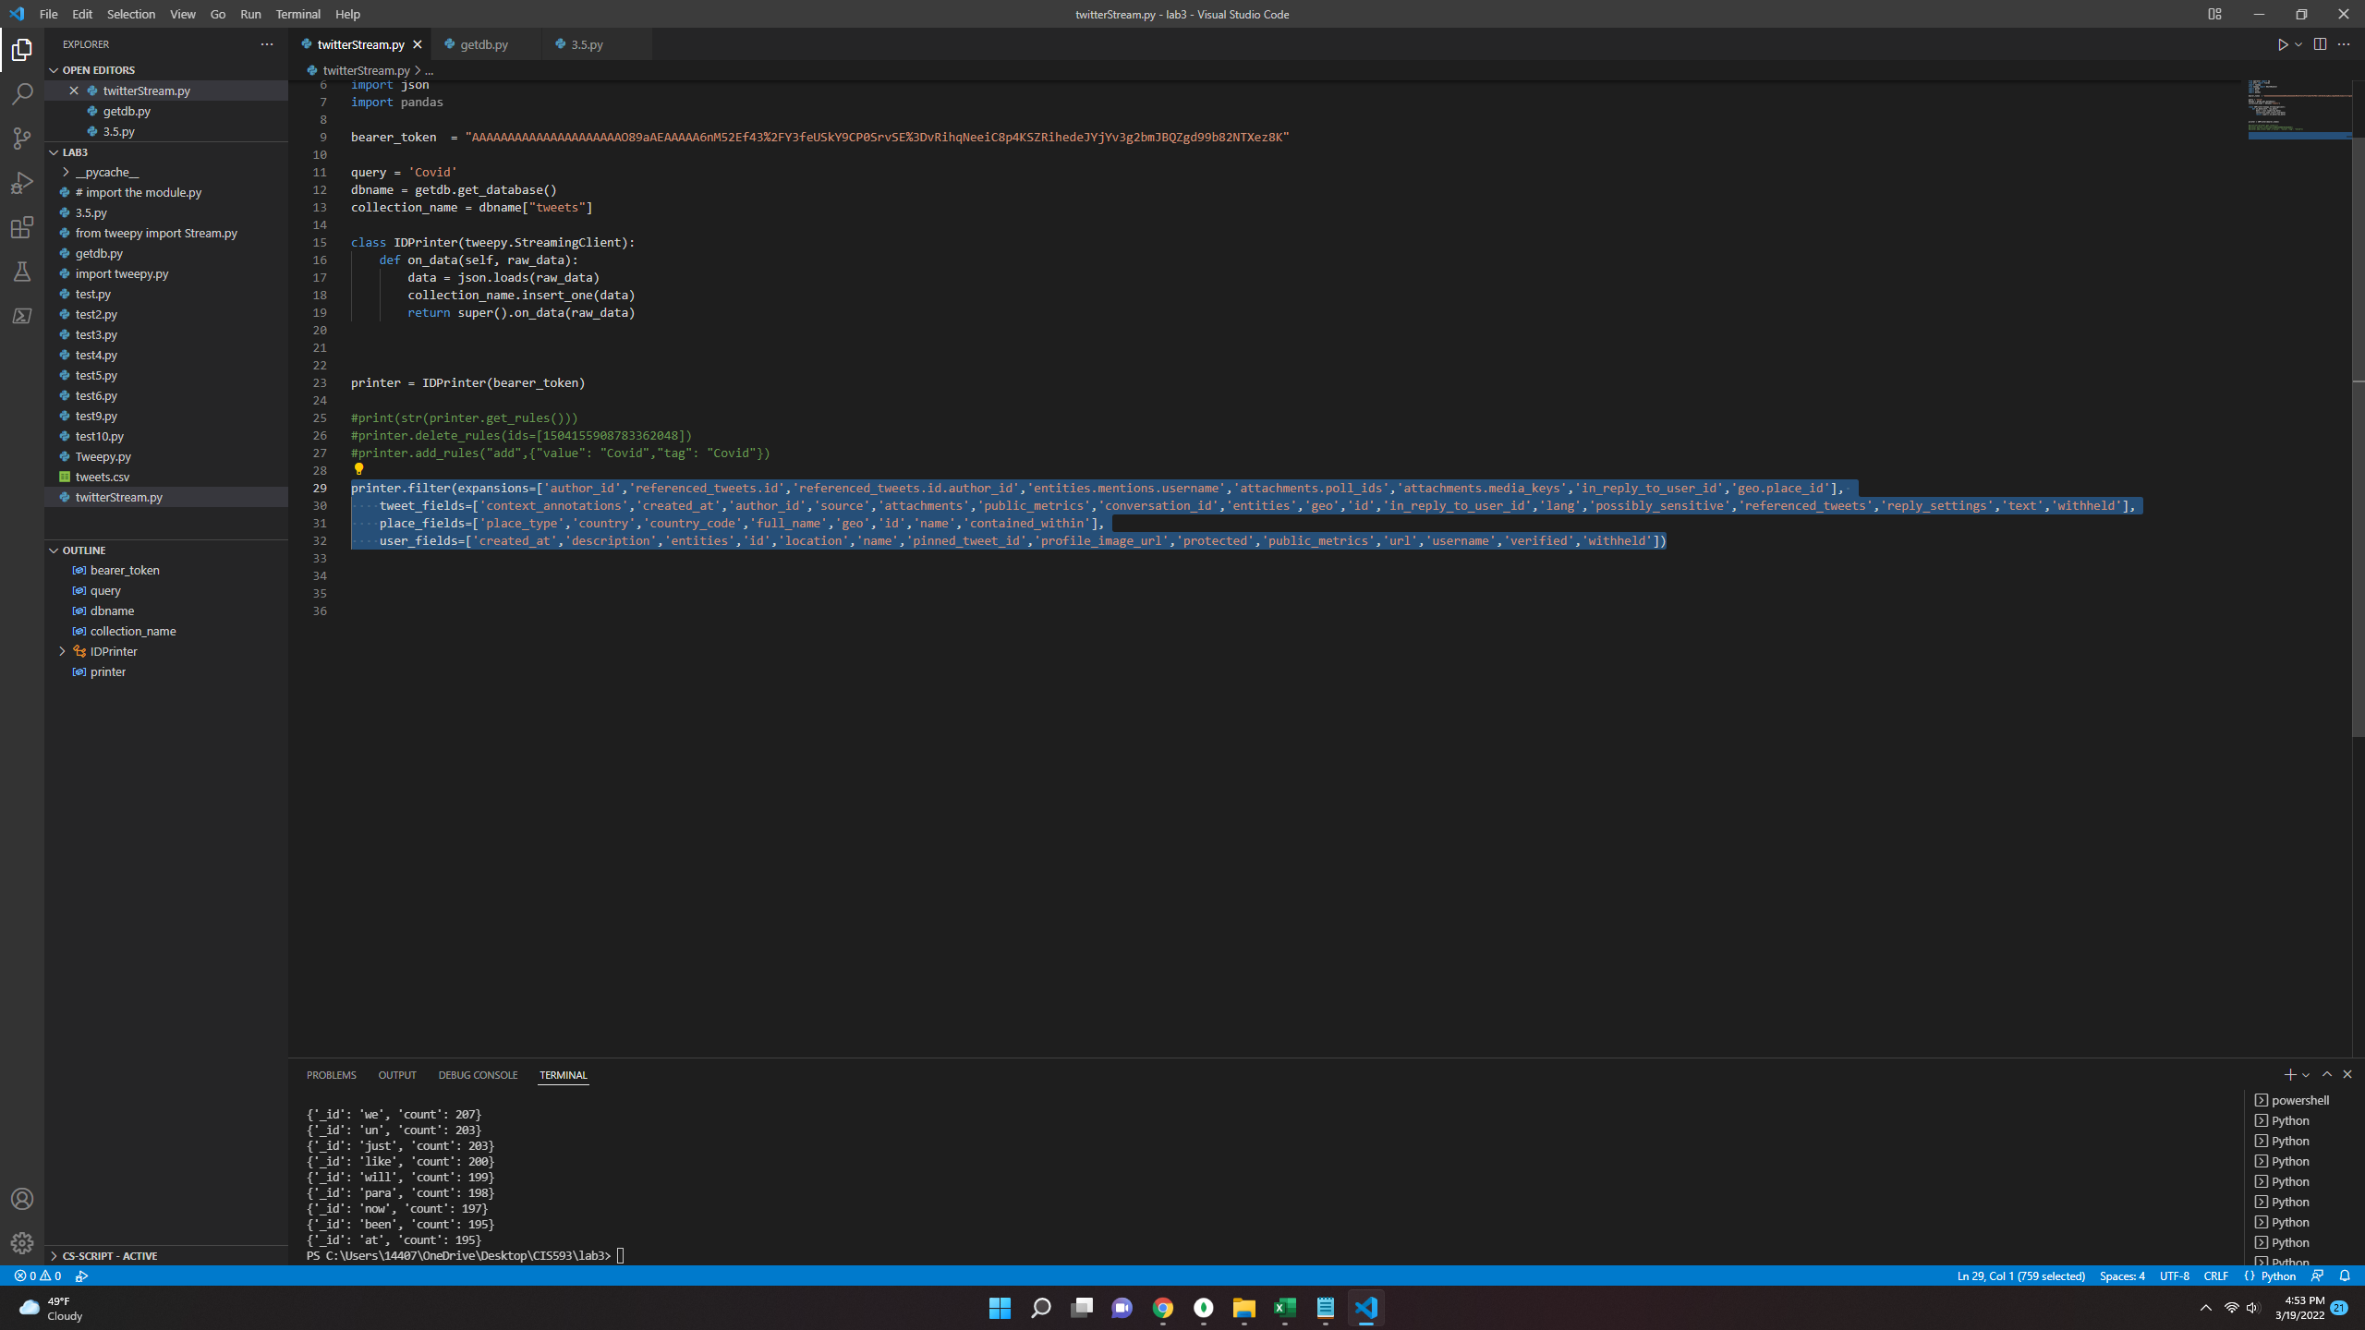

I used all the expansions and optional data fields.

printer.filter(expansions=['author_id','referenced_tweets.id','referenced_tweets.id.author_id','entities.mentions.username','attachments.poll_ids','attachments.media_keys','in_reply_to_user_id','geo.place_id'],

tweet_fields=['context_annotations','created_at','author_id','source','attachments','public_metrics','conversation_id','entities','geo','id','in_reply_to_user_id','lang','possibly_sensitive','referenced_tweets','reply_settings','text','withheld'],

place_fields=['place_type','country','country_code','full_name','geo','id','name','contained_within'],

user_fields=['created_at','description','entities','id','location','name','pinned_tweet_id','profile_image_url','protected','public_metrics','url','username','verified','withheld'])

I used the Counter package to count the most common words

