Product Specifications

Table of Contents:
Modification History 3
Major Milestones 4
Abstract 5
Document References 6
Glossary 7
Class Diagram 8
Use Case Sequence Diagram 9
Use case 1 9
General Description 9
Sequence Diagram 9
Use case 2 9
General Description 9
Sequence Diagram 9
User Interface 10
Others 11

Modification History
9/16/2014: Initial draft.
9/22/2014: Added UI mockup
10/14/2014: Added UML Classes

Major Milestones

Date | Milestone
9/16/2014 | Complete preliminary specifications
10/7/2014 | Refine specifications

Abstract
Design a multi-platform tic-tac-toe game played on a 5x5 grid that requires 4 stones in-a-row to win. Allow players to register or play as a guest. Keep track of registered player history (i.e.: wins vs losses). Game should allow player to select a difficulty when playing against the computer.

Document References
Document | Location
Requirements.doc | Google docs
SoftwareManagementPlan.doc | Google docs

Glossary

Term |  | Definition
Blue | Player 1
Red | Player 2
Grid | The playing board
Stone | Player Piece
Guest | Unregistered Player
Player | Registered Player
Leaderboard | List of top N players

Acronym | Meaning
PVP | Player-vs-Player
AI | Artificial Intelligence (the computer)
TTT | Tic-Tac-Toe

Class Diagram

Player Class
- name : string
- wins : int
- losses : int
- draws : int
(getters and setters)
+ makeMove(index : int) : void

AI Class
(inherits Player)

Grid Class
+ _grid : QList< QList <int> >
- _lastMove : int
- _gridLength : int
- _countToWin : int
(getters and setters)
+ placePiece(index : int, player : int) : void
+ checkWin(index : int) : bool
+ indexToRow(index : int) : int
+ indexToColumn(index : int) : int
+ coordinateToIndex(row : int, column : int) : int
+ valueFromIndex(index : int) : int

Registration Class

Main Class
- turn : int
- blue : color
- red : color
- isVisible : bool
- board : grid
+ players : QList < Player* >
+ createOpponent(difficulty : int) : void
+ lastMoveCheck() : void
+ tileMouseArea.onClicked() : void
+ tileMouseArea.onEntered() : void
+ tileMouseArea.onExited() : void

Login Class
+ background : image

Main Menu Class
+ divisor : int

Settings View Class

Player Selection View
+ register() : void
+ login() : void

Use Case Sequence Diagram

Use case 1

General Description

Sequence Diagram

Use case 2

General Description

Sequence Diagram

....

User Interface
Responsive 5x5 grid.
Stones are blue and grid.

Main Menu:
Tic-Tac-Toe
 | Play with:
 | A friend |  | The Computer

Main Menu: Play the computer
Tic-Tac-Toe
Choose a difficulty.
Easy
Medium
Hard
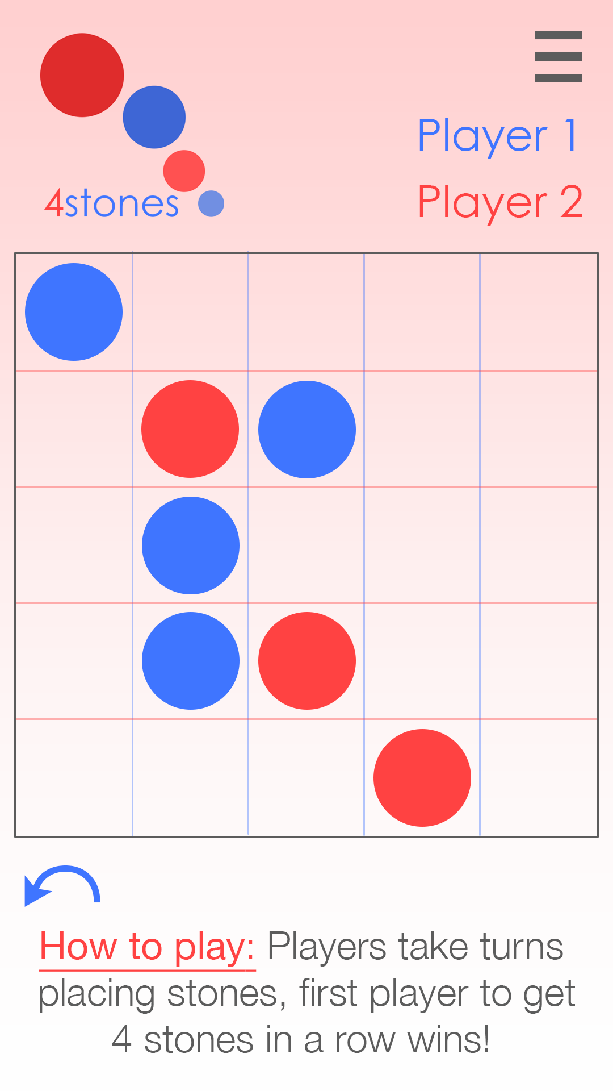

Others
