Aaron Dancer

IT-FP3212 – Assessment 2

index.html - https://aarondancer.github.io/fp3212/a2/index.html
about.html - https://aarondancer.github.io/fp3212/a2/about.html
services.html - https://aarondancer.github.io/fp3212/a2/services.html
gallery.html - https://aarondancer.github.io/fp3212/a2/gallery.html
contact.html - https://aarondancer.github.io/fp3212/a2/contact.html
template.html - https://aarondancer.github.io/fp3212/a2/template.html

Acme Logo used: https://upload.wikimedia.org/wikipedia/commons/5/5e/Acme_Markets_lolo.svg

W3C Validations
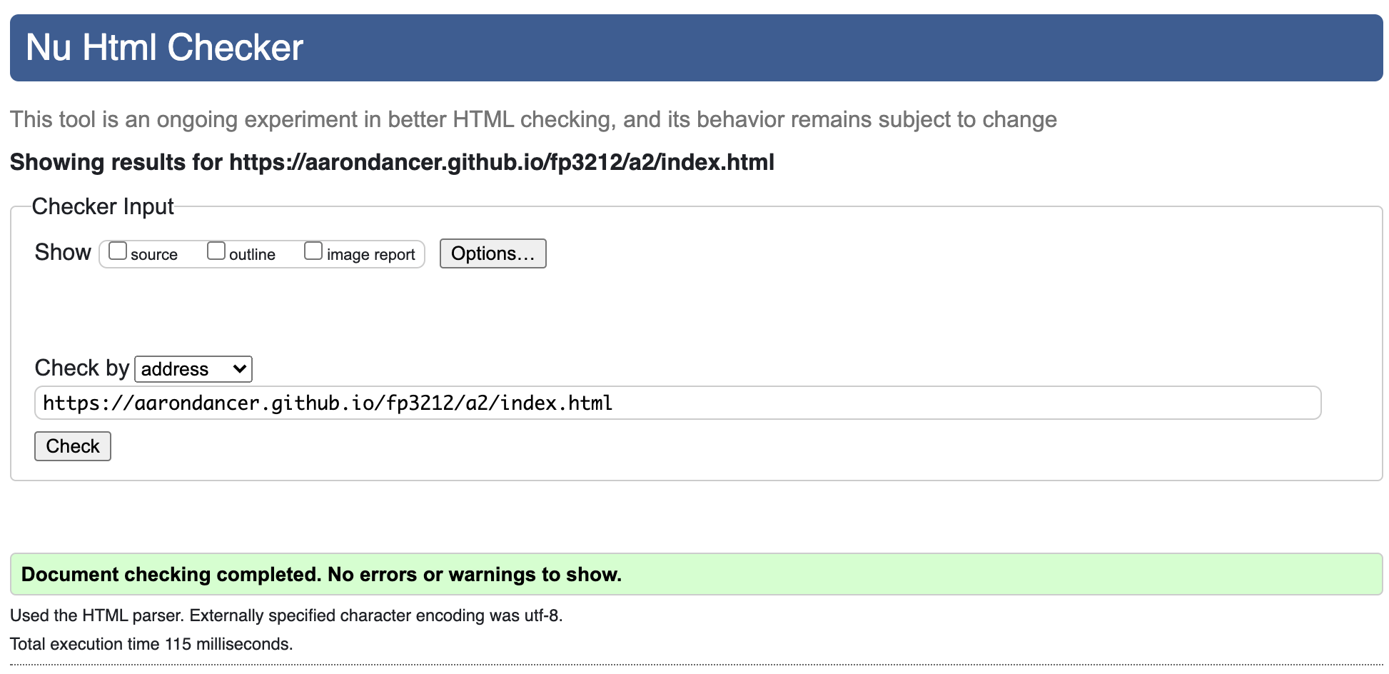
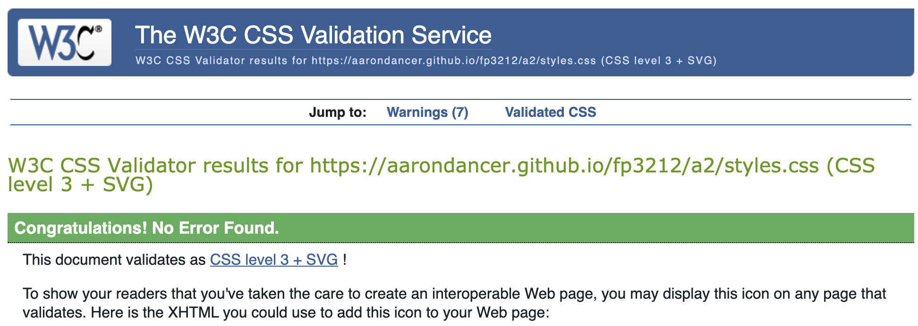

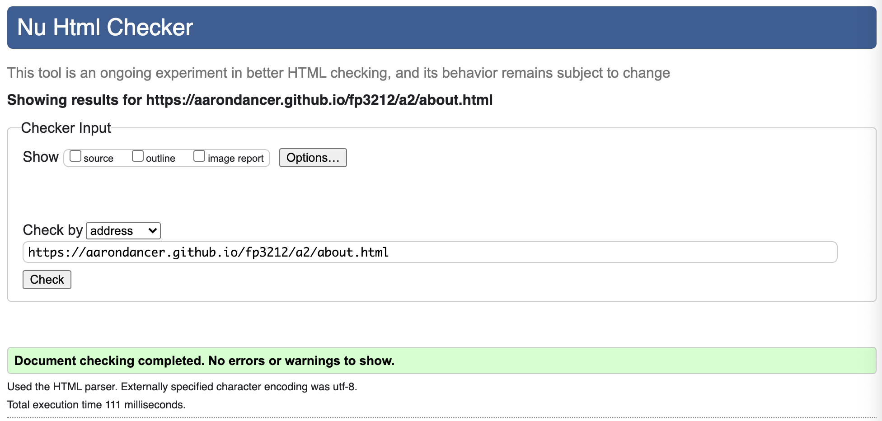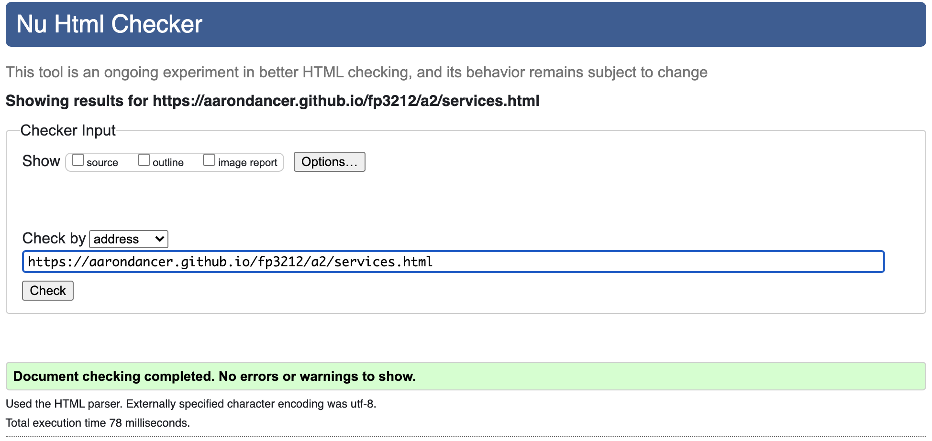
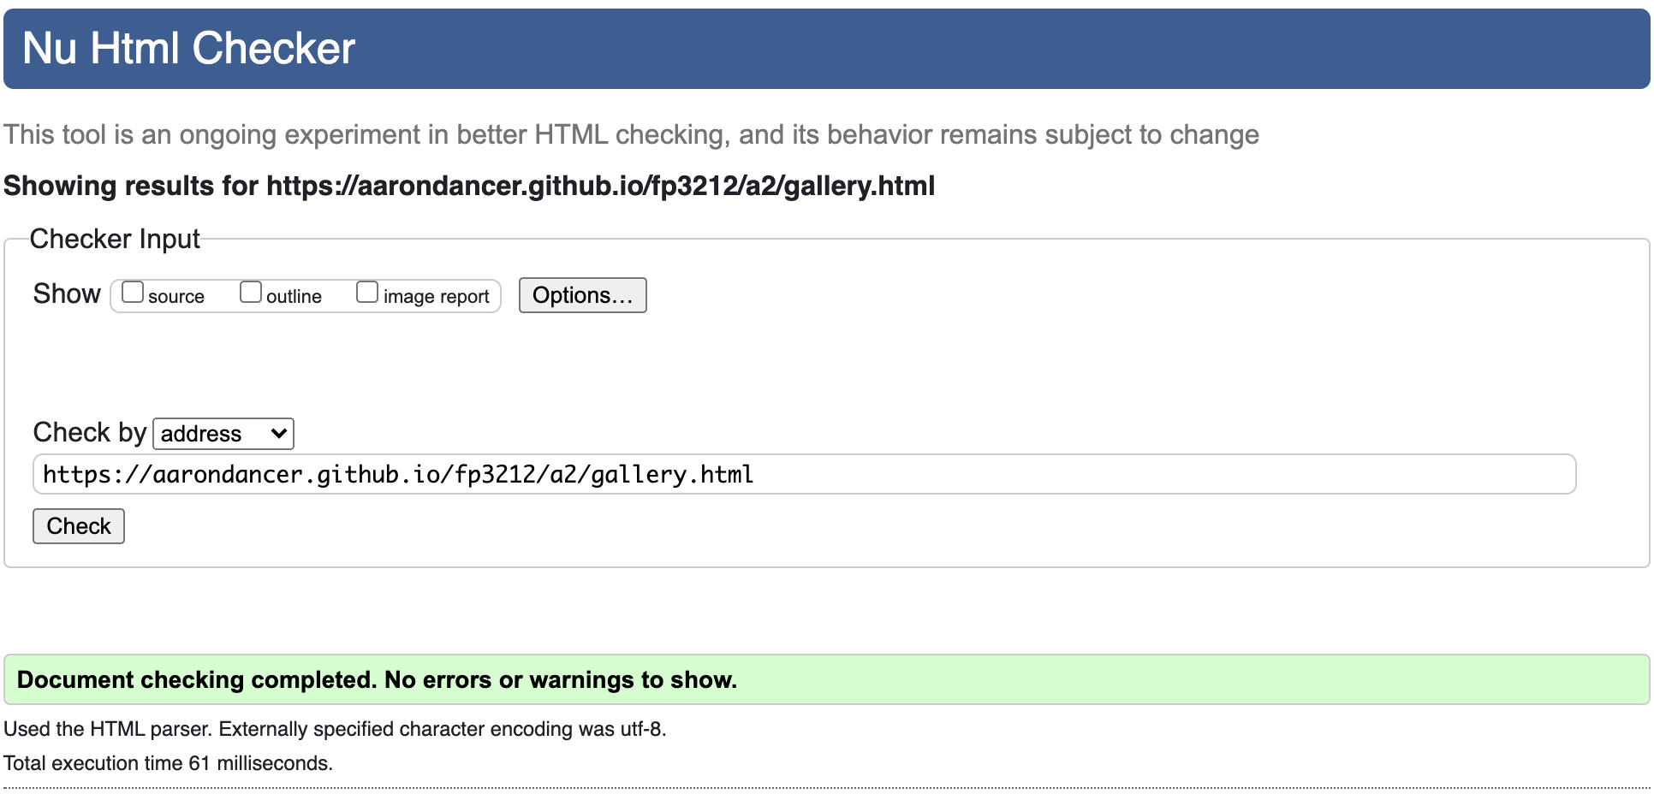

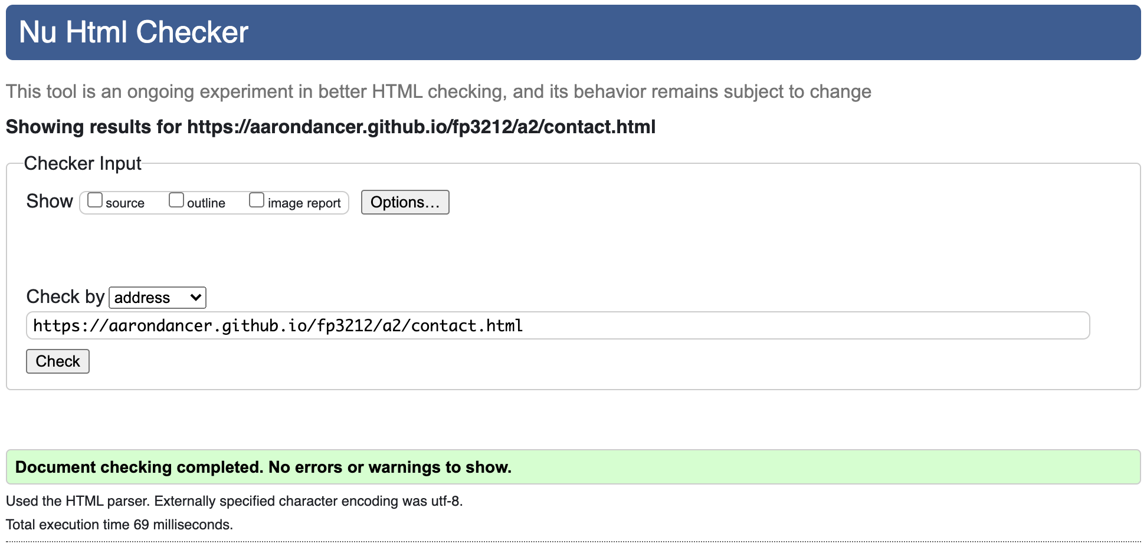
Chrome:
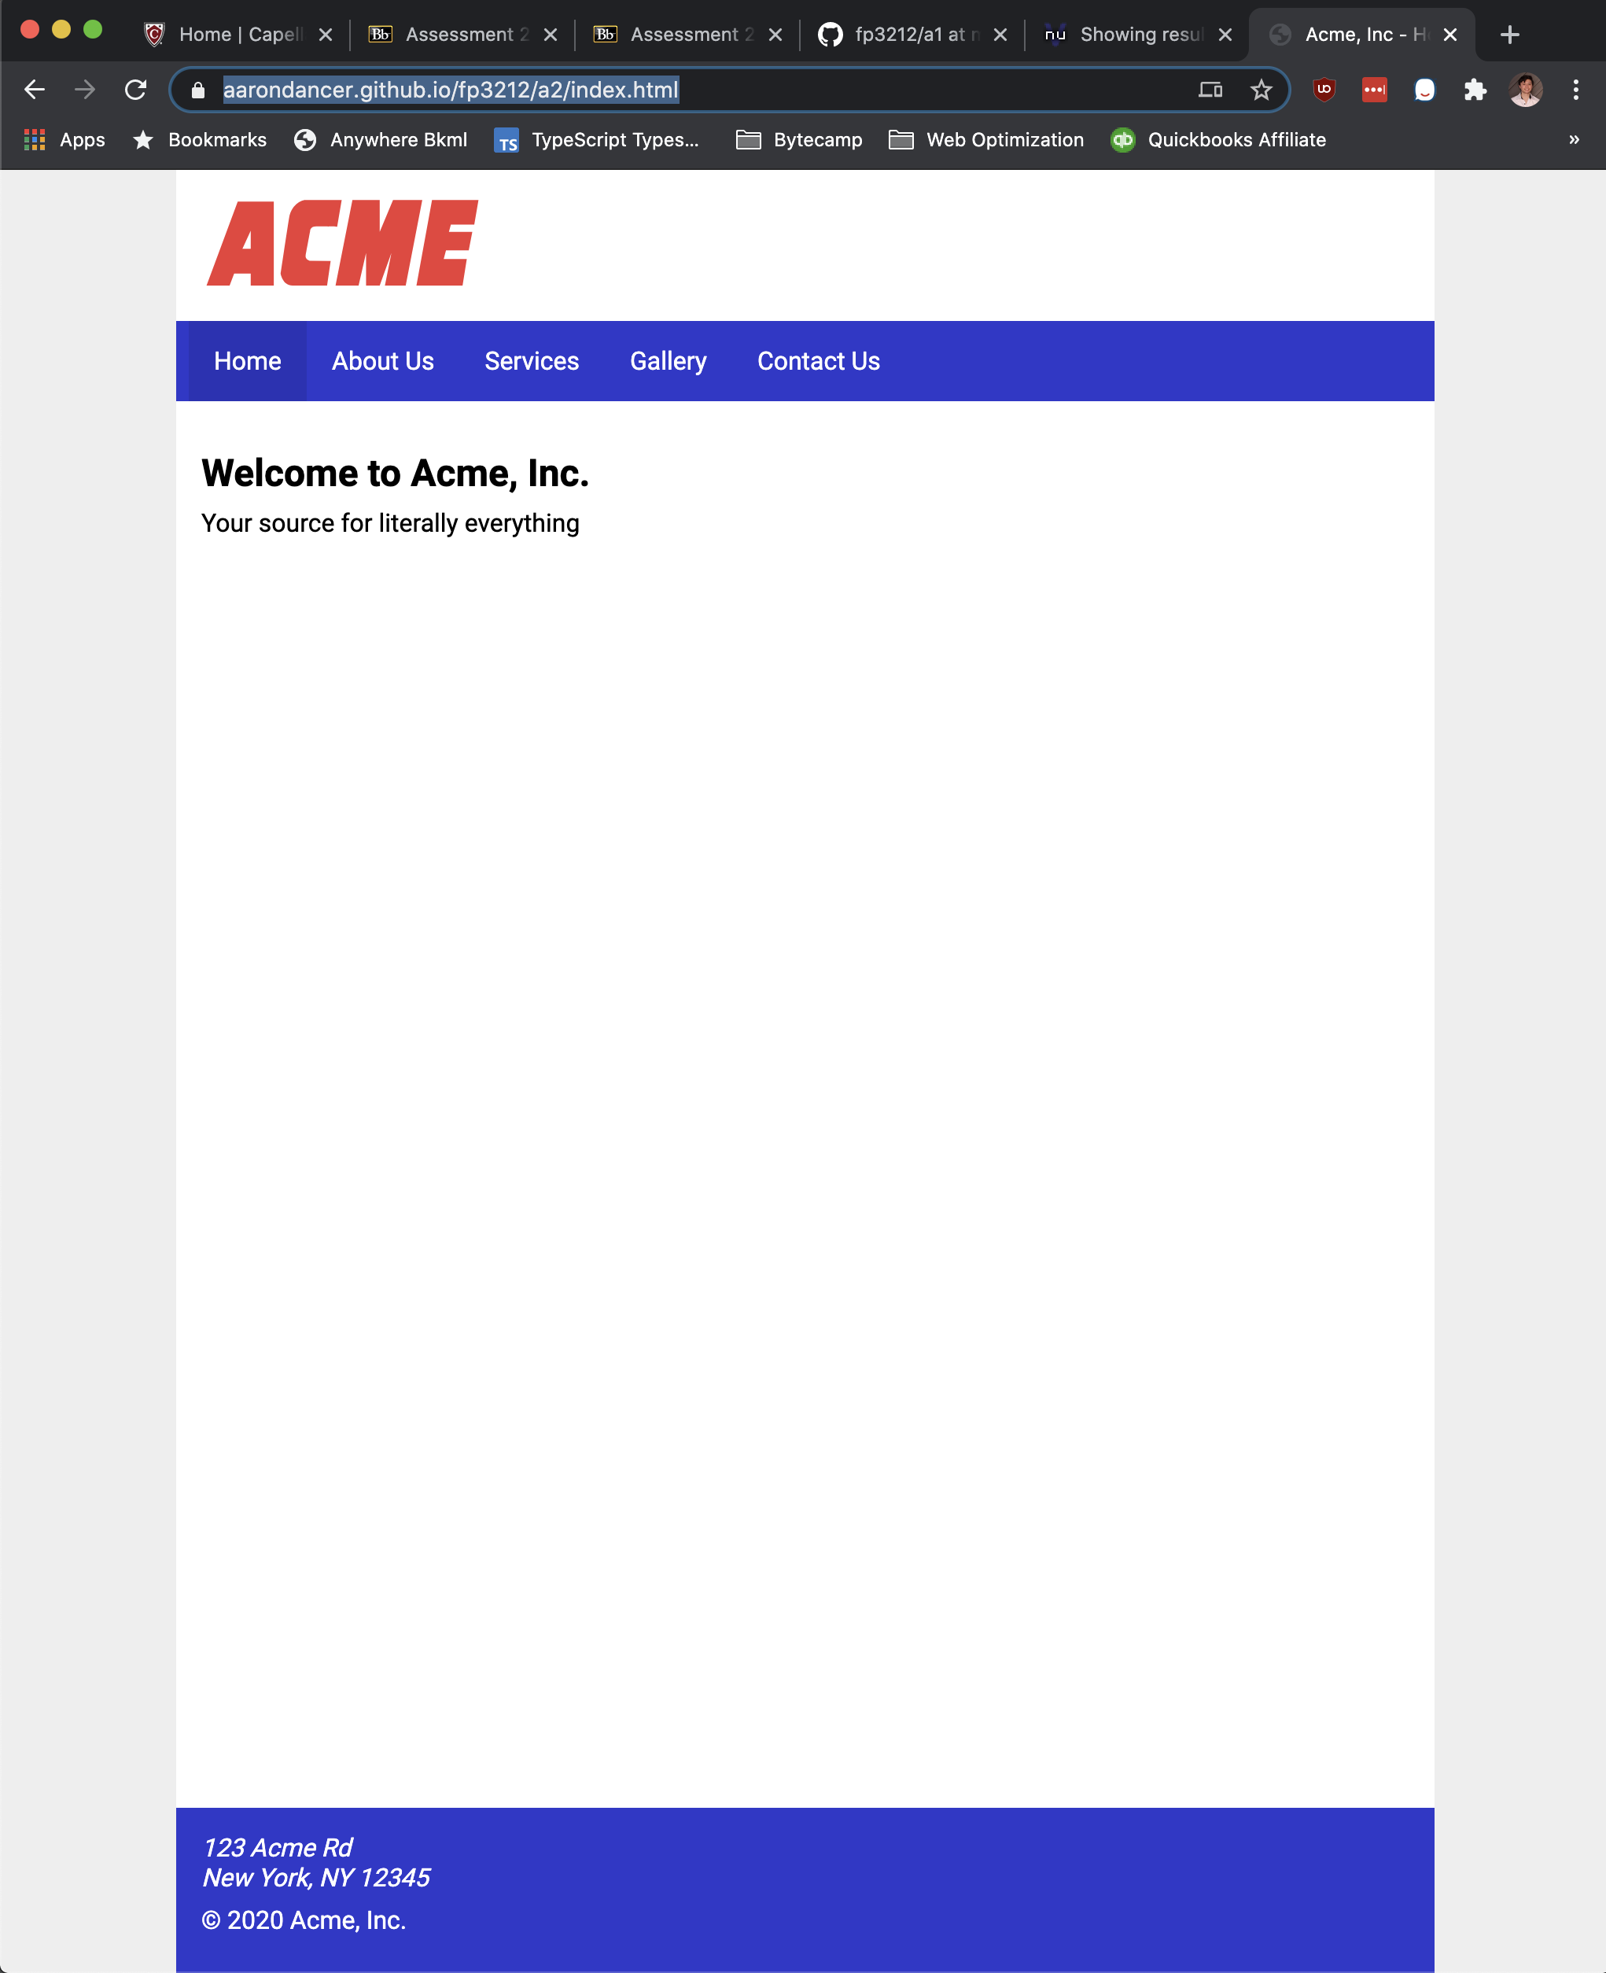

Firefox:
