Aaron Dancer

IT-FP3212 – Assessment 1

index.html - https://aarondancer.github.io/fp3212/a1/index.html
template.html - https://aarondancer.github.io/fp3212/a1/template.html

Acme Logo used: https://upload.wikimedia.org/wikipedia/commons/5/5e/Acme_Markets_lolo.svg

W3C Validation
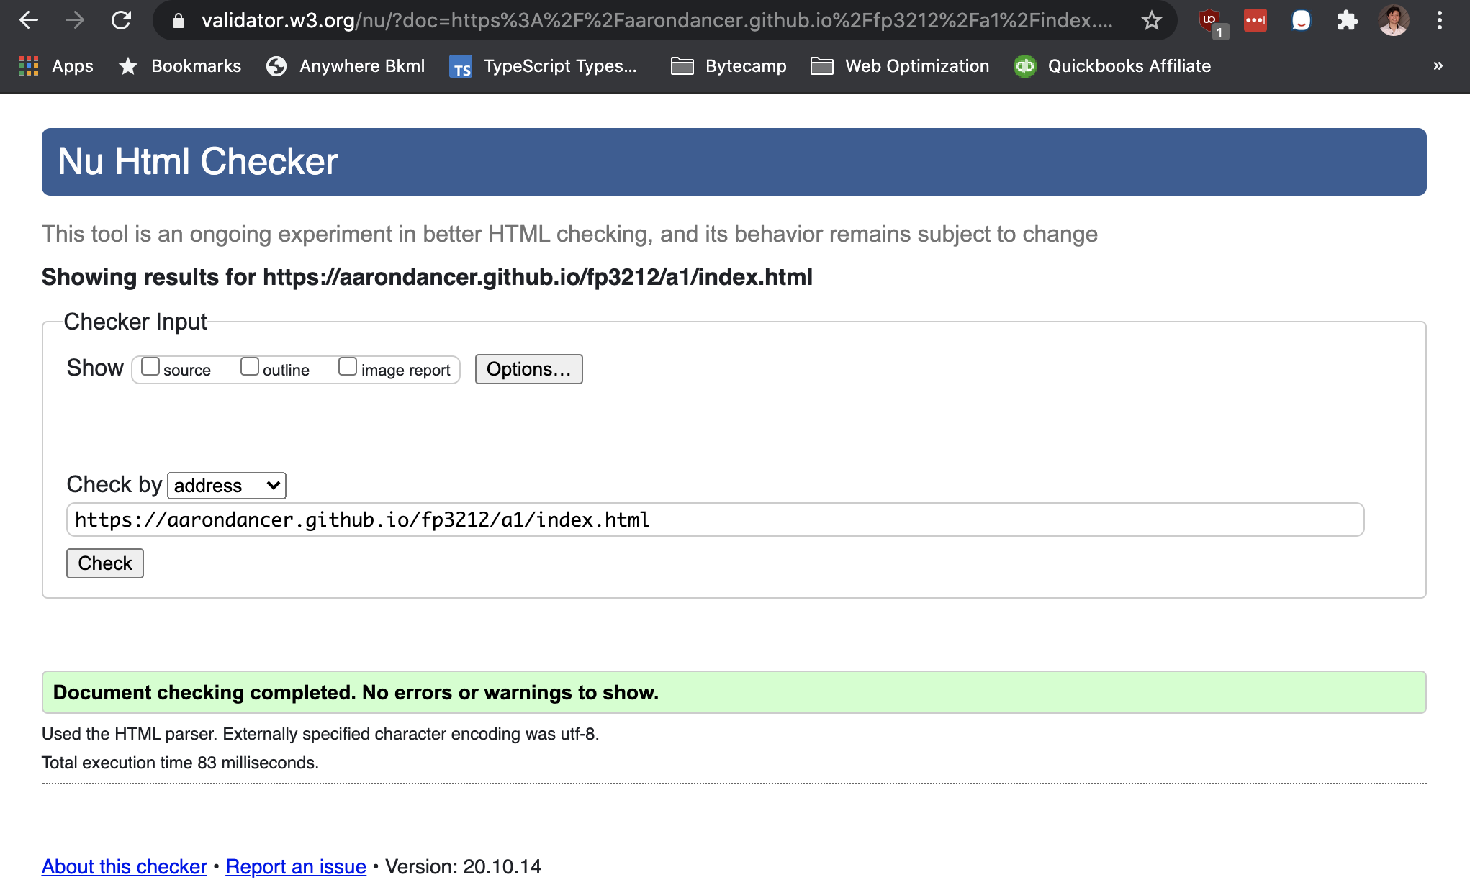

Chrome:
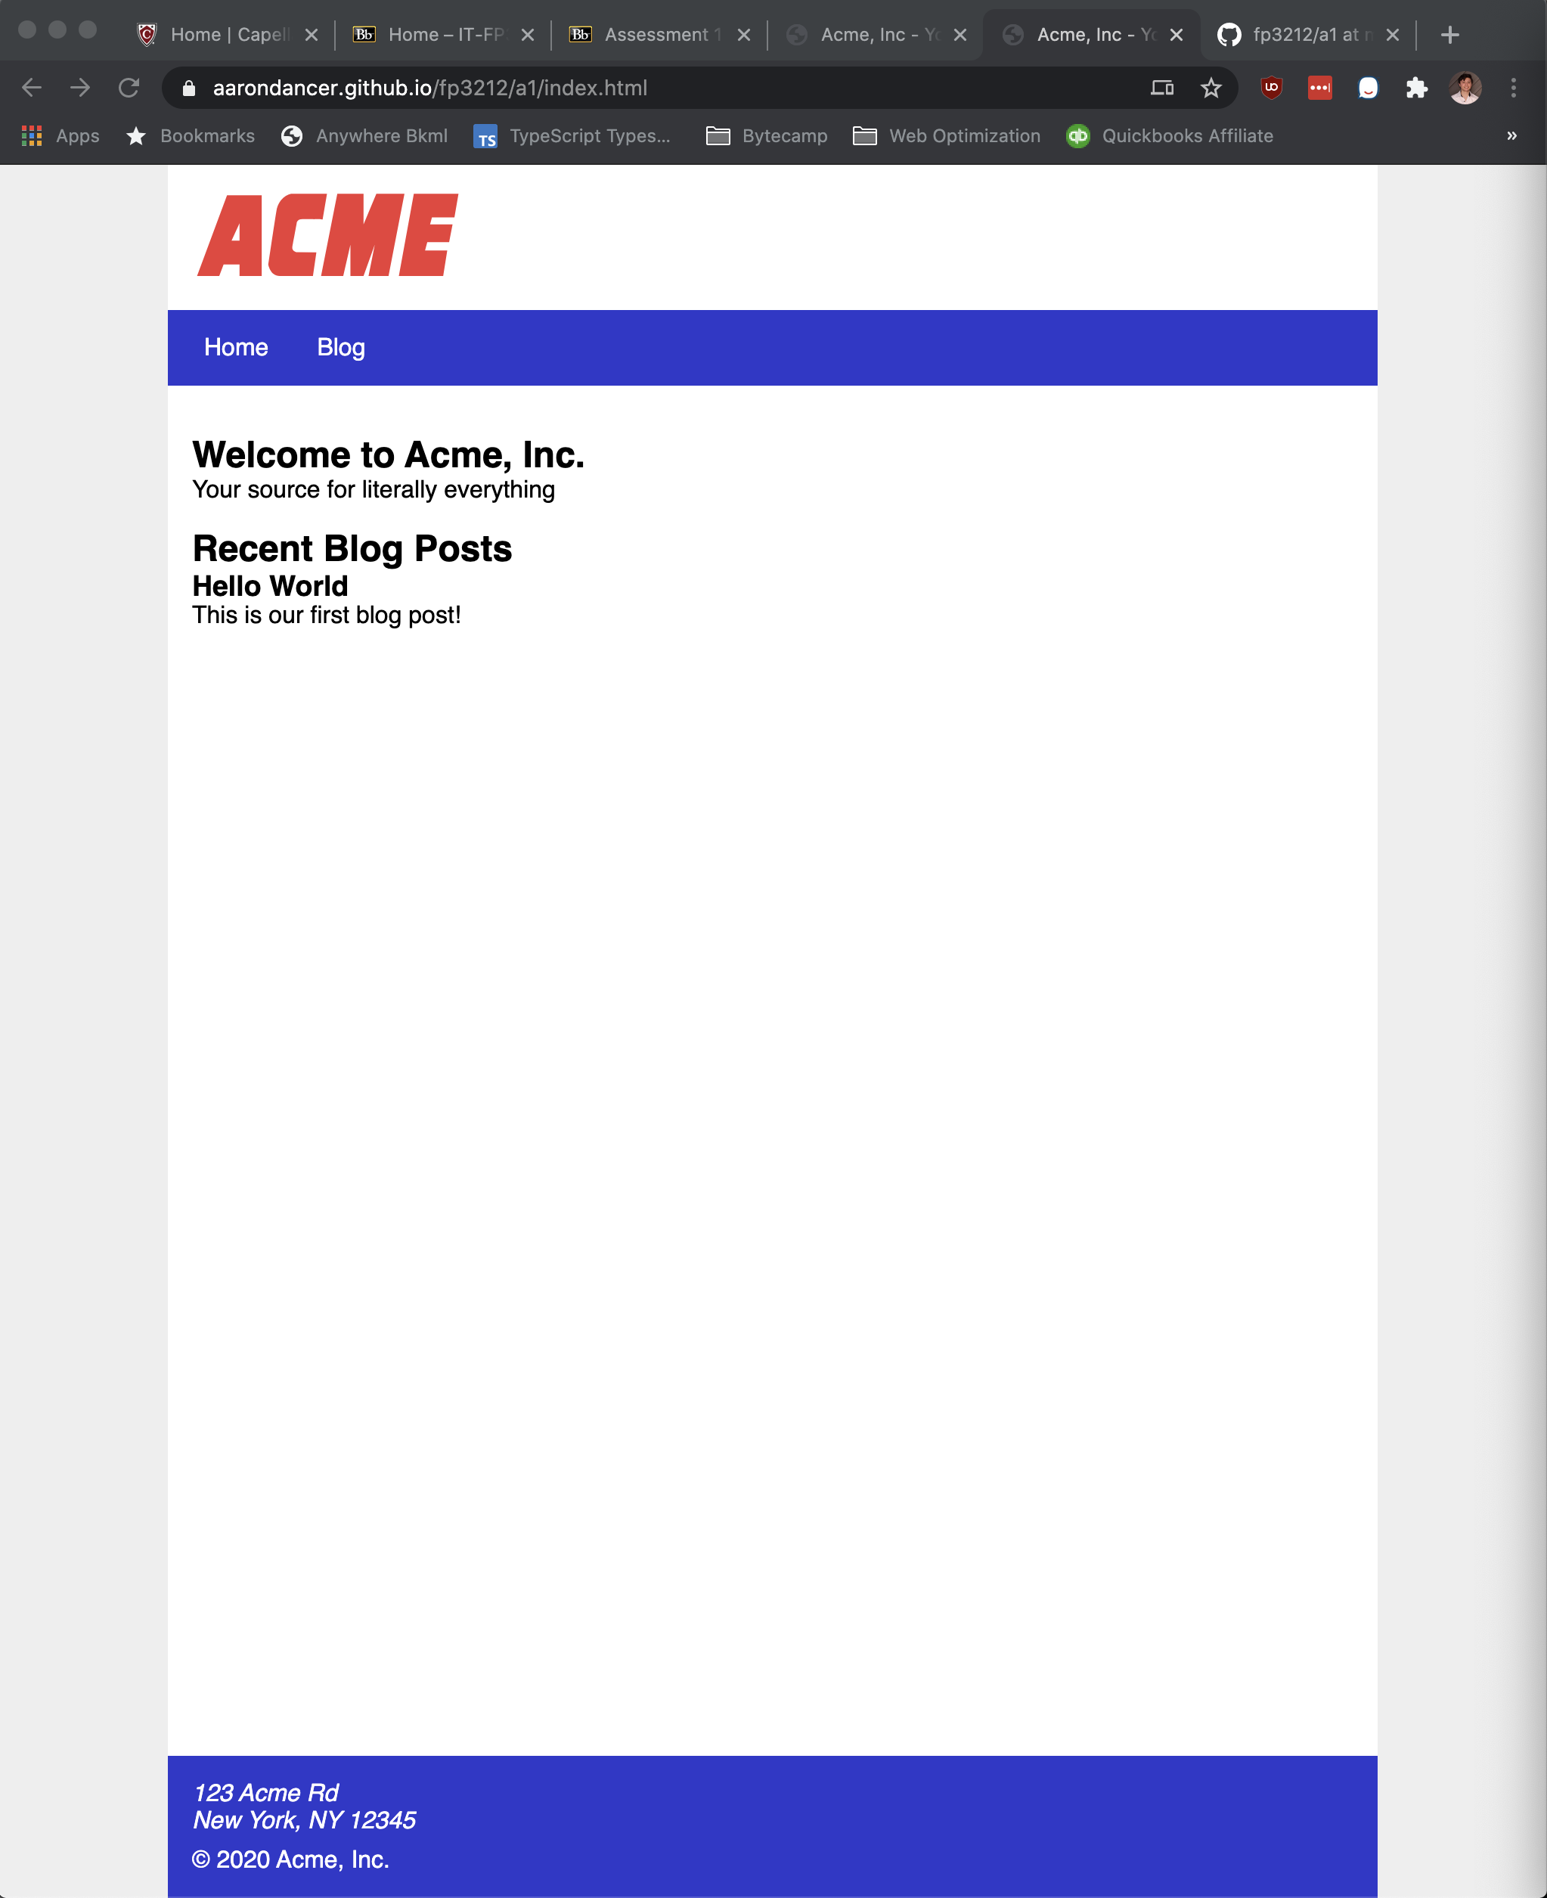

Firefox:
