Aaron Dancer – IT-FP3215 – Assessment 3

Website URL:
https://fp3215.vercel.app/a3/index.html
https://fp3215.vercel.app/a3/gallery.html

Chrome Validation:
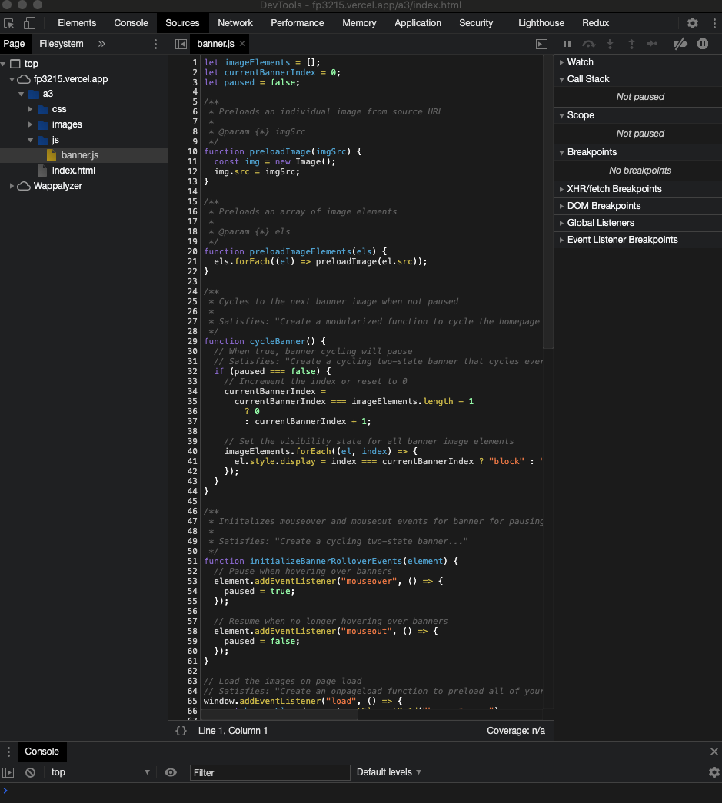
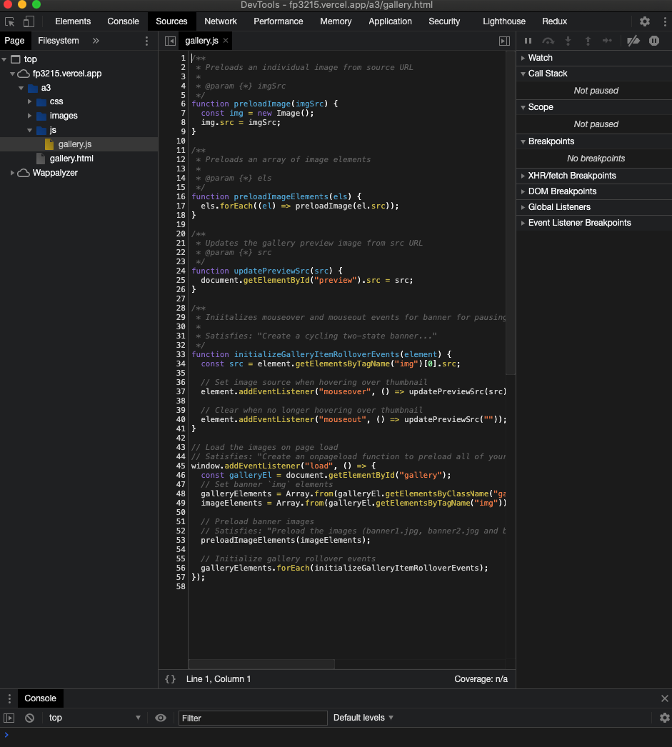
Firefox Validation:
